**Exp No: 6 Applying DML commands on Road Way Travels Tables. Data Manipulation Command**

**• Insert**

**• Update**

**• Delete**

**• Select**

insert into employees (emp_id,emp_name,DOB,age,email)values("1","taruni","1996-01-23","25","taruni@gmail.com");

insert into employees (emp_id,emp_name,DOB,age,email)values("2","dimple","1995-10-29","26","dimple@gmail.com");

insert into employees (emp_id,emp_name,DOB,age,email)values("3","santhu","1998-12-19","23","santhu@gmail.com");

insert into employees (emp_id,emp_name,DOB,age,email)values("4","jahnavi","1995-08-06","25","dimple@gmail.com");

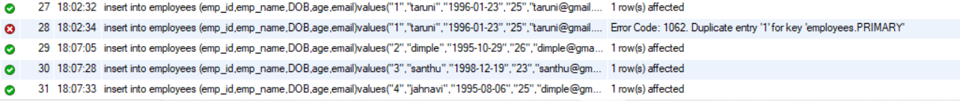

select * from employees;

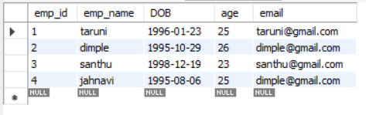

alter table employees add phoneno numeric;

update employees set phoneno = 7285955271 where emp_id=1;

update employees set phoneno = 9393242745 where emp_id=3;

update employees set phoneno = 9298802886 where emp_id=2;

update employees set phoneno = 8142810574 where emp_id=4;

alter table employees drop age;

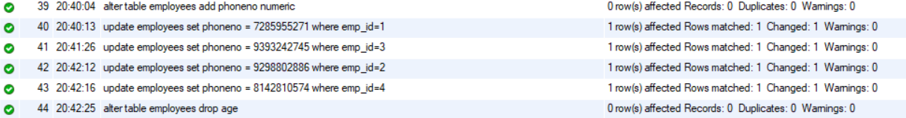

update employees set email ="jahnavi@gmail.com" where emp_id=4;

select * from employees;

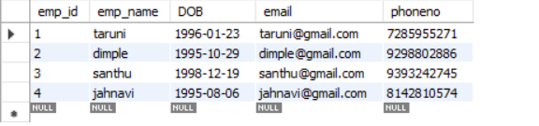

update employees set Gender = "Female" where emp_id=1;

update employees set Gender = "Female" where emp_id=2;

update employees set Gender = "Male" where emp_id=3;

update employees set Gender = "Female" where emp_id=4;

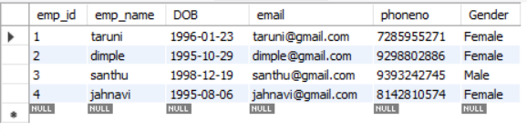

select distinct gender from employees;

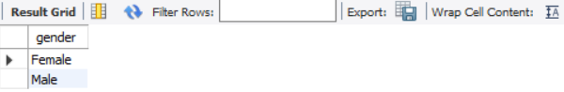

select phoneno from employees where emp_id=2;

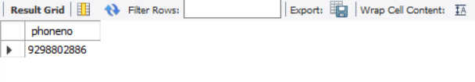

select count(distinct gender) from employees;

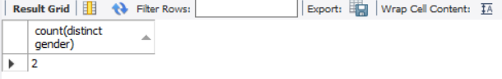

alter table employees add Salary numeric;

update employees set Salary = 45000 where emp_id=1;

update employees set Salary = 55000 where emp_id=2;

update employees set Salary = 58000 where emp_id=3;

update employees set Salary = 60000 where emp_id=4;

select * from employees;

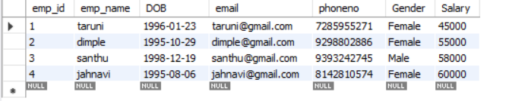

select * from employees where Salary>55000;

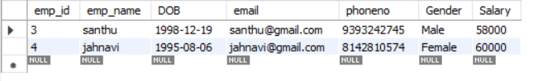

delete from employees where emp_id=1;

select * from employees;

