**Exp No:7**

**Practice Queries using ANY, ALL, IN, EXISTS, UNION, INTERSECT Set Operators**

SELECT ProductName

FROM Products

WHERE ProductID = ANY (SELECT ProductID FROM OrderDetails WHERE Quantity = 10);

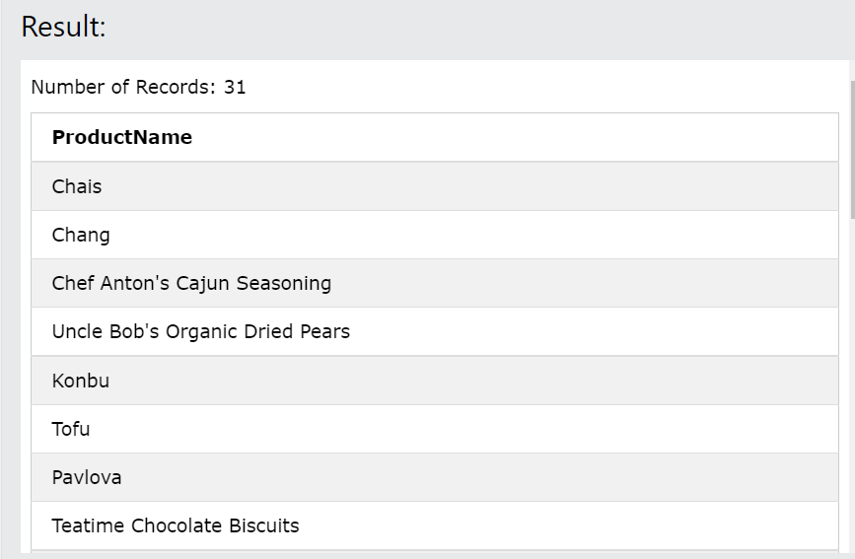

SELECT ALL ProductName

FROM Products

WHERE TRUE;

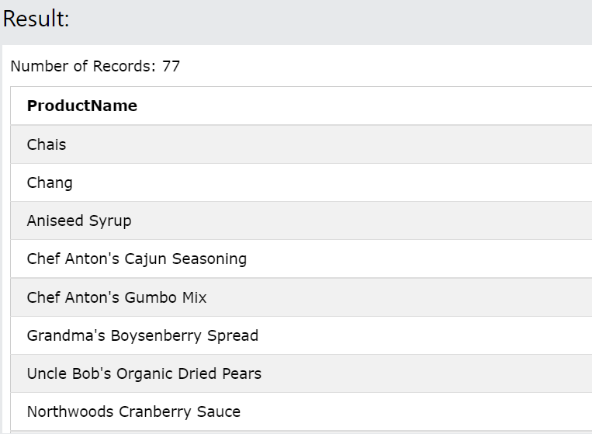

SELECT ProductName

FROM Products

WHERE ProductID = ALL (SELECT ProductID FROM OrderDetails WHERE Quantity = 10);

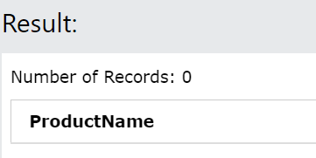

SELECT * FROM Customers

WHERE Country IN ('Germany', 'France', 'UK');

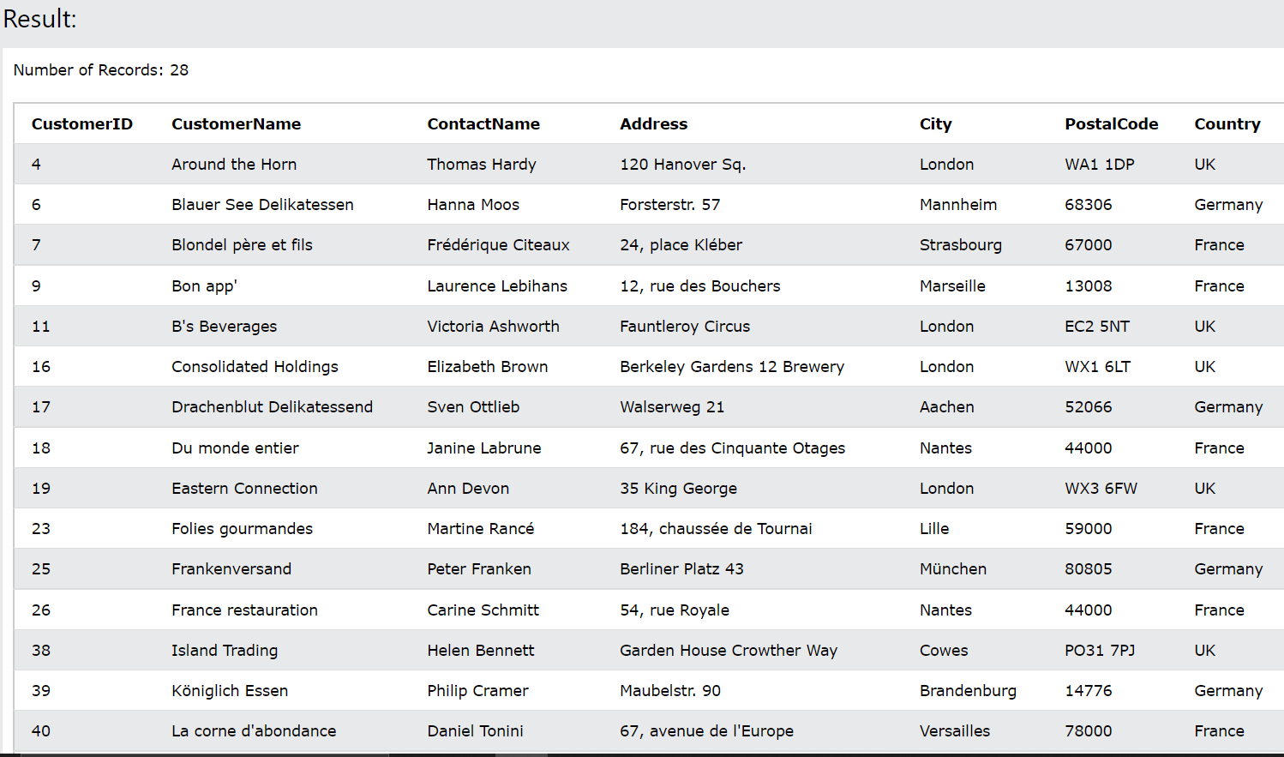

SELECT * FROM Customers

WHERE Country NOT IN ('Germany', 'France', 'UK');

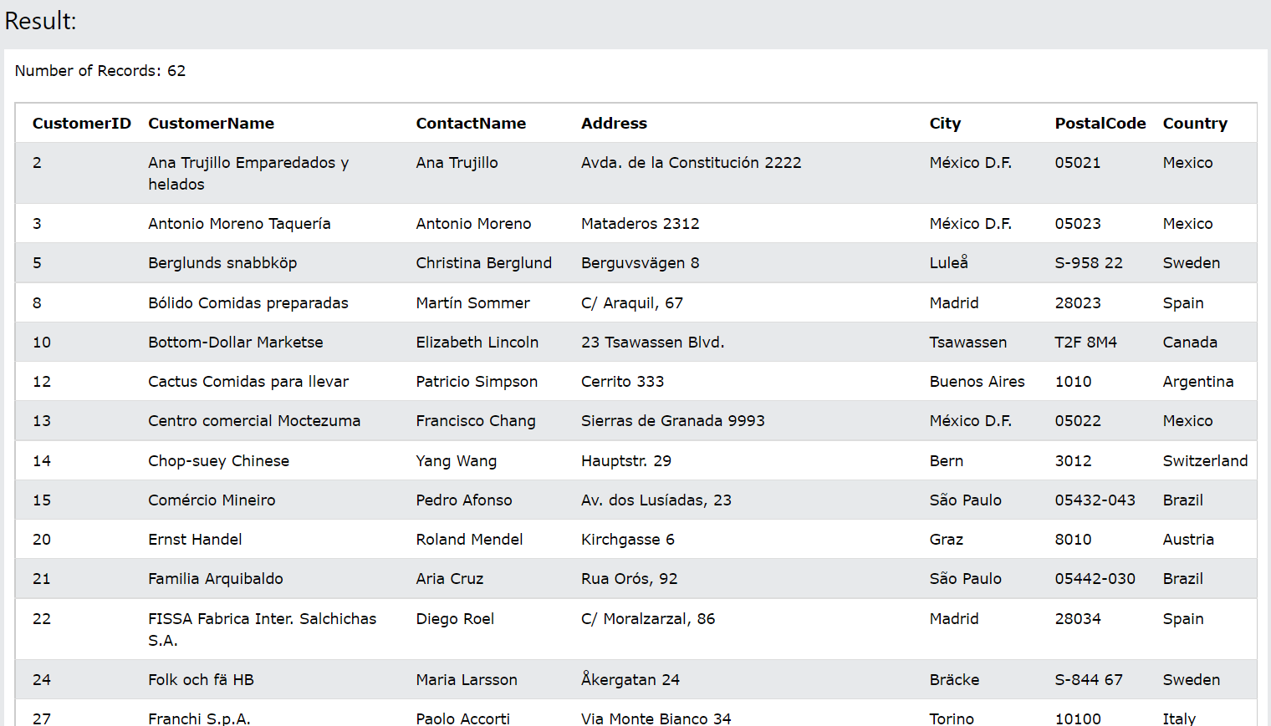

SELECT SupplierName

FROM Suppliers

WHERE EXISTS (SELECT ProductName FROM Products WHERE Products.SupplierID = Suppliers.supplierID AND Price < 20);

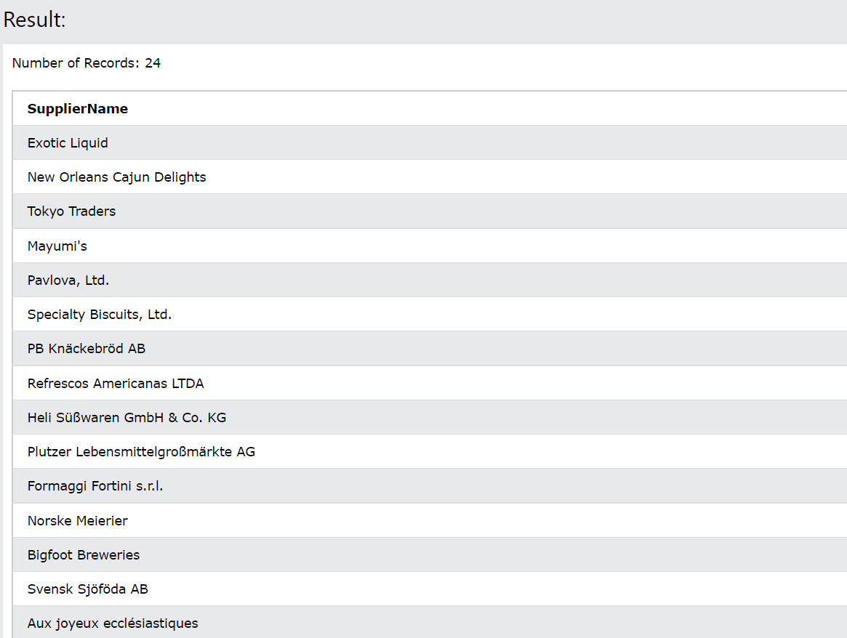

SELECT City, Country FROM Customers

WHERE Country='Germany'

UNION

SELECT City, Country FROM Suppliers

WHERE Country='Germany'

ORDER BY City;

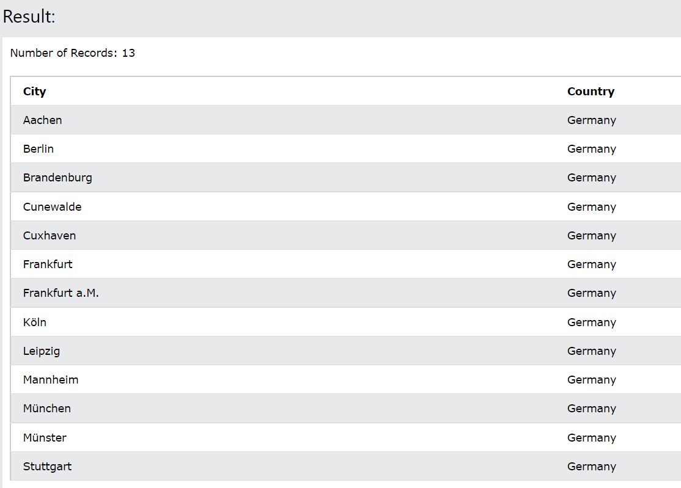

SELECT 'Customer' AS Type, ContactName, City, Country

FROM Customers

UNION

SELECT 'Supplier', ContactName, City, Country

FROM Suppliers

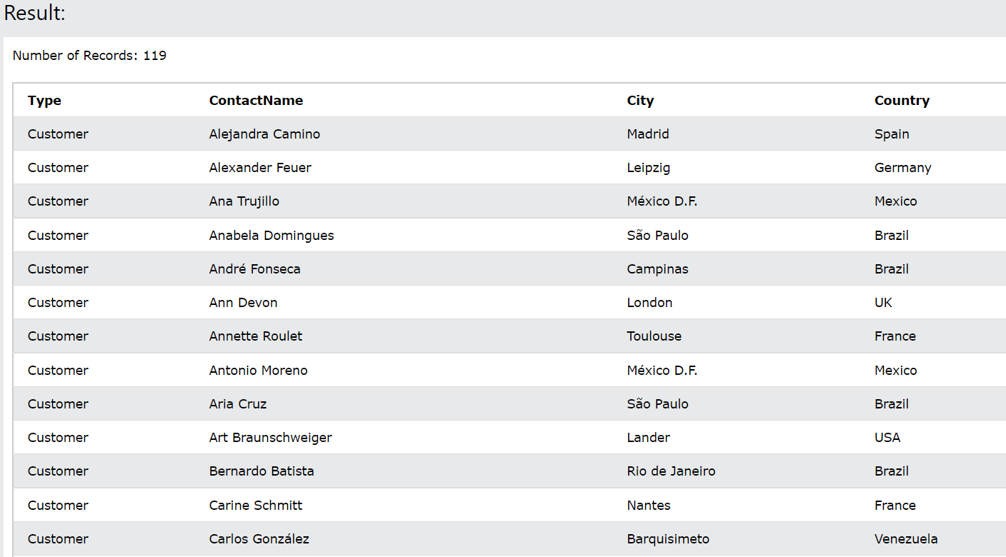

 SQL INTERSECT

SELECT supplier_id

FROM suppliers

INTERSECT

SELECT supplier_id

FROM orders;