**Experiment - 6**

**Applying DML commands on Road Way Travels Tables. Data Manipulation Command**

**• Insert**

**• Update**

**• Delete**

**• Select**

**use employee;**

CREATE TABLE employees(emp_id numeric(10) primary key, DOB date,f_name varchar(20), l_name varchar(20), date_of_join date,salary numeric,gender varchar(10),age varchar(10));

desc employees;

insert into employees values(102,'2002-11-06','veenasa','akula','2019-08-06',80000,'Female',18), (115,'1999-09-14','mohanvamshi','akula','2018-02-01',75000,'Male',21), (105,'2000-02-05','viprutha','akula','2017-08-15',65000,'Female',21);

SELECT * FROM employees;

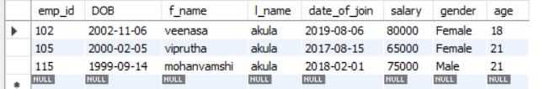

alter table employees add phoneno numeric;

update employees set phoneno = 8688399196 where emp_id=102;

update employees set phoneno = 8897085708 where emp_id=105;

update employees set phoneno = 8686324400 where emp_id=115;

alter table employees drop age;

SELECT * FROM employees;

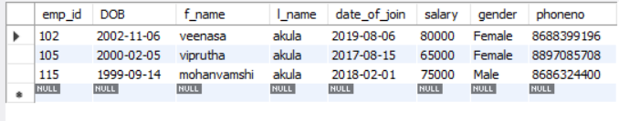

SELECT distinct gender from employees;

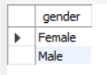

SELECT phoneno from employees where emp_id=115;

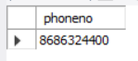

SELECT count(distinct gender) from employees;

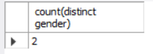

SELECT *FROM employees where salary>60000 ;

UPDATE employees set f_name='vyshnavi' where emp_id = 115;

SELECT * FROM employees;

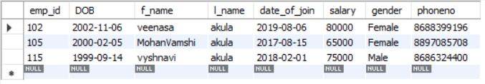

insert into employees values(100,'2000-10-05','viprutha','akula','2019-04-10',55000,'Female',21);

SELECT * FROM employees;

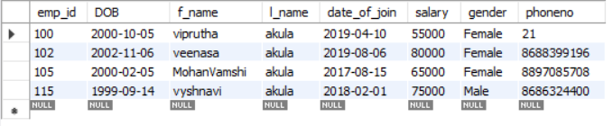

delete from employees where emp_id = 100;

SELECT * FROM employees;

