**PLANT DISEASE IDENTIFICATION**

A

Project Report

Submitted in partial fulfilment of the

Requirements for the award of the Degree of

**BACHELOR OF ENGINEERING**

IN

**COMPUTER SCIENCE & ENGINEERING**

By

**NANDINI**

**1602-18-733-304,**

**G. ANVITHA**

**1602-18-733007,**

Under the guidance of

**C. GIREESH**

**Assistant Professor**

**Department of Computer Science & Engineering**

**Vasavi College of Engineering (Autonomous)**

**(Affiliated to Osmania University)**

**Ibrahimbagh, Hyderabad-31**

**2022**

**Vasavi College of Engineering (Autonomous)**

**(Affiliated to Osmania University)**

**Hyderabad-500 031**

**Department of Computer Science & Engineering**



**DECLARATION BY THE CANDIDATE**

We, **Nandini, G. Anvitha,** bearing hall ticket numbers, **1602-18-733-304, 1602-18-733-007** hereby declare that the project report entitled “**PLANT DISEASE IDENTIFICATION”** under the guidance of **C.Gireesh,** Assistant Professor, Department of Computer Science & Engineering, VCE, Hyderabad, is submitted in partial fulfilment of the requirement for the award of the degree of **Bachelor of Engineering** in **Computer Science & Engineering**.

This is a record of bonafide work carried out by me and the results embodied in this project report have not been submitted to any other university or institute for the award of any other degree or diploma.

**Note: (This is for Dept. / Guide copy only – all the batch members)**

**Nandini,**

**1602-18-733-304.**

**G. Anvitha,**

**1602-18-733-007.**

**Vasavi College of Engineering (Autonomous)**

**(Affiliated to Osmania University)**

**Hyderabad-500 031**

**Department of Computer Science & Engineering**



**DECLARATION BY THE CANDIDATE**

We, **Nandini, G. Anvitha** bearing hall ticket numbers, **1602-18-733-304**,**1602-18-733-007,** hereby declare that the project report entitled **PLANT DISEASE IDENTIFICATION** under the guidance of C.**Gireesh,** Assistant Professor Department of Computer Science & Engineering, VCE, Hyderabad, is submitted in partial fulfilment of the requirement for the award of the degree of **Bachelor of Engineering** in **Computer Science & Engineering**.

This is a record of bonafide work carried out by me and the results embodied in this project report have not been submitted to any other university or institute for the award of any other degree or diploma.

**Note: (This is for personal copy only – name of individual)**

**NANDINI,**

**1602-18-733-304.**

**G. ANVITHA,**

**1602-18-733-007.**

**Vasavi College of Engineering (Autonomous)**

**(Affiliated to Osmania University)**

**Hyderabad-500 031**

**Department of Computer Science & Engineering**



**BONAFIDE CERTIFICATE**

Thisis to certify that the project entitled **PLANT DISEASE IDENTIFICATION** being submitted by **Nandini, G. Anvitha** bearing **1602-18-733-304,1602-18-733-007,** in partial fulfilment of the requirements for the award of the degree of Bachelor of Engineering in Computer Science & Engineering is a record of bonafide work carried out by him/her under my guidance.

**C.GIREESH Dr. T. Adilakshmi,**

**Assistant Professor Professor & HOD,**

**Internal Guide, Dept. of CSE,**

**ACKNOWLEDGEMENT**

We would like to express our heartfelt gratitude to Mr. C. Gireesh, our project internal guide, for her valuable guidance and constant support, along with her capable instructions and persistent encouragement. We are grateful to our head of department Dr T. ADILAKSHMI, for her steady support and the provision of every resource requirement for the completion of this project. We would like to take this opportunity to thank our Principal DR S. V. RAMANA, as well as the management of the institute, for having designed an excellent learning atmosphere.

**ABSTRACT**

Agriculture plays an important role in the Indian economy as it is the most important aspect of it. Often the plants suffer from many diseases which may be due to climatic conditions and pests which may also degrade the quality of the crop. Plant diseases are the biggest taboo for the farmers as it effects the plant growth.

So, Accurate and early detection of plant diseases is very crucial step in depicting the overall yield of the crop, as this can increase the yield and productivity of the crop by a great margin. In the current climatic conditions, to obtain the superior quality crop is becoming difficult day by day as the plants suffer from different diseases.

To solve the problem of early and accurate detection image processing has come up with various techniques to find best and suitable ways. In this project, we use the different techniques in detection for plant diseases and add in the agriculture advancement. In addition, we also include a conversational question and answering chatbot, which helps in answering questions related to identifying the plant disease.

**TABLE OF CONTENTS**

List of Figures………………………………………………………………………

1.Introduction……………………………………………………………………

1.1 Overview……………………………………………………………….

1.2 Motivation………………………………………………………….

1.3 Problem Definition……………………………………………………..

1.4 Objectives…………………………………………………………..

1.5 Scope……………………………………………………………….

2. System Design………………………………………………………………..

3. System Requirements………………………………………………………….

4. System Study…………………………………………………………………

5. Implementation………………………………………………………………….

6. Results………………………………………………………………………….

7. Conclusion & Future Work…………………………………………………….

8. References……………………………………………………………………….

**LIST OF FIGURES**

Figure 1: Start Home Page………………………………………………………..

Figure 2: Login Page………………………………………………………..

Figure 3: Sign Page………………………………………………………..

Figure 4: Home Page…………………………………………………………

Figure 5: Leaf Prediciton Page1………………………………….

Figure 6: Prediction Page……………………………………………………..

Figure 7: Upload Image Page………………………………………………..

Figure 8: Upload Image Page……………………………………………….

Figure 9: Chatbot……………………………………………………………

1. **INTRODUCTION**

**1.1 Overview**

AGRICULTURE is a backbone of our country. Agriculture has become more than simply a process/ method to feed ever growing populations. Every citizen in the country is dependent on agriculture. The necessary steps to consider is less amount crop of quality because of disease. Detecting disease may be a key to stop agricultural losses. Farmers selects the crops based on the external factors which is favorable for the plant growth based on location of his or her farm. Anyway, the crops cultivation for maximum profit and standard manufacture is usually scientific i.e., based on the external factors like climatic conditions. The supervision that continually recurring crops needs supreme power especially for the management of the diseases that may have a result on factors of significant production to make an economic profit.

**Machine Learning Approaches:**

Machine learning approaches are traditionally divided into three broad categories, depending on the nature of the "signal" or "feedback" available to the learning system:

**Supervised learning:** The computer is presented with example inputs and their desired outputs, given by a "teacher", and the goal is to learn a general rule that maps inputs to outputs.

**Unsupervised learning:** No labels are given to the learning algorithm, leaving it on its own to find structure in its input. Unsupervised learning can be a goal in itself (discovering hidden patterns in data) or a means towards an end (feature learning).

**Reinforcement learning:** A computer program interacts with a dynamic environment in which it must perform a certain goal (such as driving a vehicle or playing a game against an opponent). As it navigates its problem space, the program is provided feedback that's analogous to rewards, which it tries to maximise. Other approaches have been developed which don't fit neatly into this three-fold categorisation, and sometimes more than one is used by the same machine learning system. For example, topic modelling, dimensionality reduction or meta learning. As of 2020, deep learning has become the dominant approach for much ongoing work in the field of machine learning

**1.2 Motivation:**

India is ranked amongst the top five countries for its agricultural production in the world. Agriculture also plays an important role in Indian economy. Farmers have different options to cultivate crops in the field but plant diseases effect the growth of the plant. So, there is a need of a platform which helps the farmers to detect the disease which helps in the growth of the plant and helps to increase the production. We can use plant leaf to detect the disease in this process as leaves are the main motor for the disease caused plant.

**1.3 Problem Statement:**

To develop a web application which helps in identifying the plant disease by taking plant leaf as an input and provide a cure for the plant using conversational chatbot to answer the queries of the users.

**1.4 Objective:**

Identification of plant disease by using deep learning techniques by taking the plant leaf as input and provides a cure for the disease using conversational chatbot when user asks about it.

**1.5 Scope:**

The user of the application will be able to upload the image of leaf on to the platform and can get the information about the disease of the specific plant. The scope of this project is to explore the base algorithm, which is used for plant disease identification. Training this algorithm with high-coverage dataset helps with reduction of errors associated while identifying the disease of the plant.

1. **SYSTEM DESIGN**

**CNN:**

Convolutional Neural Networks (ConvNets or CNNs) are a category of Neural Networks that have proven very effective in areas such as image recognition and classification. ConvNets have been successful in identifying faces, objects, and traffic signs apart from powering vision in robots and self-driving cars.

In Neural Networks, Convolutional Neural Network (ConvNets or CNNs) is one of the main categories to do image recognition, images classifications. object Detections, Recognition faces, etc, are some of the areas where CNNs are widely used. The best thing is there is no need for feature extraction. The system learns to do feature extraction and the core concept of CNN is, it uses convolution of images and filters to generate invariant features which are passed on to the next layer.

Convolutional Neural Network Architecture. A CNN typically has three layers: a convolutional layer, a pooling layer, and Fully Connected Layer.

**Convolution Layer:**

The convolution layer is the core building block of the CNN. It carries the main portion of the network’s computational load.

This layer performs a dot product between two matrices, where one matrix is the set of learnable parameters otherwise known as a kernel, and the other matrix is the restricted portion of the receptive field. The kernel is spatially smaller than an image but is more in-depth. This means that, if the image is composed of three (RGB) channels, the kernel height and width will be spatially small, but the depth extends up to all three channels.

**Pooling Layer**:

The pooling layer replaces the output of the network at certain locations by deriving a summary statistic of the nearby outputs. This helps in reducing the spatial size of the representation, which decreases the required amount of computation and weights. The pooling operation is processed on every slice of the representation individually.

**Fully Connected Layer:**

Neurons in this layer have full connectivity with all neurons in the preceding and succeeding layer as seen in regular FCNN. This is why it can be computed as usual by a matrix multiplication followed by a bias effect. The FC layer helps to map the representation between the input and the output.

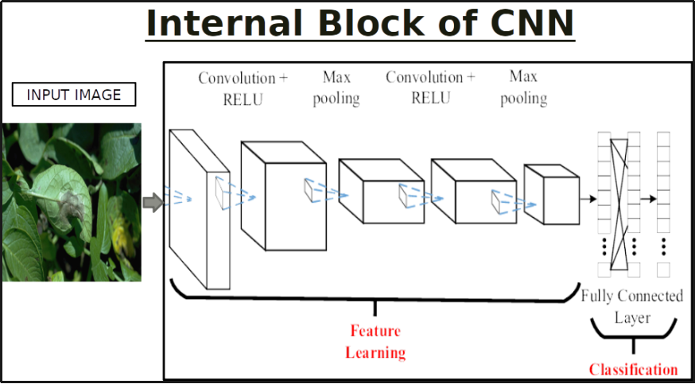

The Project deals with the real time detection of diseases that affect the plant and the area affected using**Convolutional neural network** (CNN) Model. Convolutional neural network models used to perform plant disease detection and diagnosis using simple leaves images of healthy and diseased plants, through deep learning methodologies.

**Dataset:**

We used the Dataset from Kaggle.: Link: <https://www.kaggle.com/datasets/emmarex/plantdisease>

**Pre-processing Steps:**

1. Dataset Creation Train, Test, Val
2. CNN Design
3. Pre-Processing
4. Training Model
5. Load Model-Test
6. Pre-Process Input Image
7. Classification

**3. SYSTEM REQUIREMENTS**

**HARDWARE REQUIREMENTS:**

System: Pentium i3 Processor.

Hard Disk: 500 GB.

Monitor: 15’’ LED

Input Devices: Keyboard, Mouse

Ram: 4 GB

**SOFTWARE REQUIREMENTS:**

Operating system: Windows 10.

Technologies: Python, HTML, CSS, JavaScript, PHP

Web Framework: Flask

**4. SYSTEM STUDY**

**FEASIBILITY STUDY**

The feasibility of the project is analysed in this phase and the business proposal is put forth with a very general plan for the project and some cost estimates. During system analysis, the feasibility study of the proposed system is to be carried out. This is to ensure that the proposed system is not a burden to the company. For feasibility analysis, some understanding of the major requirements for the system is essential.

Three key considerations involved in the feasibility analysis are

● ECONOMICAL FEASIBILITY

● TECHNICAL FEASIBILITY

● SOCIAL FEASIBILITY

**ECONOMICAL FEASIBILITY**

This study is carried out to check the economic impact that the system will have on the organisation. The amount of funds that the company can pour into the research and development of the system is limited. The expenditures must be justified. Thus the developed system as well within the budget and this was achieved because most of the technologies used are freely available. Only the customised products had to be purchased.

**TECHNICAL FEASIBILITY**

This study is carried out to check the technical feasibility, that is, the technical requirements of the system. Any system developed must not have a high demand on the available technical resources. This will lead to high demands on the available technical resources. This will lead to high demands being placed on the client. The developed system must have a modest requirement, as only minimal or null changes are required for implementing this system.

**SOCIAL FEASIBILITY**

The aspect of the study is to check the level of acceptance of the system by the user. This includes the process of training the user to use the system efficiently. The user must not feel threatened by the system, instead must accept it as a necessity. The level of acceptance by the users solely depends on the methods that are employed to educate the user about the system and to make him familiar with it. His level of confidence must be raised so that he is also able to make some constructive criticism, which is welcomed, as he is the final user of the system

**5. IMPLEMENTATION**

**app.py**

import os

import tensorflow as tf

import numpy as np

from tensorflow import keras

from skimage import io

from tensorflow.keras.preprocessing import image

import webbrowser

# Flask utils

from flask import Flask, redirect, url_for, request, render_template

from werkzeug.utils import secure_filename

from gevent.pywsgi import WSGIServer

# Define a flask app

app = Flask(__name__)

# Model saved with Keras model.save()

# You can also use pretrained model from Keras

# Check https://keras.io/applications/

model =tf.keras.models.load_model('PlantDNet.h5',compile=False)

print('Model loaded. Check http://127.0.0.1:5000/')

def model_predict(img_path, model):

img = image.load_img(img_path, grayscale=False, target_size=(64, 64))

show_img = image.load_img(img_path, grayscale=False, target_size=(64, 64))

x = image.img_to_array(img)

x = np.expand_dims(x, axis=0)

x = np.array(x, 'float32')

x /= 255

preds = model.predict(x)

return preds

@app.route('/', methods=['GET'])

def index():

# Main page

return render_template('index.html')

@app.route('/predict', methods=['GET', 'POST'])

def upload():

if request.method == 'POST':

# Get the file from post request

f = request.files['file']

# Save the file to ./uploads

basepath = os.path.dirname(__file__)

file_path = os.path.join(basepath, 'uploads', secure_filename(f.filename))

f.save(file_path)

# Make prediction

preds = model_predict(file_path, model)

print(preds[0])

# x = x.reshape([64, 64]);

disease_class = ['Pepper__bell___Bacterial_spot', 'Pepper__bell___healthy', 'Potato___Early_blight',

'Potato___Late_blight', 'Potato___healthy', 'Tomato_Bacterial_spot', 'Tomato_Early_blight',

'Tomato_Late_blight', 'Tomato_Leaf_Mold', 'Tomato_Septoria_leaf_spot',

'Tomato_Spider_mites_Two_spotted_spider_mite', 'Tomato__Target_Spot',

'Tomato__Tomato_YellowLeaf__Curl_Virus', 'Tomato__Tomato_mosaic_virus', 'Tomato_healthy']

a = preds[0]

ind=np.argmax(a)

print('Prediction:', disease_class[ind])

result=disease_class[ind]

return result

return None

if __name__ == '__main__':

app.run(debug=False,host='0.0.0.0')

**chatbot.html**

<!DOCTYPE html>

<html lang="en">

<head>

<meta charset="UTF-8">

<meta http-equiv="X-UA-Compatible" content="IE=edge">

<meta name="viewport" content="width=device-width, initial-scale=1.0">

<title>Chat Bot</title>

<link rel="stylesheet" href="static/css/chat.css">

<style>

body {

background-repeat: no-repeat;

background-attachment: fixed;

background-size: cover;

background-size: 100% 100%;

background-image: url('https://images.pexels.com/photos/86397/leaf-individually-linde-lipovina-86397.jpeg?cs=srgb&dl=pexels-pixabay-86397.jpg&fm=jpg');

}

</style>

</head>

<body>

<!-- CHAT BAR BLOCK -->

<div class="chat-bar-collapsible">

<button id="chat-button" type="button" class="collapsible">Chat with us!

<i id="chat-icon" style="color: #fff;" class="fa fa-fw fa-comments-o"></i>

</button>

<div class="content">

<div class="full-chat-block">

<!-- Message Container -->

<div class="outer-container">

<div class="chat-container">

<!-- Messages -->

<div id="chatbox">

<h5 id="chat-timestamp"></h5>

<p id="botStarterMessage" class="botText"><span>Loading...</span></p>

</div>

<!-- User input box -->

<div class="chat-bar-input-block">

<div id="userInput">

<input id="textInput" class="input-box" type="text" name="msg"

placeholder="Tap 'Enter' to send a message">

<p></p>

</div>

<div class="chat-bar-icons">

<i id="chat-icon" style="color: crimson;" class="fa fa-fw fa-heart" onclick="heartButton()"></i>

<i id="chat-icon" style="color: #333;" class="fa fa-fw fa-send"

onclick="sendButton()"></i>

</div>

</div>

<div id="chat-bar-bottom">

<p></p>

</div>

</div>

</div>

</div>

</div>

</div>

</body>

<script src="https://ajax.googleapis.com/ajax/libs/jquery/3.4.1/jquery.min.js"></script>

<script src="static/scripts/responses.js"></script>

<script src="static/scripts/chat.js"></script>

</html>

**Homepage.html:**

<!DOCTYPE html>

<html lang="en" dir="ltr">

<head>

<meta charset="utf-8">

<title>GreenDiagnosis</title>

<link rel="icon" type="images/ico" href="logo.jpg"/>

<link rel="stylesheet" href="style.css">

<link rel="stylesheet" href="https://cdnjs.cloudflare.com/ajax/libs/font-awesome/5.15.3/css/all.min.css"/>

</head>

<body >

<nav>

<label class="logo">Green Diagnosis</label>

<ul>

<li><a class="active" href="#">Home</a></li>

<li>

<a href="http://192.168.0.100:5000/" >Predict Disease </a>

</li>

<li><a href="C:\Users\HP\OneDrive\Desktop\VCE Project\Plant-Disease-Diagnosis-Flask-master\mscbot-main\mscbot\index.html">ChatBot</a></li>

</ul>

</nav>

<div class="slideshow-container" style="margin-top: 70px;">

<div class="mySlides fade">

<div class="numbertext">1 / 3</div>

<img src="slide1.jpg" style="width:100%;">

<div class="text">Caption Text</div>

</div>

<div class="mySlides fade">

<div class="numbertext">2 / 3</div>

<img src="slide2.jpg" style="width:100%">

<div class="text">Caption Two</div>

</div>

<div class="mySlides fade">

<div class="numbertext">3 / 3</div>

<img src="slide3.jpg" style="width:100%">

<div class="text">Caption Three</div>

</div>

<a class="prev" onclick="plusSlides(-1)">&#10094;</a>

<a class="next" onclick="plusSlides(1)">&#10095;</a>

</div>

<br>

<div style=" margin-left: 600px;" >

<span class="dot" onclick="currentSlide(1)"></span>

<span class="dot" onclick="currentSlide(2)"></span>

<span class="dot" onclick="currentSlide(3)"></span>

</div>

<script>

var slideIndex = 1;

showSlides(slideIndex)

function plusSlides(n) {

showSlides(slideIndex += n);

}

function currentSlide(n) {

showSlides(slideIndex = n);

}

function showSlides(n) {

var i;

var slides = document.getElementsByClassName("mySlides");

var dots = document.getElementsByClassName("dot");

if (n > slides.length) {slideIndex = 1}

if (n < 1) {slideIndex = slides.length}

for (i = 0; i < slides.length; i++) {

slides[i].style.display = "none";

}

for (i = 0; i < dots.length; i++) {

dots[i].className = dots[i].className.replace(" active", "");

}

slides[slideIndex-1].style.display = "block";

dots[slideIndex-1].className += " active";

}

</script>

<section></section>

</body>

</html>

**StartPage.html**

<!DOCTYPE html>

<html lang="en">

<head>

<link rel="icon" type="images/ico" href="images/project logo.jpg"/>

<title>GreenDiagonsis</title>

<meta charset="utf-8">

<meta name="viewport" content="width=device-width, initial-scale=1">

<link rel="stylesheet" href="https://maxcdn.bootstrapcdn.com/bootstrap/3.4.1/css/bootstrap.min.css">

<link href="https://fonts.googleapis.com/css?family=Montserrat" rel="stylesheet">

<script src="https://ajax.googleapis.com/ajax/libs/jquery/3.5.1/jquery.min.js"></script>

<script src="https://maxcdn.bootstrapcdn.com/bootstrap/3.4.1/js/bootstrap.min.js"></script>

<style>

body {

font: 20px Montserrat, sans-serif;

line-height: 1.8;

color: black;

}

p {font-size: 16px;}

.margin {margin-bottom: 45px;}

.bg-1 {

background-color: lightgoldenrodyellow;

color: black;

}

.bg-2 {

background-color: lightgoldenrodyellow; /* Dark Blue */

color: black;

}

.bg-3 {

background-color: #f2f2f2; /* White */

color: #555555;

}

.bg-4 {

background-color: #ffffff; /* Black Gray */

color: #fff;

}

.container-fluid {

padding-top: 70px;

padding-bottom: 70px;

height: 100%;

}

.navbar {

padding-top: 8px;

padding-bottom: 8px;

border: 0;

border-radius: 0;

margin-bottom: 0;

font-size: 18px;

letter-spacing: 5px;

background-color: green;

color: white;

width: 100%;

}

.navbar-nav li a {

color: white !important;

}

.navbar-header a{

color: white;

}

</style>

</head>

<body>

<!-- Navbar -->

<nav class="navbar navbar-default" style="position: fixed;">

<div class="container">

<div class="navbar-header">

<button type="button" class="navbar-toggle" data-toggle="collapse" data-target="#myNavbar">

<span class="icon-bar"></span>

<span class="icon-bar"></span>

<span class="icon-bar"></span>

</button>

<a class="navbar-brand" href="#home" style="color: white">Green Diagonsis</a>

</div>

<div class="collapse navbar-collapse" id="myNavbar">

<ul class="nav navbar-nav navbar-right">

<li><a href="#home">Home</a></li>

<li><a href="#about">About</a></li>

<li><a href="login.html">login</a></li>

<li><a href="signup.html">Signup</a></li>

</ul>

</div>

</div>

</nav>

<!-- First Container -->

<div class="container-fluid bg-1 text-center" id="home" ><br><br>

<h3 class="margin">Green Diagonsis</h3>

<img src="images/project logo.jpg" class="img-responsive img-circle margin" style="display:inline" alt="Bird" width="350" height="350">

</div>

<!-- Second Container -->

<div class="container-fluid bg-2 text-center" id="about" style="padding-top: 17%; padding-bottom: 17%;">

<h3 class="margin">About</h3>

<p style="padding-right: 10%; padding-left: 10%;">Green Diagonsis is a platform where you can identify the disease of the plant by uploading a clear image of the leaf of the plant and get to the cure for the disease identified by making plant care easier for you.</p>

</div>

</div>

</body>

</html>

**6 RESULTS**

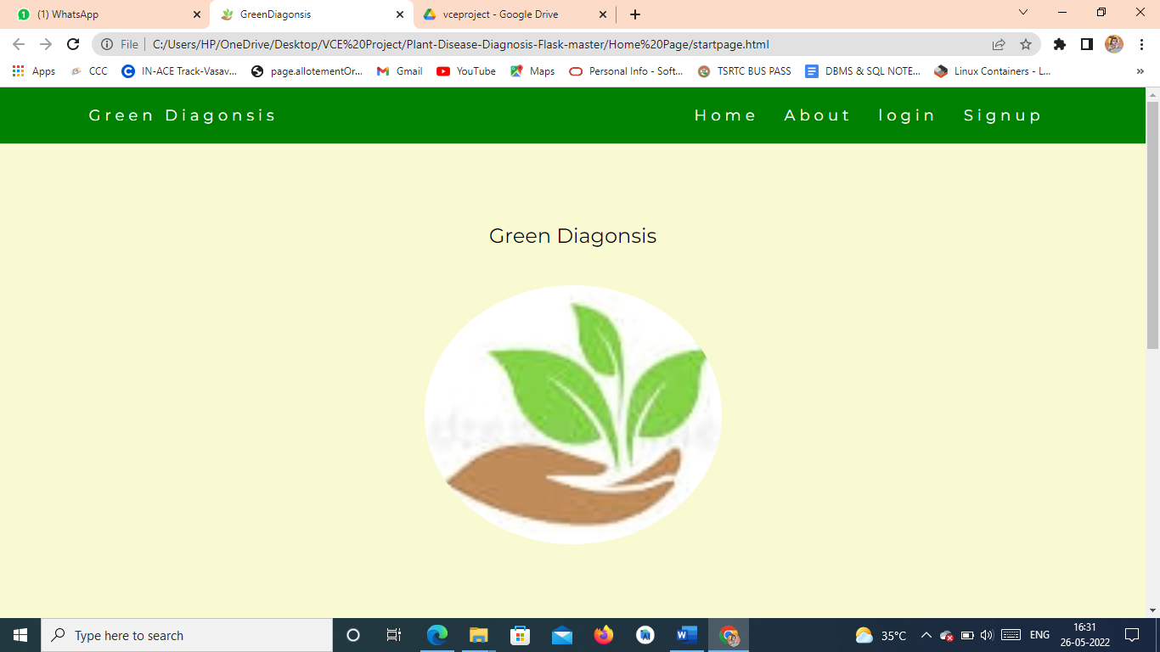

Fig1: Start Home Page

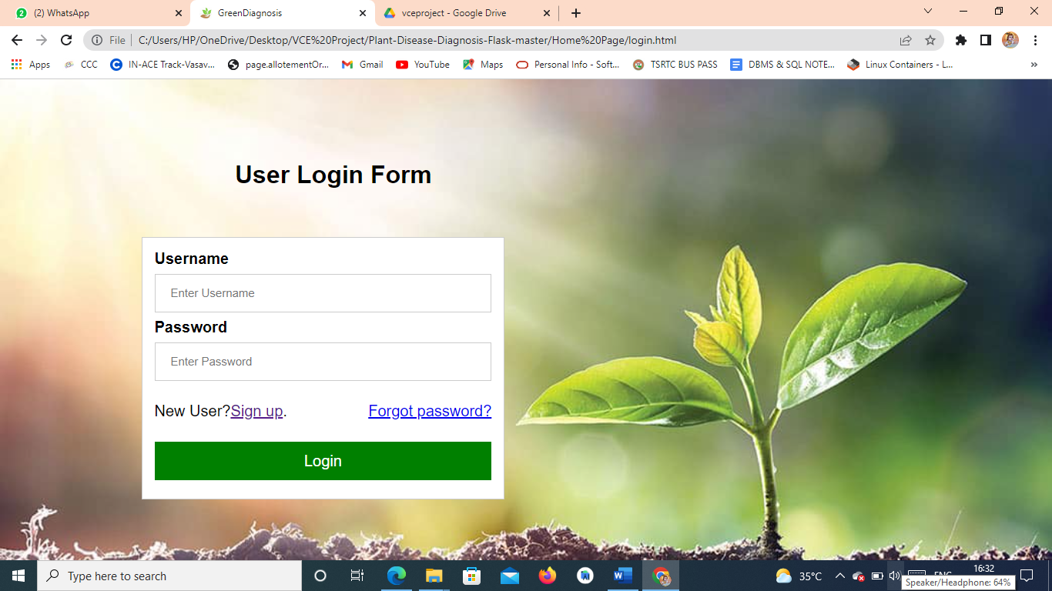

Fig2: Login Page

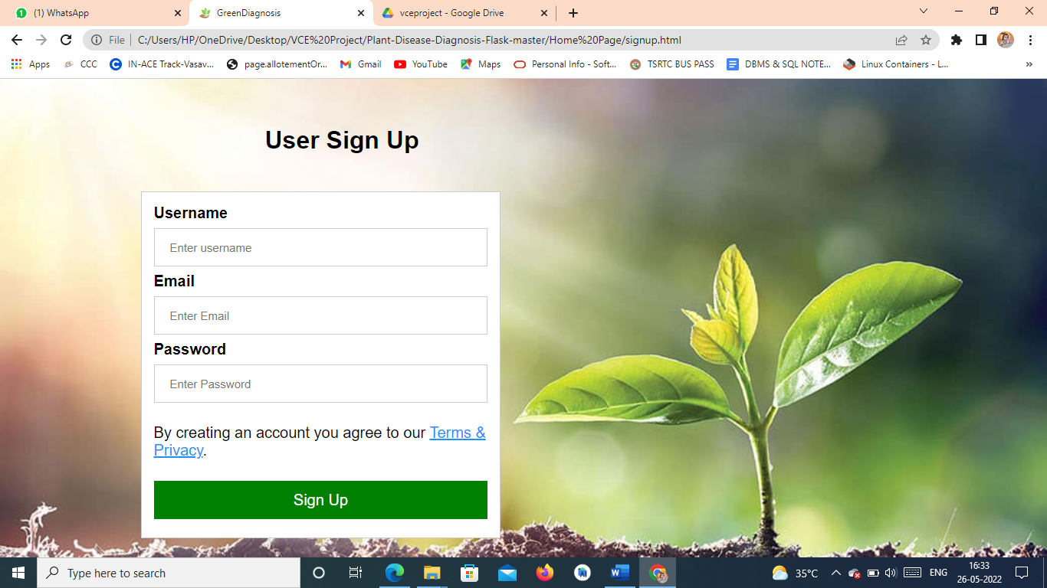

Fig3: SignUp Page

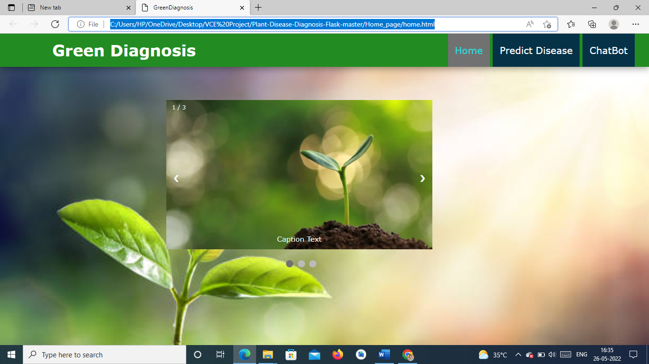

Fig4: Home Page

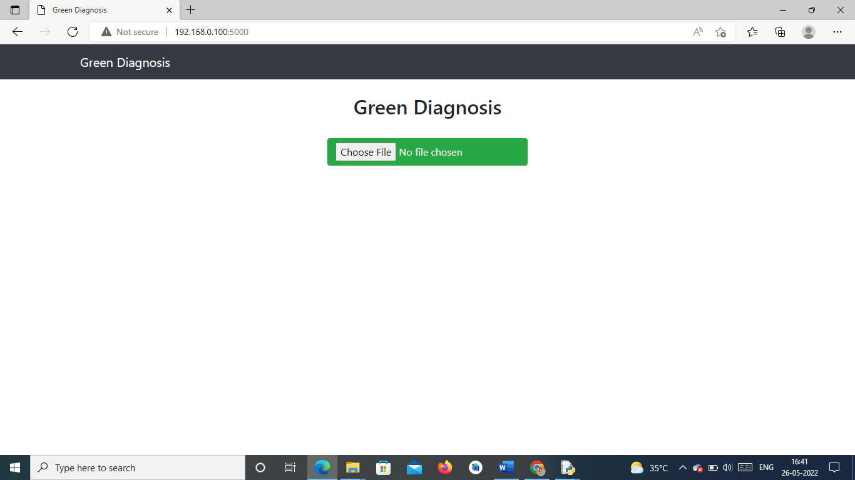

Fig5: Prediction Page

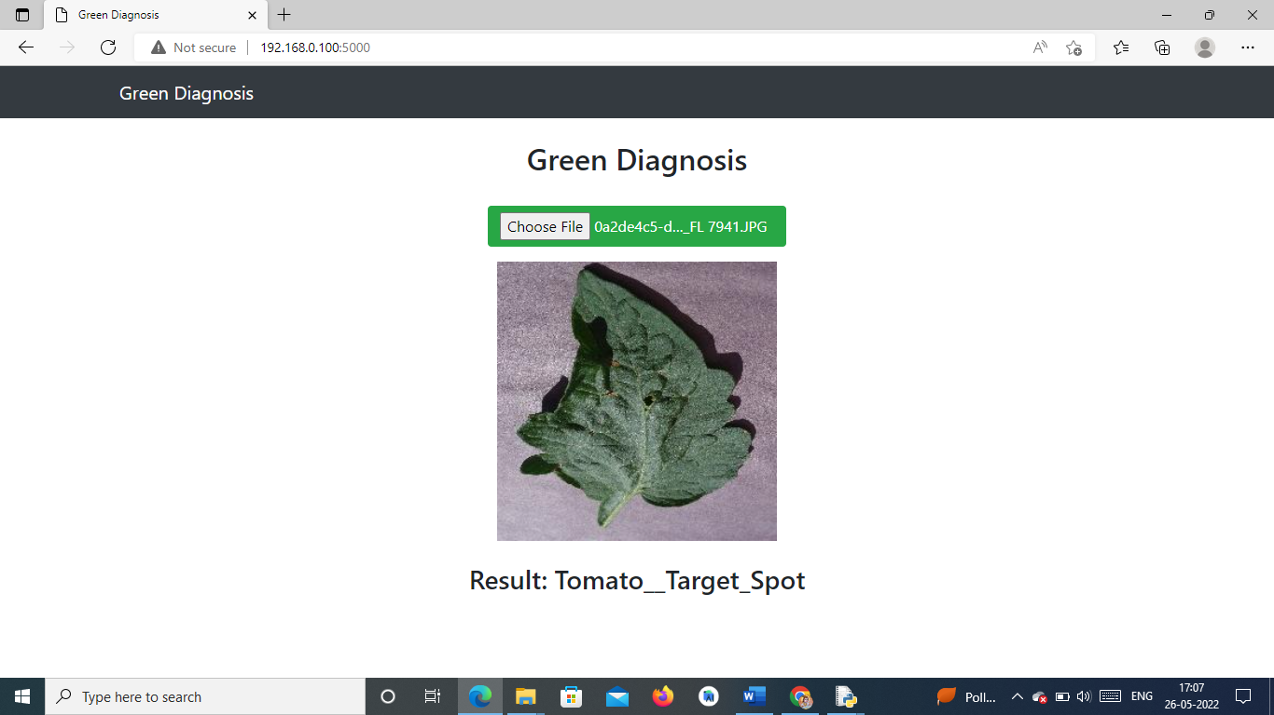

Fig6: Upload Image

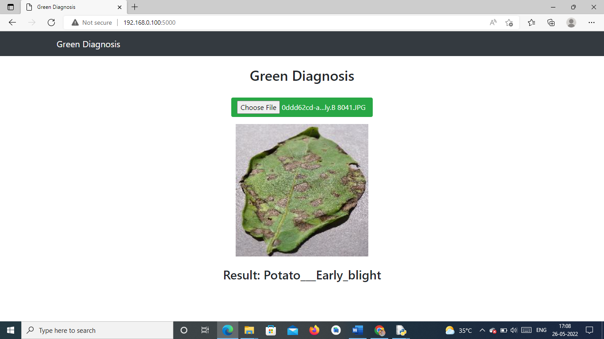

Fig7: Upload Image

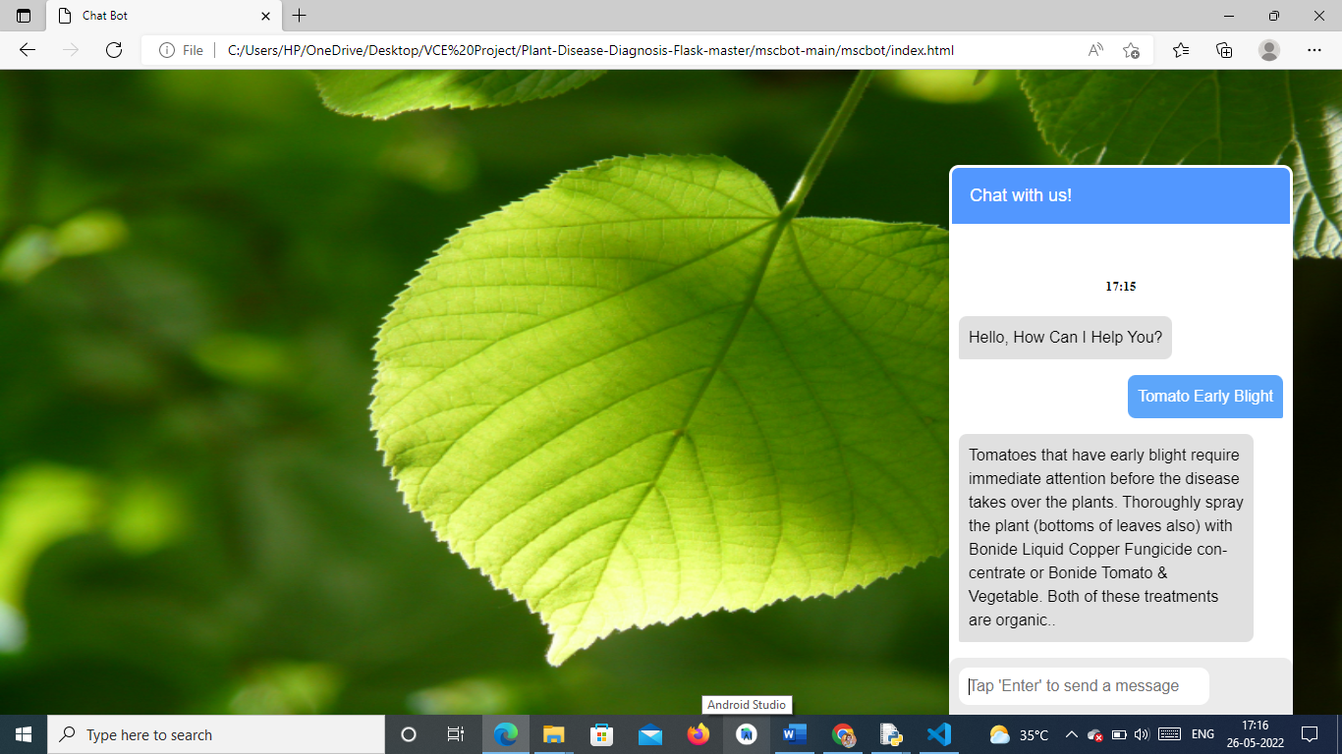

Fig8: Chatbot

**7 CONCLUSION & FUTURE WORK**

**Conclusion**

Identifying the disease is the important step in the growth of the crop and this Application helps to recognize abnormalities that occur on plants in their greenhouses or natural environment, which helps in early Identification of the disease and helps in healthy growth of the plant.

**Future Work**

This system considers only the leaf of the plant to detect the disease of that crop. It will be more convenient if the other parts of the crop such as roots, stem, branches etc. which increases the detection accuracy more than current one. Also image categorization will also be done to check whether the given leaf is of preferred category or not. If a model provided with input other than leaf image then also it shows some name of disease for it.

**8 REFERENCES**

[1] <https://www.ijert.org/crop-disease-detection-using-deep-convolutional-neural-networks>

[2] <https://www.frontiersin.org/articles/10.3389/fpls.2016.01419/full>

[3] <https://ieeexplore.ieee.org/document/8821872>

[4] <https://www.familyhandyman.com/list/most-common-plant-> diseases/