# INTRODUCTION

* 1. **Problem Statement:**

Developing a complete, integrated android based mobile application to provide students with information regarding college administration details, Departmental details, Placement activities, Library books details, Hostel details, Transportation details, and so on.

# Objective:

Students, faculty, and administration will all use this mobile application. In the previous system, all information is viewed on the website. At the same time, it is very difficult to access information and it takes a long time to search in a specific website. Hence, in order to overcome this problem a smart phone based mobile application using Android can be used to make this process easier, secure and less error prone.

# Proposed System:

Intranet is a real time application that can be installed on any Android devices and improve interactivity, accessibility and convenience in the learning process. This application consists of extra features like Placement details, Students Achieve ments and Certifications.

# LITERATURE SURVEY

1. **Shilpi, Taneja., Goel, Anita. (2015). Mobile Applications in Educational In- stitutions. Computational Intelligence Communication Technology (CICT), 2015 IEEE International Conference on. IEEE, 2015.**

In [1], It is aimed to develop an Android Mobile Application on College Management System on smart phones that is of importance to educational institution. This Mobile Application can be used as an information management system for the college.

The Usage of mobile devices in our daily life has resulted in a technological and cultural shift in the society. The availability of information through this medium is fundamentally changing how we conduct our daily activities, such as searching, shopping, interacting with the government, and learning.

For institutions, creating an excellent mobile website has become a need. With an increasing number of students using smartphones, many university websites throughout the world are adapting to meet their mobile needs. A few of prestigious colleges have already embraced mobile technology; those who have yet to do so have begun to consider it. With mobile becoming so widespread, every major educational institution is revising its "stakeholder engagement plan" to include "mobile."

Students have become so accustomed to using mobile devices that institutions must handle the issue of providing mobile access to information.

According to a study called "2013 E-Expectations,"

* 78 % of students have regular access to a mobile device
* 43 % of students use their mobile device for web surfing,
* 68 % of students have browsed a college website on their mobile device.

According to above data we can say most of the students are replying on mobile device for information needs, like, campus maps, attendance, results, calendar, etc.

# Nikhlil Jadhav1 , Bhupesh Singh2 , Kunal Lunge3 , Gopi Mali 4 , Nilesh Patil, Android Application for College Management System, in IJESC Volume 6 Issue No. 12 , 2016.

# In [2], Android College Management system is an android mobile application which is helpful for students and the colleges. In the proposed system, students can view results using mobile phones. The faculty can login through the mobile app and update the academic result. In this system, students have easy access for viewing the marks, attendance, fee details, timetable, academic calendar and they are not permitted to update the marks.

# Another component is feedback; students can provide feedback to faculties at any time and from any location. This feedback can be examined by the institute's administration or management committee, ensuring that the faculty's feedback remains confidential. This software was created to track daily student attendance at colleges and universities. It can also be useful in a corporation or organization to a certain extent, but not for the entire application.

# In the current system, all attendance management work is done on paper. The attendance for the entire session is recorded in a register, and reports are created at the end. We are not interested in creating reports in the middle of a session or according to the requirements because the calculations take longer. Students who do not have 75 percent attendance receive a notice at the end of the session. This procedure takes a long time. The current system displays the result on a notice board. It is time intensive and needs a lot of paperwork. To overcome this Android College Management system is developed.

# The application is reliable, saves time, and is simple to use. It can be used as a foundation for developing and improving applications for monitoring results and tracking attendance in colleges and other workplaces. This application allows students and their parents to view attendance and curricular information. Students can also check details and notifications at any time.

# 

1. **K. Vivek Thangam1 ,T. Shyam Kumar2 ,V.Yogesh kumar3 and S.Prabhu4,** **ANDROID APPLICATION FOR COLLEGE MANAGEMENT SYSTEM (M-INSPROPLUS),IJMTER,volume-4,issue no-2**

In [3], Many android applications are utilized for a variety of functions in today's world, including special event information, school attendance, and so on. These applications benefit the workers in practically every way. The software is used to check the accuracy of various works based on college automation. This proposed android-based application can retrieve and update any information for the benefit of students and staffs.

The administrator has the highest privilege of holding or keeping track of all current and updated information. They also have full access to the data stored in the application's database.

The administrator has the highest privilege of holding or keeping track of all current and updated information. They also have full access to the data stored in the application's database. Certain records can only be verified or approved by the administrator.

student – staff interaction or any personal grievance from a certain student can be shared with the staff.

This app benefits the institution's staff in terms of tasks such as updating student attendance, internal marks, exam schedules, and so on.

The goal of this application is to make staff members jobs easier and to benefit them in practically every way possible. The arrival of this android-based application would substantially reduce manpower and manual labor, and any information updates/retrieval will be a breeze.

1. **Mrunmayee V. Rane;Vikram M. Apte;Vishakha N. Nerkar;Mani Roja Edinburgh;K.Y. Rajput; (2021). Automated Timetabling System for University Course . 2021 International Conference on Emerging Smart Computing and Informatics (ESCI)**

In [4], It's a difficult task to create a timetable for a university with several branches, different years, and multiple batches. It takes a long time to complete and is necessary for each six-month semester. As a result, this process consumes a significant amount of time and manpower. In other circumstances, manually preparing timetables is too time consuming. When a faculty member is on leave, it is impossible to create temporary schedules.

A software-based method is preferable since a computer can process data faster and produce more accurate findings. It can also be developed and optimized to meet the needs of other colleges while maintaining the same base code.

This paper proposes a solution for difficult timetabling challenges involving electives, tutorials, various student batches, practical subjects, and interdepartmental courses.

To construct faculty, classroom/laboratory, and student timetables, the method examines a wide range of restrictions classified into soft and hard categories.

The 'Automated Timetabling System' was implemented in our institute, resulting in feasible schedules that are considerably more optimized and accurate than those created manually.

Furthermore, the proposed approach saves hours of valuable administrative time, which can be put to better use. This algorithm-based program has been shown to be effective in replacing an outdated, time-consuming timetabling method with a more advanced, flexible, and dependable automated approach.

In addition, the graphical user interfaces built for input and display module are very

convenient to save, add or delete any input data or created timetables.

1. **Alif Fatihi Abdul Fatah;Roslina Mohamad;Farah Yasmin Abdul Rahman;Nur'ain Izzati Shuhaimi; (2021). Student Attendance System Using An Android Based Mobile Application . 2021 IEEE 11th IEEE Symposium on Computer Applications &amp; Industrial Electronics (ISCAIE)**

In [5], In the digital era, the internet of things (IoT) has created a need to replace traditional attendance records in colleges. Students' attendance records are frequently kept on a piece of paper, which is then passed among the students in the class. This strategy can cause pupils to lose interest in class, and the time it takes to record attendance can drastically increase for the masses.

As a result, an Android-based mobile application with an attendance system was created. The attendance system was linked to a database that held student records and information. Furthermore, the user interface presented attendance information in an appealing manner that was simple to administer by lecturers or system administrators.

 An attendance tracking system for university students was proposed as an automated attendance recording system. To replace the old attendance system, which needs students to physically sign the attendance sheet, the system was designed utilizing a mobile Android application.

The framework's purpose is to make it easier for professors to record students' presence using Android cellphones. Additionally, attendance records can be obtained, previewed, and printed in a readable format.

The development of a student attendance system using an Android-based mobile application is presented in this study. The proposed attendance system application can replace the traditional method of taking attendance. The suggested application has the potential to improve the efficiency with which student attendance data are managed.

1. **S. Bhattacharya, "Blue-Droid: An Intelligent Library Management System on Android Platform," IOSR Journal of Computer Engineering (IOSR-JCE)- 2014.**

In [6], Several research on the development of mobile libraries have been published previously. Blue-Droid and VESIT are their names. People are assisted in doing library activities such as examining library holdings, including journals and books, and reissuing borrowed materials using the designed system, which is supported by SQL database and encryption technique.

1. **Shada, Gabriella Sekar; Ayu, Media Anugerah (2018). [IEEE 2018 International Conference on Computing, Engineering, and Design (ICCED) - Bangkok, Thailand (2018.9.6-2018.9.8)] 2018 International Conference on Computing, Engineering, and Design (ICCED) - Designing Android User Interface for University Mobile Library.**

In [7], University library management systems are rapidly evolving nowadays. The Android mobile application is one of the digital system applications. Based on these facts, the university library uses the tools available to increase library development and flexibility. This study provides a user interface design methodology based on the needs of users and assesses the usability and simplicity of use of a mobile library application.

The user interface for the library university has been designed in this study. The system includes various elements that were proposed by preliminary research and prior systems to make it easier for users to interact with the library system. It allows users to browse the library's collection, communicate with librarians, borrow and renew books, and research their own personal history.

# Ankit Bansal 1,Ajit Rana 2,Akhil Bansod 3,Prafulla Baviskar 4, Mobile based campus Information Retrieval Android Application, in IJCSMC, Vol.4, Is- sue.3,March 2015

In [8], This system focuses on helping the Faculty and Administration who are working in the institution. The android mobile application is focused to help the faculty for the progression and the academic development of the institution. i.e., by checking the performance of the students.

As a result, in a real-world setting, such as a college campus, information in the form of notices and oral communication can be directly transferred through android devices and made available to students and teachers on their android smartphones, making application maintenance easier.

# REQUIREMENTS

* 1. **Software Requirements**
* OS - Windows 10
* MySQL, NetBeans
* JAVA, XML
* XAMPP, Android Studio
* Apache server

# Hardware Requirements

* Intel Core i3 processor
* RAM 8GB
* Hard Disk Drive 1TB

# METHODOLOGY

* 1. **ARCHITECTURE**

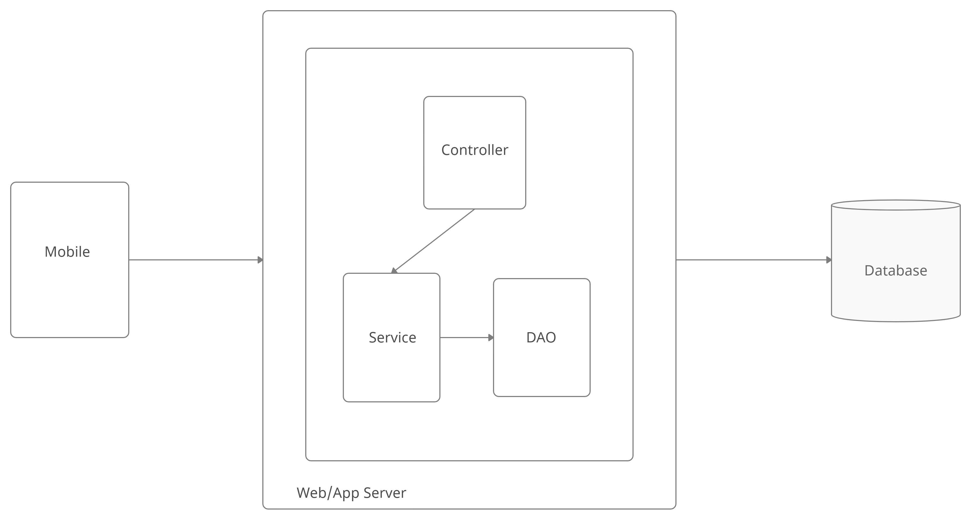

# Figure 1: Architecture

Whenever the user sends the request controller receives the request from user and sends the same request to service and it sends the same request to DAO and it will fetch all the details from Database according to the request and it send back the data to service and service will sends to controller. Now controller will give response to the user.

# ADMIN USE CASE

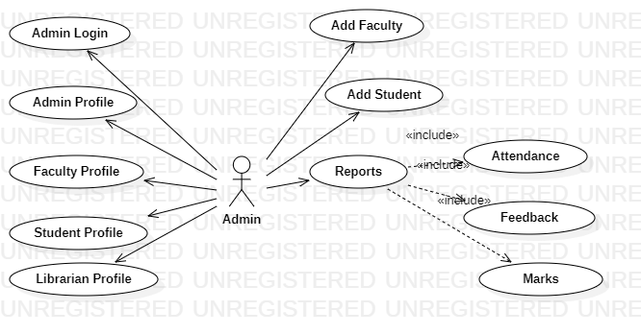

**Figure 2: Admin Use case**

# LIBRARIAN USE CASE

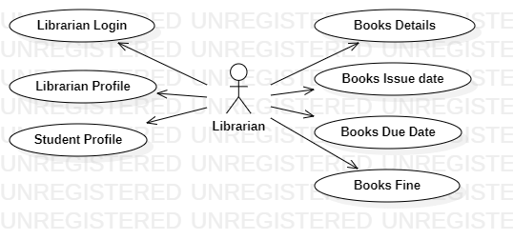

**Figure 3: Librarian Use case**

# FACULTY USE CASE

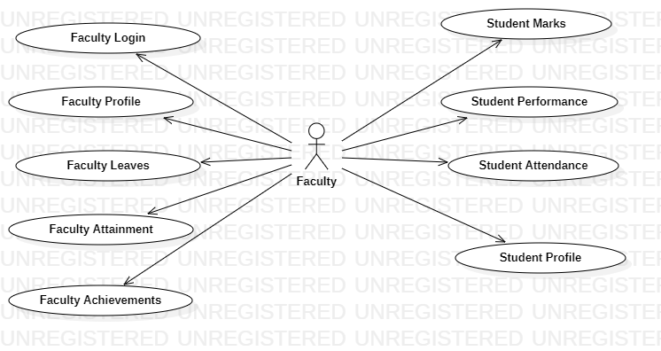

**Figure 4: Faculty Use case**

# STUDENT USE CASE

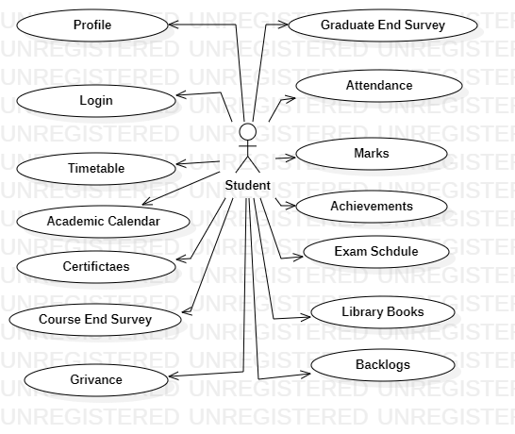

**Figure 5: Student Use case**

# LIST OF MODULES

* Admin
* Faculty
* Librarian
* Student

# IMPLEMENTATION WelcomePage.java

**package** com . example . m a j o r p r o j e c t ;

**import** a n d r o i d x . appcompat . app . App Compat Activity ;

**import** a n d r o i d . c o n t e n t . I n t e n t ; **import** a n d r o i d . os . Bundle ; **import** a n d r o i d . view . View ;

**p u b l i c c l a s s** Welcome Page **extends** App Compat Activity *{*

@ Override

**p r o t e c t e d void** o n C r e a t e ( Bundle s a v e d I n s t a n c e S t a t e )

*{*

**super** . o n C r e a t e ( s a v e d I n s t a n c e S t a t e ) ;

s e t C o n t e n t V i e w ( R . l a y o u t . a c t i v i t y w e l c o m e p a g e ) ;

*}*

**p u b l i c void** Welcome ( View view )

*{*

I n t e n t i n t e n t =**new** I n t e n t ( **t h i s** , M a i n A c t i v i t y . **c l a s s** ) ; s t a r t A c t i v i t y ( i n t e n t ) ;

*}*

*}*

# MainActivity.java

**package** com . example . m a j o r p r o j e c t ;

**import** a n d r o i d x . appcompat . app . App Compat Activity ;

**import** a n d r o i d . c o n t e n t . I n t e n t ; **import** a n d r o i d . os . Bundle ; **import** a n d r o i d . view . View ;

**p u b l i c c l a s s** M a i n A c t i v i t y **extends** App Compat Activity *{*

@ Override

**p r o t e c t e d void** o n C r e a t e ( Bundle s a v e d I n s t a n c e S t a t e )

*{*

**super** . o n C r e a t e ( s a v e d I n s t a n c e S t a t e ) ;

s e t C o n t e n t V i e w ( R . l a y o u t . a c t i v i t y m a i n ) ;

*}*

**p u b l i c void** Admin ( View view )

*{*

I n t e n t i n t e n t =**new** I n t e n t ( **t h i s** , Admin . **c l a s s** ) ; s t a r t A c t i v i t y ( i n t e n t ) ;

*}*

**p u b l i c void** F a c u l t y ( View view )

*{*

I n t e n t i n t e n t =**new** I n t e n t ( **t h i s** , F a c u l t y . **c l a s s** ) ; s t a r t A c t i v i t y ( i n t e n t ) ;

*}*

**p u b l i c void** L i b r a r i a n ( View view )

*{*

I n t e n t i n t e n t =**new** I n t e n t ( **t h i s** , L i b r a r i a n . **c l a s s** ) ; s t a r t A c t i v i t y ( i n t e n t ) ;

*}*

**p u b l i c void** S t u d e n t ( View view )

*{*

I n t e n t i n t e n t =**new** I n t e n t ( **t h i s** , S t u d e n t . **c l a s s** ) ; s t a r t A c t i v i t y ( i n t e n t ) ;

*}*

*}*

# TimeTable.java

**package** com . example . m a j o r p r o j e c t ;

**import** a n d r o i d x . appcompat . app . App Compat Activity ;

**import** a n d r o i d x . r e c y c l e r v i e w . w i d g e t . Linear Layout Manager ;

**import** a n d r o i d x . r e c y c l e r v i e w . w i d g e t . Recycler View ;

**import** a n d r o i d . os . Bundle ;

**import** a n d r o i d . w i d g e t . T o a s t ;

**import** com . a n d r o i d . v o l l e y . Request ; **import** com . a n d r o i d . v o l l e y . Request Queue ; **import** com . a n d r o i d . v o l l e y . Response ; **import** com . a n d r o i d . v o l l e y . V o l l e y E r r o r ;

**import** com . a n d r o i d . v o l l e y . t o o l b o x . S t r i n g R e q u e s t ;

**import** com . a n d r o i d . v o l l e y . t o o l b o x . V o l l e y ;

**import** org . j s o n . JSONArray ; **import** org . j s o n . JSONException ; **import** org . j s o n . JSONObject ;

**import** j a v a . u t i l . A r r a y L i s t ;

**import** j a v a . u t i l . L i s t ;

**p u b l i c c l a s s** Show Academic Calendar **extends** App Compat Activity *{*

Recycler View r e c y c l e r V i e w ;

My Adapter Calendar my Adapter ; L i s t *<*ModelImage*>* i m a g e L i s t ; ModelImage model Image ;

Linear Layout Manager l i n e a r L a y o u t M a n a g e r ;

@ Override

**p r o t e c t e d void** o n C r e a t e ( Bundle s a v e d I n s t a n c e S t a t e )

*{*

**super** . o n C r e a t e ( s a v e d I n s t a n c e S t a t e ) ;

s e t C o n t e n t V i e w ( R . l a y o u t . a c t i v i t y s h o w a c a d e m i c c a l e n d a r ) ;

r e c y c l e r V i e w = f ind View By Id ( R . i d . r e c y c l e r V i e w ) ;

l i n e a r L a y o u t M a n a g e r = **new** Linear Layout Manager ( **t h i s** ) ; r e c y c l e r V i e w . set Layout Manager ( l i n e a r L a y o u t M a n a g e r ) ;

i m a g e L i s t = **new** A r r a y L i s t *<>*();

my Adapter = **new** My Adapter Calendar ( **t h i s** , i m a g e L i s t ) ; r e c y c l e r V i e w . s e t A d a p t e r ( my Adapter ) ;

f e t c h I m a g e s ( ) ;

*}*

**p u b l i c void** f e t c h I m a g e s ( )

*{*

S t r i n g R e q u e s t r e q u e s t = **new** S t r i n g R e q u e s t ( Request . Method .

POST , ” h t t p : / / 1 0 . 0 . 2 . 2 : 1 6 0 2 / a n d r o i d d b p o o l / a c a d e m i c c a l e n d a r . php ” ,

**new** Response . L i s t e n e r *<*S t r i n g *>*() *{*

@ Override

**p u b l i c void** on Response ( S t r i n g r e s p o n s e ) *{*

# t r y

*{*

JSONObject j s o n O b j e c t = **new** JSONObject ( r e s p o n s e ) ; S t r i n g s u c c e s = j s o n O b j e c t . g e t S t r i n g ( ” s u c c e s s ” ) ;

JSONArray j s o n A r r a y = j s o n O b j e c t . get JSONArray ( ” d a t a ” ) ;

**i f** ( s u c c e s . e q u a l s ( ” 1 ” ) ) *{*

**f o r** ( **i n t** i = 0 ; i *<*j s o n A r r a y . l e n g t h ( ) ; i ++)

*{*

JSONObject o b j e c t = j s o n A r r a y . get JSONObject ( i ) ;

S t r i n g i d = o b j e c t . g e t S t r i n g ( ” i d ” ) ;

S t r i n g i m a g e u r l = o b j e c t . g e t S t r i n g ( ” image ” ) ;

S t r i n g u r l = ” h t t p : / / 1 0 . 0 . 2 . 2 : 1 6 0 2 / a n d r o i d d b po o l / images / ” + i m a g e u r l ;

model Image = **new** ModelImage ( id , u r l ) ; i m a g e L i s t . add ( model Image ) ;

my Adapter . n o t i f y D a t a S e t C h a n g e d ( ) ;

*}*

*}*

**catch** ( JSONException e ) e . p r i n t S t a c k T r a c e ( ) ;

*} {*

*}*

, **new** Response . E r r o r L i s t e n e r ( ) @ Override

*} {*

*}*

**p u b l i c void** o n E r r o r R e s p o n s e ( V o l l e y E r r o r e r r o r ) T o a s t . make Text ( Show Academic Calendar . **t h i s** ,

*{*

e r r o r . get Message ( ) , T o a s t . LENGTH SHORT ) . show ( ) ;

*}* ) ; *}*

Request Queue r e q u e s t Q u e u e = V o l l e y . new Request Queue ( **t h i s** ) ; r e q u e s t Q u e u e . add ( r e q u e s t ) ;

*}*

*}*

# ActivityMain.xml

*<*? **xml v e r s i o n** =” 1 . 0 ” e n c o d i n g =” u t f −8 ” ?*>*

*<*L i n e a r L a y o u t x m l n s : a n d r o i d =” h t t p : / / schemas . a n d r o i d . com / apk / r e s / a n d r o i d ”

x m l n s : t o o l s =” h t t p : / / schemas . a n d r o i d . com / t o o l s ” a n d r o i d : l a y o u t w i d t h =” m a t c h p a r e n t ”

a n d r o i d : l a y o u t h e i g h t =” m a t c h p a r e n t ” a n d r o i d : b a c k g r o u n d =” @drawable / c l g ”

a n d r o i d : l a y o u t g r a v i t y =” c e n t e r ” a n d r o i d : o r i e n t a t i o n =” v e r t i c a l ”

t o o l s : c o n t e x t =” . M a i n A c t i v i t y ”*>*

*<*Text View

a n d r o i d : l a y o u t w i d t h =” m a t c h p a r e n t ” a n d r o i d : l a y o u t h e i g h t =” w r a p c o n t e n t ” a n d r o i d : i d = ”@+ i d / t e x t v i e w 1 ”

a n d r o i d : l a y o u t b e l o w = ”@+ i d / t e x t v i e w ” a n d r o i d : t e x t =” Choose C a t e g o r y ”

a n d r o i d : t e x t S i z e =” 30 dp ”

a n d r o i d : l a y o u t m a r g i n T o p =” 40 dp ” a n d r o i d : g r a v i t y =” c e n t e r ” /*>*

*<*B u t t o n

a n d r o i d : i d = ”@+ i d / Admin”

a n d r o i d : l a y o u t w i d t h =” 120 dp ”

a n d r o i d : l a y o u t h e i g h t =” w r a p c o n t e n t ” a n d r o i d : l a y o u t m a r g i n T o p =” 18 dp ”

a n d r o i d : t e x t =” Admin”

a n d r o i d : g r a v i t y =” c e n t e r ”

a n d r o i d : b a c k g r o u n d =” @drawable / r o u n d e d b u t t o n ” a n d r o i d : o n C l i c k =” Admin”

a n d r o i d : l a y o u t m a r g i n L e f t =” 150 dp ” /*>*

*<*B u t t o n

a n d r o i d : i d = ”@+ i d / F a c u l t y ”

a n d r o i d : l a y o u t m a r g i n L e f t =” 150 dp ” a n d r o i d : l a y o u t w i d t h =” 120 dp ”

a n d r o i d : l a y o u t h e i g h t =” w r a p c o n t e n t ” a n d r o i d : l a y o u t m a r g i n T o p =” 40 dp ”

a n d r o i d : l a y o u t a l i g n P a r e n t B o t t o m =” t r u e ”

a n d r o i d : b a c k g r o u n d =” @drawable / r o u n d e d b u t t o n ” a n d r o i d : t e x t =” F a c u l t y ”

a n d r o i d : g r a v i t y =” c e n t e r ”

a n d r o i d : o n C l i c k =” F a c u l t y ” /*>*

*<*B u t t o n

a n d r o i d : i d = ”@+ i d / L i b r a r i a n ” a n d r o i d : l a y o u t w i d t h =” 120 dp ”

a n d r o i d : l a y o u t h e i g h t =” w r a p c o n t e n t ” a n d r o i d : l a y o u t m a r g i n T o p =” 40 dp ”

a n d r o i d : l a y o u t m a r g i n B o t t o m =” 16 dp ” a n d r o i d : l a y o u t m a r g i n L e f t =” 150 dp ”

a n d r o i d : b a c k g r o u n d =” @drawable / r o u n d e d b u t t o n ” a n d r o i d : g r a v i t y =” c e n t e r ”

a n d r o i d : o n C l i c k =” L i b r a r i a n ” a n d r o i d : t e x t =” L i b r a r i a n ” /*>*

*<*B u t t o n

a n d r o i d : i d = ”@+ i d / S t u d e n t ”

a n d r o i d : l a y o u t w i d t h =” 120 dp ”

a n d r o i d : l a y o u t h e i g h t =” w r a p c o n t e n t ” a n d r o i d : l a y o u t m a r g i n T o p =” 40 dp ”

a n d r o i d : l a y o u t m a r g i n B o t t o m =” 14 dp ” a n d r o i d : o n C l i c k =” S t u d e n t ”

a n d r o i d : l a y o u t m a r g i n L e f t =” 150 dp ”

a n d r o i d : b a c k g r o u n d =” @drawable / r o u n d e d b u t t o n ” a n d r o i d : t e x t =” S t u d e n t ” /*>*

*<* / L i n e a r L a y o u t*>*

# StudentDashboard.xml

*<*? **xml v e r s i o n** =” 1 . 0 ” e n c o d i n g =” u t f −8 ” ?*>*

*<*S c r o l l V i e w x m l n s : a n d r o i d =” h t t p : / / schemas . a n d r o i d . com / apk / r e s / a n d r o i d ”

xmlns: app =” h t t p : / / schemas . a n d r o i d . com / apk / r e s − a u t o ”

x m l n s : t o o l s =” h t t p : / / schemas . a n d r o i d . com / t o o l s ”

a n d r o i d : l a y o u t w i d t h =” m a t c h p a r e n t ” a n d r o i d : l a y o u t h e i g h t =” w r a p c o n t e n t ” a n d r o i d : b a c k g r o u n d =” @drawable / c l g ”

a n d r o i d : o r i e n t a t i o n =” v e r t i c a l ”

t o o l s : c o n t e x t =” . S t u d e n t D a s h b o a r d ”*>*

*<*L i n e a r L a y o u t

a n d r o i d : l a y o u t w i d t h =” m a t c h p a r e n t ” a n d r o i d : l a y o u t h e i g h t =” w r a p c o n t e n t ” a n d r o i d : o r i e n t a t i o n =” v e r t i c a l ”*>*

*<*Text View

a n d r o i d : l a y o u t w i d t h =” m a t c h p a r e n t ” a n d r o i d : l a y o u t h e i g h t =” w r a p c o n t e n t ” a n d r o i d : l a y o u t m a r g i n T o p =” 100 dp ”

a n d r o i d : t e x t A l i g n m e n t =” c e n t e r ” a n d r o i d : t e x t S i z e =” 40 dp ”

a n d r o i d : t e x t =” Welcome” a n d r o i d : i d = ”@+ i d / t v ”

/*>*

*<*B u t t o n

a n d r o i d : l a y o u t w i d t h =” 215 dp ”

a n d r o i d : l a y o u t h e i g h t =” w r a p c o n t e n t ” a n d r o i d : l a y o u t g r a v i t y =” c e n t e r ”

a n d r o i d : l a y o u t m a r g i n T o p =” 40 dp ” a n d r o i d : g r a v i t y =” c e n t e r ”

a n d r o i d : b a c k g r o u n d =” @drawable / r o u n d e d b u t t o n ”

a n d r o i d : t e x t =” P r o f i l e ”

a n d r o i d : o n C l i c k =” s t u d e n t p r o f i l e ” a n d r o i d : t e x t C o l o r =” #FFF”

a n d r o i d : t e x t S i z e =” 20 dp ”

/*>*

*<*B u t t o n

a n d r o i d : l a y o u t w i d t h =” 215 dp ”

a n d r o i d : l a y o u t h e i g h t =” w r a p c o n t e n t ”

a n d r o i d : l a y o u t g r a v i t y =” c e n t e r ” a n d r o i d : l a y o u t m a r g i n T o p =” 40 dp ” a n d r o i d : g r a v i t y =” c e n t e r ”

a n d r o i d : b a c k g r o u n d =” @drawable / r o u n d e d b u t t o n ”

a n d r o i d : t e x t =” A t t e n d a n c e ” a n d r o i d : t e x t C o l o r =” #FFF” a n d r o i d : t e x t S i z e =” 20 dp ”

a n d r o i d : o n C l i c k =” a t t e n d a n c e ”

/*>*

*<*B u t t o n

a n d r o i d : l a y o u t w i d t h =” 215 dp ”

a n d r o i d : l a y o u t h e i g h t =” w r a p c o n t e n t ” a n d r o i d : l a y o u t g r a v i t y =” c e n t e r ”

a n d r o i d : l a y o u t m a r g i n T o p =” 40 dp ” a n d r o i d : g r a v i t y =” c e n t e r ”

a n d r o i d : b a c k g r o u n d =” @drawable / r o u n d e d b u t t o n ”

a n d r o i d : t e x t =” Marks ”

a n d r o i d : t e x t C o l o r =” #FFF” a n d r o i d : t e x t S i z e =” 20 dp ”

/*>*

*<*B u t t o n

a n d r o i d : l a y o u t w i d t h =” 215 dp ”

a n d r o i d : l a y o u t h e i g h t =” w r a p c o n t e n t ” a n d r o i d : l a y o u t g r a v i t y =” c e n t e r ”

a n d r o i d : l a y o u t m a r g i n T o p =” 40 dp ” a n d r o i d : g r a v i t y =” c e n t e r ”

a n d r o i d : b a c k g r o u n d =” @drawable / r o u n d e d b u t t o n ”

a n d r o i d : t e x t =” Time Table ” a n d r o i d : t e x t C o l o r =” #FFF” a n d r o i d : t e x t S i z e =” 20 dp ”

a n d r o i d : o n C l i c k =” t i m e t a b l e ”

/*>*

*<*B u t t o n

a n d r o i d : l a y o u t w i d t h =” 215 dp ”

a n d r o i d : l a y o u t h e i g h t =” w r a p c o n t e n t ” a n d r o i d : l a y o u t g r a v i t y =” c e n t e r ”

a n d r o i d : l a y o u t m a r g i n T o p =” 40 dp ” a n d r o i d : g r a v i t y =” c e n t e r ”

a n d r o i d : b a c k g r o u n d =” @drawable /

r o u n d e d b u t t o n ”

a n d r o i d : t e x t =” C e r t i f i c a t i o n s ” a n d r o i d : t e x t C o l o r =” #FFF”

a n d r o i d : t e x t S i z e =” 20 dp ”

a n d r o i d : o n C l i c k =” c e r t i f i c a t e s ”

/*>*

*<*B u t t o n

a n d r o i d : l a y o u t w i d t h =” 215 dp ”

a n d r o i d : l a y o u t h e i g h t =” w r a p c o n t e n t ” a n d r o i d : l a y o u t g r a v i t y =” c e n t e r ”

a n d r o i d : l a y o u t m a r g i n T o p =” 40 dp ” a n d r o i d : g r a v i t y =” c e n t e r ”

a n d r o i d : b a c k g r o u n d =” @drawable / r o u n d e d b u t t o n ”

a n d r o i d : t e x t =” Academic C a l e n d a r ” a n d r o i d : t e x t C o l o r =” #FFF”

a n d r o i d : t e x t S i z e =” 20 dp ”

a n d r o i d : o n C l i c k =” a c a d e m i c c a l e n d a r ”

/*>*

*<*B u t t o n

a n d r o i d : l a y o u t w i d t h =” 215 dp ”

a n d r o i d : l a y o u t h e i g h t =” w r a p c o n t e n t ” a n d r o i d : l a y o u t g r a v i t y =” c e n t e r ”

a n d r o i d : l a y o u t m a r g i n T o p =” 40 dp ” a n d r o i d : g r a v i t y =” c e n t e r ”

a n d r o i d : b a c k g r o u n d =” @drawable / r o u n d e d b u t t o n ” a n d r o i d : t e x t =” G r a d u a t e E x i t Survey ”

a n d r o i d : o n C l i c k =” ges ”

a n d r o i d : t e x t C o l o r =” #FFF” a n d r o i d : t e x t S i z e =” 20 dp ”

/*>*

*<*B u t t o n

a n d r o i d : l a y o u t w i d t h =” 215 dp ”

a n d r o i d : l a y o u t h e i g h t =” w r a p c o n t e n t ” a n d r o i d : l a y o u t g r a v i t y =” c e n t e r ”

a n d r o i d : l a y o u t m a r g i n T o p =” 40 dp ” a n d r o i d : g r a v i t y =” c e n t e r ”

a n d r o i d : b a c k g r o u n d =” @drawable / r o u n d e d b u t t o n ”

a n d r o i d : t e x t =” Course End Survey ” a n d r o i d : o n C l i c k =” c o u r s e n d s u r v e y ” a n d r o i d : t e x t C o l o r =” #FFF”

a n d r o i d : t e x t S i z e =” 20 dp ”

/*>*

*<*B u t t o n

a n d r o i d : l a y o u t w i d t h =” 215 dp ”

a n d r o i d : l a y o u t h e i g h t =” w r a p c o n t e n t ” a n d r o i d : l a y o u t g r a v i t y =” c e n t e r ”

a n d r o i d : l a y o u t m a r g i n T o p =” 40 dp ” a n d r o i d : g r a v i t y =” c e n t e r ”

a n d r o i d : b a c k g r o u n d =” @drawable / r o u n d e d b u t t o n ”

a n d r o i d : t e x t =” G r i e v a n c e ” a n d r o i d : t e x t C o l o r =” #FFF”

a n d r o i d : o n C l i c k =” G r i e v a n c e ” a n d r o i d : t e x t S i z e =” 20 dp ”

/*>*

*<*B u t t o n

a n d r o i d : l a y o u t w i d t h =” 215 dp ”

a n d r o i d : l a y o u t h e i g h t =” w r a p c o n t e n t ” a n d r o i d : l a y o u t g r a v i t y =” c e n t e r ”

a n d r o i d : l a y o u t m a r g i n T o p =” 40 dp ” a n d r o i d : g r a v i t y =” c e n t e r ”

a n d r o i d : b a c k g r o u n d =” @drawable / r o u n d e d b u t t o n ”

a n d r o i d : t e x t =” Leaves ”

a n d r o i d : t e x t C o l o r =” #FFF” a n d r o i d : t e x t S i z e =” 20 dp ”

/*>*

*<*B u t t o n

a n d r o i d : l a y o u t w i d t h =” 215 dp ”

a n d r o i d : l a y o u t h e i g h t =” w r a p c o n t e n t ” a n d r o i d : l a y o u t g r a v i t y =” c e n t e r ”

a n d r o i d : l a y o u t m a r g i n T o p =” 40 dp ” a n d r o i d : g r a v i t y =” c e n t e r ”

a n d r o i d : b a c k g r o u n d =” @drawable / r o u n d e d b u t t o n ”

a n d r o i d : t e x t =” Achievements ” a n d r o i d : t e x t C o l o r =” #FFF”

a n d r o i d : t e x t S i z e =” 20 dp ”

/*>*

*<*B u t t o n

a n d r o i d : l a y o u t w i d t h =” 215 dp ”

a n d r o i d : l a y o u t h e i g h t =” w r a p c o n t e n t ” a n d r o i d : l a y o u t g r a v i t y =” c e n t e r ”

a n d r o i d : l a y o u t m a r g i n T o p =” 40 dp ” a n d r o i d : g r a v i t y =” c e n t e r ”

a n d r o i d : b a c k g r o u n d =” @drawable / r o u n d e d b u t t o n ”

a n d r o i d : t e x t =” Backlogs ” a n d r o i d : t e x t C o l o r =” #FFF” a n d r o i d : t e x t S i z e =” 20 dp ”

/*>*

*<*B u t t o n

a n d r o i d : l a y o u t w i d t h =” 215 dp ”

a n d r o i d : l a y o u t h e i g h t =” w r a p c o n t e n t ” a n d r o i d : l a y o u t g r a v i t y =” c e n t e r ”

a n d r o i d : l a y o u t m a r g i n T o p =” 40 dp ” a n d r o i d : g r a v i t y =” c e n t e r ”

a n d r o i d : b a c k g r o u n d =” @drawable / r o u n d e d b u t t o n ”

a n d r o i d : t e x t =” L i b r a r y Books ” a n d r o i d : t e x t C o l o r =” #FFF”

a n d r o i d : t e x t S i z e =” 20 dp ”

/*>*

*<*B u t t o n

a n d r o i d : l a y o u t w i d t h =” 215 dp ”

a n d r o i d : l a y o u t h e i g h t =” w r a p c o n t e n t ” a n d r o i d : l a y o u t g r a v i t y =” c e n t e r ”

a n d r o i d : l a y o u t m a r g i n T o p =” 40 dp ” a n d r o i d : g r a v i t y =” c e n t e r ”

a n d r o i d : b a c k g r o u n d =” @drawable / r o u n d e d b u t t o n ”

a n d r o i d : t e x t =” Exam S c h e d u l e ” a n d r o i d : t e x t C o l o r =” #FFF”

a n d r o i d : t e x t S i z e =” 20 dp ”

/*>*

*<*B u t t o n

a n d r o i d : l a y o u t w i d t h =” 215 dp ”

a n d r o i d : l a y o u t h e i g h t =” w r a p c o n t e n t ” a n d r o i d : l a y o u t g r a v i t y =” c e n t e r ”

a n d r o i d : l a y o u t m a r g i n T o p =” 40 dp ” a n d r o i d : g r a v i t y =” c e n t e r ”

a n d r o i d : b a c k g r o u n d =” @drawable / r o u n d e d b u t t o n ”

a n d r o i d : t e x t =” H o s t e l / T r a n s p o r t Request ” a n d r o i d : t e x t C o l o r =” #FFF”

a n d r o i d : t e x t S i z e =” 20 dp ”

/*>*

*<*B u t t o n

a n d r o i d : l a y o u t w i d t h =” 130 dp ”

a n d r o i d : l a y o u t h e i g h t =” w r a p c o n t e n t ” a n d r o i d : l a y o u t g r a v i t y =” c e n t e r ”

a n d r o i d : l a y o u t m a r g i n T o p =” 40 dp ” a n d r o i d : g r a v i t y =” c e n t e r ”

a n d r o i d : b a c k g r o u n d =” @drawable / r o u n d e d b u t t o n ”

a n d r o i d : t e x t =” Logout ”

a n d r o i d : t e x t C o l o r =” #FFF” a n d r o i d : t e x t S i z e =” 20 dp ”

a n d r o i d : o n C l i c k =” l o g o u t p r o c e s s ”

/*>*

*<* / L i n e a r L a y o u t*>*

*<* / S c r o l l V i e w*>*

# GES.xml

*<*? **xml v e r s i o n** =” 1 . 0 ” e n c o d i n g =” u t f −8 ” ?*>*

*<*S c r o l l V i e w

x m l n s : a n d r o i d =” h t t p : / / schemas . a n d r o i d . com / apk / r e s / a n d r o i d ”

x m l n s : t o o l s =” h t t p : / / schemas . a n d r o i d . com / t o o l s ”

a n d r o i d : l a y o u t w i d t h =” m a t c h p a r e n t ” a n d r o i d : l a y o u t h e i g h t =” m a t c h p a r e n t ” a n d r o i d : o r i e n t a t i o n =” h o r i z o n t a l ”

a n d r o i d : b a c k g r o u n d =” @drawable / c l g ” t o o l s : c o n t e x t =” . Ges ”*>*

*<*R e l a t i v e L a y o u t

a n d r o i d : l a y o u t w i d t h =” m a t c h p a r e n t ”

a n d r o i d : l a y o u t h e i g h t =” w r a p c o n t e n t ”*>*

*<*Text View

a n d r o i d : i d = ”@+ i d / r o l l n o ”

a n d r o i d : l a y o u t w i d t h =” w r a p c o n t e n t ” a n d r o i d : l a y o u t h e i g h t =” w r a p c o n t e n t ” a n d r o i d : l a y o u t m a r g i n L e f t =” 20 dp ”

a n d r o i d : l a y o u t m a r g i n T o p =” 10 dp ” a n d r o i d : t e x t =” R o l l Number”

a n d r o i d : t e x t S t y l e =” bol d ” /*>*

*<*E d i t T e x t

a n d r o i d : i d = ”@+ i d / e d i t r o l l n o ” a n d r o i d : l a y o u t w i d t h =” 150 dp ”

a n d r o i d : l a y o u t h e i g h t =” w r a p c o n t e n t ” a n d r o i d : l a y o u t b e l o w = ”@+ i d / r o l l n o ”

a n d r o i d : l a y o u t m a r g i n L e f t =” 20 dp ” /*>*

*<*Text View

a n d r o i d : i d = ”@+ i d / h i g h e r ”

a n d r o i d : l a y o u t w i d t h =” w r a p c o n t e n t ” a n d r o i d : l a y o u t h e i g h t =” w r a p c o n t e n t ” a n d r o i d : l a y o u t m a r g i n L e f t =” 210 dp ”

a n d r o i d : l a y o u t m a r g i n T o p =” 10 dp ”

a n d r o i d : t e x t =” Higher S t u d i e s T e s t ” a n d r o i d : t e x t S t y l e =” bol d ” /*>*

*<*E d i t T e x t

a n d r o i d : i d = ”@+ i d / e d i t h i g h e r ” a n d r o i d : l a y o u t w i d t h =” 150 dp ”

a n d r o i d : l a y o u t h e i g h t =” w r a p c o n t e n t ” a n d r o i d : l a y o u t b e l o w = ”@+ i d / h i g h e r ”

a n d r o i d : l a y o u t m a r g i n L e f t =” 200 dp ” /*>*

*<*Text View

a n d r o i d : i d = ”@+ i d / s c o r e ”

a n d r o i d : l a y o u t w i d t h =” w r a p c o n t e n t ” a n d r o i d : l a y o u t h e i g h t =” w r a p c o n t e n t ” a n d r o i d : l a y o u t m a r g i n L e f t =” 20 dp ”

a n d r o i d : l a y o u t m a r g i n T o p =” 80 dp ”

a n d r o i d : t e x t =” Higher S t u d i e s Score ” a n d r o i d : t e x t S t y l e =” bol d ” /*>*

*<*E d i t T e x t

a n d r o i d : i d = ”@+ i d / e d i t s c o r e ” a n d r o i d : l a y o u t w i d t h =” 150 dp ”

a n d r o i d : l a y o u t h e i g h t =” w r a p c o n t e n t ” a n d r o i d : l a y o u t b e l o w = ”@+ i d / s c o r e ”

a n d r o i d : l a y o u t m a r g i n L e f t =” 20 dp ” /*>*

*<*Text View

a n d r o i d : i d = ”@+ i d / p l a c e m e n t ”

a n d r o i d : l a y o u t w i d t h =” w r a p c o n t e n t ” a n d r o i d : l a y o u t h e i g h t =” w r a p c o n t e n t ” a n d r o i d : l a y o u t m a r g i n L e f t =” 210 dp ”

a n d r o i d : l a y o u t m a r g i n T o p =” 80 dp ” a n d r o i d : t e x t =” Placement D e t a i l s ” a n d r o i d : t e x t S t y l e =” bol d ” /*>*

*<*E d i t T e x t

a n d r o i d : i d = ”@+ i d / e d i t p l a c e m e n t ” a n d r o i d : l a y o u t w i d t h =” 150 dp ”

a n d r o i d : l a y o u t h e i g h t =” w r a p c o n t e n t ” a n d r o i d : l a y o u t b e l o w = ”@+ i d / p l a c e m e n t ” a n d r o i d : l a y o u t m a r g i n L e f t =” 200 dp ” /*>*

*<*Text View

a n d r o i d : i d = ”@+ i d / I n s t r u c t i o n s ”

a n d r o i d : l a y o u t w i d t h =” w r a p c o n t e n t ” a n d r o i d : l a y o u t h e i g h t =” w r a p c o n t e n t ”

a n d r o i d : l a y o u t b e l o w =”@id / e d i t p l a c e m e n t ”

a n d r o i d : l a y o u t m a r g i n L e f t =” 20 dp ” a n d r o i d : l a y o u t m a r g i n T o p =” 10 dp ” a n d r o i d : t e x t =” I n s t r u c t i o n s ”

a n d r o i d : t e x t S t y l e =” bol d ” /*>*

*<*Text View

a n d r o i d : i d = ”@+ i d / I n s t r u c t i o n s 1 ”

a n d r o i d : l a y o u t w i d t h =” w r a p c o n t e n t ” a n d r o i d : l a y o u t h e i g h t =” w r a p c o n t e n t ”

a n d r o i d : l a y o u t b e l o w =”@id / I n s t r u c t i o n s ” a n d r o i d : l a y o u t m a r g i n L e f t =” 20 dp ”

a n d r o i d : l a y o u t m a r g i n T o p =” 10 dp ”

a n d r o i d : t e x t =” E x c e l l e n t −5 Very Good−4 Good−3 Average −2 Poor −1 ”

a n d r o i d : t e x t S t y l e =” bol d ” /*>*

*<*Text View

a n d r o i d : i d = ”@+ i d / S e r v i c e ”

a n d r o i d : l a y o u t w i d t h =” w r a p c o n t e n t ” a n d r o i d : l a y o u t h e i g h t =” w r a p c o n t e n t ”

a n d r o i d : l a y o u t b e l o w =”@id / I n s t r u c t i o n s 1 ” a n d r o i d : l a y o u t m a r g i n L e f t =” 20 dp ”

a n d r o i d : l a y o u t m a r g i n T o p =” 10 dp ” a n d r o i d : t e x t =” SERVICES”

a n d r o i d : t e x t S t y l e =” bol d ” /*>*

*<*Text View

a n d r o i d : i d = ”@+ i d / t o p l i n e s 1 ”

a n d r o i d : l a y o u t w i d t h =” w r a p c o n t e n t ” a n d r o i d : l a y o u t h e i g h t =” w r a p c o n t e n t ” a n d r o i d : l a y o u t b e l o w =”@id / S e r v i c e ”

a n d r o i d : l a y o u t m a r g i n L e f t =” 20 dp ” a n d r o i d : l a y o u t m a r g i n T o p =” 10 dp ”

a n d r o i d : t e x t =” −−−−−−−−−−−−−−−−−−−−−−−−−−−−−−

−−−−−−−−−−−−−−−−−−−−−−”

a n d r o i d : t e x t S t y l e =” bol d ” /*>*

*<*Text View

a n d r o i d : i d = ”@+ i d / S e r v i c e s ”

a n d r o i d : l a y o u t w i d t h =” w r a p c o n t e n t ” a n d r o i d : l a y o u t h e i g h t =” w r a p c o n t e n t ” a n d r o i d : l a y o u t b e l o w =”@id / t o p l i n e s 1 ” a n d r o i d : l a y o u t m a r g i n L e f t =” 20 dp ”

a n d r o i d : t e x t =” S e r v i c e s R a t i n g ”

a n d r o i d : t e x t S t y l e =” bol d ” /*>*

*<*Text View

a n d r o i d : i d = ”@+ i d / b o t t o m l i n e s 1 ”

a n d r o i d : l a y o u t w i d t h =” w r a p c o n t e n t ” a n d r o i d : l a y o u t h e i g h t =” w r a p c o n t e n t ” a n d r o i d : l a y o u t b e l o w =”@id / S e r v i c e s ” a n d r o i d : l a y o u t m a r g i n L e f t =” 20 dp ”

a n d r o i d : t e x t =” −−−−−−−−−−−−−−−−−−−−−−−−−−−−−−

−−−−−−−−−−−−−−−−−−−−−−”

a n d r o i d : t e x t S t y l e =” bol d ” /*>*

*<*Text View

a n d r o i d : i d = ”@+ i d / a d m i n o f f i c e ”

a n d r o i d : l a y o u t w i d t h =” w r a p c o n t e n t ” a n d r o i d : l a y o u t h e i g h t =” w r a p c o n t e n t ” a n d r o i d : l a y o u t b e l o w =”@id / S e r v i c e s ” a n d r o i d : l a y o u t m a r g i n L e f t =” 20 dp ”

a n d r o i d : l a y o u t m a r g i n T o p =” 30 dp ”

a n d r o i d : t e x t =” Admin O f f i c e s ” /*>*

*<*E d i t T e x t

a n d r o i d : i d = ”@+ i d / e d i t a d m i n ” a n d r o i d : l a y o u t w i d t h =” 24 dp ” a n d r o i d : l a y o u t h e i g h t =” 40 dp ”

a n d r o i d : l a y o u t b e l o w = ”@+ i d / S e r v i c e s ” a n d r o i d : l a y o u t m a r g i n L e f t =” 200 dp ”

a n d r o i d : l a y o u t m a r g i n T o p =” 10 dp ” /*>*

*<*Text View

a n d r o i d : i d = ”@+ i d / t r a i n i n g ”

a n d r o i d : l a y o u t w i d t h =” w r a p c o n t e n t ” a n d r o i d : l a y o u t h e i g h t =” w r a p c o n t e n t ”

a n d r o i d : l a y o u t b e l o w =”@id / a d m i n o f f i c e ” a n d r o i d : l a y o u t m a r g i n L e f t =” 20 dp ”

a n d r o i d : l a y o u t m a r g i n T o p =” 25 dp ”

a n d r o i d : t e x t =” Placement T r a i n i n g ” /*>*

*<*E d i t T e x t

a n d r o i d : i d = ”@+ i d / e d i t t r a i n i n g ” a n d r o i d : l a y o u t w i d t h =” 24 dp ”

a n d r o i d : l a y o u t h e i g h t =” 40 dp ”

a n d r o i d : l a y o u t b e l o w = ”@+ i d / e d i t a d m i n ” a n d r o i d : l a y o u t m a r g i n L e f t =” 200 dp ”

a n d r o i d : l a y o u t m a r g i n T o p =” 5 dp ” /*>*

*<*Text View

a n d r o i d : i d = ”@+ i d / exam”

a n d r o i d : l a y o u t w i d t h =” w r a p c o n t e n t ” a n d r o i d : l a y o u t h e i g h t =” w r a p c o n t e n t ” a n d r o i d : l a y o u t b e l o w =”@id / t r a i n i n g ” a n d r o i d : l a y o u t m a r g i n L e f t =” 20 dp ”

a n d r o i d : l a y o u t m a r g i n T o p =” 25 dp ” a n d r o i d : t e x t =” Exam c e l l ” /*>*

*<*E d i t T e x t

a n d r o i d : i d = ”@+ i d / e d i t e x a m ” a n d r o i d : l a y o u t w i d t h =” 24 dp ”

a n d r o i d : l a y o u t h e i g h t =” 40 dp ”

a n d r o i d : l a y o u t b e l o w = ”@+ i d / e d i t t r a i n i n g ” a n d r o i d : l a y o u t m a r g i n L e f t =” 200 dp ”

a n d r o i d : l a y o u t m a r g i n T o p =” 5 dp ” /*>*

*<*Text View

a n d r o i d : i d = ”@+ i d / n o n t e a c h i n g ”

a n d r o i d : l a y o u t w i d t h =” w r a p c o n t e n t ” a n d r o i d : l a y o u t h e i g h t =” w r a p c o n t e n t ” a n d r o i d : l a y o u t b e l o w =”@id / exam ”

a n d r o i d : l a y o u t m a r g i n L e f t =” 20 dp ” a n d r o i d : l a y o u t m a r g i n T o p =” 25 dp ”

a n d r o i d : t e x t =” Non− Teaching F a c u l t y ” /*>*

*<*E d i t T e x t

a n d r o i d : i d = ”@+ i d / e d i t t e a c h i n g ” a n d r o i d : l a y o u t w i d t h =” 24 dp ”

a n d r o i d : l a y o u t h e i g h t =” 40 dp ”

a n d r o i d : l a y o u t b e l o w = ”@+ i d / e d i t e x a m ” a n d r o i d : l a y o u t m a r g i n L e f t =” 200 dp ”

a n d r o i d : l a y o u t m a r g i n T o p =” 5 dp ” /*>*

*<*Text View

a n d r o i d : i d = ”@+ i d / ambience ”

a n d r o i d : l a y o u t w i d t h =” w r a p c o n t e n t ” a n d r o i d : l a y o u t h e i g h t =” w r a p c o n t e n t ”

a n d r o i d : l a y o u t b e l o w =”@id / n o n t e a c h i n g ” a n d r o i d : l a y o u t m a r g i n L e f t =” 20 dp ”

a n d r o i d : l a y o u t m a r g i n T o p =” 25 dp ” a n d r o i d : t e x t =” Ambience ” /*>*

*<*E d i t T e x t

a n d r o i d : i d = ”@+ i d / e d i t a m b i e n c e ” a n d r o i d : l a y o u t w i d t h =” 24 dp ”

a n d r o i d : l a y o u t h e i g h t =” 40 dp ”

a n d r o i d : l a y o u t b e l o w = ”@+ i d / e d i t t e a c h i n g ” a n d r o i d : l a y o u t m a r g i n L e f t =” 200 dp ”

a n d r o i d : l a y o u t m a r g i n T o p =” 5 dp ” /*>*

*<*Text View

a n d r o i d : i d = ”@+ i d / d i s c i p l i n e ”

a n d r o i d : l a y o u t w i d t h =” w r a p c o n t e n t ” a n d r o i d : l a y o u t h e i g h t =” w r a p c o n t e n t ” a n d r o i d : l a y o u t b e l o w =”@id / ambience ” a n d r o i d : l a y o u t m a r g i n L e f t =” 20 dp ”

a n d r o i d : l a y o u t m a r g i n T o p =” 25 dp ” a n d r o i d : t e x t =” D i s c i p l i n e ” /*>*

*<*E d i t T e x t

a n d r o i d : i d = ”@+ i d / e d i t d i s c i p l i n e ” a n d r o i d : l a y o u t w i d t h =” 24 dp ”

a n d r o i d : l a y o u t h e i g h t =” 40 dp ”

a n d r o i d : l a y o u t b e l o w = ”@+ i d / e d i t a m b i e n c e ” a n d r o i d : l a y o u t m a r g i n L e f t =” 200 dp ”

a n d r o i d : l a y o u t m a r g i n T o p =” 5 dp ” /*>*

*<*Text View

a n d r o i d : i d = ”@+ i d / F a c i l i t i e s ”

a n d r o i d : l a y o u t w i d t h =” w r a p c o n t e n t ” a n d r o i d : l a y o u t h e i g h t =” w r a p c o n t e n t ”

a n d r o i d : l a y o u t b e l o w =”@id / e d i t d i s c i p l i n e ” a n d r o i d : l a y o u t m a r g i n L e f t =” 20 dp ”

a n d r o i d : l a y o u t m a r g i n T o p =” 10 dp ” a n d r o i d : t e x t =” FACILITIES ”

a n d r o i d : t e x t S t y l e =” bol d ” /*>*

*<*Text View

a n d r o i d : i d = ”@+ i d / t o p l i n e s 2 ”

a n d r o i d : l a y o u t w i d t h =” w r a p c o n t e n t ” a n d r o i d : l a y o u t h e i g h t =” w r a p c o n t e n t ”

a n d r o i d : l a y o u t b e l o w =”@id / F a c i l i t i e s ” a n d r o i d : l a y o u t m a r g i n L e f t =” 20 dp ”

a n d r o i d : l a y o u t m a r g i n T o p =” 10 dp ”

a n d r o i d : t e x t =” −−−−−−−−−−−−−−−−−−−−−−−−−−−−−−

−−−−−−−−−−−−−−−−−−−−−−”

a n d r o i d : t e x t S t y l e =” bol d ” /*>*

*<*Text View

a n d r o i d : i d = ”@+ i d / F a c i l i t i e ”

a n d r o i d : l a y o u t w i d t h =” w r a p c o n t e n t ” a n d r o i d : l a y o u t h e i g h t =” w r a p c o n t e n t ” a n d r o i d : l a y o u t b e l o w =”@id / t o p l i n e s 2 ” a n d r o i d : l a y o u t m a r g i n L e f t =” 20 dp ”

a n d r o i d : t e x t =” F a c i l i t i e s R a t i n g ”

a n d r o i d : t e x t S t y l e =” bol d ” /*>*

*<*Text View

a n d r o i d : i d = ”@+ i d / b o t t o m l i n e s 2 ”

a n d r o i d : l a y o u t w i d t h =” w r a p c o n t e n t ” a n d r o i d : l a y o u t h e i g h t =” w r a p c o n t e n t ” a n d r o i d : l a y o u t b e l o w =”@id / F a c i l i t i e ” a n d r o i d : l a y o u t m a r g i n L e f t =” 20 dp ”

a n d r o i d : t e x t =” −−−−−−−−−−−−−−−−−−−−−−−−−−−−−

−−−−−−−−−−−−−−−−−−−−−−−”

a n d r o i d : t e x t S t y l e =” bol d ” /*>*

*<*Text View

a n d r o i d : i d = ”@+ i d / L i b r a r y ”

a n d r o i d : l a y o u t w i d t h =” w r a p c o n t e n t ” a n d r o i d : l a y o u t h e i g h t =” w r a p c o n t e n t ”

a n d r o i d : l a y o u t b e l o w =”@id / b o t t o m l i n e s 2 ” a n d r o i d : l a y o u t m a r g i n L e f t =” 20 dp ”

a n d r o i d : l a y o u t m a r g i n T o p =” 25 dp ” a n d r o i d : t e x t =” L i b r a r y ” /*>*

*<*E d i t T e x t

a n d r o i d : i d = ”@+ i d / L i b r a r y e d i t ” a n d r o i d : l a y o u t w i d t h =” 24 dp ”

a n d r o i d : l a y o u t h e i g h t =” 40 dp ”

a n d r o i d : l a y o u t b e l o w = ”@+ i d / b o t t o m l i n e s 2 ” a n d r o i d : l a y o u t m a r g i n L e f t =” 200 dp ”

a n d r o i d : l a y o u t m a r g i n T o p =” 10 dp ” /*>*

*<*Text View

a n d r o i d : i d = ”@+ i d / Amenties ”

a n d r o i d : l a y o u t w i d t h =” w r a p c o n t e n t ” a n d r o i d : l a y o u t h e i g h t =” w r a p c o n t e n t ” a n d r o i d : l a y o u t b e l o w =”@id / L i b r a r y ”

a n d r o i d : l a y o u t m a r g i n L e f t =” 20 dp ” a n d r o i d : l a y o u t m a r g i n T o p =” 25 dp ” a n d r o i d : t e x t =” Amenties ” /*>*

*<*E d i t T e x t

a n d r o i d : i d = ”@+ i d / A m e n t i e s e d i t ” a n d r o i d : l a y o u t w i d t h =” 24 dp ”

a n d r o i d : l a y o u t h e i g h t =” 40 dp ”

a n d r o i d : l a y o u t b e l o w = ”@+ i d / L i b r a r y e d i t ” a n d r o i d : l a y o u t m a r g i n L e f t =” 200 dp ”

a n d r o i d : l a y o u t m a r g i n T o p =” 5 dp ” /*>*

*<*Text View

a n d r o i d : i d = ”@+ i d / Labs ”

a n d r o i d : l a y o u t w i d t h =” w r a p c o n t e n t ” a n d r o i d : l a y o u t h e i g h t =” w r a p c o n t e n t ” a n d r o i d : l a y o u t b e l o w =”@id / Amenties ” a n d r o i d : l a y o u t m a r g i n L e f t =” 20 dp ”

a n d r o i d : l a y o u t m a r g i n T o p =” 25 dp ”

a n d r o i d : t e x t =” I n f r a s t r u c t u r e s / Labs ” /*>*

*<*E d i t T e x t

a n d r o i d : i d = ”@+ i d / L a b s e d i t ” a n d r o i d : l a y o u t w i d t h =” 24 dp ”

a n d r o i d : l a y o u t h e i g h t =” 40 dp ”

a n d r o i d : l a y o u t b e l o w = ”@+ i d / A m e n t i e s e d i t ” a n d r o i d : l a y o u t m a r g i n L e f t =” 200 dp ”

a n d r o i d : l a y o u t m a r g i n T o p =” 5 dp ” /*>*

*<*Text View

a n d r o i d : i d = ”@+ i d / Classrooms ”

a n d r o i d : l a y o u t w i d t h =” w r a p c o n t e n t ” a n d r o i d : l a y o u t h e i g h t =” w r a p c o n t e n t ” a n d r o i d : l a y o u t b e l o w =”@id / Labs ”

a n d r o i d : l a y o u t m a r g i n L e f t =” 20 dp ” a n d r o i d : l a y o u t m a r g i n T o p =” 25 dp ” a n d r o i d : t e x t =” Classrooms ” /*>*

*<*E d i t T e x t

a n d r o i d : i d = ”@+ i d / C l a s s r o o m s e d i t ” a n d r o i d : l a y o u t w i d t h =” 24 dp ”

a n d r o i d : l a y o u t h e i g h t =” 40 dp ”

a n d r o i d : l a y o u t b e l o w = ”@+ i d / L a b s e d i t ” a n d r o i d : l a y o u t m a r g i n L e f t =” 200 dp ”

a n d r o i d : l a y o u t m a r g i n T o p =” 5 dp ” /*>*

*<*Text View

a n d r o i d : i d = ”@+ i d / Medical ”

a n d r o i d : l a y o u t w i d t h =” w r a p c o n t e n t ” a n d r o i d : l a y o u t h e i g h t =” w r a p c o n t e n t ”

a n d r o i d : l a y o u t b e l o w =”@id / Classrooms ” a n d r o i d : l a y o u t m a r g i n L e f t =” 20 dp ”

a n d r o i d : l a y o u t m a r g i n T o p =” 25 dp ”

a n d r o i d : t e x t =” Medical F a c i l i t i e s ” /*>*

*<*E d i t T e x t

a n d r o i d : i d = ”@+ i d / M e d i c a l e d i t ” a n d r o i d : l a y o u t w i d t h =” 24 dp ”

a n d r o i d : l a y o u t h e i g h t =” 40 dp ”

a n d r o i d : l a y o u t b e l o w = ”@+ i d / C l a s s r o o m s e d i t ” a n d r o i d : l a y o u t m a r g i n L e f t =” 200 dp ”

a n d r o i d : l a y o u t m a r g i n T o p =” 5 dp ” /*>*

*<*Text View

a n d r o i d : i d = ”@+ i d / A d d i t i o n a l ”

a n d r o i d : l a y o u t w i d t h =” w r a p c o n t e n t ” a n d r o i d : l a y o u t h e i g h t =” w r a p c o n t e n t ” a n d r o i d : l a y o u t b e l o w =”@id / Medical ”

a n d r o i d : l a y o u t m a r g i n L e f t =” 20 dp ” a n d r o i d : l a y o u t m a r g i n T o p =” 25 dp ”

a n d r o i d : t e x t =”ADDITIONAL INFORMATION” a n d r o i d : t e x t S t y l e =” bol d ” /*>*

*<*Text View

a n d r o i d : i d = ”@+ i d / t o p l i n e s 3 ”

a n d r o i d : l a y o u t w i d t h =” w r a p c o n t e n t ” a n d r o i d : l a y o u t h e i g h t =” w r a p c o n t e n t ”

a n d r o i d : l a y o u t b e l o w =”@id / A d d i t i o n a l ” a n d r o i d : l a y o u t m a r g i n L e f t =” 20 dp ”

a n d r o i d : l a y o u t m a r g i n T o p =” 10 dp ”

a n d r o i d : t e x t =” −−−−−−−−−−−−−−−−−−−−−−−−−−−−−−−−−−

−−−−−−−−−−−−−−−−−−”

a n d r o i d : t e x t S t y l e =” bol d ” /*>*

*<*Text View

a n d r o i d : i d = ”@+ i d / P a r a m e t e r s ”

a n d r o i d : l a y o u t w i d t h =” w r a p c o n t e n t ” a n d r o i d : l a y o u t h e i g h t =” w r a p c o n t e n t ” a n d r o i d : l a y o u t b e l o w =”@id / t o p l i n e s 3 ” a n d r o i d : l a y o u t m a r g i n L e f t =” 20 dp ”

a n d r o i d : t e x t =” P a r a m e t e r s ”

a n d r o i d : t e x t S t y l e =” bol d ” /*>*

*<*Text View

a n d r o i d : i d = ”@+ i d / b e l o w l i n e s 3 ”

a n d r o i d : l a y o u t w i d t h =” w r a p c o n t e n t ” a n d r o i d : l a y o u t h e i g h t =” w r a p c o n t e n t ”

a n d r o i d : l a y o u t b e l o w =”@id / P a r a m e t e r s ” a n d r o i d : l a y o u t m a r g i n L e f t =” 20 dp ”

a n d r o i d : t e x t =” −−−−−−−−−−−−−−−−−−−−−−−−−−−−−−−−−−−

−−−−−−−−−−−−−−−−−”

a n d r o i d : t e x t S t y l e =” bol d ” /*>*

*<*Text View

a n d r o i d : i d = ”@+ i d / p1 ”

a n d r o i d : l a y o u t w i d t h =” 250 dp ”

a n d r o i d : l a y o u t h e i g h t =” w r a p c o n t e n t ”

a n d r o i d : l a y o u t b e l o w =”@id / b e l o w l i n e s 3 ” a n d r o i d : l a y o u t m a r g i n L e f t =” 20 dp ”

a n d r o i d : l a y o u t m a r g i n T o p =” 20 dp ”

a n d r o i d : t e x t =” Are t h e r e any o t h e r s k i l l s or knowledge you would l i k e t o have , t h e

UG programme o f f e r , t o c u r r e n t s t u d e n t s

t o e n s u r e t h e i r p r e p a r e d n e s s f o r employment

and / or h i g h e r s t u d i e s ? I f YES , p l e a s e s p e c i f y ” /*>*

*<*E d i t T e x t

a n d r o i d : i d = ”@+ i d / e d i t p 1 ”

a n d r o i d : l a y o u t w i d t h =” m a t c h p a r e n t ” a n d r o i d : l a y o u t h e i g h t =” w r a p c o n t e n t ”

a n d r o i d : l a y o u t b e l o w = ”@+ i d / b e l o w l i n e s 3 ” a n d r o i d : l a y o u t m a r g i n L e f t =” 300 dp ”

a n d r o i d : l a y o u t m a r g i n T o p =” 55 dp ” /*>*

*<*Text View

a n d r o i d : i d = ”@+ i d / p2 ”

a n d r o i d : l a y o u t w i d t h =” 250 dp ”

a n d r o i d : l a y o u t h e i g h t =” w r a p c o n t e n t ” a n d r o i d : l a y o u t b e l o w =”@id / p1 ”

a n d r o i d : l a y o u t m a r g i n L e f t =” 20 dp ” a n d r o i d : l a y o u t m a r g i n T o p =” 20 dp ”

a n d r o i d : t e x t =” T o t a l number of c o u r s e s or t r a i n i n g programs

t a k e n d u r i n g t h e programme ”

/*>*

*<*E d i t T e x t

a n d r o i d : i d = ”@+ i d / e d i t p 2 ”

a n d r o i d : l a y o u t w i d t h =” m a t c h p a r e n t ” a n d r o i d : l a y o u t h e i g h t =” w r a p c o n t e n t ” a n d r o i d : l a y o u t b e l o w = ”@+ i d / e d i t p 1 ”

a n d r o i d : l a y o u t m a r g i n L e f t =” 300 dp ”

a n d r o i d : l a y o u t m a r g i n T o p =” 30 dp ” /*>*

*<*Text View

a n d r o i d : i d = ”@+ i d / p3 ”

a n d r o i d : l a y o u t w i d t h =” 250 dp ”

a n d r o i d : l a y o u t h e i g h t =” w r a p c o n t e n t ” a n d r o i d : l a y o u t b e l o w =”@id / p2 ”

a n d r o i d : l a y o u t m a r g i n L e f t =” 20 dp ” a n d r o i d : l a y o u t m a r g i n T o p =” 20 dp ”

a n d r o i d : t e x t =” T o t a l number of c o n f e r e n c e s , workshops , p r o f e s s i o n a l m e e t i n g s e t c . a t t e n d e d ”

/*>*

*<*E d i t T e x t

a n d r o i d : i d = ”@+ i d / e d i t p 3 ”

a n d r o i d : l a y o u t w i d t h =” m a t c h p a r e n t ” a n d r o i d : l a y o u t h e i g h t =” w r a p c o n t e n t ” a n d r o i d : l a y o u t b e l o w = ”@+ i d / e d i t p 2 ”

a n d r o i d : l a y o u t m a r g i n L e f t =” 300 dp ”

a n d r o i d : l a y o u t m a r g i n T o p =” 20 dp ” /*>*

*<*Text View

a n d r o i d : i d = ”@+ i d / p4 ”

a n d r o i d : l a y o u t w i d t h =” 250 dp ”

a n d r o i d : l a y o u t h e i g h t =” w r a p c o n t e n t ”

a n d r o i d : l a y o u t b e l o w =”@id / p3 ”

a n d r o i d : l a y o u t m a r g i n L e f t =” 20 dp ” a n d r o i d : l a y o u t m a r g i n T o p =” 20 dp ”

a n d r o i d : t e x t =” T o t a l number of s p o r t s and c u l t u r a l a c t i v i t i e s p a r t i c i p a t e d ”

/*>*

*<*E d i t T e x t

a n d r o i d : i d = ”@+ i d / e d i t p 4 ”

a n d r o i d : l a y o u t w i d t h =” m a t c h p a r e n t ” a n d r o i d : l a y o u t h e i g h t =” w r a p c o n t e n t ” a n d r o i d : l a y o u t b e l o w = ”@+ i d / e d i t p 3 ”

a n d r o i d : l a y o u t m a r g i n L e f t =” 300 dp ”

a n d r o i d : l a y o u t m a r g i n T o p =” 20 dp ” /*>*

*<*Text View

a n d r o i d : i d = ”@+ i d / p5 ”

a n d r o i d : l a y o u t w i d t h =” 250 dp ”

a n d r o i d : l a y o u t h e i g h t =” w r a p c o n t e n t ” a n d r o i d : l a y o u t b e l o w =”@id / p4 ”

a n d r o i d : l a y o u t m a r g i n L e f t =” 20 dp ” a n d r o i d : l a y o u t m a r g i n T o p =” 20 dp ”

a n d r o i d : t e x t =” S p e c i f y d e t a i l s r e g a r d i n g your a c h i e v e m e n t s i n c u r r i c u l a r / non − c u r r i c u l a r a c t i v i t i e s ”

/*>*

*<*E d i t T e x t

a n d r o i d : i d = ”@+ i d / e d i t p 5 ”

a n d r o i d : l a y o u t w i d t h =” m a t c h p a r e n t ” a n d r o i d : l a y o u t h e i g h t =” w r a p c o n t e n t ” a n d r o i d : l a y o u t b e l o w = ”@+ i d / e d i t p 4 ”

a n d r o i d : l a y o u t m a r g i n L e f t =” 300 dp ”

a n d r o i d : l a y o u t m a r g i n T o p =” 20 dp ” /*>*

*<*Text View

a n d r o i d : i d = ”@+ i d / Answer ”

a n d r o i d : l a y o u t w i d t h =” w r a p c o n t e n t ” a n d r o i d : l a y o u t h e i g h t =” w r a p c o n t e n t ” a n d r o i d : l a y o u t b e l o w =”@id / p5 ”

a n d r o i d : l a y o u t m a r g i n L e f t =” 20 dp ” a n d r o i d : l a y o u t m a r g i n T o p =” 25 dp ”

a n d r o i d : t e x t =”ANSWER THE FOLLOWING WITH A STATEMENT”

a n d r o i d : t e x t S t y l e =” bol d ” /*>*

*<*Text View

a n d r o i d : i d = ”@+ i d / t o p l i n e s 4 ”

a n d r o i d : l a y o u t w i d t h =” w r a p c o n t e n t ” a n d r o i d : l a y o u t h e i g h t =” w r a p c o n t e n t ” a n d r o i d : l a y o u t b e l o w =”@id / Answer ”

a n d r o i d : l a y o u t m a r g i n L e f t =” 20 dp ” a n d r o i d : l a y o u t m a r g i n T o p =” 10 dp ”

a n d r o i d : t e x t =” −−−−−−−−−−−−−−−−−−−−−−−−−−−−−

−−−−−−−−−−−−−−−−−−−−−−−”

a n d r o i d : t e x t S t y l e =” bol d ” /*>*

*<*Text View

a n d r o i d : i d = ”@+ i d / P a r a m e t e r s 1 ”

a n d r o i d : l a y o u t w i d t h =” w r a p c o n t e n t ” a n d r o i d : l a y o u t h e i g h t =” w r a p c o n t e n t ” a n d r o i d : l a y o u t b e l o w =”@id / t o p l i n e s 4 ” a n d r o i d : l a y o u t m a r g i n L e f t =” 20 dp ”

a n d r o i d : t e x t =” P a r a m e t e r s ”

a n d r o i d : t e x t S t y l e =” bol d ” /*>*

*<*Text View

a n d r o i d : i d = ”@+ i d / b e l o w l i n e s 4 ”

a n d r o i d : l a y o u t w i d t h =” w r a p c o n t e n t ” a n d r o i d : l a y o u t h e i g h t =” w r a p c o n t e n t ”

a n d r o i d : l a y o u t b e l o w =”@id / P a r a m e t e r s 1 ” a n d r o i d : l a y o u t m a r g i n L e f t =” 20 dp ”

a n d r o i d : t e x t =” −−−−−−−−−−−−−−−−−−−−−−−−−−−−−−−−−

−−−−−−−−−−−−−−−−−−−”

a n d r o i d : t e x t S t y l e =” bol d ” /*>*

*<*Text View

a n d r o i d : i d = ”@+ i d / a1 ”

a n d r o i d : l a y o u t w i d t h =” 250 dp ”

a n d r o i d : l a y o u t h e i g h t =” w r a p c o n t e n t ”

a n d r o i d : l a y o u t b e l o w =”@id / b e l o w l i n e s 4 ” a n d r o i d : l a y o u t m a r g i n L e f t =” 20 dp ”

a n d r o i d : l a y o u t m a r g i n T o p =” 20 dp ”

a n d r o i d : t e x t =” Mention one v a l u e t h a t you p i c k e d up i n BVRITH” /*>*

*<*E d i t T e x t

a n d r o i d : i d = ”@+ i d / e d i t a 1 ”

a n d r o i d : l a y o u t w i d t h =” m a t c h p a r e n t ” a n d r o i d : l a y o u t h e i g h t =” w r a p c o n t e n t ”

a n d r o i d : l a y o u t b e l o w = ”@+ i d / b e l o w l i n e s 4 ”

a n d r o i d : l a y o u t m a r g i n L e f t =” 300 dp ”

a n d r o i d : l a y o u t m a r g i n T o p =” 20 dp ” /*>*

*<*Text View

a n d r o i d : i d = ”@+ i d / a2 ”

a n d r o i d : l a y o u t w i d t h =” 250 dp ”

a n d r o i d : l a y o u t h e i g h t =” w r a p c o n t e n t ” a n d r o i d : l a y o u t b e l o w =”@id / a1 ”

a n d r o i d : l a y o u t m a r g i n L e f t =” 20 dp ” a n d r o i d : l a y o u t m a r g i n T o p =” 25 dp ”

a n d r o i d : t e x t =” What you l i k e d t h e most i n BVRITH? ”

/*>*

*<*E d i t T e x t

a n d r o i d : i d = ”@+ i d / e d i t a 2 ”

a n d r o i d : l a y o u t w i d t h =” m a t c h p a r e n t ” a n d r o i d : l a y o u t h e i g h t =” w r a p c o n t e n t ” a n d r o i d : l a y o u t b e l o w = ”@+ i d / e d i t a 1 ”

a n d r o i d : l a y o u t m a r g i n L e f t =” 300 dp ”

a n d r o i d : l a y o u t m a r g i n T o p =” 10 dp ” /*>*

*<*Text View

a n d r o i d : i d = ”@+ i d / r a t e ”

a n d r o i d : l a y o u t w i d t h =” w r a p c o n t e n t ” a n d r o i d : l a y o u t h e i g h t =” w r a p c o n t e n t ” a n d r o i d : l a y o u t b e l o w =”@id / a2 ”

a n d r o i d : l a y o u t m a r g i n L e f t =” 20 dp ” a n d r o i d : l a y o u t m a r g i n T o p =” 25 dp ”

a n d r o i d : t e x t =” PLS RATE THE FOLLOWING” a n d r o i d : t e x t S t y l e =” bol d ” /*>*

*<*Text View

a n d r o i d : i d = ”@+ i d / t o p l i n e s 5 ”

a n d r o i d : l a y o u t w i d t h =” w r a p c o n t e n t ” a n d r o i d : l a y o u t h e i g h t =” w r a p c o n t e n t ” a n d r o i d : l a y o u t b e l o w =”@id / r a t e ”

a n d r o i d : l a y o u t m a r g i n L e f t =” 20 dp ” a n d r o i d : l a y o u t m a r g i n T o p =” 10 dp ”

a n d r o i d : t e x t =” −−−−−−−−−−−−−−−−−−−−−−−−−−−−−−−

−−−−−−−−−−−−−−−−−−−−−”

a n d r o i d : t e x t S t y l e =” bol d ” /*>*

*<*Text View

a n d r o i d : i d = ”@+ i d / P a r a m e t e r s 2 ”

a n d r o i d : l a y o u t w i d t h =” w r a p c o n t e n t ”

a n d r o i d : l a y o u t h e i g h t =” w r a p c o n t e n t ” a n d r o i d : l a y o u t b e l o w =”@id / t o p l i n e s 5 ” a n d r o i d : l a y o u t m a r g i n L e f t =” 20 dp ”

a n d r o i d : t e x t =” P a r a m e t e r s R a t i n g ”

a n d r o i d : t e x t S t y l e =” bol d ” /*>*

*<*Text View

a n d r o i d : i d = ”@+ i d / b e l o w l i n e s 5 ”

a n d r o i d : l a y o u t w i d t h =” w r a p c o n t e n t ” a n d r o i d : l a y o u t h e i g h t =” w r a p c o n t e n t ”

a n d r o i d : l a y o u t b e l o w =”@id / P a r a m e t e r s 2 ” a n d r o i d : l a y o u t m a r g i n L e f t =” 20 dp ”

a n d r o i d : t e x t =” −−−−−−−−−−−−−−−−−−−−−−−−−−−−

−−−−−−−−−−−−−−−−−−−−−−−−”

a n d r o i d : t e x t S t y l e =” bol d ” /*>*

*<*Text View

a n d r o i d : i d = ”@+ i d / P r i n c i p a l ”

a n d r o i d : l a y o u t w i d t h =” w r a p c o n t e n t ” a n d r o i d : l a y o u t h e i g h t =” w r a p c o n t e n t ”

a n d r o i d : l a y o u t b e l o w =”@id / b e l o w l i n e s 5 ” a n d r o i d : l a y o u t m a r g i n L e f t =” 20 dp ”

a n d r o i d : l a y o u t m a r g i n T o p =” 25 dp ” a n d r o i d : t e x t =” P r i n c i p a l ” /*>*

*<*E d i t T e x t

a n d r o i d : i d = ”@+ i d / e d i t p r i n c i p l e ” a n d r o i d : l a y o u t w i d t h =” 24 dp ”

a n d r o i d : l a y o u t h e i g h t =” 40 dp ”

a n d r o i d : l a y o u t b e l o w = ”@+ i d / b e l o w l i n e s 5 ” a n d r o i d : l a y o u t m a r g i n L e f t =” 200 dp ”

a n d r o i d : l a y o u t m a r g i n T o p =” 10 dp ” /*>*

*<*Text View

a n d r o i d : i d = ”@+ i d /HOD”

a n d r o i d : l a y o u t w i d t h =” w r a p c o n t e n t ” a n d r o i d : l a y o u t h e i g h t =” w r a p c o n t e n t ” a n d r o i d : l a y o u t b e l o w =”@id / P r i n c i p a l ” a n d r o i d : l a y o u t m a r g i n L e f t =” 20 dp ”

a n d r o i d : l a y o u t m a r g i n T o p =” 25 dp ” a n d r o i d : t e x t =”HOD ” /*>*

*<*E d i t T e x t

a n d r o i d : i d = ”@+ i d / HODedit ”

a n d r o i d : l a y o u t w i d t h =” 24 dp ”

a n d r o i d : l a y o u t h e i g h t =” 40 dp ”

a n d r o i d : l a y o u t b e l o w = ”@+ i d / e d i t p r i n c i p l e ” a n d r o i d : l a y o u t m a r g i n L e f t =” 200 dp ”

a n d r o i d : l a y o u t m a r g i n T o p =” 5 dp ” /*>*

*<*Text View

a n d r o i d : i d = ”@+ i d / t e a c h i n g ”

a n d r o i d : l a y o u t w i d t h =” w r a p c o n t e n t ” a n d r o i d : l a y o u t h e i g h t =” w r a p c o n t e n t ” a n d r o i d : l a y o u t b e l o w =”@id /HOD”

a n d r o i d : l a y o u t m a r g i n L e f t =” 20 dp ” a n d r o i d : l a y o u t m a r g i n T o p =” 25 dp ”

a n d r o i d : t e x t =” Teaching F a c u l t y ” /*>*

*<*E d i t T e x t

a n d r o i d : i d = ”@+ i d / T e a c h i n g e d i t ” a n d r o i d : l a y o u t w i d t h =” 24 dp ”

a n d r o i d : l a y o u t h e i g h t =” 40 dp ”

a n d r o i d : l a y o u t b e l o w = ”@+ i d / HODedit ” a n d r o i d : l a y o u t m a r g i n L e f t =” 200 dp ”

a n d r o i d : l a y o u t m a r g i n T o p =” 5 dp ” /*>*

*<*Text View

a n d r o i d : i d = ”@+ i d / o ve r ”

a n d r o i d : l a y o u t w i d t h =” w r a p c o n t e n t ” a n d r o i d : l a y o u t h e i g h t =” w r a p c o n t e n t ” a n d r o i d : l a y o u t b e l o w =”@id / t e a c h i n g ” a n d r o i d : l a y o u t m a r g i n L e f t =” 20 dp ”

a n d r o i d : l a y o u t m a r g i n T o p =” 25 dp ” a n d r o i d : t e x t =”OVERALL RATING”

a n d r o i d : t e x t S t y l e =” bol d ” /*>*

*<*Radio Group

a n d r o i d : i d = ”@+ i d / r a d i o g r o u p ”

a n d r o i d : l a y o u t w i d t h =” w r a p c o n t e n t ” a n d r o i d : l a y o u t h e i g h t =” w r a p c o n t e n t ” a n d r o i d : l a y o u t b e l o w = ”@+ i d / o v e r ”

a n d r o i d : o r i e n t a t i o n =” v e r t i c a l ”*>*

*<*Radio Button

a n d r o i d : l a y o u t w i d t h =” w r a p c o n t e n t ” a n d r o i d : l a y o u t h e i g h t =” w r a p c o n t e n t ” a n d r o i d : l a y o u t m a r g i n L e f t =” 20 dp ”

a n d r o i d : t e x t =” Highly S a t i s f i e d ” /*>*

*<*Radio Button

a n d r o i d : l a y o u t w i d t h =” w r a p c o n t e n t ” a n d r o i d : l a y o u t h e i g h t =” w r a p c o n t e n t ” a n d r o i d : l a y o u t m a r g i n L e f t =” 20 dp ”

a n d r o i d : t e x t =” S a t i s f i e d ” /*>*

*<*Radio Button

a n d r o i d : l a y o u t w i d t h =” w r a p c o n t e n t ” a n d r o i d : l a y o u t h e i g h t =” w r a p c o n t e n t ” a n d r o i d : l a y o u t m a r g i n L e f t =” 20 dp ”

a n d r o i d : t e x t =” N e u t r a l ” /*>*

*<*Radio Button

a n d r o i d : l a y o u t w i d t h =” w r a p c o n t e n t ” a n d r o i d : l a y o u t h e i g h t =” w r a p c o n t e n t ” a n d r o i d : l a y o u t m a r g i n L e f t =” 20 dp ”

a n d r o i d : t e x t =” D i s s a t i s f i e d ” /*>*

*<*Radio Button

a n d r o i d : l a y o u t w i d t h =” w r a p c o n t e n t ” a n d r o i d : l a y o u t h e i g h t =” w r a p c o n t e n t ” a n d r o i d : l a y o u t m a r g i n L e f t =” 20 dp ”

a n d r o i d : t e x t =” Highly D i s s a t i s f i e d ” /*>*

*<* / Radio Group*>*

*<*Text View

a n d r o i d : i d = ”@+ i d / pg ”

a n d r o i d : l a y o u t w i d t h =” w r a p c o n t e n t ” a n d r o i d : l a y o u t h e i g h t =” w r a p c o n t e n t ”

a n d r o i d : l a y o u t b e l o w = ”@+ i d / r a d i o g r o u p ” a n d r o i d : l a y o u t m a r g i n L e f t =” 20 dp ”

a n d r o i d : l a y o u t m a r g i n T o p =” 20 dp ”

a n d r o i d : t e x t =”PG ADMISSION DETAILS” a n d r o i d : t e x t S t y l e =” bol d ” /*>*

*<*E d i t T e x t

a n d r o i d : i d = ”@+ i d / e d i t p g ”

a n d r o i d : l a y o u t w i d t h =” m a t c h p a r e n t ” a n d r o i d : l a y o u t h e i g h t =” w r a p c o n t e n t ” a n d r o i d : l a y o u t b e l o w = ”@+ i d / pg ”

a n d r o i d : l a y o u t m a r g i n L e f t =” 20 dp ”

a n d r o i d : l a y o u t m a r g i n T o p =” 20 dp ” /*>*

*<*Text View

a n d r o i d : i d = ”@+ i d / Improvements ”

a n d r o i d : l a y o u t w i d t h =” w r a p c o n t e n t ” a n d r o i d : l a y o u t h e i g h t =” w r a p c o n t e n t ” a n d r o i d : l a y o u t m a r g i n L e f t =” 20 dp ”

a n d r o i d : l a y o u t m a r g i n T o p =” 20 dp ”

a n d r o i d : l a y o u t b e l o w = ”@+ i d / e d i t p g ” a n d r o i d : t e x t =”IMPROVEMENTS”

a n d r o i d : t e x t S t y l e =” bol d ” /*>*

*<*E d i t T e x t

a n d r o i d : i d = ”@+ i d / e d i t I m p r o v e m e n t s ” a n d r o i d : l a y o u t w i d t h =” m a t c h p a r e n t ”

a n d r o i d : l a y o u t h e i g h t =” w r a p c o n t e n t ”

a n d r o i d : l a y o u t b e l o w = ”@+ i d / Improvements ” a n d r o i d : l a y o u t m a r g i n L e f t =” 20 dp ”

a n d r o i d : l a y o u t m a r g i n T o p =” 20 dp ” /*>*

*<*Text View

a n d r o i d : i d = ”@+ i d / S u g g e s t i o n s ”

a n d r o i d : l a y o u t w i d t h =” w r a p c o n t e n t ” a n d r o i d : l a y o u t h e i g h t =” w r a p c o n t e n t ” a n d r o i d : l a y o u t m a r g i n L e f t =” 20 dp ”

a n d r o i d : l a y o u t m a r g i n T o p =” 20 dp ”

a n d r o i d : l a y o u t b e l o w = ”@+ i d / e d i t I m p r o v e m e n t s ” a n d r o i d : t e x t =”SUGGESTIONS”

a n d r o i d : t e x t S t y l e =” bol d ” /*>*

*<*E d i t T e x t

a n d r o i d : i d = ”@+ i d / e d i t S u g g e s t i o n s ”

a n d r o i d : l a y o u t w i d t h =” m a t c h p a r e n t ” a n d r o i d : l a y o u t h e i g h t =” w r a p c o n t e n t ”

a n d r o i d : l a y o u t b e l o w = ”@+ i d / S u g g e s t i o n s ” a n d r o i d : l a y o u t m a r g i n L e f t =” 20 dp ”

a n d r o i d : l a y o u t m a r g i n T o p =” 20 dp ” /*>*

*<*B u t t o n

a n d r o i d : i d = ”@+ i d / b u t t o n ”

a n d r o i d : l a y o u t w i d t h =” w r a p c o n t e n t ” a n d r o i d : l a y o u t h e i g h t =” w r a p c o n t e n t ” a n d r o i d : t e x t =”SUBMIT”

a n d r o i d : b a c k g r o u n d =” @drawable / r o u n d e d b u t t o n ” a n d r o i d : l a y o u t m a r g i n T o p =” 20 dp ”

a n d r o i d : l a y o u t m a r g i n L e f t =” 180 dp ”

a n d r o i d : l a y o u t b e l o w = ”@+ i d / e d i t S u g g e s t i o n s ” /*>*

*<* / R e l a t i v e L a y o u t*>*

*<* / S c r o l l V i e w*>*

# Login.php

*<*?php

$conn= m y s q l i c o n n e c t ( ” l o c a l h o s t : 3306 ” , ” r o o t ” , ” ” ) ; m y s q l i s e l e c t d b ( $conn , ” t e s t ” ) ;

$uname= **i s s e t** ( $ GET [ ’ t 1 ’ ] ) ? $ GET [ ’ t 1 ’ ] : ’ ’ ;

$pwd= **i s s e t** ( $ GET [ ’ t 2 ’ ] ) ? $ GET [ ’ t 2 ’ ] : ’ ’ ;

$qry =” s e l e c t * from u s e r where u s e r = ’ $uname ’ and p a s s = ’ $pwd ’ ” ;

$raw= m y s q l i q u e r y ( $conn , $qry ) ;

$ c o u n t = mysqli num rows ( $raw ) ;

**i f** ( $ c o u n t *>* 0 )

*{*

**echo** ” found ” ;

*}* **e l s e** *{***e cho** ” n o t found ” ;

*}*

?*>*

# AcademicCalendar.php

*<*?php

$ c o n n e c t = m y s q l i c o n n e c t ( ” l o c a l h o s t : 3306 ” , ” r o o t ” , ” ” , ” t e s t ” ) ;

**i f** ( **i s s e t** ( $ POST [ ’ image ’ ] ) )

*{*

$ t a r g e t d i r = ” images / ” ;

$image = $ POST [ ’ image ’ ] ;

$ i m a g e S t o r e = **rand** ( ) . ” ” . **t ime** ( ) . ” . j p e g ” ;

$ t a r g e t d i r = $ t a r g e t d i r . ” / ” . $ i m a g e S t o r e ;

f i l e p u t c o n t e n t s ( $ t a r g e t d i r , **base 64 decode** ( $image ) ) ;

$ s e l e c t = ” INSERT i n t o a c a d e m i c c a l e n d a r ( image ) VALUES

( ’ $ i m a g e’);

$ r e s p o n c e = m y s q l i q u e r y ( $connect , $ s e l e c t ) ;

**i f** ( $ r e s p o n c e )

# e l s e *{*

*{*

**echo** ” Image Uploaded ” ;

m y s q l i c l o s e ( $ c o n n e c t ) ;

*}*

?*> }*

**echo** ” F a i l e d ” ;

*}*

# AddStudent.php

*<*?php

$ h o s t = ’ l o c a l h o s t : 3306 ’ ;

$uname= ’ r o o t ’ ;

$pwd= ’ ’ ;

$db=” t e s t ” ;

$con = m y s q l i c o n n e c t ( $host , $uname , $pwd , $db ) or **d i e** ( ” c o n n e c t i o n

f a i l ed );

$ r i d =$ POST [ ” r i d ” ] ;

$stuname =$ POST [ ” name ” ] ;

$fname=$ POST [ ” fname ” ] ;

$mname=$ POST [ ” mname” ] ;

$ a d d r e s s =$ POST [ ” a d d r e s s ” ] ;

$ e m a i l =$ POST [ ” e m a i l ” ] ;

$phone=$ POST [ ” phoneno ” ] ;

$ d e p a r t m e n t =$ POST [ ” d e p a r t m e n t ” ] ;

$ s e c t i o n =$ POST [ ” s e c t i o n ” ] ;

$blood group =$ POST [ ” b l o o d g r o u p ” ] ;

$r1="insert into addstudent(rid,name,fathersname,mothersname,address,email,phoneno,

department,section,bloodgroup)values('$rid','$stuname','$fname','$mname','$address','$email',

'$phone','$department','$section','$bloodgroup')";

$r = m y s q l i q u e r y ( $con , $r 1 ) ;

**i f** ( $r ==1)

*{* **echo** ” s u c e s s f u l l ” ;

# *}*e l s e

*{* **echo** ” e r r o r ” ;

*}*

m y s q l i c l o s e ( $con ) ;

?*>*

# RESULTS OF STAGE-I

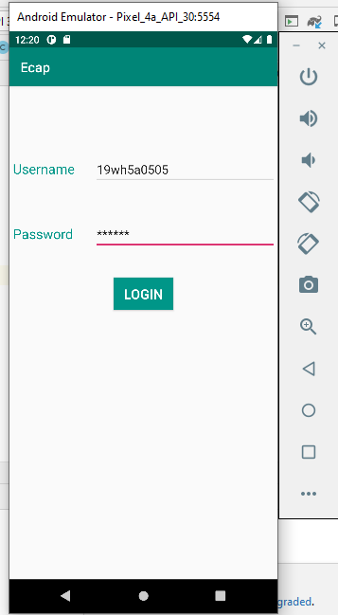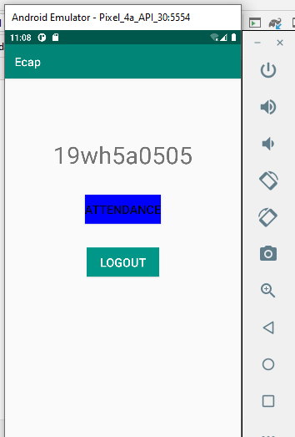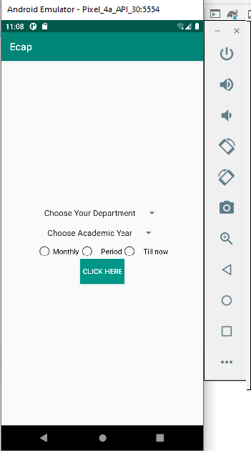

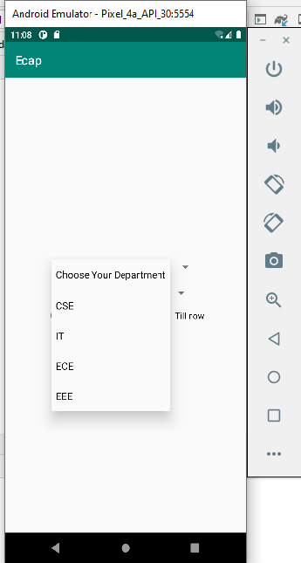

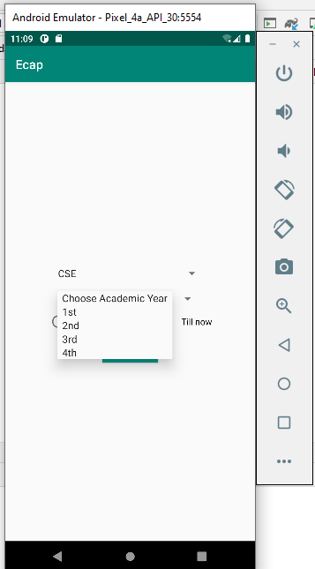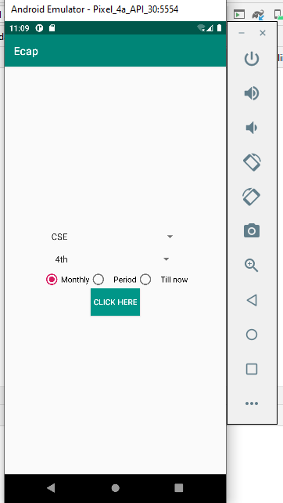

# RESULTS OF STAGE-II

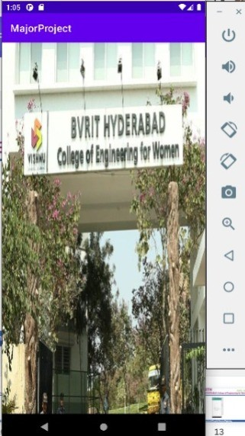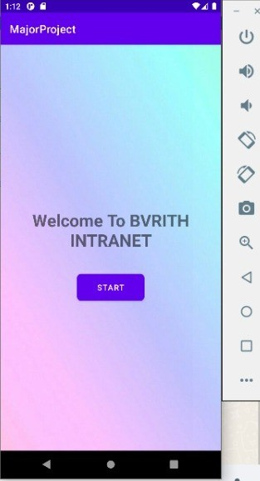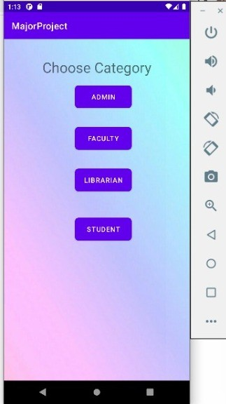

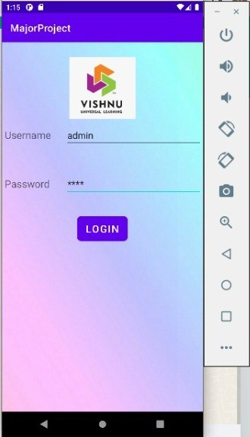 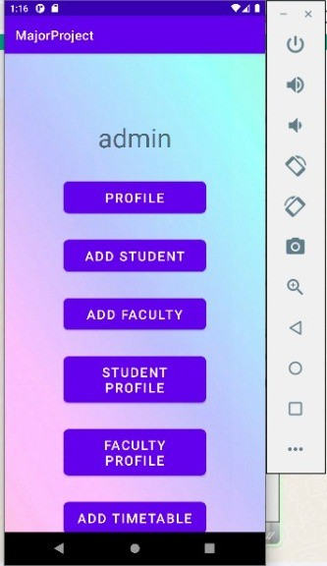 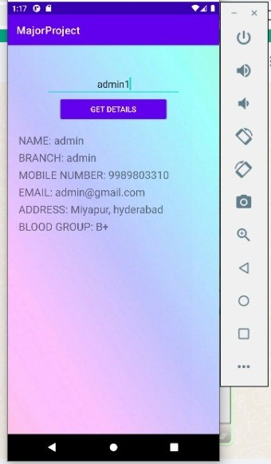

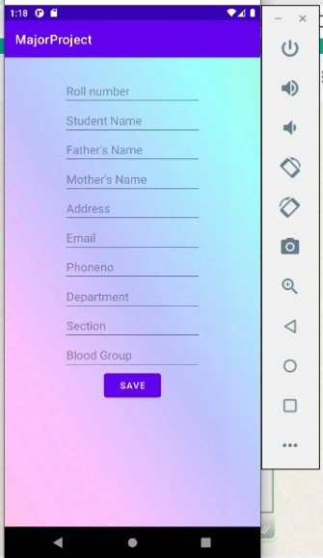 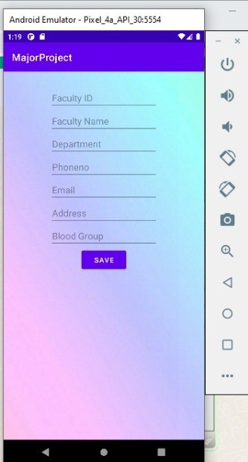 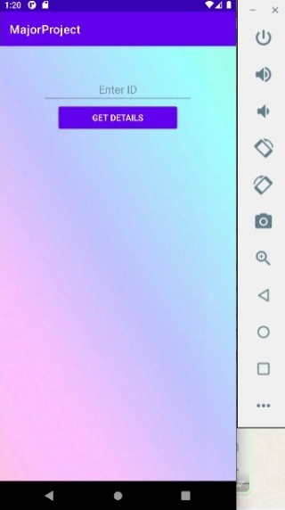

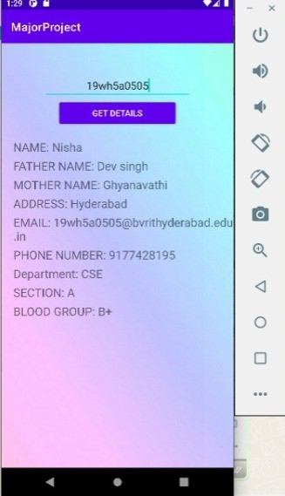 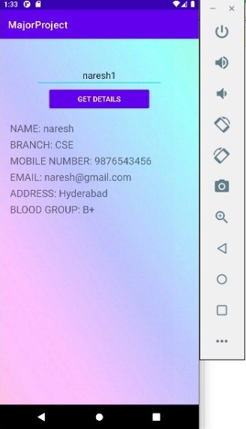 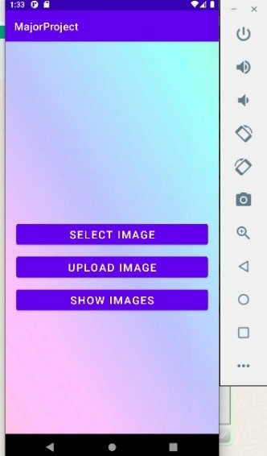

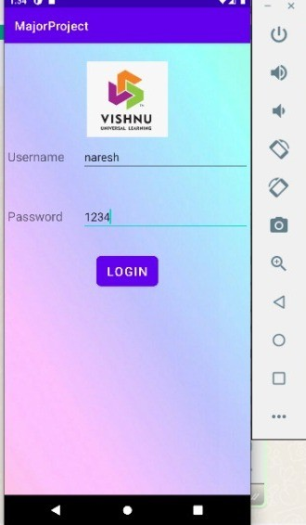 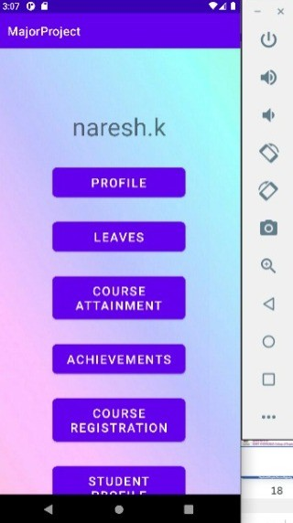 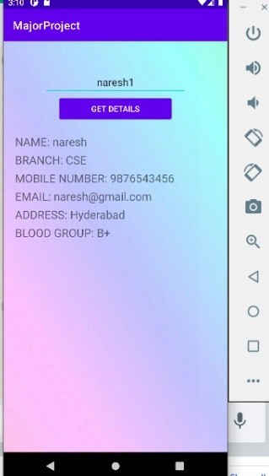

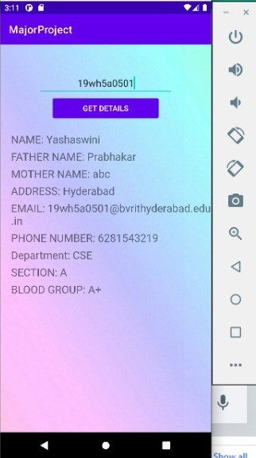 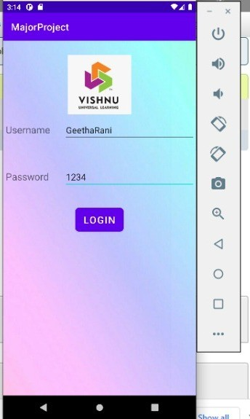 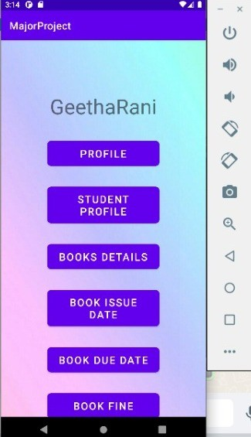

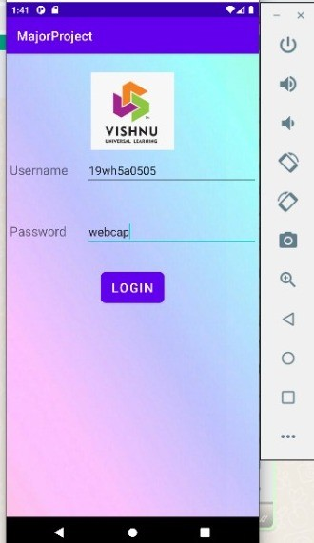 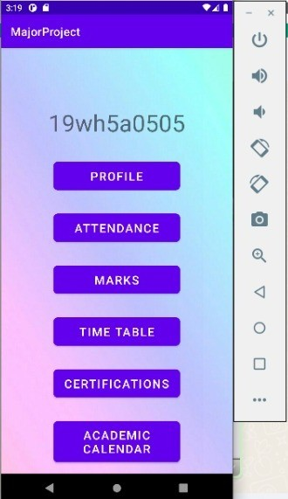 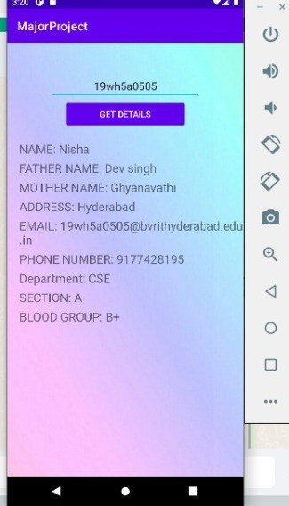

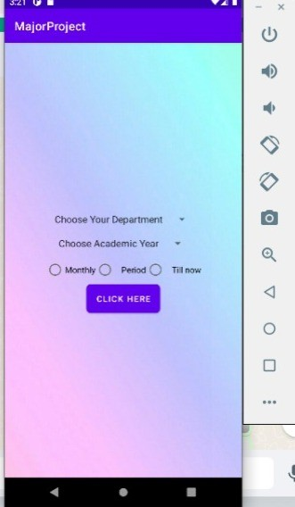 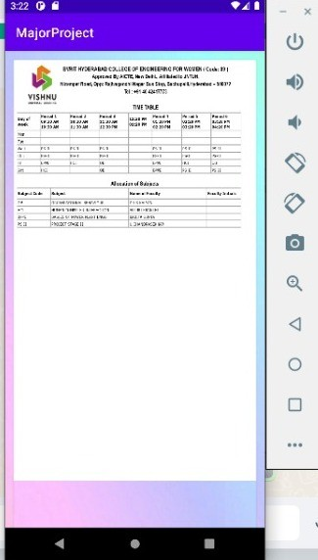 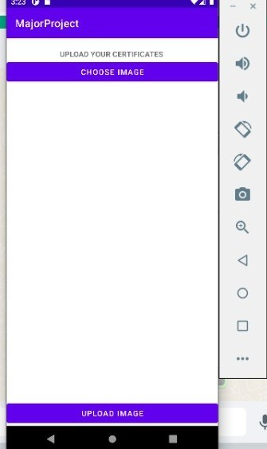

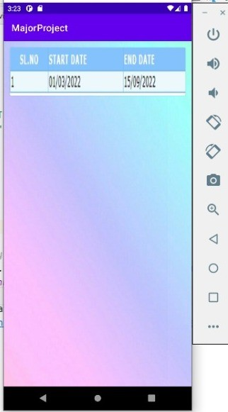 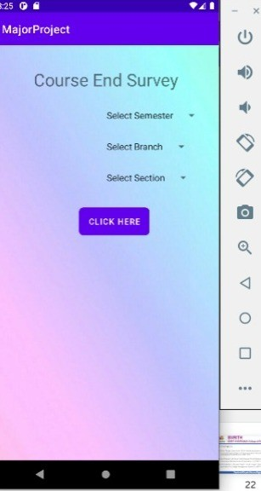 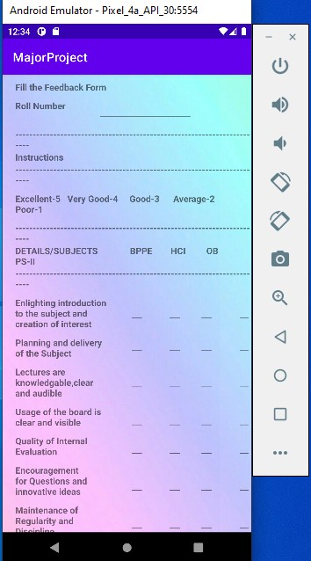

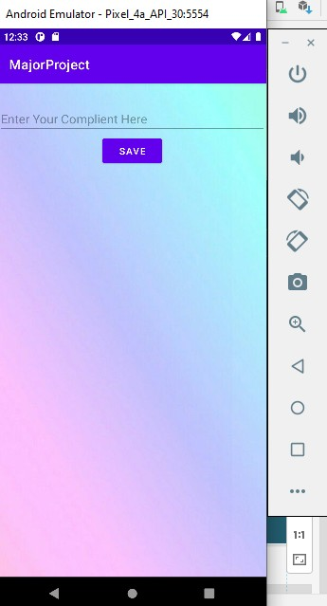 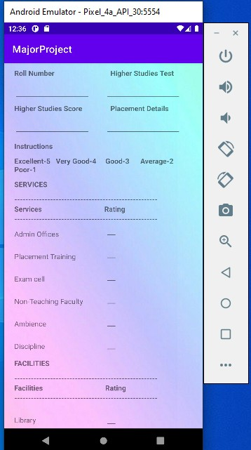 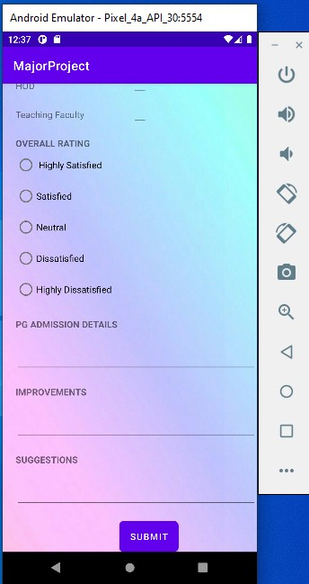

# REFERENCES

* Shilpi, Taneja., Goel, Anita. (2015). Mobile Applications in Educational Insti- tutions. Computational Intelligence Communication Technology (CICT), 2015 IEEE International Conference on. IEEE, 2015.
* Nikhlil Jadhav1 , Bhupesh Singh2 , Kunal Lunge3 , Gopi Mali 4 , Nilesh Patil, Android Application for College Management System, in IJESC Volume 6 Issue No. 12 , 2016.
* K. Vivek Thangam1 ,T. Shyam Kumar2 ,V.Yogesh kumar3 and S.Prabhu4, ANDROID APPLICATION FOR COLLEGE MANAGEMENT SYSTEM (M-INSPROPLUS),IJMTER,volume-4,issue no-2.
* Mrunmayee V. Rane;Vikram M. Apte;Vishakha N. Nerkar;Mani Roja Edinburgh;K.Y. Rajput; (2021). Automated Timetabling System for University Course . 2021 International Conference on Emerging Smart Computing and Informatics (ESCI).
* Alif Fatihi Abdul Fatah;Roslina Mohamad;Farah Yasmin Abdul Rahman;Nur'ain Izzati Shuhaimi; (2021). Student Attendance System Using An Android Based Mobile Application . 2021 IEEE 11th IEEE Symposium on Computer Applications &amp; Industrial Electronics (ISCAIE)
* S. Bhattacharya, "Blue-Droid: An Intelligent Library Management System on Android Platform," IOSR Journal of Computer Engineering (IOSR-JCE)- 2014.
* Shada, Gabriella Sekar; Ayu, Media Anugerah (2018). [IEEE 2018 International Conference on Computing, Engineering, and Design (ICCED) - Bangkok, Thailand (2018.9.6-2018.9.8)] 2018 International Conference on Computing, Engineering, and Design (ICCED) - Designing Android User Interface for University Mobile Library.
* Ankit Bansal 1,Ajit Rana 2,Akhil Bansod 3,Prafulla Baviskar 4, Mobile based campus Information Retrieval Android Application, in IJCSMC, Vol.4, Is- sue.3,March 2015
* https://sbphptricks.blogspot.com/2020/03/insert-data-into-database-using.html
* [https://www.youtube.com/w](http://www.youtube.com/watch?v=KOXwulnDfIo)atch?v=K[OXwulnDfIo](http://www.youtube.com/watch?v=KOXwulnDfIo)
* *https://www.simplifiedcoding.net/android-upload-image-using-php-mysql-android-studio/*
* *https://www.youtube.com/watch?v=D-w3WXR6ltE&t=188s*
* *https://www.youtube.com/watch?v=4e8be8xseqE&t=299s*