DARKSKY NEXUS
w033
Getting Started & Quick Start Guide
For SDRplay receivers running SDRConnect, and RTL-SDR via rtl_tcp

What is DARKSKY NEXUS?
DARKSKY NEXUS is a companion application for SDRplay receivers running SDRConnect. Install it like any other app (a .dmg on macOS, an installer on Windows) — it runs a local server in the background and opens in your browser, providing a signal intelligence interface, HF utility panel, and a suite of decoders (CW, RTTY, PSK31, NAVTEX, FT8, WSPR, ADS-B, ACARS, AIS, and more).
It can also run with an RTL-SDR dongle via rtl_tcp — no SDRConnect required in that mode.
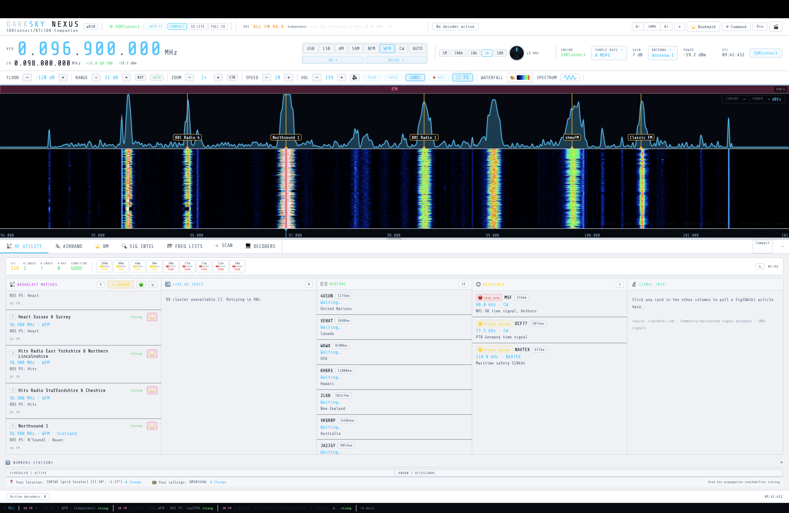
Main NEXUS dashboard — live and connected

New in w031: live decoder testing pass across Rivet, FreeDV, WSPR Beacons, CW Skimmer, and Marine/VHF turned up and fixed several real bugs (see the Troubleshooting guide). NEXUS can now also upload FT8, WSPR, and CW spots to PSK Reporter (pskreporter.info) — set your callsign and grid locator in the HF Utility tab's location bar and enable reporting there. A round of UI polish also landed: tab headings now resize to fill the tab bar, the space-weather strip spaces its groups evenly, the AIRBAND tab makes better use of wide columns, and yellow text in light theme now has proper contrast.

Also new in w031 (CW/FT8 follow-up pass): the CW tab's mini-waterfall, keying-scope digit jitter, and stuck decoded-text placeholder were all fixed, and the tab was reorganised into 3 side-by-side sub-columns with a new SKIMMER/SINGLE toggle so nothing requires scrolling to reach (Section 6.2). FT8 INTERNAL's monitor audio distortion was fixed and a MON VOL slider added for local playback volume (Section 6.6). The BW dropdown no longer renders oversized, and the FT8 SOURCE buttons now look like buttons instead of plain text. See the Troubleshooting guide for details on each.

w033 — experimental fork, not the main release: this build adds two new decoders — a native SSTV decoder (Martin M1/M2, Scottie S1/S2/DX; Robot 36/72 detected but not yet decoded) and an rtl_433 ISM-band sensor engine (TPMS, weather stations, smart meters) — plus a second AIS front end (a Dire Wolf-derived decoder that runs alongside the existing one and merges results by MMSI) and a redesigned DECODERS dropdown that now matches the BANDS dropdown's category-tab-and-button-grid layout. w032 remains the main, stable release; w033 is a scoped fork for testing these additions before any of them are considered for w032. See the Troubleshooting guide and User Manual for details, including several real bugs found and fixed during this pass (an AIS status badge that didn't sync on reconnect, a slow memory leak in SSTV that froze the waterfall, a bookmark popup that could close while editing, and FT8 INTERNAL producing zero decodes in Full IQ mode).

Installing DARKSKY NEXUS
NEXUS is distributed as a ready-to-run app — most users never need Python, pip, or any command line. Download the installer for your platform, install it, and launch it like any other app.

macOS
- Download DARKSKY_NEXUS_w033_macOS.dmg.
- Open the .dmg and drag DARKSKY NEXUS w033 macOS into your Applications folder.
- First launch only: the app isn't code-signed/notarized, so Gatekeeper will warn it's from an unidentified developer. Right-click (Control-click) the app in Applications, choose Open, then confirm in the dialog. This one-time step isn't needed again after the first launch.
- NEXUS starts its local server and opens automatically in Chrome (or your default browser if Chrome isn't installed) at http://127.0.0.1:8888 — no separate file to open.

Windows
- Download DARKSKY_NEXUS_w033_Setup.exe.
- Run it and follow the installer. It installs per-user by default (no administrator rights required) and adds a DARKSKY NEXUS w033 shortcut to the Start Menu.
- First launch only: the installer isn't code-signed, so Windows SmartScreen may show "Windows protected your PC". Click More info, then Run anyway. This one-time step isn't needed again after the first launch.
- Launch DARKSKY NEXUS w033 from the Start Menu. NEXUS starts its local server and opens automatically in Chrome (or your default browser) at http://127.0.0.1:8888.

Then: start NEXUS before SDRConnect
Important — launch order: start NEXUS before SDRConnect. NEXUS will idle, waiting for SDRConnect's WebSocket on port 5454 (status shows OFFLINE until it connects) — this is normal. Launching SDRConnect first and interacting with it while it's still settling can cause it to fall back to its own "choose an IQ file" prompt instead of using your SDRplay hardware. Starting NEXUS first avoids this, since SDRConnect then gets a clean, undisturbed startup.

Then: start SDRConnect
With NEXUS already running and idling (OFFLINE status), launch SDRConnect and let it start up undisturbed. Connect your SDRplay receiver and confirm it's streaming (spectrum/waterfall moving in SDRConnect). NEXUS will connect automatically once SDRConnect's device session is live, and the status will switch to SDRConnect (green).
For a remote SDRConnect server (on another machine on your network), see "Command-Line Options" below for --sdr.
For SDRplay nRSP-ST/RSPdx devices, NEXUS now auto-selects Full IQ stream mode on connect (changed in w0.2.3 — see "IQ Lite vs Full IQ" below for why).
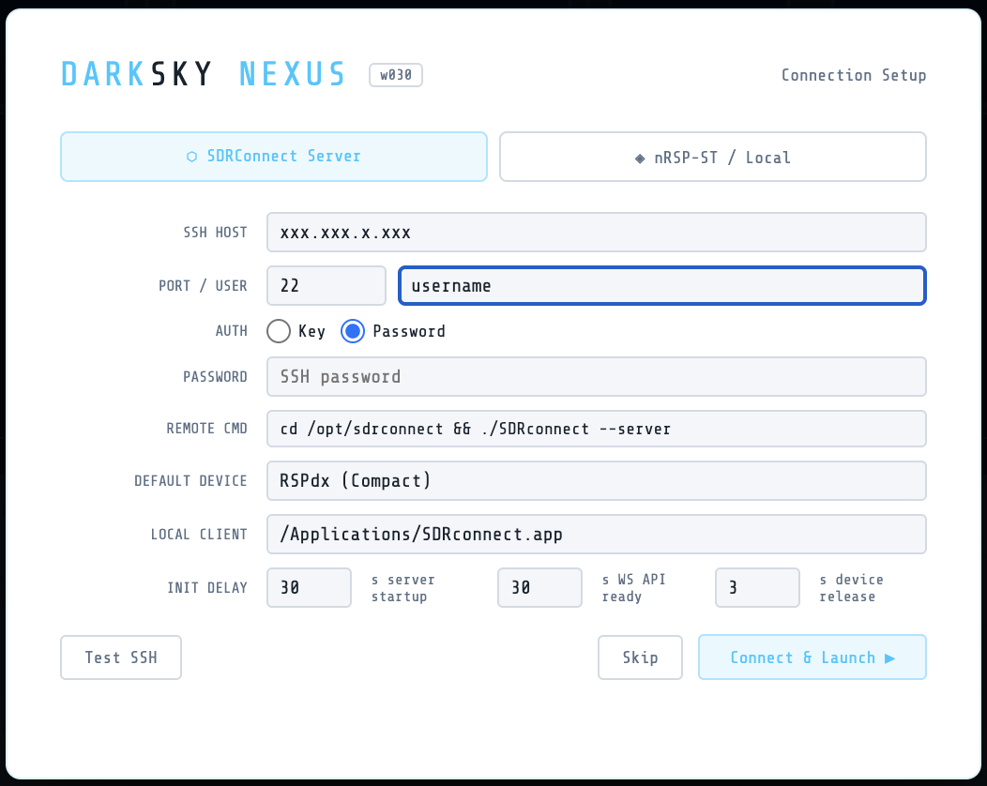
Connection Setup — SDRConnect Server mode
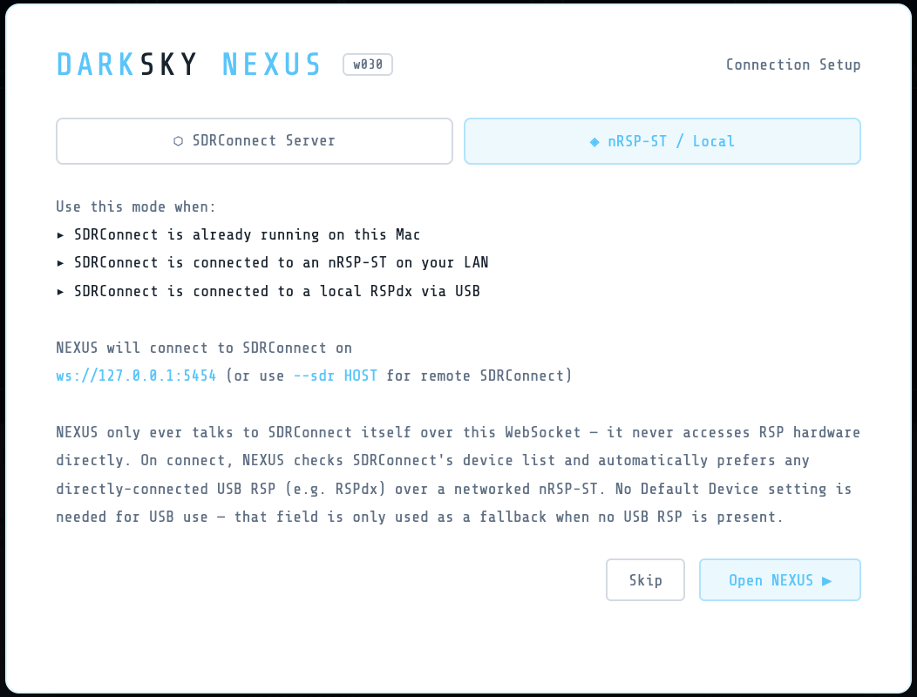
Connection Setup — nRSP-ST / Local mode

Running everything on one computer (recommended / default)
The default setup — and the one to use unless you have a specific reason not to — is NEXUS, SDRConnect, and (if you use FT8/WSPR) WSJT-X all running on the same Windows/macOS/Linux PC that your SDRplay receiver is physically plugged into. This is what NEXUS assumes with no --sdr flag (it talks to SDRConnect on 127.0.0.1:5454), and it's the only configuration where every feature works, since some integrations — notably FT8/WSPR decode display — read local files/processes on the same machine rather than over the network. The --sdr <IP> remote option (see "Command-Line Options" below) and the SSH Launcher exist for advanced setups (e.g. a separate "RF box" headless machine next to the antenna, controlled from a laptop elsewhere) — they're optional, not required, and not the right starting point for a first install.
For an all-in-one-PC setup, suggested launch order: NEXUS → SDRConnect → WSJT-X (if using FT8/WSPR) → start the FT8/WSPR decoder panel in NEXUS last, after WSJT-X is already open. See section 6.6 in the User Manual and the Troubleshooting guide's FT8/WSPR entry for how NEXUS and WSJT-X actually communicate (it's two separate one-way channels, not a single link).

Requirements

To use NEXUS
- SDRConnect running locally (for SDRplay) or rtl_tcp running (for RTL-SDR)
- Google Chrome (recommended) or any modern browser
That's it — the installer above bundles everything else NEXUS itself needs. Python and its packages are only relevant if you're building NEXUS from source (see below).

Optional external tools (decoders)
Tool | Decoder | Install
fldigi | CW, RTTY, PSK31, NAVTEX | https://www.w1hkj.com
dump1090 / readsb | ADS-B | brew install readsb (macOS)
dumphfdl | HFDL | https://github.com/szpajder/dumphfdl
dumpvdl2 | VDL2 | https://github.com/szpajder/dumpvdl2
multimon-ng | POCSAG, FLEX, DTMF | brew install multimon-ng (macOS)
wsprd | WSPR | Part of WSJT-X install
DSD+ | Digital Voice | https://www.dsdplus.com
codec2 (freedv_rx) | FreeDV HF Digital Voice | https://github.com/drowe67/codec2 (build from source)
BlackHole / VB-Audio | Virtual audio (fldigi) | https://existential.audio/blackhole

Note: the Numbers-Station / HF-Intel (Rivet) decoder needs no external tool — it's a clean-room NEXUS-native decoder with nothing to install.

Building & Running from Source (developers)
Skip this section unless you specifically want to run or modify NEXUS's Python source directly instead of using the installer above — most users don't need to.

Requirements
- Python 3.9 or later

Python packages (required)
numpy
websockets

Python packages (optional but recommended)
scipy — better audio demodulation filters
sounddevice — audio output from RTL-SDR path
paramiko — SSH Launcher (remote SDRConnect)
Install all at once:
pip install numpy websockets scipy sounddevice paramiko
On macOS with Homebrew Python:
pip3 install numpy websockets scipy sounddevice paramiko
Place these files in the same folder:
w033_NEXUS.py
DARKSKY_NEXUS_w033.html
eibi.csv (auto-downloaded on first run if missing)
airports.csv (auto-downloaded on first run if missing)
airport-frequencies.csv (auto-downloaded on first run if missing)
darksky_bookmarks.json (auto-created on first run)
Local SDRConnect (default):
python3 w033_NEXUS.py
Remote SDRConnect:
python3 w033_NEXUS.py --sdr 192.168.1.xx
RTL-SDR via rtl_tcp:
Start rtl_tcp first:
rtl_tcp -a 127.0.0.1
Then:
python3 w033_NEXUS.py --rtl 127.0.0.1
NEXUS will open Chrome automatically at http://127.0.0.1:8888. If Chrome is not found it falls back to your default browser.
The build/ folder's build_macOS.sh and build_Windows.bat scripts are what produce the .dmg and installer .exe described in "Installing DARKSKY NEXUS" above, if you want to package your own build.

IQ Lite vs Full IQ (changed in w0.2.3)
Earlier builds defaulted SDRplay nRSP-ST/RSPdx devices to IQ Lite mode, on the assumption that it provided a lower-bandwidth raw IQ stream suitable for decoders. Direct testing against SDRplay's own reference client confirmed this was never the case: IQ Lite and Compact modes never deliver raw IQ frames on the nRSP-ST — they exist only for demodulated/decoder-rate audio streaming, not IQ. This was confirmed both empirically (packet capture) and directly by SDRplay support.
As of w0.2.3:
- Full IQ is now the default stream mode for SDRplay devices. Direct testing sustained 2 MSps Full IQ over Wi-Fi cleanly with zero dropped frames, so the earlier "bandwidth too limited for Full IQ" assumption no longer holds.
- The IQ LITE+ decoder category has been removed from the Decoders dropdown. WEFAX (previously listed there) now appears under FULL IQ, alongside ACARS, POCSAG, and AIS — all of these genuinely require raw IQ and will not work in Compact mode.
- If you notice any IQ-dependent decoder or audio path behaving unexpectedly, confirm SDRConnect's stream mode is set to Full IQ (status bar, top of waterfall) — Compact mode never carries IQ, by design, not by bug.

First Use Walkthrough

1. Check connection status
The top-right corner shows connection status. Look for SDRConnect (green) when connected to an SDRplay receiver, or RTL-SDR when using rtl_tcp.

2. Set your frequency
Click the large VFO frequency display and type a frequency, or click on the waterfall to tune. The VFO shows the signal frequency; the LO line beneath it shows the hardware centre.

3. Choose a mode
The mode buttons (USB / LSB / AM / SAM / NFM / WFM / CW / AUTO) sit above the waterfall. Click to change.

4. Adjust the waterfall
- FLOOR — sets the noise floor (lower = more sensitive, more noise)
- RANGE — sets the dynamic range (how many dB are displayed)
- ZOOM — zooms the waterfall in/out
- CTR — recentres the visible span on your tuned VFO frequency (w0.2.6) — handy if the signal has drifted to the edge
- SPEED — waterfall scroll speed
- Drag the resize handle below the waterfall to give more space to the decoder panels
- Use the A− / 100% / A+ control in the top bar (w0.2.6) if the whole UI is too small to read comfortably

4a. Sample rate / display span and antenna (SDRplay nRSP-ST / RSPdx)
The SAMPLE RATE control in the status bar opens a dropdown of available rates, and in Full IQ mode (the default — see above) this sets the actual hardware sample rate.
If your SDRplay device has multiple antenna ports (e.g. nRSP-ST/RSPdx Antenna A/B/C), an ANTENNA control appears next to GAIN in the status bar. Click it to switch input ports without leaving NEXUS. It only appears once SDRConnect reports available antennas for your connected device.

5. Explore decoders
Click DECODERS in the tab bar and select a decoder. Decoder categories (COMPACT / FULL IQ / EXTERNAL) are collapsible — click a category header to expand or collapse it. For fldigi-based decoders (CW, RTTY, PSK31, NAVTEX), choose NEXUS engine (internal) or FLDIGI engine (requires fldigi running with virtual audio).
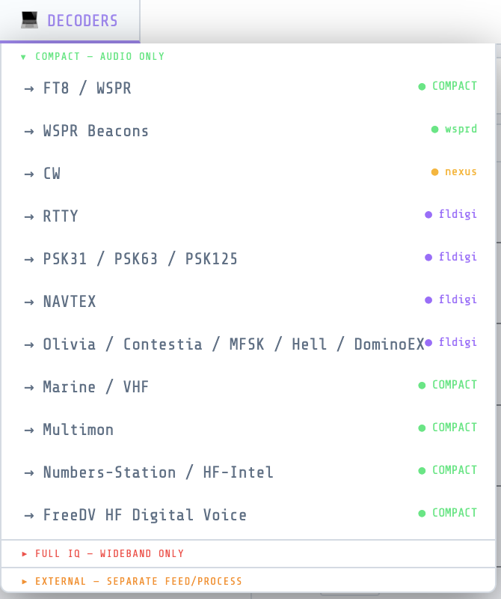
DECODERS dropdown — COMPACT (audio only) category
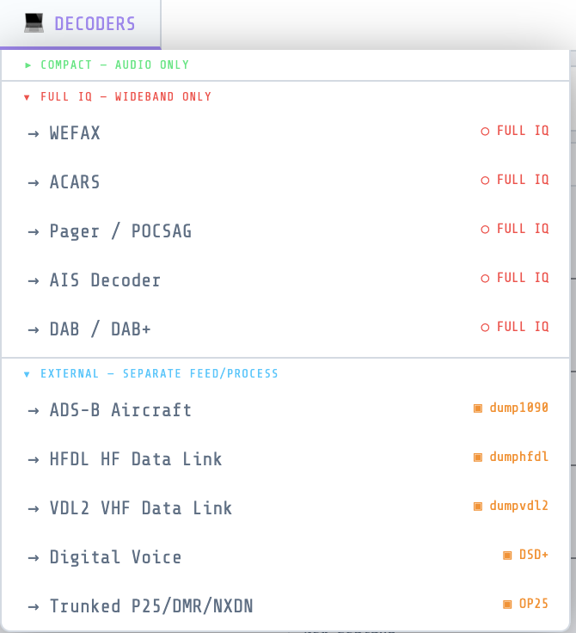
DECODERS dropdown — FULL IQ and EXTERNAL categories

Two COMPACT decoders worth a quick look:
- Numbers-Station / HF-Intel (Rivet) — tune to a DSC or Baudot numbers-station frequency (use the Quick Tune buttons in the tab), pick DSC or Baudot mode, click Start. No external tool needed.
- FreeDV HF Digital Voice — tune to an active FreeDV signal, pick the matching mode (1600/700C/700D/700E/2400A/2400B/800XA), click Start. Audio plays through your browser speakers. Requires freedv_rx (from codec2) on your PATH — see Requirements above.

6. HF Utility tab
The HF UTILITY tab shows space weather, band conditions, DX spots, and an EIBI signal lookup. Click any signal label on the waterfall to look it up automatically.

7. Import your own frequency lists
The 📂 FREQ LISTS tab is where your own frequency data lives, separate from the built-in EIBI/SigID database. Drop a CSV, TXT, or XLSX file onto the tab (or use its file picker) to import your own list — a monitoring log, a club's band plan, a utility-station list, anything with a frequency column.
- Accepted columns (case-insensitive, any order): a frequency column (header containing "freq", "khz", or "mhz"), plus optional name/station, mode, language, time/UTC, and site columns. SwSKEDS format (from Roger Need's shortwave schedule tool) is also recognised — its 'On'/'Off' time columns are parsed automatically.
- Frequencies are auto-detected as kHz or MHz based on header text and magnitude.
- On import you're asked for a list name and a region tag (e.g. "Colorado", or "Global" for worldwide lists) — this drives a colour badge showing whether the list matches your current location. Lists are flagged, never hidden, if they don't match.
- Imported lists are saved in your browser (localStorage) and persist between sessions.
- Entries show up alongside EIBI/SigID results in SIG INTEL and SW SCHEDULE lookups, tagged CUSTOM, whenever the tuned frequency is within 5 kHz of one of your entries.
- The tab itself gives you a searchable table of every entry across all lists, with click-to-tune, per-list visibility toggle, colour tag, and delete.
- Filters (w0.2.6): use Near VFO to show only entries within 5 kHz of your current tuned frequency (auto-refreshes as you tune), On Now to filter to entries currently on-air by UTC time, All Languages to filter by language, and All Sources to filter by list name. Note: On Now requires your list to have time data — if it does nothing, your list's time column wasn't detected on import (see the Troubleshooting guide).
- The Airband tab's FM Nearby panel also uses this data: if the live FM station lookup doesn't respond, it falls back to FM-band (87.5–108 MHz) entries from your imported lists instead of hanging on "Looking up...". If you see a message there suggesting you import a list, this is the tab to do it from.
- See a wrong frequency in the Airband tab's Nearby Airports list? Click the ✎ next to it to correct it (or hide it) — your fix is remembered locally and re-applied automatically going forward.
- The Airband tab's VOLMET list now covers VHF stations across Europe/UK plus HF stations worldwide (Americas, Asia/Pacific) — VHF VOLMET is a European/UK-only service in real life, so HF is how the rest of the world gets it.
- To bookmark whatever frequency you're currently tuned to, click the ⭐ Bookmark button on the top command row — no need to hunt for a per-row button. A popup opens prefilled with the best match it can find (from your Frequency Lists, Nearby Airports data, or the SigID database); edit anything before saving.

8. Scan a band automatically
The ⟳ SCAN tab steps the VFO across a frequency range and flags anything above an SNR threshold. Set From/To/Step/Dwell/SNR/Mode, press Start, and it'll pause on each hit so you can listen — click any hit in the log to tune to it. The spectrum and waterfall stay visible above the tab the whole time.

Ports Used
Port | Purpose
8888 | HTTP — serves the NEXUS UI to your browser
8889 | WebSocket — browser ↔ Python bridge
5454 | SDRConnect WebSocket (inbound from SDRConnect)
7362 | fldigi XML-RPC (outbound to fldigi)
4532 | Hamlib NET rigctld (WSJT-X / fldigi CAT)
8080 / 8754 | dump1090-fa / readsb ADS-B JSON feed (aircraft.json, tries 8080 then 8754)
30003 | dump1090 SBS BaseStation fallback (text, ADS-B)
5556 | dumphfdl JSON output
5557 | dumpvdl2 JSON output

All ports are localhost only by default.

Command-Line Options
Only needed for a remote SDRConnect server or a non-default rtl_tcp host — the default install (NEXUS and SDRConnect on the same machine) needs none of these. If you're running from source:
python3 w033_NEXUS.py [options]

--sdr HOST[:PORT] SDRConnect WebSocket host (default: 127.0.0.1:5454)
--rtl HOST[:PORT] rtl_tcp host (default: 127.0.0.1:1234)

Quick Tips
- Shift+Scroll on the waterfall adjusts the noise floor
- Ctrl+Scroll adjusts zoom
- Right-click the waterfall or spectrum to save a bookmark; click a bookmark label on the spectrum to tune to it
- Drag the resize handle between waterfall and panels to resize
- Press F5 (or Cmd+Shift+R on macOS) to force-reload if UI looks stale after an update
- EIBI schedule is auto-downloaded on first run; click Refresh EIBI in SIG INTEL to update
- SDRplay devices default to Full IQ stream mode (changed in w0.2.3) — IQ Lite/Compact never carry raw IQ, by design
- Decoder categories in the DECODERS dropdown are collapsible — click a category header to expand/collapse it
- The ANTENNA control (status bar) only appears for devices with multiple antenna ports and switchable inputs reported by SDRConnect
- Text too small? Use the A− / 100% / A+ UI size control in the top bar (added in w0.2.6) to scale the whole app from 80% up to 160%. Your setting is remembered across launches. (Browser zoom — Ctrl/Cmd + Plus/Minus — still works too, but the in-app control is the recommended way now.)
- Signal stuck at the left/right edge of the waterfall? Click CTR next to the ZOOM controls (added in w0.2.6) to recentre the visible span on your tuned frequency — works at any zoom level and doesn't retune the radio.
- Freq Lists On Now filter does nothing? Your list's time column wasn't detected on import (common with SwSKEDS format on older builds). Delete and re-import the list — the parser now correctly handles SwSKEDS 'On'/'Off' time columns.
- Bookmark popup closed when you were typing in it? Fixed in w0.2.6 — keyboard shortcuts are now suppressed while any input field is focused. Enter saves the bookmark; Escape cancels.
- Want to decode FT8/FT4 without installing WSJT-X? New in w030 — switch FT8 SOURCE to INTERNAL on the FT8/WSPR tab. It's a native in-browser decoder; click ▶ Start and you're done, no other setup. See the User Manual section 6.6 for details, including the propagation map's band-colour markers, multi-band persistence, and map style picker.
- Want your FT8/WSPR/CW spots on PSK Reporter? New in w031 — set your callsign and grid locator in the HF Utility tab's location bar and turn on reporting. Spots upload automatically in the background as your decoders find them; no separate program to run. See the User Manual's PSK Reporter section for details.
- Want to receive weather-fax-style images off the air? New in w033 (SSTV) — tune to an SSTV transmission, open the SSTV tab, and the image builds line-by-line as it's decoded. No external program needed.
- Want to see nearby TPMS/weather-station/smart-meter ISM sensors? New in w033 (rtl_433) — open the rtl_433 tab from the DECODERS dropdown for a live table of readings as they're received.
- DECODERS dropdown looks different? Redesigned in w033 to match the BANDS dropdown — pick a category tab (Compact / Full IQ / External), then click a decoder's button to open its tab, same as picking a band.
- Want to keep a logbook? New in w033 — the 📒 REPORTING tab is a general SWL logbook, not just FT8/ham QSOs. Press Ctrl+N anywhere to log a new entry, or click ⭳ Populate from FT8 to pull in FT8 decodes automatically (with country, band, distance, and bearing worked out for you). Export to ADIF or CSV any time. See User Manual Section 9a for the full feature list.

