**MODEL BRD**

1. **Model Screen**

The model screen will resemble the attached wireframe, with Refresh, Upload, and Execute buttons in the top bar, and the body displaying information for all uploaded models.

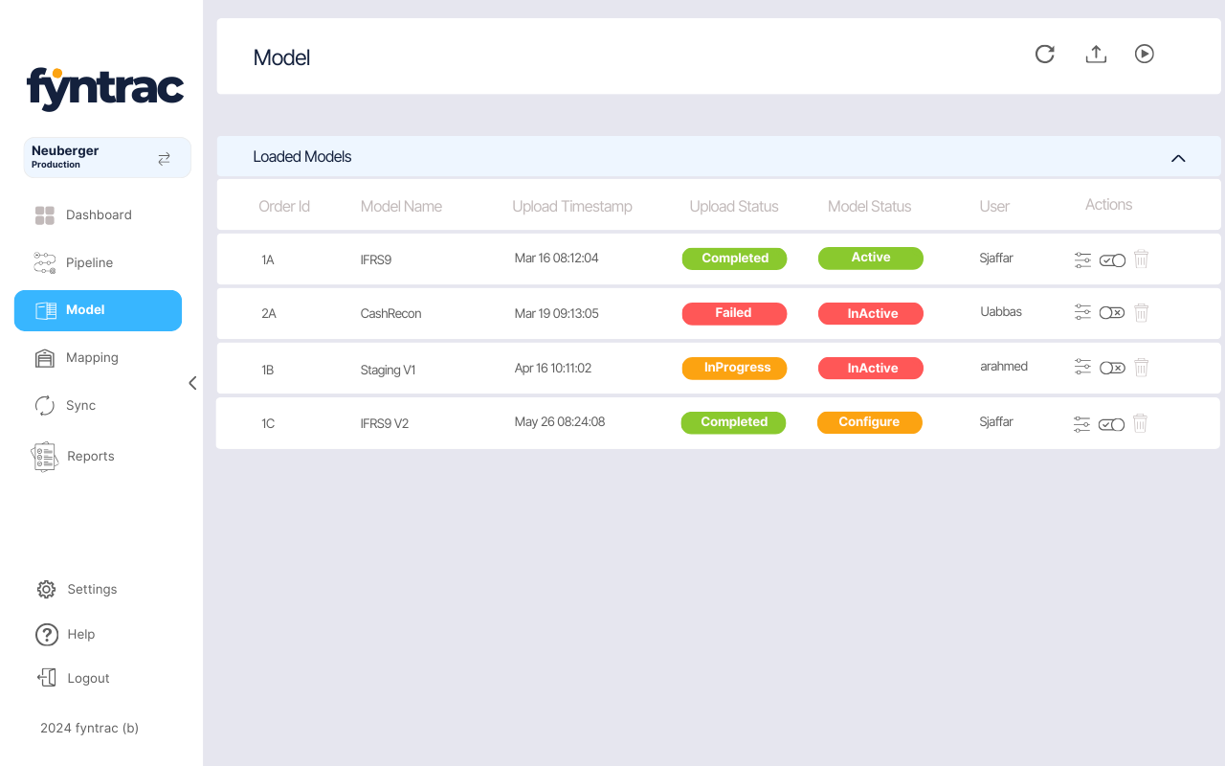

1. **Model Upload**

Users can upload a model by clicking the second icon on the top bar (Upload Button). Upon clicking the icon, a popup will appear where the user needs to provide the following details:

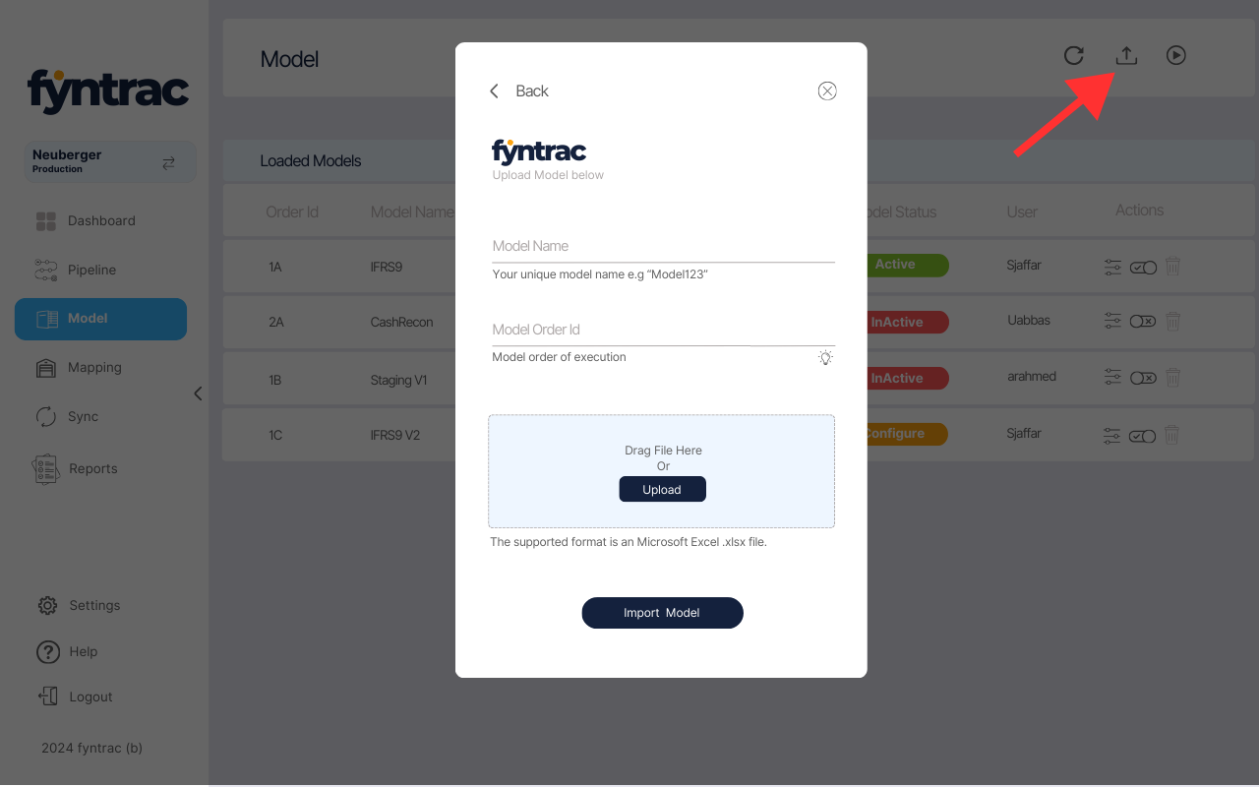

* **Model Name**: A unique name for the model. Duplicate names are not allowed. If a name already exists, the system will display an error message: *"The Model Name is already used."*
* **Model Order ID**:  
  Users can upload multiple models, which can be arranged either **horizontally** or **vertically**. This ID should be unique for each model **Active** ( Two models can have same Order ID only in a situation where model status for only one of them is **Active**)
  + **Horizontal Model Order**: In this arrangement, models are loaded sequentially. The first model processes data from the Transaction History, Instrument Attribute History, and Aggregation tables, performs calculations, and appends the new data back to these tables. A second model, set up horizontally, will then use this updated data and perform its own calculations. Multiple models can be executed one after another in this manner.
  + **Vertical Model Order**: In this arrangement, two or more models run in parallel, each using the Transaction History, Instrument Attribute History, or Aggregation tables. Each model performs its calculations and appends the results to the relevant tables, which can later be used by horizontally arranged models.

**2.1 Defining the Order ID:**

* **Vertical Models**: Use numeric identifiers (1, 2, 3, etc.).
* **Horizontal Models**: Use alphabetical identifiers (A, B, C, etc.).

For example:

* The first model would have the order ID **1A**. (Always be **1A**)
* If a horizontal model is added next, its ID would be **1B**, and the following one would be **1C**.
* If a vertical model is added after the first horizontal model (1A), its order ID would be **2A**.

This system helps organize and define the order of model execution.

**Model Upload**: Users can upload a Microsoft Excel file as a model. They can either drag the file onto the screen or browse their machine by clicking the upload button. Once the file is selected, the file name with its extension will appear in the "Drag and Drop" box.

1. **Loaded Models Table**

The model screen will display a table containing all uploaded models and their relevant information, including:



* **Order ID**: As discussed earlier, this ID helps organize and define the execution order of the models.
* **Model Name**: The unique name assigned to each uploaded model.
* **Upload Timestamp**: The date and time when the model was uploaded.
* **Upload Status**: Indicates the status of the upload, with possible values: *In Progress*, *Completed*, or *Failed*.
* **Model Status**: The model can be activated or deactivated using the toggle button in the "Action" column. If a model is inactive, it will not be included in execution during model runs. Possible values: *active, inactive, configure (will be discussed under configure model paragraph)*
* **User**: The username of the person who uploaded the model.
* **Action**: The "Action" column contains three buttons:
  + **Configure**: Allows the user to configure the model by specifying what data should be fed into it.
  + **Activation Toggle**: Used to activate or deactivate the model.
  + **Delete**: Deletes the model, but only if no execution has been performed. If an execution has occurred (check the execution table), the delete button will be grayed out.

1. **Configure Model:**

After a model is uploaded, its status will initially be set to **"Configure."** The status will change to **"Active"** only after the user configures the model. To configure the model, the user can click the "Configure" button (the first button) in the "Action" column of the Loaded Models table. Upon clicking, the following popup will appear:

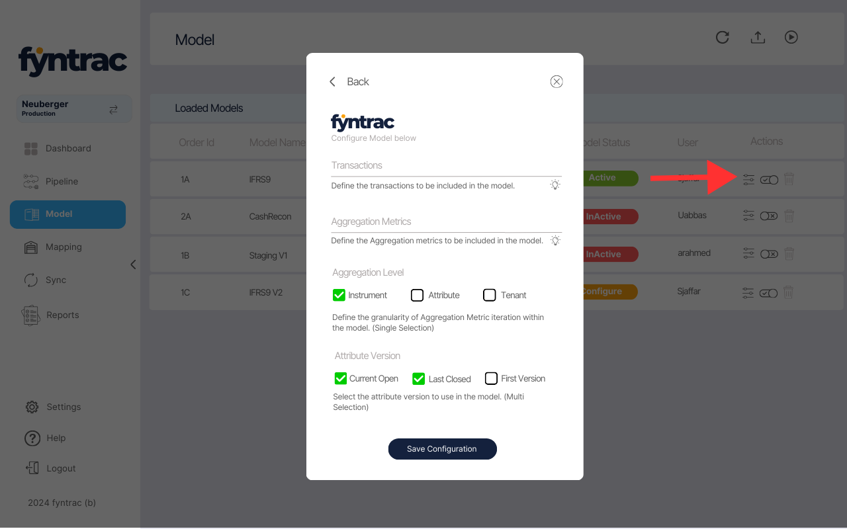

* **Transactions**: Users must specify the transaction names to be used in the model. The values are case-sensitive. The correct format is to enclose the names in curly brackets {}, separating each with a comma, e.g., *{Transaction1,Transaction2,Transaction3}.*
* **Aggregation Metrics**: Users must specify the aggregation metric names to be used in the model. The values are case-sensitive. The correct format is to enclose the metric names in curly brackets {}, separating each with a comma, e.g., *{Metric1,Metric2,Metric3}.*
* **Aggregation Level**: Users must define the level at which the aggregation metrics (mentioned above) should be pushed into the model. Only one selection is allowed, with the options being instrument, attribute, or tenant level.
* **Attribute Version**: Users can also include instrument attribute history in the model. To choose which version to push, the user can select checkboxes (multiple selections allowed). If Current Open is selected, the system will push the current version into the model. If Last Closed is selected, the system will push the last closed version (i.e., the current open version -1). If First is selected, the first version of the instrument and attribute will be pushed into the model.

Once all the required information is provided, the user can click the Save Configuration button to save the settings.

1. **Executing Models:**

Users can execute the models by clicking the play button on the top bar. Once clicked, a popup will appear on the screen.

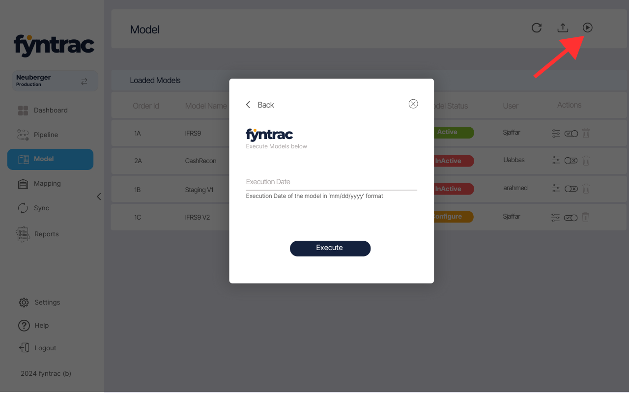

Users need to provide the execution date in the 'mm/dd/yyyy' format and click the Execute button to run the models.

**Execution Logic**:

* Execution Date should always be > the last Execution date unless you are executing for the first time. System should Create a table where all execution dates along with its respective accounting period will be saved.
* **Transactions**: The system will only push data from the transaction history table into the model where the execution date matches the transaction date in the transaction table (only for transactions selected in the model configuration).
* **Aggregation Metrics**: The system will only push data from the aggregation table into the model where the execution date's accounting period matches the aggregation accounting period (only for the metrics and level selected in the model configuration).

Note: Refer to the excel file for Model Inputs and Output