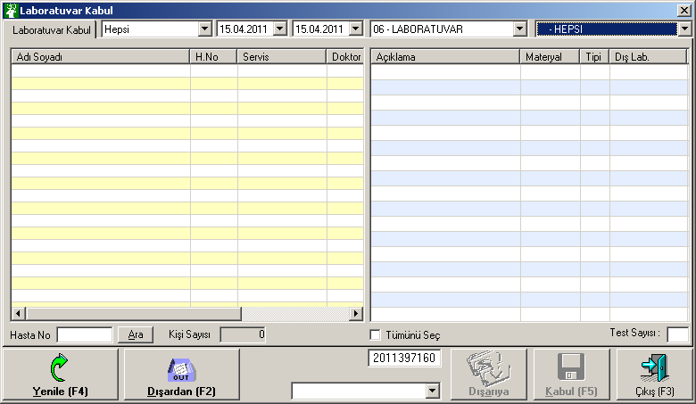

**LOAD**

select SLT from TIPDATA.dbo.KEYDAT where SLK='00' and SLB='LABRDYGRMZ'

SELECT SLT FROM TIPDATA.dbo.KEYDAT WHERE SLK='00' AND SLB='LRKGOR'

select SLT from TIPDATA.dbo.KEYDAT where SLK='00' and SLB='LABKABULNO'

select SLB, SLT from TIPDATA.dbo.KEYDAT where SLK='01' and SLX=1 order by SLB

select SLB, SLT from TIPDATA.dbo.KEYDAT where SLK='30' and SLB like '06%' order by SLB

SELECT SLT FROM TIPDATA.dbo.KEYDAT WHERE SLK='00' AND SLB='LRKGOR'

select SLT from TIPDATA.dbo.KEYDAT where SLK='00' and SLB='LABKABULNO'

select KNR, ADI1 from TIPDATA.dbo.DISMERKEZLER where TIPI='L' order by ADI1

**YENİLE**

SELECT SLT FROM TIPDATA.dbo.KEYDAT WHERE SLK='00' AND SLB='LRKGOR'

select SLT from TIPDATA.dbo.KEYDAT where SLK='00' and SLB='LABKABULNO'

**KABUL**

SELECT SLT FROM TIPDATA.dbo.KEYDAT WHERE SLK='00' AND SLB='LABBARKOD'

select SLT from TIPDATA.dbo.KEYDAT where SLK='25' and SLB='LABKABULNO'

select SLT from TIPDATA.dbo.KEYDAT where SLK='00' and SLB='LABKABULNO'

UPDATE TIPDATA.dbo.LBISTE set KABUL='1',KABUL_ID='AYDIN SAKAR', KABUL_TARIH = '22.09.2011 11:06:50', KABUL_NO='2011431018' where KNR='185648' and SNR='995' and TANIM='06' and GRUP='006' and CODE='9008' and TARIH = '22.09.2009 11:06:48'

SELECT ORNEK_TARIHI FROM LBISTE WHERE KNR='185648' and SNR='995' and TANIM='06' and GRUP='006' and CODE='9008' and TARIH = '22.09.2009 11:06:48'

UPDATE LBISTE SET ORNEK_TARIHI='22.09.2011 11:06:50' WHERE KNR='185648' and SNR='995' and TANIM='06' and GRUP='006' and CODE='9008' and TARIH = '22.09.2009 11:06:48'

select SLT from TIPDATA.dbo.KEYDAT where SLK='00' and SLB='LABBRCDBAS'

select SLT from TIPDATA.dbo.KEYDAT where SLK='00' and SLB='LABSAYAC'

select SLT from TIPDATA.dbo.KEYDAT where SLK='17' and SLB='AL'

select SLT from TIPDATA.dbo.KEYDAT where SLK='07' and SLB='0010'

select SLT from TIPDATA.dbo.KEYDAT where SLK='17' and SLB='U2'

select SLT from TIPDATA.dbo.KEYDAT where SLK='07' and SLB='0111'

SELECT SLT FROM TIPDATA.dbo.KEYDAT WHERE SLK='00' AND SLB='LRKGOR'

select SLT from TIPDATA.dbo.KEYDAT where SLK='00' and SLB='LABKABULNO'

**ARA**

SELECT L.TANIM, L.GRUP, L.CODE, H.NAME1, H.MATERYAL, H.LABTIPI, L.TARIH, L.TOOLTIPTEXT, HZ.SIRANO, HZ.SATISF+HZ.KSATISF as SATISF FROM LBISTE L, HIZMET H, HIZIL HZ, BEHAND B where H.TANIM=L.TANIM and H.GRUP=L.GRUP and H.CODE=L.CODE and HZ.KNR=L.KNR and HZ.SNR=L.SNR and HZ.KNR=B.KNR and HZ.SNR=B.SNR and HZ.TANIM=L.TANIM and HZ.GRUP=L.GRUP and HZ.CODE=L.CODE and HZ.TARIH=L.TARIH and ( ((B.AMBU='P' and (HZ.SATISF>0 and (HZ.LRGOR IS NOT NULL OR HZ.MAKNO is not null)) or HZ.SATISF=0)) or (B.AMBU='Y') or (B.AMBU='A') ) and L.KNR='771315' and L.SNR='997' and L.KABUL='0' and L.ONAY = '0' AND L.TARIH >= '22.09.2009' and L.TARIH < '23.09.2009'

**DIŞARIDAN**

Hasta arama ekranı açılıyor. Kullanılmıyor.

**DIŞARIYA**

Başka Lab. Gönderilen tahliler için

select MSATISF from DISMERKEZLER_FIYAT where KNR='00000' and TANIM='06' and GRUP='006' and CODE='9058'

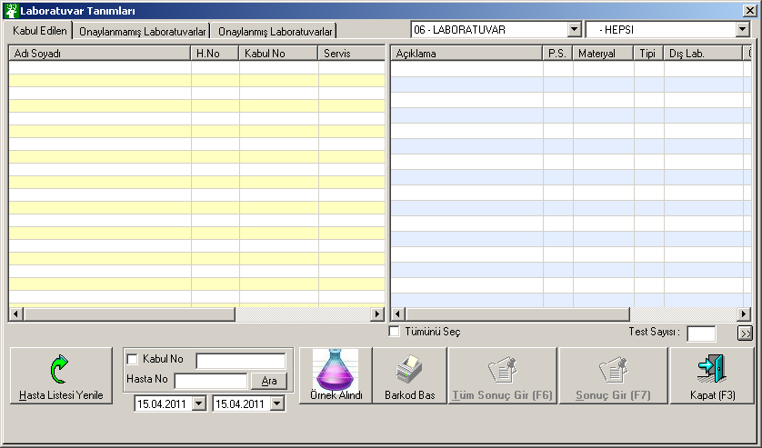

**LOAD**

select KNR, ADI1 from TIPDATA.dbo.DISMERKEZLER where TIPI='L' order by ADI1

select SLT from TIPDATA.dbo.KEYDAT where SLK='00' and SLB='LABDRONAY'

select SLB, SLT from TIPDATA.dbo.KEYDAT where SLK='01' and SLX=1 order by SLB

select SLB, SLT from TIPDATA.dbo.KEYDAT where SLK='30' and SLB like '06%' order by SLB

select SLT from TIPDATA.dbo.KEYDAT where SLK='17' and SLB='HS'

select SLT from TIPDATA.dbo.KEYDAT where SLK='07' and SLB='0192'

select SLT from TIPDATA.dbo.KEYDAT where SLK='17' and SLB='U2'

select SLT from TIPDATA.dbo.KEYDAT where SLK='07' and SLB='0010'

SELECT L.TANIM, L.GRUP, L.CODE, L.TARIH, H.NAME1, H.PARSAYI, H.MATERYAL, H.LABTIPI, L.TOOLTIPTEXT, L.DISMERKEZ,L.ORNEK_TARIHI,H.TESTSAAT FROM LBISTE L, HIZMET H where H.TANIM=L.TANIM and H.GRUP=L.GRUP and H.CODE=L.CODE and L.KNR='185648' and L.SNR='995' and L.TANIM='06' and L.KABUL_NO='2011431018' and L.KABUL='1' and L.ONAY = '0' and H.PARSAYI > 0 order by L.CODE

select ADI1 from TIPDATA.dbo.DISMERKEZLER where KNR=''

select SLB, SLT from TIPDATA.dbo.KEYDAT where SLK='30' and SLB like '06%' order by SLB

**HASTA LİSTESİ YENİLE**

select SLT from KEYDAT where SLK='17' and SLB='HS'

select SLT from KEYDAT where SLK='07' and SLB='0192'

select SLT from KEYDAT where SLK='17' and SLB='U2'

select SLT from KEYDAT where SLK='07' and SLB='0010'

SELECT L.TANIM, L.GRUP, L.CODE, L.TARIH, H.NAME1, H.PARSAYI, H.MATERYAL, H.LABTIPI, L.TOOLTIPTEXT, L.DISMERKEZ,L.ORNEK_TARIHI,H.TESTSAAT FROM LBISTE L, HIZMET H where H.TANIM=L.TANIM and H.GRUP=L.GRUP and H.CODE=L.CODE and L.KNR='185648' and L.SNR='995' and L.TANIM='06' and L.KABUL_NO='2011431018' and L.KABUL='1' and L.ONAY = '0' and H.PARSAYI > 0 order by L.CODE

select ADI1 from DISMERKEZLER where KNR=''

**ÖRNEK ALINDI**

SELECT L.TANIM, L.GRUP, L.CODE, L.TARIH, H.NAME1, H.PARSAYI, H.MATERYAL, H.LABTIPI, L.TOOLTIPTEXT, L.DISMERKEZ,L.ORNEK_TARIHI,H.TESTSAAT FROM LBISTE L, HIZMET H where H.TANIM=L.TANIM and H.GRUP=L.GRUP and H.CODE=L.CODE and L.KNR='185648' and L.SNR='995' and L.TANIM='06' and L.KABUL_NO='2011431018' and L.KABUL='1' and L.ONAY = '0' and H.PARSAYI > 0 order by L.CODE

select ADI1 from DISMERKEZLER where KNR=''

**SONUÇ GİR**

SELECT HASTAADI, HASTASOYADI, CINSIYETI, DOGUMTARIHI from TIPDATA.dbo.ADRES where KNR='722905'

SELECT IND, PARISMI, BIRIMI FROM TIPDATA.dbo.LABTANIMLARI WHERE TANIM='06' and GRUP='006' and CODE='9008' order by IND

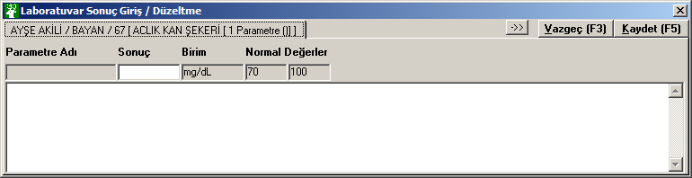

**KAYDET**

select SLT from TIPDATA.dbo.KEYDAT where SLK='00' and SLB='LABDRONAY'

select PANIK1,PANIK2 from TIPDATA.dbo.LABTANIMLARINORMAL where TANIM='06' AND GRUP='006' AND CODE='9008'

INSERT into LABORSONUC (KNR, SNR, TANIM, GRUP, CODE, TARIH, IND, PARISMI, SONUC, BIRIMI, NORMAL1, NORMAL2) values ('722905','996','06','006','9008','22.09.2009 13:40:06',1,'','85','mg/dL','70','100')

INSERT into LABORTEXT (KNR, SNR, TANIM, GRUP, CODE, TARIH, LABTEXT) values ('722905','996','06','006','9008','22.09.2009 13:40:06','')

UPDATE LBISTE set ONAY='1', ONAY_ID='AYDIN SAKAR', ONAY_TARIH = '22.09.2011 12:05:35', DRONAY='0' WHERE KNR='722905' and SNR='996' and TANIM='06' and GRUP='006' and CODE='9008' and TARIH = '22.09.2009 13:40:06'

SELECT L.TANIM, L.GRUP, L.CODE, L.TARIH, H.NAME1, H.PARSAYI, H.MATERYAL, H.LABTIPI, L.TOOLTIPTEXT, L.DISMERKEZ,L.ORNEK_TARIHI,H.TESTSAAT FROM LBISTE L, HIZMET H where H.TANIM=L.TANIM and H.GRUP=L.GRUP and H.CODE=L.CODE and L.KNR='722905' and L.SNR='996' and L.TANIM='06' and L.KABUL_NO='2011431017' and L.KABUL='1' and L.ONAY = '0' and H.PARSAYI > 0 order by L.CODE

select SLT from KEYDAT where SLK='17' and SLB='HS'

select SLT from KEYDAT where SLK='07' and SLB='0192'

SELECT L.TANIM, L.GRUP, L.CODE, L.TARIH, H.NAME1, H.PARSAYI, H.MATERYAL, H.LABTIPI, L.TOOLTIPTEXT, L.DISMERKEZ,L.ORNEK_TARIHI,H.TESTSAAT FROM LBISTE L, HIZMET H where H.TANIM=L.TANIM and H.GRUP=L.GRUP and H.CODE=L.CODE and L.KNR='185648' and L.SNR='995' and L.TANIM='06' and L.KABUL_NO='2011431018' and L.KABUL='1' and L.ONAY = '0' and H.PARSAYI > 0 order by L.CODE

select ADI1 from DISMERKEZLER where KNR=''

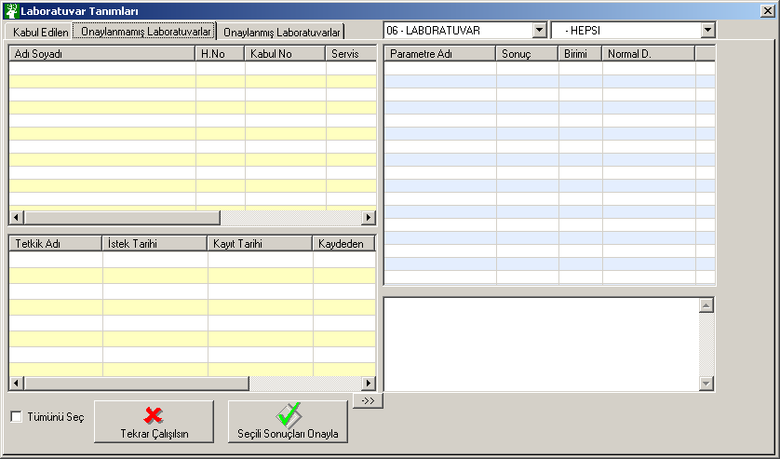

**LOAD**

SELECT H.NAME1, H.MATERYAL, H.LABTIPI, L.SNR, L.TANIM, L.GRUP, L.CODE, L.TARIH, L.KABUL_NO, L.ONAY_TARIH, L.ONAY_ID, L.ONAY,H.TESTSAAT FROM LBISTE L, HIZMET H where L.TANIM=H.TANIM and L.GRUP=H.GRUP and L.CODE=H.CODE and L.KNR='722905' and L.SNR='996' and ISNULL(L.ONAY,'') = '1' and ISNULL(L.DRONAY,'') NOT IN ('2','9') and L.KABUL_NO='2011431017' and 1=1order by L.ONAY_TARIH

SELECT PARISMI, SONUC, BIRIMI, NORMAL1, NORMAL2 FROM LABORSONUC WHERE KNR='722905' and SNR='996' and TANIM='06' and GRUP='006' and CODE='9008' and TARIH = '22.09.2009 13:40:06' order by IND

SELECT LABTEXT FROM LABORTEXT WHERE KNR='722905' and SNR='996' and TANIM='06' and GRUP='006' and CODE='9008' and TARIH = '22.09.2009 13:40:06'

SELECT HASTAADI, HASTASOYADI, CINSIYETI, DOGUMTARIHI from ADRES where KNR='722905'

**TEKRAR ÇALIŞILSIN**

SELECT H.NAME1, H.MATERYAL, H.LABTIPI, L.SNR, L.TANIM, L.GRUP, L.CODE, L.TARIH, L.KABUL_NO, L.ONAY_TARIH, L.ONAY_ID, L.ONAY,H.TESTSAAT FROM LBISTE L, HIZMET H where L.TANIM=H.TANIM and L.GRUP=H.GRUP and L.CODE=H.CODE and L.KNR='722905' and L.SNR='996' and ISNULL(L.ONAY,'') = '1' and ISNULL(L.DRONAY,'') NOT IN ('2','9') and L.KABUL_NO='2011431017' and 1=1order by L.ONAY_TARIH

SELECT PARISMI, SONUC, BIRIMI, NORMAL1, NORMAL2 FROM LABORSONUC WHERE KNR='722905' and SNR='996' and TANIM='06' and GRUP='006' and CODE='9008' and TARIH = '22.09.2009 13:40:06' order by IND

SELECT LABTEXT FROM LABORTEXT WHERE KNR='722905' and SNR='996' and TANIM='06' and GRUP='006' and CODE='9008' and TARIH = '22.09.2009 13:40:06'

**SEÇİLİ SONUÇLARI ONAYLA**

update LBISTE set DRONAY='2', DRONAY_ID='AYDIN SAKAR', DRONAY_TARIH='22.09.2011 12:17:21' WHERE KNR='722905' and SNR='996' and TANIM='06' and GRUP='006' and CODE='9008' and TARIH = '22.09.2009 13:40:06'

SELECT H.NAME1, H.MATERYAL, H.LABTIPI, L.SNR, L.TANIM, L.GRUP, L.CODE, L.TARIH, L.KABUL_NO, L.ONAY_TARIH, L.ONAY_ID, L.ONAY,H.TESTSAAT FROM LBISTE L, HIZMET H where L.TANIM=H.TANIM and L.GRUP=H.GRUP and L.CODE=H.CODE and L.KNR='722905' and L.SNR='996' and ISNULL(L.ONAY,'') = '1' and ISNULL(L.DRONAY,'') NOT IN ('2','9') and L.KABUL_NO='2011431017' and 1=1order by L.ONAY_TARIH

SELECT H.NAME1, H.MATERYAL, H.LABTIPI, L.SNR, L.TANIM, L.GRUP, L.CODE, L.TARIH, L.KABUL_NO, L.ONAY_TARIH, L.ONAY_ID, L.ONAY,H.TESTSAAT FROM LBISTE L, HIZMET H where L.TANIM=H.TANIM and L.GRUP=H.GRUP and L.CODE=H.CODE and L.KNR='185648' and L.SNR='995' and ISNULL(L.ONAY,'') = '1' and ISNULL(L.DRONAY,'') NOT IN ('2','9') and L.KABUL_NO='2011431018' and 1=1order by L.ONAY_TARIH

SELECT PARISMI, SONUC, BIRIMI, NORMAL1, NORMAL2 FROM LABORSONUC WHERE KNR='185648' and SNR='995' and TANIM='06' and GRUP='006' and CODE='9008' and TARIH = '22.09.2009 11:06:48' order by IND

SELECT LABTEXT FROM LABORTEXT WHERE KNR='185648' and SNR='995' and TANIM='06' and GRUP='006' and CODE='9008' and TARIH = '22.09.2009 11:06:48'

SELECT HASTAADI, HASTASOYADI, CINSIYETI, DOGUMTARIHI from ADRES where KNR='185648'

select SLT from KEYDAT where SLK='00' and SLB='RPRSORMA'

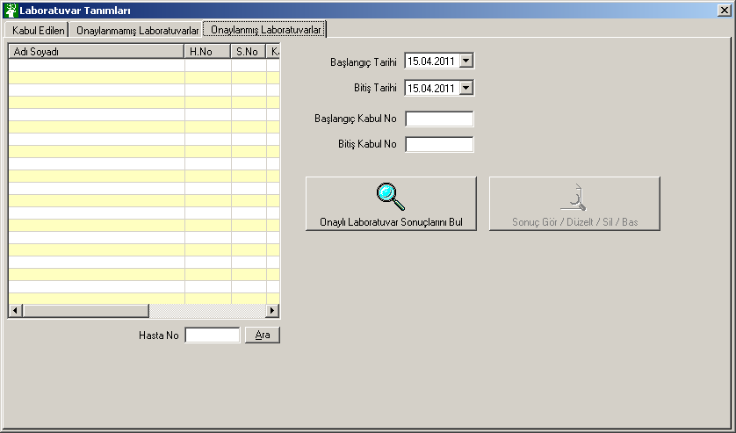

**ONAYLI SONUÇLARI BUL**

Ekrandan buluyor

**SONUÇ / GÖR / DÜZELT /SİL / BAS**

select SLT from KEYDAT where SLK='00' and SLB='LABDRONAY'

SELECT L.KABUL_TARIH,H.NAME1, H.MATERYAL, H.LABTIPI, L.SNR, L.TANIM, L.GRUP, L.CODE, L.TARIH, L.KABUL_NO, L.ONAY_TARIH, L.ONAY_ID, ISNULL(L.ONAY,'') AS ONAY, L.YAZILDIMI,L.ORNEK_TARIHI,L.DRONAY_ID,L.DRONAY_TARIH, ISNULL(DRONAY,'') AS DRONAY FROM LBISTE L, HIZMET H where L.TANIM=H.TANIM and L.GRUP=H.GRUP and L.CODE=H.CODE and L.KNR='722905' and L.SNR='996' order by L.ONAY_TARIH

select SLT from KEYDAT where SLK='00' and SLB='LABDRONAY'

SELECT LS.PARISMI, LS.SONUC, LS.BIRIMI, LS.NORMAL1, LS.NORMAL2 FROM LABORSONUC LS,LBISTE LI WHERE LS.KNR='722905' and ISNULL(LI.DRONAY,'') = '2' AND LS.SNR='996' and LS.TANIM='06' and LS.GRUP='006' and LS.CODE='9008' and LI.KNR = LS.KNR AND LI.SNR = LS.SNR AND LI.TANIM = LS.TANIM AND LI.GRUP = LS.GRUP AND LI.CODE = LS.CODE AND LI.TARIH = LS.TARIH AND LS.TARIH = '12.09.2009 13:15:01' order by IND

SELECT LT.LABTEXT FROM LABORTEXT LT,LBISTE LI WHERE LT.KNR='722905' and ISNULL(LI.DRONAY,'') = '2' AND LT.SNR='996' and LT.TANIM='06' and LT.GRUP='006' and LT.CODE='9008' and LI.KNR = LT.KNR AND LI.SNR = LT.SNR AND LI.TANIM = LT.TANIM AND LI.GRUP = LT.GRUP AND LI.CODE = LT.CODE AND LI.TARIH = LT.TARIH AND LT.TARIH = '12.09.2009 13:15:01'

SELECT HASTAADI, HASTASOYADI, CINSIYETI, DOGUMTARIHI from ADRES where KNR='722905'

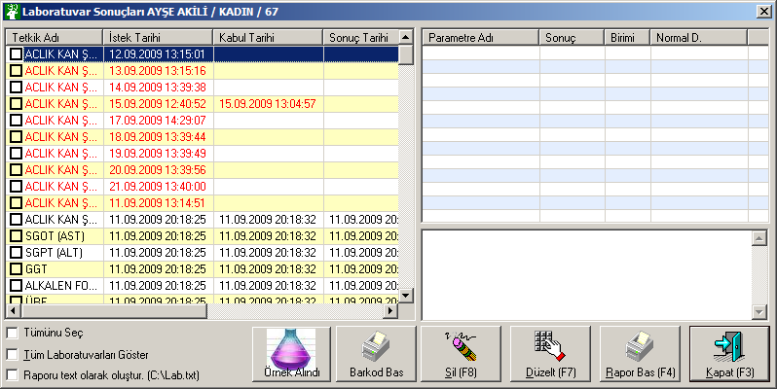

**ÖRNEK ALINDI**

select SLT from KEYDAT where SLK='00' and SLB='LABDRONAY'

SELECT L.KABUL_TARIH,H.NAME1, H.MATERYAL, H.LABTIPI, L.SNR, L.TANIM, L.GRUP, L.CODE, L.TARIH, L.KABUL_NO, L.ONAY_TARIH, L.ONAY_ID, ISNULL(L.ONAY,'') AS ONAY, L.YAZILDIMI,L.ORNEK_TARIHI,L.DRONAY_ID,L.DRONAY_TARIH, ISNULL(DRONAY,'') AS DRONAY FROM LBISTE L, HIZMET H where L.TANIM=H.TANIM and L.GRUP=H.GRUP and L.CODE=H.CODE and L.KNR='722905' and L.SNR='996' order by L.ONAY_TARIH

select SLT from KEYDAT where SLK='00' and SLB='LABDRONAY'

SELECT LS.PARISMI, LS.SONUC, LS.BIRIMI, LS.NORMAL1, LS.NORMAL2 FROM LABORSONUC LS,LBISTE LI WHERE LS.KNR='722905' and ISNULL(LI.DRONAY,'') = '2' AND LS.SNR='996' and LS.TANIM='06' and LS.GRUP='006' and LS.CODE='9008' and LI.KNR = LS.KNR AND LI.SNR = LS.SNR AND LI.TANIM = LS.TANIM AND LI.GRUP = LS.GRUP AND LI.CODE = LS.CODE AND LI.TARIH = LS.TARIH AND LS.TARIH = '12.09.2009 13:15:01' order by IND

SELECT LT.LABTEXT FROM LABORTEXT LT,LBISTE LI WHERE LT.KNR='722905' and ISNULL(LI.DRONAY,'') = '2' AND LT.SNR='996' and LT.TANIM='06' and LT.GRUP='006' and LT.CODE='9008' and LI.KNR = LT.KNR AND LI.SNR = LT.SNR AND LI.TANIM = LT.TANIM AND LI.GRUP = LT.GRUP AND LI.CODE = LT.CODE AND LI.TARIH = LT.TARIH AND LT.TARIH = '12.09.2009 13:15:01'

**SİL**

DELETE from LABORSONUC WHERE KNR='722905' and SNR='996' and TANIM='06' and GRUP='006' and CODE='9008' and TARIH = '20.09.2009 13:39:56'

DELETE from LABORTEXT WHERE KNR='722905' and SNR='996' and TANIM='06' and GRUP='006' and CODE='9008' and TARIH = '20.09.2009 13:39:56'

UPDATE LBISTE set YAZILDIMI='0', ONAY='0', ONAY_TARIH = null, ONAY_ID=null WHERE KNR='722905' and SNR='996' and TANIM='06' and GRUP='006' and CODE='9008' and TARIH = '20.09.2009 13:39:56'

**DÜZELT**

SELECT HASTAADI, HASTASOYADI, CINSIYETI, DOGUMTARIHI from ADRES where KNR='722905'

SELECT IND, PARISMI, SONUC, BIRIMI, NORMAL1, NORMAL2 FROM LABORSONUC WHERE KNR='722905' and SNR='996' and TANIM='06' and GRUP='006' and CODE='9008' and TARIH = '11.09.2009 20:18:25' order by IND

select NORMAL1,NORMAL2 from LABTANIMLARINORMAL where IND='1' and TANIM='06' AND GRUP='006' AND CODE='9008'

SELECT LABTEXT FROM LABORTEXT WHERE KNR='722905' and SNR='996' and TANIM='06' and GRUP='006' and CODE='9008' and TARIH = '11.09.2009 20:18:25'

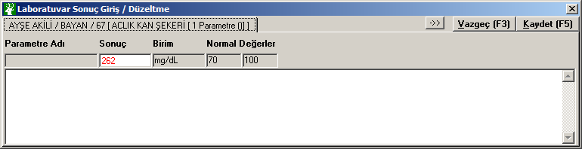

**KAYDET**

select SLT from KEYDAT where SLK='00' and SLB='LABDRONAY'

select PANIK1,PANIK2 from LABTANIMLARINORMAL where TANIM='06' AND GRUP='006' AND CODE='9008'

UPDATE LABORSONUC set SONUC='265' WHERE KNR='722905' and SNR='996' and TANIM='06' and GRUP='006' and CODE='9008' and IND=1 and TARIH = '11.09.2009 20:18:25'

SELECT COUNT(*) as SONUCSAYISI from LABORTEXT WHERE KNR='722905' and SNR='996' and TANIM='06' and GRUP='006' and CODE='9008' and TARIH = '11.09.2009 20:18:25'

UPDATE LABORTEXT set LABTEXT='' WHERE KNR='722905' and SNR='996' and TANIM='06' and GRUP='006' and CODE='9008' and TARIH = '11.09.2009 20:18:25'

select SLT from KEYDAT where SLK='00' and SLB='LABDRONAY'

SELECT LS.PARISMI, LS.SONUC, LS.BIRIMI, LS.NORMAL1, LS.NORMAL2 FROM LABORSONUC LS,LBISTE LI WHERE LS.KNR='722905' and ISNULL(LI.DRONAY,'') = '2' AND LS.SNR='996' and LS.TANIM='06' and LS.GRUP='006' and LS.CODE='9008' and LI.KNR = LS.KNR AND LI.SNR = LS.SNR AND LI.TANIM = LS.TANIM AND LI.GRUP = LS.GRUP AND LI.CODE = LS.CODE AND LI.TARIH = LS.TARIH AND LS.TARIH = '11.09.2009 20:18:25' order by IND

SELECT LT.LABTEXT FROM LABORTEXT LT,LBISTE LI WHERE LT.KNR='722905' and ISNULL(LI.DRONAY,'') = '2' AND LT.SNR='996' and LT.TANIM='06' and LT.GRUP='006' and LT.CODE='9008' and LI.KNR = LT.KNR AND LI.SNR = LT.SNR AND LI.TANIM = LT.TANIM AND LI.GRUP = LT.GRUP AND LI.CODE = LT.CODE AND LI.TARIH = LT.TARIH AND LT.TARIH = '11.09.2009 20:18:25'

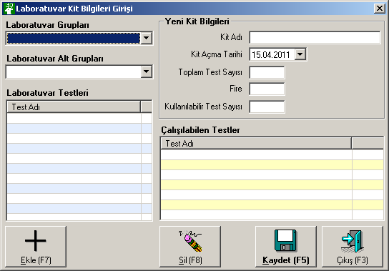

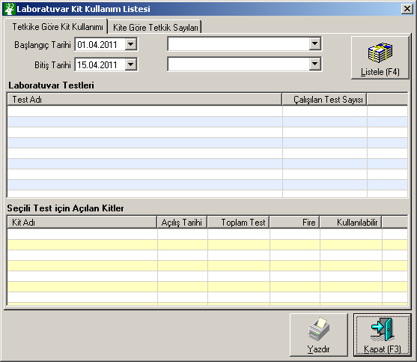

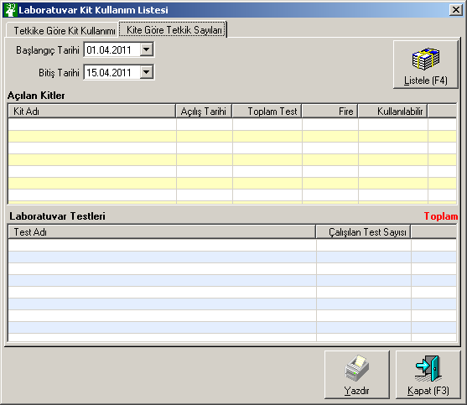

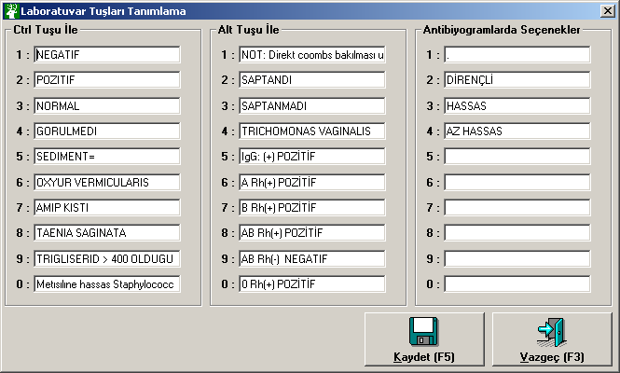

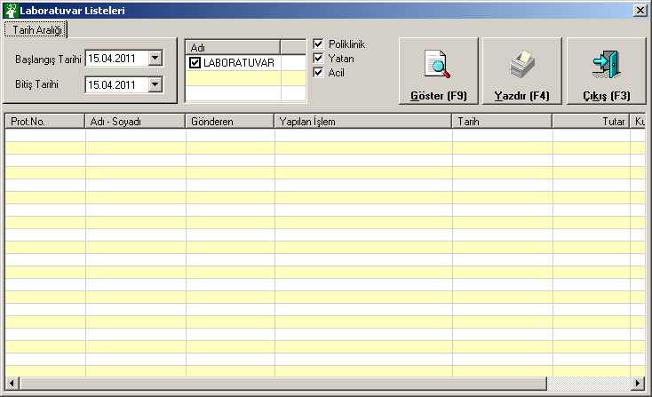

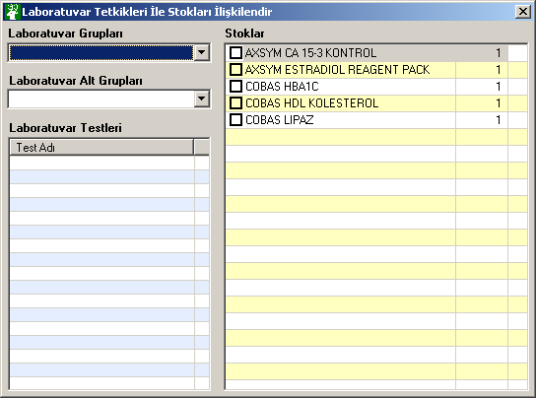

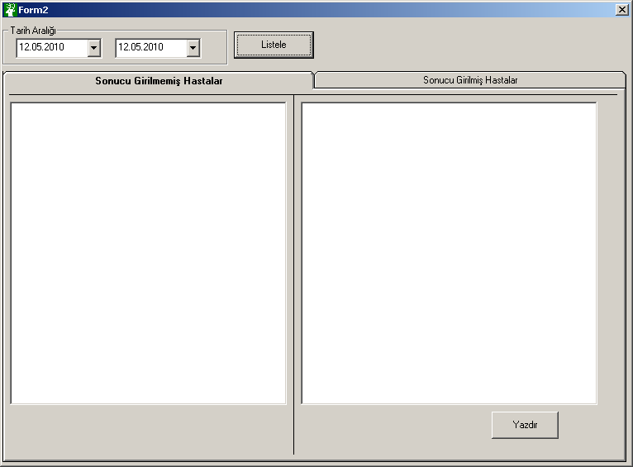

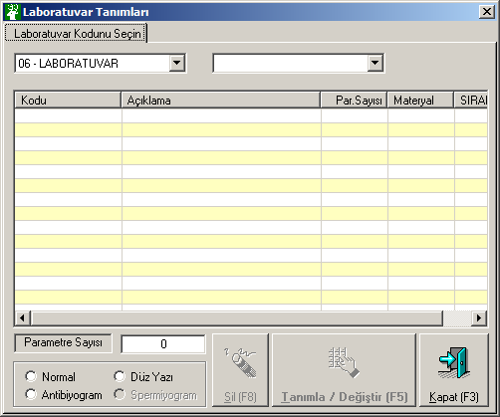

Cmb1 = select SLB, SLT from KEYDAT where SLK='01' and SLX=1 order by SLB

Cmb2 = select SLB, SLT from KEYDAT where SLK='30' and SLB like '06%' order by SLB

Grid = select CODE, NAME1, PARSAYI, MATERYAL, LABTIPI,TANIM,GRUP,SIRANO from HIZMET where TANIM='06' and GRUP='007' order by NAME1

**Tanımla Değiştir**

SELECT TOP 4 IND, PARISMI, BIRIMI FROM LABTANIMLARI WHERE TANIM='06' and GRUP='006' and CODE='9096' order by IND

select SIRANO from HIZMET WHERE TANIM='06' AND GRUP='006' AND CODE='9096'

select TESTSAAT from HIZMET WHERE TANIM='06' AND GRUP='006' AND CODE='9096'

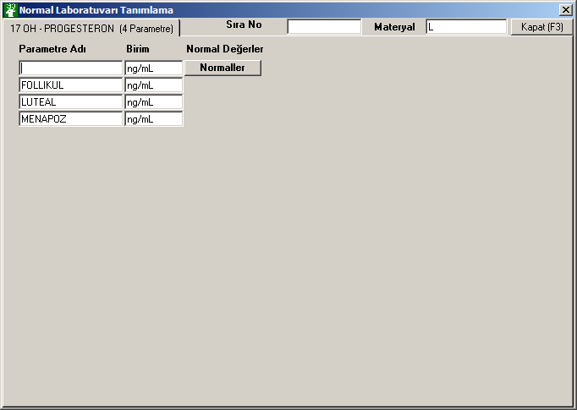

**Normaller Click**

UPDATE LABTANIMLARI SET PARISMI='' where TANIM='06' and GRUP='006' and CODE='9096' and IND=1

SELECT PARISMI, BIRIMI, ACIKLAMA,MEDTAHLILKODU,MEDGONDER FROM LABTANIMLARI WHERE TANIM='06' and GRUP='006' and CODE='9096' and IND=1

SELECT CINSIYET, DMY, DMY1, DMY2, NORMAL1, NORMAL2,PANIK1,PANIK2 FROM LABTANIMLARINORMAL WHERE TANIM='06' and GRUP='006' and CODE='9096' and IND=1 order by CINSIYET, DMY, DMY1

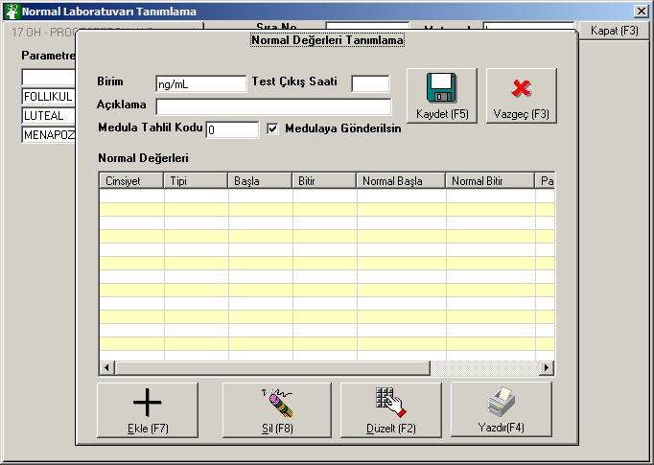

**Kaydet**

update LABTANIMLARI set ACIKLAMA='yok' where TANIM='06' and GRUP='006' and CODE='9096' and IND=1

update LABTANIMLARI set MEDTAHLILKODU='0' where TANIM='06' and GRUP='006' and CODE='9096' and IND=1

update LABTANIMLARI set MEDGONDER='1' where TANIM='06' and GRUP='006' and CODE='9096' and IND=1

delete LABTANIMLARINORMAL where TANIM='06' and GRUP='006' and CODE='9096' and IND=1

insert into LABTANIMLARINORMAL (TANIM, GRUP, CODE, IND, CINSIYET, DMY, DMY1, DMY2, NORMAL1,PANIK1 ,PANIK2,NORMAL2) values('06', '006', '9096', 1, '3', 'Y', 1, 1, '1', '1', '1', '1')

delete LABTANIMLARINORMAL where TANIM='06' and GRUP='006' and CODE='9096' and IND=1

