## AVANS EKRANI

**Kartların geldiği ekran sorgusu,**

* xSql = "select SNR, BHDAT, MTOPT, KTOPT from BEHAND where KNR='" & SKNR & "' order by SNR"

**Avansla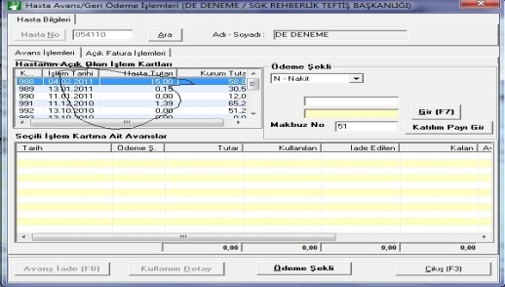rın geldiği ekran sorgusu,**

* xSql = "select AV_ID, TARIH, ODEMESEKLI, TUTAR, KULLANILAN, IADEEDILEN, USER_ID,MAKNO,TIPI,AFATNO from AVANSLAR " & _ "where KNR='" & SKNR & "' and " & "SNR='" & SSNR & "' " “

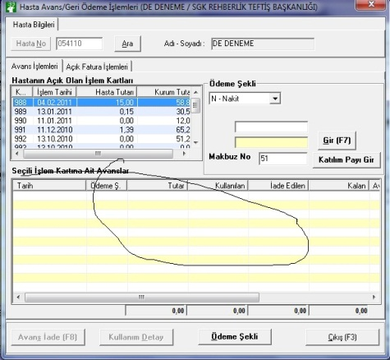

**Avans girme sorgusu,**

INSERT AVANSLAR

* (AV_ID=SELECT SLT FROM KEYDAT WHERE SLB=’AV_ID’
* , KNR=HASTA NO
* , SNR=HASTA KARTNO
* , TARIH=AVANS GİRME TARIHI
* , TUTAR=AVANS TUTARI
* , ODEMESEKLI=ODEMESEKLI N,K….
* ,MAKNO=SELECT SLT FROM KEYDAT WHERE SLB=’MAKNO’
* , USER_ID=KULLANICI
* ,DATE_CREATE=KAYIT OLUŞRUMA TARİHİ

"INSERT into KASA

* (MAKNO=MAKNO KEYDAT
* , KNR=HASTA NO
* , SNR=HASTA KARTNO
* , ACIKLAMA="Alınan Avans"
* , HNEREYEODENDI=HASTA ADI SOYADI
* , TARIH=AVANS GİRME TARIHI
* , MAKBUZNO=MAKNO
* , MAKBUZTIPI=A
* , ODEMESEKLI=ODEME SEKLI N,K
* , TUTAR=AVANS TUTARI
* , BORCALACAK=B
* , VEZNE=VEZNE NO
* ,USER_ID=KULLANICI , DATE_CREATE=KAYIT TARIHI

**AVANS IADE**

UPDATE AVANSLAR set " & _

"IADEEDILEN=IADEEDILEN+" & Dbl2StrDbl(nIadeEdilen) & " " & _

"where AV_ID=" & LswAvanslar.SelectedItem.Text

xSql = "INSERT into AVANSLAR_IADE

(AV_ID=IADE EDILEN AVANSIN ID SI

, TARIH=IADE TARIHI

, IADEMAKNO=MAKNO KEYDAT

, TUTAR=IADE TUTARI

, USER_ID=KULLANICI

, DATE_CREATE =KAYIT OLUŞTURMA TARIHI

**Fatura İptal ,**

xSql = "UPDATE HIZIL set MAKNO=NULL where KNR='" & SKNR & "' and " & _

"MAKNO='" & CMAKNO & "'"

xSql = "UPDATE FATURA set ISIPTAL='1', " & _

"USER_ID_UPDATE='" & ActiveUser & "', " & _

"DATE_UPDATE='" & Now & "' " & _

"where FATURA_ID='" & CFATNO & "'"

## TAHSİLAT EKRANI

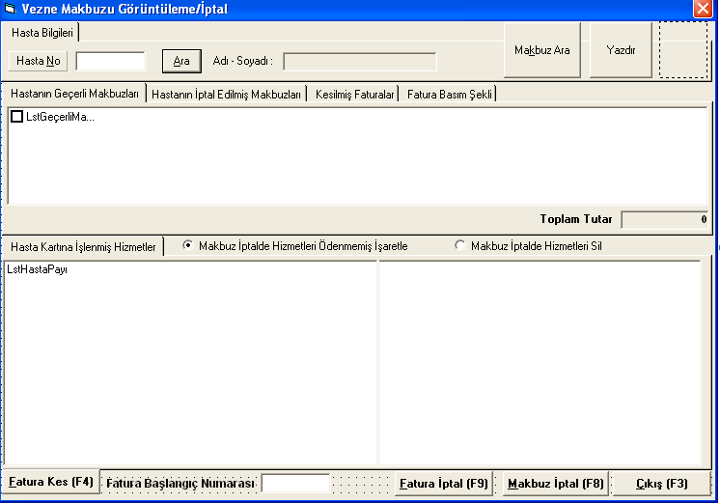

**Hastanın geçerli makbuzları**

* xSql = "select K.FATURATARIHI, K.SLNR, K.FATURATUTARI, K.USER_ID, K.FATURA_ID, K.MAKFATURANO AS FATNO,K.MAKNO,K.KNR " & _
  + "from MAKBUZ K LEFT OUTER JOIN FATURA F ON (K.FATURA_ID = F.MAKBUZNO) " & _
  + "where K.KNR = '" & SKNR & "' " & _
  + "and K.ISIPTAL is NULL " & _
  + "order by K.FATURATARIHI DESC"

**Hastanın Kartına İşlenmiş Faturalar**

* xSql = "SELECT ADET, TANIM, GRUP, CODE, NAME1, SATISF, KSATISF, ARZT FROM HIZIL " & _
* "where KNR='" & SKNR & "' and " & _
* "MAKNO='" & Item.SubItems(6) & "' order by SIRANO"

**Fatura Kes**

* xSql = "INSERT INTO FATURA (KNR, FATURA_ID, SLNR,MAKBUZNO, FATURANO, FATURATARIHI, " & _
  + "HIZMETTUTARI, KDVTUTARI, FATURATUTARI, KDVORANI, NAME, FATURATIPI, FAK, ZHLKZ, " & _
  + "PSG, VEZNE, USER_ID, DATE_CREATE) VALUES ('" & _
  + SKNR & "','" & _
  + CFATNO & "','" & _
  + "" & "','" & _
  + MAKBUZNO & "','" & _
  + TxtFaturaNo & "','" & _
  + Now & "'," & _
  + Dbl2StrDbl(Toplam) & "," & _
  + "0" & "," & _
  + Dbl2StrDbl(Toplam) & ",'" & _
  + "0" & "','" & _
  + lblhastaadisoyadi & "','" & _
  + "H" & "','" & _
  + "T" & "','" & _
  + "N" & "','" & _
  + "" & "','" & _
  + Activevezne & "','" & _
  + ActiveUser & "','" & _
  + Now & "')"
* **Fatura İptal**
* xSql = "update FATURA set ISIPTAL = '1', " & _
* "USER_ID_UPDATE = '" & ActiveUser & "', " & _
* "DATE_UPDATE = '" & Now & "' " & _
* "where KNR = '" & SKNR & "' " & _
* "and FATURA_ID = '" & LstKesilmişFaturalar.SelectedItem.SubItems(1) & "'"
* cn.Execute xSql

**Makbuz** İptal

* xSql = "UPDATE MAKBUZ set ISIPTAL='1', " & _
* "USER_ID_UPDATE='" & ActiveUser & "', " & _
* "DATE_UPDATE='" & Now & "' " & _
* "where FATURA_ID='" & CFATNO & "'"
* cn.Execute xSql, lngAffRows

**İptal Makbuzlar**

xSql = "SELECT FATURATARIHI, SLNR, FATURATUTARI, USER_ID, DATE_UPDATE, USER_ID_UPDATE FROM MAKBUZ where KNR='" & SKNR & "' AND ISIPTAL='1' order by FATURATARIHI DESC"

**Kesilmiş Faturalar**

xSql = "SELECT FATURATARIHI, SLNR, FATURATUTARI, USER_ID, MAKNO FROM MAKBUZ " & _

"where KNR='" & SKNR & "' and " & _

"MAKFATURANO='" & Item.SubItems(2) & "' order by FATURATARIHI"

**Kuruma Kesilmiş Faturalar**

xSql = "SELECT F.FATURATARIHI, F.FATURA_ID, F.FATURANO, F.HIZMETTUTARI, F.INDIRIM, F.KDVTUTARI, F.YUVARLAMA, F.FATURATUTARI, F.MAKNO, F.USER_ID, F.ISIPTAL,F.ISODENDI FROM FATURA F, SCARI S where " & _

"S.EVRAKNO=F.FATURA_ID and F.FATURATIPI = 'K' and left(S.EEVRAKNO,6)='" & SKNR & "' order by F.FATURATARIHI DESC"