1. Introduction

Phoenix is becoming a public city for people to retire. Although it is hot during summer time, the living cost is well balanced. Recently, Alex and Jenny moved from Chicago to Phoenix and are looking for a place to open a restaurant. They would like to know what type of food they want to server. Who are the targeting customers and what is the price range? They also want to pick up a location where there are not having too many competitions but also with reasonable rent.

1. Data Source

Three sources of data, including Foursquare data location, zip code, and population, will be used for the recommending system. Data such as different type of restaurants, traffics, surroundings, etc. will be extracted and used for analysis. In addition, the population distribution will also be used for analysis.

1. Data Cleaning and Exploratory

The data from above mentioned sources were extracted and compiled for predictive model. The neighborhood based on zip code and different types of restaurants are the key features in the model.

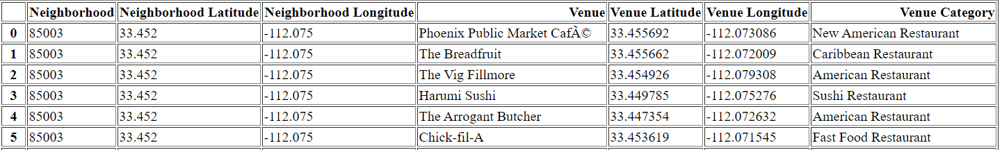

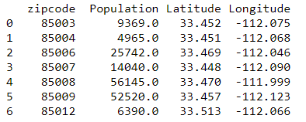

1. Modeling Results

K-Means classification model was used to classify the neighborhood in terms of the number of restaurants and populations. The results were classified as the most popular restaurants in the area with population.

American restaurants:

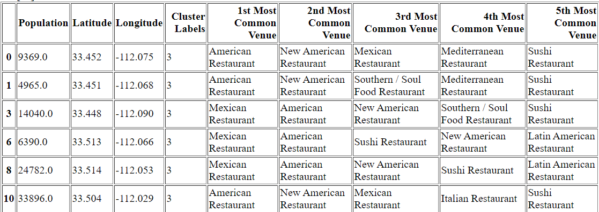

Mexico Restaurants:

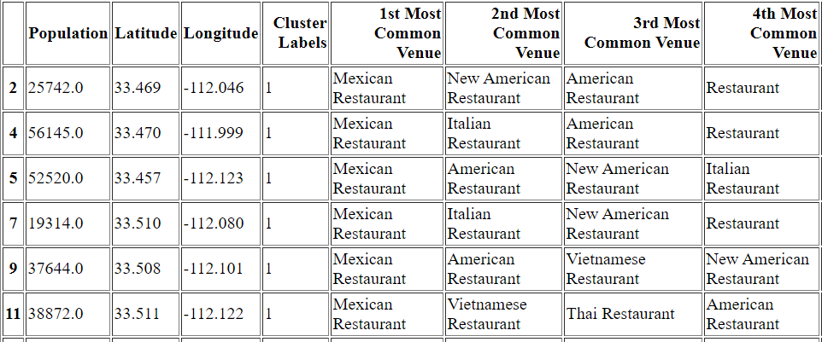

Asia Restaurants:

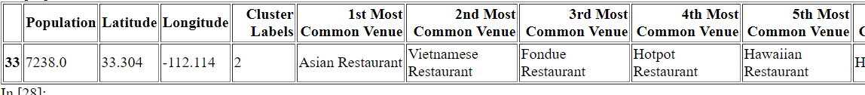

1. Conclusion

If you want to have a new restaurant in the Phoenix area, you can either have the same type of restaurant in the area with most populations or try to open a total different type of restaurant based on the above result.