**How Human Brain Works? Unveiling the Biology into Computer Science by Unlocking the Secrete of Human Neuorons, A Cable Theory Perspective on Dendrites**

Let’s talk about neurons, the fundamental building blocks of our brains. These remarkable cells are spread throughout our bodies, enabling us to think, move, and sense the world around us. Each neuron is a complex structure with distinct parts that play crucial roles. We have the *cell body*, which acts as the neuron’s metabolic center, where all the incoming signals are finally integrated. Inside the cell body resides the *nucleus*, the neuron’s control center. Then there are *synapses*, the vital connection points between sending and receiving neurons, where information is exchanged. *Dendrites*, with their tree-like branching structures, reach out and connect with the axons of other neurons, carrying signals towards the cell body. Finally, the *axon*, a long, slender projection, carries signals away from the cell body to the synapses, where they pass information on to the dendrites of other neurons.

Lets go through!

**What are Dendrites?**

At the end of a neuron, you’ll find these finger-like structures called dendrites. They’re like short, branching wires that sprout out from the cell’s main body. This branching pattern is really important, because it dramatically increases the surface area the neuron has to receive incoming information, kind of like a net catching more signals.

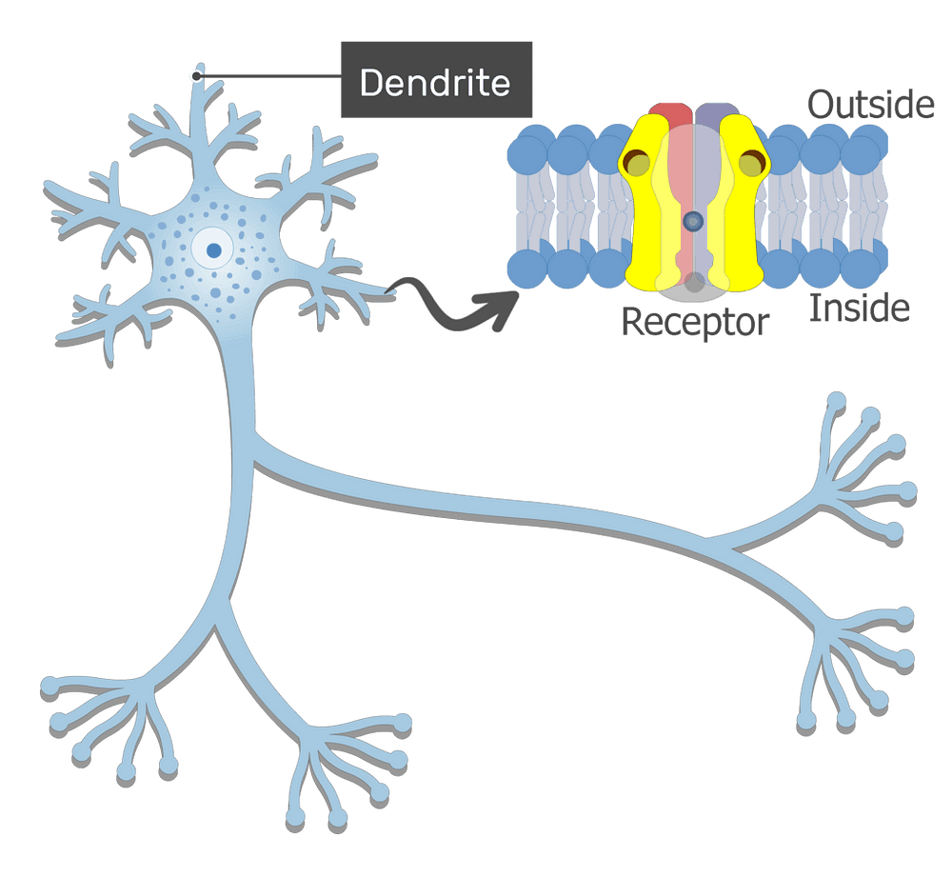Figure 1: Dendrite and its receptor! Think of it like a neuron’s mailbox.

**Structure of Dendrite**

Think of dendrites as the neuron’s little signal-catching branches, like a mini tree around the cell. They’re short and numerous, spreading out to grab messages from other neurons. Inside, they’re packed with all the cell’s machinery, like protein-making factories, to help process and pass along those signals.

**Function of Dendrites**

Dendrites are the structures on the neuron, that function by receiving electrical messages.

* They grab signals, or data, from other neurons.
* Dendrites gather all the incoming information from the axon terminals of other neurons.
* Dendrites conduct these electrical impulses toward the neuron’s main body, the cell body.
* Dendrites collect messages from neurons or nerves throughout the body.
* These messages travel through the nervous system to the brain.
* The brain then sends instructions back through the nervous system, causing our bodies to react to the messages.

**Dendrites as Cable**

Neurons aren’t just simple on/off switches. They have a sophisticated way of processing information, especially through their intricate dendritic trees. Imagine the dendrites as a complex network of cables, branching out to receive signals from other neurons at various locations. These cables don’t just passively carry signals; they actively integrate them over both space and time.

Neurons aren’t just simple on/off switches. They have a sophisticated way of processing information, especially through their intricate dendritic trees. Imagine the dendrites as a complex network of cables, branching out to receive signals from other neurons at various locations. These ‘cables’ don’t just passively carry signals; they actively integrate them over both space and time.

Now, here is where it gets interesting, many of these dendritic cables have their own voltage-gated channels, which means they can generate their own electrical activity. This leads to nonlinear signal processing and sometimes even dendritic spikes. These spikes aren’t just local events; they can travel, or propagate, either towards the soma or even back out to other distant parts of the dendritic tree. Essentially, the dendrites act as individual computational compartments, each capable of complex signal processing.

Much of the insight can be obtained via simulations, which typically  
replace the continuous dendritic structure in Figure 2 (a) with a network  
of discrete compartments in Figure 2 (b)

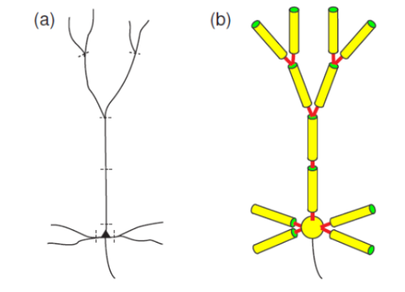Figure 2: A dendritic tree of nueron (a) is replaced by a network of compartments

**Cable Theory**

In essence, cable theory helps us predict how an electrical signal, introduced at one location on a dendrite, will affect the voltage at other locations and at different times. For example, if we send an electrical signal i.e the *current* into one end of the wire, how the *voltage* i.e electrical charge changes along the wire’s length over time. Basically, it shows how the signal weakens as it travels down the dendrite.

The structure of dendrites can be very complex but to approximate their shape in three dimensions we can model them as cylinders. When we consider the inside of the cylinder, the cylinder is still part of the neuron, so we can imagine it as having phospholipid bilayer shell and the inside filled with cytoplasm.

We will asume that the cylinders have as constant radius *a*,and we will attribute a value *L* to the length of the cylinder. To make a better approximation we can segment the cylider into small units of lenght ∆x.

*Note: The length of the cylinder is inthe axial axis.*

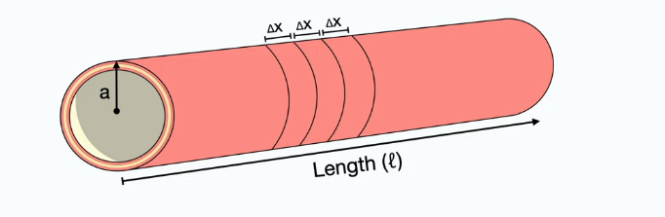Figure 3: Simplified model of a dendrite segment

Let establish few geometric equations, what will first be relevant for us is the area of the cross-section of the cylinder which is:

Equation 1: Area of a circle

The other is the area of the surface of the cylinder:

Equation 2: Area of a surface cylinder

Cylinder will generate some form of capacitance by separating positive and negative charges, if we consider the total capacitance of the cylinder (Ct) we can determine the membrane capacitance by dividing the total capacitance with length: Equation 3: Membrane capacitance

Equation 3: Membrane capacitance

we can also determine the membrane capacitance per unit area as the specific capacitance by dividing the capacitance per unit length by the circumference:

Equation 4: Membrane capacitance per unit area

One simple relation we can already establish with out model is that if we decrease the radius of the cylinder we decrease the size of the model dendrite, thereby we reduce the amount of charges that the membrane can store. Hence, the capacitance is proportional to the size of the cylinder. The membrane has channels that allow ions to flow in and out of the cell as we can establish same quantities for the total memebrane resistance per unit length and resistance per unit area:

Equation 5: Membrane resistance per unit lengthEquation 6: Membrane resistance per unit area

The areas are not at the correct places. This is because resistance is inversely proportional to the area, and thus, increasing the area reduces the amount of resistance because with a larger membrane, there are more channels that ions can take to flow out of the cell. To get the opposite relation, you can consider the  
conductance, which is proportional to the area. So as you increase the surface, you increase the conductance.

The relevant properties and equations we will need to keep in mind, these are the three *Passive membrane properties:*

**Longitudnal Resistance and Current:**

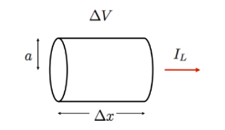Figure 4: Cylindrical wire with voltage drop and current.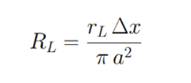Equation 7: Longitudinal Resistance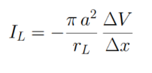Equation 8: Longitudinal current

**Radial Resistance and Current:**

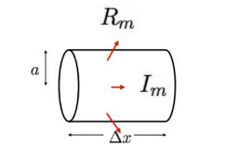Figure 5: Membrane resistance in a cylindrical segment, with current flowing through the membrane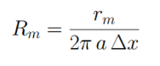Equation 9: Radial Resistance

This equation below describes how the voltage change across a dendrite’s membrane is determined by the radial current and membrane resistance. Essentially, it shows that the voltage drop is directly proportional to the amount of current flowing across the membrane and the membrane’s resistance to that flow.

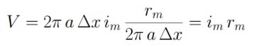Equation 10: Radial Current

**Membrane Capacitance:**

The total membrane capacitance of a dendritic segment, where the capacitance is determined by the segment’s surface area and the intrinsic capacitance per unit area of the membrane, which together determine how much electrical charge the segment can store;

Equation 11: Membrane Capacitance

Let’s get started on electric circuit model which will take place  
at the membrane. We can consider the extracellular matrix and the cytoplasm as two conductors. Contrarily to the equivalent circuit model, we need to indicate on the intracellular side the axial resistance. Now there is a resistance that you can technically attribute to the extracellular side and it is relevant when the extracellular space is restricted, such as in nerve fiber bundles, but we will just assume that for simplicity, our neuron is isolated and the extracellular space is pretty vast. With this assumption, the extracellular axial resistance becomes negligible. Since we are still dealing with the membrane, we need to indicate the membrane resistance and membrane capacitance, which are connected in parallel to our conductors. Remember that we have segmented our membrane in short segments of  
length Δx. Hence, each segment of length Δx will have its own little  
circuit. Also, since each component is defined as per length, we need to  
multiply them by the length of the slice to get an accurate value, except for  
the membrane resistance, which is divided because of its inverse  
proportionality.

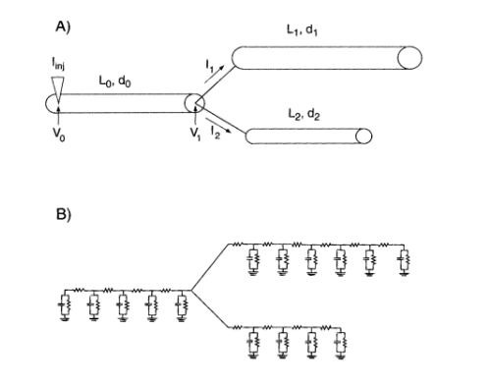Figure 6: A) Dendritic branch structure with current injection and voltage measurements. B) Equivalent electrical circuit representing the branch’s resistance and capacitance.

Assuming we are injecting positive charges inside and the resting state is negatively charged, the site where the current is injected will have the highest voltage with respect to the outside with value V0. Now, as the charges begin to spread out, they will have three choices for where they can go:

1. The charges can continue flowing through the cytoplasm. We will name this current *I*.
2. Another option for the charges is to leak out of the membrane through ion channels.

3. Finally, they can be stored by the membrane as capacitance, which both  
 constitute a form of membrane current noted as *Im*.

As charges continue moving in the cytoplasm, they are faced with that same decision and they ultimately leak out of the membrane through the channels which progressively decays the voltage back to a resting value. Both the current and voltage diminish as a function of time and distance.

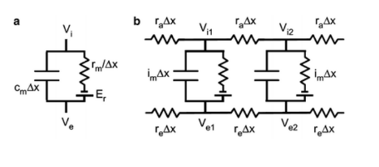Figure 7: Dendritic cable circuit models: (a) Single segment, (b) Multiple segments showing signal propagation.

In figure 7 (a) it depicts the cmΔx (Membrane Capacitance) represents the capacitance of the membrane for the specific segment length Δx. It stores charge across the membrane. rm/Δx (Membrane Resistance) represents the resistance of the membrane for the segment length Δx. It resists the flow of ions across the membrane. Er (Resting Potential) represents the equilibrium potential across the membrane when there’s no net current flow. Vi (Intracellular Potential) represents the electrical potential inside the dendritic segment. Ve (Extracellular Potential) represents the electrical potential outside the dendritic segment (often considered ground or 0V). In figure 7 (b) The circuit shows how multiple segments are connected. The intracellular and extracellular resistances represent the axial flow of current along the dendrite. The transmembrane current (imΔx) represents the current flowing across the membrane at each segment. This circuit models how signals propagate along the dendrite.

**Cable Equation Derivation**

We model dendrite electrical activity by tracking current flow within simplified segments. Four currents longitudinal(left, right), transmembrane, and electrode, combine to determine the net current, which dictates membrane voltage changes.

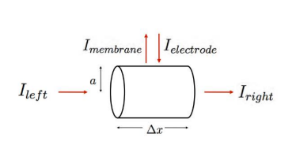Figure 8: A Flow of CurrentEquation 12: The Net Current Equation

It states that the net current (Inet) in a dendritic segment is the sum of the longitudinal currents (left and right), the transmembrane current, and any injected electrode current

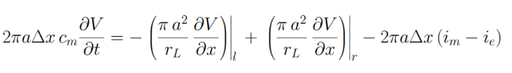Equation 13: Expressing Current in terms of Voltage

* It expresses each current term in the Inet equation as a function of the voltage V(x, t) and other relevant parameters.
* **2πaΔx cm ∂V/∂t:** This represents the membrane capacitance current. It’s proportional to the rate of change of voltage over time (∂V/∂t) and the membrane capacitance.
* **-(πa² / rL ∂²V/∂x²)|l + (πa² / rL ∂²V/∂x²)|r:** These terms represent the longitudinal currents (Ileft and Iright). They are proportional to the second spatial derivative of voltage (∂²V/∂x²), which describes how the voltage curvature changes along the dendrite’s length. ‘l’ and ‘r’ denote the left and right sides of the segment.
* **-2πaΔx (im — ie):** This represents the transmembrane current (Imembrane) and electrode current (Ielectrode). im is the transmembrane current density, and ie is the electrode current density.

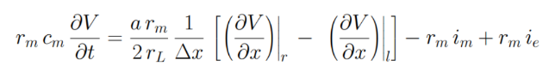Equation 14: Multiplying both sides by rm / 2παΔx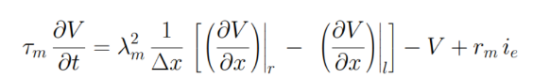Equation 15: The space- and time-dependent voltage

*τm* represents the membrane time constant (rmcm), which dictates how quickly the membrane voltage changes in response to a current. *λm* represents the membrane length constant, which describes how far a voltage change can spread along the dendrite.

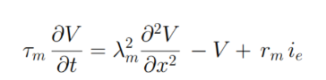Equation 16: Steady-state Solution

*Δx → 0* indicates that the equation is derived by considering the limit as the segment length (Δx) approaches zero, making it a continuous function.

It shows that the voltage changes over time and space are determined by factors like membrane properties (time and length constants) and current flow. However, if we keep the injected current constant, the voltage eventually stabilizes, and we can use a simpler equation to describe the voltage distribution along the dendrite. This simplified equation is easier to solve, allowing us to better understand how signals spread in dendrites.

**Simulation**