# 

# Solution

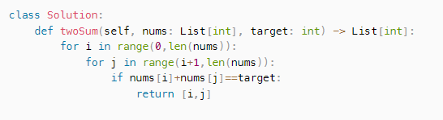

## Time and Space Complexity

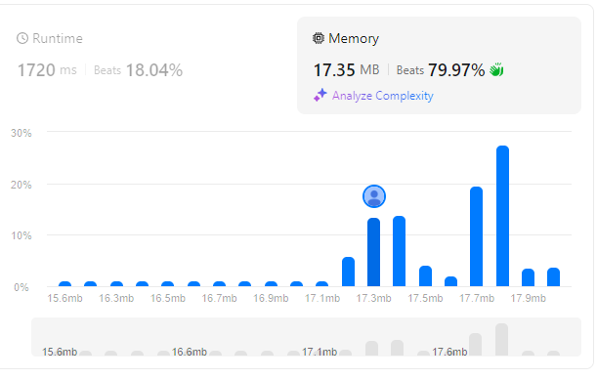

Can you come up with an algorithm that is less than $O(n^{2})$ time complexity?

# Solution

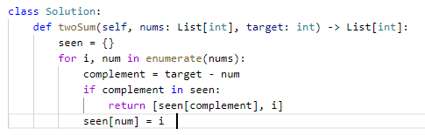

## Time and Space Complexity