**Design Document for:**

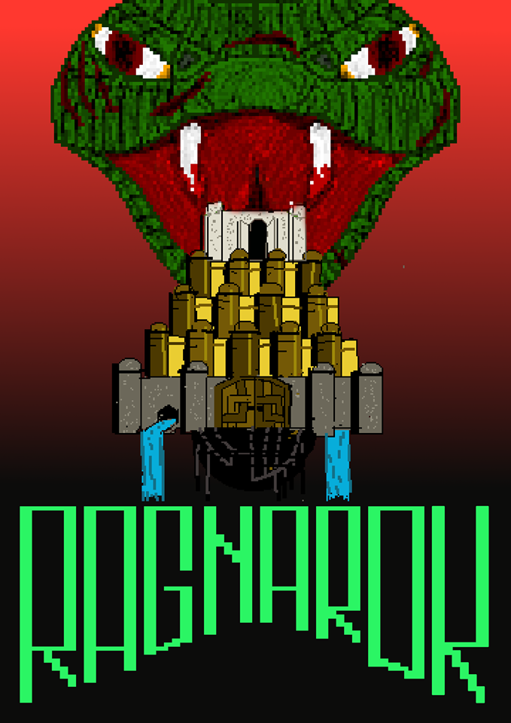

All work Copyright ©2019 by Team Ragnarok

Version # 2.00

Report Template Written by Chris Taylor

Table of Contents

Design History 4

Version 1.00 4

Version 1.10 4

Version 2.00 4

Included in the changes are: 4

Game Overview 5

Philosophy 5

Philosophical point #1 5

Philosophical point #2 5

Common Questions 5

What is the game? 5

Why create this game? 5

Where does the game take place? 6

What do I control? 6

What is the main focus? 6

What’s different? 6

Feature Set 7

General Features 7

Multiplayer Features 7

Gameplay 7

The Game World 8

Overview 8

Rendering System 8

Camera 8

Game Engine 8

Game Characters and Player Roles 9

Thor 9

Jörmungandr (Midgard Serpent) 10

User Interface 11

Power-ups (Player 1) 12

Overview 12

Health Potions 12

Triple Jump 12

Weapons (Player 2) 13

Eye Blasts 13

Fireball 14

Tail Attack 15

Musical Scores and Sound Effects 16

Overview 16

Sound Design 16

Design History

This design document outlines our team’s approach and process when to creating our entry for 2019’s GamesFleadh, Ragnarök.

Our design concept remains largely intact from our initial sessions where the bulk of our features were decided upon. However, some features were tweaked, added and removed to ensure that the game would be balanced for both players.

## Version 1.00

1. Initial design decisions added to document.
2. Outlined rationale for choosing Unity as our game engine for this project.

## Version 1.10

**Tweaks to the proposed design:**

1. Weapon concepts for Player 2 (Jörmungandr) replaced from initial design:
   * + Wind Vortex (to suck player backwards) removed – Altering Player 1 movement in a direct way decided as being both overpowered and potentially disruptive to the skill contest between the two players.
     + Replaced with vertical and horizontal attacks – Tail to descend (with warning) from ceiling to remove vertical slice of environment. Fireball from snake mouth to remove horizontal slice.

## Version 2.00

## Included in the changes are:

1. Setting for the game altered – initial concept involving multiple time periods/industrial settings – Returning to single, mythical/natural setting. This has tightened the scope of the game and reduced our time creating new art assets – allowing greater focus on game testing and bug fixes.

# Game Overview

## Philosophy

### Philosophical point #1

Our primary game design goal was to create an intense game of cat and mouse between two players, creating excited glee as our runner skips between vanishing platforms and a sense of triumphant, awesome power from the world serpent player as the carve up the game world ahead of them.

### Philosophical point #2

Our use of the Unity game engine means that the game can easily be deployed across a wide range of platforms if desired.

## Common Questions

### What is the game?

Ragnarök is an epic head to head battle chase platformer/shooter game. It is an intense, rapidly changing platforming experience where adaptability and strategy are as important as mastery of the mechanics as the Thor player navigates the constantly changing maze of death being created by the Serpent player.

### Why create this game?

Our team wanted to make a game which would allow us to flex all our competitive muscles in an environment where platforming skill would have to be adapted to a destructible environment, where strategy and tactics could also be an element.

### Where does the game take place?

The game takes place during the mythical Norse event of Ragnarök, the great battle between monsters and the gods which ultimately leads to the destructions and rebirth of the world. Our story focuses on a specific fight between the Thunder god Thor and the great serpent Jörmungandr (also known as the Midgard/World Serpent).

### What do I control?

Player 1 will control Thor, the god of Thunder, as he evades the destruction of the world by Jörmungandr, fleeing between magical portals while building up enough strength to defeat the serpent.

Player 2 controls Jörmungandr as he annihilates the land around Thor, hoping to destroy him and continue to consume the cosmos.

### What is the main focus?

The focus will be creating and maintaining tension and intensity between the two players as the contest unfolds.

### What’s different?

Ragnarök is an unusual combination of genres as a competitive, asymmetrical battle game platformer mechanics are contested against a shooter.

# Feature Set

## General Features

* 2D custom pixel-art graphics
* Destructible Environments
* Mystical Setting

## Multiplayer Features

* Local Head to Head Multiplayer
* Multiple Controller / Keyboard Support

## Gameplay

* Epic mythical chase sequences
* Increasing Difficulty/Pace Per level
* Frantic Multitasking
* Risk/Reward mechanisms
* Near Death/Victory experiences

# The Game World

## Overview

The game takes place at the beginning of Ragnarök (which translates from Old Norse as *Fate/Twilight of the Gods)*. As the game progresses to later stages the players journey through different parts of the Norse realms/cosmos. The Unity engine was our tool for managing the creation of this world, providing pre-built tools and functions for physics interactions, rendering and scene management.

## Rendering System

The game will be rendered using the Unity 2D engine’s toolset for sprite rendering. Unity’s editor and interface allows simple control over aspects such as layer management and sprite/tilemap shaping.

## Camera

As both players share the same screen space a single, main camera was used to display the game. If the Thor character jumps above the camera’s vertical view, a green indicator arrow is placed at the top of the screen to indicate his point of return.

## Game Engine

The Unity engine allowed us to import our sprites and tilemaps, render them within the game world and assign them our C# scripts and physical components through a simple and intuitive drag and drop interface. It also handled the UI calls, performed update operations, collision detection of the meshes assigned to our sprites and handled our scene management.

# Game Characters and Player Roles

## Thor

Player one controls our runner character, Thor – God of Thunder. The goal for this player is move from platform to platform, anticipating the destruction being unleashed by Jörmungandr and dodging platforms accordingly. He is assigned three health points at the beginning of each round of the game, a point of which can be lost either by colliding with Jörmungandr or by falling off the bottom of the screen.

Thor is capable of double jumping between platforms by default but is capable of a single triple jump if he has obtained a specific powerup (details below.   
After a certain time period has expired, a portal to the next level of the game will appear at the right edge of the screen. Once the portal is reached, we transition to the next round of the game. If the portal at the end of the third level is reached, Thor has amassed enough power to slay Jörmungandr and wins the match.

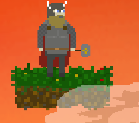

## Jörmungandr (Midgard Serpent)

Player 2 controls the role of the world destroying serpent whose aim is to carve through the game world and hunt down Thor. This player has a wide range of destructive weapons at their disposal (detailed below) but is required to eliminate Thor before the level’s time limit is reached. Efficient use of resources, denying Player 1 access to powerups and care precision with aim/timing are required to achieve this goal.

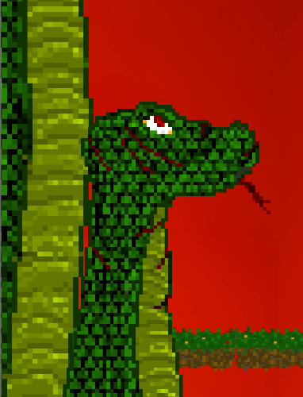

# User Interface

The game uses a simple interface for beginning a new round of the game. From the main menu the settings option provides access to options such as volume control and screen resolution control.

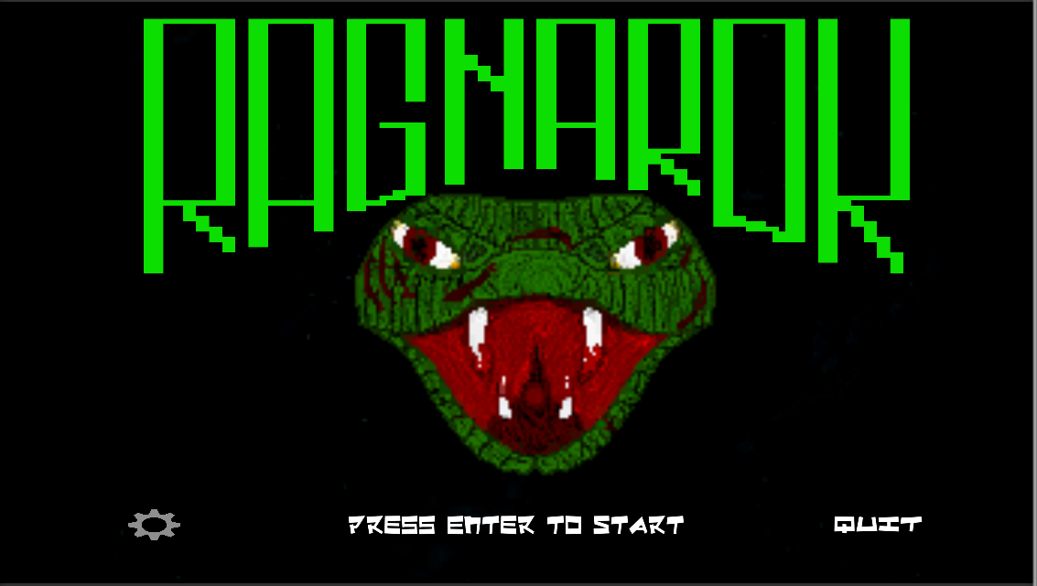

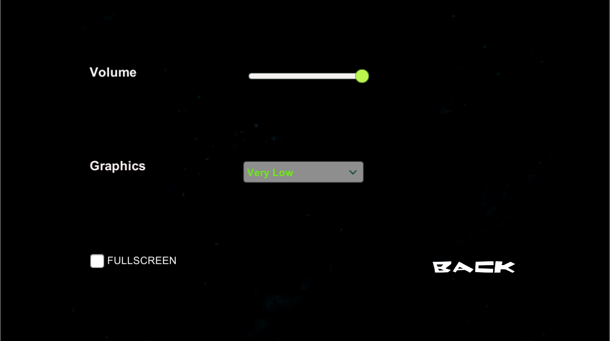

# Power-ups (Player 1)

## Overview

Bonus items will appear for the Thor character to retrieve throughout the game, greatly increasing their likelihood of survival. This creates an incentive for Player 1 to risk entering potential danger areas created by Player 2 as they attempt to destroy the platforms holding the powerups.

## Health Potions

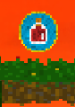

Health potions will restore one point of health to Thor, allowing him to survive one extra fall before the game ends.

## Triple Jump

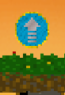

The triple jump powerup when picked up will allow the player to perform a third additional jump once before they need to touch a platform. Using the triple jump will expend the power up. These powerups do not stack.

# Weapons (Player 2)

## Eye Blasts

These are Jörmungandr’s primary weapon, quick fire blasts which fly towards the center of the target reticle. They are weak and cannot directly harm player 1, but they can destroy platforms with repeated attacks. This provides a constant pressure on player 1 to move and avoid attacks.

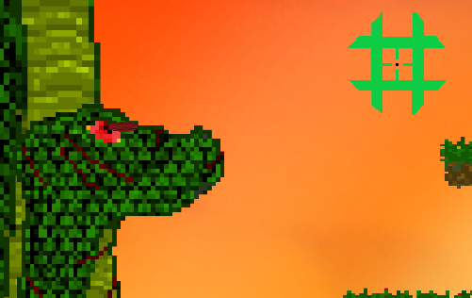

## Fireball

The fireball travels horizontally across the game screen when triggered, capable of carving through multiple central platforms. However, as the serpent moves vertically while travelling forward, being efficiently destructive with this ability requires careful timing on the part of Player 2.

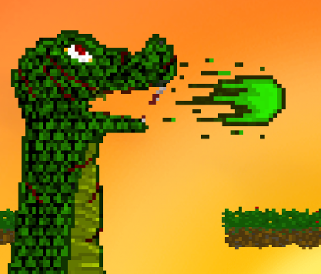

## Tail Attack

The tail attack is Jörmungandr’s most powerful weapon, striking down from above to slice out a vertical section of platforms. It can severely disrupt Thor’s movements and knock him directly to his death. To counter this, it is a slow, well projected attack, with a wiggling animation preceding the strike at the top of the screen to warn an observant Thor. It also operates with a significant cooldown to prevent its overuse by Player 2.

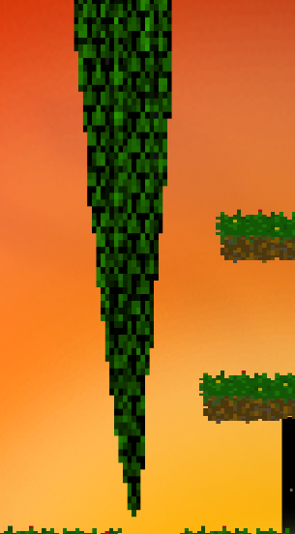

# 

# Musical Score

The themes for Ragnarök were composed to blend traditional folk with synth music to create a retro-style platforming soundtrack which would match the setting of the game. Composition was completed using FL studio to give access to a wider range of instrumentations and timbres for the music.

# Sound Effects