COMPANY:

Resim alanında mümkün ise [www.techone.ist](http://www.techone.ist) adresindeki slayt resimler.

**The best in quality and professionalism delivered on schedule and on budget.**

Techone LTD. based in Samsun/Turkey has been providing our clients superior design, installation and services. We pride ourself on working with our clients to provide a Project that fits their budget and timeline every time. Our staff is the backbone of our success, from our Project Manager, Designer and Estimators, to our Project Superintendents, Masters, Journeyman and Apprentice Electricians. TECHONE Electrical Contractor and its staff have the expertise to ensure your projects are done properly by trained professionals. TECHONE Electrical Contractors serves the Industrial, Agricultural, Municipal and Commercial markets. We have our roots in motor control and process electrical systems, but we have grown and expanded, allowing us to service customers and projects of all sizes. We specialize in USA Based Project which requires NFPA- 70(NEC). At TECHONE Electrical Contractors, “Safety is First”, we are very proud of our safety record. Continuous training for our entire staff ensures that our electricians will perform safely and exceed the requirements your project demands per NFPA-70E. All keyperson of TECHONE has been trained by OSHA certified trainer for 30 hours at least. TECHONE also has `Master Installer and Designer` for Lightning Protection and Grounding System certified by Lightining Protection Institute in USA. TECHONE Electrical Contractors, Inc., specializes in OBO Projects requires NFPA-70 complying with Industrial, Agricultural, Municipal and Commercial projects such as: American Embasy Project (Design input, procurement support, shop drawings, material take off, material submittal process, installation, tests & commissioning… etc)

SERVICE

“Resim-7 “

***COMPANY CAPABILITIES***

***Techone LTD specializes in OBO Project requires NFPA-70 and also the Project complying with Industrials, Agricultural, Municipal and Commercial Project such as;***

* ***American Embassy Projects. ( Desing, procurement, logistic support&Coordinate, shop drawings, field sketch, material take off, material submittal process, site supervisoring, laboring, etc. )***
* ***Clean Room. ( ISO-8, ISO7 and ISO6 Class***
* ***Water Well and Towers,***
* ***Manufacturing,***
* ***Industrial Plants,***
* ***Heath CAre Centers and Hospital Project,***
* ***Convention Center Project,***

***Techone offer design, installation and service for the following system,***

* ***Medium Voltage Systems,***
* ***Low Voltage System,***
* ***Power Distribution and Control System,***
* ***Emergency Power System,***
* ***Process Automation and Integrations,***
* ***TSS. ( Technical Security System including Audio, Signals and SMSe)***
* ***Telecom Systems,***
* ***Fire Alarm Systems,***
* BAS/BMS ( Building Automation/Management Systems)
* ***Mechanical Air Conditioning Systems for Clean Rooms,***

***Projects;***

* **1-Afghanistan/Kabul Customs and Trade Headquarters-Electrical Works. ( With Yuksel Proje İnşaat Co. Inc. )**
* **2-IRAQ /COB Spicer Tikrit- Warehouses Electrical Works. ( with Asfa Group Co. Inc. )**
* **3-Qatar/QP Industrial and facility area in Dukhan- Industrial Site Electrical&Telecom. Works. ( With Samko Co., Inc. )**

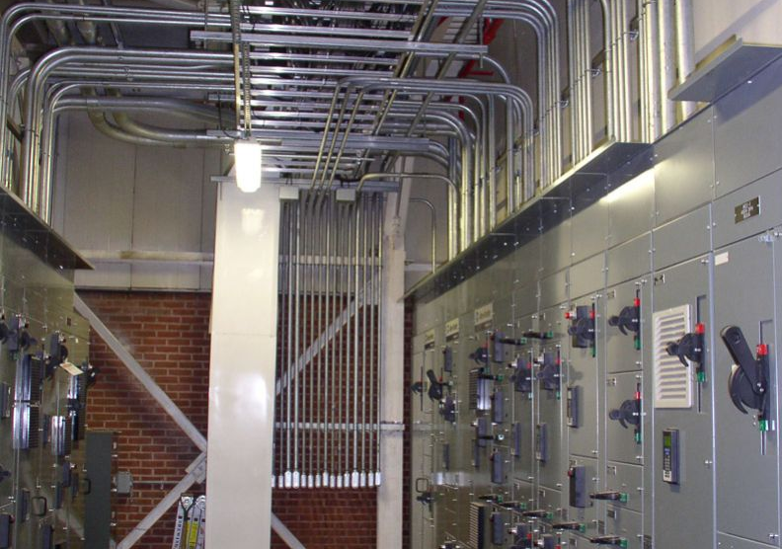

* ***4- Kazakhistan/Almaty C.P. ( Capital Partners) Co. Inc. Esentai Towers and Residances.***

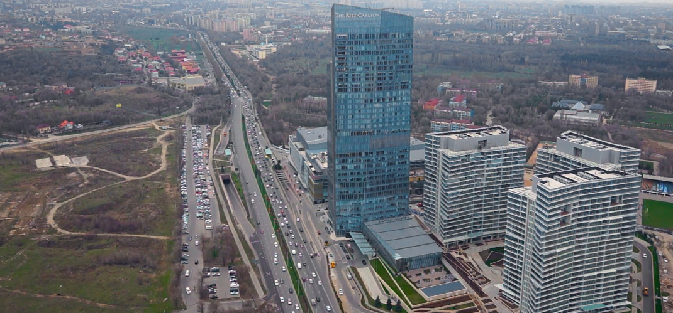

* **5-Kyrgyzstan / U.S.A. Embassy Project_Bishkek Kyrgyzstan – NOB, SCAC, MCAC, CCAC, SPX, WHE, MSGQ and CMPD site civil electric, TSS, Telecom, BAS, Power Monitoring&Control, Fuel Oil Control System, Site irrigation system, design input, shop drawings, submittal and procurements. ( As an Electrical Coordinator & ECCI’s Electrical Subcontractor)**

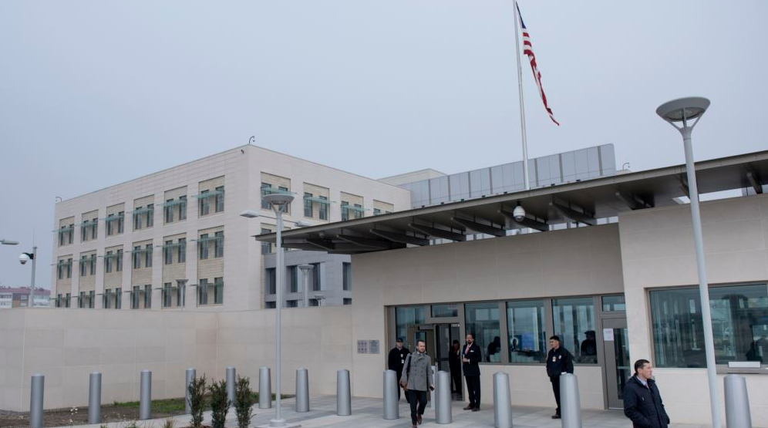

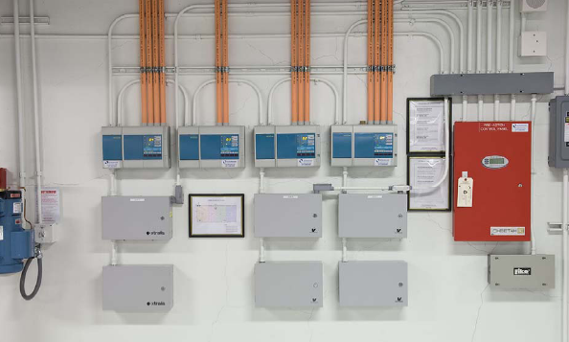

* ***6-ARKEL- Congo /*** U.S.A ***Embassy Project, WHE, SCAC, MSGR / Congo Brazzaville. ( Techone is electrical subcontractor)***

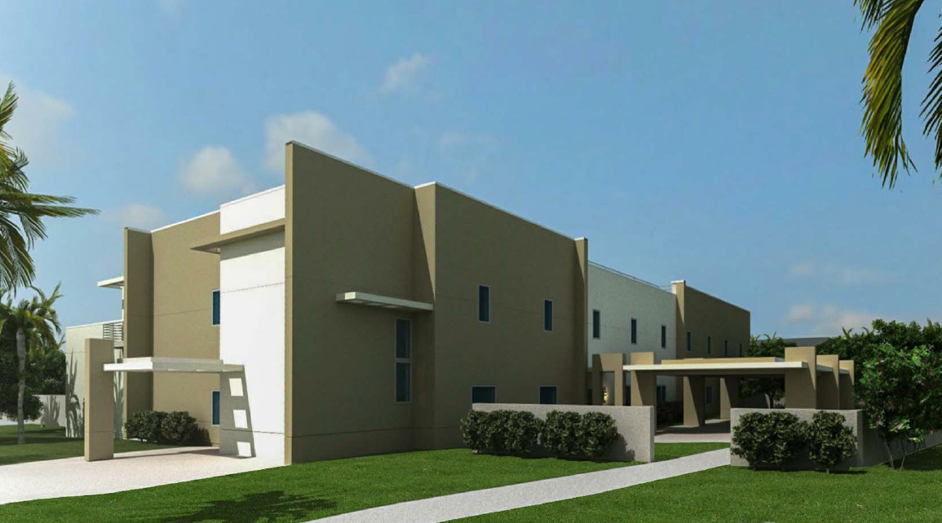

* ***7-Turkey Samsun-Borkonut, Business Center Project. Main Contractor is Borkonut Co., Inc. (Techone is Electric Contractor)***

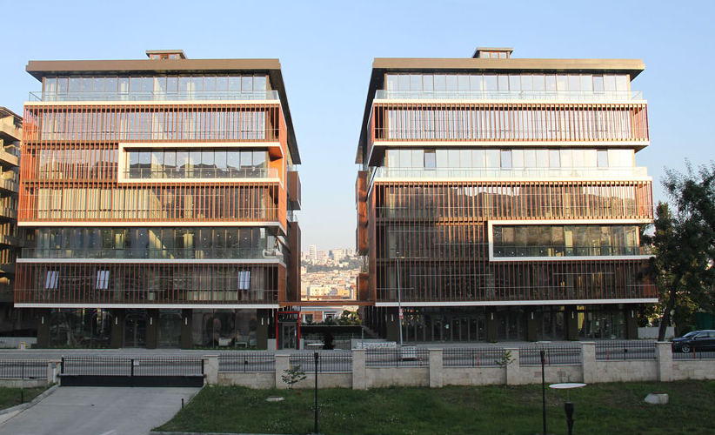

* ***8-Aygun Surgical Instruments Co., Inc. / Clean Room_Turn Key Project ( MEP, Structural, Architectural, BMS ) / Samsun -Turkey (Techone is Main Contractor)***

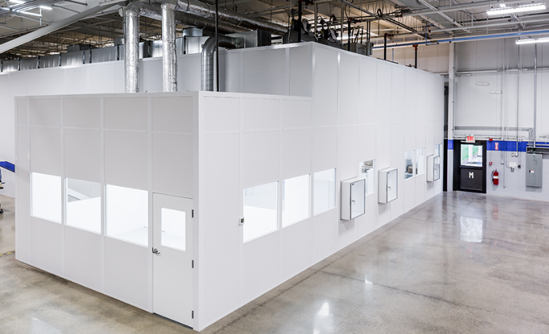

***Contact Us:***

***TECHONE MÜHENDİSLİK SAN. VE TİC. LTD. ŞTİ.***

***Organize Sanayi Bölgesi. Yaşar Doğu Cad. No:76/2 Kutlukent SAMSUN / TURKEY***

***Tel: +90 533 518 32 01 Email:*** [***fnamdar@techone.ist***](mailto:fnamdar@techone.ist)[***www.techone.ist***](http://www.techone.ist)