A
Minor Project Report
on
Spam Mail Detection
Submitted for partial fulfillment for the degree of

Bachelor of Technology

(Information Technology)

in
Department of Information Technology

by

Maturi Santosh
169108083

Under the Guidance of
Dr. Vivek Kumar Verma
(April-2019)

SCHOOL OF COMPUTING AND INFORMATION TECHNOLOGY

MANIPAL UNIVERSITY JAIPUR



CERTIFICATE

Date 27-04/2019

This is to certify that the project titled Spam Mail Detection is a record of the Bonafede work done by Santosh Maturi (169108083) submitted in partial fulfilment of the requirements for the award of the Degree of Bachelor of Technology (B.Tech) in (Discipline) of Manipal University Jaipur, during the academic semester VI

Dept Guide Name

Dr Vivek Kumar Verma, Dept of information of technology

Manipal University Jaipur

HOD Name

Pankaj Vyas, Dept of information of technology

Manipal University Jaipur

ABSTRACT

E-mail has become the most powerful source of communication both for professional and private purpose. However there are sample emails which are of no use and a few emails which try to extract sensitive details of the users. Such emails are known are spam mails. Spam mails are emails which are unwanted and serve no purpose hence of no use. Spam is major threat to the users mainly because it wastes time and causes the flee of important mails .To protect the users from spammers, a lot of algorithms were developed but these algorithm failed to be effective and hence couldn’t stop the spammers from spamming .The method that was adopted in this project was Naïve bayes technique which gives promising results as it is effective and efficient. The ultimatum of the project is to create an efficient spam mail detector.

LIST OF FIGURES

Figure No | Figure Title | Page No
1. | Data Cleaning | 12
2. | Dataset | 14
3. | Types of Emails and Representation | 14
4. | Confusion Matrix | 15
5. | Output 1 | 15
6. | Work plan | 17

Contents

CERTIFICATE 2
ABSTRACT 3
LIST OF FIGURES 4
Contents 5
INTRODUCTION 6
Motivation 7
Problem Statement 7
Objective of Report 7
Background Overview 9
Conceptual Overview 9
Technologies Involved 10
METHODOLOGY 11
Detailed methodology that will be adopted 11
Block Diagrams 13
IMPLEMENTATION AND RESULTS 14
Modules 14
Results and Discussion 14
FUTURE WORK AND CONCLUSION 15
Progress Chart/Time Line Chart 15
Future work 16
Conclusion 16
REFERENCES 17

INTRODUCTION

E-mail system due to its effectiveness is widely used in today’s world. Spam is one of the major threats posted to email users and it tends to pollute inbox hence it is necessary to detect and categorize them as spam or ham. Spam emails are commercial or bulk mails which are unwanted and sent by some unwanted users known as spammers. Spam can be categorized into the following categories:
- Commercial E-mails
- Bulk E-mails
- Phishing spam E-mails
Spam Mail Detection is important as sorting the E-mails into categories becomes difficult for the user and thereby wasting time. A few important mails often get missed out due to bulk spam mails which causes lot of problems for users. Phishing mails can access and disrupt the receiver’s computer systems and can gather sensitive information from it. Spam mails become quite annoying for the users. Spam reduces the productivity of the employees due to the time wasted on sorting Spam mail detector is used to filter out irrelevant E-mails and distinguish between spam and ham. The approaches for filtering spam mails are:
- Knowledge Engineering approach
- Machine Learning approach
In Knowledge Engineering approach there are a set of rules for differentiating the mails. But it takes more time and high maintenance is required whereas Machine Learning is more effective and time saving approach. There are many Machine Learning algorithms available for detection of spam mail which includes Neural Networks, Bayesian technique, Support vector machine, K-nearest neighbor and other classification approaches. We will be using naïve Bayesian approach in this project. Traditionally for effective results Bayesian technique is used but there is no such technique which provides 100% efficiency for spam mail detection till date. There is always a chance for the occurrence of error.

Motivation

E-mail has become one of the most important medium of communication and spam is a major threat posed to e-mail users. So we have opted for this project as spam has become a big issue nowadays in this era of modern technology. Spam has caused a lot of loss and it is necessary to detect it. Spam Mail Detection is required as:
- Sorting the E-mails into categories becomes difficult for the user and thereby wasting time
- A few important mails often get missed out due to bulk spam mails which causes a lot of problems for the users.
- Phishing mails can access and disrupt the receiver’s computer systems and can gather sensitive information from it.
- Spam reduces the productivity of the employees due to the time wasted on sorting.

In order to fix these problems we chose this project so that it would prevent the loss of money and time. Machine Learning has always intrigued us and we always look forward to gain knowledge from it. Spam mail detection using machine learning has caught our interest because it is very challenging and useful. Hence we are looking forward to further work on this project in an efficient way and contribute towards our society.

Problem Statement

- Sorting the e-mails into categories becomes difficult for the user and thereby wasting time
- A few important mails often get missed out due to bulk spam mails which causes lot of problems for the users.
- Phishing mails can access and disrupt the receiver’s computer systems and can gather sensitive information from it.
- Spam mails become quite annoying for the users.
- Spam reduces the productivity of the employees due to the time wasted on sorting.

Objective of Report
The objective of our research is:
- To gain knowledge about the classification methods in machine learning.
- To obtain information about spam mail detection using naïve Bayes classifier.
- To try improving the accuracy of spam mail detection.

Background Overview

Conceptual Overview

Naïve Bayes Classifier
This classification algorithm is based on bayes theorem. Bayes Theorem is stated as:
P(h|d) = (P(d|h) * P(h)) / P(d)
Where
- P(h|d) is the probability of hypothesis h given the data d. This is called the posterior probability.
- P(d|h) is the probability of data d given that the hypothesis h was true.
- P(h) is the probability of hypothesis h being true (regardless of the data). This is called the prior probability of h.
- P(d) is the probability of the data (regardless of the hypothesis).

The fundamental Naive Bayes assumption is that each feature makes an independent and equal contribution to the outcome. This classification uses bag of words algorithm to extract the features and identify the spam e-mails. Using bayes theorem it calculates the probability of a mail being spam or ham. Every word has a particular probability of its occurrence in spam or ham mails but the probability is know only after the data is trained using supervised learning. After training the prediction can be made based on the probability of the occurrence of words in spam or ham.

Bag of words
It is an algorithm that determines the frequency of a word in a document. It extracts features from the text for use in machine learning algorithms. In this approach firstly frequency of the words is determined, then the words which occur more frequently are considered to be features. Each email is considered to be a different document and depending on the features present in the email, a vector is created for each email. The process of converting the text into vectors is called as vectorization. In our project we have used tf-idf method for vectorization. Tf stands of term frequency and idf stands for inverse document frequency. TF-IDF weight evaluates the importance of a word in a corpus. The importance increases proportionally to the number of times a word appears in the document but is offset by the frequency of the word in the corpus. Using this approach we reduce the value of words that repeat very frequently in corpus and increase the value of words that rarely occur and ultimately the numeric form is normalized.

Technologies Involved

Software Requirements
- Python 3.7
Python is a general-purpose interpreted, interactive, object-oriented, and high-level programming language. It was created by Guido van Rossum during 1985- 1990. Like Perl, Python source code is also available under the GNU General Public License (GPL)
- Jupyter Notebook
The Jupyter Notebook App is a server-client application that allows editing and running notebook documents via a web browser. The Jupyter Notebook App can be executed on a local desktop requiring no internet access (as described in this document) or can be installed on a remote server and accessed through the internet.
- Microsoft Excel
The powerful Excel spreadsheet app lets you create, view, edit and share your files with others quickly and easily. It also lets you view and edit workbooks attached to email messages. Work in accounting, auditing, finance or other fields, with anyone, anywhere with confidence. With Excel, your Office moves with you and can implement the most complex formulas, with amazing features.

METHODOLOGY

Detailed methodology that will be adopted

- Data Preprocessing: It includes data collection, cleaning of data and representation of data.
- Data collection: A data-set in the form of csv file containing 5572 emails is collected which is a mixture of spam and ham emails. As shown in Figure 1 the csv file contains 2 columns in which the first one represents the email and the other one represents label. As shown in Figure 2 the dataset contains spam mails and ham mails. The length of emails varies as shown in Figure 3.

- Data cleaning: It is a substantial step in filtering out spam mails. The main objective is to remove irrelevant information as well as redundant information and convert the raw data into an understandable format. The steps performed in this project include:
- Removal of Alphanumeric: There were many words in corpus which were found to be alphanumeric. Such words are of no use while training, so we remove all the alphanumeric words.

- Removal of Stopwords: In the dataset there are words that do not carry any useful information and hence are ignored during spam detection. Stop words includes words like "and", "the", "a", "an", and similar words. In order to save time and space such words are removed.

Removal of alphanumeric words

Removal of stop words

Figure 1 Data Cleaning

1.Data Representation: After cleaning the data it needs to be represented in such a form that the machine could understand it and since understanding words is difficult, we convert our data into numeric form. For converting the data into numeric form we first extract features. Based on the word count we choose the most frequent words to be our features and using the bag of words approach we convert our data into numeric form. After converting it into numeric form we further try to normalize it by using tf-idf method. Tf is referred as term frequency and idf is the inverse document frequency. Using this approach we reduce the value of words which are repeated frequently in corpus and increase the value of words that rarely occur and ultimately the numeric form is normalized.

2. Training: After the data preprocessing step the data is ready to be trained. First the dataset is divided into two parts which is training data and testing data. We train the model using the training data. Here we are using naïve Bayes approach to train our model. Naïve Bayes is a conventional and popular method for classification problems. The distinguishing feature in this approach is that each feature makes an independent and equal contribution to the outcome.

3.Testing: Once the classifiers are trained, testing can be performed on the test data set.

4.Performance Evaluation: we can check the performance of models on the test set. And compare the results of the actual label and the predicted label. Later the performance is calculated using the confusion matrix.

Block Diagrams

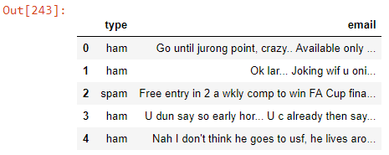
Figure 2 Dataset

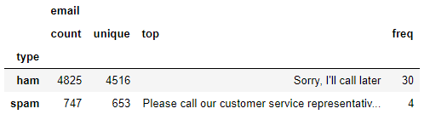
Figure 3(a) Types of Emails

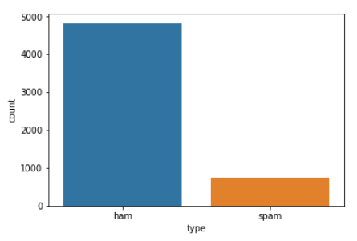
Figure 3(b) Representation of types of emails

IMPLEMENTATION AND RESULTS

Modules

- Data Preprocessing
- Feature Scaling
- Converting words to numbers
- Fitting the model
- Predicting
- Visualizing

Results and Discussion

The project was implemented successfully with an efficiency of 98.25%, which is quite good but the efficiency could be increased further to make more efficient. Naïve Bayes technique can be considered as a good model for this problem. F1-score and recall was calculated to be 98% and 98% respectively as shown in Figure-5. Confusion matrix is shown in Figure-6. The score is shown in Figure-7.

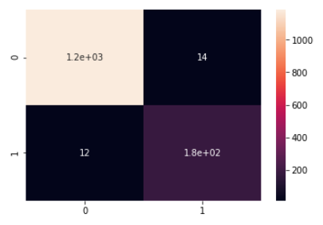
Figure 4 : confusion matrix

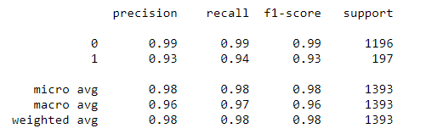
Figure 5 : output

FUTURE WORK AND CONCLUSION

Progress Chart/Time Line Chart

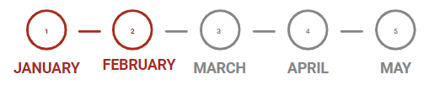
A thorough research Data Pre-processing Training the Testing the model Project
was performed model submission
on the problem Figure 6: Work Plan

MONTH 1: To gain knowledge on this project a thorough research on various algorithms was performed. Various research papers and blogs were referred regarding the project. Several models on classification were analyzed thoroughly and the most efficient one was selected.

MONTH 2: Data preprocessing was performed which includes three major steps which includes data collection, data preprocessing and data representation. A data-set in the form of csv file containing 5572 emails was collected which is a mixture of spam and ham emails. Removed of alphanumeric words and removal of stop words was performed under data cleaning. Finally data was represented in vector form using tf-idf.

MONTH 3: Training was performed in this month. First the dataset was divided into two parts which was training data and testing data. The model was trained using naïve Bayes technique.

MONTH 4: Testing and performance evaluation was done.

MONTH 5: Project is to be submitted.

Future work

Although we made efforts towards solving the problem of spam mail using naïve bayes technique, the results weren’t accurate .Future efforts would be extended towards:
- Achieving accurate classification ,with 0 misclassification.
- Efforts would be applied to block phishing emails which is a matter of concern now a days.
- Implementing this project efficiently by using neural network.

Conclusion

It is concluded from our project that for filtering out spam mails naïve Bayes technique is an efficient model which could be used as it provided quite satisfying results on our dataset. The fundamental Naive Bayes assumption is that each feature makes an independent and equal
contribution to the outcome which is not true in all the cases and is a major drawback for this technique. On the other hand neural networks may not provide efficient results as compared to naïve Bayes but there is a dependency on features. Hence neural network is the best approach, although it does not provide efficient results it can be further improvised upon to make the most efficient technique.

REFERENCES

Research Papers
[1] *David Ndumiyana, Munyaradzi Magomelo, and Lucy Sakala, “Spam Detection using a Neural Network Classifier”, Volume-2, 2013, 10 Pages

[2] S. B. Kotsiantis, D. Kanellopoulos and P. E. Pintelas, “Data Preprocessing for Supervised Leaning”, Volume-1, 2006, 7 Pages

[3] Priti Sharma1 Uma Bhardwaj1*, “Machine Learning based Spam E-Mail Detection”, Volume-11, 2017, 10 Pages

[4] Priyanka Sao, Pro. Kare Prashanthi, “E-mail Spam Classification Using Naïve Bayesian Classifier”, Volume-4, 2015, 5 Pages

[5]P. U. Anitha, C. V. Guru Rao and Suresh Babu, “Email Spam Classification using Neighbor Probability based Naïve Bayes Algorithm”, 2017, 6 Pages

[6]Vishal Kumar Singh and Shweta Bhardwag, “Spam Mail Detection using Classification Techniques and global training set”,2007, 8 Pages

[7] Megha Rathi and Vikas Pareek, “Spam Mail Detection through data mining-A Comparitive performance analysis”, 2013, 9 Pages

[8]Parhat Parveen and Gambhir Halse, “Spam Mail Detection using classification”, Volume-5, 2016, 3 Pages

Web

[1]How to Prepare Text Data for Machine Learning with scikit-learn, Machine learning mastery
(https://machinelearningmastery.com/prepare-text-data-machine-learning-scikit-learn/)

[2]Steps to learn naïve bayes algorithm, AnalyticsVidhya (https://www.analyticsvidhya.com/blog/2017/09/naive-bayes-explained/)

