Q-3

When a client connects to a server, the server pings the client with a message of “Hello” and the client responds the server with the same message “Hello”. We record the RTT for each client. We calculate 𝚫T(delay) which is the max of all the RTT of different clients.

All time quantities below is in microseconds.

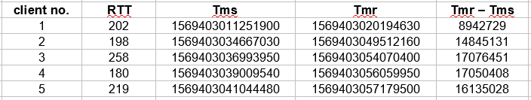

So, from above table we can see that Maximum RTT is 258 microseconds.

Here, (Tmr – Tms) is time it takes to completely transfer file from server to client. It will include time it takes for one packet to arrive at client and time to transmit file which will always be far greater than RTT. So, practically we can ignore it and display file as soon as it arrives.