NAME = VISHESH-KUMAR

REG_NO = 11615540

ROLL_NO = B52

SECTION = K1641 G2

==============================================================================================================================================

Q28. Consider a scenario of demand paged memory. Page table is held in registers. It takes 8 milliseconds to service a page fault if an empty page is available or the replaced page is not modified and 20 milliseconds if the replaced page is modified. Memory access time is 100 nanoseconds. Assume that the page to be replaced is modified 70 percent of the time.
Generate a solution to find maximum acceptable page-fault rate for access time that is not more than 200 nanoseconds.

MATHEMATICAL SOLUTION

Let p be the page fault rate (the probability that a memory access results in a pagefault). Then (1−p) is the probability that a memory access costs 100 nsec. The probability that a page fault costs 20 msec is 0.7∗p and the probability that a pagefault costs 8 msec is 0.3∗p. Since 1 nsec = 1000000 msec.

(1−p)∗100 + 0.7*p∗20000000 + 0.3∗p∗8000000 = 200
(14000000 + 2400000−100)p= 100
p= 100/(16400100)
p= 6.1∗10−6
p=.0000061
p=.00061%

We are implementing this mathematical expression in form of C programming language.

----------------------------------------------------------------------------------------------------------------------------- ----------------------------------------------------------------------------------------------------------------------------- ======================================================

CODE FOR THE PROGRAM

#include<stdio.h>
double change(double x)
{
x=x*1000000; //Converting from millisecond to nanosecond
return x; //returning the value in nanosec
}

int main()
{
double a,b,p,SPF,RPNM,MAT,EAT;

/* SPF=Service Page-Fault
RPNM=Replace Page Not Modified
MAT=Memory Access Time
EAT=Effective Address Time
*/

printf("Enter for the Replace Page Not Modified in millisecond:\n"); //Taking the value from user
scanf("%lf",&RPNM);
RPNM=change(RPNM); //Changing the value from millisec to nanosecond

printf("Enter for the Service Page Fault in millisecond:\n"); //Taking the value from user
scanf("%lf",&SPF);
SPF=change(SPF); //Changing the value from millisec to nanosecond

printf("Enter the Percentage of Page Replaced Modified TIME :\n"); //Taking the value from user
scanf("%le",&a);
a=a*0.01; //converting the value in percentage in integer form
SPF=a*SPF;

b=1-a;
RPNM=b*RPNM;

printf("Enter for the Memory Access Timein nanosecond:\n\n"); //Taking the value from user
scanf("%lf",&MAT);

printf("Enter for the Effective Address Time in nanosecond:\n"); //Taking the value from user
printf("Effective Address Time Should not be more than 200ns\n");
scanf("%lf",&EAT);

if(EAT>200)
{
printf("\tSorry\nThe Value of Effective Access Time is more than 200\n");
}
else
{
p=(EAT-MAT)/(RPNM+SPF-MAT); //using the formula for finding Page-Fault
p=p*100;
printf("The Maximum Acceptable Page-fault rate is: %lf%\n",p); //returning the Page-fault after calculation
return 0;
7 }

} //End of scope of the program

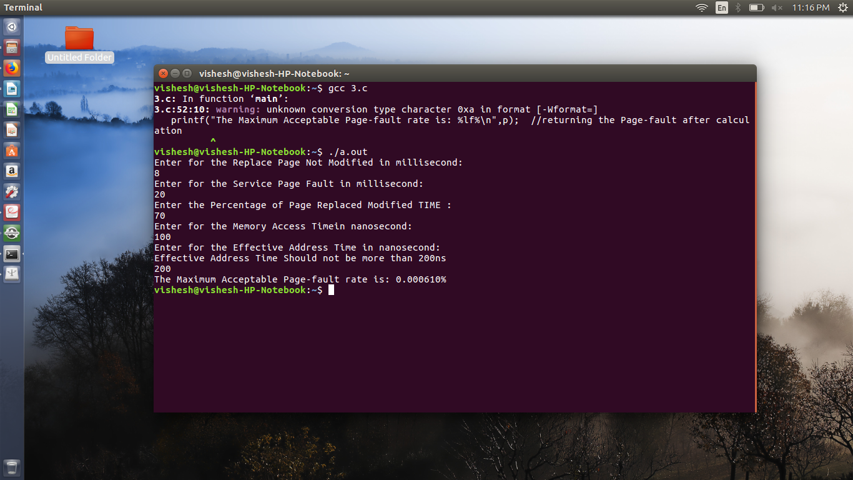

====================================================================================================================================================================================

Q5. The Fibonacci sequence is the series of numbers 0, 1, 1, 2, 3, 5, 8, .... Formally, it can be
expressed as:
f ib0 = 0
f ib1 = 1
f ibn = f ibn−1 + f ibn−2
Write a multithreaded program that generates the Fibonacci sequence. This program should work as follows: On the command line, the user will enter the number of Fibonacci numbers that the program is to generate. The program will then create a separate thread that will generate the Fibonacci numbers, placing the sequence in data that can be shared by the threads (an array is probably the most convenient data structure). When the thread finishes execution, the parent
thread will output the sequence generated by the child thread. Because the
parent thread cannot begin outputting the Fibonacci sequence until the child thread finishes, the parent thread will have to wait for the child thread to finish.

--------------------------------------------------------------------------------------------------------------------------------------------------------------------------------------------------------------

CODE FOR THE PROBLEM

#include<stdio.h> //Initialization of header files
#include<pthread.h>
int arr[1000];

void *fibo(); //creating Function for Parent thread
void *sequence(); //creating fucntion for child thread

void *sequence(int n)
{
int i,a=0,b=1,nextterm=0; //intialization of arguments

arr[n];
arr[1]=a;
arr[2]=b;
for(i=3;i<n;i++) //for loop for the child thread
{
nextterm=a+b; //using the fibonnaci formula
arr[i]=nextterm;
a=b;
b=nextterm;
nextterm=0;
}sleep(1);
//using sleep command
}

void *fibo()
{
int n,j;

scanf("%d",&n); //Child thread created
printf("child process created\n");
sequence(n);
printf("child process ended\n");
printf("Fibonacci Series is:\n");
for(j=0;j<n;j++)
{ //for the iteration of the process
printf("%d\n",arr[j]);
}

}

int main()
{
pthread_t p1,p2; // initilization of Thread p1 and p2
pthread_create(&p1,NULL,fibo,NULL); //parent thread created
printf("Enter the number for fibonacci series \n "); //taking the input from user
pthread_create(&p2,NULL,sequence,NULL); //child thread created
pthread_join(p1,NULL); //parent thread joined
pthread_join(p2,NULL); //child thread joined
//pthread_exit(NULL);
} //End of scope of the program

