**EXPERIMENT - 7**

Exp No:7 Practice Queries using ANY, ALL, IN, EXISTS, UNION, INTERSECT Set Operators Set operators combine the results of two queries into a single one. The following set operators are available in SQL.

* Union
* Union All
* Intersect
* Minus

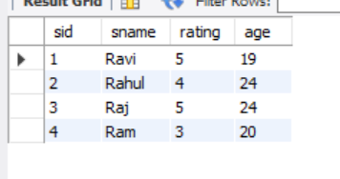



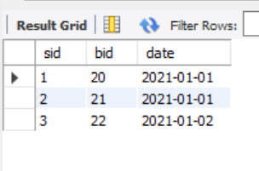

ANY

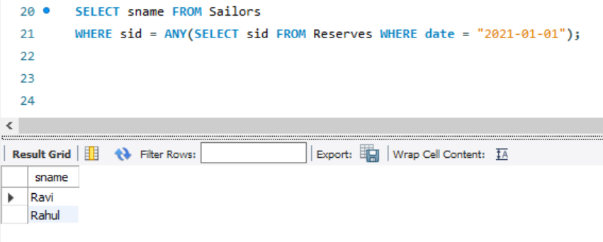

ALL

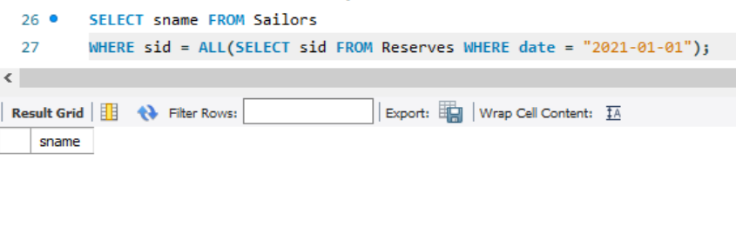

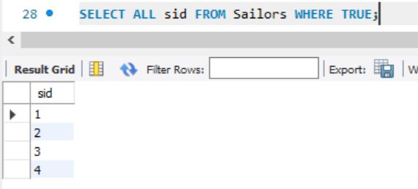

IN

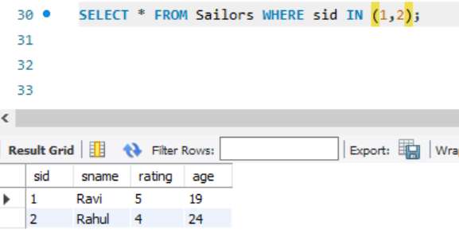

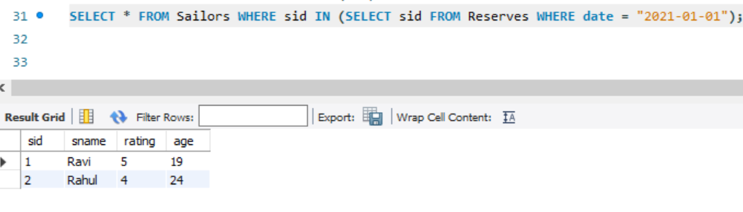

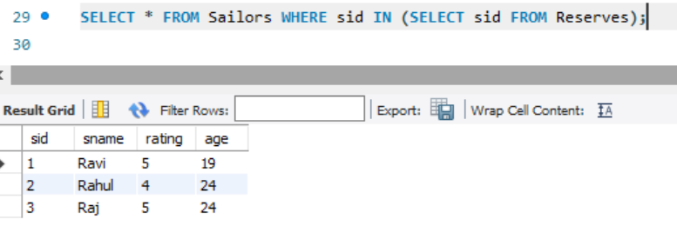

EXISTS

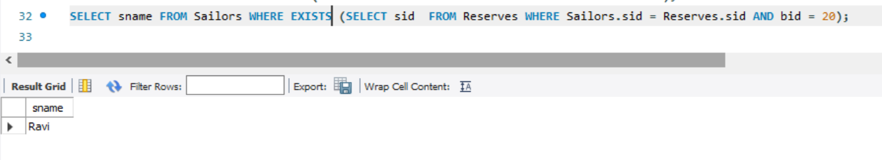

UNION

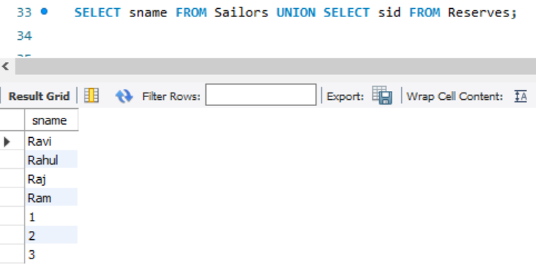

UNION ALL

