**EXPERIMENT – 8**

Exp No 8: Practice Queries using Aggregate functions, Group By, Having Clause and Order by Clause.

Average

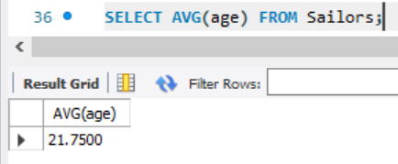

Min

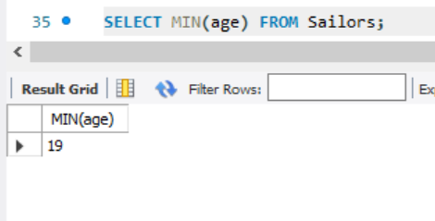

Max

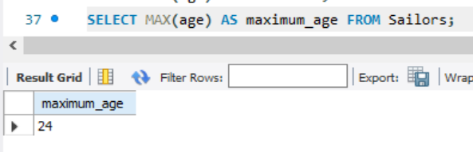

Sum

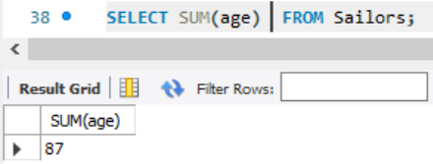

COUNT

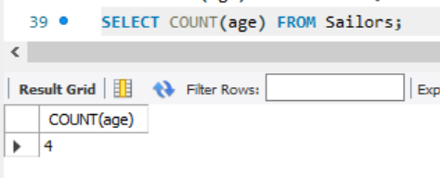

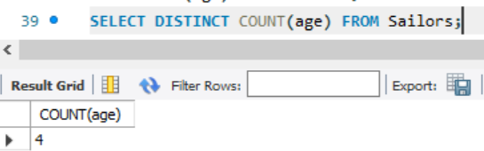

GROUP BY

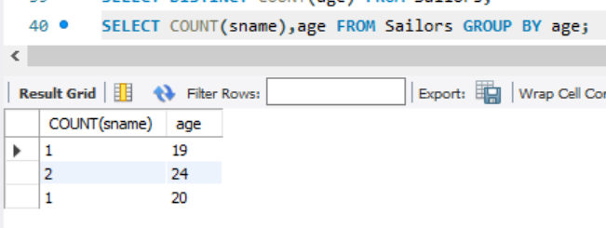

ORDER BY

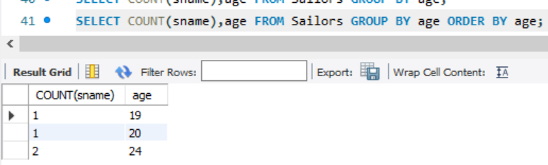

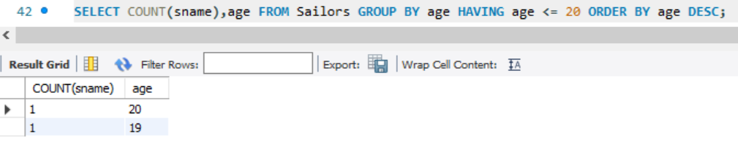

HAVING

