**EXPERIMENT – 9**

Views

Creating views

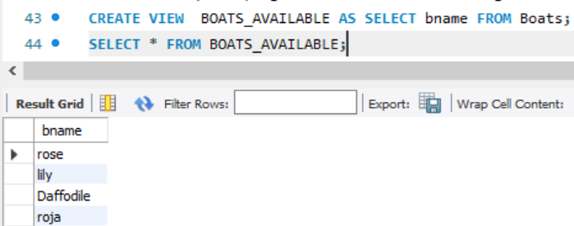

Create or Replace View

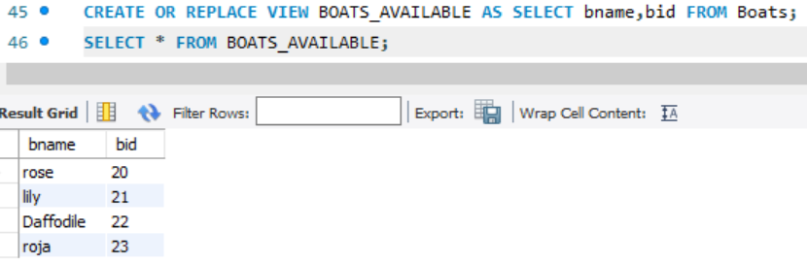

Drop View

