**EXPERIMENT – 1**

Exp No: 1 Analyze the problem and come with the entities in it. Identify what data has to be persisted in the databases. (E-R Model)

Student – ENTITY

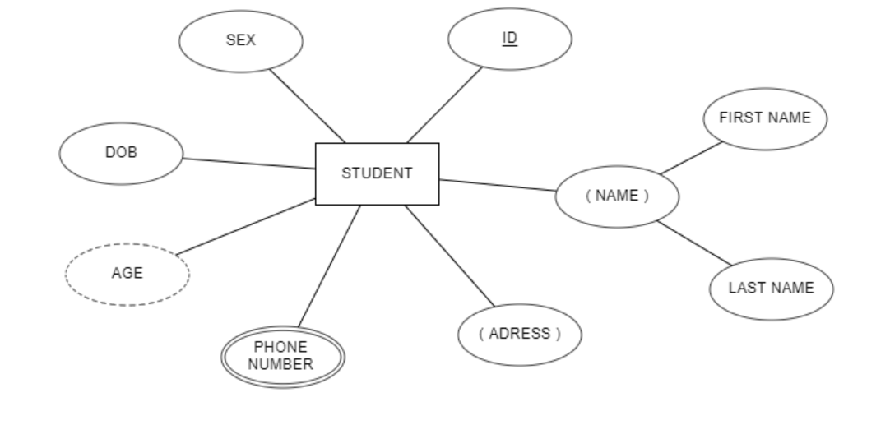

Exam – ENTITY

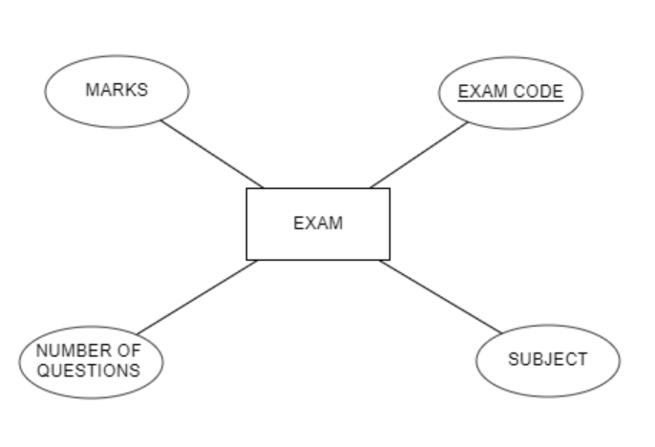

Report Card – ENTITY

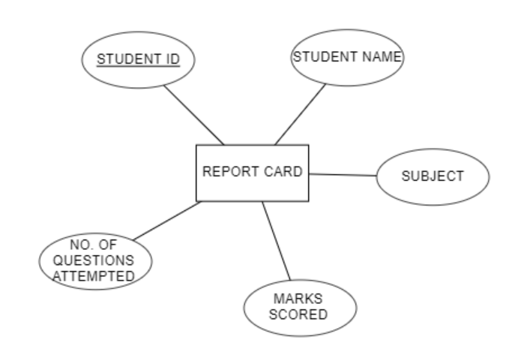

Application Form – RELATIONSHIP

