Mini Project

On

SENTIMENT ANALYSIS ON LIVE TWEETS
Submitted in partial fulfillment of the requirements for the award of degree of

BACHELOR OF TECHNOLOGY
in
COMPUTER SCIENCE & ENGINEERING

BY

19WH1A05B3 M. SRINIDHI
19WH1A0590 T. LAHARI
19WH1A0579 G. SUVIDHA

Under the esteemed guidance of

Mr. C.Nagaraju
Assistant Professor



Department of Computer Science & Engineering

BVRIT HYDERABAD
COLLEGE OF ENGINEERING FOR WOMEN
(NBA Accredited EEE.ECE.CSE.IT B.Tech Courses)
(Approved by AICTE, New Delhi and Affiliated to JNTUH, Hyderabad)
Bachupally, Hyderabad – 500090

Jan 2023

Department of Computer Science & Engineering

BVRIT HYDERABAD
COLLEGE OF ENGINEERING FOR WOMEN
(NBA Accredited EEE.ECE.CSE.IT B.Tech Courses)
(Approved by AICTE, New Delhi and Affiliated to JNTUH, Hyderabad)
Bachupally, Hyderabad – 500090

CERTIFICATE

This is to certify that the mini project entitled “Sentiment Analysis on Live tweets” is a bonafide work carried out by Ms. M. Srinidhi (19wh1a05b3), Ms. T. Lahari(19wh1a0590), Ms. S. Suvidha(19wh1a0579) in partial fulfillment for the award of B.Tech degree in Computer Science & Engineering , BVRIT HYDERABAD College of Engineering for Women, Bachupally, Hyderabad, affiliated to Jawaharlal Nehru Technological University Hyderabad, Hyderabad under my guidance and supervision. The results embodied in the project work have not been submitted to any other University or Institute for the award of any degree or diploma.

Internal Guide Head of the Department
C. Nagaraju Dr.Suneetha Rani
Assistant Professor, CSE Professor, CSE

External Examiner
DECLARATION

We hereby declare that the work presented in this project entitled “Sentiment Analysis on Live tweets” submitted towards completion of Project work in IV Year of B.Tech of CSE at BVRIT HYDERABAD College of Engineering for Women, Hyderabad is an authentic record of our original work carried out under the guidance of C. Nagaraju, Assistant Professor, Department of CSE.

Sign with Date:
M. Srinidhi
(19wh1a05b3)

Sign with Date:
T. Lahari
(19wh1a0590)

Sign with Date:
G. Suvidha
(19wh1a0579)

ACKNOWLEDGEMENT

We would like to express our sincere thanks to Dr.K.V.N.Sunitha, Principal, BVRIT HYDERABAD College of Engineering for Women, for her support by providing the working facilities in the college.

Our sincere thanks and gratitude to Dr. R. Suneetha Rani, Head, Department of CSE, BVRIT HYDERABAD College of Engineering for Women, for all timely support and valuable suggestions during the period of our project.

We are extremely thankful to our Internal Guide, C. Nagaraju, Assistant Professor, CSE, BVRIT HYDERABAD College of Engineering for Women, for his constant guidance and encouragement throughout the project.

Finally, we would like to thank our Mini Project Coordinator, all Faculty and Staff of CSE department who helped us directly or indirectly. Last but not least, we wish to acknowledge our Parents and Friends for giving moral strength and constant encouragement.

M. Srinidhi (19wh1a05b3)

T. Lahari (19wh1a0590)

G. Suvidha (19wh1a0579)

ABSTRACT

Sentiment analysis uses machine learning to automatically identify how people are talking about a given topic. The most common use of sentiment analysis is detecting the polarity of text data, that is, automatically identifying if a tweet, product review or support ticket is talking positively, negatively, or neutral about something. Opinion of people matters a lot to analyze how the propagation of information impacts the lives in a large-scale network like twitter. This project deals with analyzing sentiments behind the tweets, whether they are about a person, product, movie. Analyzing the public sentiment is more important for many applications such as firms trying to find out the response of their products in the market, predicting political elections and predicting socio-economic phenomena like stock exchange. The goal of this is to determine whether the expressed opinion in the text is positive, negative or neutral. We created an application where the input can be a single tweet or a twitter handle or a hashtag.

LIST OF CONTENTS

S.No Topic Page No.

1 Introduction 1

2 Requirements 2

3 Design 3

4 Implementation 9

5 Testing 14

6 Conclusion & Future scope 15

7 References 16

LIST OF FIGURES

S.No | Description | Page. No
1 | Architecture | 7
2 | Create application | 8
3 | Application settings | 9
4 | Access Token | 9
5 | Use case diagram | 11
6 | Activity diagram | 12
7 | Sample input (Trendy Hashtag) | 22
8 | Sample output (Trendy Hashtag) | 22
9 | Sample input (Twitter Handle) | 23
10 | Sample output (Twitter Handle) | 23
11 | Sample output (Bar graph) | 24

1.INTRODUCTION
1.1 Problem statement:
Given a tweet, classify whether the message is of positive, negative, or neutral sentiment. For messages conveying both a positive and negative sentiment.
1.2 Objective:
Sentiment analysis is a way to analyze the subjective information in the text and then mine the opinion. Sentiment analysis is the procedure by which information is extracted from opinions, appraisals and emotions of people in regards to entities, events and their attributes.
1.3 Proposed system:
We have a system that performs sentiment analysis on twitter data or tweets and classify them into three categories:
- Positive
- Negative
- Neutral
Features of our application includes
- Live tweets
- Twitter handle
- Trendy hashtag
- Bar graph
Sentiment analysis is the process of using text analytics to understand the polarity of sentences. The basic task in sentiment analysis is classifying the polarity of sentence. We extracted the tweets from twitter.
The following is a brief description associated with the various tweets.
- Sentiment: Expressions which are used to describe the users conditions or feeling for an issue or their personal issues.
- Twitter Handle: The twitter users will use the special characters “@” symbol to simply refer to other users on the various microblog which continuously alerts them.
- Hashtags: The users usually use the hashtags “#” symbol to refer to various topics.This is to increase the views of their personal tweets.
2. REQUIREMENTS

2.1 Software requirements:
- Programming Language : Python 3.6
- Graphical User Interface : HTML5, CSS3
- Dataset : twitter dataset
- Packages : Tweepy, Numpy, Pandas, Scikit-learn, Pipeline, NLTK
- Framework : Django
- Tool : Pycharm

2.2 Hardware Requirements:
- Intel core i3 processor
- RAM 4GB
- Hard Disk Drive 1 TB

2.3 Technologies Description
PYTHON
Python is an interpreted high-level programming language for general-purpose programming. Created by Guido van Rossum and first released in 1991, Python has a design philosophy that emphasizes code readability, notably using significant whitespace.
Python features a dynamic type system and automatic memory management. It supports multiple programming paradigms, including object-oriented, imperative, functional and procedural, and has a large and comprehensive standard library.
- Python is Interpreted − Python is processed at runtime by the interpreter. You do not need to compile your program before executing it. This is similar to PERL and PHP.
- Python is Interactive − you can actually sit at a Python prompt and interact with the interpreter directly to write your programs.

Python also acknowledges that speed of development is important. Readable and terse code is part of this, and so is access to powerful constructs that avoid tedious repetition of code. Maintainability also ties into this may be an all but useless metric, but it does say something about how much code you have to scan, read and/or understand to troubleshoot problems or tweak behaviors. This speed of development, the ease with which a programmer of other languages can pick up basic Python skills and the huge standard library is key to another area where Python excels. All its tools have been quick to implement, saved a lot of time, and several of them have later been patched and updated by people with no Python background - without breaking.

HTML
HTML stands for Hypertext Markup Language, and it is the most widely used language to write Web Pages.
- Hypertext refers to the way in which Web pages (HTML documents) are linked together. Thus, the link available on a webpage is called Hypertext.
- As its name suggests, HTML is a Markup Language which means you use HTML to simply "mark-up" a text document with tags that tell a Web browser how to structure it to display.
Originally, HTML was developed with the intent of defining the structure of documents like headings, paragraphs, lists, and so forth to facilitate the sharing of scientific information between researchers.
Now, HTML is being widely used to format web pages with the help of different tags available in HTML language.

CSS
Cascading Style Sheets, fondly referred to as CSS, is a simple design language intended to simplify the process of making web pages presentable.
CSS handles the look and feel part of a web page. Using CSS, you can control the color of the text, the style of fonts, the spacing between paragraphs, how columns are sized and laid out, what background images or colors are used, layout designs, and variations in display for different devices and screen sizes as well as a variety of other effects.
CSS is easy to learn and understand but it provides powerful control over the presentation of an HTML document. Most commonly, CSS is combined with the markup languages HTML or XHTML.

DATASET
tweets.csv
https://www.kaggle.com/datasets/yasserh/twitter-tweets-sentiment-dataset

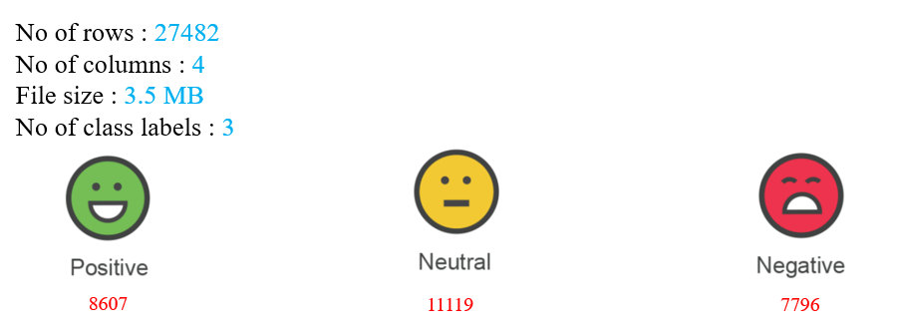

TWEEPY
Tweepy is used for accessing the twitter api. It is basically a python library, which is magnificent for the generation of automations and twitters bots. The StreamListener object in tweepy monitors the tweets in real time and catches them.
NUMPY
Numpy is a general-purpose array-processing package. It provides a high-performance multidimensional array object, and tools for working with these arrays.
It is the fundamental package for scientific computing with Python. It contains various features including these important ones:
- A powerful N-dimensional array object
- Sophisticated (broadcasting) functions
- Tools for integrating C/C++ and Fortran code
- Useful linear algebra, Fourier transform, and random number capabilities
Besides its obvious scientific uses, Numpy can also be used as an efficient multi-dimensional container of generic data. Arbitrary data-types can be defined using Numpy which allows Numpy to seamlessly and speedily integrate with a wide variety of databases.

Pandas
Pandas is an open-source Python Library providing high-performance data manipulation and analysis tool using its powerful data structures. Python was majorly used for data munging and preparation. It had very little contribution towards data analysis. Pandas solved this problem.
Scikit – learn
Scikit-learn provides a range of supervised and unsupervised learning algorithms via a consistent interface in Python. It is licensed under a permissive simplified BSD license and is distributed under many Linux distributions, encouraging academic and commercial use. The library is built upon the SciPy (Scientific Python) that must be installed before you can use scikit-learn. This stack that includes:
- NumPy: Base n-dimensional array package
- SciPy: Fundamental library for scientific computing
- Matplotlib: Comprehensive 2D/3D plotting
- IPython: Enhanced interactive console
- Sympy: Symbolic mathematics
- Pandas: Data structures and analysis
- Extensions or modules for SciPy care conventionally named SciKits. As such, the module provides learning algorithms and is named scikit-learn.

PIPELINE
ML pipeline is a means of automating the machine learning workflow by enabling data to be transformed and correlated into a model that can then be analyzed to achieve outputs. This type of ML pipeline makes the process of inputting data into the ML model fully automated.
NLTK
NLTK is a leading platform for building Python programs to work with human language data. It provides easy-to-use interfaces to over 50 corpora and lexical resources such as WordNet, along with a suite of text processing libraries for classification, tokenization, stemming, tagging, parsing, and semantic reasoning, wrappers for industrial-strength NLP libraries, and an active discussion forum.
DJANGO
Django is a high-level Python web framework that encourages rapid development and clean, pragmatic design. Django makes it easier to build better web apps quickly and with less code.
Django is a registered trademark of the Django Software Foundation, and is licensed under BSD License.

PYCHARM
PyCharm takes care of the routine while you focus on the bigger things. Embrace the keyboard-centric approach and get more productive with PyCharm.

3. DESIGN
Architecture:

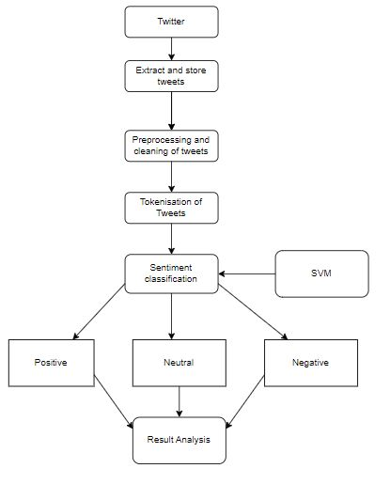
Figure 1. Architecture

3.1 Getting authentication credentials:
- To have access to the Twitter API, we need to login the Twitter Developer website and create an application.
- After creating an application we will be provided with few keys such as access token, consumer key, consumer secret, consumer secret token through which we can get tweets.

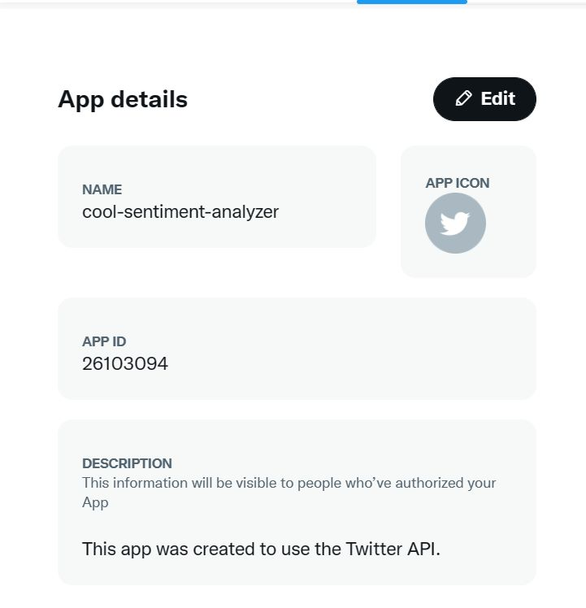

Figure 2. Creating an application

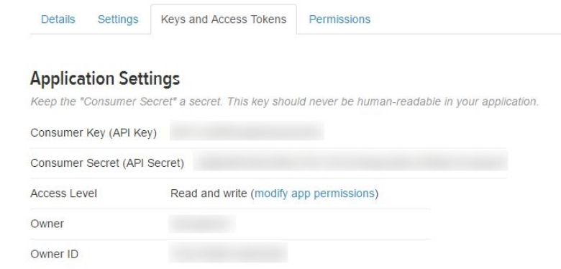

Figure 3. Application settings

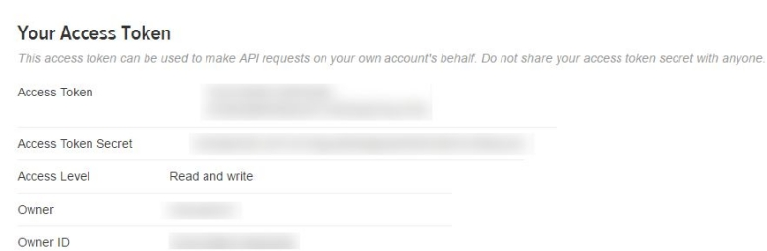

Figure 4. Access tokens

3.2 Fetching tweets:
- First of all, we create a TwitterClient class. This class contains all the methods to interact with Twitter API and parsing tweets.
- In get_tweets function, we use search method to retrieve tweets.

3.3 Processing of tweets:
- After retrieving tweets first step is to clean tweets which removes links, special characters etc., from the tweets.
- Then cleaned tweets are passed to nltk which performs tokenizing tweets i.e., splitting words from body of text along with removing stop words from the tokens (stop words are the commonly used words which are irrelevant in text analysis like I, am, you, are, etc.)
- Do POS (part of speech) tagging of the tokens and select only significant features/tokens like adjectives, adverbs, etc.
- Pass the tokens to a sentiment classifier which classifies the tweet sentiment as positive, negative or neutral.
- Then the classified tweets are show in tabular format.

Use case Diagram:
A use case diagram is used to represent the dynamic behavior of a system. It encapsulates the system's functionality by incorporating use cases, actors, and their relationships. It models the tasks, services, and functions required by a system/subsystem of an application. It depicts the high-level functionality of a system and also tells how the user handles a system.

The main purpose of a use case diagram is to portray the dynamic aspect of a system. It accumulates the system's requirement, which includes both internal as well as external influences. It invokes persons, use cases, and several things that invoke the actors and elements accountable for the implementation of use case diagrams. It represents how an entity from the external environment can interact with a part of the system.

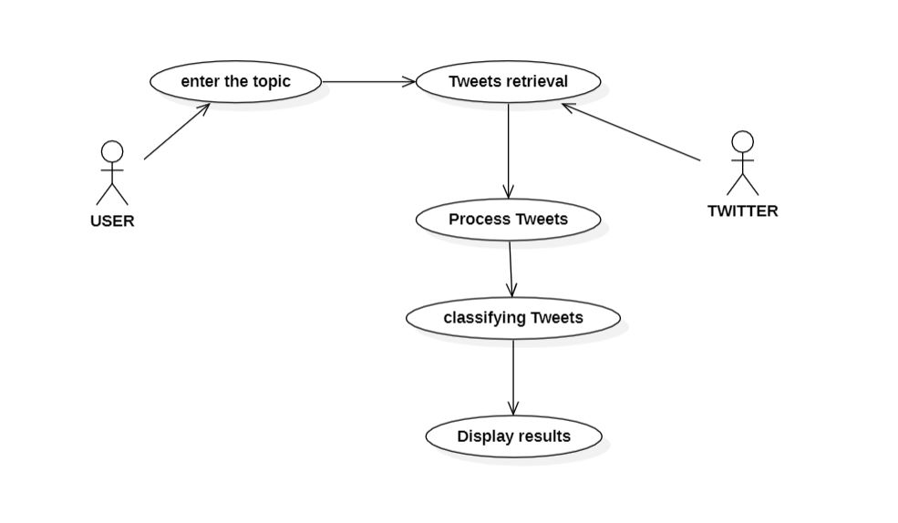

Figure 5. Use case diagram

Activity Diagram:
An activity diagram visually presents a series of actions or flow of control in a system similar
to a flowchart or a data flow diagram. Activity diagrams are often used in business process
modeling. They can also describe the steps in a use case diagram. Activities modeled can be
sequential and concurrent. In both cases an activity diagram will have a beginning (an initial
state) and an end (a final state).

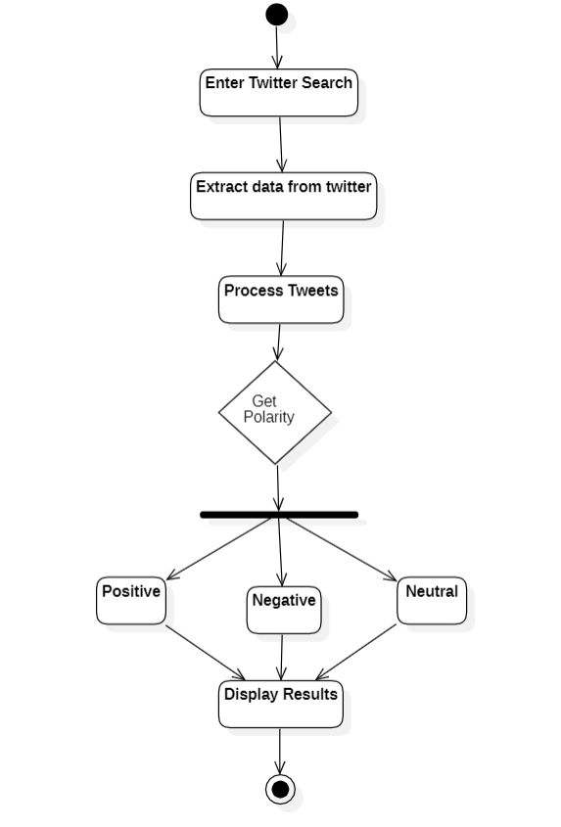
Figure 6. Activity diagram

4. IMPLEMENTATION

#import necessary libraries
import pandas as pd
import numpy as np
import seaborn as sns
import re

import nltk
nltk.download('stopwords')
nltk.download('wordnet')
nltk.download('punkt')
nltk.download('averaged_perceptron_tagger')
nltk.download('omw-1.4')

#Load the dataset
tweets = pd.read_csv(r'/content/sample_data/train.csv')
tweets.head()

tweets = tweets[['selected_text','sentiment']].rename(columns={'selected_text':'text'})
tweets.head()

tweets.dropna(inplace=True)
# Dropping duplicates from text column
tweets.drop_duplicates(subset={'text'}, inplace=True)

from nltk.corpus import stopwords
from nltk.tokenize import word_tokenize
stop_words = set(stopwords.words('english'))

def remove_stop_words(x):
word_tokens = word_tokenize(x)
return ' '.join([word for word in word_tokens if word not in stop_words])

tweets['text'] = tweets['text'].apply(lambda x: remove_stop_words(x))

import string

#Clean the text
def de_emojify(input_string):
return input_string.encode('ascii', 'ignore').decode('ascii')

REPLACE_BY_SPACE_RE = re.compile('[/(){}\[\]\|]')
BAD_SYMBOLS_RE = re.compile('[^a-z #+_]')
def clean_txt(df, text_col='text'):
# Lower case
df[text_col] = df[text_col].apply(lambda x: x.lower())
# Remove twitter handles
df[text_col] = df[text_col].apply(lambda x: re.sub('@[^\s]+','',x))
# Remove puntuation
df[text_col] = df[text_col].apply(lambda x: ''.join([c for c in x if c not in string.punctuation]))
# Remove URLs
df[text_col] = df[text_col].apply(lambda x: re.sub(r"http\S+", '', x))
# Remove emojis
df[text_col] = df[text_col].apply(de_emojify)
# Remove Emails
df[text_col] = df[text_col].apply(lambda x: re.sub('[^\n]*@\S*\s?', '', x))
# Remove new line characters
df[text_col] = df[text_col].apply(lambda x: re.sub(r'\s+', ' ', x))
# Remove distracting single quotes
df[text_col] = df[text_col].apply(lambda x: re.sub(r"\'", '', x))
# Replace REPLACE_BY_SPACE_RE symbols by space in text
df[text_col] = df[text_col].apply(lambda x: REPLACE_BY_SPACE_RE.sub(' ', x))
# Delete symbols which are in BAD_SYMBOLS_RE from text
df[text_col] = df[text_col].apply(lambda x: BAD_SYMBOLS_RE.sub('', x))

# Remove hashtags
df[text_col] = df[text_col].apply(lambda x: re.sub(r'\B#\S+','',x))
return df[df[text_col]!='']
tweets = clean_txt(tweets)
from nltk.corpus import wordnet
from nltk.stem import WordNetLemmatizer
def get_wordnet_pos(word):
"""Map POS tag to first character lemmatize() accepts"""
tag = nltk.pos_tag([word])[0][1][0].upper()
tag_dict = {"J": wordnet.ADJ,
"N": wordnet.NOUN,
"V": wordnet.VERB,
"R": wordnet.ADV}

return tag_dict.get(tag, wordnet.NOUN)
# 1. Init Lemmatizer
lemmatizer = WordNetLemmatizer()
# 2. Lemmatize a Sentence with the appropriate POS tag
def lem(x):
return ''.join(lemmatizer.lemmatize(w, get_wordnet_pos(w)) for w in x.split())

tweets['text'] = tweets['text'].apply(lambda x: lem(x))

X = tweets['text']
y = tweets['sentiment']

from sklearn.model_selection import train_test_split
X_train, X_test, y_train, y_test = train_test_split(X, y, test_size=0.3, random_state=42)

from sklearn.pipeline import Pipeline
from sklearn.feature_extraction.text import TfidfTransformer
from sklearn.metrics import classification_report, confusion_matrix, accuracy_score

from sklearn.naive_bayes import MultinomialNB

nb = Pipeline([('vect', CountVectorizer(ngram_range=[1,1])),
('tfidf', TfidfTransformer()),
('clf', MultinomialNB()),
])
nb.fit(X_train, y_train)
y_pred = nb.predict(X_test)

print('Classification Report: \n', classification_report(y_test, y_pred, target_names = ['positive', 'neutral', 'negative']))
print('Confusion Matrix: \n', confusion_matrix(y_test, y_pred))
print('Accuracy score: \n', accuracy_score(y_test, y_pred))

from sklearn.ensemble import RandomForestClassifier
from sklearn.model_selection import RandomizedSearchCV

# Create a search grid of parameters that will be shuffled through

param_grid = {

'bootstrap': [True],

'max_depth': [10, 20, 30, 40, 50, 60, 70, 80, 90, 100, None],

'max_features': ['auto', 'sqrt'],

'min_samples_leaf': [1, 2, 4],

'min_samples_split': [2, 5, 10],

'n_estimators': [200, 400, 600, 800, 1000, 1200, 1400, 1600, 1800, 2000]
}

# Using the random grid and searching for best hyperparameters
rf = RandomForestClassifier() #creating base model
rf_random = RandomizedSearchCV(estimator = rf, param_distributions = random_grid, n_iter = 100, cv = 5, verbose=2, random_state=42, n_jobs = -1)
rf = Pipeline([
('bow',CountVectorizer(ngram_range=[1,1])),
('tfidf',TfidfTransformer()),
('classifier',rf_random)
])
rf.fit(X_train, y_train)

from sklearn.model_selection import GridSearchCV
# Create the parameter grid based on the results of random search

param_grid = {

'bootstrap': [True],

'max_depth': [80, 90, 100, 110],

'max_features': [2, 3],
'min_samples_leaf': [3, 4, 5],
'min_samples_split': [8, 10, 12],
'n_estimators': [100, 200, 300, 1000]

}

# Create a based model

rf = RandomForestClassifier()

# Instantiate the grid search model

grid_search = GridSearchCV(estimator = rf, param_grid = param_grid,

cv = 3, n_jobs = 4, verbose = 2)

rf = Pipeline([
('bow',CountVectorizer(ngram_range=[1,1])),
('tfidf',TfidfTransformer()),
('classifier',grid_search)
])

rf.fit(X_train, y_train)
y_pred = rf.predict(X_test)

grid_search.best_params_
best_grid = grid_search.best_estimator_

print('Classification Report: \n', classification_report(y_test, y_pred, target_names = ['positive', 'neutral', 'negative']))
print('Confusion Matrix: \n', confusion_matrix(y_test, y_pred))
print('Accuracy score: \n', accuracy_score(y_test, y_pred))

from sklearn.model_selection import GridSearchCV
from sklearn.svm import SVC

grid_values = {'clf__kernel':['linear', 'rbf'], 'clf__C':[1e0, 1e1, 1e2, 1e-1, 1e-2], 'clf__gamma': [1, 0.1, 0.01, 10]}
grid_clf = GridSearchCV(SVC(), param_grid = grid_values, scoring='accuracy', cv=3)

svm = Pipeline([('vect', CountVectorizer(ngram_range=[1, 1])),
('tfidf', TfidfTransformer()),
('clf', grid_clf),
])

svm.fit(X_train, y_train)
y_pred = svm.predict(X_test)

grid_clf.best_params_
model = grid_clf.best_estimator_

print('Classification Report: \n', classification_report(y_test, y_pred, target_names = ['positive', 'neutral', 'negative']))
print('Confusion Matrix: \n', confusion_matrix(y_test, y_pred))
print('Accuracy score: \n', accuracy_score(y_test, y_pred))

import pickle
pickle.dump(SVM, open('models' + ".p", "wb"))

5. TESTING

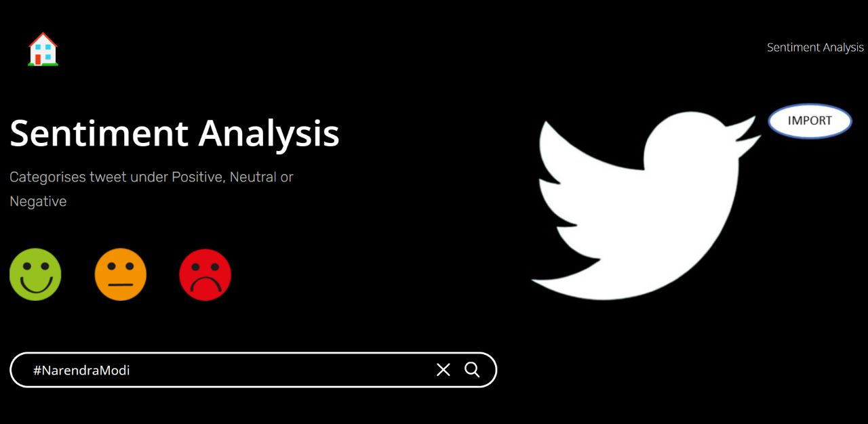

Figure 7. Sample input (Trendy Hashtag)

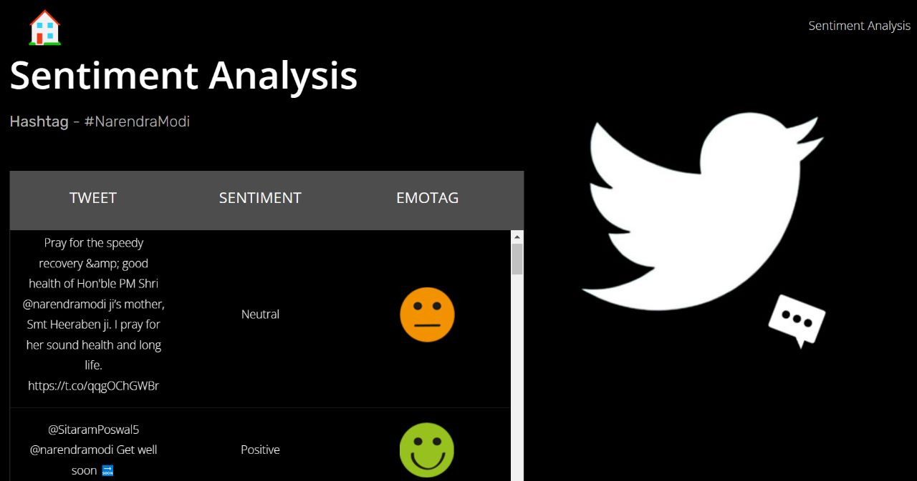

Figure 8. Sample output (Trendy hashtag tweets)

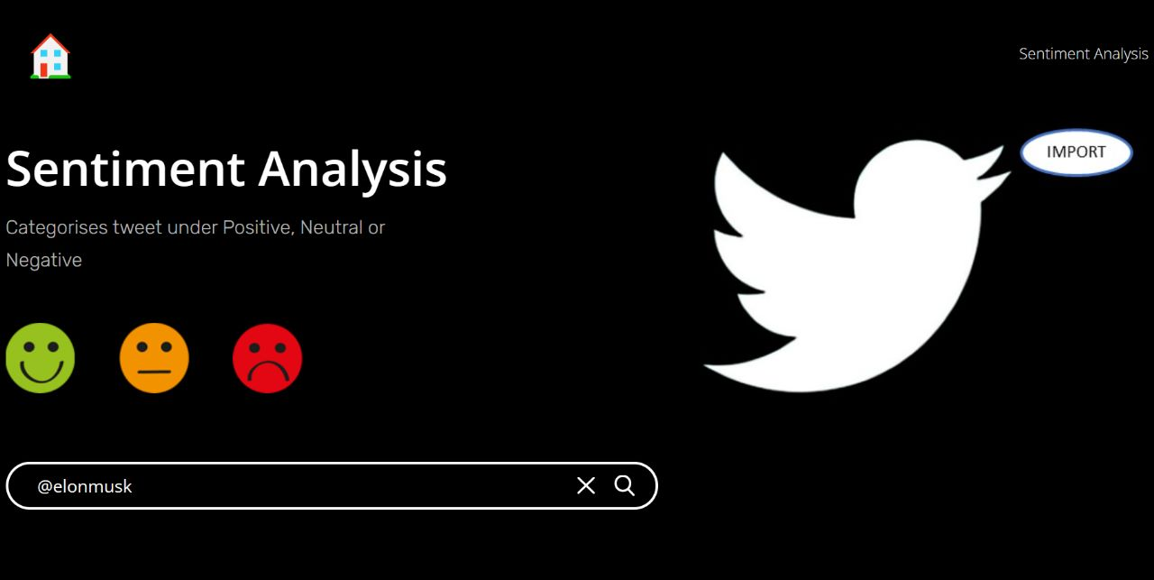

Figure 9. Sample input (Twitter Handle)

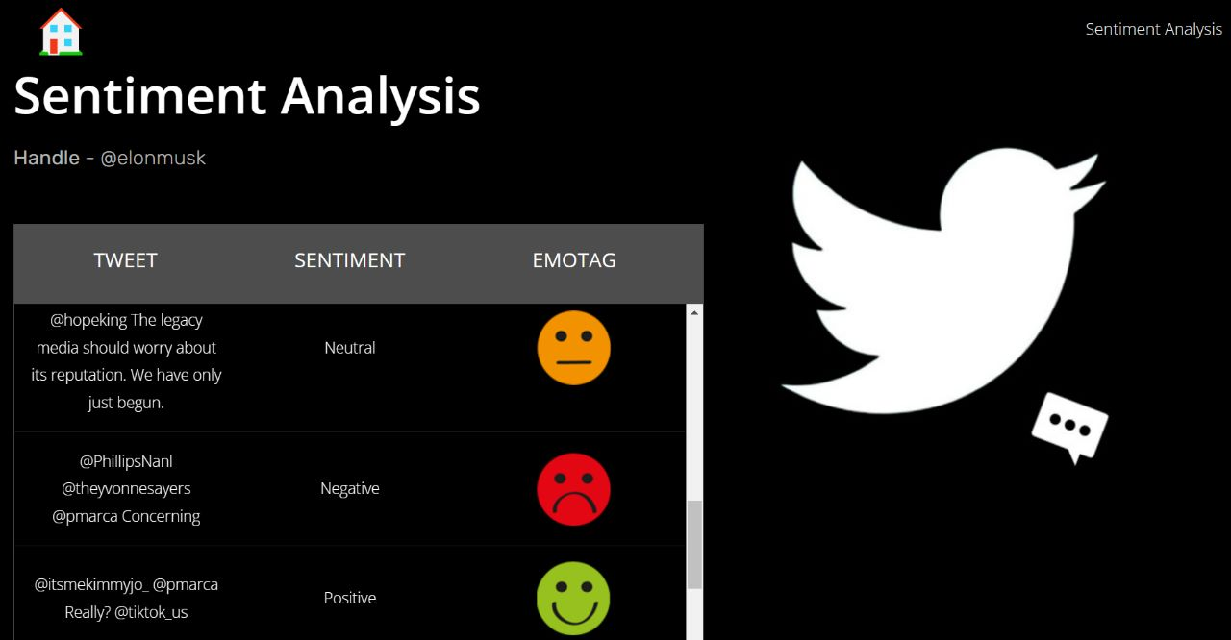

Figure 10. Sample input (Twitter Handle)

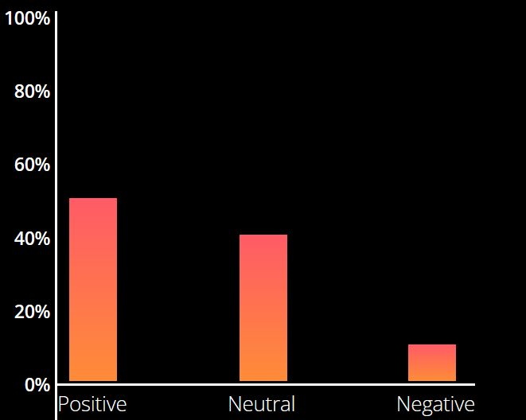

Figure 11. Sample output (Bar graph)

6. CONCLUSION & FUTURE SCOPE

Sentiment analysis is a field of study for analyzing opinions expressed in text in several social media sites such as twitter.
Our proposed model used several algorithms to enhance the accuracy of classifying tweets as positive, negative and neutral.
Our application provides Sentiment analysis for the tweets on a particular topic, or twitter handle by classifying the tweet using SVM algorithm.
We are still far to detect the sentiments of texts very accurately because of the complexity in the English language and sarcasm.

7. REFERENCES

[1] Adyan Marendra Ramadhani & Hong Soon Goo, “Twitter Sentiment Analysis using Deep Learning Methods”, Department of Management Information Systems Dong-A University Busan South Korea, 2017.

[2] C. Kaur and A. Sharma, “Twitter Sentiment Analysis on Coronavirus using Textblob,” EasyChair2516-2314, 2020.

[3] Assiri, A., Emam, A. and Al-Dossari, H. (2016). Saudi Twitter Corpus for Sentiment Analysis. International Journal of Computer and Information Engineering, [online] 10. Available at: http://waset.org/publications/10003483/saudi-twitter-corpus-forsentiment-analysis [Accessed 1 Mar. 2018].

