SET OPERATIONS:

* UNION
* UNION ALL
* INTERSECT
* MINUS

QUERIES:

create table first(ID integer, stdName varchar(20));

create table second(ID integer, stdName varchar(20));

desc table first;

desc table second;

insert into first values(1,"Rishi");

insert into first values(2,'dinesh');

insert into first values(3,'shreya');

select\*from first;

insert into second values(4,"poojitha");

insert into second values(5,'sanju');

insert into second values(6,'gowtham');

select\*from second;

select\*from first UNION select\*from second;

select\*from first UNION ALL select\*from second;

select\*from first INTERSECT select\*from second;

select\*from first MINUS select\*from second;

OUTPUT:

Table 1:

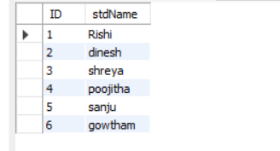

Table 2:

