
BVRIT HYDERABAD
College of Engineering for Women
Department of Information Technology
Major Project - Academic Year 2022-23
Abstract
IoT technology nowadays is used for many purposes which make the user’s daily life more comfortable. Internet of Things is the combination of multiple technologies, real time analytics, machine learning, commodity sensors, and embedded systems. These physical devices are embedded with electronics, Internet connectivity, and other forms of hardware like sensors. These physical devices can communicate and interact with others over the Internet, and they can be remotely monitored and controlled. Wearable Smart- Shoe technology which works with the help of IoT consists of embedded features like GSM module (sending SMS), Arduino, GPRS device (sends alert messages when tapped by foot when in danger). This paper focus on the use of Wearable Smart-Shoe technology for the health fitness purpose. The shoe is designed in such a way that anyone who do running or walking by wearing this shoe, they will get to know how many steps they have walked and if the person sits ideal for some time, then he’ll get a warm-up message and in case if he does over exercise, then he’ll get rest for a while SMS.

Smart Shoe for Health Fitness
using IoT
Modules
Movement Detection
Calculating Steps
Calculating Time
Calculating Distance
Tracking location with GPS
Sending SMS

Architecture
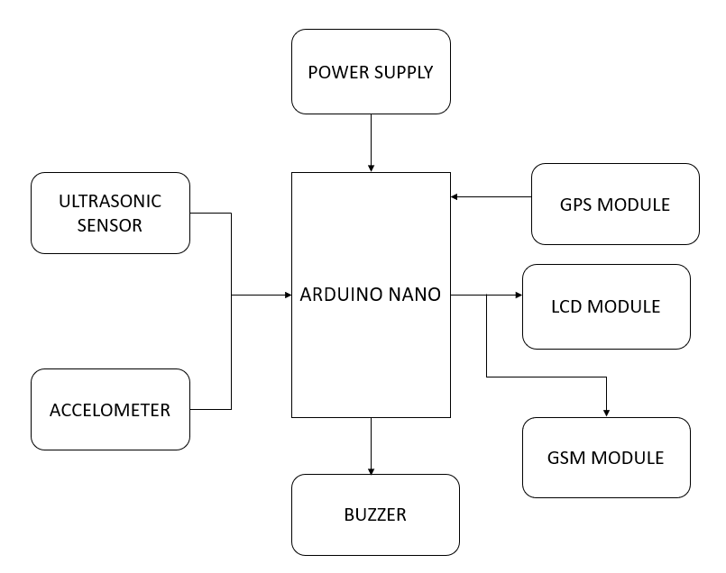

Tools and Technologies
- Arduino UNO, Mems Sensor, LCD Display, Power Supply, Ultra Sonic Sensor, Buzzer Alarm, GPS Module, GSM Module, Arduino-IDE, Embedded C
Conclusion and Future Scope
The Wearable device Smart-Shoe technology is in higher demand by the consumer market with its no of various features embedded in it. The proposed system consists of embedded features as: Step Count, helping from over exercise through walking and running by remaindering user to take some rest through "Rest for a while" message, helping user from dehydration by giving him water remainder message, if the user sat ideal for some time then remaindering him to do some exercise by giving "Warm up “message and also tracks the user’s location with the help of GPS device. This whole process is done by sending SMS to our mobile phones with the help of GSM module. In the future, extending multi-functional Smart Shoe related applications can be created.

TEAM
8
Guide
Ms. K.S.Niraja
Assistant Professor
niraja.ksvce@gmail.com

Team

19wh1a1262 19wh1a1273 19wh1a1280 19wh1a1298
C. Neha Reddy K. Deekshita S. Sravani B. Sai Likhitha

Github Link
- https://github.com/19wh1a1262
- http://github.com/19wh1a1273
- https://github.com/sravani1280
- https://github.com/likhitha-battula

