Exploratory Analysis and Marketing Campaign Design for a Restaurant Chain

By

Muhammad Abdullah Butt

Contents

Data Cleaning and Preparation: 4

Identified Missing Values: 4

Handled Missing Values: 4

Corrected Data Inconsistencies: 4

Exploratory Data Analysis: 4

Descriptive Statistics: 4

Distribution Analysis: 7

Distribution of Ratings 7

Top 10 Cuisines 7

Correlation Analysis: 8

Regional Analysis: 9

Distribution of Establishments in Top Cities 9

Unique Dining Scene in Different Regions 10

Customer Preference Analysis: 11

Popular Cuisines in Different Regions 11

Relationship between Restaurant Ratings, Price Range, and Popularity 12

Correlation Matrix 12

Summary Statistics: 13

Frequency of Price Ranges: 14

Competitive Analysis: 16

Identifying Major Competitors 16

Strengths and Weaknesses Analysis 18

Strengths: 18

Weaknesses: 19

Market Gap Analysis: 19

Identified Gaps in the Market 19

Strategies to Capitalize on Market Gaps 20

Strategies: 20

Designing the Marketing Campaign: 21

Marketing Campaign Overview 21

Campaign Strategies 21

Regional Targeting: 21

Customer Segmentation: 21

Differentiation from Competitors: 21

Promotional Tactics: 21

Campaign Execution Plan: 22

Digital Marketing: 22

Offline Marketing: 22

Community Engagement: 22

Online Reputation Management: 22

Measurement and Optimization: 22

Conclusion: 23

# Data Cleaning and Preparation:

## Identified Missing Values:

Missing values were identified using each column using the isnull().sum() method.

## Handled Missing Values:

- The 'address' column missing values were filled using geocoding based on latitude and longitude.

- Missing values in the 'cuisines' column were filled with 'Unknown'.

- Missing values in the 'opentable_support' column were filled with 0.

- For the 'timings' column, missing values were filled by grouping the data by restaurant name and then removing the remaining missing values.

## Corrected Data Inconsistencies:

- Duplicate rows were removed using the .drop_duplicates() method.

- Unnecessary columns ('currency', 'zipcode') were dropped using the drop(columns=[]) method.

# Exploratory Data Analysis:

## Descriptive Statistics:

- res_id: The restaurant ID ranges from 50 to 19,159,790 with a mean of approximately 13,021,840.

- city_id: City IDs range from 1 to 11,354 with a mean of around 3,340.68.

- latitude: The latitude values range from 0 to 10,000 with a mean of approximately 21.35.

- longitude: Longitude values range from 0 to 91.83 with a mean of approximately 76.59.

- average_cost_for_two: The average cost for two people ranges from 0 to 30,000 with a mean of approximately 542.45.

- price_range: Price range varies from 1 to 4 with a mean of approximately 1.74.

- aggregate_rating: Aggregate ratings range from 0 to 4.9 with a mean of approximately 3.05.

- votes: The number of votes ranges from -18 to 42,539 with a mean of approximately 264.98.

- photo_count: Photo counts range from 0 to 17,702 with a mean of approximately 196.83.

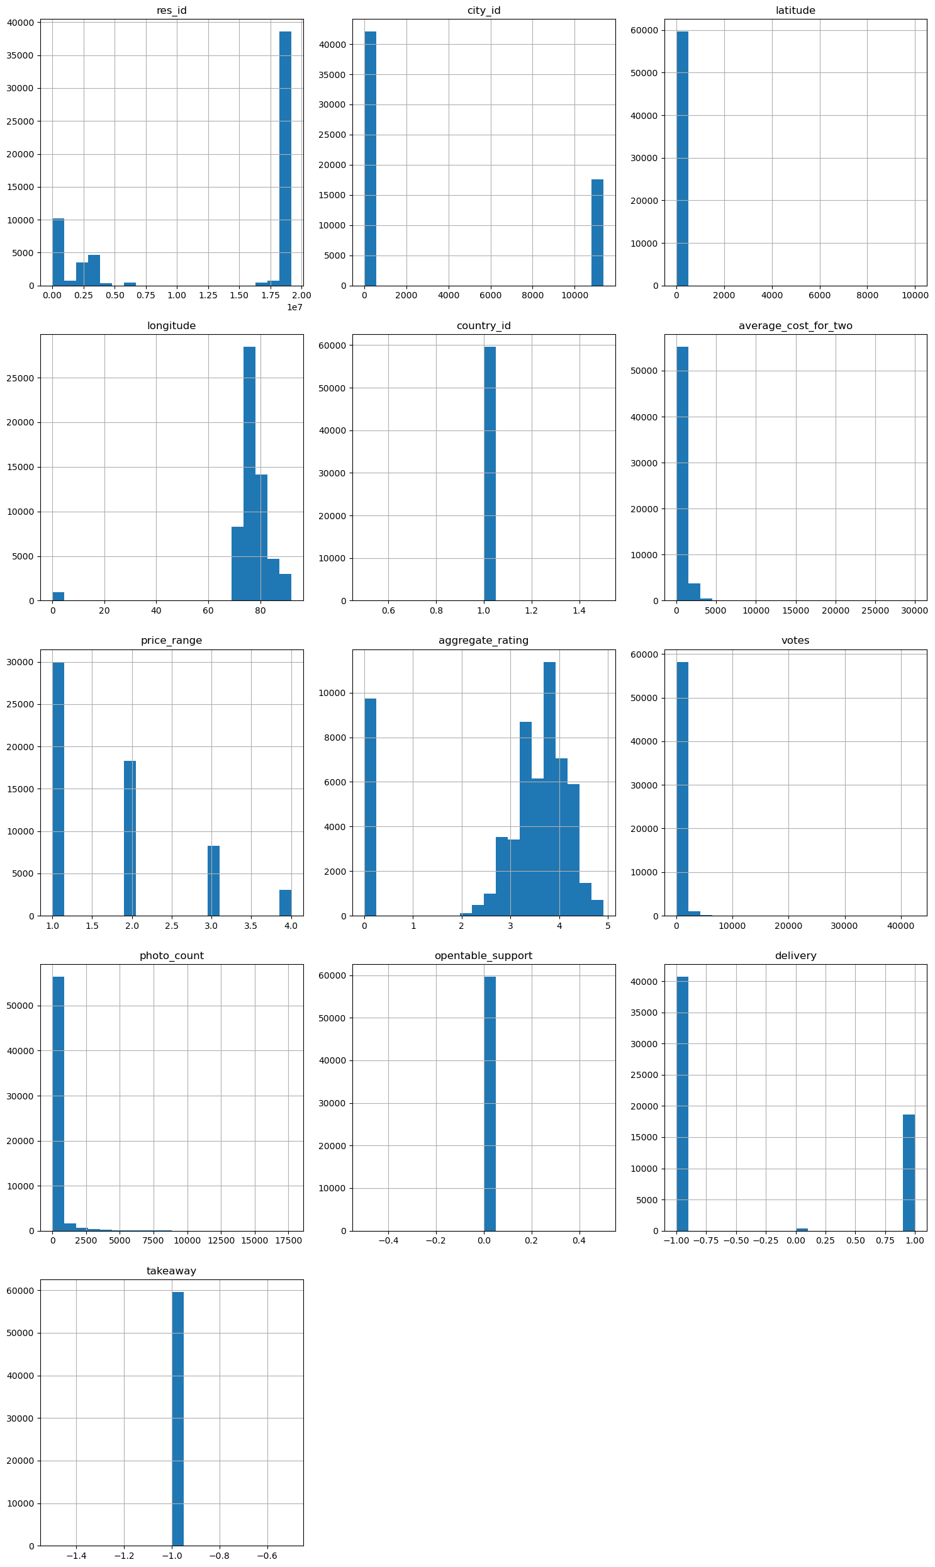

## Distribution Analysis:

### Distribution of Ratings

The distribution of ratings showcases the following insights:

- Most restaurants have ratings between 3.5 and 4.0.

- A significant number of restaurants have ratings below 2.5, indicating a wide range of quality in the dataset.

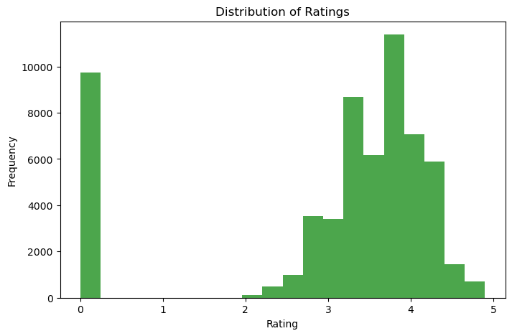

### Top 10 Cuisines

Analysis of the distribution of cuisines reveals the following:

- The top cuisines in the dataset include North Indian, Fast Food, North Indian with Chinese, Bakery, and South Indian.

- North Indian cuisine appears to be the most popular among restaurants in the dataset, followed by Fast Food and combinations of North Indian with Chinese.

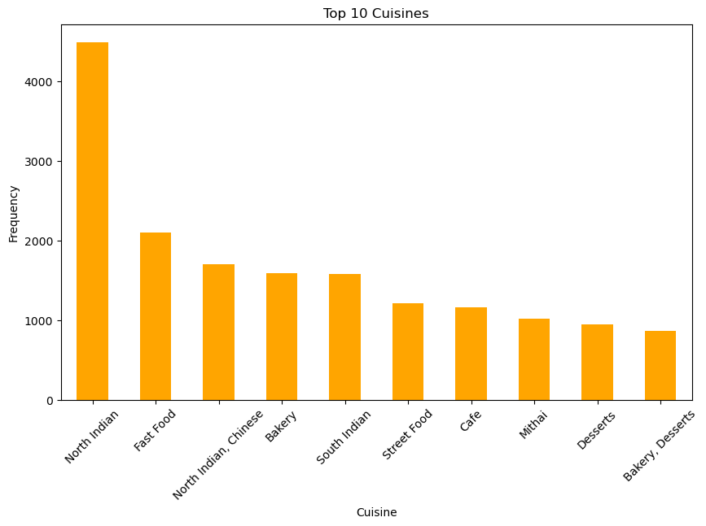

## Correlation Analysis:

- Aggregate Rating vs. Price Range: There is a moderate positive correlation (0.25) between aggregate rating and price range, suggesting that higher-priced restaurants tend to have slightly higher ratings.

- Votes vs. Photo Count: A strong positive correlation (0.68) between the number of votes and the photo count indicates that restaurants with more photos receive more votes.

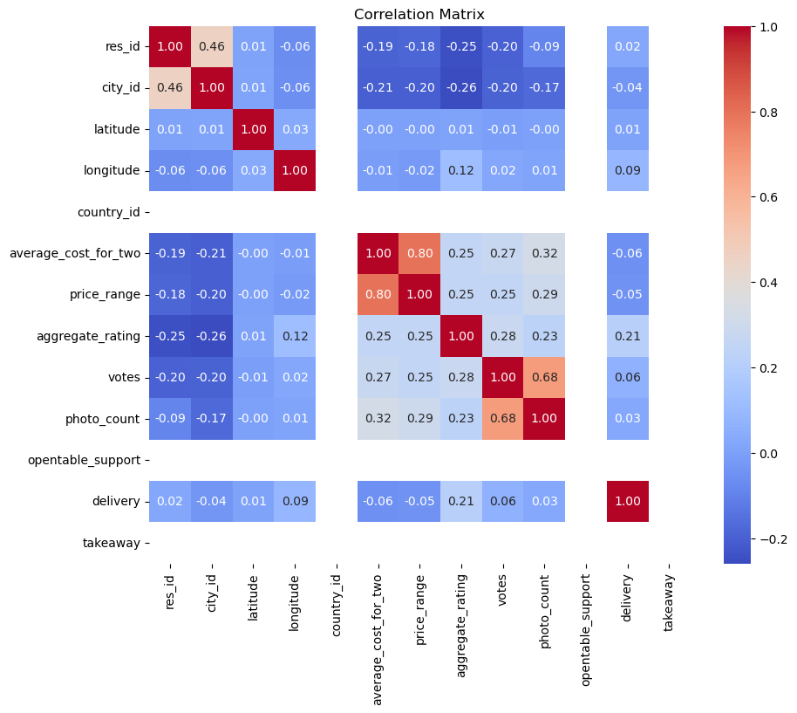

# Regional Analysis:

## Distribution of Establishments in Top Cities

**Bangalore:** The most prevalent establishments include Casual Dining, Quick Bites, Café, and Bakery.

**Chennai:** Like Bangalore, Casual Dining, Quick Bites, and Café are popular, but Beverage Shops and Casual Dining establishments are notably higher compared to other cities.

**Mumbai:** Mumbai showcases a diverse dining scene with prominent establishments such as Casual Dining, Quick Bites, Café, and Bars. Notably, Microbreweries and Pubs are also well-represented.

**New Delhi:** New Delhi exhibits a mix of traditional and modern dining preferences with a significant presence of Casual Dining, Quick Bites, and Café. Additionally, Sweet Shops and Bakeries are prevalent.

**Pune:** Quick Bites, Casual Dining, and Café are the dominant establishments in Pune. Microbreweries and Bars also have a notable presence.

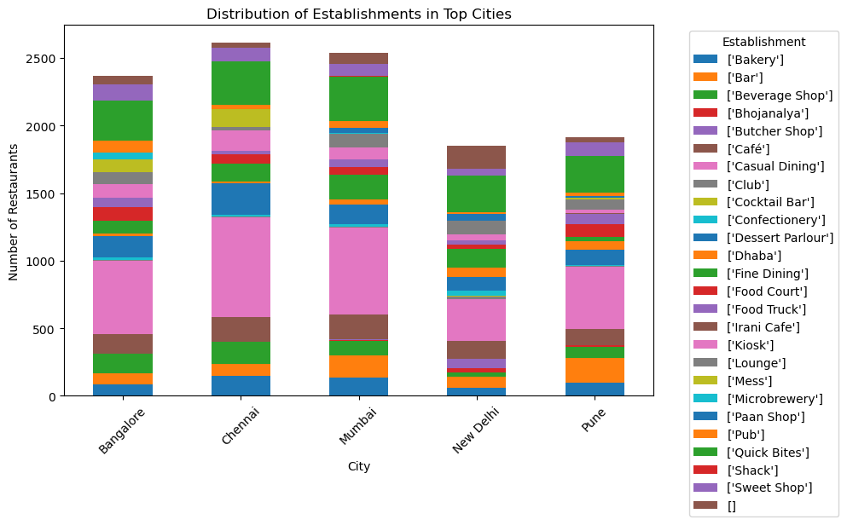

## Unique Dining Scene in Different Regions

**Chennai:** Takeaway, Delivery and Outdoor Seating are notable features of the dining scene, along with a preference for Pure Vegetarian options.

**Mumbai:** Mumbai's dining scene is characterized by options for Takeaway, No Seating Available, and Dinner offerings.

The data provided offers limited insights into the unique dining scenes in each region. Further analysis with additional data may provide a more comprehensive understanding of regional preferences and trends.

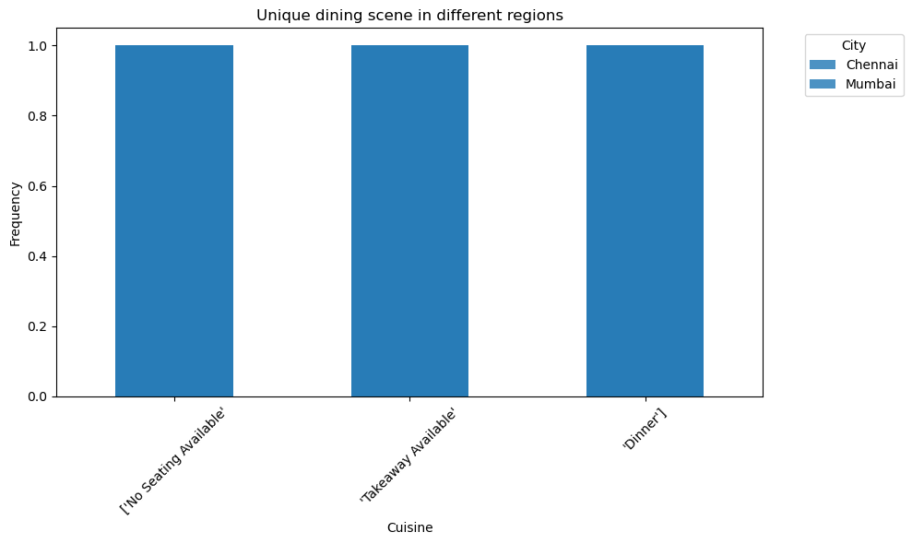

# Customer Preference Analysis:

## Popular Cuisines in Different Regions

North Indian Cuisine: It emerges as the most popular cuisine across all regions, with a significant presence in Chennai, Mumbai, Bangalore, Pune, and New Delhi.

Chinese Cuisine: Chinese cuisine also holds a notable position in the top cuisines across all regions, indicating its widespread popularity.

Fast Food: Fast food is among the top choices in all regions, reflecting the global appeal of quick and convenient dining options.

Desserts: Desserts feature prominently across all regions, indicating a universal fondness for sweet treats.

Beverages: Beverages round up the top five cuisines, with a considerable presence in the dining scenes of the top cities.

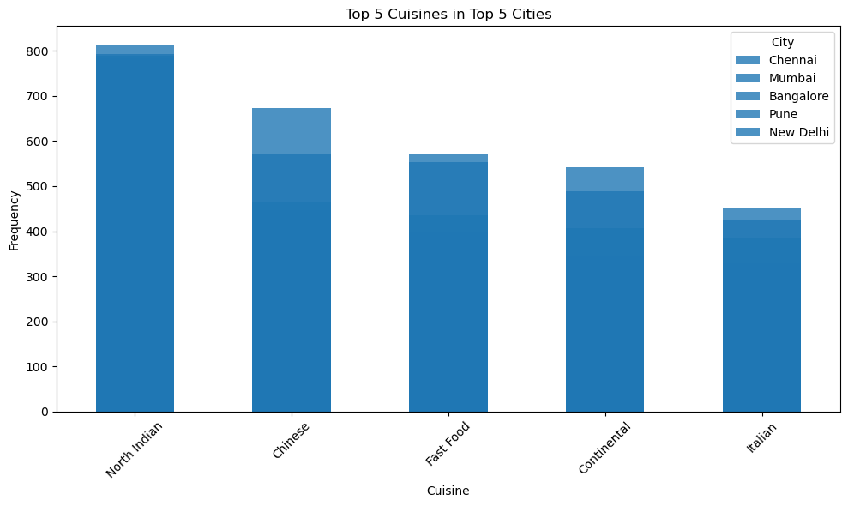

## Relationship between Restaurant Ratings, Price Range, and Popularity

### Correlation Matrix

- Aggregate Rating vs. Price Range: A moderate positive correlation (0.25) suggests that restaurants with higher price ranges tend to have slightly higher ratings.

- Aggregate Rating vs. Votes: There is a positive correlation (0.28) between aggregate rating and the number of votes, indicating that restaurants with higher ratings tend to receive more votes.

- Price Range vs. Votes: There is a modest positive correlation (0.25) between price range and the number of votes, suggesting that higher-priced restaurants may attract more votes.

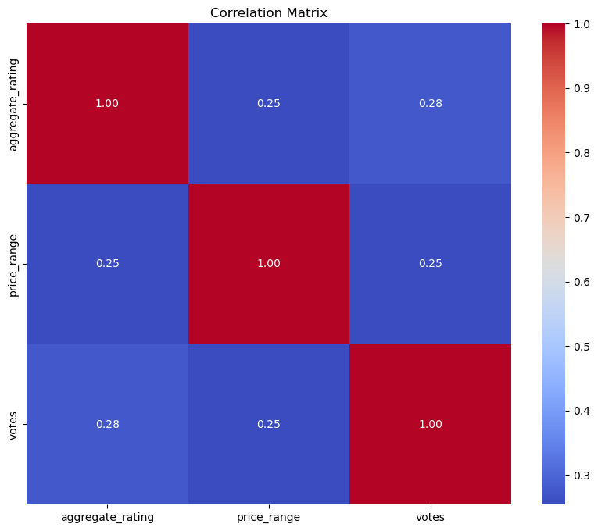

### Summary Statistics:

- Aggregate Rating: The mean aggregate rating is approximately 3.05, with a standard deviation of 1.43, indicating some variability in ratings.

- Votes: The mean number of votes is around 265, with a wide range from -18 to 42,539, indicating varying levels of customer engagement and feedback.

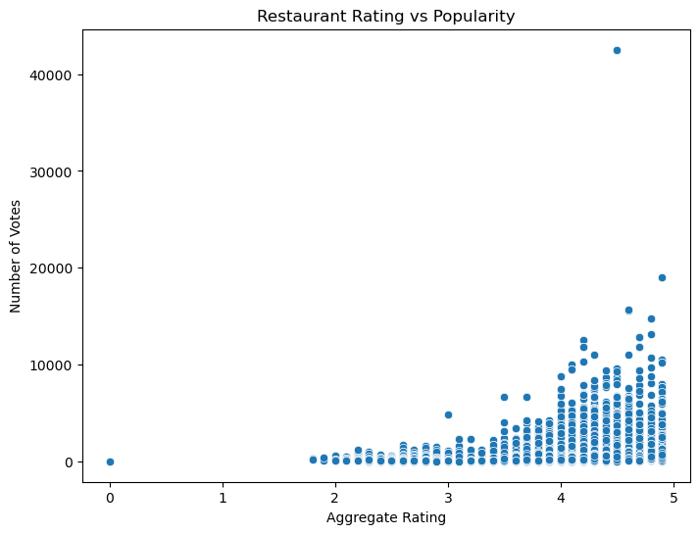

### Frequency of Price Ranges:

Price range 1 is the most common, followed by price ranges 2, 3, and 4, suggesting a preference for moderately priced dining options.

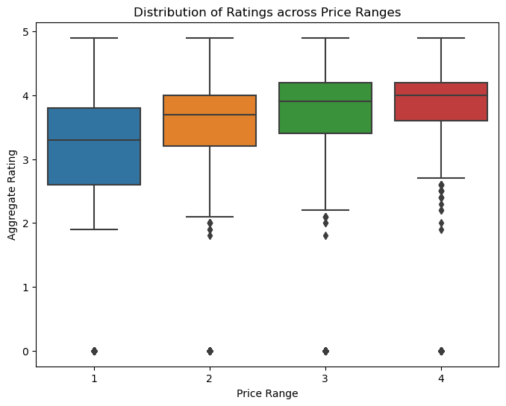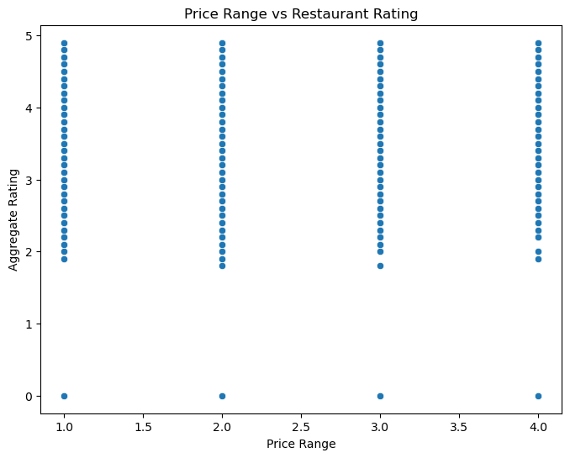

# Competitive Analysis:

## Identifying Major Competitors

1. Amritsar:

- Cuisines: Fast Food, Italian

- Average Cost for Two: 500

- Aggregate Rating: 4.9

2. Bangalore:

- Cuisines: Continental, North Indian, Chinese, European, etc.

- Average Cost for Two: 2100

- Aggregate Rating: 4.9

3. Bhubaneshwar:

- Cuisines: Tex-Mex, Fast Food

- Average Cost for Two: 700

- Aggregate Rating: 4.9

4. New Delhi:

- Cuisines: Asian

- Average Cost for Two: 0

- Aggregate Rating: 4.9

5. Mangalore:

- Cuisines: Ice Cream, Desserts, Beverages, Fast Food

- Average Cost for Two: 250

- Aggregate Rating: 4.9

|  |  |  |  |  |
| --- | --- | --- | --- | --- |
|  | **city** | **cuisines** | **average_cost_for_two** | **aggregate_rating** |
| **15114** | Amritsar | Fast Food, Italian | 500 | 4.9 |
| **19630** | Bangalore | Continental, North Indian, Chinese, European, ... | 2100 | 4.9 |
| **27257** | Bhubaneshwar | Tex-Mex, Fast Food | 700 | 4.9 |
| **129079** | Mangalore | Ice Cream, Desserts, Beverages, Fast Food | 250 | 4.9 |
| **134885** | Thane | Modern Indian, North Indian, Chinese, Momos, A... | 1600 | 4.9 |
| **151290** | Nashik | Continental, Indian, Chinese | 1000 | 4.9 |
| **173048** | Rajkot | North Indian, Gujarati, South Indian, Continental | 700 | 4.9 |
| **5936** | Ajmer | Continental, Beverages, South Indian, Fast Foo... | 600 | 4.8 |
| **11147** | Allahabad | North Indian | 200 | 4.8 |
| **24601** | Bhopal | Street Food, South Indian, Fast Food, Desserts... | 400 | 4.8 |
| **33460** | Chennai | North Indian, European, Mediterranean, Contine... | 1500 | 4.8 |
| **134905** | Navi Mumbai | Italian, Continental, Mexican | 1600 | 4.8 |
| **193113** | Trichy | Arabian, Chinese, BBQ, Rolls | 500 | 4.8 |
| **29812** | Chandigarh | European, Continental, North Indian, Finger Fo... | 1600 | 4.7 |
| **45090** | Coimbatore | Biryani, South Indian | 700 | 4.7 |
| **53885** | New Delhi | Asian, Chinese, Thai, Japanese | 2500 | 4.7 |
| **146468** | Nagpur | Cafe, Chinese, Fast Food, Beverages | 500 | 4.7 |
| **186818** | Surat | Beverages, North Indian | 250 | 4.7 |
| **114338** | Kolkata | Italian, Chinese, Finger Food | 1300 | 4.6 |
| **132502** | Meerut | North Indian | 100 | 4.6 |

## Strengths and Weaknesses Analysis

### Strengths:

- High Aggregate Ratings: Competitors like those in Amritsar, Bangalore, and Bhubaneshwar boast exceptionally high aggregate ratings (4.6 to 4.9), indicating high customer satisfaction and quality food service.

- Diverse Cuisine Offerings: Many competitors offer a wide range of cuisines, such as Continental, North Indian, Chinese, etc., appealing to a broader customer base with varying preferences.

- Reasonable Average Cost for Two: Despite delivering high-quality food and service, several competitors maintain a reasonable average cost for two, catering to budget-conscious customers while offering value for money.

- Consistency Across Multiple Cities: Competitors with branches in multiple cities consistently deliver high-quality food and service across different locations, showcasing strong brand management and operational efficiency.

### Weaknesses:

- Limited Analysis Scope: The provided data lacks insights into specific weaknesses of individual competitors, such as customer complaints or operational challenges, necessitating further data and context for a comprehensive analysis.

- Potential Operational Challenges: Competitors may face challenges in maintaining consistency in quality across locations, managing operational costs, or adapting to changing consumer preferences, impacting their overall performance.

- External Factors: External factors such as economic conditions or unforeseen events like pandemics can also impact the strengths and weaknesses of competitors in the restaurant industry, adding uncertainty to their operational environment.

In conclusion, while competitors exhibit strengths such as high ratings, diverse cuisine offerings, and reasonable pricing, a detailed analysis of weaknesses would require additional data and context to identify specific improvement areas or potential challenges they may encounter.

# Market Gap Analysis:

## Identified Gaps in the Market

1. Underrepresented Cuisines:

- While the analysis highlights popular cuisines such as North Indian, Chinese, Fast Food, and Desserts across different regions, there may be opportunities to capitalize on underrepresented cuisines. Exploration of niche cuisines or regional specialties that are not extensively covered in the dataset could uncover gaps in the market where the restaurant chain can introduce unique offerings.

1. Price Range Variation:

- The frequency analysis of price ranges indicates that lower-priced options (Price Range 1) are the most common, followed by moderately priced options (Price Range 2), with higher-priced options (Price Range 3 and 4) being less prevalent. This suggests a potential gap in the market for upscale dining experiences or premium offerings that cater to customers willing to spend more for elevated culinary experiences.

1. Unique Dining Concepts:

- The analysis of the dining scene in different regions reveals certain unique features such as takeaway, delivery, outdoor seating, and specific cuisine preferences like pure vegetarian options. Identifying innovative dining concepts or experiential offerings that align with emerging consumer preferences or lifestyle trends could fill gaps in the market and differentiate the restaurant chain from competitors.

1. Geographic Expansion Opportunities:

- While the analysis focuses on specific cities and regions, there may be untapped markets or underserved areas where the restaurant chain can expand its presence. Conducting market research to identify locations with high demand for dining options but limited competition could reveal potential opportunities for geographic expansion and market penetration.

## Strategies to Capitalize on Market Gaps

### Strategies:

- Menu Diversification: Introduce new and unique menu items representing underrepresented cuisines or fusion concepts to cater to diverse customer preferences. This could include exploring ethnic cuisines, plant-based options, or innovative culinary creations that set the restaurant chain apart from competitors.

- Price Range Expansion: Consider introducing premium dining experiences or upscale offerings targeting customers seeking high-quality dining experiences. This could involve curated tasting menus, chef-led experiences, or exclusive dining events that justify higher price points and appeal to discerning customers.

- Innovative Dining Experiences: Develop innovative dining concepts or experiential offerings that capitalize on emerging trends such as delivery-friendly menus, interactive dining experiences, or themed pop-up events. By offering unique and memorable dining experiences, the restaurant chain can attract new customers and foster customer loyalty.

- Market Segmentation and Targeting: Utilize market segmentation techniques to identify specific customer segments with unmet needs or preferences not adequately addressed by existing competitors. Tailor marketing campaigns and menu offerings to target these segments effectively and position the restaurant chain as a preferred choice within niche markets.

- Strategic Expansion Planning: Conduct thorough market research and feasibility studies to identify strategic expansion opportunities in new geographic locations or untapped markets. Prioritize expansion into areas with favorable demographics, growing populations, and limited competition to maximize the restaurant chain's growth potential.

By capitalizing on identified market gaps and implementing targeted strategies, the restaurant chain can enhance its competitive positioning, drive revenue growth, and establish itself as a leader in the evolving restaurant industry landscape.

# Designing the Marketing Campaign:

## Marketing Campaign Overview

The marketing campaign aims to leverage insights from the exploratory analysis and market gap analysis to drive brand awareness, customer engagement, and revenue growth for the restaurant chain. By targeting different regions, focusing on specific customer segments, and differentiating from competitors, the campaign seeks to position the restaurant chain as a preferred choice for dining experiences and capitalize on identified market gaps.

## Campaign Strategies

### Regional Targeting:

- Tailor marketing efforts to specific regions based on dining preferences, market dynamics, and competitor landscape.

- Develop region-specific campaigns highlighting unique dining scenes, popular cuisines, and exclusive offerings to resonate with local customers.

### Customer Segmentation:

- Utilize market segmentation techniques to identify distinct customer segments with unique preferences and dining behaviors.

- Design targeted campaigns catering to different customer segments, such as families, young professionals, food enthusiasts, and health-conscious individuals, offering personalized experiences and menu options.

### Differentiation from Competitors:

- Emphasize key differentiators such as menu diversity, quality ingredients, innovative dining concepts, and exceptional customer service to stand out from competitors.

- Highlight competitive advantages through promotional materials, social media content, and experiential marketing initiatives to capture audience attention and loyalty.

### Promotional Tactics:

- Discounts and Offers: Implement promotional discounts, special offers, and bundle deals to incentivize trial and repeat purchases.

- Loyalty Programs: Introduce a loyalty program rewarding customers for their patronage with exclusive perks, discounts, and rewards.

- Special Events and Collaborations: Host special events, themed nights, and collaborative partnerships with local artists, influencers, or brands to create buzz and drive foot traffic.

## Campaign Execution Plan:

### Digital Marketing:

- Launch targeted digital marketing campaigns across social media platforms, search engines, and online review sites to reach a wider audience and drive website traffic.

- Utilize geo-targeting and retargeting strategies to engage potential customers based on their location, interests, and previous interactions with the brand.

### Offline Marketing:

- Implement local advertising initiatives such as print ads, billboards, and radio spots in key target markets to increase brand visibility and generate local interest.

- Distribute flyers, coupons, and promotional materials in strategic locations such as shopping centers, office complexes, and residential communities to attract nearby diners.

### Community Engagement:

- Foster community engagement through participation in local events, sponsorships, and charitable partnerships to build brand affinity and demonstrate corporate social responsibility.

- Collaborate with local businesses, schools, and organizations to host fundraisers, charity drives, and community outreach programs, reinforcing the restaurant chain's commitment to supporting the community.

### Online Reputation Management:

- Monitor and respond to customer reviews, feedback, and inquiries across online review platforms, social media channels, and customer service channels to maintain a positive brand reputation and address customer concerns promptly.

- Encourage satisfied customers to leave positive reviews and share their dining experiences on social media, amplifying word-of-mouth marketing and generating social proof.

### Measurement and Optimization:

- Establish key performance indicators (KPIs) such as website traffic, social media engagement, customer acquisition, and revenue growth to measure the effectiveness of the marketing campaign.

- Regularly analyze campaign performance metrics, conduct A/B testing, and gather customer feedback to identify areas for improvement and optimization.

- Adapt and refine marketing strategies based on data-driven insights, emerging trends, and evolving customer preferences to maximize ROI and achieve long-term success.

By executing a comprehensive marketing campaign aligned with strategic objectives and tailored to target regions and customer segments, the restaurant chain can enhance brand visibility, drive customer acquisition, and foster loyalty, ultimately driving business growth and success.

# Conclusion:

The exploratory analysis and market gap analysis provide valuable insights into the restaurant chain's performance, market dynamics, and growth opportunities. By leveraging these insights and implementing targeted strategies, the restaurant chain can enhance its competitive positioning, drive revenue growth, and establish itself as a leader in the evolving restaurant industry landscape. Continued monitoring, optimization, and adaptation are essential to ensure sustained success in the dynamic and competitive market environment.