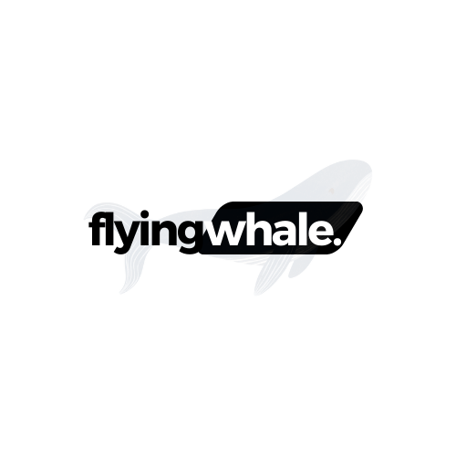

**Business Intelligence Case Study: FlyingWhale Airline**

**By**

**Muhammad Abdullah Butt**

Contents

Executive Summary: 3

Introduction: 3

Dataset Overview: 3

Business Scenarios: 3

Key Findings: 5

Recommendations: 6

Conclusion: 6

# Executive Summary:

This report provides insights into the customer flight activity and loyalty history of FlyingWhale Airline, aiming to optimize customer experience and loyalty programs. Through analysis of two key datasets, actionable recommendations are derived to enhance flight bookings and customer retention.

# Introduction:

FlyingWhale Airline seeks to improve business intelligence capabilities by analyzing customer flight activity and loyalty history. This analysis aims to understand travel patterns and maximize the effectiveness of loyalty programs.

# Dataset Overview:

Two main datasets are utilized:

1. Customer Flight Activity: Information on booked flights, distances traveled, and loyalty points earned and redeemed.

2. Customer Loyalty History: Includes demographic details, loyalty card status, and enrollment and cancellation information.

# Business Scenarios:

1. Flight Activity Analysis:

- Monthly and yearly flight booking patterns are analyzed, identifying peak booking periods.

- The correlation between flight distances and loyalty points accumulated is explored.

- The Impact of companion bookings on loyalty points redeemed is assessed, identifying the number of companions where members redeem the most points.

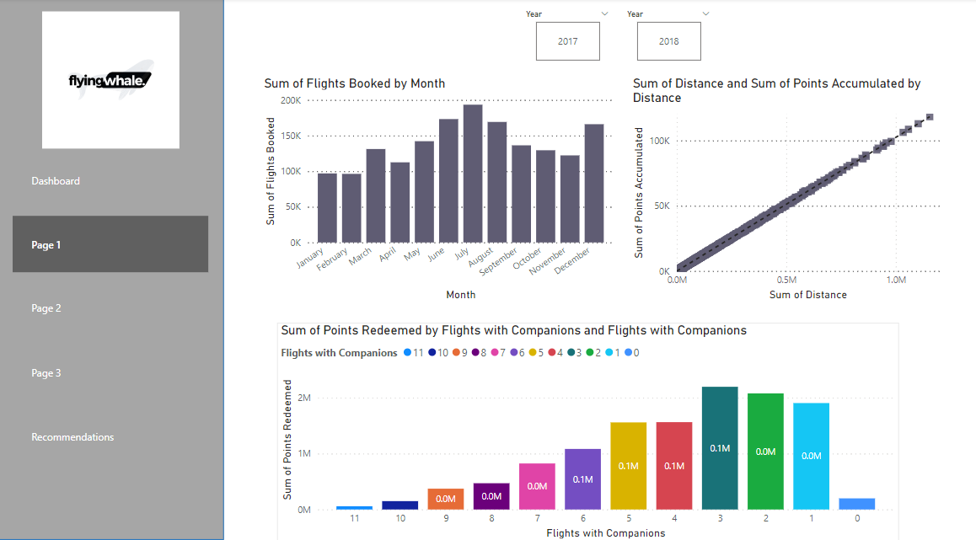

# Key Findings:

1. Peak booking periods coincide with summer and holiday vacations, suggesting tailored promotions during these times.

2. Points redemption is highest when customers travel with family, indicating a focus on family-oriented offers.

3. 'Stars' loyalty members exhibit the highest flight booking frequency, mirroring overall booking trends. However, their Customer Lifetime Value averages lower than other segments, indicating a need for targeted marketing strategies and loyalty packages to encourage more bookings.

4. Married individuals represent the majority of flight bookings, underscoring the importance of tailored campaigns for this demographic. Their tendency to travel with companions also presents opportunities for increased bookings.

5. 'Aurora' loyalty members have the shortest enrolment duration among cancellations, suggesting a need for focused retention efforts for this segment.

6. December stands out with a significant proportion of cancellations. Identifying the underlying reasons behind this trend can inform strategies to improve customer retention during this period.

# Recommendations:

1. Introduce tailored promotions during peak booking periods to increase bookings and customer retention.

2. Adjust point allocation based on the number of companions to boost point usage.

3. Implement targeted marketing strategies for 'Stars' loyalty members to encourage more bookings.

4. Launch tailored campaigns for married individuals and focus on family-oriented offers.

5. Develop retention efforts specifically for 'Aurora’ loyalty members to improve enrollment duration.

6. Identify the reasons for December cancellations and implement strategies to improve customer retention during this period.

# Conclusion:

The analysis provides valuable insights into customer flight activity and loyalty history, enabling FlyingWhale Airline to optimize its operations and enhance customer experience. By implementing the recommended strategies, the airline can improve flight bookings and customer retention, ultimately driving business growth.