Name:Allahdad

Lab 10

Section D

1. Write GUI application as shown in the Figure. Each time the "Count" button is clicked, the counter value shall increase by 1.

Code

import javax.swing.*;

import java.awt.*;

import java.awt.event.*;

class Task1 extends JFrame implements MouseListener

{

JLabel l1;

JTextField text;

JButton b1;

int a;

Task1()

{

addMouseListener(this);

//Label

l1=new JLabel("Counter");

l1.setBounds(30,10,50,30);

add(l1);

//TextField

text=new JTextField();

text.setBounds(80,10,120,30);

add(text);

text.addMouseListener(this);

//Button

b1=new JButton("Count");

b1.setBounds(200,10,100,30);

add(b1);

b1.addMouseListener(this);

setDefaultCloseOperation(JFrame.EXIT_ON_CLOSE);

setLayout(null);

setSize(400,150);

setVisible(true);

}

public void mouseClicked(MouseEvent e)

{

if(e.getSource()==b1)

{

a++;

text.setText(a+"");

}

}

public void mousePressed(MouseEvent e)

{

}

public void mouseEntered(MouseEvent e)

{

}

public void mouseExited(MouseEvent e)

{

}

public void mouseReleased(MouseEvent e)

{

}

public static void main(String args[])

{

Task1 obj=new Task1();

}

}

OUTPUT

1. 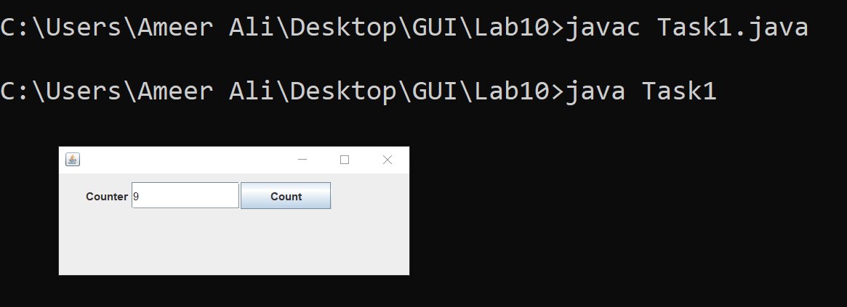

2.Examine the following picture and create a given GUI. Add 2 textboxes and one button. When a user write a text in textbox1 and click on OK button, text should be copied from textbox1 and added to textbox2.

CODE

import javax.swing.*;//JFrame

import java.awt.event.*;//MouseListener

class Task2 extends JFrame implements MouseListener

{

JTextField textBox2,textBox1;

JButton b1;

Task2()

{

//For title

super("Copy text");

addMouseListener(this);

//TextField

textBox1=new JTextField();

textBox1.setBounds(80,30,120,30);

add(textBox1);

textBox1.addMouseListener(this);

textBox2=new JTextField();

textBox2.setBounds(80,70,120,30);

add(textBox2);

textBox2.addMouseListener(this);

//Button

b1=new JButton("Count");

b1.setBounds(100,110,70,30);

add(b1);

b1.addMouseListener(this);

setDefaultCloseOperation(JFrame.EXIT_ON_CLOSE);

setLayout(null);

setSize(300,200);

setVisible(true);

}

public void mouseClicked(MouseEvent e)

{

String text=textBox1.getText();

textBox2.setText(text);

}

public void mousePressed(MouseEvent e)

{

}

public void mouseEntered(MouseEvent e)

{

}

public void mouseExited(MouseEvent e)

{

}

public void mouseReleased(MouseEvent e)

{

}

public static void main(String args[])

{

Task2 obj=new Task2();

}

}

Output

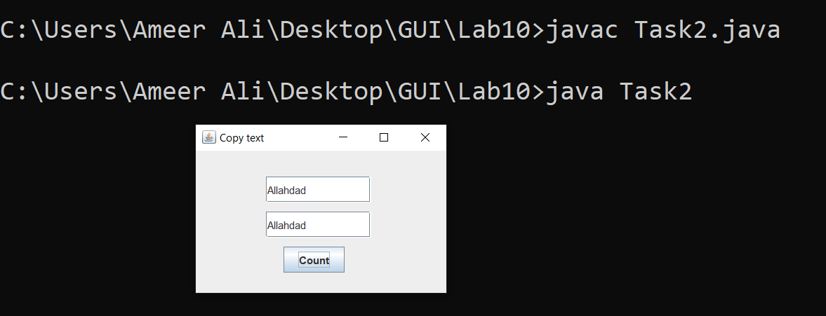

3.Examine the following picture and wrote a program for given picture.

Code

import javax.swing.*;

class Task3

{

public static void main(String args[])

{

JFrame frame=new JFrame("Java SWING Examples");

//Label

JLabel L1=new JLabel("Controll in action:JButton");

L1.setBounds(200,100,200,30);

frame.add(L1);

//Button

JButton b1=new JButton("Ok");

b1.setBounds(150,200,50,30);

frame.add(b1);

JButton b2=new JButton("Submit");

b2.setBounds(200,200,100,30);

frame.add(b2);

JButton b3=new JButton("Cancel");

b3.setBounds(300,200,100,30);

frame.add(b3);

//Label

JLabel L2=new JLabel("Ok Button Clicked");

L2.setBounds(220,400,200,30);

frame.add(L2);

frame.setDefaultCloseOperation(JFrame.EXIT_ON_CLOSE);

frame.setLayout(null);

frame.setSize(600,500);

frame.setVisible(true);

}

}

OUTPUT

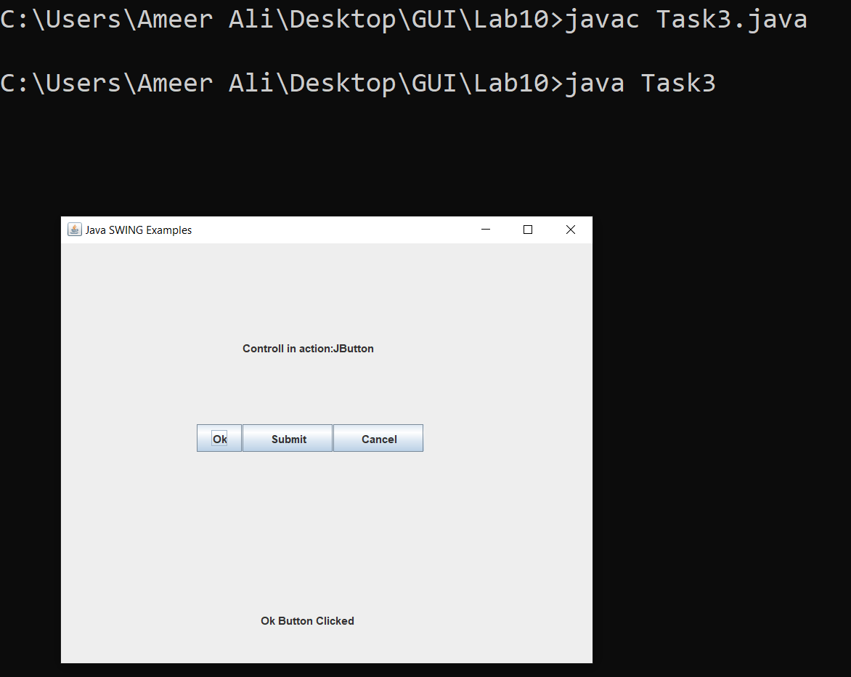

4. Examine the following picture and write a code to create a given GUI. For this GUI you need to create and add 27 buttons and one textbox/textfield. Once a user run this application, all alphabets of buttons should not be visible until unless a user click on a particular button then it should display its label. Also if a user write a character in textbox/textfield and hit a enter key then button label should be visible. As given in picture when a user entered B and hit enter button then button B’s text is visible now.

CODE

import javax.swing.*;  
import java.awt.event.*;  
  
public class Ad1 extends JFrame implements MouseListener {  
 JButton b1,b2,b3,b4,b5,b6,b7,b8,b9,b10,b11,b12,b13,b14,b15,b16,b17,b18,b19,b20,b21,b22,b23,b24,b25,b26,b27;  
 JTextField text;  
  
 public Ad1() {  
 //title  
 super("Complete Alphabets");  
 addMouseListener(this);  
  
 //TEXTFIELD  
 text=new JTextField(20);  
 text.setBounds(300,100,300,40);  
 add(text);  
 text.addMouseListener(this);  
  
 //BUTTONS  
 b1=new JButton("A");  
 b1.setBounds(200,200,60,30);  
 add(b1);  
 b1.addMouseListener(this);  
  
 b2=new JButton("B");  
 b2.setBounds(270,200,60,30);  
 add(b2);  
 b2.addMouseListener(this);  
  
 b3=new JButton("C");  
 b3.setBounds(340,200,60,30);  
 add(b3);  
 b3.addMouseListener(this);  
  
 b4=new JButton("D");  
 b4.setBounds(410,200,60,30);  
 add(b4);  
 b4.addMouseListener(this);  
  
 b5=new JButton("E");  
 b5.setBounds(480,200,60,30);  
 add(b5);  
 b5.addMouseListener(this);  
  
 b6=new JButton("F");  
 b6.setBounds(550,200,60,30);  
 add(b6);  
 b6.addMouseListener(this);  
  
 b7=new JButton("G");  
 b7.setBounds(620,200,60,30);  
 add(b7);  
 b7.addMouseListener(this);  
  
 b8=new JButton("H");  
 b8.setBounds(200,240,60,30);  
 add(b8);  
 b8.addMouseListener(this);  
  
 b9=new JButton("I");  
 b9.setBounds(270,240,60,30);  
 add(b9);  
 b9.addMouseListener(this);  
  
 b10=new JButton("J");  
 b10.setBounds(340,240,60,30);  
 add(b10);  
 b10.addMouseListener(this);  
  
 b11=new JButton("K");  
 b11.setBounds(410,240,60,30);  
 add(b11);  
 b11.addMouseListener(this);  
  
 b12=new JButton("L");  
 b12.setBounds(480,240,60,30);  
 add(b12);b12.addMouseListener(this);  
  
  
 b13=new JButton("M");  
 b13.setBounds(550,240,60,30);  
 add(b13);  
 b13.addMouseListener(this);  
  
 b14=new JButton("N");  
 b14.setBounds(620,240,60,30);  
 add(b14);  
 b14.addMouseListener(this);  
  
 b15=new JButton("O");  
 b15.setBounds(200,280,60,30);  
 add(b15);  
 b15.addMouseListener(this);  
  
 b16=new JButton("P");  
 b16.setBounds(270,280,60,30);  
 add(b16);  
 b16.addMouseListener(this);  
  
 b17=new JButton("Q");  
 b17.setBounds(340,280,60,30);  
 add(b17);  
 b17.addMouseListener(this);  
  
 b18=new JButton("R");  
 b18.setBounds(410,280,60,30);  
 add(b18);  
 b18.addMouseListener(this);  
  
 b19=new JButton("S");  
 b19.setBounds(480,280,60,30);  
 add(b19);  
 b19.addMouseListener(this);  
  
 b20=new JButton("T");  
 b20.setBounds(550,280,60,30);  
 add(b20);  
 b20.addMouseListener(this);  
  
 b21=new JButton("U");  
 b21.setBounds(620,280,60,30);  
 add(b21);  
 b21.addMouseListener(this);  
  
 b22=new JButton("V");  
 b22.setBounds(200,320,60,30);  
 add(b22);  
 b22.addMouseListener(this);  
  
 b23=new JButton("W");  
 b23.setBounds(270,320,60,30);  
 add(b23);  
 b23.addMouseListener(this);  
  
 b24=new JButton("X");  
 b24.setBounds(340,320,60,30);  
 add(b24);  
 b24.addMouseListener(this);  
  
 b25=new JButton("Y");  
 b25.setBounds(410,320,60,30);  
 add(b25);  
 b25.addMouseListener(this);  
  
 b26=new JButton("Z");  
 b26.setBounds(480,320,60,30);  
 add(b26);  
 b26.addMouseListener(this);  
  
  
  
  
 setSize(1000, 800);  
 setDefaultCloseOperation(JFrame.*EXIT_ON_CLOSE*);  
 setLayout(null);  
 setVisible(true);  
 }  
  
 @Override  
 public void mouseClicked(MouseEvent e) {  
 if(e.getSource()==b1)  
 {  
 text.setText("A");  
 }  
 if(e.getSource()==b2)  
 {  
 text.setText("B");  
 }  
 if(e.getSource()==b3)  
 {  
 text.setText("C");  
 }  
 if(e.getSource()==b4)  
 {  
 text.setText("D");  
 }  
 if(e.getSource()==b5)  
 {  
 text.setText("E");  
 }  
 if(e.getSource()==b6)  
 {  
 text.setText("F");  
 }if(e.getSource()==b7)  
 {  
 text.setText("G");  
 }  
 if(e.getSource()==b8)  
 {  
 text.setText("H");  
 }if(e.getSource()==b9)  
 {  
 text.setText("I");  
 }  
 if(e.getSource()==b10)  
 {  
 text.setText("J");  
 }  
 if(e.getSource()==b11)  
 {  
 text.setText("K");  
 }  
 if(e.getSource()==b12)  
 {  
 text.setText("L");  
 }  
 if(e.getSource()==b13)  
 {  
 text.setText("M");  
 }  
 if(e.getSource()==b14)  
 {  
 text.setText("N");  
 }  
 if(e.getSource()==b15)  
 {  
 text.setText("O");  
 }  
  
 if(e.getSource()==b16)  
 {  
 text.setText("P");  
 }  
 if(e.getSource()==b17)  
 {  
 text.setText("Q");  
 }if(e.getSource()==b18)  
 {  
 text.setText("R");  
 }  
 if(e.getSource()==b19)  
 {  
 text.setText("S");  
 }if(e.getSource()==b20)  
 {  
 text.setText("T");  
 }  
 if(e.getSource()==b21)  
 {  
 text.setText("U");  
 }  
 if(e.getSource()==b22)  
 {  
 text.setText("V");  
 }  
 if(e.getSource()==b23)  
 {  
 text.setText("W");  
 }  
 if(e.getSource()==b24)  
 {  
 text.setText("X");  
 }  
 if(e.getSource()==b25)  
 {  
 text.setText("Y");  
 }  
 if(e.getSource()==b26)  
 {  
 text.setText("Z");  
 }  
  
  
  
 }  
  
 @Override  
 public void mousePressed(MouseEvent e) {}  
  
 @Override  
 public void mouseReleased(MouseEvent e) {}  
  
 @Override  
 public void mouseEntered(MouseEvent e) {}  
  
 @Override  
 public void mouseExited(MouseEvent e) {}  
  
 public static void main(String[] args) {  
 Ad1 obj=new Ad1();  
 }  
}

OUTPUT

