DTU
SCHOOL OF COMPUTER SCIENCE
FACULTY OF SOFTWARE ENGINEERING
$$🙦🕮🙤$$


SYSTEM INTEGRATION

CASE STUDY III - DATA INTEGRATION

LECTURER : Nguyen Minh Nhat
CLASS : SE 445 B
GROUP : 9
MEMBER : Le Anh Khoa - 28210204596
Bui Dinh Sang - 28214553546
Huynh Vu Truc Phuong - 28211154237 Tran Anh Vu - 28211106334

Da Nang, 13/05/2025

TABLE OF CONTENTS

1. Introduction 1
1.1. Purpose 1
1.2. Scope 1
2. Objectives 1
3. Problem 2
4. Requirements 3
5. Build a database for HR System and HR System applications 4
5.1. Database Management System 4
5.2. Payroll system database 4
5.3. Human resource management database 5
6. Solution 7
6.1. Data Integration Model 1 7
6.2. Data Integration Model 2 8
6.3. Our recommendations 8
7. Database Integration System 9
7.1. Unified Database Schema 9
7.2. Normalization 9
7.3. Integrated Database Relationships 20
8. System-wide database synchronization 21
8.1. About the tools 21
8.2. Inspection results 22
8.2.1. Database Connection 22
8.2.2. Comparison and after synchronization of the structure 23
8.2.3. Data Comparison 23
8.2.4. After Data Synchronization 24

DATA INTEGRATION

1. Introduction
In case study 3, we will introduce two systems: the HR system and the payroll system and the solution to integrate the two systems.
Payroll systems have a lot of employee data, some of which are the same as the HR system contains, some are different.
We will show you the database of the two HR and Payroll systems and the new system once they are integrated and something related to it.

1.1. Purpose
Develop a solution for the CEO to have a comprehensive view of employee status and payroll information. Data consistency between the two systems should be ensured and the CEO should be allowed to update the necessary information in both databases.

1.2. Scope
The purpose of this project is to integrate the payroll system and the HR system. The final product will provide:
- The CEO can view all of our employee status and payroll information together
Displays the following summary information about:
- Total earnings by shareholder, gender, ethnicity, part-time and full-time employees to date and the previous year, by division
- Total number of vacation days by shareholder, gender, ethnicity, part-time and full-time
- Average benefits paid to shareholders and non-shareholders to date under the benefit plan

2. Objectives
- Fully integrate the two applications, ensuring that the data is consistent between all databases.
- Understand how business processes support information consistency requirements.
- Understand that system integration often limits what can be done with legacy software.
- Ensure near-real-time data consistency, but record instances when data can become inconsistent.
- Develop a workable approach to database consistency in a limited time.

3. Problem
CEO:
- Executives currently lack a comprehensive view of both employee information and payroll. This makes it difficult to assess the overall performance of the workforce, identify trends, and make informed strategic decisions.
- Executives need to access multiple systems and reports to gather the necessary data, which is time-consuming and inefficient.
Human Resources Staff:
- HR staff must enter employee data that can be automatically transferred from the payroll system, resulting in duplicate work.
- After entering the employee into the HR system, the HR staff needs to manually communicate payroll information related to the payroll department.
Payroll Staff:
- Payroll employees have to re-enter some data that has been entered by HR staff, leading to potential errors and inefficiencies.
- Payroll employees are often not notified of new hires until those employees complain about not receiving paychecks, causing delays and frustration.
General:
- The lack of integration between HR systems and payroll leads to redundant data entry, manual reporting, and communication gaps, leading to inefficient processes.
- When a payroll employee enters data into the payroll system, the HR employee must also enter some of that data.
- Often, payroll discovers that there is a new employee when they complain that they are not being paid.
- The HR department needs some information and the payroll department has to make some reports.
- When an HR officer enters an employee into the system, the payroll also has a lot of information that they have to enter into their system.

4. Requirements
- Data should only be entered once into either system. Once imported, the other system will be updated automatically.
- Any update in one system will result in an update in another, if any.
- The database must be consistent within a few seconds after the update takes place in one of the databases.
- Neither app can be modified to match database consistency.
- Total earnings of shareholders, gender, ethnicity, part-time and full-time employees to date and the previous year, by department.
- Total number of vacation days of shareholders, gender, ethnicity, part-time employees, full-time employees so far and the previous year.
- Average benefits are paid to shareholders and non-shareholders so far under the benefit plan.
- In addition, the desired management can set an alert when the following conditions occur:
- An employee is within a certain number of days from the anniversary of their recruitment.
- An employee has accumulated more than a certain number of vacation days.
- Employees who make changes to their benefit plan affect their payroll.
- All employees have birthdays in the current month.

5. Build a database for HR System and HR System applications

5.1. Database Management System
SQL Server is a powerful relational database management system from Microsoft, known for its high performance, scalability, and robust security features. Seamless integration with other Microsoft products and extensive support for business intelligence tools make it an ideal choice for enterprise applications. Therefore, I will choose SQL Server for my project.

5.2. Payroll system database
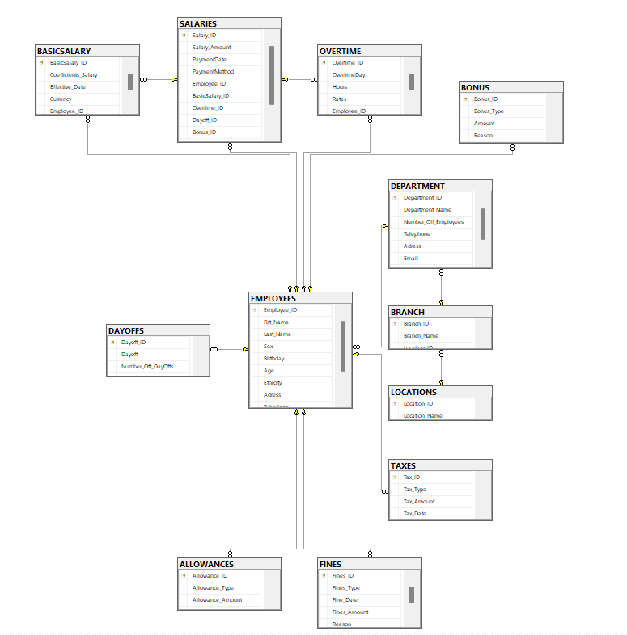
LOCATION (Location_ID, Location_Name)
BRANCHES (Branch_ID, Branch_Name, Location_ID)
ROOM (Department_ID, Department_Name, Number_Off_Employees, Phone, Address, Email, Notes, Brench_ID)
STAFF (Employee_ID, Firt_Name, Last_Name, Gender, Birthday, Age, Address, Phone, Email, Department_ID)
TAXES (Tax_ID, Tax_Type, Tax_Amount, Tax_Date, Employee_ID)
PENALTY (Fines_ID, Fines_Type, Fine_Date, Fines_Amonut, Reason, Employee_ID)
BONUS (Bonus_ID, Bonus_Type, Amount, Reason, Employee_ID)
ALLOWANCE (Allowance_ID, Allowance_Type, Allowance_Amount, Employee_ID)
HOLIDAYS (Dayoff_ID, Dayoff, Number_Off_Dayoffs, Employee_ID)
SALARY (Salary_ID, Salary_Amount, Payment Date, Payment Methord, Employee_ID, Basicsalary_ID, Overtime_ID, Dayoff_ID, Bonus_ID, Tax_ID, Allowance_ID, Fines_ID)
BASICSALARY (Basicsalary_ID, Coefficients_Salary, Effective_Date, Currency, Employee_ID)

5.3. Human resource management database
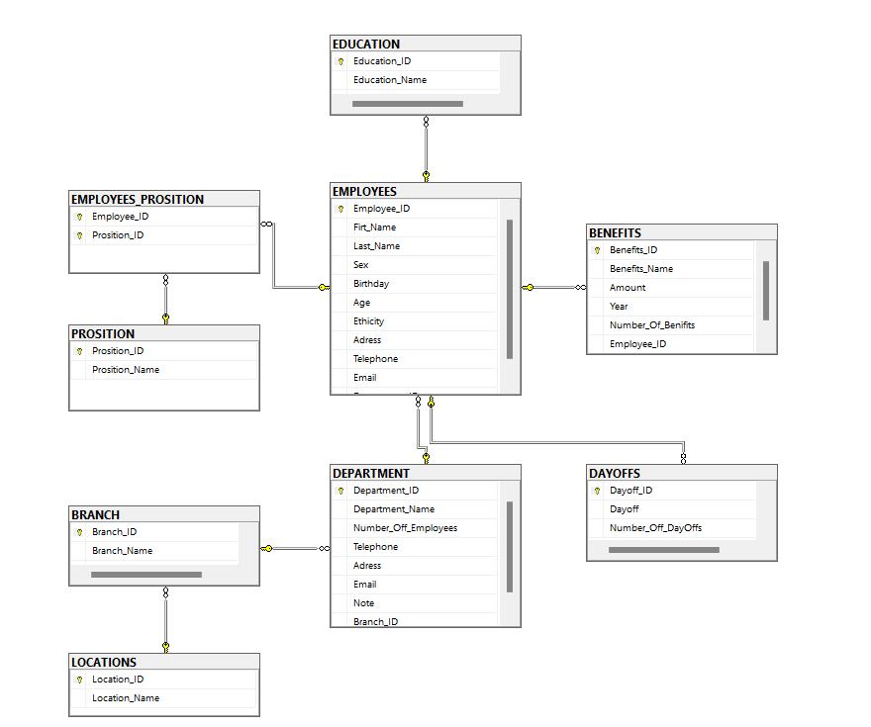
LOCATION (Location_ID, Location_Name)
BRANCHES (Branch_ID, Branch_Name, Location_ID)
ROOM (Department_ID, Department_Name, Number_Off_Employees, Phone, Address, Email, Notes, Brench_ID)
STAFF (Employee_ID, Firt_Name, Last_Name, Gender, Birthday, Age, Address, Phone, Email, Department_ID)
PROSITION (Prosition_ID, Prosition_Name)
EMPLOYEES_PROSITION (Employee_ID, Prosition_ID)
HOLIDAYS (Dayoff_ID, Dayoff, Number_Off_Dayoffs, Employee_ID)
EDUCATION (Education_ID, Education_Name, Employee_ID)
BENEFITS (Benefits_ID, Benefits_Name, Amount, Year, Number_Off_ Benefits, Employee_ID)

6. Solution
There are two solutions for data integration

6.1. Data Integration Model 1
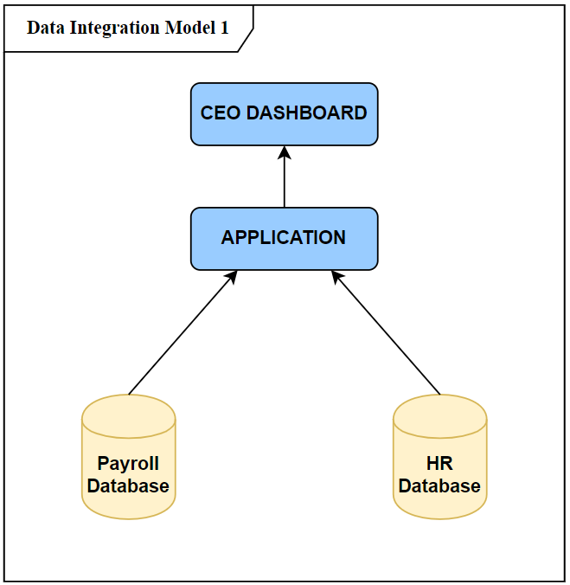
Description: This model uses an application to process 2 databases and provide information to the CEO. The two databases are not centralized. When the CEO requests information, the app pulls the results from the two databases and returns to the CEO dashboard.
For example, when the CEO asks to see some information about an employee's salary, the application queries the Payroll database and returns the results to the CEO dashboard. And when the CEO sends another request to view an employee's work history, the app queries the HR database and returns the results to the dashboard.

6.2. Data Integration Model 2
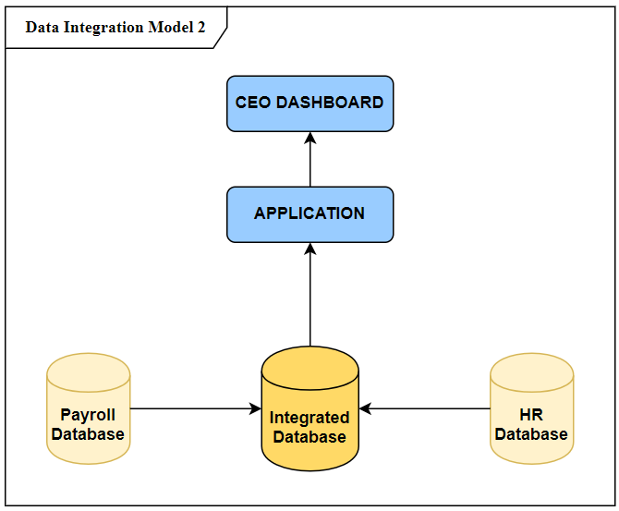
Description: In the data integration model 2, two databases will be integrated into one main database without any data loss. We will choose a solution to build a new database based on 2 existing databases and according to the CEO's requirements. The app will not need to connect to the other 2 databases.
For example, when the CEO has a request for some information about salary or employee information, the application queries into the new database and then returns to the resulting CEO dashboard.

6.3. Our recommendations
We propose Solution 2: Create a new integrated database and data integration model. The unified database will serve as a central source for all HR and payroll data, allowing executives to easily access comprehensive insights and facilitate data-driven decision-making.
The data integration model will ensure that data is synchronized between existing systems and new databases, minimizing the risk of inconsistencies. The operational binding document will provide clear guidelines for maintaining data integrity and ensuring the smooth operation of the integrated system.

7. Database Integration System

7.1. Unified Database Schema
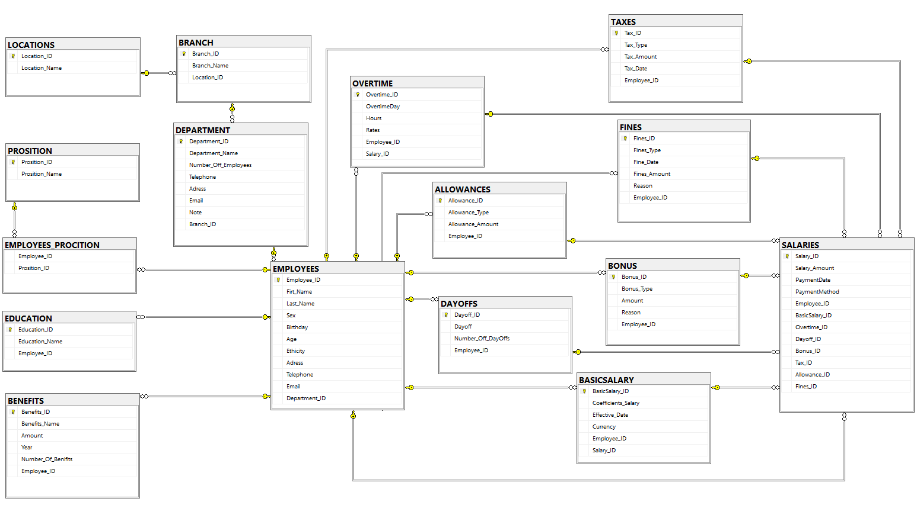

7.2. Normalization
- LOCATION

Location_ID (PK) | One
Location_Name | B
Key Key: Location_ID
All attributes of LOCATION have a unique value
- Standard 1NF
Relations: R (A, B)
A->B is a fully functional dependency.
- Standard 2NF
LOCATION is 3NF because B, C are not dependent on the relay function A
- BRANCH
Branch_ID (PK) | One
Branch_Name | B
Location_ID | C
Key Key: Branch_ID
All Branch attributes have a unique value
- Standard 1NF
Relations: R (A, B, C)
A->B is a fully functional dependency.
A->C is a fully functional dependency.
- Standard 2NF
BRANCH is 3NF because B, C are not dependent on the relay function A
- EMPLOYEE
Employee_ID (PK) | One
Firt_Name | B
Last_Name | C
Sexual activity | D
Birthday | E
Age | F
Athicity | G
Address | H
Telephone | I
Email | K
Department_ID | L
Primary key: Employee_ID
All assets of the EMPLOYEE are of unique value
- Standard 1NF
Relation: R (A, B, C, D, E, F, G, H, I, K, L)
A->B is a fully functional dependency.
A->C is a fully functional dependency.
A->D is a fully functional dependency.
A->E is a fully functional dependency.
A->F is a fully functional dependency.
A->G is a fully functional dependency.
A->H is a fully functional dependency.
A->I is a fully functional dependency.
A->K Fully Functional Dependent
A->L is fully functional dependent
- Standard 2NF
EMPLOYEES is 3NF because B, C, D, E, F, G, H, I, K, L are not dependent on the relay function A

- DEPARTMENT
Department_ID (PK) | One
Department_Name | B
Number_Off_Employees | C
Telephone | D
Address | E
Email | F
Record | G
Brench_ID | H
Key Key: Department_ID
All DEPARTMENT attributes have a unique value
- Standard 1NF
Relations: R (A, B, C, D, E, F, G, H)
A-> is a fully functional dependency.
A->C is a fully functional dependency.
A->D is a fully functional dependency.
A->E is a fully functional dependency.
A->F is a fully functional dependency.
A->G is a fully functional dependency.
A->H is a fully functional dependency.
- Standard 2NF
DEPARTMENT is 3NF because B, C, D, E, F, G, H are not dependent on the relay function A
- ALLOWANCE
Allowance_ID (PK) | One
Allowance_Type | B
Allowance_Amount | C
Curency | D
Employee_ID | E

Key Key: Allowance_ID
All attributes of ALLOWANCE have unique values
- Standard 1NF
Relations: R (A, B, C, D, E)
A->B is a fully functional dependency.
A->C is a fully functional dependency.
A->D is a fully functional dependency.
A->E is a fully functional dependency.
- Standard 2NF
ALLOWANCE is 3NF because B, C, D, E are not dependent on the relay function A
- BASIC SALARY
Basicsalary_ID (PK) | One
Coefficients_Salary | B
Effective_Date | C
Currency | D
Employee_ID | E
Key Key: Basicsalary_ID
All attributes of BASICSALARY have a unique value
- Standard 1NF
Relations: R (A, B, C, D, E)
A->B is a fully functional dependency.
A->C is a fully functional dependency.
A->D is a fully functional dependency.
A->E is a fully functional dependency.
- Standard 2NF
BASICSALAYR is 3NF because B,C,D,E is not a forward function dependency A
- DAY OFF
Dayoff_ID (PK) | One
Year | B
Number_OFF_DayOffs | C
Employee_ID | D
Key Key: Dayoff_ID
All attributes of DAYOFFS have a unique value
- Standard 1NF
Relations: R (A, B, C, D)
A->B is a fully functional dependency.
A->C is a fully functional dependency.
A->D is a fully functional dependency.
- Standard 2NF
DAYOFFS are 3NF because B, C, D are not transitional function dependencies A
- EDUCATION
Education_ID (PK) | One
Education_Name | B
Employee_ID | C
Key Key: Education_ID
All attributes of EDUCATION have unique value
- Standard 1NF
Relations: R (A, B, C)
A->B is a fully functional dependency.
A->C is a fully functional dependency.
- Standard 2NF
EDUCATION is 3NF because B,C is not a transitional function dependent A
- TAX
Tax_ID (PK) | One
Tax_Type | B
Tax_Amount | C
Tax_Rate | D
Currency | E
Employ_ID | F
Key Key: Tax_ID
All assets of TAX have a unique value
- Standard 1NF
Relations: R (A, B, C, D, E, F)
A->B is a fully functional dependency.
A->C is a fully functional dependency.
A->D is a fully functional dependency.
A->E is a fully functional dependency.
A->F is a fully functional dependency.
- Standard 2NF
TAXES is 3NF because B, C, D, E, F are not transitional function dependencies A

- FINE
Fines_ID (PK) | One
Fines_Type | B
Fine_Date, | C
Fines_Amount | D
Currency | E
Reason | F
Employee_ID | G
Key Key: Fines_ID
All properties of FINES have a unique value
- Standard 1NF
Relations: R (A, B, C, D, E, F, G)
A->B is a fully functional dependency.
A->C is a fully functional dependency.
A->Dis is fully functionally dependent.
A->E is a fully functional dependency.
A->F is a fully functional dependency.
A->G is a fully functional dependency.
- Standard 2NF
FINES is 3NF because B, C, D, E, F, G are not dependent on the relay function A
- BONUS
Bonus_ID (PK) | One
Bonus_Name, | B
Bonus_Type | C
Amount | D
Reason | E
Employee_ID | F
Key Key: Bonus_ID
All attributes of the BONUS have a unique value
- Standard 1NF
Relations: R (A, B, C, D, E, F)
A->B is a fully functional dependency.
A->C is a fully functional dependency.
A->D is a fully functional dependency.
A->E is a fully functional dependency.
A->F is a fully functional dependency.
- Standard 2NF
The BONUS is 3NF because B, C, D, E, F are not dependent on the forward function A
- EMPLOYEES_PROSITION
Employee_ID | One
Prosition_ID | B
Primary key: Employee_ID
All attributes of EMPLOYEES_PROSITION have a unique value
- Standard 1NF
Relations: R (A, B)
A->B is a fully functional dependency.
- Standard 2NF
EMPLOYEES-PROSITION is 3NF because B is not a forward function dependent A
- PROSITION
Procition_ID (PK) | One
Procition_Name | B
Key Key: Prosition_ID
All attributes of PROSITION have a unique value
- Standard 1NF
Relations: R (A, B)
A->B is a fully functional dependency.
- Standard 2NF
PROSITION is 3NF because B is not a forward function dependency A
- OVERTIME
Overtime_ID (PK) | One
Overtime days | B
Hour | C
Price | D
Employee_ID | E
Key Key: Overtime_ID
All attributes of OVERTIME have a unique value
- Standard 1NF
Relations: R (A, B, C, D, E)
A->B is a fully functional dependency.
A->C is a fully functional dependency.
A->D is a fully functional dependency.
A->E is a fully functional dependency.
- Standard 2NF
OVERTIME is 3NF because B, C, D, E are not dependent on the relay function A

- BENEFIT
Benefits_ID | One
Benefits_Name, | B
Amount | C
Year | D
Number_Off_Benefits | E
Employee_ID | F
Key Key: Benefits_ID
All attributes of BENEFITS have a unique value
- Standard 1NF
Relations: R (A, B, C, D, E, F)
A->B is a fully functional dependency.
A->C is a fully functional dependency.
A->D is a fully functional dependency.
A->E is a fully functional dependency.
A->F is a fully functional dependency.
- Standard 2NF
BENEFITS is 3NF because B, C, D, E, F are not dependent on the relay function A

- SALARY
Salary_ID (PK) | One
Salary_Amount | B
Payment date | C
Payment Methods | D
Employee_ID | E
Primary key: Employee_ID
All assets of the EMPLOYEE are of unique value
- Standard 1NF
Relations: R (A, B, C, D, E)
A->B is a fully functional dependency.
A->C is a fully functional dependency.
A->D is a fully functional dependency.
A->E is a fully functional dependency.
- Standard 2NF
SALARIES is 3NF because B, C, D, E are not dependent on a forward function A

7.3. Integrated Database Relationships
- EMPLOYEE(Department_ID) - DEPARTMENT(Department_ID): Multiple employees may belong to the same department.
  - Foreign Key Relations: STAFF. Department_ID refer to the BOARD. Department.
- STAFF(Employee_ID) - EDUCATION(Employee_ID): An employee can have multiple levels of education.
  - Foreign Key Relations: EDUCATION. Employee_ID refer to STAFF. Employee code.
- EMPLOYEE(Emloyee_ID) - WELFARE(Employee_ID): An employee can have many benefits
  - Foreign Locked Relations: BENEFITS. Employee_ID refer to STAFF. Employee code.
- EMPLOYEE(Employee_ID) - OVERTIME (Employee_ID): An employee can have many hours of overtime
  - Foreign key relations: OVERTIME. Employee_ID refer to STAFF. Employee code.
- EMPLOYEE(Employee_ID) - ALLOWANCE(Employee_ID): An employee can have multiple allowances.
  - Foreign Locked Relations: SUBSIDIZ. Employee_ID refer to STAFF. Employee code.
- EMPLOYEE(Employee_ID) - DAYOFFS(Employee_ID): An employee can have multiple days off.
  - Foreign Key Relations: DAYOFFS. Employee_ID refer to STAFF. Employee code.
- EMPLOYEE(Employee_ID) - TAX(Employee_ID): An employee can have multiple types of taxes.
  - Foreign key relations: TAX. Employee_ID refer to STAFF. Employee code.
- EMPLOYEE(Employee_ID) - FINE (Employee_ID): An employee can be fined a lot of money
  - Foreign Key Relations: FINES. Employee_ID refer to STAFF. Employee code.
- EMPLOYEE(Employee_ID) - BONUS(Employee_ID): An employee can have multiple bonuses.
  - Foreign key relations: BONUS. Employee_ID refer to STAFF. Employee code.
- EMPLOYEE(Employee_ID) - BASICSALARY(Employee_ID): An employee with a basic salary
  - Foreign Key Relations: BASICSALARY. Employee_ID refer to STAFF. Employee code.
- EMPLOYEE(Employee_ID) - SALARY(Employee_ID): An employee can have a lot of salary
  - Foreign Key Relations: SALARIES. Employee_ID refer to STAFF. Employee code.
- TAXES (Tax_ID) – SALARY (Tax_ID): A salary can have multiple taxes.
  - Foreign Key Relations: SALARIES. Tax_ID refer to TAX. Tax_ID.
- SALARIES (_ID Fines) - FINES (Fines_ID): A salary can have multiple Fines.
  - Foreign Key Relations: SALARIES. Fines_ID refer to FINES. Fines_ID.
- SALARY(Bonus_ID) - BONUS(Bonus_ID): A salary can have multiple bonuses.
  - Foreign Key Relations: SALARIES. Bonus_ID refer to BONUS. Bonus_ID.
- SALARIES (Basicsalary _ID) - BASICSALARY(Basicsalary_ID): Salary can have a basic salary.
  - Foreign Key Relations: SALARIES. Basicsalary _ID refer to BASICSALARY. Basic salary _ID.
- SALARIES (Dayoff _ID) - DAYOFFS(Dayoff_ID): A salary can have multiple days off.
  - Foreign Key Relations: SALARIES. Dayoff _ID refer to DAYOFFS. Holidays _ID.
- SALARIES (Overtime _ID) - OVERTIME (Overtime_ID): A salary that can have multiple overtime.
  - Foreign Key Relations: SALARIES. Overtime_ID refer to OVERTIME. Overtime_ID.
- DEPRANTMENT (Branch_ID) – BRANCH (_ID Branch): A branch can have multiple departments
  - Foreign Key Relations: DEPRANTMENT. Branch_ID refer to BRANCH. Branch_ID.
- BRANCH (Location_ID) – LOCATION (location_ID): A location can have multiple branches.
  - Foreign Key Relations: DEPRANTMENT. Branch_ID refer to BRANCH. Branch_ID.

8. System-wide database synchronization

8.1. About the tools
We use SQL delta for SQL server to synchronize the database
SQL Delta is a database comparison and synchronization tool designed to help database developers and administrators efficiently manage database schemas and data changes. It supports various database platforms and provides an intuitive interface for comparing, analyzing, and deploying database updates.
Advantage:
- Easy-to-use interface for quick database comparisons
- Supports multiple database platforms
- Detailed reports and script changes
- Automatic synchronization process
Difficult:
- Requires a permit, which can be costly for small groups
- Limited support for non-relational databases

8.2. Inspection results

8.2.1. Database Connection
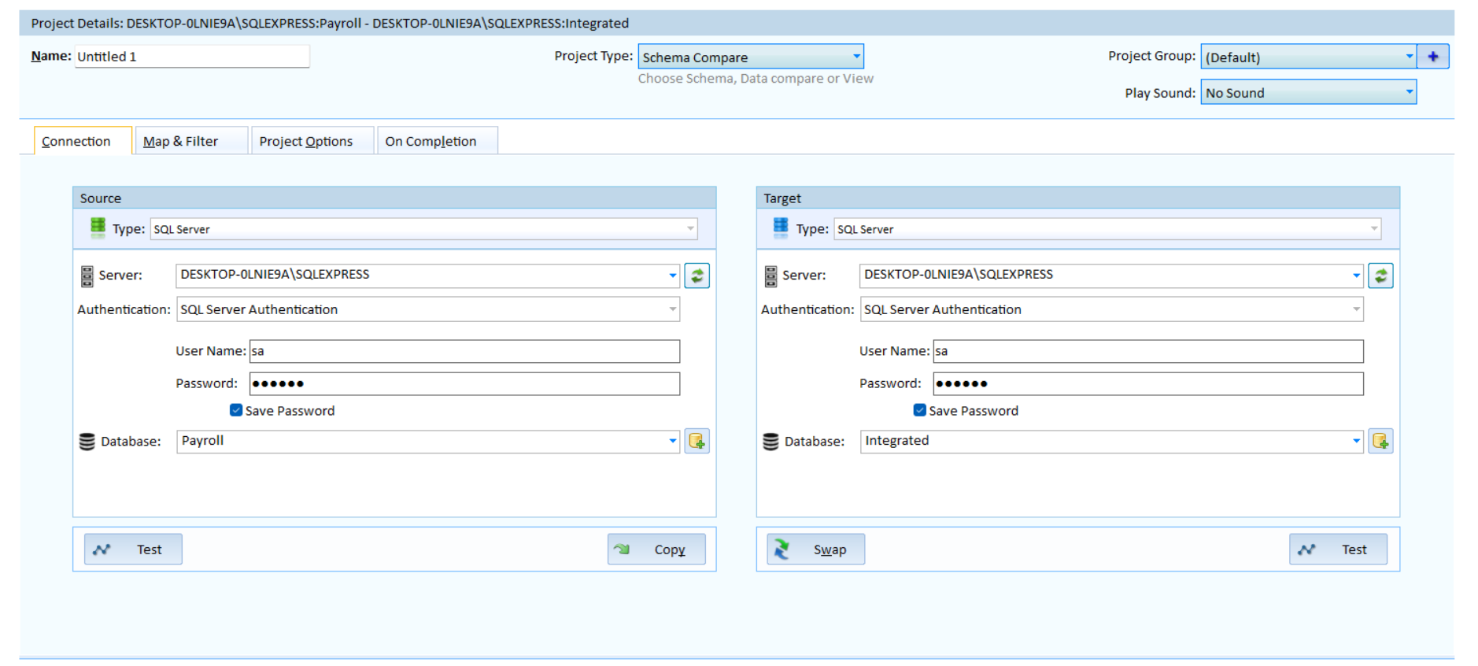

8.2.2. Comparison and after synchronization of the structure
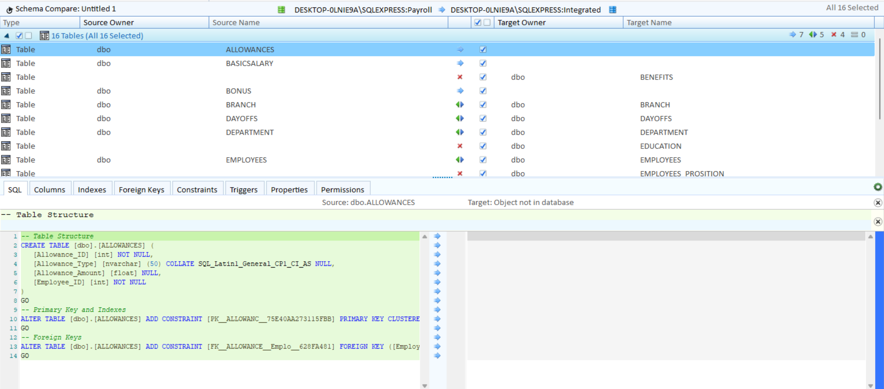

8.2.3. Data Comparison
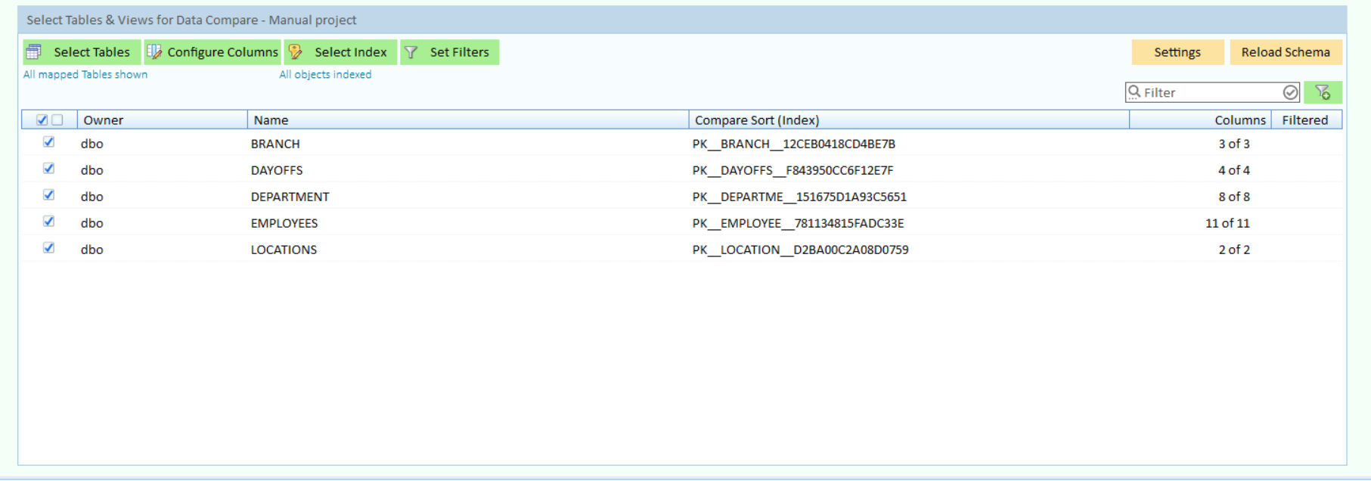

8.2.4. After Data Synchronization
