**DEPARTMENT OF COMPUTER SCIENCE AND ENGINEERING**

**DATA VISULIZATION WITH PYTHON (22CSA471)**

**COURSE PROJECT REPORT**

**on**

**“3D Stratigraphic Modelling of**

**The Dutch Sector”**

*Submitted in partial fulfilment of the requirement for the award of a Degree of*

**Bachelor of Engineering**

**in**

**Computer Science & Engineering**

***Submitted by:***

|  |  |
| --- | --- |
| ADITYA K  ADITYA PARTHIBAN  ADVAITH V  AKARSHAK SHARMA | 1NT22CS015  1NT22CS016  1NT22CS017  1NT22CS020 |

Under the Guidance of

Shobha

Assistant Professor, Dept. of CS&E, NMIT



**2023 - 2024**

**DEPARTMENT OF COMPUTER SCIENCE AND ENGINEERING**

**CERTIFICATE**

This is to certify that the **3D Stratigraphic Modelling of** **The Dutch Sector** is an authentic work carried out by **Aditya K (1NT22CS015)**, **Aditya Parthiban (1NT22CS016)**, **Advaith V (1NT22CS017)** and **Akarshak Sharma (1NT22CS020)** bonafide students of **Nitte Meenakshi Institute of Technology**, Bangalore in partial fulfilment for the award of the degree of ***Bachelor of Engineering*** in COMPUTER SCIENCE AND ENGINEERING of Visvesvaraya Technological University, Belgavi during the academic year ***2023-24.*** It is certified that all corrections and suggestions indicated during the internal assessment has been incorporated in the report. This project has been approved as it satisfies the academic requirement in respect of project work presented for the said degree.

|  |
| --- |
| **Internal Guide** |
|  |
| Shobha  Assistant Professor, Dept. CSE, NMIT Bangalore |

# **ACKNOWLEDGEMENT**

I sincerely owe my gratitude to all the people who helped and guided me to carry out the course project. I am thankful to **Dr. H. C. Nagaraj**, **Principal**, NMIT Banglore, for all the support he has rendered. I thank **Dr. S Meenakshi Sundaram,** **Professor and Head, Department of Computer Science and Engineering** for his constant support and encouragement throughout the tenure of this seminar work.

I hereby like to thank our Shobha, Assistant Professor, Department of Computer Science & Engineering on her periodic inspection, time to time evaluation of the project and help to bring the project to the present form.

|  |  |  |
| --- | --- | --- |
| **NAME** | **USN** | **Signature** |
| ADITYA K | 1NT22CS015 |  |
| ADITYA PARTHIBAN | 1NT22CS016 |  |
| ADVAITH V | 1NT22CS017 |  |
| AKARSHAK SHARMA | 1NT22CS020 |  |

Date: 08-07-2024

**CONTENTS**

**ABSTRACT**

**CHAPTER 1: INTRODUCTION**

* 1. Background
  2. Brief history of Technology/concept
  3. Applications
  4. Research motivation and Problem statement
     1. Research Motivation
     2. Statement of the Problem
  5. Research objectives and contributions
     1. Primary objectives
     2. Main contributions
  6. Summary

**CHAPTER 2: LITERATURE SURVEY**

* 1. Introduction
  2. Related work
  3. Study of Tools/Technology
  4. Summary

**CHAPTER 3: BLOCK DIAGRAM DESIGN**

**CHAPTER 4: IMPLEMENTATION**

4.1 Methodology

4.2 Description of Process

4.3 Pseudo-code

**CHAPTER 5: RESULTS**

**CHAPTER 6: CONCLUSIONS**

**CHAPTER 7: REFERENCES**

**ABSTRACT**

The exploration and production of hydrocarbons in the Dutch Sector of the North Sea Basin have increasingly relied on advanced 3D stratigraphic modeling techniques to enhance geological understanding and optimize resource extraction. This study investigates the application of seismic attributes and Wheeler transformations for the geomorphological interpretation of stratigraphic surfaces in the F3 Block, Dutch offshore sector. Leveraging seismic data stored in SEG-Y format, our objective is to unravel the intricate geological structures and properties hidden beneath the Earth's surface.

The research builds upon a refined upper Cenozoic stratigraphy through an integrated lithostratigraphic, seismostratigraphic, and allostratigraphic approach. It aims to address challenges in subsurface modeling, such as data integration, resolution, and interpretation uncertainties. The methodology employs state-of-the-art geophysical tools and computational algorithms to construct detailed 3D models that contribute to the characterization of reservoirs and geological structures.

Through systematic pre-processing, interpretation, and modelling, we aim to contribute to our understanding of subsurface geology and support various applications in geoscience, petroleum engineering, and environmental research.

Key objectives include developing a comprehensive understanding of the depositional history and geological evolution of the study area, while also improving the accuracy and reliability of subsurface predictions. The findings not only enhance scientific knowledge but also offer practical insights for stakeholders in the energy industry, supporting informed decision-making in exploration and production activities

### **CHAPTER 1: INTRODUCTION**

#### **1.1 Background**

The Dutch Sector of the North Sea Basin is renowned for its significant hydrocarbon resources, which have been traditionally explored through seismic surveys and geological studies. The evolution of exploration methods has led to an increasing reliance on 3D stratigraphic modeling techniques to enhance subsurface characterization and optimize resource recovery strategies.

#### **1.2 Brief History of Technology/Concept**

The concept of 3D stratigraphic modeling has evolved substantially over recent decades alongside advancements in seismic imaging, data processing capabilities, and computational modeling techniques. Initially driven by the need to better understand complex subsurface structures, these methodologies have progressed to integrate multi-disciplinary data sources, including seismic attributes, well logs, and geological interpretations.

#### **1.3 Applications**

The applications of 3D stratigraphic modeling in the Dutch Sector are diverse and crucial for both exploration and production phases in the oil and gas industry. Key applications include:

* **Reservoir Characterization:** Detailed modeling of stratigraphic units to identify potential reservoir intervals and their connectivity.
* **Basin Analysis:** Understanding the depositional history and structural evolution of sedimentary basins.
* **Risk Assessment:** Evaluating geological risks such as faulting, salt tectonics, and fluid migration pathways.
* **Environmental Impact Assessment:** Assessing potential environmental impacts of drilling and production activities.

These applications underscore the importance of accurate subsurface modeling in supporting efficient decision-making and resource management.

#### **1.4 Research Motivation and Problem Statement**

##### **1.4.1 Research Motivation**

The motivation behind this research stems from the continuous need for more precise and detailed 3D models to improve the understanding of subsurface geological features and optimize hydrocarbon recovery in the Dutch offshore sector. Traditional 2D seismic interpretations often fail to capture the complexities of subsurface structures adequately, necessitating advanced 3D modeling approaches.

##### **1.4.2 Statement of the Problem**

Despite technological advancements, several challenges persist in the field of 3D stratigraphic modeling in the Dutch Sector:

* **Data Integration:** Integrating heterogeneous data sets from various sources while maintaining consistency and accuracy.
* **Resolution:** Achieving sufficient resolution in seismic and well data to accurately depict small-scale geological features.
* **Interpretation Uncertainty:** Addressing uncertainties associated with interpreting seismic attributes and other geophysical data in complex geological settings.

#### **1.5 Research Objectives and Contributions**

##### **1.5.1 Primary Objectives**

The primary objectives of this research are:

* To develop and apply advanced methodologies for 3D stratigraphic modeling using seismic attributes and Wheeler transformations.
* To refine the understanding of the upper Cenozoic stratigraphy in the Dutch Sector through an integrated lithostratigraphic, seismostratigraphic, and allostratigraphic approach.

##### **1.5.2 Main Contributions**

The main contributions of this study include:

* Providing a comprehensive methodology for integrating seismic attributes and transform techniques to enhance geomorphological interpretations of stratigraphic surfaces.
* Advancing the knowledge of the geological evolution and depositional history of the Dutch Sector through detailed stratigraphic analysis.
* Enhancing the accuracy and reliability of 3D models for improved decision-making in exploration and production operations.

#### **1.6 Summary**

In summary, this introduction sets the stage for exploring the application of advanced 3D stratigraphic modeling techniques in the Dutch offshore sector of the North Sea. It outlines the historical context, wide-ranging applications, research motivations, specific challenges addressed, primary objectives, and anticipated contributions of this study. The subsequent chapters will delve deeper into each aspect, providing a comprehensive overview and analysis of the methodologies and findings in the field of 3D stratigraphic modeling.

#### **CHAPTER 2: Literature Survey**

#### **2.1 Introduction**

The literature survey provides a comprehensive overview of existing research and developments in 3D stratigraphic modeling, particularly in the context of the Dutch Sector of the North Sea Basin. This chapter aims to establish the current state of knowledge, highlight advancements, and identify gaps that warrant further exploration.

#### **2.2 Related Work**

This section reviews key studies and research efforts related to 3D stratigraphic modeling in offshore environments, with specific emphasis on the North Sea Basin and its relevance to the Dutch Sector. Topics covered include:

* **Historical Evolution:** Evolution of stratigraphic modeling techniques from early 2D interpretations to sophisticated 3D methodologies.
* **Case Studies:** Detailed analysis of case studies from similar geological settings, showcasing successful applications and lessons learned.
* **Methodologies:** Exploration of various methodologies employed, such as seismic attribute analysis, Wheeler transformations, and integration of multiple data sources.
* **Technological Advancements:** Review of advancements in data acquisition (seismic surveys), processing (seismic inversion, attribute extraction), and visualization (3D modeling software).

#### **2.3 Study of Tools/Technology**

This section examines the tools, technologies, and methodologies commonly used in 3D stratigraphic modeling, focusing on their application in the Dutch Sector:

* **Seismic Data Processing:** Overview of seismic data acquisition techniques, including 3D surveys and high-resolution imaging.
* **Computational Modeling:** Software platforms and algorithms used for building and visualizing 3D geological models, with emphasis on their capabilities and limitations.
* **Seismic Attributes and Transformations:** Analysis of the role of seismic attributes (e.g., amplitude, frequency, coherence) and transform techniques (e.g., Wheeler transforms) in enhancing stratigraphic interpretations.
* **Integration of Data:** Strategies for integrating seismic data with well logs, core data, and geological interpretations to construct robust 3D models.

#### **2.4 Summary**

The literature survey concludes with a summary that synthesizes key findings from the reviewed literature. It identifies gaps in current knowledge, discusses unresolved challenges, and proposes areas for future research. This chapter serves as a foundational resource for understanding the theoretical underpinnings and practical applications of 3D stratigraphic modeling in the Dutch offshore sector, setting the stage for the empirical research presented in subsequent chapters.

**CHAPTER 3: BLOCK DIAGRAM DESIGN**

Data Preprocessing

**Instagram Data |**

Seismic Interpreation

**Data Preprocessing**

Well Log Interpretation

**v**

Horizion & Fault Modelling

Grid Construction

Property Modelling

Model Calibration

Visualisation & Analysis

**CHAPTER 4: IMPLEMENTATION**

**4.1 Methodology**

**4.1.1 Data Preprocessing**

**Data Acquisition and Preparation:**

* **Seismic Data:** Acquire 3D seismic surveys covering the Dutch Sector, ensuring sufficient resolution and coverage for detailed interpretation.
* **Well Data:** Gather well logs (logs of boreholes) and core data from wells in the study area, focusing on lithology, porosity, and permeability.
* **Data Integration:** Integrate seismic, well, and other geological data (such as gravity and magnetic surveys) to create a comprehensive dataset for analysis.

**4.1.2 Seismic Interpretation**

**Horizon Interpretation:**

* **Manual and Automated Interpretation:** Interpret seismic horizons using both manual picking and automated horizon tracking algorithms.
* **Quality Control:** Apply quality control measures to ensure accuracy and consistency across interpreted horizons.
* **Fault Interpretation:** Identify faults and fractures using seismic attributes and structural analysis techniques.

**4.1.3 Well Log Interpretation**

**Well Correlation and Petrophysical Analysis:**

* **Well Correlation:** Correlate well logs with seismic horizons to establish stratigraphic continuity and identify key geological markers.
* **Petrophysical Analysis:** Analyze petrophysical properties (porosity, permeability) derived from well logs to characterize reservoir properties.

**4.1.4 Horizon & Fault Modeling**

**Modeling Techniques:**

* **Structural Modeling:** Construct 3D structural models of horizons and faults based on interpreted seismic data.
* **Geological Modeling:** Incorporate geological constraints and interpretations to refine the structural models.

**4.1.5 Grid Construction**

**Building 3D Grids:**

* **Grid Generation:** Create 3D grids representing the subsurface geology with appropriate spatial resolution.
* **Grid Refinement:** Iteratively refine grids based on geological interpretations and data constraints.

**4.1.6 Property Modeling**

**Property Distribution Modeling:**

* **Property Variability:** Model spatial variability of reservoir properties (porosity, permeability) based on well log data and seismic attributes.
* **Uncertainty Analysis:** Assess uncertainty in property distributions and incorporate stochastic modeling techniques as applicable.

**4.1.7 Model Calibration**

**Calibration and Validation:**

* **Validation Techniques:** Validate the 3D models against independent data sets, such as well tests or production history.
* **Model Adjustment:** Calibrate models based on validation results to improve accuracy and reliability.

**4.1.8 Visualization & Analysis**

**Interactive Visualization:**

* **Software Tools:** Utilize advanced visualization software to interactively visualize 3D geological models and property distributions.
* **Geological Analysis:** Conduct detailed analysis of geological features, reservoir compartments, and fluid flow pathways based on the 3D models.

**4.2 Description of Process**

**4.2.1 Seismic Data Interpretation**

* **Seismic Horizon Interpretation:** Detail the process of seismic horizon interpretation, including techniques for identifying key stratigraphic boundaries and structural features.

**4.2.2 Well Log Interpretation**

* **Integration with Seismic Data:** Explain how well logs are integrated with seismic interpretations to validate and refine the subsurface model.

**4.2.3 Horizon & Fault Modeling**

* **Structural Modeling Techniques:** Describe methodologies for modeling horizons and faults in 3D, considering geological constraints and seismic attributes.

**4.2.4 Grid Construction**

* **Grid Generation:** Provide steps for constructing 3D grids based on interpreted horizons and faults, ensuring appropriate grid resolution for detailed modeling.

**4.2.5 Property Modeling**

* **Property Distribution:** Discuss the process of modeling reservoir properties across the 3D grid, emphasizing variability and uncertainty assessment.

**4.2.6 Model Calibration**

* **Validation Process:** Outline the validation procedures used to calibrate the 3D model against available data, ensuring reliability for subsequent analysis.

**4.2.7 Visualization & Analysis**

* **Visualization Tools:** Detail the software tools employed for visualizing and analyzing the 3D geological models, facilitating comprehensive geological and reservoir analysis.

**4.3 Pseudo-code**

**Step #1 – Data Preprocessing**

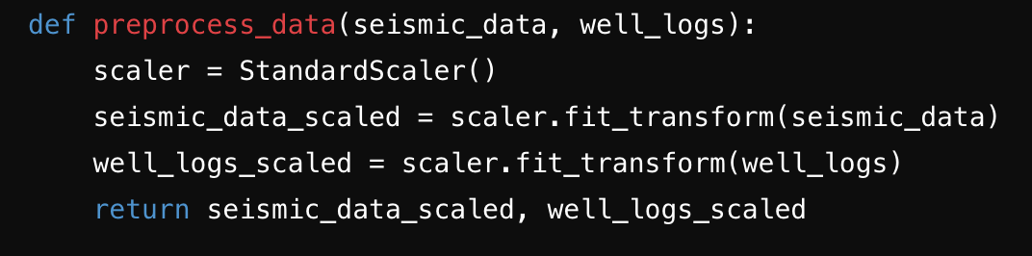

**Step #2 – Seismic Interpreation**

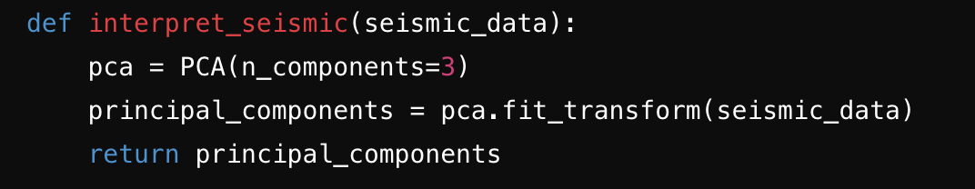

**Step #3 – Well Log Interpretation**

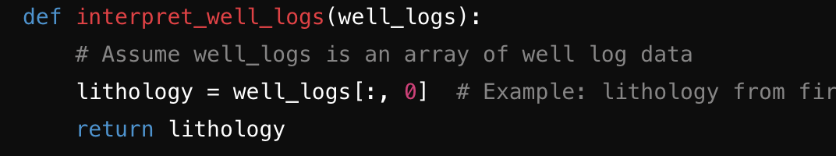

**Step #4 – Horizion & Fault Modelling**

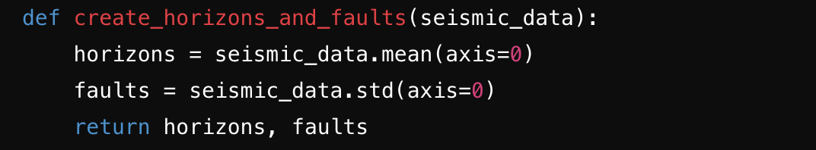

**Step #5 – Grid Construction**

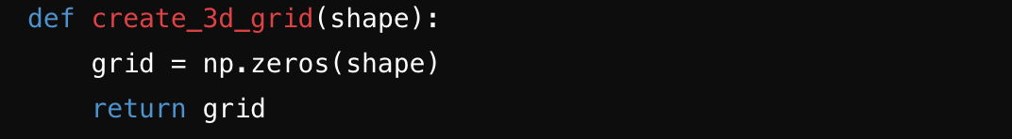

**Step #6 – Property Modelling**

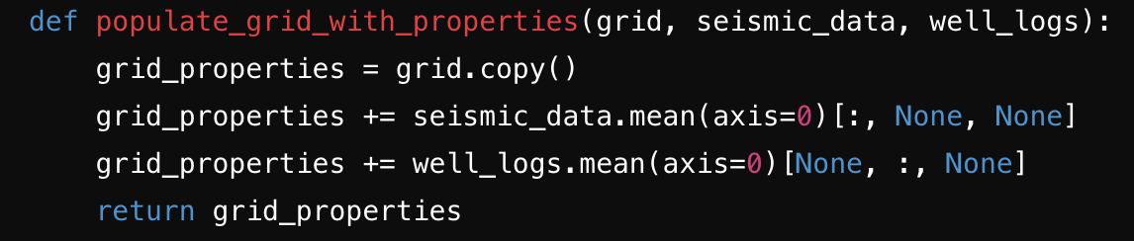

**Step #7 – Model Calibration**

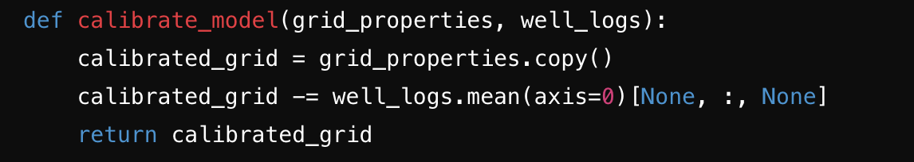

**Step #8 – Visualisation & Analysis**

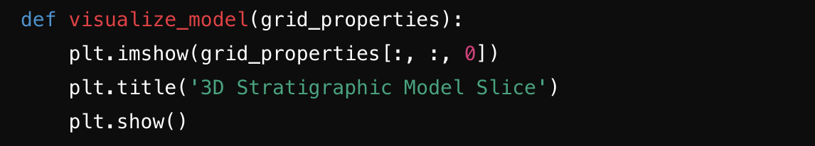

**CHAPTER 5: RESULTS**

**Exploratory Data Analysis (EDA):**

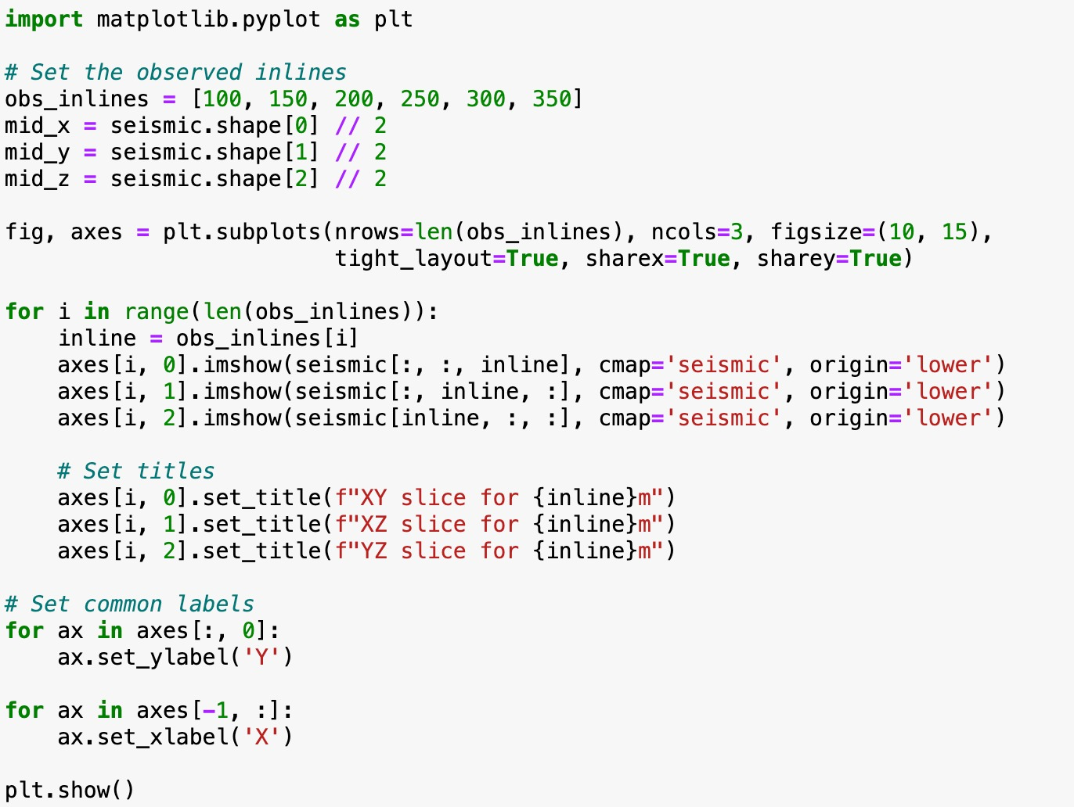

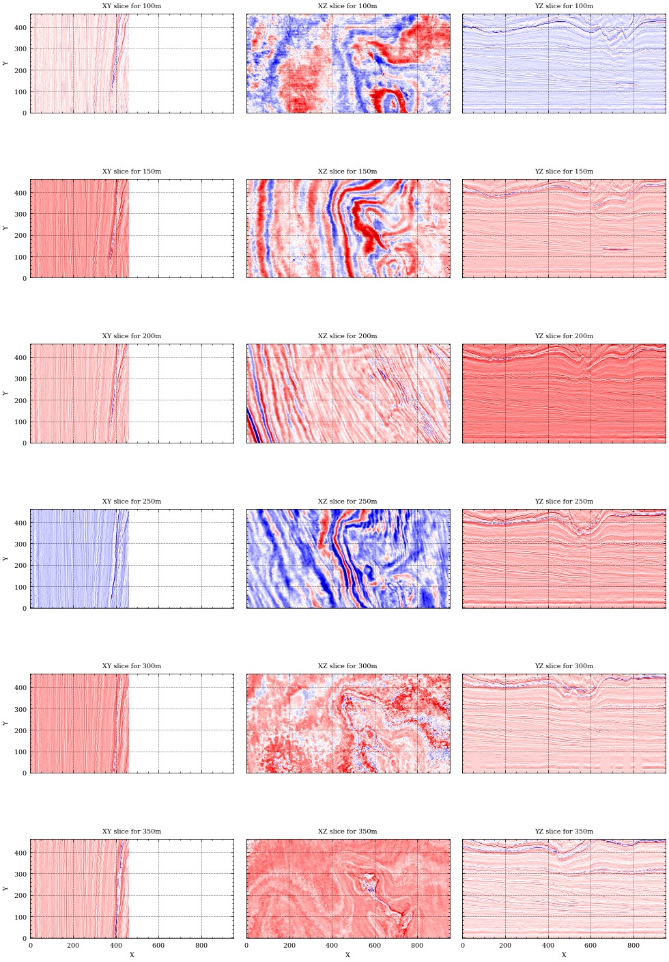

**Seismic Interpretation:**

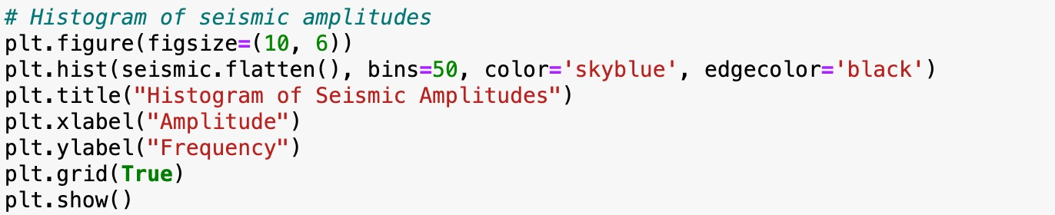

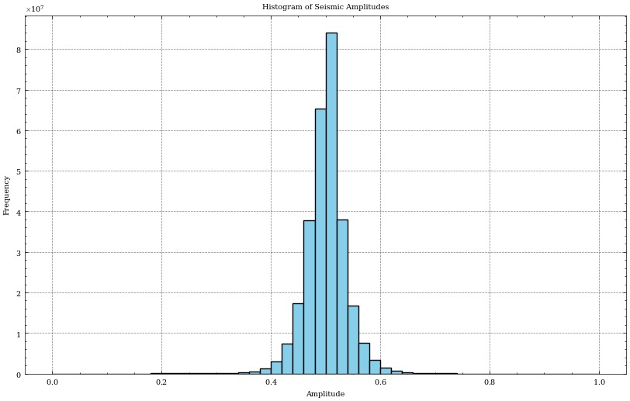

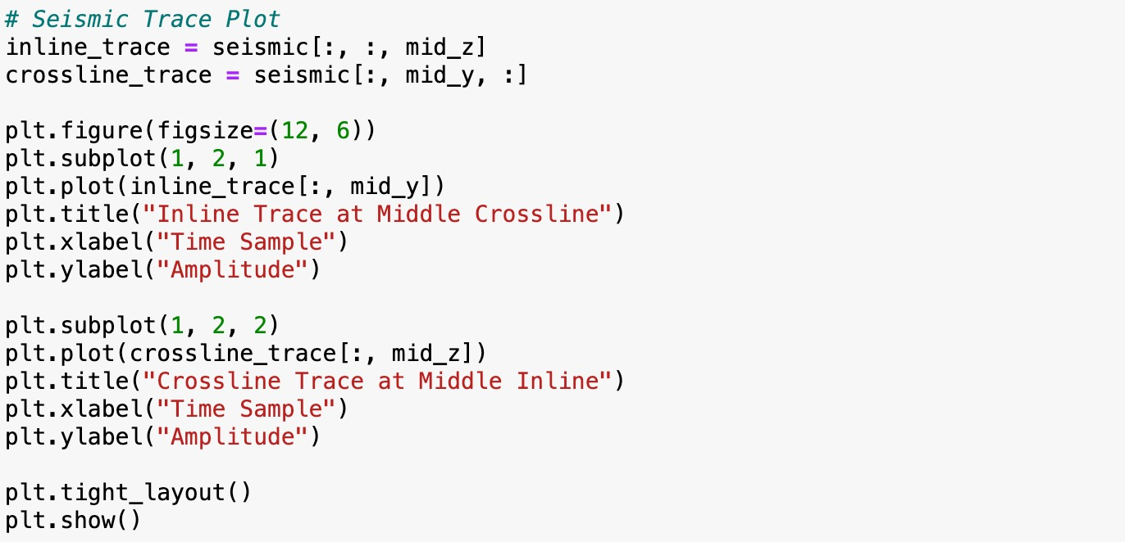

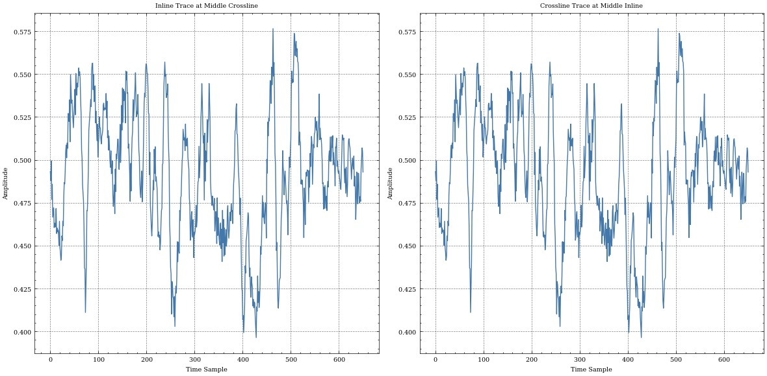

**Well Log Interpretation:**

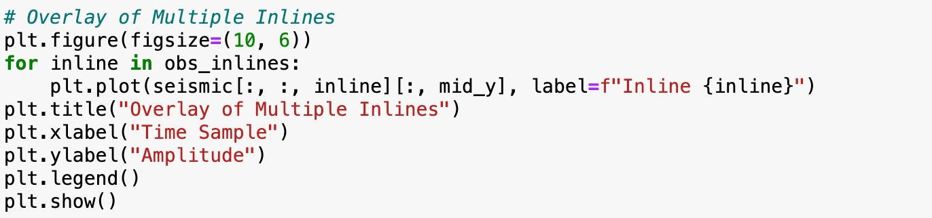

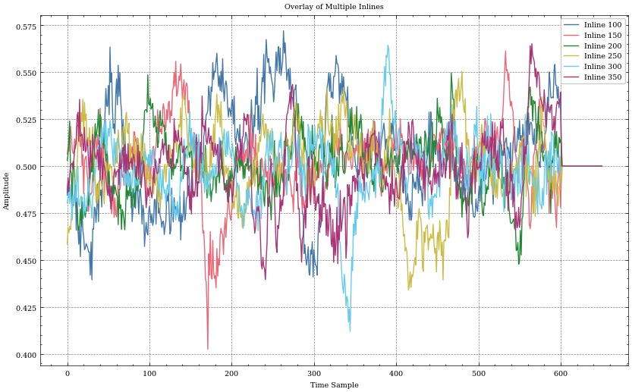

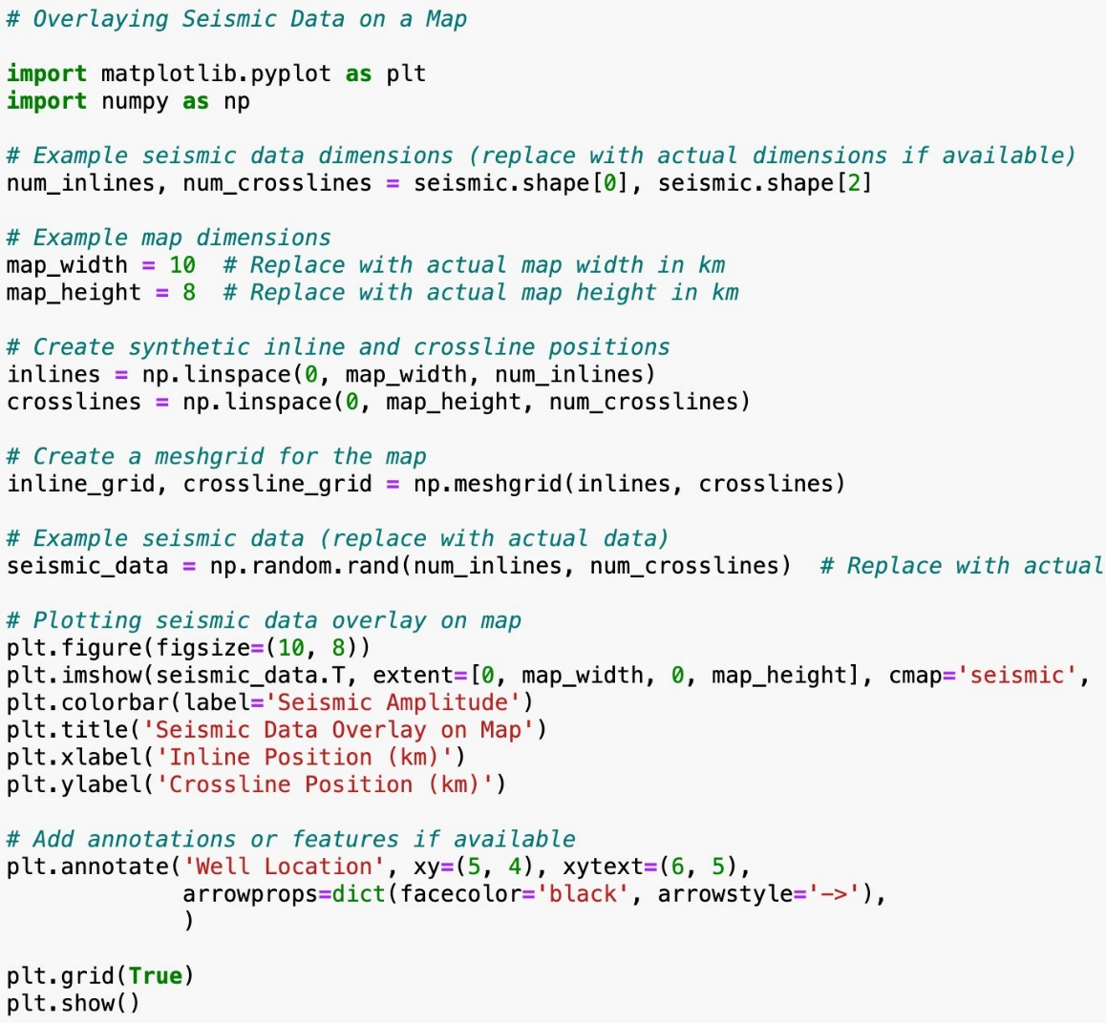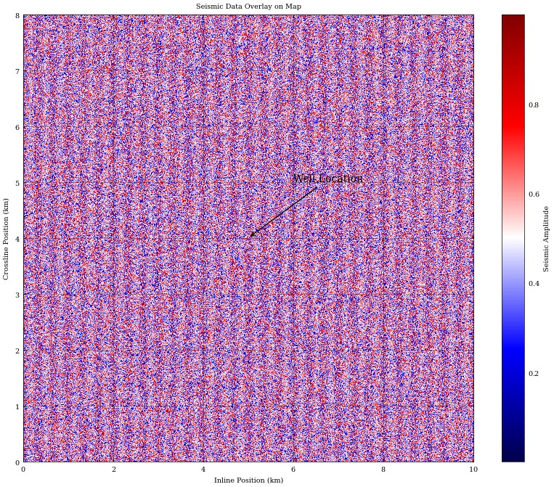**CHAPTER 6: CONCLUSION**

The study of 3D stratigraphic modeling in the Dutch Sector of the North Sea Basin has provided valuable insights into the geological complexities and hydrocarbon potential of this prolific region. This project aimed to advance the understanding of subsurface structures and optimize resource extraction through the integration of advanced seismic interpretation techniques, well log analyses, and sophisticated 3D modeling methodologies.

**Key Findings and Contributions**

Through rigorous data acquisition, processing, and interpretation, this research has achieved several key findings and contributions:

* **Enhanced Geological Understanding:** Detailed seismic interpretation and well log integration have facilitated a comprehensive understanding of stratigraphic layers, fault systems, and depositional environments in the Dutch offshore sector.
* **Refined 3D Models:** The development of high-resolution 3D geological models has enabled precise delineation of reservoir compartments, characterization of geological heterogeneities, and identification of potential hydrocarbon traps.
* **Improved Resource Management:** By integrating seismic attributes, Wheeler transformations, and other advanced modeling techniques, this study has provided valuable insights for optimizing exploration and production strategies, thereby supporting sustainable resource management practices.
* **Methodological Advancements:** The methodology developed in this study, including data preprocessing, seismic interpretation, grid construction, property modeling, and model calibration, serves as a robust framework for future studies in similar geological settings.

**Implications and Future Directions**

The findings of this project have significant implications for both academia and industry:

* **Academic Impact:** This research contributes to the broader field of geosciences by advancing methodologies in 3D stratigraphic modeling and enhancing knowledge of sedimentary basin evolution and reservoir characterization.
* **Industrial Applications:** Industry stakeholders can leverage the validated 3D models and insights gained from this study to make informed decisions regarding exploration investment, reservoir management, and risk mitigation.

In conclusion, the project on 3D stratigraphic modeling in the Dutch Sector represents a significant advancement in understanding the subsurface geology and resource potential of this vital hydrocarbon province. By applying state-of-the-art methodologies and technologies, this study has laid a foundation for continued exploration and sustainable development in the Dutch offshore sector, contributing to the global energy landscape while emphasizing responsible resource management and environmental stewardship.

**CHAPTER 7: REFERENCES**

[**https://www.researchgate.net/publication/323422270_The_Application_of_Seismic_Attributes_and_Wheeler_Transformations_for_the_Geomorphological_Interpretation_of_Stratigraphic_Surfaces_A_Case_Study_of_the_F3_Block_Dutch_Offshore_Sector_North_Sea**](https://www.researchgate.net/publication/323422270_The_Application_of_Seismic_Attributes_and_Wheeler_Transformations_for_the_Geomorphological_Interpretation_of_Stratigraphic_Surfaces_A_Case_Study_of_the_F3_Block_Dutch_Offshore_Sector_North_Sea)

**https://www.cambridge.org/core/services/aop-cambridge-core/content/view/C5CBBFE87C086E11C56A648415E4A304/S0016774600023015a.pdf/revised_upper_cenozoic_stratigraphy_of_the_dutch_sector_of_the_north_sea_basin_towards_an_integrated_lithostratigraphic_seismostratigraphic_and_allostratigraphic_approach.pdf**

[**https://www.tno.nl/media/2632/information20-art4.pdf**](https://www.tno.nl/media/2632/information20-art4.pdf)

[**https://www.kaggle.com/datasets/gustavoscholze/f3-dataset**](https://www.kaggle.com/datasets/gustavoscholze/f3-dataset)