SOFTWARE DEVELOPMENT LIFE CYCLE OF NASA FLIGHT SOFTWARE
Course Name: Introduction To Software Engineering
Course Code: IS1103-1
Assignment Number & Title: Assignment 1 - Software Process Models and Requirements Engineering
Student Name: Akash Acharya
USN / Roll Number: NNM24IS014
Semester & Section: 4th Sem A
Department: Information Science And Engineering
Institution Name: NMAM INSTITUTE OF TECHNOLOGY
Academic Year: 2
Instructor Name: Dr. JASON ELROY MARTIS
Date of Submission: 13th February 2026
ABSTRACT
This paper compares Waterfall, Incremental, and Spiral development methods by thinking through how each one would work when building NASA Flight Software — one of the most demanding software projects in the world where even the smallest mistake can mean losing a spacecraft or a human life. I studied how each method handles requirements, reliability, risk management, time, and cost. I also built a full requirements document and a plan to check if those requirements are correct. My study shows the Spiral method fits best, because it constantly looks for and eliminates risks at every step — and in space software, that careful approach is absolutely non-negotiable.
GITHUB REPOSITORY LINK
GitHub URL: 1Akash-Acharya/SDLC_OF_NASA_FLIGHT_SOFTWARE
1. INTRODUCTION
Software engineering means using organized methods to design, build, and maintain software systems [1]. The Software Development Lifecycle maps out each step from planning all the way through maintaining the finished product. The method chosen directly impacts whether the project succeeds, stays within budget, and delivers what was needed [2].
For this study, I am comparing Waterfall, Incremental, and Spiral methods by thinking through how each would apply to NASA Flight Software. This software controls spacecraft navigation, handles Earth communication, monitors critical onboard systems, and makes real-time decisions that could mean the difference between mission success and complete failure. It must work perfectly every single time with zero tolerance for error [3], making it an ideal case for comparing how different methods hold up under the most extreme pressure imaginable.
Research shows poor requirements management contributes to around 71% of failed software projects [4]. In NASA software, a failed requirement does not just mean a bad product — it could mean losing a billion-dollar spacecraft. My goals: 1) Pick best build method for safety-critical aerospace software. 2) List what software must do and how well. 3) Plan full checks for those needs
2. PROBLEM STATEMENT
This study looks at Waterfall, Incremental, and Spiral methods for NASA flight software. It checks how each deals with requirements, risks, and time-cost tradeoffs.I will produce a full requirements document and a checking plan with identified challenges. Assumptions:Software runs unmanned deep-space mission,50-80 specialized engineers on team,5-8 year timeline,hundreds-of-millions budget like NASA norm,works on radiation-hardened hardware.
3. CASE STUDY: NASA FLIGHT SOFTWARE
3.1 What the Software Is
NASA Flight Software is code built into a spacecraft.It runs everything after launch: navigation, power, comms,science tools,fault detection, and auto choices when Earth signals lag. Examples: Mars Rovers,James Webb Space Telescope,Orion spacecraft. Every function happens millions of miles from any repair technician, making getting it right the first time absolutely everything [5].
3.2 Main Features
- Autonomous navigation and trajectory correction without Earth commands
- Real-time monitoring of temperature, power, and pressure across all systems
- Communication management with NASA's Deep Space Network
- Scientific instrument control and data collection scheduling
- Fault detection, isolation, and automatic recovery from hardware failures
- Power balancing to keep all systems within safe limits
- Software update capability to patch issues after launch
- Redundant system management to switch to backups when primary systems fail
3.3 Who Depends on It
Flight software engineers, mission control at NASA's Jet Propulsion Laboratory, scientists relying on it to run their instruments, safety and reliability engineers who certify it, and in crewed missions, astronauts whose lives depend on it.
3.4 Technical Demands
Zero unplanned downtime over years or decades. Millisecond response for critical decisions Must handle radiation, big temperature changes, and vacuum. Must run fully on its own during 24-minute comms blackouts at Mars distance. Must follow NASA-STD-8739.8 and DO-178C certification rules.
4. LOOKING AT THE THREE BUILDING METHODS
4.1 Waterfall Method
The Waterfall approach moves in a straight line — each phase finishes completely before the next one starts [6]. The steps are: gather requirements, design, build, test, launch, and maintain.
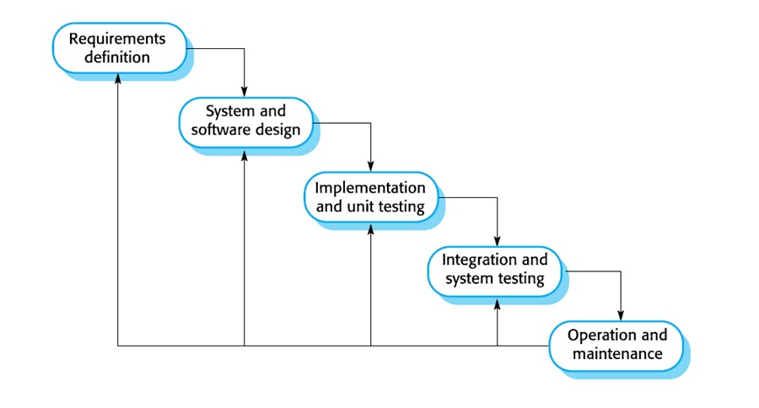
Good things about it for NASA flight software: All requirements and designs are written down with extreme detail before building starts, which helps with the massive certification documentation NASA requires. Regulatory and safety compliance paperwork is easier to prepare when everything follows a strict order. Works well when the mission profile is completely understood before development, like for well-established satellite types.
Bad things about it for NASA flight software: A wrong requirement discovered during testing means going back to the very beginning — losing years and hundreds of millions of dollars. Scientific goals and hardware capabilities evolve across a multi-year build, and Waterfall cannot adapt to that. Testing comes very late, meaning critical safety flaws are found at the most expensive possible moment.
Why it does not fit: Space missions are filled with unknowns and evolving goals. Waterfall has no good way to handle mid-project changes without starting over, which is simply unacceptable at NASA's scale [7].
4.2 Incremental Building Method
The Incremental method breaks the software into smaller working pieces and delivers each piece one at a time, with all stages of development happening for each piece [8].
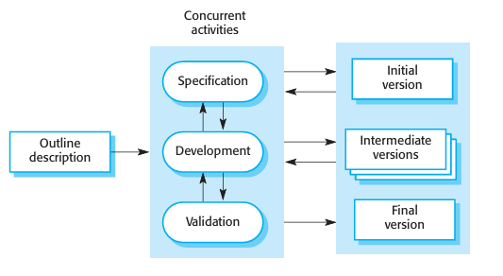
Good things about it for NASA flight software: Core functions like basic navigation and communication can be built and tested first, before more complex features are added. Early increments allow testing on hardware simulators while later increments are still being developed. Fixes in early builds get caught before they spread everywhere. Easier to handle flight software's huge complexity by splitting into focused parts.
Stage example:Stage 1 (Years 1-2): Core navigation,basic telemetry, power management. Stage 2 (Years 2-3):Communication protocols, fault detection, scientific instrument interfaces. Stage 3 (Years 3-5): Autonomous decision-making, software update system, full redundancy management.Stage 4 (Years 5-7):Integration testing, simulation campaigns, final certification.
Bad things about it for NASA flight software: All parts of the software must work together perfectly in space — poor integration planning between increments could create dangerous conflicts. Safety-critical requirements cannot be "added later" as an afterthought in a future increment. Incremental delivery assumes we can test each piece somewhat independently, which is extremely hard when everything in a spacecraft is deeply interconnected.
Why it partially fits: Incremental building helps manage the scale and complexity of flight software, but it needs to be combined with very heavy upfront safety and architectural planning to be safe enough for a NASA mission [9].
4.3 Spiral Method
The Spiral approach builds the software in repeated loops, where every single loop begins by carefully identifying and planning around risks before any building begins [10]. The four steps in each loop are: Plan what to build, Identify and address risks, Build it, and Review what was built.
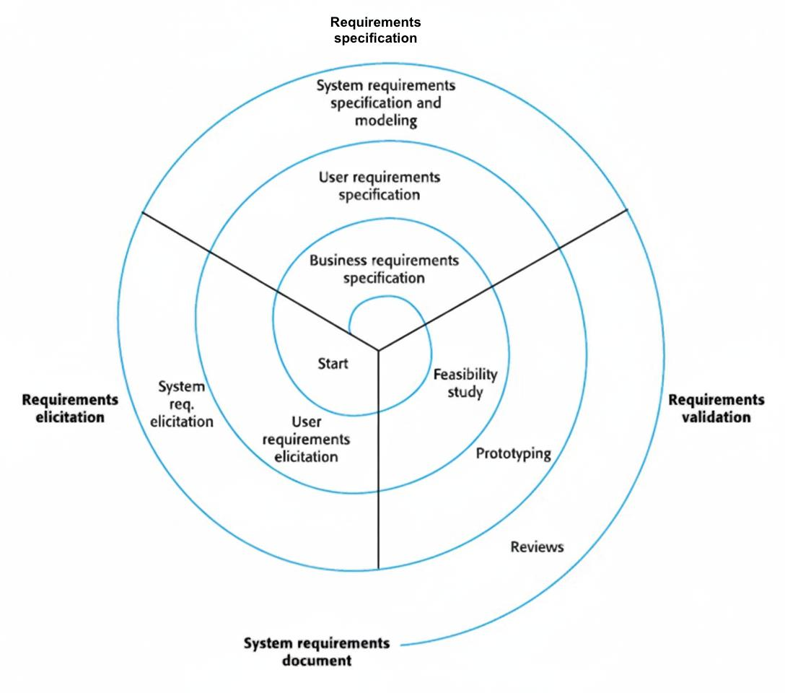
Good things about it for NASA flight software: Risk management is built into the very core of every loop, which is essential for software where a mistake means mission failure. Every loop produces something testable — a simulation, a prototype, or a working module — which is checked thoroughly before the next loop begins. Stakeholders including scientists, engineers, and safety officers review progress at the end of every loop, catching problems early. The method naturally fits NASA's own development approach called the Systems Engineering process, which also emphasizes continuous risk assessment. Changes discovered mid-development — like a change in the spacecraft's hardware specifications — can be absorbed into the next loop without collapsing the whole project.
Risks relevant to NASA flight software: Software failure mid-mission causing complete mission loss, radiation-induced bit flips corrupting critical variables, timing errors causing navigation calculations to fail, communication protocol bugs causing loss of contact with Earth, insufficient fault recovery leading to system lockup, and certification failure delaying launch by years. Each Spiral loop checks all these risks and addresses them with specific countermeasures before building proceeds.
Bad things about it for NASA flight software: Every loop needs full involvement from safety experts, mission designers, and hardware engineers — slow and resource-heavy. Repeated prototyping and risk analysis cost a lot. Requires project managers experienced in both software and aerospace. Some stakeholders find the looping approach harder to follow than a straight-line plan.
Why it fits best: The reason I am confident the Spiral method is right for NASA flight software is that this is exactly the kind of project the Spiral method was designed for — extremely high stakes, enormous complexity, deep technical uncertainty, and an absolute intolerance for failure [11].NASA's own internal processes at JPL and other centers already use risk-driven iterative development that closely mirrors the Spiral model.
4.4 Table Of Comparison Between Waterfall, Incremental and Spiral Models
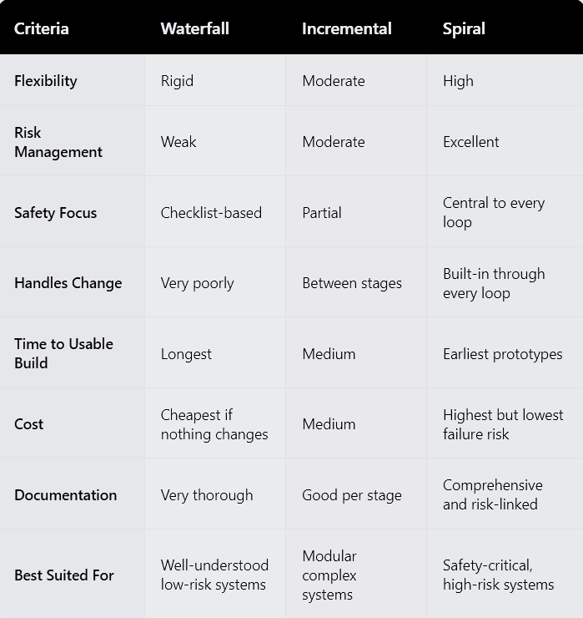
5. FIGURING OUT THE SOFTWARE NEEDS
5.1 How I Gathered Requirements
Requirements were gathered through [12]:published NASA mission documents and lessons-learned reports,flight software architecture from Curiosity and Perseverance missions, aerospace standards (NASA-STD-8739.8, DO-178C), analysis of historical mission failures, and scenario-based walkthroughs of simulated mission profiles.
5.2 WHAT THE SOFTWARE MUST DO
1:Navigation and Guidance: Calculates and fixes spacecraft path on its own, runs planned moves at exact times, handles urgent fixes without Earth input.
2: Health Monitoring - Continuously watches temperature, voltage, pressure, and radiation in all subsystems, flags issues outside safe limits, and saves all readings to onboard storage and downlink queue.
3: Fault Detection and Recovery - Spots hardware fails in 100 milliseconds, tries auto recovery with set procedures, switches to backup systems if main fails, goes to safe standby if fix won't work.
4: Communication Management -Handles all Earth comms through NASA's Deep Space Network, sends key data first in short contact times, stores data during blackouts, and resends lost packets.
5: Scientific Instrument Control: Runs instrument observation schedules, collects and stores science data, compresses data for sending, keeps instruments in safe heat and power limits.
6: Power Management - Balances power made against system use, cuts non-key loads in low-power times, keeps enough reserve for key systems always.
7: Software Update System - Takes patches from Earth, checks new code is good before running, rolls back to last good version if update breaks things.
5.3 HOW WELL THE SOFTWARE MUST PERFORM
Reliability:Must hit 99.9999% reliability - it's a must, not a goal. Fix every failure type that could end the mission completely.
Timing:Fault fixes in 100 milliseconds. Navigation math finishes in its time slots. No timing misses allowed in hard real-time jobs.
Safety:Must meet DO-178C Level A certification - needed if failure risks life or mission loss. Every code line must link to a checked requirement.
Autonomy:Must run alone up to 24 minutes in Earth comms blackouts. Handles normal and surprise issues without people.
Radiation Tolerance:Must find and fix single-event upsets from cosmic radiation using error-correcting memory and regular state checks.
Compliance:Must meet NASA-STD-8739.8 safety standard, follow DO-178C avionics certification, and pass outside checks before flight.[15].
6. HOW WE MAKE SURE REQUIREMENTS ARE RIGHT
We check that requirements are correct with several methods that overlap. [13 Must meet NASA-STD-8739.8 safety standard, follow DO-178C avionics certification, and pass outside checks before flight.Separate verification and validation teams check every requirement and test. Model-based tools make diagrams that find errors written docs miss. Each requirement needs a traceable test case - rewrite it if no test fits. NASA's review steps - Preliminary Design Review, Critical Design Review, Flight Readiness Review - give formal sign-off at each stage.
7. CHALLENGES WHILE CHECKING REQUIREMENTS
Science goals shift with new finds during build. Fix:Change control board checks each change for safety, cert, and cost before OK.
Reliability hard to prove with tests only:No real test set shows 99.9999% uptime.
Solution:Combine formal mathematical verification, static code analysis, and fault tree analysis.
Hardware and Software Develop in Parallel: The software team writes code for hardware that does not fully exist yet. Solution: Build high-fidelity hardware simulators early and update them continuously as hardware designs finalize.
Certification Takes Years: DO-178C Level A is extremely thorough. Hitting both certification and launch windows creates intense pressure. Solution: Start certification activities in parallel with development from day one.
Autonomous Decisions Are Hard to Fully Specify: The software must make smart decisions in unanticipated situations. Solution: Use formal scenario analysis and fault tree reviews to systematically map every situation and ensure a valid response exists.
8. DISCUSSION AND MY RECOMMENDATION
After careful analysis, I have no doubt the Spiral Method is the right choice for NASA Flight Software. NASA flight software is arguably the most demanding software humans have ever built. The Mars Science Laboratory software had to execute a never-before-attempted landing on another planet with a 14-minute communication delay — no human could intervene if anything went wrong. The cost of a single bug is measured not just in dollars but in years of scientific opportunity lost forever.
The Spiral method matches this reality directly. Making risk analysis the first thing in every development loop ensures dangers are found and fixed while they are cheap to address, not during final testing or after launch [14]. Waterfall hides risks until the testing phase. Incremental allows risks from one stage to carry forward into the next. Only Spiral deals with them systematically from day one.
Importantly, NASA's own JPL Design Principles and Systems Engineering Handbook already reflect Spiral-like thinking — continuous review, risk-driven decisions, and prototype-then-validate cycles. Choosing Spiral is therefore not just theoretical preference but a reflection of what NASA itself actually does.
My Spiral plan: Loop 1 (Years 1-2) builds a hardware simulator and validates core navigation algorithms. Loop 2 (Years 2-4) builds fault detection, communication, and power management with hardware-in-the-loop testing. Loop 3 (Years 4-6) integrates all modules, runs full mission simulations, and begins DO-178C certification. Loop 4 (Years 6-8) completes certification, final safety audits, and Flight Readiness Review.
9. CONCLUSION
After studying the three development approaches for NASA Flight Software, the clearest thing I can say is that in this domain, picking the wrong method is not just an academic mistake — it could end a mission.
Waterfall's rigid one-pass structure cannot handle the complexity and evolving knowledge of a long space mission. Incremental development manages complexity better but lacks formal built-in risk management — insufficient when a single undetected fault causes total mission failure.
The Spiral method is the right answer because it treats risk assessment as the main force behind every decision, not an afterthought. I also came away appreciating how different requirements engineering is in safety-critical aerospace work. Every requirement must be provably testable, every test must trace to a requirement, and every risk must have a documented mitigation. There is no room for vague language or "we'll figure it out later."
Key learnings: Method choice must match the consequences of failure. Safety-critical requirements need formal verification, not just functional testing. Risk management is most valuable when done earliest. Independent review catches a different class of problem than self-review.
Final recommendation: Use the Spiral method for NASA Flight Software, with every loop anchored to rigorous risk assessment and every milestone tied to formal independent review.
10. REFERENCES
[1] I. Sommerville, "Software Engineering," 10th ed., Pearson Education, 2015.
[2] R. S. Pressman and B. R. Maxim, "Software Engineering: A Practitioner's Approach," 8th ed., McGraw-Hill Education, 2014.
[3] Engineering a safer world: Systems thinking applied to safety | books gateway | MIT press, https://direct.mit.edu/books/oa-monograph/2908/Engineering-a-Safer-WorldSystems-Thinking-Applied (accessed Feb. 12, 2026).
[4] Project managers fail to help software projects (Standish Group Chaos 2020) | by Anthony Mersino | Medium, https://amersino.medium.com/project-managers-fail-to-help-software-projects-standish-group-chaos-2020-e65d803e99f2 (accessed Feb. 12, 2026).
[5] “HHRG 118 GO12 WSTATE shellenbergerm 20241113,” Scribd, https://www.scribd.com/document/996460750/HHRG-118-GO12-Wstate-ShellenbergerM-20241113 (accessed Feb. 13, 2026).
[6] Managing the development of Large Software Systems dr. Winston W. Rovce, https://www.praxisframework.org/files/royce1970.pdf (accessed Feb. 12, 2026).
[7] B. W. Boehm, "A Spiral Model of Software Development and Enhancement," IEEE Computer, vol. 21, no. 5, pp. 61-72, May 1988.
[8] 0018-9162/03/$17.00 © 2003 IEEE june 2003 47 C O V E R f e a T U R E, https://www.cs.umd.edu/~basili/publications/journals/J90.pdf (accessed Feb. 12, 2026).
[9] Principles behind the Agile Manifesto, https://agilemanifesto.org/iso/en/principles.html (accessed Feb. 13, 2026).
[10] identing and dealing with risks early in development lessons long-term, https://www.cs.virginia.edu/~sherriff/papers/Boehm%20-%201991.pdf (accessed Feb. 12, 2026).
[11] National Aeronautics and Space Administration NASA Systems Engineering Handbook, https://www.nasa.gov/wp-content/uploads/2018/09/nasa_systems_engineering_handbook_0.pdf (accessed Feb. 12, 2026).
[12] “Requirements Engineering, fundamentals, principles, and Techniques - Klaus Pohl-Springer (2010),” Scribd, https://www.scribd.com/document/522691087/Requirements-Engineering-Fundamentals-Principles-And-Techniques-Klaus-Pohl-Springer-2010 (accessed Feb. 13, 2026).
[13] “IEEE Software Requirements specification standard,” studylib.net, https://studylib.net/doc/26181885/ieee-830-software-requirements-spec (accessed Feb. 13, 2026).
[14] Lamsweerde, “Requirements engineering : From system goals to UML models to software specifications : Lamsweerde, A. Van (Axel) : Free Download, borrow, and streaming,” Internet Archive, https://archive.org/details/requirementsengi0000lams/page/n3/mode/2up (accessed Feb. 13, 2026).
[15] “DO-178C - software considerations in Airborne Systems and Equipment Certification,” arc42 Quality Model, https://quality.arc42.org/standards/do-178c (accessed Feb. 13, 2026).
DECLARATION OF ACADEMIC INTEGRITY
I hereby declare that this assignment is my original work and has not been copied or plagiarized from any source. All references and resources used have been properly cited. I understand that any form of academic dishonesty will result in severe consequences including but not limited to forfeiting my marks for this assignment.
Signature: Date: 13th February 2026 

