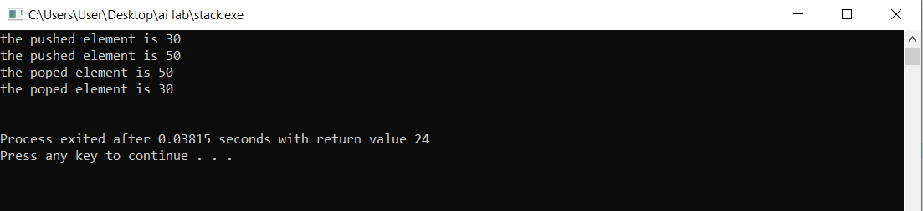

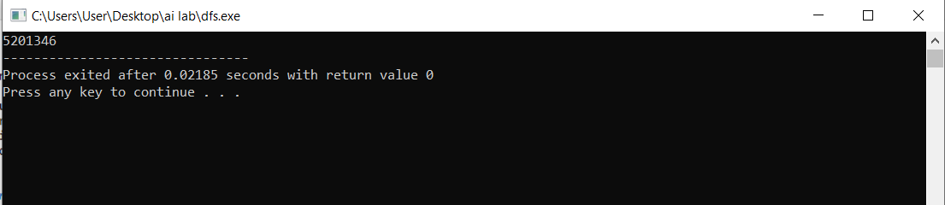

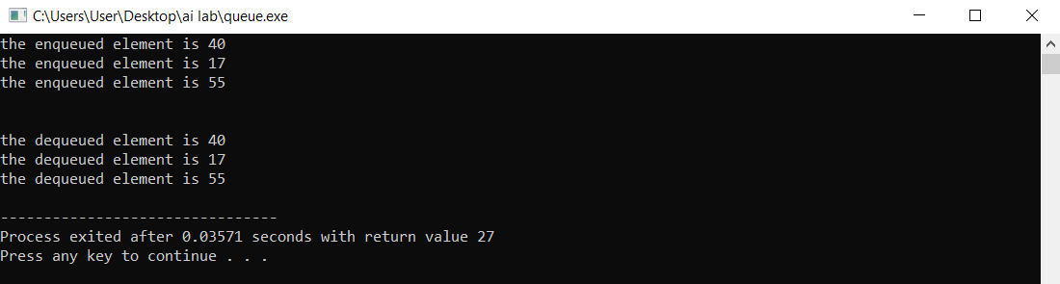

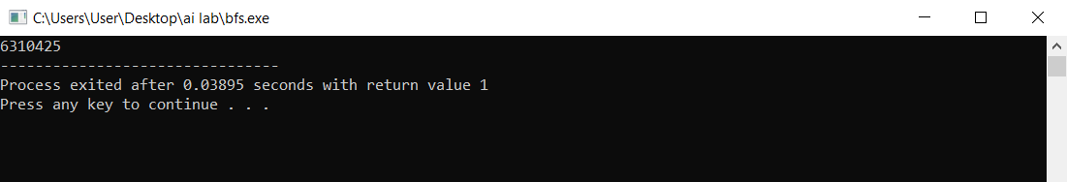

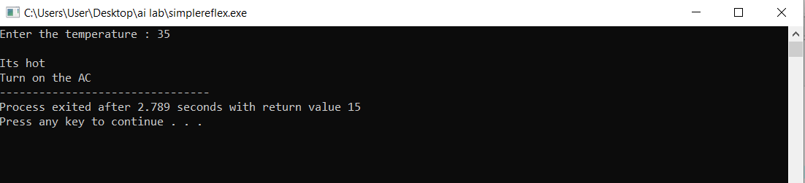

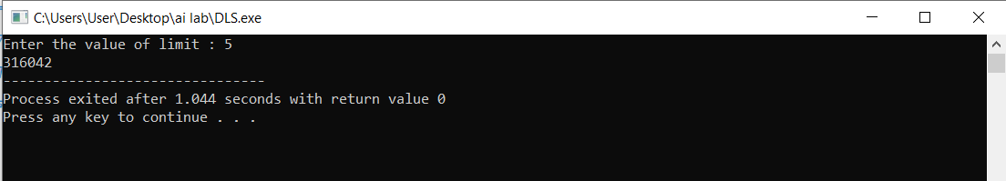

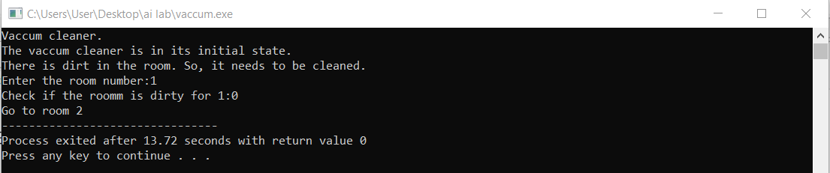

|  |  |
| --- | --- |
| CONTENT | **SIGNATURE** |
| TOWER OF HANOI |  |
| SIMPLE REFLEX AGENT |  |
| STACK USING STRUCTURE |  |
| DEPTH FIRST SEARCH(DFS) |  |
| QUEUE USING STRUCTURE |  |
| BREADTH FIRST SEARCH |  |
| DEPTH LIMIT SEARCH(DLS) |  |
| VACCUM CLEANER PROGRAM |  |