**15B17CI371 – Data Structures Lab**

**ODD 2024**

**Week 0-LAB B**

**Practice Lab**

**9923103023 – F1**

1. **Ans :**

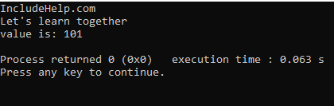

Yes, this code can serve as a basic skeleton for more complex problems. While the provided code is basic, its structure provides a solid foundation for creating more complex classes and programs. It demonstrates fundamental concepts in C++ that can be built upon for a variety of applications.

Q2 .Write a CPP program to design a calculator do the following:

(i) Add two natural numbers.

(ii) Add two complex numbers.

(iii) Add two matrices.

Your code must showcase the use of operator and/or function overloading.

Ans : #include <iostream>

using namespace std;

class naturalnumber {

public:

int value;

naturalnumber(int v) : value(v) {}

naturalnumber operator+(const naturalnumber& other) {

return naturalnumber(value + other.value);

}

};

class complex {

public:

double real, imag;

complex(double r = 0, double i = 0) : real(r), imag(i) {}

complex operator+(const complex& other) {

return complex(real + other.real, imag + other.imag);

}

void display() const {

cout << real << " + " << imag << "i" << endl;

}

};

class matrix {

public:

int rows, cols;

int** data;

matrix(int r, int c) : rows(r), cols(c) {

data = new int*[rows];

for (int i = 0; i < rows; ++i) {

data[i] = new int[cols]();

}

}

void input() {

cout << "enter elements of the matrix (" << rows << "x" << cols << "):" << endl;

for (int i = 0; i < rows; ++i) {

for (int j = 0; j < cols; ++j) {

cin >> data[i][j];

}

}

}

matrix operator+(const matrix& other) {

if (rows != other.rows || cols != other.cols) {

cerr << "matrices dimensions do not match!" << endl;

exit(EXIT_FAILURE);

}

matrix result(rows, cols);

for (int i = 0; i < rows; ++i) {

for (int j = 0; j < cols; ++j) {

result.data[i][j] = data[i][j] + other.data[i][j];

}

}

return result;

}

void display() const {

for (int i = 0; i < rows; ++i) {

for (int j = 0; j < cols; ++j) {

cout << data[i][j] << " ";

}

cout << endl;

}

}

~matrix() {

for (int i = 0; i < rows; ++i) {

delete[] data[i];

}

delete[] data;

}

};

int main() {

naturalnumber num1(10), num2(20);

naturalnumber sum = num1 + num2;

cout << "sum of natural numbers: " << sum.value << endl;

complex c1(3.4, 5.6), c2(1.2, 4.3);

complex csum = c1 + c2;

cout << "sum of complex numbers: ";

csum.display();

int rows, cols;

cout << "enter the number of rows and columns for matrices: ";

cin >> rows >> cols;

matrix m1(rows, cols), m2(rows, cols);

m1.input();

m2.input();

matrix msum = m1 + m2;

cout << "sum of matrices:" << endl;

msum.display();

return 0;

}

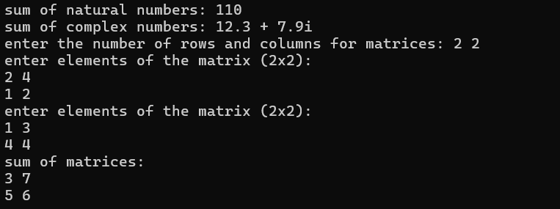

Q3. Write a CPP program to take input from user for 10 vendors who supply computer

accessories. Design attributes and functions to satisfy the below mentioned

requirements. Write function to

(i) input accessory details of individual vendors.

(ii) print the above details.

(iii) Compare between the prices of the same component/accessory of different

vendors.

(iv) Find the vendor who has maximum quantity of “LAN Cable” currently available.

(v) Find the vendor who has the lowest selling price of “Keyboard”.

Ans : #include<iostream>

using namespace std;

class vendor

{

    public:

    string name;

    int liscnumber;

    int lanq;

    int keyboard_sp;

    void inputdetails()

    {

        cout<<"enter the name of the vendor : ";

        cin>>name;

        cout<<"enter the License number of the vendor : ";

        cin>>liscnumber;

        cout<<"enter the quantity of LAN cables available : ";

        cin>>lanq;

        cout<<"enter the selling price of the keyboard : ";

        cin>>keyboard_sp;

    }

    void printdetails()

    {

        cout<<"\n\nPrinting Details :\n\n";

        cout<<"name of the vendor : "<<name<<"\n";

        cout<<"License number of the vendor : "<<liscnumber<<"\n";

        cout<<"quantity of LAN cables available : "<<lanq<<"\n";

        cout<<"selling price of the keyboard : "<<keyboard_sp<<"\n";

    }

    void compareven(vendor v1,vendor v2)

    {

        if(v1.keyboard_sp>v2.keyboard_sp)

        {

            cout<<"Vendor "<<[v2.name](http://v2.name/)<<" has lower selling price of the keyboard \n";

        }

        else

        {

            cout<<"Vendor "<<[v1.name](http://v1.name/)<<" has lower selling price of the keyboard \n";

        }

        if(v1.lanq>v2.lanq)

        {

            cout<<"Vendor "<<[v1.name](http://v1.name/)<<" has more LAN cables\n";

        }

        else

        {

            cout<<"Vendor "<<[v2.name](http://v2.name/)<<" has more LAN cables\n";

        }

    }

    void findv(vendor p[],int countr)

    {

        int maxlan= p[0].lanq;

        int index = 0;

        for(int i=0; i<countr; i++)

        {

            if(p[i].lanq>maxlan)

            {

                maxlan=p[i].lanq;

                index=i;

            }

        }

        cout<<"the vendor with maximum quantity of LAN cables is : "<<p[index].name<<"\n\n";

    }

    void findprice(vendor k[],int countr)

    {

        int minprice = k[0].keyboard_sp;

        int index = 0;

        for(int i=0; i<countr; i++)

        {

            if(k[i].keyboard_sp<minprice)

            {

                minprice=k[i].keyboard_sp;

                index=i;

            }

        }

        cout<<"the vendor with maximum quantity of LAN cables is : "<<k[index].name<<"\n\n";

    }

};

int main()

{

    int countr;

    cout<<"enter the number of counter : ";

    cin>>countr;

    vendor * arr = new vendor[countr];

    for(int i=0;i<countr;i++)

    {

        arr[i].inputdetails();

    }

    for(int i=0;i<countr;i++)

    {

        arr[i].printdetails();

    }

    int index1,index2;

    cout<<"enter the indexes of the vendors to be compared : ";

    cin>>index1>>index2;

    arr[0].compareven(arr[index1],arr[index2]);

    arr[0].findprice(arr,countr);

    arr[0].findv(arr,countr);

    return 0;

}

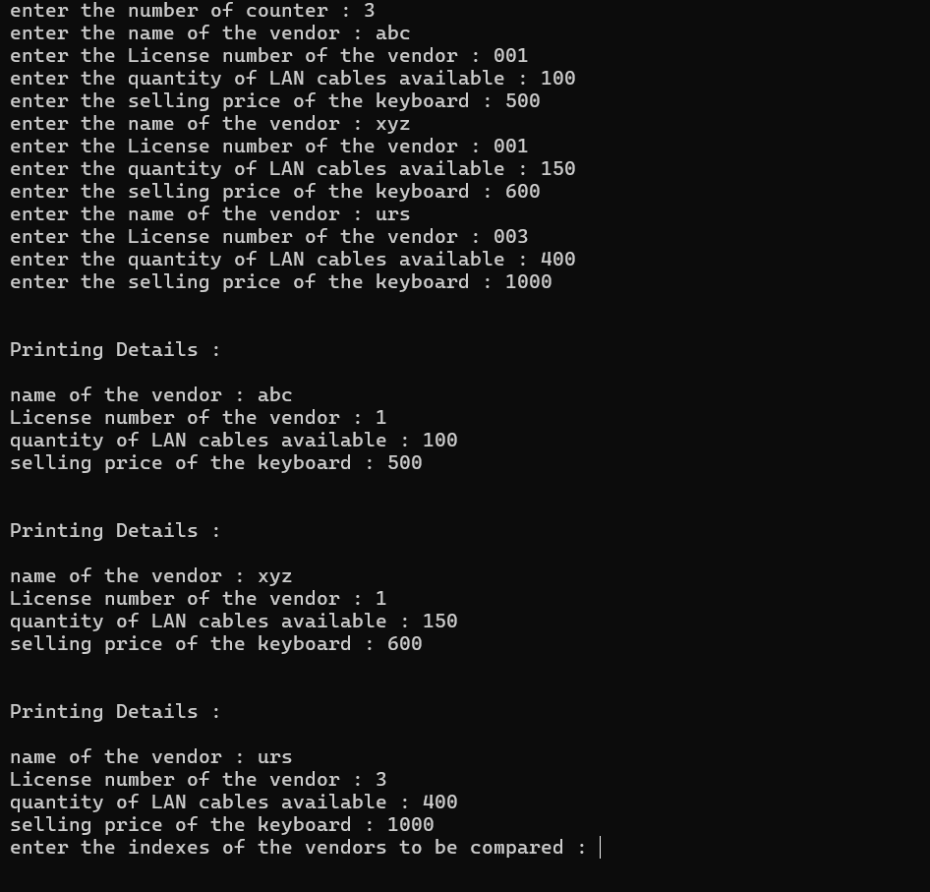

**4)**

a.

#include<iostream>

using namespace std;

class Test {

public:

int x;

};

int main()

{

Test t;

cout << t.x;

return 0;

}

Output

Error: The variable ‘x’ is private within the context and cannot be accessed outside the class.

b. #include<iostream>

using namespace std;

class Empty {};

int main()

{

cout << sizeof(Empty);

return 0;

}

Output:1

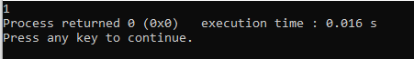

c.

#include<iostream>

using namespace std;

class Test

{

static int x;

int *ptr;

int y;

};

int main()

{

Test t;

cout << sizeof(t)<<"\n";

cout << sizeof(Test *);

}

Output:

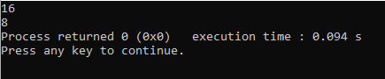

d.

#include <iostream>

class Test

{

public:

int i;

void get();

};

void Test::get()

{

std::cout << "Enter the value of i:"<<"\n";

std::cin>>i;

}

Test t;

int main()

{

Test t; // local object

t.get();

std::cout <<"value of i in local t:"<<t.i<<"\n";

::t.get();

std::cout << "value of i in global t:"<<::t.i<<"\n";

return 0;

}

Output:

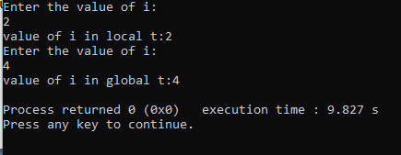

e.

#include <iostream>

#include <string>

using namespace std;

class Student {

private:

int rollNo;

string stdName;

float perc;

public:

void setValue()

{

rollNo = 0;

stdName = "None";

perc = 0.0f;

}

void printValue()

{

cout << "Student's Roll No.: " << rollNo <<

"\n";

cout << "Student's Name: " << stdName <<

"\n";

cout << "Student's Percentage: " << perc <<

"\n";

}

};

int main()

{

Student std;

std.setValue();

std.printValue();

return 0;

}

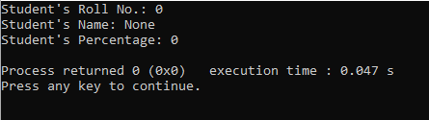

f.

#include <iostream>

using namespace std;

class Person {

};

int main() {

Person per;

cout << "size of per: " << sizeof(per) << endl;

return 0;

}

