**9923103024**

**Vasu Jain**

**WEEK 1 LAB b**

1. Write a C/C++ program to find the average of n numbers using arrays.

#include<iostream>

using namespace std;

int main(){

int n;

cin>>n;

int *arr=new int[n];

for(int i=0; i<n; i++){

cin>>arr[i];

}

float sum=0;

for(int j=0; j<n;j++){

sum+=arr[j];

}

sum/=n;

cout<<"Average : "<<sum;

return 0;}

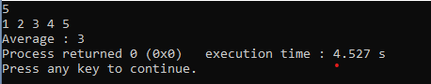

1. Write a C/C++ program to find the frequency of each element in an array.

#include<iostream>

#include<set>

using namespace std;

int main(){

int n;

cin>>n;

int *arr=new int[n];

for(int i=0; i<n; i++){

cin>>arr[i];

}

set <int>s;

for(int i=0; i<n; i++){

int cnt=0;

for(int j=i; j<n;j++){

if(arr[i]==arr[j]) cnt++;

}

if (s.find(arr[i])==s.end()) cout<<arr[i]<<" present "<<cnt<<" times"<<endl;

s.insert(arr[i]);

}

return 0;}

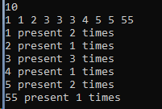

1. Given an array, write a program in C/C++to left rotate the elements of the array by one

#include<iostream>

using namespace std;

int main(){

int n;

cin>>n;

int *arr=new int[n];

for(int i=0; i<n; i++){

cin>>arr[i];

}

int a=arr[0];

for(int i=0; i<n-1; i++){

arr[i]=arr[i+1];

}

arr[n-1]=a;

for(int i=0; i<n; i++){

cout<<arr[i]<<' ';

}

return 0;}

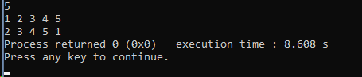

1. Write a C/C++ program to find the second smallest element in a one-dimensional array

#include<iostream>

using namespace std;

int main(){

int n;

cin>>n;

int *arr=new int[n];

for(int i=0; i<n; i++){

cin>>arr[i];

}

int low=arr[0],sec=arr[0];

for(int i=0; i<n; i++){

if(arr[i]<low){

low=arr[i];

}

if(arr[i]>sec) sec=arr[i];

}

for(int j=0;j<n;j++){

if(arr[j]!=low && arr[j]<sec){

sec=arr[j];

}

}

cout<<"Second Lowest : "<<sec;

return 0;}

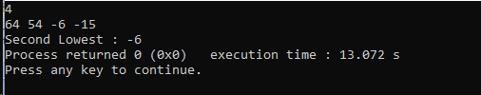

1. A dynamically created array stores following integer elements (odd and even integers). It is desired to print/display the elements of this array in such manner that it first prints all the even elements then it prints all the odd elements.

#include<iostream>

using namespace std;

int main(){

int n;

cin>>n;

int *arr=new int[n];

for(int i=0; i<n; i++){

cin>>arr[i];

}

for(int i=0; i<n;i++){

if(!(arr[i]%2)){

cout<<arr[i]<<' ';

}

}

for(int i=0; i<n;i++){

if(arr[i]%2){

cout<<arr[i]<<' ';

}

}

return 0;}



1. Write a program without STL to create the dynamic array of user inputted length (n), assign values at different indices of the array, and as presented in above example, display the elements of this array. (Note: don’t enter the elements manually, rather use following statement in loop to randomly assign elements (in range between 0 and 99) in the array: A[i] = rand()%100, where A is an array).

#include<iostream>

#include<bits/stdc++.h>

using namespace std;

int main(){

int n;

cin>>n;

int *arr=new int[n];

srand(time(NULL));

for(int i=0; i<n; i++){

arr[i]=rand()%100;

}

for(int i=0; i<n;i++){

if(!(arr[i]%2)){

cout<<arr[i]<<' ';

}

}

for(int i=0; i<n;i++){

if(arr[i]%2){

cout<<arr[i]<<' ';

}

}

return 0;}

