Semi-1)

1. Find the perpendicular distance between the point (3,1,-2) from the plane 2x+y-2z=8

Ans: 1 units

1. Give any one square root of (-2i) [where ‘i’ is the square root of (-1)]

Ans: (1-i) or (-1+i)

1. Given  
   [image]  
   what is the value of  
   [image] (in terms of x and y)

Answer:

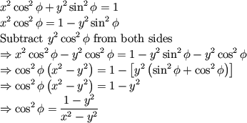

Explanation:

[image]  
[image]  
it follows that  


|  |  |
| --- | --- |
| 4. | From a group of 7 men and 6 women, five persons are to be selected to form a committee so that at least 3 men are there on the committee. In how many ways can it be done? |
| |  |  | | --- | --- | |  |  |   We may have (3 men and 2 women) or (4 men and 1 woman) or (5 men only).   |  |  | | --- | --- | | http://www.indiabix.com/_files/images/aptitude/1-sym-tfr.gif Required number of ways | = (7C3 x 6C2) + (7C4 x 6C1) + (7C5) | |  | |  |  |  |  |  |  |  | | --- | --- | --- | --- | --- | --- | --- | | = | http://www.indiabix.com/_files/images/aptitude/1-sym-oparen-h1.gif | 7 x 6 x 5 | x | 6 x 5 | http://www.indiabix.com/_files/images/aptitude/1-sym-cparen-h1.gif | + (7C3 x 6C1) + (7C2) | | 3 x 2 x 1 | 2 x 1 | | |  | |  |  |  |  |  |  |  |  |  | | --- | --- | --- | --- | --- | --- | --- | --- | --- | | = 525 + | http://www.indiabix.com/_files/images/aptitude/1-sym-oparen-h1.gif | 7 x 6 x 5 | x 6 | http://www.indiabix.com/_files/images/aptitude/1-sym-cparen-h1.gif | + | http://www.indiabix.com/_files/images/aptitude/1-sym-oparen-h1.gif | 7 x 6 | http://www.indiabix.com/_files/images/aptitude/1-sym-cparen-h1.gif | | 3 x 2 x 1 | 2 x 1 | | |  | = (525 + 210 + 21) | |  | = 756. |  1. Find the sum: |

\begin{equation}  \sum _{k=1}^\infty \frac{1}{k^2} = \frac{\pi ^2}{6}. \end{equation}

Ans:

\begin{equation}  \sum _{k=1}^\infty \frac{1}{k^2} = \frac{\pi ^2}{6}. \end{equation}

[image]

Ans: 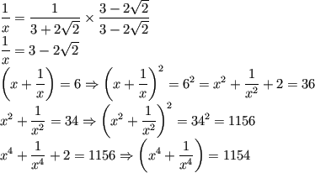

2)

What are the values of tanθ obtained from the equation  
[image]

The given equation is  
[image]  
It is known that  
[image].  
Hence the original equation becomes  
[image]  
This can be written as a quadratic equation where x = tanθ  
Therefore,  
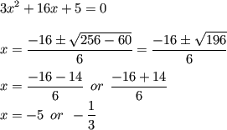  
Therefore,  
[image]

|  |
| --- |
| A two-digit number is such that the product of the digits is 8. When 18 is added to the number, then the digits are reversed. The number is: |
| |  |  | | --- | --- | | [**A.**](javascript:%20void%200;) | 18 | | [**B.**](javascript:%20void%200;) | 24 | | [**C.**](javascript:%20void%200;) | 42 | | [**D.**](javascript:%20void%200;) | 81 |   **Answer:** Option **B**  **Explanation:**   |  |  |  | | --- | --- | --- | | Let the ten's and unit digit be *x* and | 8 | respectively. | | *x* |  |  |  |  |  |  |  |  |  | | --- | --- | --- | --- | --- | --- | --- | --- | | Then, | http://www.indiabix.com/_files/images/aptitude/1-sym-oparen-h1.gif | 10*x* + | 8 | http://www.indiabix.com/_files/images/aptitude/1-sym-cparen-h1.gif | + 18 = 10 x | 8 | + *x* | | *x* | *x* |   http://www.indiabix.com/_files/images/aptitude/1-sym-imp.gif 10*x*2 + 8 + 18*x* = 80 + *x*2  http://www.indiabix.com/_files/images/aptitude/1-sym-imp.gif 9*x*2 + 18*x* - 72 = 0  http://www.indiabix.com/_files/images/aptitude/1-sym-imp.gif *x*2 + 2*x* - 8 = 0  http://www.indiabix.com/_files/images/aptitude/1-sym-imp.gif (*x* + 4)(*x* - 2) = 0  http://www.indiabix.com/_files/images/aptitude/1-sym-imp.gif *x* = 2. |

|  |
| --- |
|  |

|  |  |
| --- | --- |
| 2. | In how many different ways can the letters of the word 'LEADING' be arranged in such a way that the vowels always come together? |
| |  |  | | --- | --- | | [**A.**](javascript:%20void%200;) | 360 | | [**B.**](javascript:%20void%200;) | 480 | | [**C.**](javascript:%20void%200;) | 720 | | [**D.**](javascript:%20void%200;) | 5040 | | [**E.**](javascript:%20void%200;) | None of these |   **Answer:** Option **C**  **Explanation:**  The word 'LEADING' has 7 different letters.  When the vowels EAI are always together, they can be supposed to form one letter.  Then, we have to arrange the letters LNDG (EAI).  Now, 5 (4 + 1 = 5) letters can be arranged in 5! = 120 ways.  The vowels (EAI) can be arranged among themselves in 3! = 6 ways.  http://www.indiabix.com/_files/images/aptitude/1-sym-tfr.gif Required number of ways = (120 x 6) = 720. |

|  |  |
| --- | --- |
| 3. | In how many different ways can the letters of the word 'CORPORATION' be arranged so that the vowels always come together? |
| |  |  | | --- | --- | | [**A.**](javascript:%20void%200;) | 810 | | [**B.**](javascript:%20void%200;) | 1440 | | [**C.**](javascript:%20void%200;) | 2880 | | [**D.**](javascript:%20void%200;) | 50400 | | [**E.**](javascript:%20void%200;) | 5760 |   **Answer:** Option **D**  **Explanation:**  In the word 'CORPORATION', we treat the vowels OOAIO as one letter.  Thus, we have CRPRTN (OOAIO).  This has 7 (6 + 1) letters of which R occurs 2 times and the rest are different.   |  |  |  | | --- | --- | --- | | Number of ways arranging these letters = | 7! | = 2520. | | 2! |   Now, 5 vowels in which O occurs 3 times and the rest are different, can be arranged   |  |  |  | | --- | --- | --- | | in | 5! | = 20 ways. | | 3! |   http://www.indiabix.com/_files/images/aptitude/1-sym-tfr.gif Required number of ways = (2520 x 20) = 50400. |

|  |  |
| --- | --- |
| 4. | Out of 7 consonants and 4 vowels, how many words of 3 consonants and 2 vowels can be formed? |
| |  |  | | --- | --- | | [**A.**](javascript:%20void%200;) | 210 | | [**B.**](javascript:%20void%200;) | 1050 | | [**C.**](javascript:%20void%200;) | 25200 | | [**D.**](javascript:%20void%200;) | 21400 | | [**E.**](javascript:%20void%200;) | None of these |   **Answer:** Option **C**  **Explanation:**  Number of ways of selecting (3 consonants out of 7) and (2 vowels out of 4)   |  |  | | --- | --- | |  | = (7C3 x 4C2) | |  | |  |  |  |  |  |  | | --- | --- | --- | --- | --- | --- | | = | http://www.indiabix.com/_files/images/aptitude/1-sym-oparen-h1.gif | 7 x 6 x 5 | x | 4 x 3 | http://www.indiabix.com/_files/images/aptitude/1-sym-cparen-h1.gif | | 3 x 2 x 1 | 2 x 1 | | |  | = 210. |   Number of groups, each having 3 consonants and 2 vowels = 210.  Each group contains 5 letters.   |  |  | | --- | --- | | Number of ways of arranging  5 letters among themselves | = 5! | |  | = 5 x 4 x 3 x 2 x 1 | |  | = 120. |   http://www.indiabix.com/_files/images/aptitude/1-sym-tfr.gif Required number of ways = (210 x 120) = 25200. |

|  |  |  |  |  |  |  |  |  |  |  |  |
| --- | --- | --- | --- | --- | --- | --- | --- | --- | --- | --- | --- |
|  | |  |  | | --- | --- | | [**A.**](javascript:%20void%200;) | 3 | | [**B.**](javascript:%20void%200;) | 4 | | [**C.**](javascript:%20void%200;) | 9 | | [**D.**](javascript:%20void%200;) | Cannot be determined | | [**E.**](javascript:%20void%200;) | None of these |   **Answer:** Option **B**  **Explanation:**  Let the ten's digit be *x* and unit's digit be *y*.  Then, (10*x* + *y*) - (10*y* + *x*) = 36  http://www.indiabix.com/_files/images/aptitude/1-sym-imp.gif 9(*x* - *y*) = 36  http://www.indiabix.com/_files/images/aptitude/1-sym-imp.gif *x* - *y* = 4. |

|  |  |
| --- | --- |
| 4. | The difference between a two-digit number and the number obtained by interchanging the digits is 36. What is the difference between the sum and the difference of the digits of the number if the ratio between the digits of the number is 1 : 2 ? |
| |  | | --- | |  |   **Answer:** 24  **Explanation:**  Since the number is greater than the number obtained on reversing the digits, so the ten's digit is greater than the unit's digit.  Let ten's and unit's digits be 2*x* and *x* respectively.  Then, (10 x 2*x* + *x*) - (10*x* + 2*x*) = 36  http://www.indiabix.com/_files/images/aptitude/1-sym-imp.gif 9*x* = 36  http://www.indiabix.com/_files/images/aptitude/1-sym-imp.gif *x* = 4.  http://www.indiabix.com/_files/images/aptitude/1-sym-tfr.gif Required difference = (2*x* + *x*) - (2*x* - *x*) = 2*x* = 8. |

Find:

## Problem 1

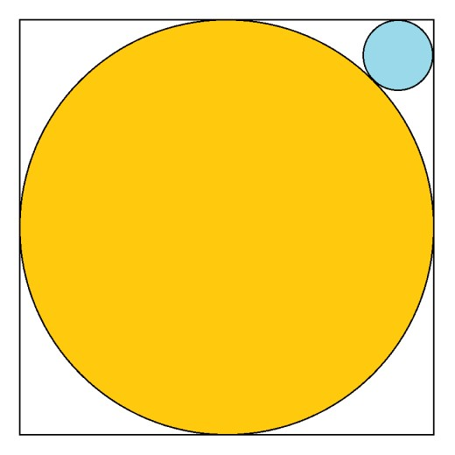

A circle with a radius of 1 is inscribed within a 2-by-2 square. A smaller circle is inscribed in the corner such that it is tangent to two adjacent sides of the square and the larger circle. What is the radius of this smaller circle?

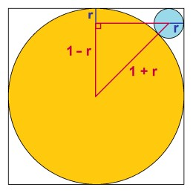

**Solution:** Call the radius of the smaller circle r. If you connect the centers of the two circles with a straight line, it will pass through the point of tangency and this line segment will have a length of 1 + r. This line makes a 45-degree angle with the corner of the square. As shown in the figure on the right, you can add two more lines to form an isosceles right triangle whose hypotenuse is 1 + r, and whose two legs are both 1 - r.

Since it is an isosceles right triangle, the hypotenuse must be sqrt(2) times longer than each leg. Thus we have the equation

1 + r = sqrt(2)(1 - r)  
r + sqrt(2)r = sqrt(2) - 1  
r(1 + sqrt(2)) = sqrt(2) - 1  
r = [sqrt(2) -1]/[sqrt(2) + 1]   
r = 3 - 2\*sqrt(2)  
r ≈ 0.171573

## Problem 2

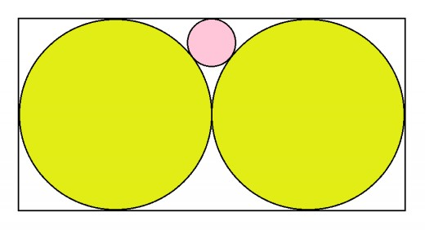

Two circles each with a radius of 1 and tangent to each other are inscribed in a 2-by-4 rectangle. A smaller circle is inscribed in the space between the circles and the long edge of the rectangle, such that it is tangent to both circles and the edge of the rectangle. What is the radius of this smaller circle?

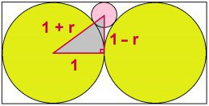

**Solution:** A right triangle can be formed that connects the center of the smaller circle, the center of one of the larger circles, and the tangent point between the two larger circles. Call the radius of the smaller circle r. Then the legs of this triangle have lengths of 1 and 1 - r, and the hypotenuse has a length of 1 + r. This gives us the following Pythagorean equation to solve for r:

1^2 + (1-r)^2 = (1+r)^2  
1 + 1 - 2r + r^2 = 1 + 2r + r^2  
2 - 2r = 1 + 2r  
1 = 4r  
r = 1/4.

## Problem 3

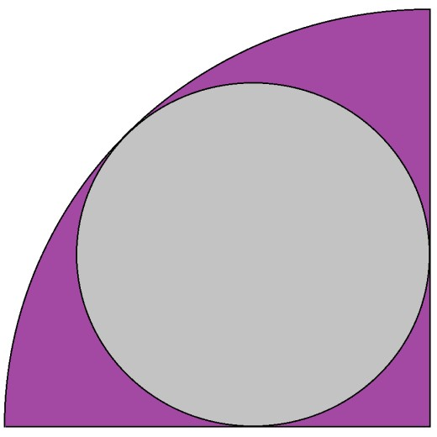

A circle is inscribed within a quarter-circle sector. It is tangent to the arc of the sector and the two perpendicular radii of the sector. What is the ratio of the area of the circle to the area of the sector?

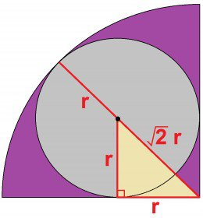

**Solution:** Since this is a ratio problem, it does not matter what the radius of each circle is, only their sizes relative to one another. Therefore we can simplify the problem by setting the radius of the sector equal to 1. If we draw a line from the vertex of the sector to the point on the arc where it is tangent to the circle, this line segment has a length of 1 because it is a radius.

If we call the radius of the smaller circle r, we can see that the length of this line segment is also equal to r + sqrt(2)r. Therefore we can solve for r:

r + sqrt(2)r = 1  
[1 + sqrt(2)]r = 1  
r = 1/[1 + sqrt(2)]  
r = sqrt(2) - 1

The area of the quarter circle is π/4. The area of the smaller inscribed circle is π(3 - 2\*sqrt(2)). Thus, the ratio of the circle to the sector is

[ π(3 - 2\*sqrt(2)) ] / [ π/4 ]  
= 12 - 8\*sqrt(2)  
≈ 0.68629

## Problem 4

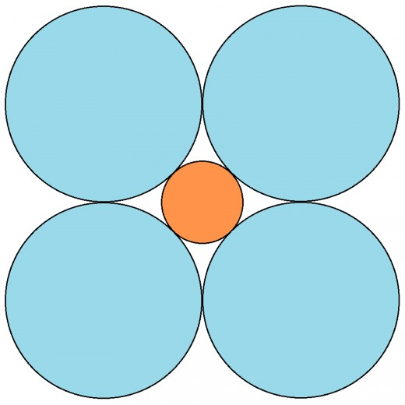

Four circles, each with a radius of 1, are arranged so that they are tangent to two others and their centers form the corners of a square. A smaller circle is inscribed in the space bounded by the four circles, and this smaller circle is tangent to each of the other four. What is its radius?

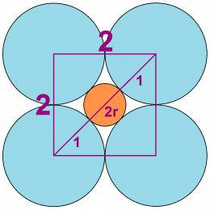

**Solution:** The square formed by the four circles has an edge length of 2. The diagonal of this square is 2\*sqrt(2). If the radius of the smaller circle is r, the diagonal of the square is also equal to 1 + 2r + 1. Thus we can solve for r:

1 + 2r + 1 = 2\*sqrt(2)  
2 + 2r = 2\*sqrt(2)  
1 + r = sqrt(2)  
r = sqrt(2) - 1  
r ≈ 0.41421

## Problem 5

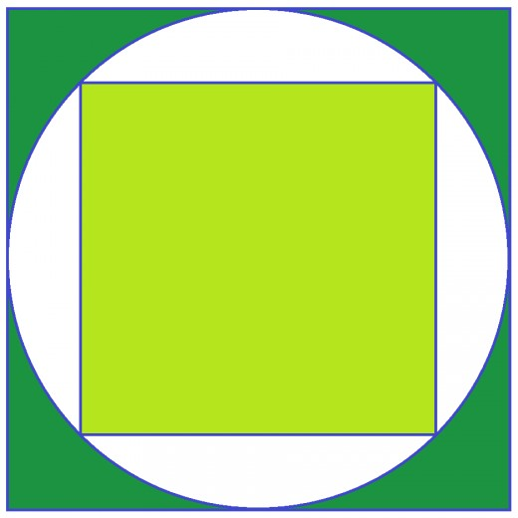

A circle is inscribed within a square. A smaller square is inscribed within this circle. What is the ratio of the area of the larger square to that of the smaller square?

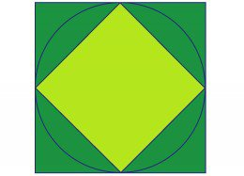

**Solution:** This is a classic math brain teaser question that requires no sophisticated geometry or algebra knowledge. Spin the circle so that the corners of the inscribed square lie on the centers of the edges of the larger square. Now you can see that the smaller square occupies exactly half the space of the larger square. Therefore the area ratio is 2:1.

## Problem 6

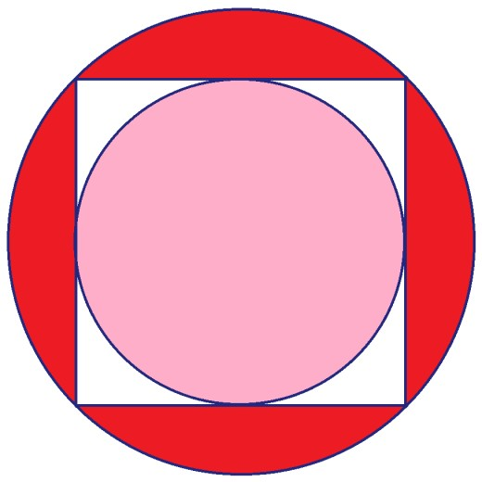

A square is inscribed in a circle. Within this square is inscribed a smaller circle. What is the ratio of the area of the larger circle to that of the smaller circle?

**Solution:** Inscribe another smaller square within the smaller circle. Call the are of the large square Q, the area of the small square q, the area of the large circle M, and the area of the small circle m. We know that M/Q = m/q by properties of scale. And from the previous problem we know that Q/q = 2. Therefore

M/Q = m/q  
Mq = mQ  
M/m = Q/q  
M/m = 2

So the ratio of the area of the large circle to the area of the small circle is also 2:1.

## Problem 7

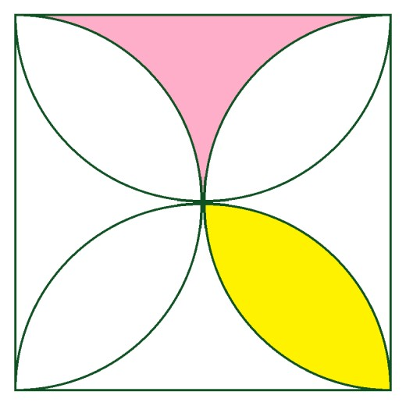

The figure above shows a square with a side length of 1. Along the edges are four half-circles with each a radius of 0.5. Their intersections inside the square create eight regions: four like the one shown in pink, and four like the one shown in yellow. What are the areas of the pink and yellow regions?

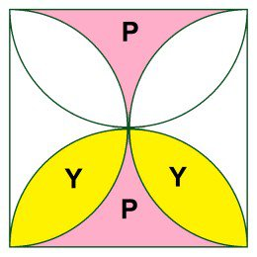

**Solution:** Call the area of the pink region P and the area of the yellow region Y. We know that 4P + 4Y equals the area of the square. We also know that 2Y + P equals the area of one half-circle within the square. This information gives us a set of two equations in two unknowns.

4P + 4Y = 1  
2Y + P = π/8

If we multiply the second equation by 2 and subtract it from the first we get

2P = 1 - π/4  
P = 1/2 - π/8  
P ≈ 0.1073

Solving back for Y gives us

Y = π/8 - 1/4  
Y ≈ 0.1427

## BONUS Problem #1

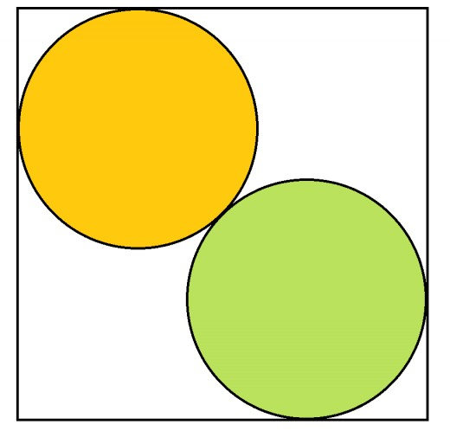

Two circles of equal size are inscribed in a square such that the circles are tangent to each other and to two sides of the square. The centers of the circle lie on the square's diagonal. If the radius of each circle is 1, what is the side length of the square?

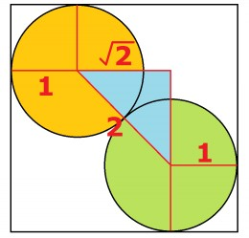

**Solution:** As shown in the figure at left, if you connect the centers of the squares with a line segment, this line segment can be made into the hypotenuse of an isosceles right triangle. Because this line segment passes through the point of tangency between the two circles, its length is 2. The other two sides of the triangle have a length of 2/sqrt(2), which is equivalent to sqrt(2).

Now draw a line segment that connects the center of a circle with the point on the square's edge where it is tangent. Do this for both circles for all four points of tangency on the square's boundary. You can now see that the side length of the square is equal to

1 + sqrt(2) + 1

= 2 + sqrt(2).

## BONUS Problem #2

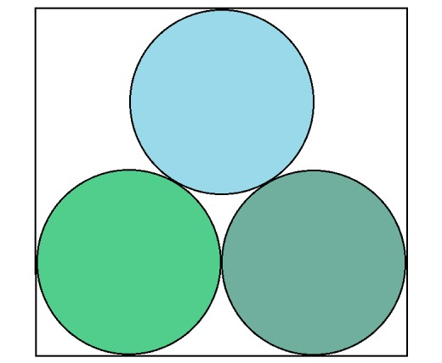

Three circles have a radius of 6 and are inscribed in a rectangle as shown in the figure above. What is the area and perimeter of the rectangle?

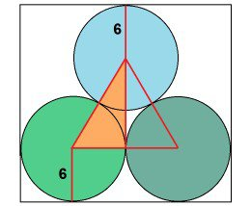

**Solution:** It's easy to see that the width of the rectangle is four times the radius of the circles, 4\*6 = 24. The height of the rectangle is a little harder to work out, but it can be figured in the same way as in Bonus Problem #1 by making a triangle with the radii and centers of the circles, as in the image on the right.

The triangle formed by the centers of the circles is equilateral with a side length of 12, and its height is 6\*sqrt(3). Therefore, the height of the bounding rectangle is 6 + 6\*sqrt(3) + 6 = 12 + 6\*sqrt(3).

The area of the rectangle is 24\*(12 + 6\*sqrt(3)) = 288 + 144\*sqrt(3). The perimeter of the rectangle is 24 + 12 + 6\*sqrt(3) + 24 + 12 + 6\*sqrt(3) = 72 + 12\*sqrt(3).

## Some Related Geometry Facts and Formulas

* If a square and a circle have equal area, then the diameter of the circle is 2/sqrt(π) times the side length of the square. Equivalently, the side length of the square is sqrt(π)/2 times the diameter of the circle.
* If a square and circle have equal perimeter, then the diameter of the circle is 4/π times the side length of the square. Equivalently, the side length of the square is π/4 times the diameter of the circle.
* In terms of area, the largest quadrilateral that can be inscribed in a circle is a square.

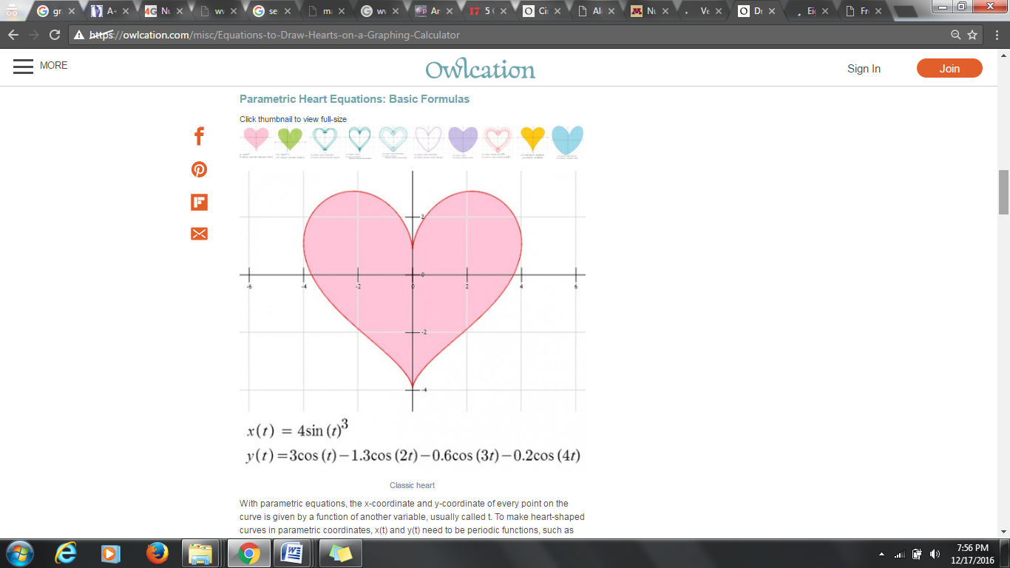

Emotional mathematics

[What is 5349 to the third power equals](http://www.proprofs.com/discuss/q/214724/what-is-5349-to-the-third-power-equals)

* A.

28,611,805

* B.

28,610,803

* C.

28,613,800

* D.

28,611,801

In a lake, there is a patch of lily pads. Every day, the patch doubles in size. If it takes 48 days for the patch to cover the entire lake, how long would it take for the patch to cover half of the lake?

47 days

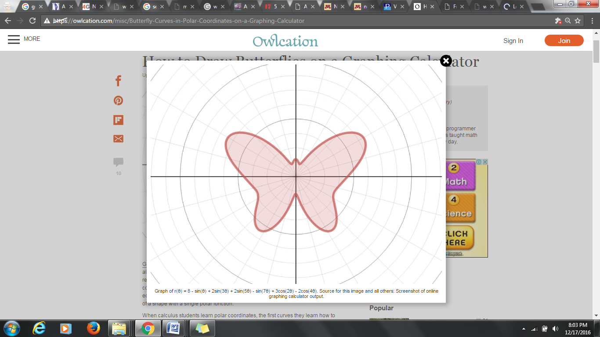

1. **If both 112 and 33 are factors of the number a \* 43 \* 62 \* 1311, then what is the smallest possible value of a?**
   1. 121
   2. 3267
   3. 363
   4. 33
   5. None of the above
   6. Correct answer
   7. [Explanatory Answer](http://www.questionbank.4gmat.com/mba_prep_sample_questions/number_systems/factors_divisors_220605.shtml)
   8. Factors & Divisibility
   9. Medium
2. **How many different positive integers exist between 106 and 107, the sum of whose digits is equal to 2?**
   1. 6
   2. 7
   3. 5
   4. 8
   5. 18
   6. Correct answer
   7. [Explanatory Answer](http://www.questionbank.4gmat.com/mba_prep_sample_questions/number_systems/number_theory_121304.shtml)
   8. Number Properties
   9. Easy
3. **A number when divided by a divisor leaves a remainder of 24. When twice the original number is divided by the same divisor, the remainder is 11. What is the value of the divisor?**
   1. 13
   2. 59
   3. 35
   4. 37
   5. 12
   6. Correct answer
   7. [Explanatory Answer](http://www.questionbank.4gmat.com/mba_prep_sample_questions/number_systems/number_theory_041404.shtml)
   8. Divisors & Remainders
   9. Medium
4. **How many keystrokes are needed to type numbers from 1 to 1000?**
   1. 3001
   2. 2893
   3. 2704
   4. 2890
   5. None of these
   6. Correct answer
   7. [Explanatory Answer](http://www.questionbank.4gmat.com/mba_prep_sample_questions/number_systems/number_theory_031604.shtml)
   8. Counting Methods
   9. Easy
5. **When 242 is divided by a certain divisor the remainder obtained is 8. When 698 is divided by the same divisor the remainder obtained is 9. When the sum of the two numbers 242 and 698 is divided by the divisor, the remainder obtained is 4. What is the value of the divisor?**
   1. 11
   2. 17
   3. 13
   4. 23
   5. None of these
   6. Correct answer
   7. [Explanatory Answer](http://www.questionbank.4gmat.com/mba_prep_sample_questions/number_systems/number_theory_022604.shtml)
   8. Remainders & Divisors
   9. Medium
6. **How many integral divisors does the number 120 have?**
   1. 14
   2. 16
   3. 12
   4. 20
   5. None of these
   6. Correct answer
   7. [Explanatory Answer](http://www.questionbank.4gmat.com/mba_prep_sample_questions/number_systems/number_theory_020904.shtml)
   8. Number of Divisors
   9. Medium
7. **How many trailing zeros will be there after the rightmost non-zero digit in the value of 25! (factorial 25)?**
   1. 25
   2. 8
   3. 6
   4. 5
   5. 2
   6. Correct answer
   7. [Explanatory Answer](http://www.questionbank.4gmat.com/mba_prep_sample_questions/number_systems/number_theory_011404.shtml)
   8. Factorials
   9. Medium
8. **What is the remainder when 1044 \* 1047 \* 1050 \* 1053 is divided by 33?**
   1. 3
   2. 27
   3. 30
   4. 21
   5. 18
   6. Correct answer
   7. [Explanatory Answer](http://www.questionbank.4gmat.com/mba_prep_sample_questions/number_systems/number_theory_121903.shtml)
   8. Remainders
   9. Medium
9. **Data Sufficiency : Is x3 > x2 ?**
   1. x > 0
   2. x < 1
   3. Correct answer
   4. [Explanatory Answer](http://www.questionbank.4gmat.com/mba_prep_sample_questions/number_systems/number_properties_9.shtml)
   5. Indices
   6. Medium
10. **Data Sufficiency : Is x/y a terminating decimal?**
    1. x is a multiple of 2
    2. y is a multiple of 3
    3. Correct answer
    4. [Explanatory Answer](http://www.questionbank.4gmat.com/mba_prep_sample_questions/number_systems/number_theory_DS_10.shtml)
    5. Terminating Decimals
    6. Medium
11. **Data Sufficiency : Is the positive integer X divisible by 21?**
    1. When X is divided by 14, the remainder is 4
    2. When X is divided by 15, the remainder is 5
    3. Correct answer
    4. [Explanatory Answer](http://www.questionbank.4gmat.com/mba_prep_sample_questions/number_systems/number_properties_DS_11.shtml)
    5. Test of Divisibility
    6. Easy
12. **Data Sufficiency : If x and y are positive integers, is y odd?**
    1. x is odd.
    2. xy is odd.
    3. Correct answer
    4. [Explanatory Answer](http://www.questionbank.4gmat.com/mba_prep_sample_questions/number_systems/number_properties_DS_12.shtml)
    5. Odd and even integers
    6. Easy
13. **Data Sufficiency : Is xy < 0?**
    1. 5|x| + |y| = 0
    2. |x| + 5|y| = 0
    3. Correct answer
    4. [Explanatory Answer](http://www.questionbank.4gmat.com/mba_prep_sample_questions/number_systems/number_theory_DS_13.shtml)
    5. Absolute values
    6. Medium
14. **Data Sufficiency : When a positive integer 'x' is divided by a divisor 'd', the remainder is 24. What is d?**
    1. When 2x is divided by d, the remainder is 23.
    2. When 3x is divided by d, the remainder is 22.
    3. Correct answer
    4. [Explanatory Answer](http://www.questionbank.4gmat.com/mba_prep_sample_questions/number_systems/Divisor_remainder_DS_14.shtml)
    5. Divisors & Remainders
    6. Hard
15. **Data Sufficiency : How many of the numbers x, y, and z are positive if each of these numbers is less than 10?**
    1. x + y + z = 20
    2. x + y = 14

|  |  |
| --- | --- |
| 5. | In how many ways can the letters of the word 'LEADER' be arranged? |
| |  |  | | --- | --- | | [**A.**](javascript:%20void%200;) | 72 | | [**B.**](javascript:%20void%200;) | 144 | | [**C.**](javascript:%20void%200;) | 360 | | [**D.**](javascript:%20void%200;) | 720 | | [**E.**](javascript:%20void%200;) | None of these |   **Answer:** Option **C**  **Explanation:**  The word 'LEADER' contains 6 letters, namely 1L, 2E, 1A, 1D and 1R.   |  |  |  | | --- | --- | --- | | http://www.indiabix.com/_files/images/aptitude/1-sym-tfr.gif Required number of ways = | 6! | = 360. | | (1!)(2!)(1!)(1!)(1!) | |

|  |  |
| --- | --- |
| 1. | If one-third of one-fourth of a number is 15, then three-tenth of that number is: |
| |  |  | | --- | --- | | [**A.**](javascript:%20void%200;) | 35 | | [**B.**](javascript:%20void%200;) | 36 | | [**C.**](javascript:%20void%200;) | 45 | | [**D.**](javascript:%20void%200;) | 54 |   **Answer:** Option **D**  **Explanation:**  Let the number be *x*.   |  |  |  |  |  | | --- | --- | --- | --- | --- | | Then, | 1 | Of | 1 | of *x* = 15    http://www.indiabix.com/_files/images/aptitude/1-sym-bim.gif  *x* = 15 x 12 = 180. | | 3 | 4 |  |  |  |  |  |  |  | | --- | --- | --- | --- | --- | --- | | So, required number = | http://www.indiabix.com/_files/images/aptitude/1-sym-oparen-h1.gif | 3 | x 180 | http://www.indiabix.com/_files/images/aptitude/1-sym-cparen-h1.gif | = 54. | | 10 |   [View Answer](javascript:%20void%200;) [Discuss in Forum](http://www.indiabix.com/aptitude/problems-on-numbers/discussion-251) [Workspace](javascript:%20void%200;) [Report](javascript:%20void%200;) |

|  |  |
| --- | --- |
| 2. | Three times the first of three consecutive odd integers is 3 more than twice the third. The third integer is: |
| |  |  | | --- | --- | | [**A.**](javascript:%20void%200;) | 9 | | [**B.**](javascript:%20void%200;) | 11 | | [**C.**](javascript:%20void%200;) | 13 | | [**D.**](javascript:%20void%200;) | 15 |   **Answer:** Option **D**  **Explanation:**  Let the three integers be *x*, *x* + 2 and *x* + 4.  Then, 3*x* = 2(*x* + 4) + 3   http://www.indiabix.com/_files/images/aptitude/1-sym-bim.gif   *x* = 11.  http://www.indiabix.com/_files/images/aptitude/1-sym-tfr.gif Third integer = *x* + 4 = 15. |

|  |  |
| --- | --- |
| 3. | The difference between a two-digit number and the number obtained by interchanging the positions of its digits is 36. What is the difference between the two digits of that number? |

|  |
| --- |
| 5. |
|