If sinx+cosx=

Find sin(2x)

Ans: 1

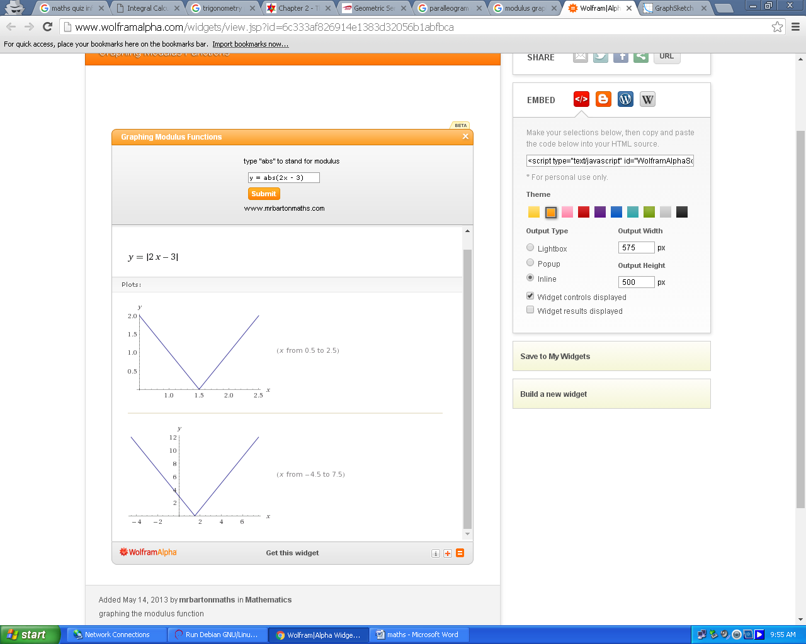

What is the equation of the given curve in graph?

|2x-3| or |3-2x|(any one scores marks)

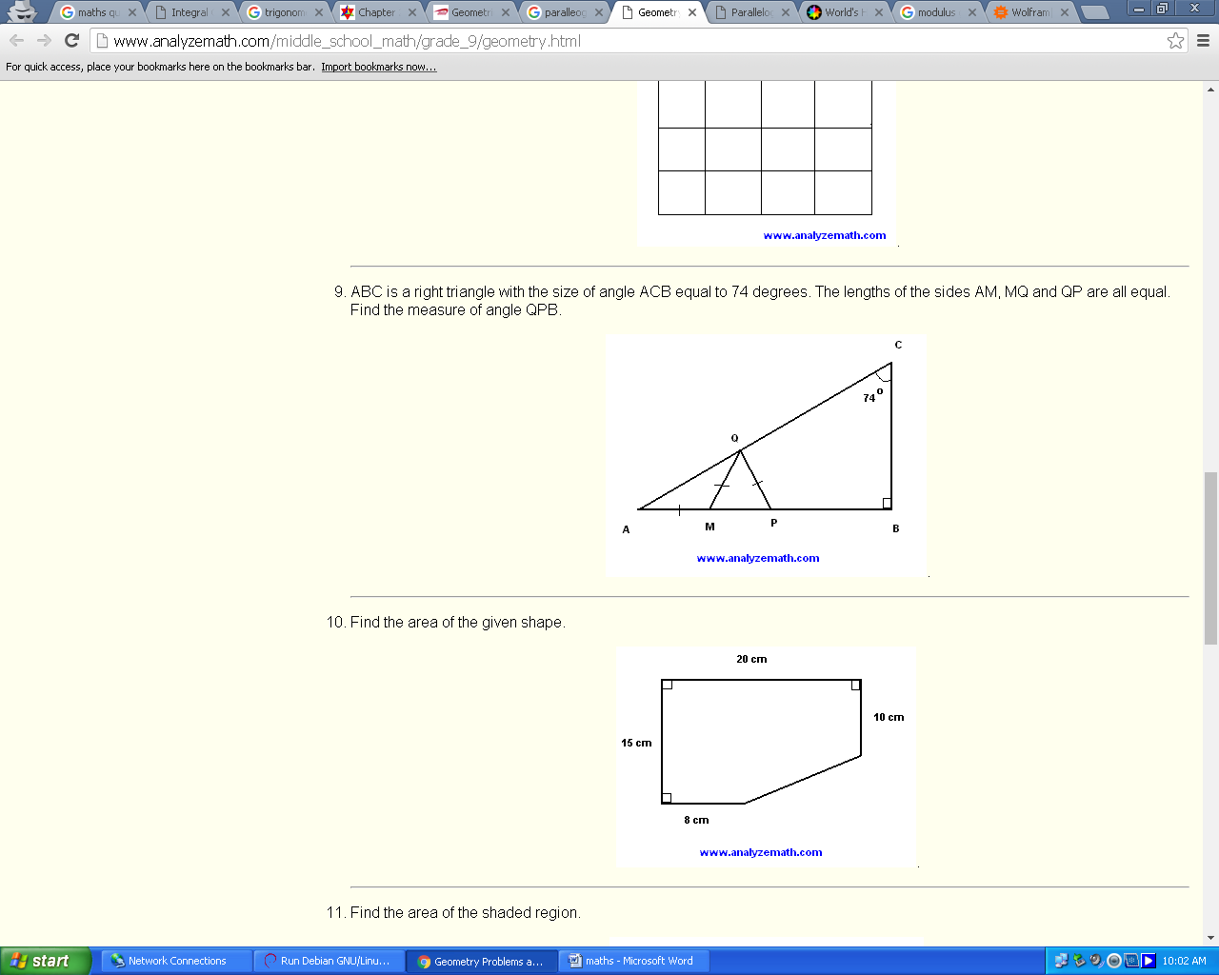

ABC is a right triangle with the size of angle ACB equal to 74 degrees. The lengths of the sides AM, MQ and QP are all equal. Find the measure of angle QPB.

1. measure of angle QPB = 148 degrees

Alexandra(Sasha) is driving her car. If a tire rotates at 400 revolutions per minute when the car is traveling 72km/h, what is the circumference of the tire?

* 1. 400 rev / minute = 400 * 60 rev / 60 minutes   
     = 24,000 rev / hour
  2. 24,000 * C = 72,000 m : C is the circumference
  3. C = 3 meters

Digdarshan has four children.The children have small toys. The first child has 1/10 of the toys, the second child has 12 more toys than the first, the third child has one more toy of what the first child has and the fourth child has double the third child. How many toys are there?

* 1. x : the total number of toys
  2. x/10 : the number of toys for first child
  3. x/10 + 12 : the number of toys for second child
  4. x/10 + 1 : the number of toys for the third child
  5. 2(x/10 + 1) : the number of toys for the fourth child
  6. x/10 + x/10 + 12 + x/10 + 1 + 2(x/10 + 1) = x
  7. x = 30 toys : solve for x

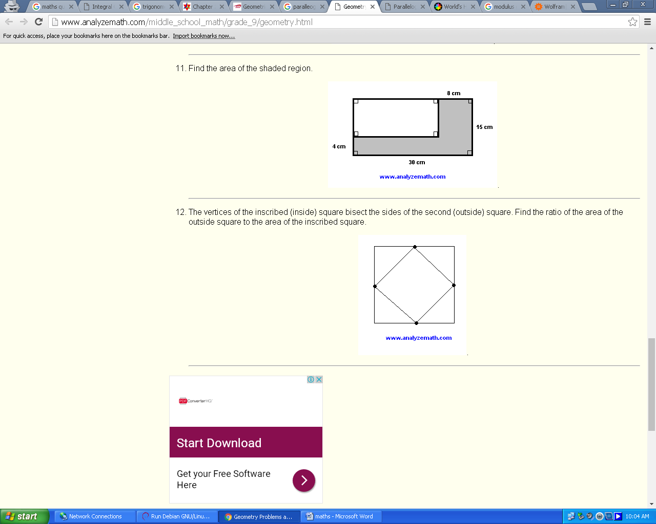

The vertices of the inscribed (inside) square bisect the sides of the second (outside) square. Find the ratio of the area of the larger square to the area of the inscribed square.

ratio of area of outside square to area of inscribed square = 2:1

Evaluate:

Ans:

* 1. (1 - 1/10)(1 - 1/11)(1 - 1/12)...(1 - 1/99)(1 - 1/100)
  2. = (9/10)(10/11)(11/12)...(98/99)(99/100)
  3. = 9/100 : simplify

Digdarshan can solve this problem. Can you?

Solve the logarithmic equation   
log5(x - 2) + log5(x + 2) = 1.

The solutions to the given equation is x = 3

Find all complex numbers of the form z = a + bi , where a and b are real numbers such that z z' = 25 and a + b = 7 where z' is the complex conjugate of z.

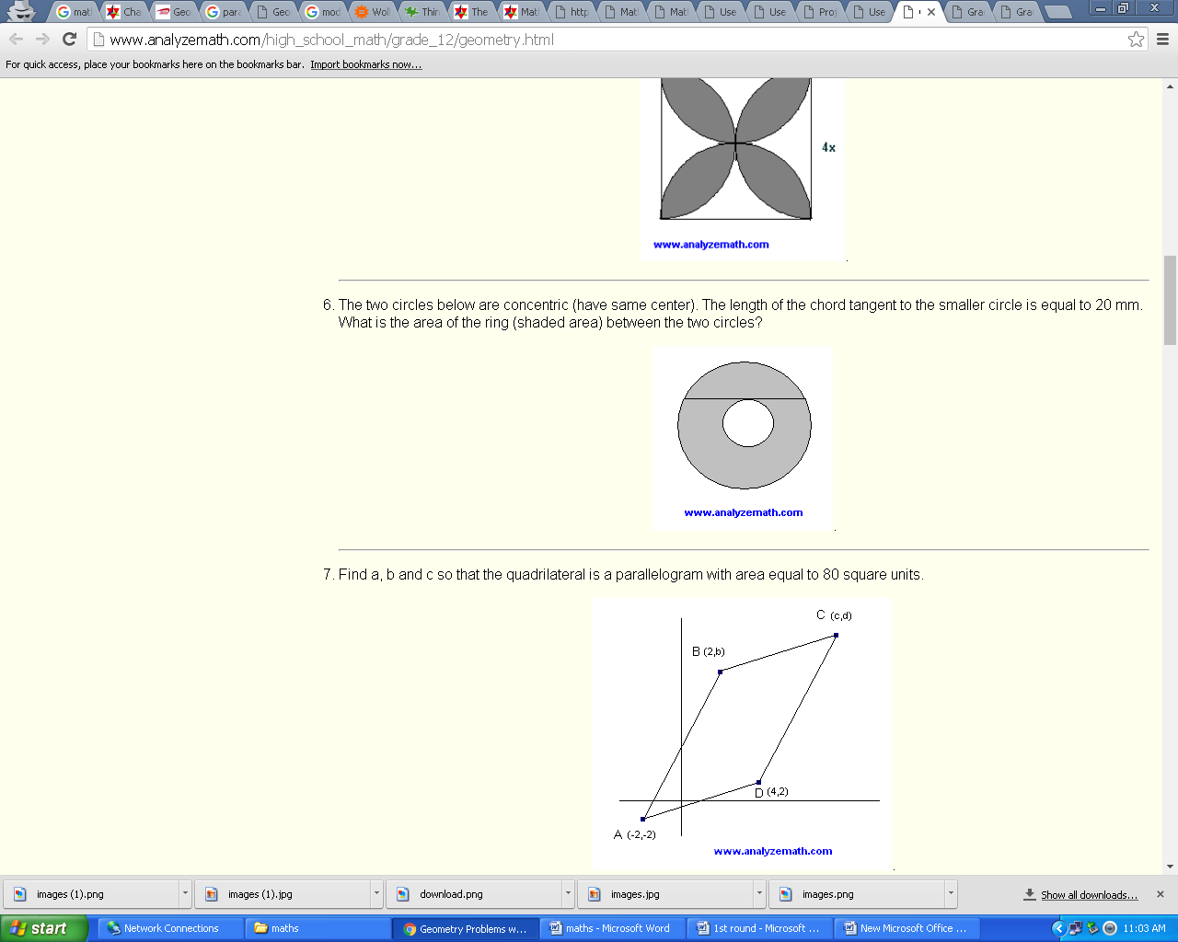

The two circles below are concentric (have same center). The length of the chord tangent to the smaller circle is equal to 20 mm. What is the area of the ring (shaded area) between the two circles?

* 1. R2 = r2 + 102 : Pythagora's theorem
  2. Pi(R2 - r2) = 100 Pi : area of ring

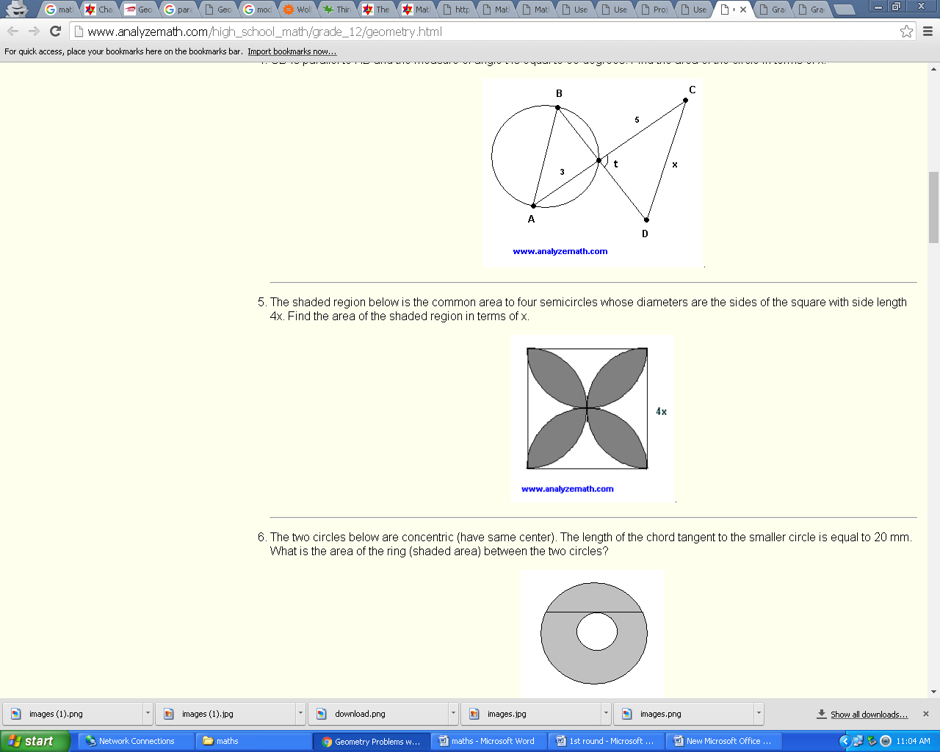

The shaded region below is the common area to four semicircles whose diameters are the sides of the square with side length 4x. Find the area of the shaded region in terms of x.

* 1. The square below has side length 2x, half of the given square. Part of this is shaded and the other part is not shaded. Let us find the area of the non shaded part (white). The shaded part is a quarter of a disk (circle).
  2. area of non shaded area = (2x)2 - (1/4) Pi (2x)2
  3. If we go back to the given shape in problem 5, the area of the non shaded part is 8 times the non shaded area in the present shape which was calculated above.
  4. area of shaded part in shape of problem 5 = total area of square - total non shaded area = (4x)2 - 8*[ (2x)2 - (1/4) Pi (2x)2 ]
  5. = 16x2(Pi/2 - 1)

 You decide to construct a rectangle of perimeter 400 mm and maximum area. Find the length and the width of the rectangle.

The second derivative d2A/dx2 = -2 is negative. (see calculus theorem on using the first and second derivative to determine extremma of functions). The value of the area A at x = 100 is equal to 10000 mm2 and it is the largest (maximum). So if you select a rectangle of width x = 100 mm and length y = 200 - x = 200 - 100 = 100 mm (it is a square!), you obtain a rectangle with maximum area equal to 10000 mm2.

Find the area of the given shape. 

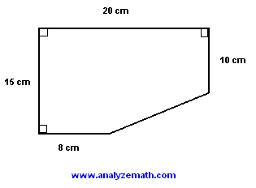

1. area of given shape = 270 square cm

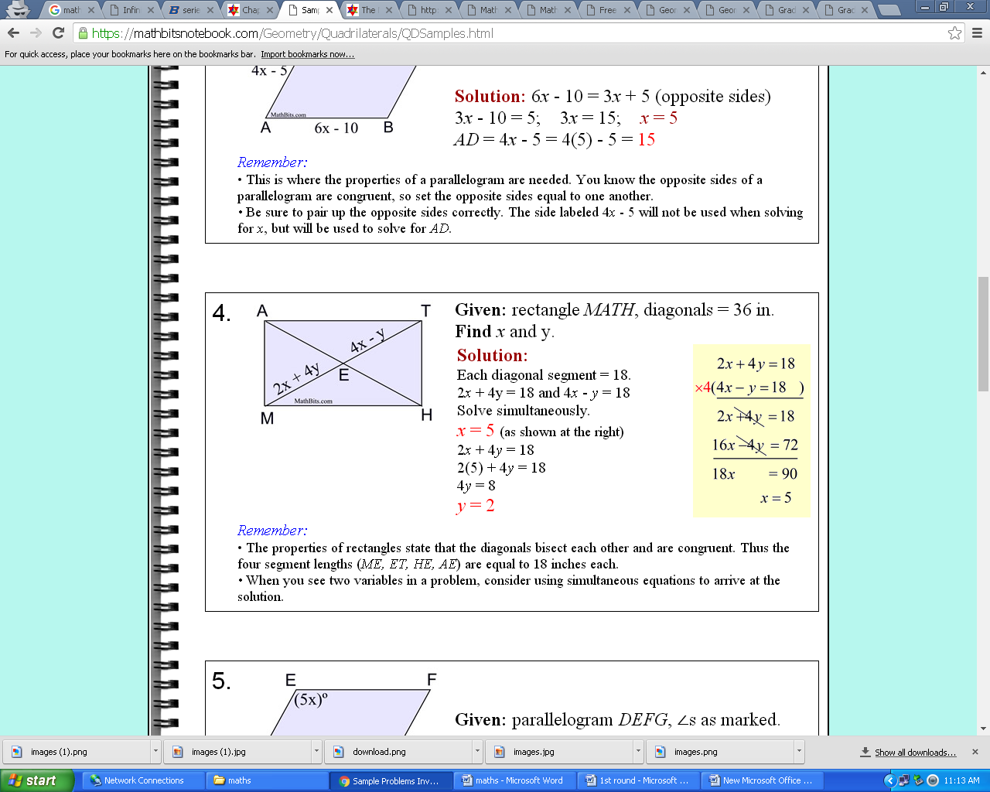

**Given:**rectangle *MATH*, diagonals = 36 in.  
**Find** *x* and y.

|  |
| --- |
|  |

**Solution:**

Each diagonal segment = 18.  
2*x* + 4y = 18 and 4*x* - *y* = 18  
Solve simultaneously.  
*x* = 5 (as shown at the right)  
2*x* + 4*y* = 18  
2(5) + 4*y* = 18  
4*y* = 8  
*y* = 2

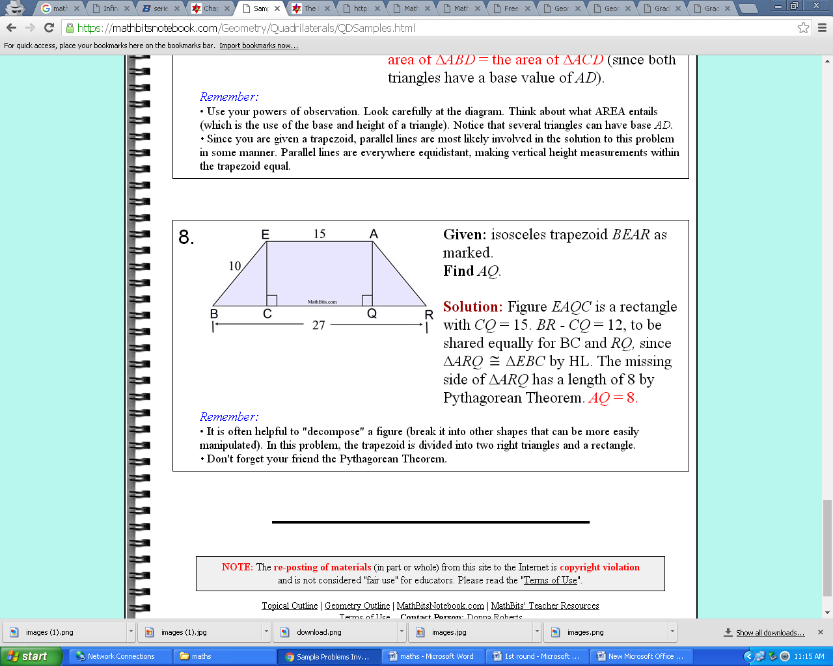

**Given:** isosceles trapezoid BEARas marked.  
**Find**AQ. 

**Solution:**Figure EAQCis a rectangle with CQ = 15. BR - CQ = 12, to be shared equally for BC and RQ,since ΔARQ  ΔEBCby HL. The missing side of ΔARQ has a length of 8 by Pythagorean Theorem. AQ = 8.

The area of the [trapezoid](http://www.analyzemath.com/Geometry/trapezoid_problems.html)shown below is equal to 270 square units. Find its perimeter and round your answer to the nearest unit.

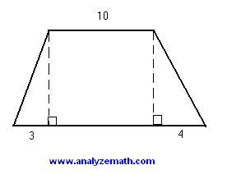.

Shrisha knows how to find the area of the figure. Can you? Find the area of the cyclic quadrilateral shown in the figure.(NOTE: figure not drawn to scale)

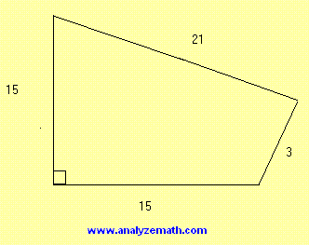

1. (1/2)*15*15 + (1/2)*21*3 = 144

An airplane flies against the wind from A to B in 8 hours. The same airplane returns from B to A, in the same direction as the wind, in 7 hours. Find the ratio of the speed of the airplane (in still air) to the speed of the wind.

* 1. Let: S be the speed of the airplane in still air, r be the speed of the wind and d the distance between A and B.
  2. d = 8(S - r) : airplane flies against the wind
  3. d = 7(S + r) : airplane flies in the same direction as the wind
  4. 8(S - r) = 7(S + r)
  5. S/r = 15

I can solve this. Can you?

Find the sum given

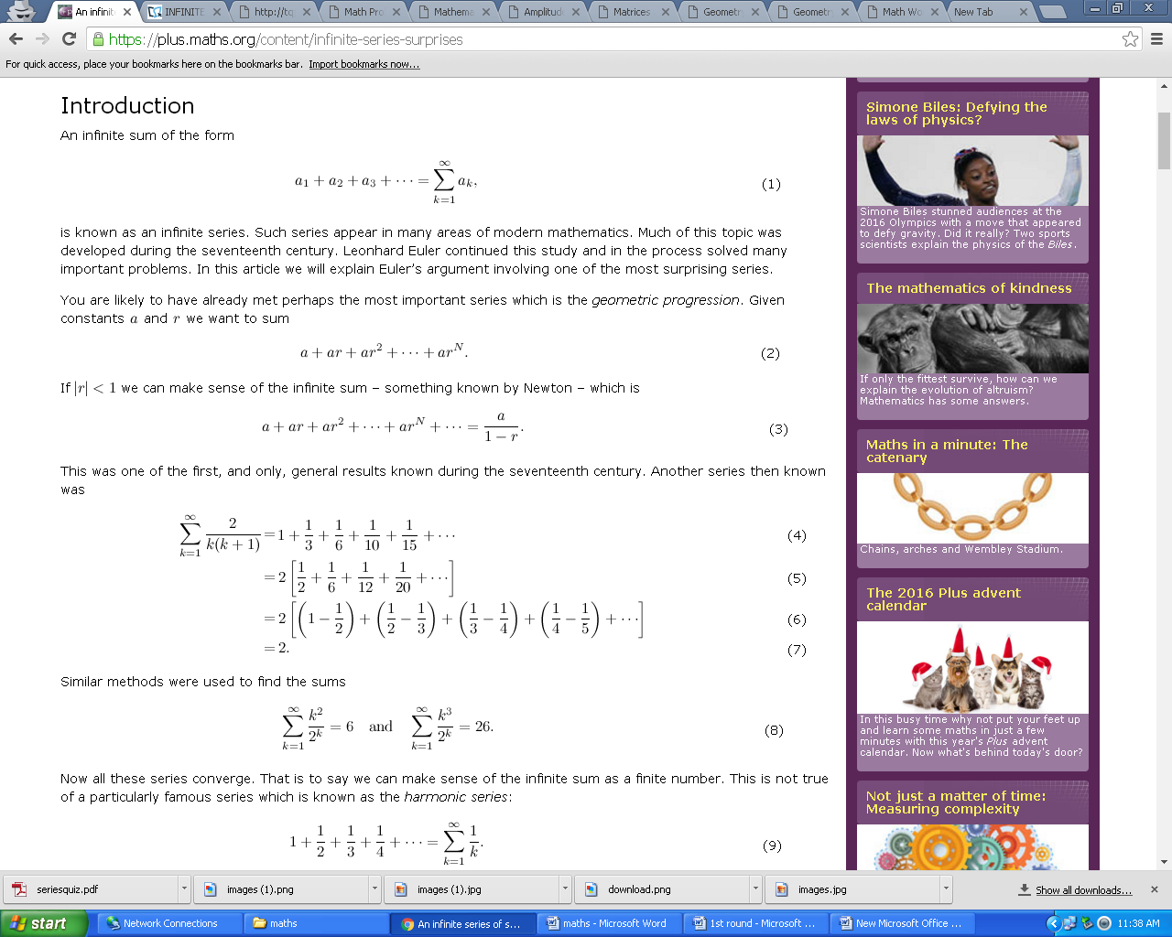



The semicircle of area 1250 pi centimeters is inscribed inside a rectangle. The diameter of the semicircle coincides with the length of the rectangle. Find the area of the rectangle.

1. Let r be the radius of the semicircle. Area of the semicircle is known; hence   
     
   1250Pi = (1/2) Pi r2 (note the 1/2 because of the semicircle)   
     
   Solve for r: r = 50   
     
   Length of rectangle = 2r = 100 (semicircle inscribed)   
     
   Width of rectangle = r = 50 (semicircle inscribed)   
     
   Area = 100 * 50 = 5000