create user suraj identified by suraj2104;

grant dba to suraj;

create table person( driver_id varchar(5),name varchar(20),address varchar(30));

create table car(reg_num varchar(10),model varchar(10),year int);

create table owns(driver_id varchar(5),reg_num varchar(10));

create table accident(report_num int,accident_date date,location varchar(30));

create table participated(driver_id varchar(5),reg_num varchar(10),report_num int,damage_amount int);

desc participated;

alter table person

add primary key(driver_id);

alter table car

add primary key(reg_num,reg_num);

alter table owns

add constraint pk_owns primary key(driver_id,reg_num);

alter table owns

ADD CONSTRAINT fk1_owns

FOREIGN KEY (driver_id)

REFERENCES person(driver_id);

alter table owns

ADD CONSTRAINT fk2_owns

FOREIGN KEY (reg_num)

REFERENCES car(reg_num);

alter table accident

add primary key(report_num);

alter table participated

add constraint pk_participated primary key(driver_id,reg_num,report_num);

alter table participated

ADD CONSTRAINT fk1_participated

FOREIGN KEY (driver_id)

REFERENCES person(driver_id);

alter table participated

ADD CONSTRAINT fk2_participated

FOREIGN KEY (reg_num)

REFERENCES car(reg_num);

alter table participated

ADD CONSTRAINT fk3_participated

FOREIGN KEY (report_num)

REFERENCES accident(report_num);

insert into person values('&driver_id','&name','&address');

commit;

select * from person;

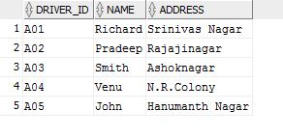

insert into car values('&reg_num','&model', &year);

commit;

select * from car;

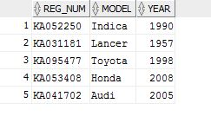

DELETE FROM car WHERE reg_num='KA052250';

insert into accident values(&report_num,'&accident_date','&location');

commit;

select * from accident;

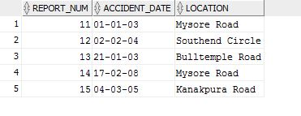

insert into owns values ('&driver_id','&reg_num');

commit;

select * from owns;

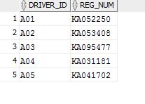

insert into participated values ('&driver_id','&reg_num',&report_num,&damage_amount);

commit;

select * from participated;

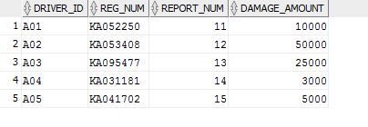

update participated set damage_amount=25000 where reg_num='KA053408' and

report_num=12;

commit;

select * from participated;

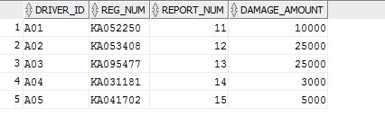

insert into accident values(16,'15-MAR-08','Domlur');

select * from accident;

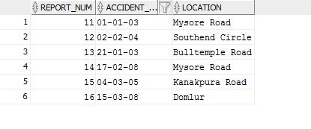

select count(distinct driver_id) CNT from participated a, accident b where

a.report_num=b.report_num and b.accident_date like '%08';

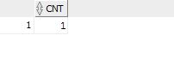

select count(report_num) CNT from car c,participated p where c.reg_num=p.reg_num and

model='Lancer';

