**VISVESVARAYA TECHNOLOGICAL UNIVERSITY**

“JnanaSangama”, Belgaum -590014, Karnataka.



**LAB REPORT**

**on**

**COMPILER DESIGN**

*Submitted by*

**G Sai Vikrant (1BM21CS061)**

***Under the Guidance of***

| **Prof. Sonika Sharma D**  **Assistant Professor, BMSCE** |  |
| --- | --- |

*in partial fulfilment for the award of the degree of*

**BACHELOR OF ENGINEERING**

in

**COMPUTER SCIENCE AND ENGINEERING**



**B.M.S. COLLEGE OF ENGINEERING**

**(Autonomous Institution under VTU)**

**BENGALURU-560019**

**November 2023-February 2024**

**B. M. S. College of Engineering,**

**Bull Temple Road, Bangalore 560019**

**(Affiliated To Visvesvaraya Technological University, Belgaum)**

**Department of Computer Science and Engineering**



**CERTIFICATE**

This is to certify that the Lab work entitled “**Compiler Design**” carried out by **G Sai Vikrant (1BM21CS061)** , who is bonafide student of **B. M. S. College of Engineering.** It is in partial fulfilment for the award of **Bachelor of Engineering in Computer Science and Engineering** of the Visvesvaraya Technological University, Belgaum during the year 2023-24.

The Lab report has been approved as it satisfies the academic requirements in respect of **Compiler Design- (22CS5PCCPD)** work prescribed for the said degree.

Prof. Sonika Sharma D Dr. Jyothi Nayak

Assistant professor Professor and Head

Department of CSE Department of CSE

BMSCE, Bengaluru BMSCE, Bengaluru

**B. M. S. COLLEGE OF ENGINEERING**

**DEPARTMENT OF COMPUTER SCIENCE AND ENGINEERING**



***DECLARATION***

I, G Sai Vikrant (1BM21CS061), student of 5th Semester, B.E, Department of Computer Science and Engineering, B. M. S. College of Engineering, Bangalore, here by declare that, this lab report entitled " **Compiler Design**" has been carried out by me under the guidance of Prof. Sonika Sharma D, Assistant Professor, Department of CSE, B. M. S. College of Engineering, Bangalore during the academic semester November-2023-February-2024.

I also declare that to the best of my knowledge and belief, the development reported here is not from part of any other report by any other students.

| **Lab No** | **Title** | **Page No** |
| --- | --- | --- |
| **1** |  | **6-8** |
| 1.1 | Write a program in LEX to recognize different tokens: Keywords, Identifiers, Constants, Operators and Punctuation symbols**.** | 6 |
| 1.2 | Write a program in LEX to count the number of characters and digits in a string. | 7 |
|  | Write a program in LEX to count the number of vowels and consonants in a string. | 8 |
| **2** |  | **9-15** |
| 2.1 | Write a program in lex to count the number of words in a sentence. | 9 |
| 2.2 | Write a program in lex to demonstrate regular definition. | 10 |
| 2.3 | Write a program in lex to identify tokens in a program by taking input from a file and printing the output on the terminal. | 11-12 |
| 2.4 | Write a program in lex to identify tokens in a program by taking input from a file and printing the output in another file. | 13-14 |
| 2.5 | Write a program in lex to find the length of the input string. | 15 |
| **3** |  | **16-23** |
| 3.1 | Write a program in LEX to recognize Floating Point Numbers. | 16 |
| 3.2 | Read and input sentence, and check if it is compound or simple. If a sentence has the word- and , or ,but ,because ,if ,then ,nevertheless then it is compound else it is simple. | 17 |
| 3.3 | Write a program to check if the input sentence ends with any of the following  punctuation marks ( ? , fullstop , ! ) | 18-19 |
| 3.4 | Write a program to read an input sentence and to check if the sentence begins with  English articles (A, a,AN,An,THE and The). | 20-21 |
| 3.5 | Lex program to count the number of comment lines (multi line comments or single line) in a program. Read the input from a file called input.txt and print the count in a file called output.txt. | 22 |
| 3.6 | Write a program to read and check if the user entered number is signed or unsigned using appropriate meta character. | 23 |
| **4** |  | **24-36** |
| 4.1 | Write a LEX program that copies a file, replacing each nonempty sequence of white spaces by a single blank. | 24-25 |
| 4.2 | Write a LEX program to recognize the following tokens over the alphabets {0,1,..,9} | 26-36 |
| 4.2.1 | The set of all string ending in 00. | 26 |
| 4.2.2 | The set of all strings with three consecutive 222’s. | 27 |
| 4.2.3 | The set of all string such that every block of five consecutive symbols contains at least two 5’s. | 28-29 |
| 4.2.4 | The set of all strings beginning with a 1 which, interpreted as the binary representation of an integer, is congruent to zero modulo 5. | 30-31 |
| 4.2.5 | The set of all strings such that the 10th symbol from the right end is 1. | 32 |
| 4.2.6 | The set of all four digits numbers whose sum is 9. | 33-34 |
| 4.2.7 | The set of all four digital numbers, whose individual digits are in ascending order from left to right. | 35-36 |
| **5** |  | **37-38** |
| 5.1 | Write a C program to design lexical analysis to recognize any five keywords, identifiers, numbers, operators and punctuations. | 37-38 |
| **6** |  | **39-40** |
| 6.1 | Write a program to perform recursive descent parsing on the following grammar:  S->cAd  A->ab | a | 39-40 |
| **7** |  | **41-47** |
| 7.1 | Write a program in YACC to design a suitable grammar for evaluation of arithmetic expression having +, -, * and /. | 41-42 |
| 7.2 | Write a program in YACC to recognize strings of the form {(a^n)b,n>=5}. | 43-44 |
| 7.3 | Write a program in YACC to generate a syntax tree for a given arithmetic expression. | 45-47 |
| **8** |  | **48-49** |
| 8.1 | Write a program in YACC to convert infix to postfix expression. | 48-49 |
| **9** |  | **50-52** |
| 9.1 | Write a program in YACC to generate three address code for a given expression. | 50-52 |

**Lab 1**

**1.1 Write a program in LEX to recognize different tokens: Keywords, Identifiers, Constants, Operators and Punctuation symbols.**

**Code:**

%{

#include<stdio.h>

%}

%%

printf|for|void|main|while|do|switch|case|int|char|float|double|if|else {printf(“%s-keyword\n”,yytext);

, {printf("%s-separator\n",yytext);}

; {printf("%s-delimiter\n",yytext);}

[a-zA-Z_][a-zA-Z0-9_]* {printf("%s-Identifier\n",yytext);}

">"|"<"|">="|"<="|"==" {printf("%s- Relational operator\n",yytext);}

"=" {printf("%s-assignment operator\n",yytext);}

[0-9]+ {printf("%s-digit\n",yytext);}

%%

void main()

{

printf("Give an input:\n");

yylex();

}

int yywrap()

{

return 1;

}

**Output**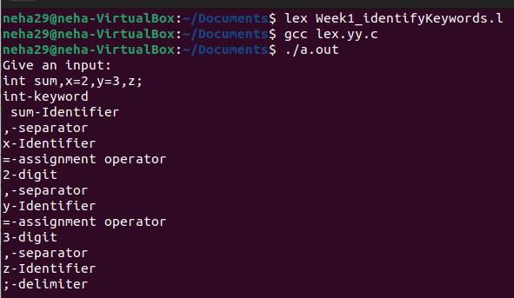

**1.2 Write a program in LEX to count the number of characters and digits in a string.**

**Code**

%{

#include<stdio.h>

int d=0,c=0;

%}

%%

[a-zA-Z] {c++;}

[0-9] {d++;}

. ;

\n {printf("No of characters and digits are %d and %d\n",c,d),c=0,d=0;}

%%

void main()

{

printf("Enter a sentence:\n");

yylex();

}

int yywrap()

{

return 1;

}

**Output**

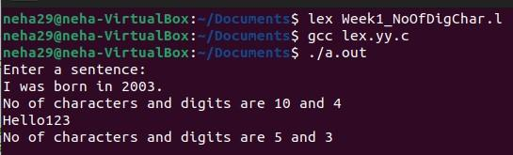

**1.3 Write a program in LEX to count the number of vowels and consonants in a string.**

**Code**

%{

#include<stdio.h>

int v=0,c=0;

%}

%%

[AEIOUaeiou] {v++;}

[A-Za-z] {c++;}

\n {printf("No of vowels and consonants are %d and %d\n",v,c),v=0,c=0;}

%%

void main()

{

printf("Enter a sentence:\n");

yylex();

}

int yywrap()

{

return 1;

}

**Output**

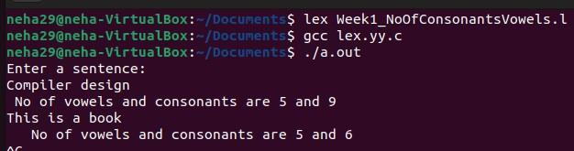

**Lab 2**

**2.1Write a program in lex to count the number of words in a sentence.**

**Code**

%{

#include<stdio.h>

int words;

%}

%%

[^\t\n ]+ {words++;}

\n {printf("No of words in the sentence are %d.\n",words),words=0;}

%%

void main()

{

printf("Enter a sentence:\n");

yylex();

}

int yywrap()

{

return 1;

}

**Output**

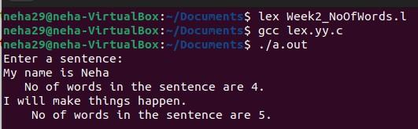

**2.2 Write a program in lex to demonstrate regular definition.**

**Code**

%{

#include<stdio.h>

%}

alpha [a-zA-Z0-9]

%%

[a-zA-Z]+ {printf("Characters\n");}

[0-9]+ {printf("Digits");}

{alpha}+ {printf("Invalid input!\n");}

%%

void main()

{

printf("Enter a string:\n");

yylex();

}

int yywrap()

{

return 1;

}

**Output**

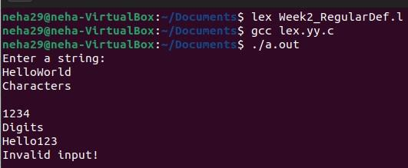

**2.3 Write a program in lex to identify tokens in a program by taking input from a file and printing the output on the terminal.**

**Code**

%{

#include<stdio.h>

%}

%%

char|int|float {printf("%s is a keyword.\n",yytext);}

[a-zA-Z][a-zA-Z0-9]* {printf("%s is an identifier.\n",yytext);}

, {printf("%s is a separator.\n",yytext);}

; {printf("%s is a delimiter.\n",yytext);}

"=" {printf("%s is an assignment operator.\n",yytext);}

"+"|"-"|"*"|"/" {printf("%s is a binary operator.\n",yytext);}

[0-9]+ {printf("%s is/are digit(s).\n",yytext);}

\n ;

%%

void main()

{

yyin=fopen("input.txt","r");

yylex();

fclose(yyin);

}

int yywrap()

{

return 1;

}

**Output**

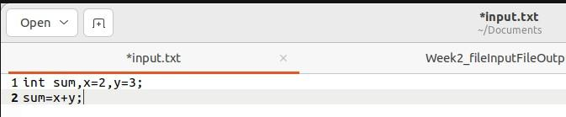

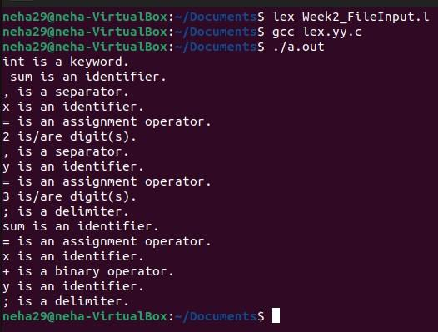

**2.4 Write a program in lex to identify tokens in a program by taking input from a file and printing the output in another file.**

**Code**

%{

#include<stdio.h>

%}

%%

char|int|float {fprintf(yyout,"%s is a keyword.\n",yytext);}

[a-zA-Z][a-zA-Z0-9]* {fprintf(yyout,"%s is an identifier.\n",yytext);}

, {fprintf(yyout,"%s is a separator.\n",yytext);}

; {fprintf(yyout,"%s is a delimiter.\n",yytext);}

"=" {fprintf(yyout,"%s is an assignment operator.\n",yytext);}

"+"|"-"|"*"|"/" {fprintf(yyout,"%s is a binary operator.\n",yytext);}

[0-9]+ {fprintf(yyout,"%s is/are digit(s).\n",yytext);}

\n ;

%%

void main()

{

yyin=fopen("input.txt","r");

yyout=fopen("output.txt","w");

yylex();

printf("Printed in output.txt\n");

fclose(yyin);

fclose(yyout);

}

int yywrap()

{

return 1;

}

**Output**



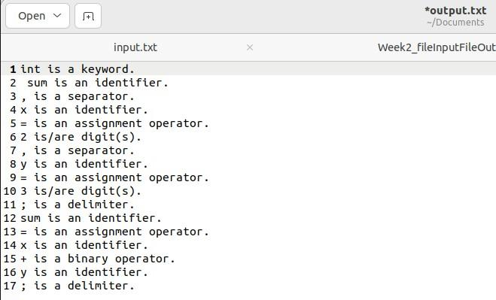

**2.5 Write a program in lex to find the length of the input string.**

**Code**

%{

#include<stdio.h>

%}

%%

[a-zA-Z0-9.,!? \t]+ {printf("Length of input string is %d.\n",yyleng);}

%%

void main()

{

printf("Enter a string:\n");

yylex();

}

int yywrap()

{

return 1;

}

**Output**

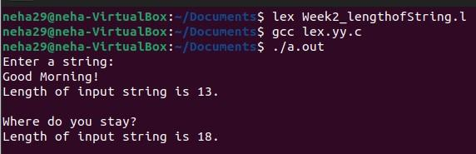

**Lab 3**

**3.1Write a program in LEX to recognize Floating Point Numbers.**

**Code**

%{

#include<stdio.h>

%}

%%

[+-]?[0-9]*[.][0-9][0-9]* {printf("Floating point number!\n");};

[+-]?[0-9][0-9]* {printf("Not a floating point number!\n");};

%%

int yywrap()

{

return 1;

}

void main()

{

printf("Enter a number:\n");

yylex();

}

**Output**

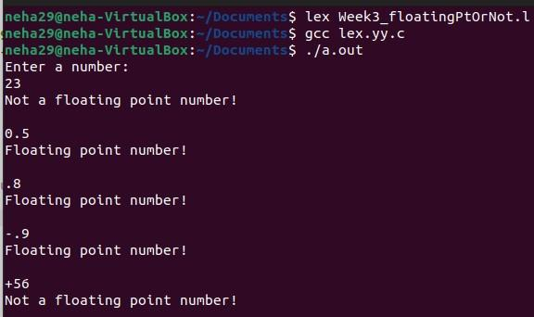

**3.2 Read and input sentence, and check if it is compound or simple. If a sentence has the word- and , or ,but ,because ,if ,then ,nevertheless then it is compound else it is simple.**

**Code**

%{

#include<stdio.h>

int flag=0;

%}

%%

if|then|but|because|nevertheless|and|or {flag=1;}

. ;

\n {return 0;}

%%

int yywrap()

{

return 1;

}

void main()

{

printf("Enter a sentence:\n");

yylex();

if(flag==1)

printf("Compound sentence!\n");

else

printf("Simple sentence!\n");

}

**Output**

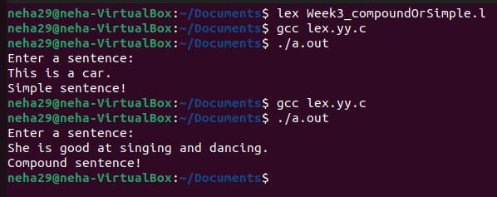



**3.3 Write a program to check if the input sentence ends with any of the following**

**punctuation marks ( ? , fullstop , ! )**

**Code**

%{

#include<stdio.h>

int flag=0;

%}

%%

.*[?|!|.]$ {flag=1;}

.* {flag=0;}

\n {return 0;}

%%

int yywrap()

{

return 1;

}

void main()

{

printf("Enter a sentence:\n");

yylex();

if(flag==1)

printf("Ends with a punctuation!\n");

else

printf("Does not end with punctuation!\n");

}

**Output**

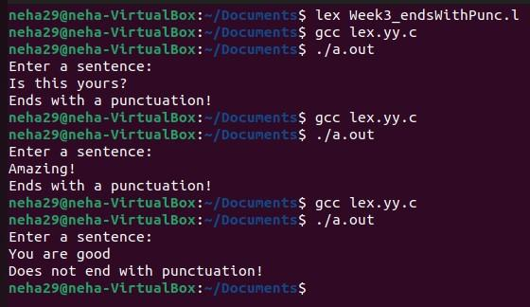

**3.4 Write a program to read an input sentence and to check if the sentence begins with**

**English articles (A, a,AN,An,THE and The).**

**Code**

%{

#include<stdio.h>

int flag=0;

%}

%%

^(an|An|The|the|A|a)[" "].* {flag=1;}

.* {flag=0;}

\n {return 0;}

%%

int yywrap()

{

return 1;

}

void main()

{

printf("Enter a sentence:\n");

yylex();

if(flag==1)

printf("Starts with an article!\n");

else

printf("Does not start with an article!\n");

}

**Output**

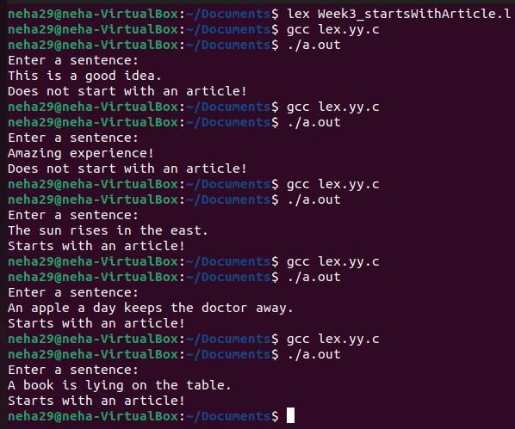



**3.5 Lex program to count the number of comment lines (multi line comments or single line) in a program. Read the input from a file called input.txt and print the count in a file called output.txt.**

**Code**

%{

#include<stdio.h>

int c=0;

%}

%%

"\/\*"[^*]*\*+([^/*][^*]*\*+)*\/ {c++;}

"//".* {c++;}

. ECHO;

%%

int yywrap()

{

return 1;

}

void main()

{

yyin=fopen("input.txt","r");

yyout=fopen("output.txt","w");

yylex();

printf("The number of comments are:%d\n",c);

fclose(yyin);

fclose(yyout);

}

**Output**

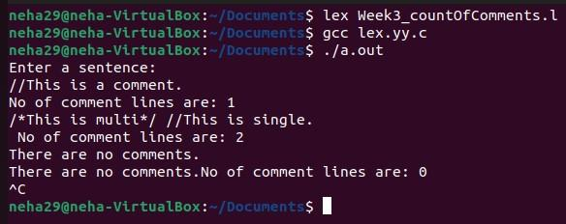

**3.6 Write a program to read and check if the user entered number is signed or unsigned**

**using appropriate meta character.**

**Code**

%{

#include<stdio.h>

%}

%%

[+|-][0-9]+ {printf("Signed number!\n");}

[0-9]+ {printf("Unsigned number!\n");}

%%

int yywrap()

{

return 1;

}

void main()

{

printf("Enter a number:\n");

yylex();

}

**Output**

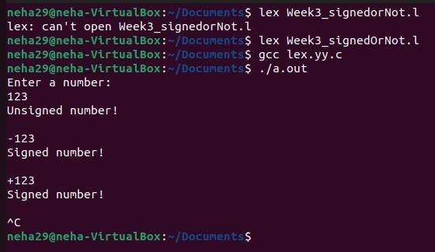

**Lab 4**

**4.1 Write a LEX program that copies a file, replacing each nonempty sequence of white spaces by a single blank.**

**Code**

%{

#include<stdio.h>

%}

%%

[ \t]+ {fprintf(yyout," ");}

.|\n {fprintf(yyout,"%s",yytext);}

%%

void main()

{

yyin=fopen("text.txt","r");

yyout=fopen("print.txt","w");

yylex();

fclose(yyin);

fclose(yyout);

printf("Printed!\n");

}

int yywrap()

{

return 1;

}

**Output**

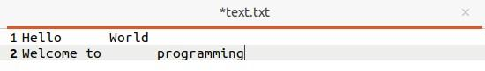

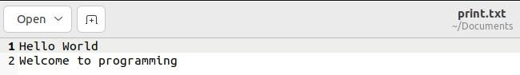

**4.2 Write a LEX program to recognize the following tokens over the alphabets {0,1,..,9}**

**4.2.1 The set of all string ending in 00.**

**Code**

%{

#include<stdio.h>

int flag=0;

%}

%%

[0-9]+[00] {flag=1;}

. ;

\n {return 0;}

%%

void main()

{

printf("Enter a string:\n");

yylex();

if(flag==1)

printf("Ends with 0.\n");

else

printf("Does not end with 0.\n");

}

int yywrap()

{

return 1;

}

**Output**

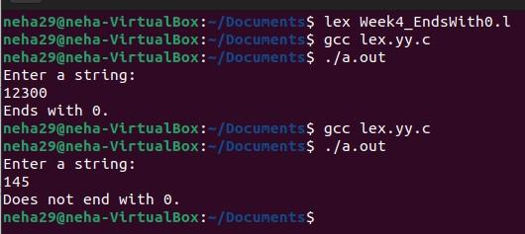

**4.2.2 The set of all strings with three consecutive 222’s.**

**Code**

%{

#include<stdio.h>

int flag=0;

%}

%%

[0-9]*[2][2][2][0-9]* {flag=1;}

. ;

\n {return 0;}

%%

void main()

{

printf("Enter a string:\n");

yylex();

if(flag==1)

printf("Has 3 consecutive 2's.\n");

else

printf("Does not have 3 consecutive 2's.\n");

}

int yywrap()

{

return 1;

}

**Output**

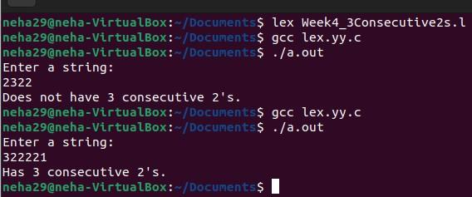



**4.2.3 The set of all string such that every block of five consecutive symbols contains at least two 5’s.**

**Code**

%{

#include<stdio.h>

int i,count=0,flag;

%}

%%

.{1,5} {flag=0;

for(i=0;i<5;i++)

{

int c=yytext[i]-'0';

if(c==5)

{

count++;

if(count==2)

{

flag=1;

break;

}

}

}

count=0;

printf("yytext:%s,flag(1 if no of 5 is atleast 2):%d\n",yytext,flag);

if(flag!=1)

{

printf("Not a valid string!\n");

return 0;

}

}

\n {return 0;}

%%

void main()

{

printf("Enter a string:\n");

yylex();

if(flag==1)

printf("Valid string.\n");

}

int yywrap()

{

return 1;

}

**Output**

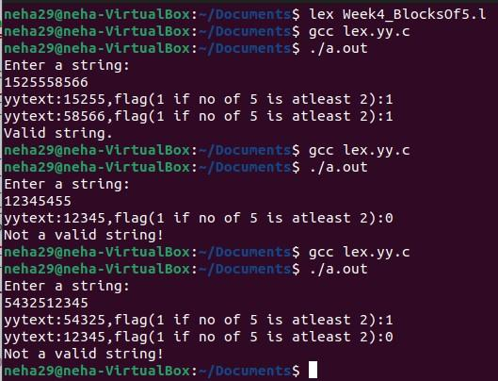



**4.2.4 The set of all strings beginning with a 1 which, interpreted as the binary representation of an integer, is congruent to zero modulo 5.**

**Code**

%{

#include<stdio.h>

int c,i,flag=1,sum=0,power=1;

%}

%%

^1[01]* {for(i=yyleng-1;i>=0;i--)

{

c=yytext[i]-'0';

sum+=c*power;

power*=2;

}

printf("Decimal representation:%d\n",sum);

if(sum%5!=0)

{

printf("Not congruent to modulo 5.\n");

sum=0;

power=1;

}

else

{

printf("Congruent to modulo 5.\n");

sum=0;

power=1;

}

}

.* {printf("Not a binary number.\n");}

\n {return 0;}

%%

void main()

{

printf("Enter a string:\n");

yylex();

}

int yywrap()

{

return 1;

}

**Output**

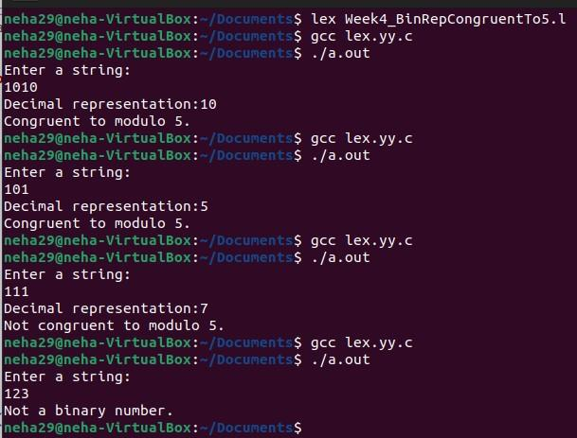



**4.2.5 The set of all strings such that the 10th symbol from the right end is 1.**

**Code**

%{

#include<stdio.h>

int flag=0;

%}

%%

[0-9]*1[0-9][0-9][0-9][0-9][0-9][0-9][0-9][0-9][0-9] {flag=1;}

. ;

\n {return 0;}

%%

void main()

{

printf("Enter a string:\n");

yylex();

if(flag==1)

printf("10th symbol from right is 1.\n");

else

printf("10th symbol from right is not 1.\n");

}

int yywrap()

{

return 1;

}

**Output**

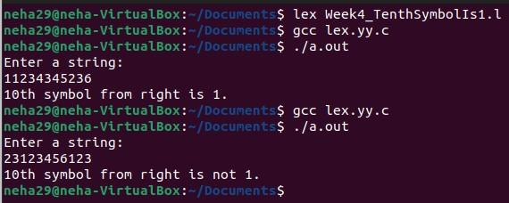



**4.2.6 The set of all four digits numbers whose sum is 9.**

**Code**

%{

#include<stdio.h>

int sum=0,i,flag=0;

%}

%%

[0-9][0-9][0-9][0-9] {for(i=0;i<yyleng;i++)

{

sum+=yytext[i]-'0';

}

if(sum==9)

{

flag=1;

sum=0;

}

else

{

flag=0;

sum=0;

}

}

\n {return 0;}

%%

void main()

{

printf("Enter a string:\n");

yylex();

if(flag==1)

printf("The sum of digits is 9.\n");

else

printf("The sum of digits is not 9.\n");

}

int yywrap()

{

return 1;

}

**Output**

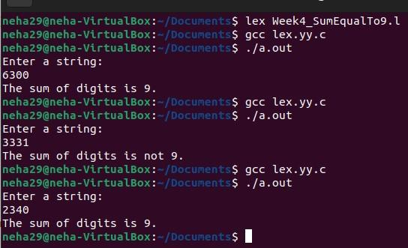



**4.2.7 The set of all four digital numbers, whose individual digits are in ascending order from left to right.**

**Code**

%{

#include<stdio.h>

int c,i,flag=1;

%}

%%

[0-9][0-9][0-9][0-9] {for(i=0;i<yyleng-1;i++)

{

if(yytext[i]>=yytext[i+1])

{

flag=0;

break;

}

}

}

\n {return 0;}

%%

void main()

{

printf("Enter a string:\n");

yylex();

if(flag==1)

printf("The digits are in ascending order.\n");

else

printf("The digits are not in ascending order.\n");

}

int yywrap()

{

return 1;

}

**Output**

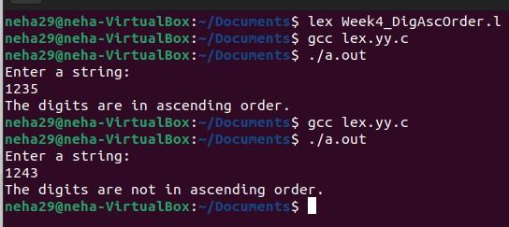



**Lab 5**

**Write a C program to design lexical analysis to recognize any five keywords, identifiers, numbers, operators and punctuations.**

**Code**

#include <stdio.h>

#include <string.h>

#include <ctype.h>

void lexicalAnalyzer(char input_code[]) {

char *keywords[] = {"if", "else", "while", "for", "return"};

char *operators[] = {"+", "-", "*", "/", "=", "==", "<", ">", "<=", ">="};

char *punctuations[] = {",", ";", "(", ")", "{", "}"};

char *token = strtok(input_code, " \t\n");

while (token != NULL) {

if (isdigit(token[0])) {

printf("Number: %s\n", token);

} else if (isalpha(token[0]) || token[0] == '_') {

int isKeyword = 0;

for (int i = 0; i < sizeof(keywords) / sizeof(keywords[0]); i++) {

if (strcmp(token, keywords[i]) == 0) {

printf("Keyword: %s\n", token);

isKeyword = 1;

break;

}

}

if (!isKeyword) {

printf("Identifier: %s\n", token);

}

} else if (strchr("+-*/=<>(){}[]", token[0]) != NULL) {

printf("Operator: %s\n", token);

}

else if(strchr(",;", token[0]) != NULL)

{

printf("Punctuation:%s\n",token);

}

token = strtok(NULL, " \t\n");

}

}

int main() {

char input_code[] = "if ( x > 0 ) { return x ; } else { return -x ; }";

lexicalAnalyzer(input_code);

return 0;

}

**Output**

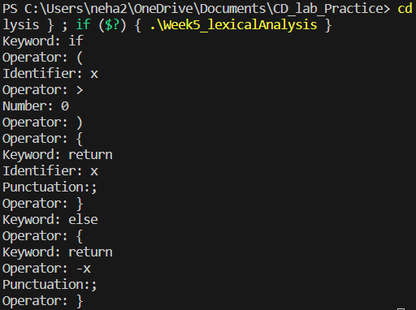

**Lab 6**

**Write a program to perform recursive descent parsing on the following grammar:**

**S->cAd**

**A->ab | a**

**Code**

#include <stdio.h>

#include<stdlib.h>

char input[100];

int ind = 0;

void match(char expected)

{

if (input[ind] == expected)

{

ind++;

}

}

void A();

void S()

{

match('c');

A();

match('d');

}

void A()

{

if (input[ind] == 'a')

{

printf("Hello\n");

match('a');

match('b');

} /*else if (input[ind] == 'a')

{

printf("Hi!\n");

match('a');

}*/

else

{

printf("Parsing failed.\n", ind);

exit(1);

}

}

int main() {

printf("Enter the input string:\n");

scanf("%s", input);

S();

if (input[ind] == '$') {

printf("Parsing successful.\n");

} else {

printf("Parsing failed. Extra characters found.\n");

}

return 0;

}

**Output**

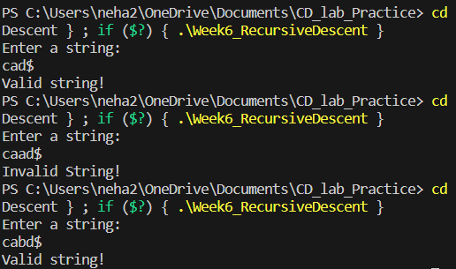



**Lab 7**

**7.1Write a program in YACC to design a suitable grammar for evaluation of arithmetic expression having +, -, * and /.**

**Code**

LEX

%{

#include<stdio.h>

#include<stdlib.h>

#include "y.tab.h"

extern int yylval;

%}

%%

[0-9]+ {yylval=atoi(yytext);return num;}

[\t ] ;

\n {return 0;}

. {return yytext[0];}

%%

int yywrap()

{

}

YACC

%{

#include<stdio.h>

#include<stdlib.h>

int yyerror(const char *s);

int yylex(void);

%}

%token num;

%left '+' '-'

%left '*' '/'

%left ')'

%left '('

%%

s:e {printf("Valid expression!\n");

printf("Result:%d\n",$$);

exit(0);

}

;

e:e'+'e {$$=$1+$3;}

|e'-'e {$$=$1-$3;}

|e'*'e {$$=$1*$3;}

|e'/'e {$$=$1/$3;}

|'('e')' {$$=$2;}

|num {$$=$1;}

;

%%

void main()

{

printf("Enter an arithmetic expression:\n");

yyparse();

}

int yyerror(const char *s)

{

printf("Invalid expression!\n");

return 0;

}

**Output**

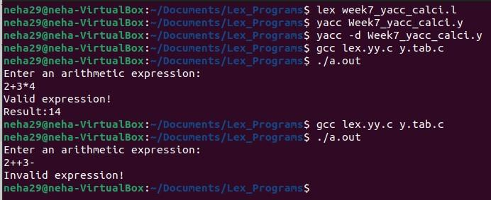



**7.2 Write a program in YACC to recognize strings of the form {(a^n)b , n>=5}.**

**Code**

LEX

%{

#include<stdio.h>

#include<stdlib.h>

#include "y.tab.h"

extern int yylval;

%}

%%

[aA] {yylval=yytext[0];return A;}

[bB] {yylval=yytext[0];return B;}

\n {return NL;}

. {return yytext[0];}

%%

int yywrap()

{

return 1;

}

YACC

%{

#include<stdio.h>

#include<stdlib.h>

int yyerror(char *s);

int yylex(void);

%}

%token A

%token B

%token NL

%%

smtr:A A A A A S B NL {printf("Parsed using the rule (a^n)b, n>=5.\nValid String!\n");}

;

S:S A

|

;

%%

void main()

{

printf("Enter a string!\n");

yyparse();

}

int yyerror(char *s)

{

printf("Invalid String!\n");

return 0;

}

**Output**

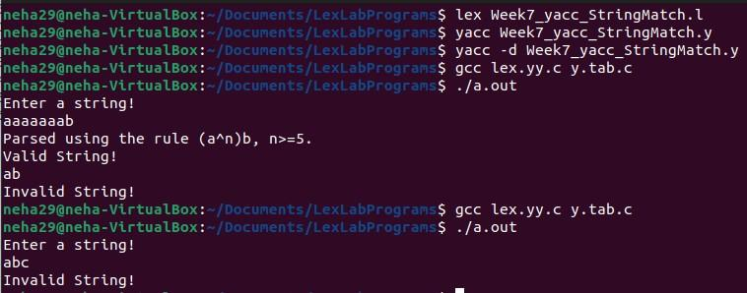

**7.3 Write a program in YACC to generate syntax tree for a given arithmetic expression.**

**Code**

LEX

%{

#include<stdio.h>

#include<stdlib.h>

#include "y.tab.h"

extern int yylval;

%}

%%

[0-9]+ {yylval=atoi(yytext);return digit;}

[\t] ;

[\n] return 0;

. return yytext[0];

%%

int yywrap()

{

return 1;

}

YACC

%{

#include <math.h>

#include<ctype.h>

#include<stdio.h>

#include<stdlib.h>

#include<string.h>

int yyerror(char *s);

int yylex(void);

struct tree_node

{

char val[10];

int lc;

int rc;

};

int ind;

struct tree_node syn_tree[100];

void my_print_tree(int cur_ind);

int mknode(int lc,int rc,char *val);

%}

%token digit

%%

S:E {my_print_tree($1);}

;

E:E'+'T {$$=mknode($1,$3,"+");}

|T {$$=$1;}

;

T:T'*'F {$$= mknode($1,$3,"*");}

|F {$$=$1;}

;

F:'('E')' {$$=$2;}

|digit {char buf[10];sprintf(buf,"%d", yylval);$$ = mknode(-1,-1,buf);}

;

%%

int main()

{

ind=0;

printf("Enter an expression:\n");

yyparse();

return 0;

}

int yyerror(char *s)

{

printf("NITW Error\n");

return 0;

}

int mknode(int lc,int rc,char val[10])

{

strcpy(syn_tree[ind].val,val);

syn_tree[ind].lc = lc;

syn_tree[ind].rc = rc;

ind++;

return ind-1;

}

/*my_print_tree function to print the syntax tree in DLR fashion*/

void my_print_tree(int cur_ind)

{

if(cur_ind==-1) return;

if(syn_tree[cur_ind].lc==-1&&syn_tree[cur_ind].rc==-1)

printf("Digit Node -> Index : %d, Value : %s\n",cur_ind,syn_tree[cur_ind].val);

else

printf("Operator Node -> Index : %d, Value : %s, Left Child Index : %d,Right Child Index : %d\n",cur_ind,syn_tree[cur_ind].val, syn_tree[cur_ind].lc,syn_tree[cur_ind].rc);

my_print_tree(syn_tree[cur_ind].lc);

my_print_tree(syn_tree[cur_ind].rc);

}

**Output**

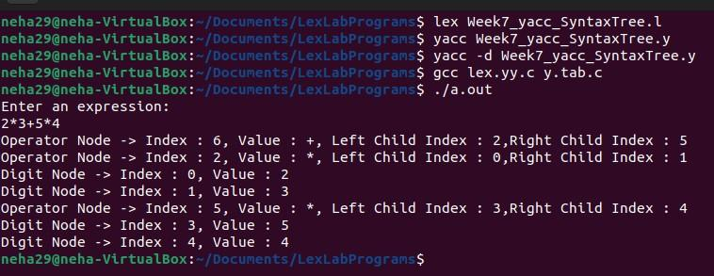

**Lab 8**

**8.1Write a program in YACC to convert infix to postfix expression.**

**Code**

LEX

%{

#include<stdio.h>

#include<stdlib.h>

#include "y.tab.h"

extern int yylval;

%}

%%

[0-9]+ {yylval=atoi(yytext);return num;}

[\t ] ;

\n {return 0;}

. {return yytext[0];}

%%

int yywrap()

{

}

YACC

%{

#include<stdio.h>

#include<stdlib.h>

int yyerror(const char *s);

int yylex(void);

%}

%token num

%left '+' '-'

%left '*' '/'

%left ')'

%left '('

%right '^'

%%

s:e {printf("\n");}

;

e:e'+'t {printf("+");}

|e'-'t {printf("-");}

|t

;

t:t'*'h {printf("*");}

|t'/'h {printf("/");}

|h

;

h:f'^'h {printf("^");}

|f

;

f:'('e')'

|num {printf("%d",$1);}

;

%%

void main()

{

printf("Enter an infix expression:\n");

yyparse();

}

int yyerror(const char *s)

{

printf("Invalid infix expression!\n");

return 0;

}

**Output**

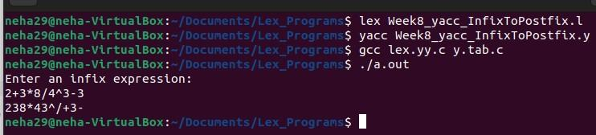

**Lab 9**

**9.1Write a program in YACC to generate three address code for a given expression.**

**Code**

LEX

%{

#include<stdio.h>

#include<stdlib.h>

#include"y.tab.h"

extern int yylval;

extern char iden[20];

%}

d [0-9]+

a [a-zA-Z]+

%%

{d} { yylval=atoi(yytext); return digit; }

{a} { strcpy(iden,yytext); yylval=1; return id;}

[ \t] {;}

\n return 0;

. return yytext[0];

%%

int yywrap()

{

return 1;

}

YACC

%{

#include <math.h>

#include<ctype.h>

#include<stdio.h>

int yyerror(char *s);

int yylex(void);

int var_cnt=0;

char iden[20];

%}

%token id

%token digit

%%

S:id '=' E {printf("%s=t%d\n",iden,var_cnt-1);}

E:E '+' T {$$=var_cnt; var_cnt++; printf("t%d = t%d + t%d;\n", $$, $1, $3 );}

|E '-' T { $$=var_cnt; var_cnt++; printf("t%d = t%d - t%d;\n", $$, $1, $3 );}

|T {$$=$1;}

;

T:T '*' F {$$=var_cnt; var_cnt++; printf("t%d = t%d * t%d;\n", $$, $1, $3 );}

|T '/' F {$$=var_cnt; var_cnt++; printf("t%d = t%d / t%d;\n", $$, $1, $3 );}

|F {$$=$1;}

;

F:P '^' F {$$=var_cnt; var_cnt++; printf("t%d = t%d ^ t%d;\n", $$, $1, $3 );}

|P {$$ = $1;}

;

P: '(' E ')' {$$=$2;}

|digit {$$=var_cnt; var_cnt++; printf("t%d = %d;\n",$$,$1);}

;

%%

int main()

{

var_cnt=0;

printf("Enter an expression:\n");

yyparse();

return 0;

}

int yyerror(char *s)

{

printf("Invalid expression!");

return 0;

}

**Output**

