**VISVESVARAYA TECHNOLOGICAL UNIVERSITY**

**“JnanaSangama”, Belgaum -590014, Karnataka.**



**LAB REPORT**

**on**

**Operating Systems**

**(22CS4PCOPS)**

***Submitted by:***

**POORVIKA S K (1BM22CS412)**

***in partial fulfillment for the award of the degree of***

**BACHELOR OF ENGINEERING**

***in***

**COMPUTER SCIENCE AND ENGINEERING**



**B.M.S. COLLEGE OF ENGINEERING**

**(Autonomous Institution under VTU)**

**BENGALURU-560019**

**June 2023 - August 2023**

**B. M. S. College of Engineering,**

**Bull Temple Road, Bangalore 560019**

(Affiliated To Visvesvaraya Technological University, Belgaum)

**Department of Computer Science and Engineering**



**CERTIFICATE**

This is to certify that the Lab work entitled “**Operating Systems**” carried out by **POORVIKA S K (1BM22CS412),** who is bonafide student of **B. M. S. College of Engineering.** It is in partial fulfillment for the award of **Bachelor of Engineering in Computer Science and Engineering** of the Visvesvaraya Technological University, Belgaum during the year 2022-23. The Lab report has been approved as it satisfies the academic requirements in respect of **Operating Systems - (22CS4PCOPS)** work prescribed for the said degree.

**Dr. Prasadh**             **Dr. Jyothi S Nayak**

Assistant Professor Professor and Head

Department of CSE Department of CSE

BMSCE, Bengaluru BMSCE, Bengaluru

**Table Of Contents**

|  |  |  |  |  |
| --- | --- | --- | --- | --- |
| **S.No.** | **Experiment Title** | | | **Page No.** |
| **1** | **Course Outcomes** | | | **6** |
| **2** | **Experiments** | | | **6 - 184** |
|  | **2.1** | **Experiment - 1** | | **6 - 16** |
| **2.1.1** | **Question:**  Write a C program to simulate the following non-pre-emptive CPU scheduling algorithm to find turnaround time and waiting time.   1. FCFS 2. SJF (pre-emptive & Non-pre-emptive) | **6** |
| **2.1.2** | **Code** | **6** |
| **2.1.3** | **Output** | **9** |
|  | **Experiment - 2** | | **10 - 15** |
| **2.2.1** | **Question:**  Write a C program to simulate the following CPU scheduling algorithm to find turnaround time and waiting time.   1. Priority (pre-emptive & Non-pre-emptive) 2. Round Robin (Experiment with different quantum sizes for RR algorithm) | **10** |
| **2.2.2** | **Code** | **10** |
| **2.2.3** | **Output** | **15** |
| **2.3** | **Experiment - 3** | | **16 - 19** |
| **2.3.1** | **Question:**  Write a C program to simulate multi-level queue scheduling algorithm considering the following scenario. All the processes in the system are divided into two categories – system processes and user processes. System processes are to be given higher priority than user processes. Use FCFS scheduling for the processes in each queue. | **16** |
| **2.3.2** | **Code** | **16** |
| **2.3.3** | **Output** | **19** |
| **2.4.** | **Experiment - 4** | | **20 - 28** |
| **2.4.1** | **Question:**  Write a C program to simulate Real-Time CPU Scheduling algorithms:   1. Rate- Monotonic 2. Earliest-deadline First   **(c)** Proportional scheduling | **20** |
| **2.4.2** | **Code** | **20** |
| **2.4.3** | **Output** | **27 - 28** |
| **2.5.** | **Experiment - 5** | | **29 - 31** |
| **2.5.1** | **Question:**  Write a C program to simulate producer-consumer problem using semaphores. | **29** |
| **2.5.2** | **Code** | **29** |
| **2.5.3** | **Output** | **31** |
| **2.6** | **Experiment - 6** | | **32 - 34** |
| **2.6.1** | **Question:**  Write a C program to simulate the concept of Dining-Philosophers problem. | **32** |
| **2.6.2** | **Code** | **32** |
| **2.6.3** | **Output** | **34** |
| **2.7** | **Experiment - 7** | | **35 - 39** |
| **2.7.1** | **Question:**  Write a C program to simulate Bankers algorithm for the purpose of deadlock avoidance. | **35** |
| **2.7.2** | **Code** | **35** |
| **2.7.3** | **Output** | **38 - 39** |
| **2.8** | **Experiment - 8** | | **40 - 44** |
| **2.8.1** | **Question:**  Write a C program to simulate deadlock detection. | **40** |
| **2.8.2** | **Code** | **40** |
| **2.8.3** | **Output** | **43 - 44** |
|  | **2.9** | **Experiment - 9** | | **45 - 48** |
|  |  | **2.9.1** | **Question:**  Write a C program to simulate the following contiguous memory allocation techniques:   1. Worst-fit 2. Best-fit   **(c)** First-fit | **45** |
|  |  | **2.9.2** | **Code** | **45** |
|  |  | **2.9.3** | **Output** | **48** |
|  | **2.10** | **Experiment - 10** | | **49 - 51** |
|  |  | **2.10.1** | **Question:**  Write a C program to simulate paging technique of memory management. | **49** |
|  |  | **2.10.2** | **Code** | **49** |
|  |  | **2.10.3** | **Output** | **50 - 51** |
|  | **2.11** | **Experiment - 11** | | **52 - 58** |
|  |  | **2.11.1** | **Question:**  Write a C program to simulate page replacement algorithms:   1. FIFO 2. LRU   **(c)** Optimal | **52** |
|  |  | **2.11.2** | **Code** | **52** |
|  |  | **2.11.3** | **Output** | **57 - 58** |
|  | **2.12** | **Experiment - 12** | | **59 - 63** |
|  |  | **2.12.1** | **Question:**  Write a C program to simulate disk scheduling algorithms:   1. FCFS 2. SCAN   **(c)** C-SCAN | **59** |
|  |  | **2.12.2** | **Code** | **59** |
|  |  | **2.12.3** | **Output** | **64** |
|  | **2.13** | **Experiment - 13** | | **65 - 69** |
|  |  | **2.13.1** | **Question:**  Write a C program to simulate disk scheduling algorithms:   1. SSTF 2. LOOK   **(c)** c-LOOK | **65** |
|  |  | **2.13.2** | **Code** | **65** |
|  |  | **2.13.3** | **Output** | **70** |

1. **Course Outcomes**

**CO1:** Apply the different concepts and functionalities of Operating System.

**CO2:** Analyse various Operating system strategies and techniques.

**CO3:** Demonstrate the different functionalities of Operating System.

**CO4:** Conduct practical experiments to implement the functionalities of Operating system.

1. **Experiments**
   1. **Experiment - 1**
      1. **Question:**

Write a C program to simulate the following non-pre-emptive CPU scheduling algorithm to find turnaround time and waiting time.

1. FCFS
2. SJF
   * 1. **Code:**

#include<stdio.h>

int n, i, j, pos, temp, choice, Burst_time[20], Waiting_time[20], Turn_around_time[20], process[20], total=0;

float avg_Turn_around_time=0, avg_Waiting_time=0;

int FCFS()

{

Waiting_time[0]=0;

for(i=1;i<n;i++)

{

Waiting_time[i]=0;

for(j=0;j<i;j++)

Waiting_time[i]+=Burst_time[j];

}

printf("\nProcess\t\tBurst Time\t\tWaiting Time\t\tTurnaround Time");

for(i=0;i<n;i++)

{

Turn_around_time[i]=Burst_time[i]+Waiting_time[i];

avg_Waiting_time+=Waiting_time[i];

avg_Turn_around_time+=Turn_around_time[i];

printf("\nP[%d]\t\t%d\t\t\t%d\t\t\t\t%d",i+1,Burst_time[i],Waiting_time[i],Turn_around_time[i]);

}

avg_Waiting_time =(float)(avg_Waiting_time)/(float)i;

avg_Turn_around_time=(float)(avg_Turn_around_time)/(float)i;

printf("\nAverage Waiting Time:%.2f",avg_Waiting_time);

printf("\nAverage Turnaround Time:%.2f\n",avg_Turn_around_time);

return 0;

}

int SJF()

{

//sorting

for(i=0;i<n;i++)

{

pos=i;

for(j=i+1;j<n;j++)

{

if(Burst_time[j]<Burst_time[pos])

pos=j;

}

temp=Burst_time[i];

Burst_time[i]=Burst_time[pos];

Burst_time[pos]=temp;

temp=process[i];

process[i]=process[pos];

process[pos]=temp;

}

Waiting_time[0]=0;

for(i=1;i<n;i++)

{

Waiting_time[i]=0;

for(j=0;j<i;j++)

Waiting_time[i]+=Burst_time[j];

total+=Waiting_time[i];

}

avg_Waiting_time=(float)total/n;

total=0;

printf("\nProcess\t\tBurst Time\t\tWaiting Time\t\tTurnaround Time");

for(i=0;i<n;i++)

{

Turn_around_time[i]=Burst_time[i]+Waiting_time[i];

total+=Turn_around_time[i];

printf("\nP[%d]\t\t%d\t\t\t%d\t\t\t\t%d",process[i],Burst_time[i],Waiting_time[i],Turn_around_time[i]);

}

avg_Turn_around_time=(float)total/n;

printf("\n\nAverage Waiting Time=%f",avg_Waiting_time);

printf("\nAverage Turnaround Time=%f\n",avg_Turn_around_time);

}

int main()

{

printf("Enter the total number of processes:");

scanf("%d",&n);

printf("\nEnter Burst Time:\n");

for(i=0;i<n;i++)

{

printf("P[%d]:",i+1);

scanf("%d",&Burst_time[i]);

process[i]=i+1;

}

while(1)

{ printf("\n-----MAIN MENU-----\n");

printf("1. FCFS Scheduling\n2. SJF Scheduling\n");

printf("\nEnter your choice:");

scanf("%d", &choice);

switch(choice)

{

case 1: FCFS();

break;

case 2: SJF();

break;

default: printf("Invalid Input!!!");

}

}

return 0;

}

**2.1.3 Output:**

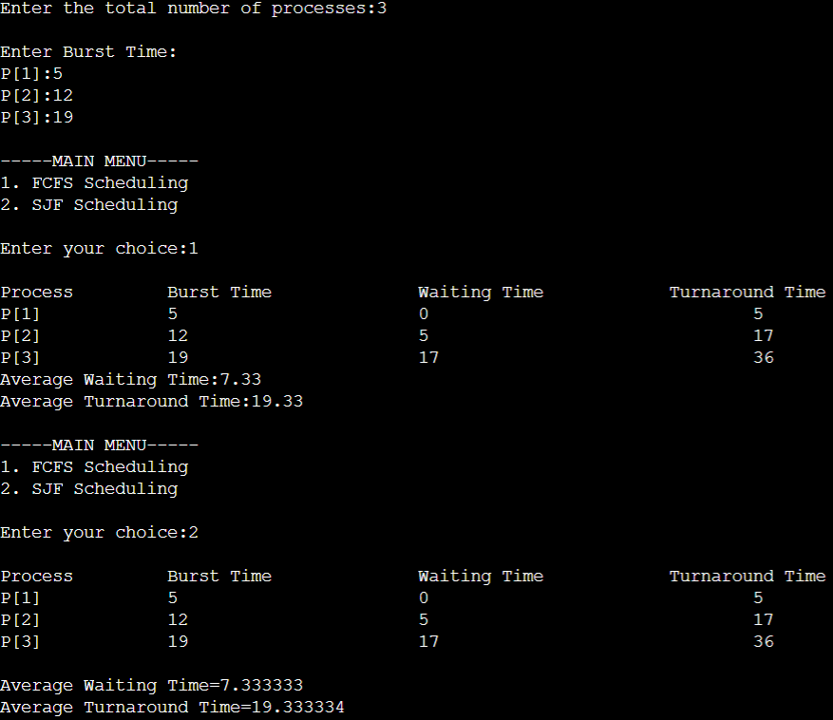

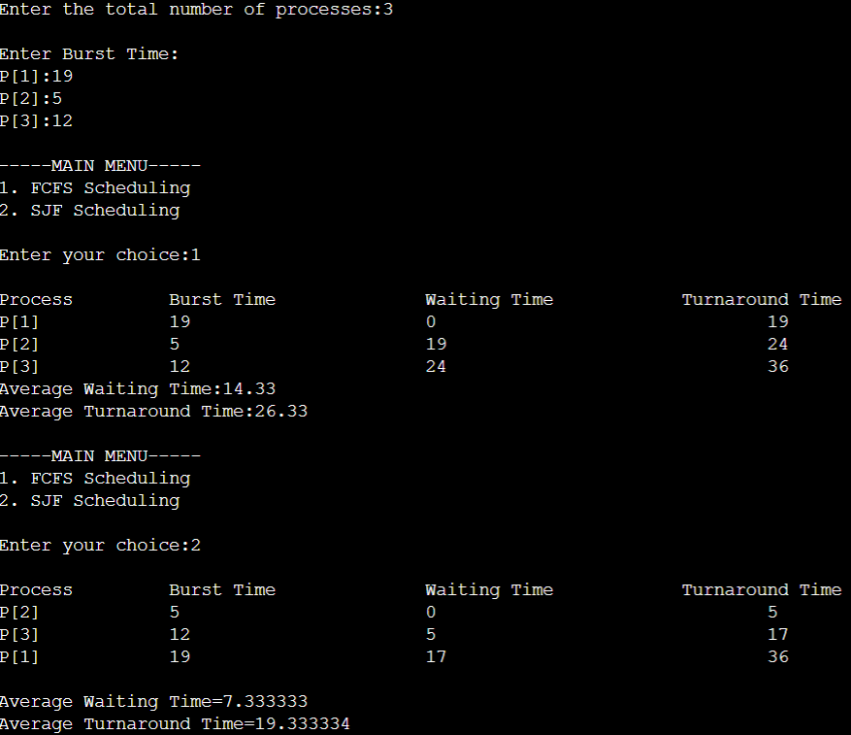

* 1. **Experiment - 2**
     1. **Question:**

Write a C program to simulate the following CPU scheduling algorithm to find turnaround time and waiting time.

1. Priority (pre-emptive & Non-pre-emptive)
2. Round Robin (Experiment with different quantum sizes for RR algorithm)
   * 1. **Code:**
3. **Priority (Non-pre-emptive)**

#include<stdio.h>

#include<stdlib.h>

struct process {

int process_id;

int burst_time;

int priority;

int waiting_time;

int turnaround_time;

};

void find_average_time(struct process[], int);

void priority_scheduling(struct process[], int);

int main()

{

int n, i;

struct process proc[10];

printf("Enter the number of processes: ");

scanf("%d", &n);

for(i = 0; i< n; i++)

{

printf("\nEnter the process ID: ");

scanf("%d", &proc[i].process_id);

printf("Enter the burst time: ");

scanf("%d", &proc[i].burst_time);

printf("Enter the priority: ");

scanf("%d", &proc[i].priority);

}

priority_scheduling(proc, n);

return 0;

}

void find_waiting_time(struct process proc[], int n, int wt[])

{

int i;

wt[0] = 0;

for(i = 1; i< n; i++)

{

wt[i] = proc[i - 1].burst_time + wt[i - 1];

}

}

void find_turnaround_time(struct process proc[], int n, int wt[], int tat[])

{

int i;

for(i = 0; i< n; i++)

{

tat[i] = proc[i].burst_time + wt[i];

}

}

void find_average_time(struct process proc[], int n)

{

int wt[10], tat[10], total_wt = 0, total_tat = 0, i;

find_waiting_time(proc, n, wt);

find_turnaround_time(proc, n, wt, tat);

printf("\nProcess ID\tBurst Time\tPriority\tWaiting Time\tTurnaround Time");

for(i = 0; i< n; i++)

{

total_wt = total_wt + wt[i];

total_tat = total_tat + tat[i];

printf("\n%d\t\t%d\t\t%d\t\t%d\t\t%d", proc[i].process_id, proc[i].burst_time, proc[i].priority, wt[i], tat[i]);

}

printf("\n\nAverage Waiting Time = %f", (float)total_wt/n);

printf("\nAverage Turnaround Time = %f\n", (float)total_tat/n);

}

void priority_scheduling(struct process proc[], int n)

{

int i, j, pos;

struct process temp;

for(i = 0; i< n; i++)

{

pos = i;

for(j = i + 1; j < n; j++)

{

if(proc[j].priority< proc[pos].priority)

pos = j;

}

temp = proc[i];

proc[i] = proc[pos];

proc[pos] = temp;

}

find_average_time(proc, n);

}

1. **Round Robin (Non-pre-emptive)**

#include <stdio.h>

#include <stdbool.h>

int turnarroundtime(int processes[], int n, int bt[], int wt[], int tat[]) {

for (int i = 0; i < n ; i++)

tat[i] = bt[i] + wt[i];

return 1;

}

int waitingtime(int processes[], int n, int bt[], int wt[], int quantum)

{

int rem_bt[n];

for (int i = 0 ; i < n ; i++)

rem_bt[i] = bt[i];

int t = 0;

while (1)

{

bool done = true;

for (int i = 0 ; i < n; i++)

{

if (rem_bt[i] > 0)

{

done = false;

if (rem_bt[i] > quantum)

{

t += quantum;

rem_bt[i] -= quantum;

}

else

{

t = t + rem_bt[i];

wt[i] = t - bt[i];

rem_bt[i] = 0;

}

}

}

if (done == true)

break;

}

return 1;

}

int findavgTime(int processes[], int n, int bt[], int quantum) {

int wt[n], tat[n], total_wt = 0, total_tat = 0;

waitingtime(processes, n, bt, wt, quantum);

turnarroundtime(processes, n, bt, wt, tat);

printf("\n\nProcesses\t\t Burst Time\t\t Waiting Time\t\t turnaround time\n");

for (int i=0; i<n; i++)

{

total_wt = total_wt + wt[i];

total_tat = total_tat + tat[i];

printf("\n\t%d\t\t\t%d\t\t\t%d\t\t\t%d\n",i+1, bt[i], wt[i], tat[i]);

}

printf("\nAverage waiting time = %f", (float)total_wt / (float)n);

printf("\nAverage turnaround time = %f", (float)total_tat / (float)n);

return 1;

}

int main()

{

int n, processes[n], burst_time[n], quantum;

printf("Enter the Number of Processes: ");

scanf("%d",&n);

printf("\nEnter the quantum time: ");

scanf("%d",&quantum);

int i=0;

for(i=0;i<n;i++)

{

printf("\nEnter the process: ");

scanf("%d",&processes[i]);

printf("Enter the Burst Time:");

scanf("%d",&burst_time[i]);

}

findavgTime(processes, n, burst_time, quantum);

return 0;

}

**2.2.3 Output:**

1. **Priority (Non-pre-emptive)**

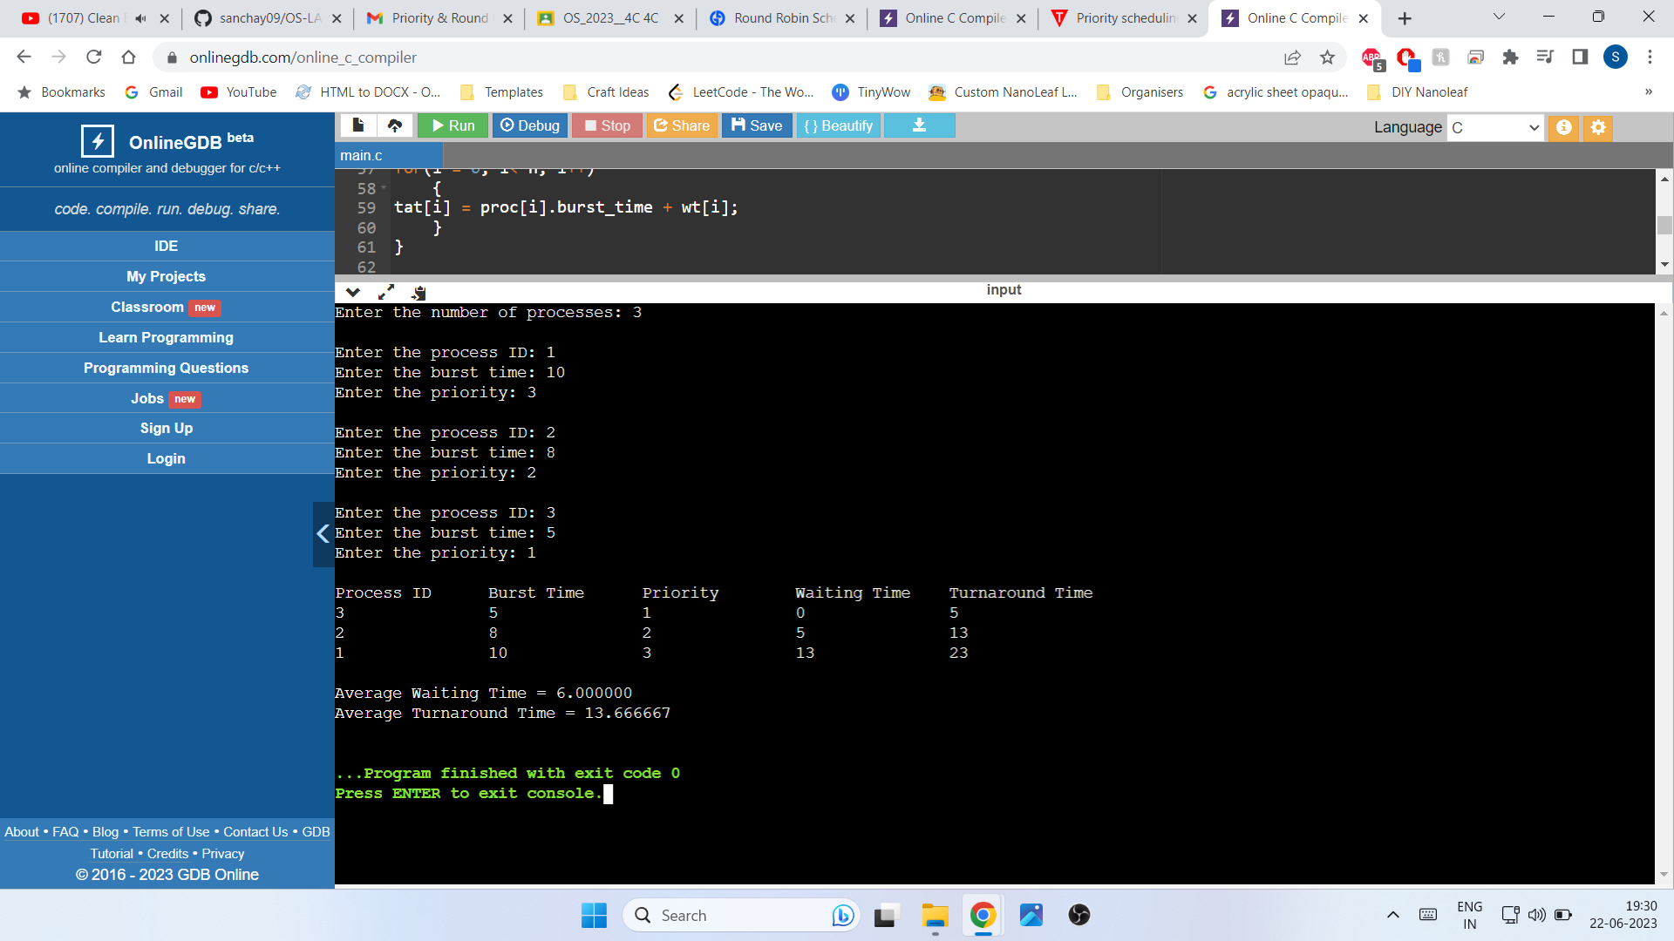

1. **Round Robin (Non-pre-emptive)**

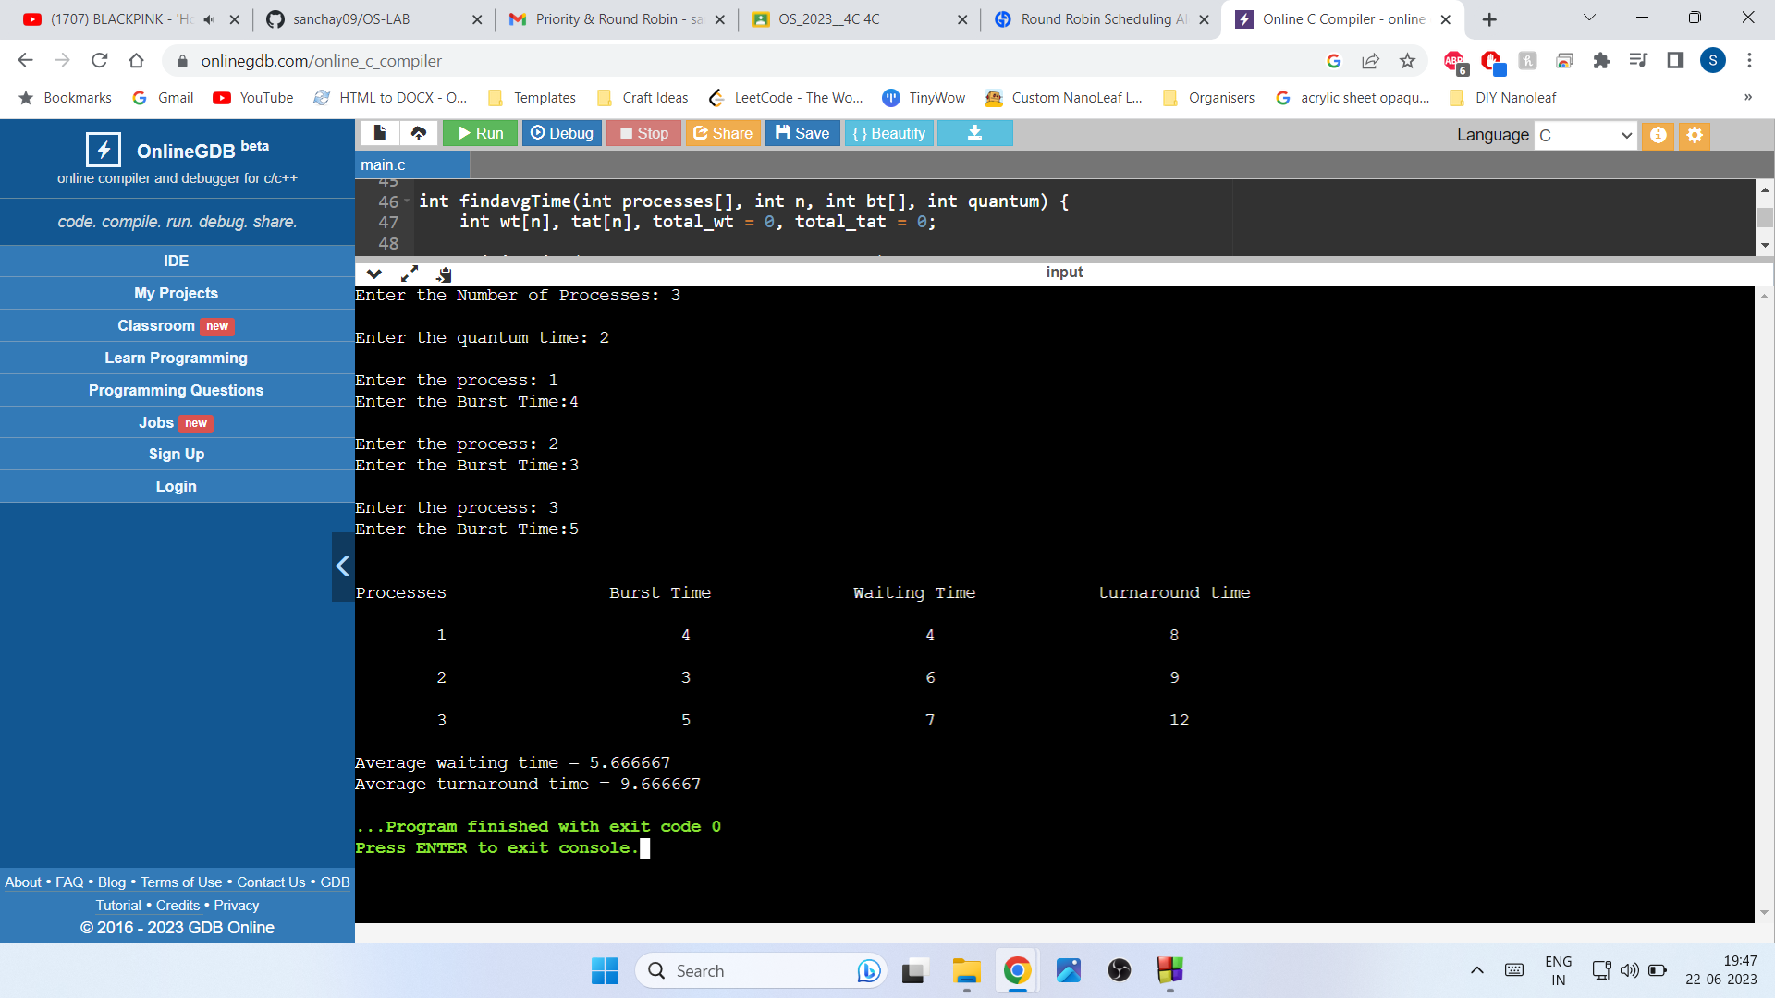

* 1. **Experiment - 3**
     1. **Question:**

Write a C program to simulate multi-level queue scheduling algorithm considering the following scenario. All the processes in the system are divided into two categories – system processes and user processes. System processes are to be given higher priority than user processes. Use FCFS scheduling for the processes in each queue.

* + 1. **Code:**

#include <stdio.h>

#include <stdlib.h>

struct process {

int pid;

int arrival_time;

int burst_time;

int priority;

int waiting_time;

int turnaround_time;

};

void FCFS(struct process *queue, int n) {

int i, j;

struct process temp;

for (i = 0; i < n; i++) {

for (j = i + 1; j < n; j++) {

if (queue[i].arrival_time > queue[j].arrival_time) {

temp = queue[i];

queue[i] = queue[j];

queue[j] = temp;

}

}

}

}

int main() {

int n, i;

struct process *system_queue, *user_queue;

int system_n = 0, user_n = 0;

float avg_waiting_time = 0, avg_turnaround_time = 0;

printf("Enter the number of processes: ");

scanf("%d", &n);

system_queue = (struct process *) malloc(n * sizeof(struct process));

user_queue = (struct process *) malloc(n * sizeof(struct process));

for (i = 0; i < n; i++) {

struct process p;

printf("Enter arrival time, burst time, and priority (0-System/1-User) for process %d: ", i + 1);

scanf("%d %d %d", &p.arrival_time, &p.burst_time, &p.priority);

p.pid = i + 1;

p.waiting_time = 0;

p.turnaround_time = 0;

if (p.priority == 0) {

system_queue[system_n++] = p;

} else {

user_queue[user_n++] = p;

}

}

FCFS(system_queue, system_n);

FCFS(user_queue, user_n);

int time = 0;

int s=0,u=0;

while(s<system_n || u<user_n){

if(system_queue[s].arrival_time <= time){

if(user_queue[u].arrival_time <= time && user_queue[u].arrival_time < system_queue[s].arrival_time){

user_queue[u].waiting_time = time - user_queue[u].arrival_time;

time += user_queue[u].burst_time;

user_queue[u].turnaround_time = user_queue[u].waiting_time + user_queue[u].burst_time;

avg_waiting_time += user_queue[u].waiting_time;

avg_turnaround_time += user_queue[u].turnaround_time;

u++;

}

else{

system_queue[s].waiting_time = time - system_queue[s].arrival_time;

time += system_queue[s].burst_time;

system_queue[s].turnaround_time = system_queue[s].waiting_time + system_queue[s].burst_time;

avg_waiting_time += system_queue[s].waiting_time;

avg_turnaround_time += system_queue[s].turnaround_time;

s++;

}

}

else if(user_queue[u].arrival_time <= time){

user_queue[u].waiting_time = time - user_queue[u].arrival_time;

time += user_queue[u].burst_time;

user_queue[u].turnaround_time = user_queue[u].waiting_time + user_queue[u].burst_time;

avg_waiting_time += user_queue[u].waiting_time;

avg_turnaround_time += user_queue[u].turnaround_time;

u++;

}

else{

if(system_queue[s].arrival_time <= user_queue[u].arrival_time){

time = system_queue[s].arrival_time;

}

else{

time = user_queue[u].arrival_time;

}

}

}

avg_waiting_time /= n;

avg_turnaround_time /= n;

printf("PID\tBurst Time\tPriority\tQueue Type\tWaiting Time\tTurnaround Time\n");

for (i = 0; i < system_n; i++) {

printf("%d\t%d\t\t%d\t\tSystem\t\t%d\t\t%d\n", system_queue[i].pid, system_queue[i].burst_time, system_queue[i].priority, system_queue[i].waiting_time, system_queue[i].turnaround_time);

}

for (i = 0; i < user_n; i++) {

printf("%d\t%d\t\t%d\t\tUser\t\t%d\t\t%d\n", user_queue[i].pid, user_queue[i].burst_time, user_queue[i].priority, user_queue[i].waiting_time, user_queue[i].turnaround_time);

}

printf("Average Waiting Time: %.2f\n", avg_waiting_time);

printf("Average Turnaround Time: %.2f\n", avg_turnaround_time);

free(system_queue);

free(user_queue);

return 0;

}

**2.3.3 Output:**

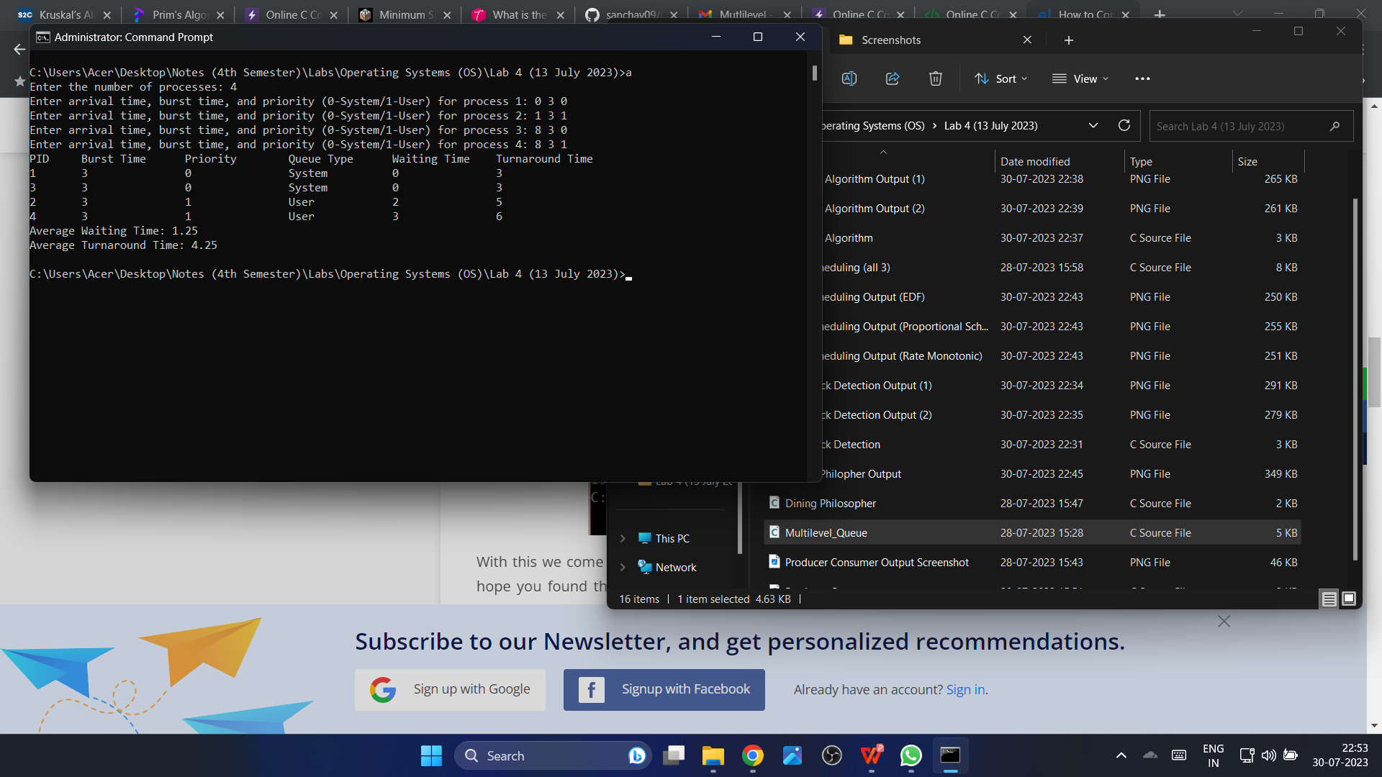

* 1. **Experiment - 4**
     1. **Question:**

Write a C program to simulate Real-Time CPU Scheduling algorithms:

1. Rate- Monotonic
2. Earliest-deadline First
3. Proportional scheduling
   * 1. **Code:**

#include <stdio.h>

#include <stdlib.h>

#include <math.h>

#include <stdbool.h>

#define MAX_PROCESS 10

typedef struct {

int id;

int burst_time;

float priority;

} Task;

int num_of_process;

int execution_time[MAX_PROCESS], period[MAX_PROCESS], remain_time[MAX_PROCESS], deadline[MAX_PROCESS], remain_deadline[MAX_PROCESS];

void get_process_info(int selected_algo)

{

printf("Enter total number of processes (maximum %d): ", MAX_PROCESS);

scanf("%d", &num_of_process);

if (num_of_process < 1)

{

exit(0);

}

for (int i = 0; i < num_of_process; i++)

{

printf("\nProcess %d:\n", i + 1);

printf("==> Execution time: ");

scanf("%d", &execution_time[i]);

remain_time[i] = execution_time[i];

if (selected_algo == 2)

{

printf("==> Deadline: ");

scanf("%d", &deadline[i]);

}

else

{

printf("==> Period: ");

scanf("%d", &period[i]);

}

}

}

int max(int a, int b, int c)

{

int max;

if (a >= b && a >= c)

max = a;

else if (b >= a && b >= c)

max = b;

else if (c >= a && c >= b)

max = c;

return max;

}

int get_observation_time(int selected_algo)

{

if (selected_algo == 1)

{

return max(period[0], period[1], period[2]);

}

else if (selected_algo == 2)

{

return max(deadline[0], deadline[1], deadline[2]);

}

}

void print_schedule(int process_list[], int cycles)

{

printf("\nScheduling:\n\n");

printf("Time: ");

for (int i = 0; i < cycles; i++)

{

if (i < 10)

printf("| 0%d ", i);

else

printf("| %d ", i);

}

printf("|\n");

for (int i = 0; i < num_of_process; i++)

{

printf("P[%d]: ", i + 1);

for (int j = 0; j < cycles; j++)

{

if (process_list[j] == i + 1)

printf("|####");

else

printf("| ");

}

printf("|\n");

}

}

void rate_monotonic(int time)

{

int process_list[100] = {0}, min = 999, next_process = 0;

float utilization = 0;

for (int i = 0; i < num_of_process; i++)

{

utilization += (1.0 * execution_time[i]) / period[i];

}

int n = num_of_process;

int m = (float) (n * (pow(2, 1.0 / n) - 1));

if (utilization > m)

{

printf("\nGiven problem is not schedulable under the said scheduling algorithm.\n");

}

for (int i = 0; i < time; i++)

{

min = 1000;

for (int j = 0; j < num_of_process; j++)

{

if (remain_time[j] > 0)

{

if (min > period[j])

{

min = period[j];

next_process = j;

}

}

}

if (remain_time[next_process] > 0)

{

process_list[i] = next_process + 1;

remain_time[next_process] -= 1;

}

for (int k = 0; k < num_of_process; k++)

{

if ((i + 1) % period[k] == 0)

{

remain_time[k] = execution_time[k];

next_process = k;

}

}

}

print_schedule(process_list, time);

}

void earliest_deadline_first(int time){

float utilization = 0;

for (int i = 0; i < num_of_process; i++){

utilization += (1.0*execution_time[i])/deadline[i];

}

int n = num_of_process;

int process[num_of_process];

int max_deadline, current_process=0, min_deadline,process_list[time];

bool is_ready[num_of_process];

for(int i=0; i<num_of_process; i++){

is_ready[i] = true;

process[i] = i+1;

}

max_deadline=deadline[0];

for(int i=1; i<num_of_process; i++){

if(deadline[i] > max_deadline)

max_deadline = deadline[i];

}

for(int i=0; i<num_of_process; i++){

for(int j=i+1; j<num_of_process; j++){

if(deadline[j] < deadline[i]){

int temp = execution_time[j];

execution_time[j] = execution_time[i];

execution_time[i] = temp;

temp = deadline[j];

deadline[j] = deadline[i];

deadline[i] = temp;

temp = process[j];

process[j] = process[i];

process[i] = temp;

}

}

}

for(int i=0; i<num_of_process; i++){

remain_time[i] = execution_time[i];

remain_deadline[i] = deadline[i];

}

for (int t = 0; t < time; t++){

if(current_process != -1){

--execution_time[current_process];

process_list[t] = process[current_process];

}

else

process_list[t] = 0;

for(int i=0;i<num_of_process;i++){

--deadline[i];

if((execution_time[i] == 0) && is_ready[i]){

deadline[i] += remain_deadline[i];

is_ready[i] = false;

}

if((deadline[i] <= remain_deadline[i]) && (is_ready[i] == false)){

execution_time[i] = remain_time[i];

is_ready[i] = true;

}

}

min_deadline = max_deadline;

current_process = -1;

for(int i=0;i<num_of_process;i++){

if((deadline[i] <= min_deadline) && (execution_time[i] > 0)){

current_process = i;

min_deadline = deadline[i];

}

}

}

print_schedule(process_list, time);

}

void proportionalScheduling() {

int n;

printf("Enter the number of tasks: ");

scanf("%d", &n);

Task tasks[n];

printf("Enter burst time and priority for each task:\n");

for (int i = 0; i < n; i++) {

tasks[i].id = i + 1;

printf("Task %d - Burst Time: ", tasks[i].id);

scanf("%d", &tasks[i].burst_time);

printf("Task %d - Priority: ", tasks[i].id);

scanf("%f", &tasks[i].priority);

}

// Sort tasks based on priority (ascending order)

for (int i = 0; i < n - 1; i++) {

for (int j = 0; j < n - i - 1; j++) {

if (tasks[j].priority > tasks[j + 1].priority) {

// Swap tasks

Task temp = tasks[j];

tasks[j] = tasks[j + 1];

tasks[j + 1] = temp;

}

}

}

printf("\nProportional Scheduling:\n");

int total_burst_time = 0;

float total_priority = 0.0;

for (int i = 0; i < n; i++) {

total_burst_time += tasks[i].burst_time;

total_priority += tasks[i].priority;

}

for (int i = 0; i < n; i++) {

float time_slice = (tasks[i].priority / total_priority) * total_burst_time;

printf("Task %d executes for %.2f units of time\n", tasks[i].id, time_slice);

}

}

int main()

{

int option;

int observation_time;

while (1)

{

printf("\n1. Rate Monotonic\n2. Earliest Deadline first\n3. Proportional Scheduling\n\nEnter your choice: ");

scanf("%d", &option);

switch(option)

{

case 1: get_process_info(option);

observation_time = get_observation_time(option);

rate_monotonic(observation_time);

break;

case 2: get_process_info(option);

observation_time = get_observation_time(option);

earliest_deadline_first(observation_time);

break;

case 3: proportionalScheduling();

break;

case 4: exit (0);

default: printf("\nInvalid Statement");

}

}

return 0;

}

* + 1. **Output:**

1. **Rate Monotonic:**

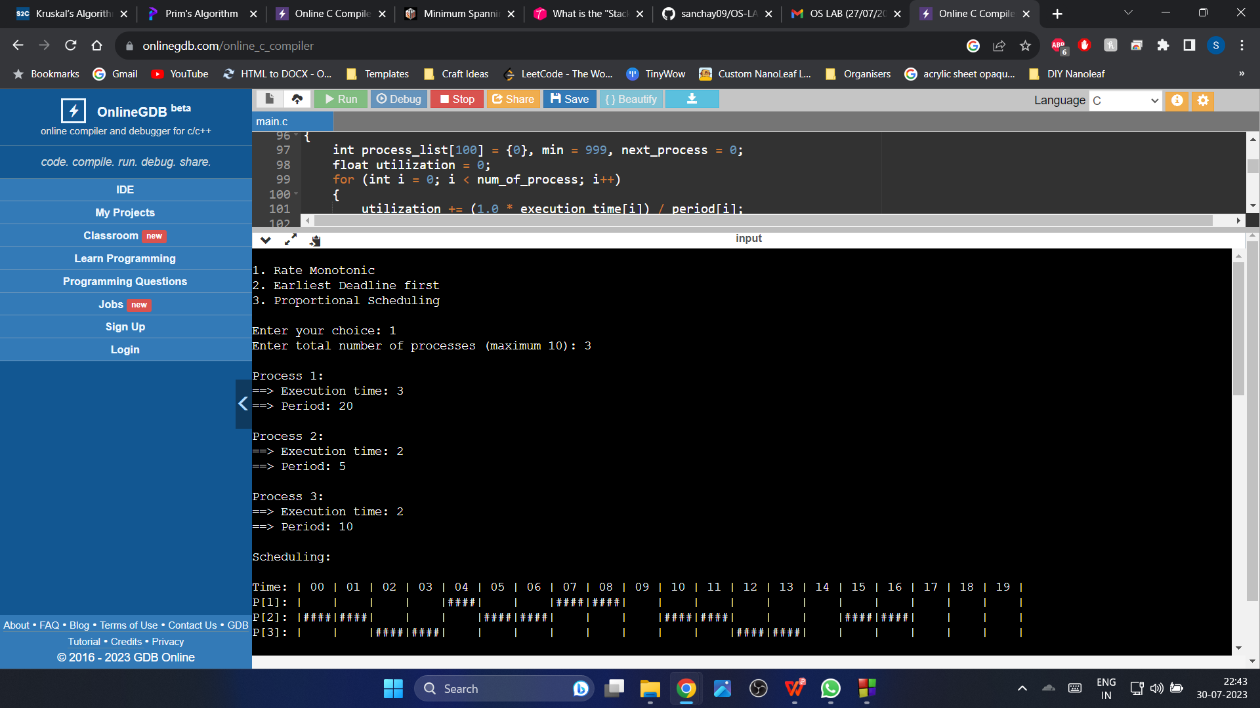

1. **Earliest Deadline First:**

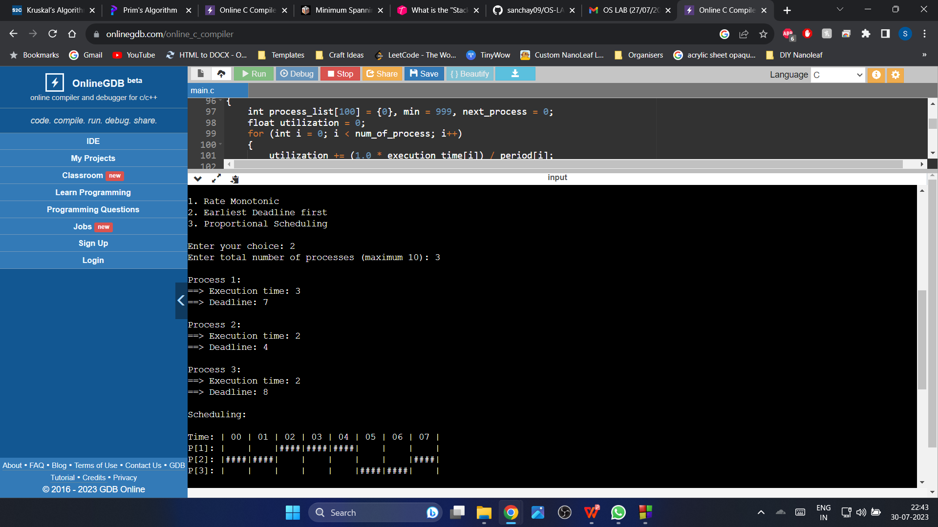

**(c) Proportional Scheduling:**

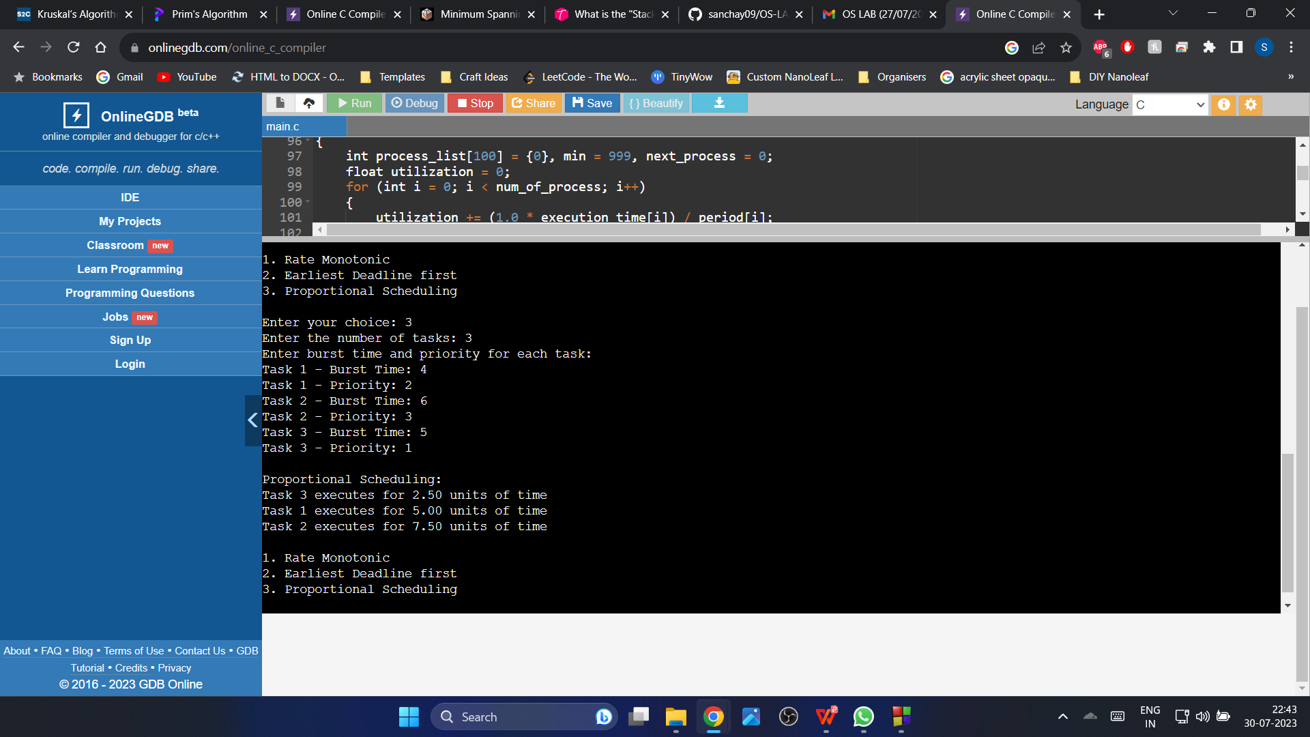

* 1. **Experiment - 5**
     1. **Question:**

Write a C program to simulate producer-consumer problem using semaphores.

* + 1. **Code**:

#include<stdio.h>

#include<stdlib.h>

int mutex=1,full=0,empty=3,x=0;

int main()

{

int n;

void producer();

void consumer();

int wait(int);

int signal(int);

printf("\n1.Producer\n2.Consumer\n3.Exit");

while(1)

{

printf("\nEnter your choice: ");

scanf("%d&",&n);

switch(n)

{

case 1: if((mutex==1)&&(empty!=0))

producer();

else

printf("Buffer is full!!");

break;

case 2: if((mutex==1)&&(full!=0))

consumer();

else

printf("Buffer is empty!!");

break;

case 3: exit(0);

break;

}

}

return 0;

}

int wait(int s)

{

return (--s);

}

int signal(int s)

{

return(++s);

}

void producer()

{

mutex=wait(mutex);

full=signal(full);

empty=wait(empty);

x++;

printf("\nProducer produces the item %d",x);

mutex=signal(mutex);

}

void consumer()

{

mutex=wait(mutex);

full=wait(full);

empty=signal(empty);

printf("\nConsumer consumes item %d",x);

x--;

mutex=signal(mutex);

}

**2.5.3 Output:**

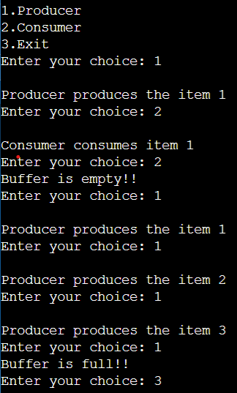

* 1. **Experiment - 6**
     1. **Question:**

Write a C program to simulate the concept of Dining-Philosophers problem.

* + 1. **Code**:

#include <stdio.h>

#include <pthread.h>

#include <semaphore.h>

#define N 5

#define THINKING 2

#define HUNGRY 1

#define EATING 0

#define LEFT (num_of_philosopher + 4) % N

#define RIGHT (num_of_philosopher + 1) % N

int state[N];

int phil[N] = {0,1,2,3,4};

sem_t mutex;

sem_t S[N];

void test(int num_of_philosopher)

{

if (state[num_of_philosopher] == HUNGRY && state[LEFT] != EATING && state[RIGHT] != EATING)

{

state[num_of_philosopher] = EATING;

sleep(2);

printf("Philosopher %d takes fork %d and %d\n", num_of_philosopher +1, LEFT +1, num_of_philosopher +1);

printf("Philosopher %d is Eating\n", num_of_philosopher +1);

sem_post(&S[num_of_philosopher]);

}

}

void take_fork(int num_of_philosopher)

{

sem_wait(&mutex);

state[num_of_philosopher] = HUNGRY;

printf("Philosopher %d is Hungry\n", num_of_philosopher +1);

test(num_of_philosopher);

sem_post(&mutex);

sem_wait(&S[num_of_philosopher]);

sleep(1);

}

void put_fork(int num_of_philosopher)

{

sem_wait(&mutex);

state[num_of_philosopher] = THINKING;

printf("Philosopher %d putting fork %d and %d down\n",num_of_philosopher +1, LEFT +1, num_of_philosopher +1);

printf("Philosopher %d is thinking\n", num_of_philosopher +1);

test(LEFT);

test(RIGHT);

sem_post(&mutex);

}

void* philosopher(void* num)

{

while (1)

{

int* i = num;

sleep(1);

take_fork(*i);

sleep(0);

put_fork(*i);

}

}

int main()

{

int i;

pthread_t thread_id[N];

sem_init(&mutex,0,1);

for (i =0; i < N; i++)

sem_init(&S[i],0,0);

for (i =0; i < N; i++)

{

pthread_create(&thread_id[i],NULL,philosopher, &phil[i]);

printf("Philosopher %d is thinking\n", i +1);

}

for (i =0; i < N; i++)

{

pthread_join(thread_id[i],NULL);

}

}

* + 1. **Output:**

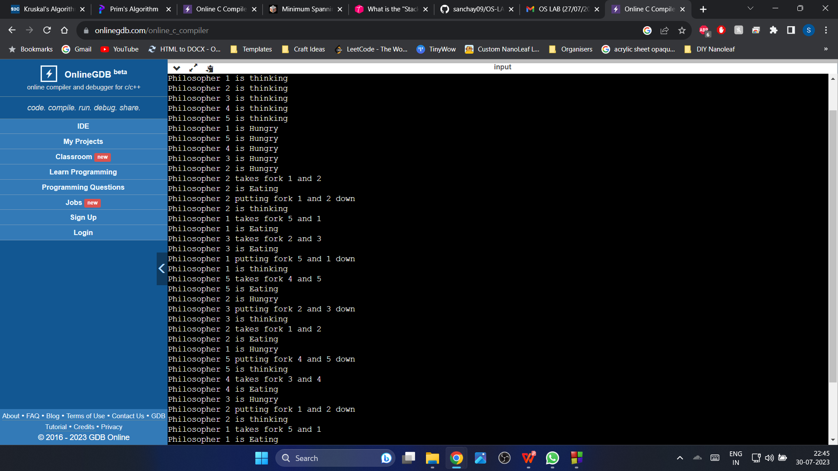

* 1. **Experiment - 7**
     1. **Question:**

Write a C program to simulate Bankers algorithm for the purpose of deadlock avoidance.

* + 1. **Code**:

#include <stdio.h>

int main()

{

int n, m, i, j, k;

printf("Enter the number of processes: ");

scanf("%d", &n);

printf("Enter the number of resources: ");

scanf("%d", &m);

int allocation[n][m];

printf("Enter the Allocation Matrix:\n");

for (i = 0; i < n; i++)

{

for (j = 0; j < m; j++)

{

scanf("%d", &allocation[i][j]);

}

}

int max[n][m];

printf("Enter the MAX Matrix:\n");

for (i = 0; i < n; i++)

{

for (j = 0; j < m; j++)

{

scanf("%d", &max[i][j]);

}

}

int available[m];

printf("Enter the Available Resources:\n");

for (i = 0; i < m; i++)

{

scanf("%d", &available[i]);

}

int f[n], ans[n], ind = 0;

for (k = 0; k < n; k++)

{

f[k] = 0;

}

int need[n][m];

for (i = 0; i < n; i++)

{

for (j = 0; j < m; j++)

{

need[i][j] = max[i][j] - allocation[i][j];

}

}

int y = 0;

for (k = 0; k < n; k++)

{

for (i = 0; i < n; i++)

{

if (f[i] == 0)

{

int flag = 0;

for (j = 0; j < m; j++)

{

if (need[i][j] > available[j])

{

flag = 1;

break;

}

}

if (flag == 0)

{

ans[ind++] = i;

for (y = 0; y < m; y++)

{

available[y] += allocation[i][y];

}

f[i] = 1;

}

}

}

}

int flag = 1;

for (i = 0; i < n; i++)

{

if (f[i] == 0)

{

flag = 0;

printf("The following system is not safe\n");

break;

}

}

if (flag == 1)

{

printf("Following is the SAFE Sequence\n");

for (i = 0; i < n - 1; i++)

{

printf(" P%d ->", ans[i]);

}

printf(" P%d\n", ans[n - 1]);

}

return 0;

}

* + 1. **Output:**

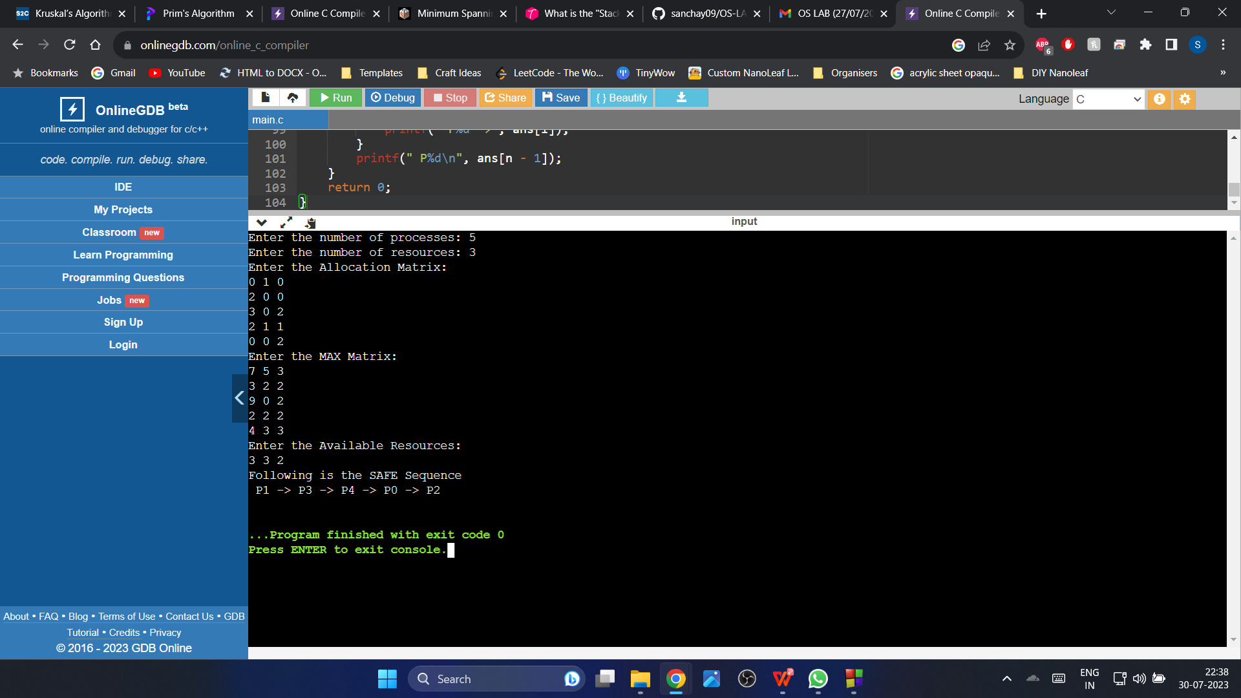

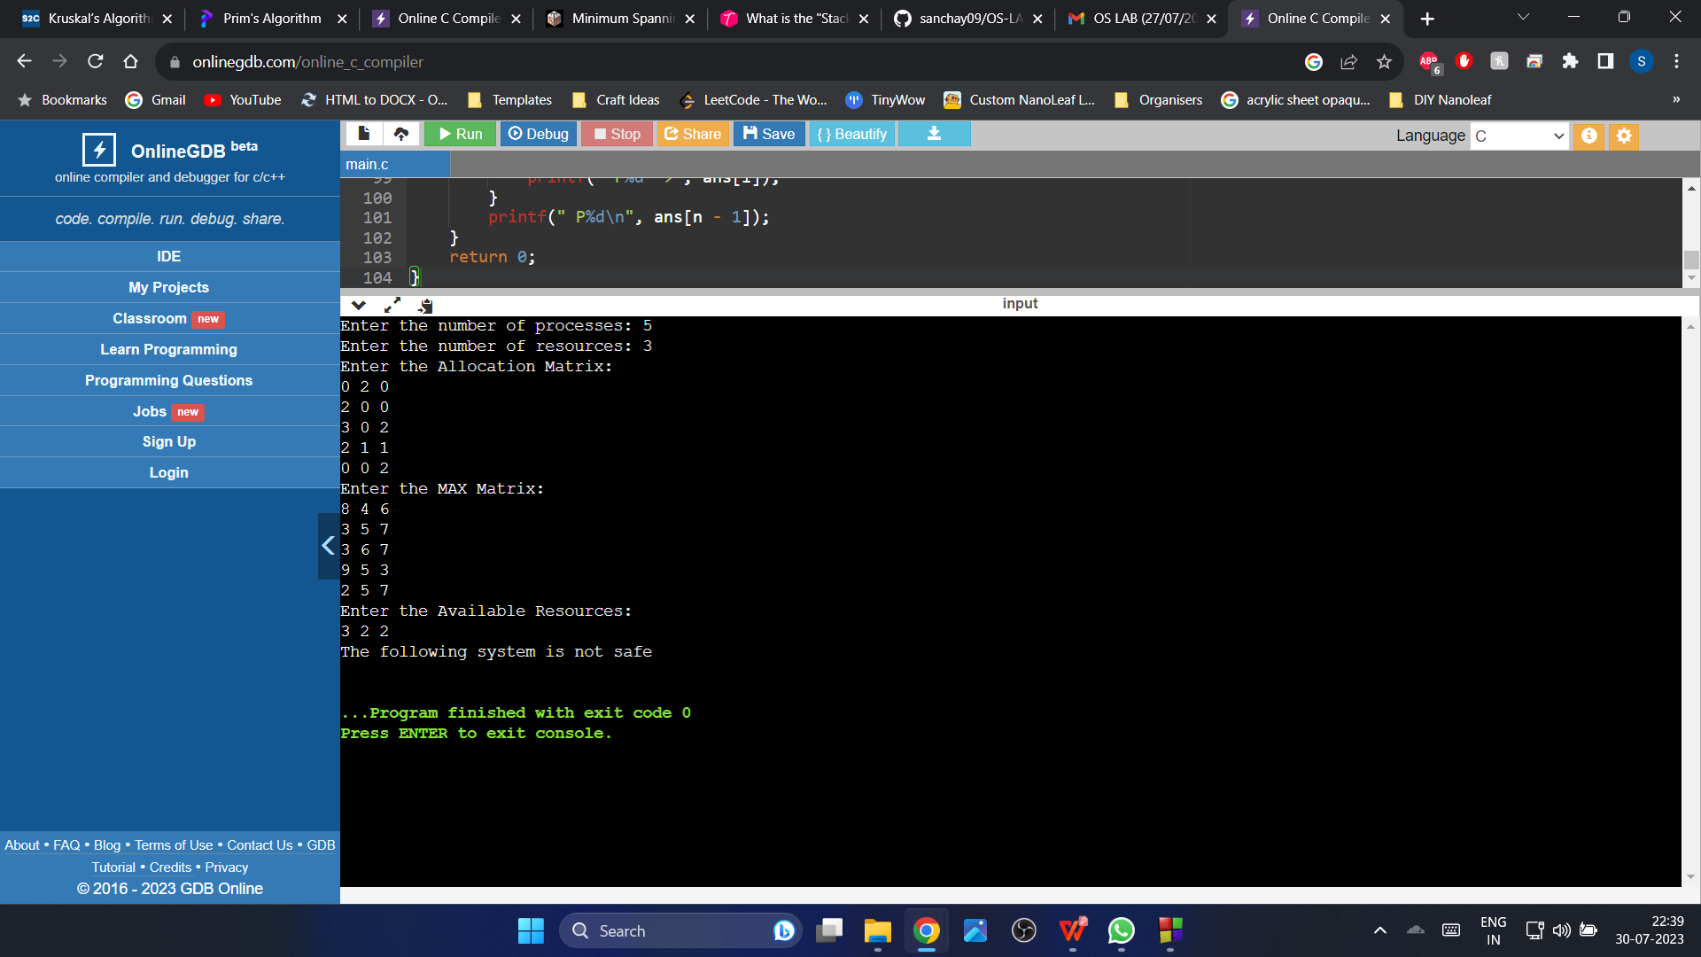

* 1. **\Experiment - 8**
     1. **Question:**

Write a C program to simulate deadlock detection.

* + 1. **Code**:

#include<stdio.h>

int max[100][100];

int allocation[100][100];

int need[100][100];

int available[100];

int n,r;

int main()

{

int i,j;

printf("Deadlock Detection\n");

input();

show();

cal();

return 0;

}

void input()

{

int i,j;

printf("Enter the no of Processes: ");

scanf("%d",&n);

printf("Enter the no of resource instances: ");

scanf("%d",&r);

printf("Enter the Max Matrix:\n");

for(i=0;i<n;i++)

{

for(j=0;j<r;j++)

{

scanf("%d",&max[i][j]);

}

}

printf("Enter the Allocation Matrix:\n");

for(i=0;i<n;i++)

{

for(j=0;j<r;j++)

{

scanf("%d",&allocation[i][j]);

}

}

printf("Enter the available Resources:\n");

for(j=0;j<r;j++)

{

scanf("%d",&available[j]);

}

}

void show()

{

int i,j;

printf("Process\t Allocation\t Max\t Available\t");

for(i=0;i<n;i++)

{

printf("\nP%d\t ",i+1);

for(j=0;j<r;j++)

{

printf("%d ",allocation[i][j]);

}

printf("\t");

for(j=0;j<r;j++)

{

printf("%d ",max[i][j]);

}

printf("\t");

if(i==0)

{

for(j=0;j<r;j++)

printf("%d ",available[j]);

}

}

}

void cal()

{

int finish[100],temp,need[100][100],flag=1,k,c1=0;

int dead[100];

int safe[100];

int i,j;

for(i=0;i<n;i++)

{

finish[i]=0;

}

for(i=0;i<n;i++)

{

for(j=0;j<r;j++)

{

need[i][j]=max[i][j]-allocation[i][j];

}

}

while(flag)

{

flag=0;

for(i=0;i<n;i++)

{

int c=0;

for(j=0;j<r;j++)

{

if((finish[i]==0)&&(need[i][j]<=available[j]))

{

c++;

if(c==r)

{

for(k=0;k<r;k++)

{

available[k]+=allocation[i][j];

finish[i]=1;

flag=1;

}

if(finish[i]==1)

{

i=n;

}

}

}

}

}

}

j=0;

flag=0;

for(i=0;i<n;i++)

{

if(finish[i]==0)

{

dead[j]=i;

j++;

flag=1;

}

}

if(flag==1)

{

printf("\n\nSystem is in Deadlock and the Deadlock process are\n");

for(i=0;i<n;i++)

{

printf("P%d\t",dead[i]);

}

}

else

{

printf("\nNo Deadlock Occur");

}

}

**2.8.3 Output:**

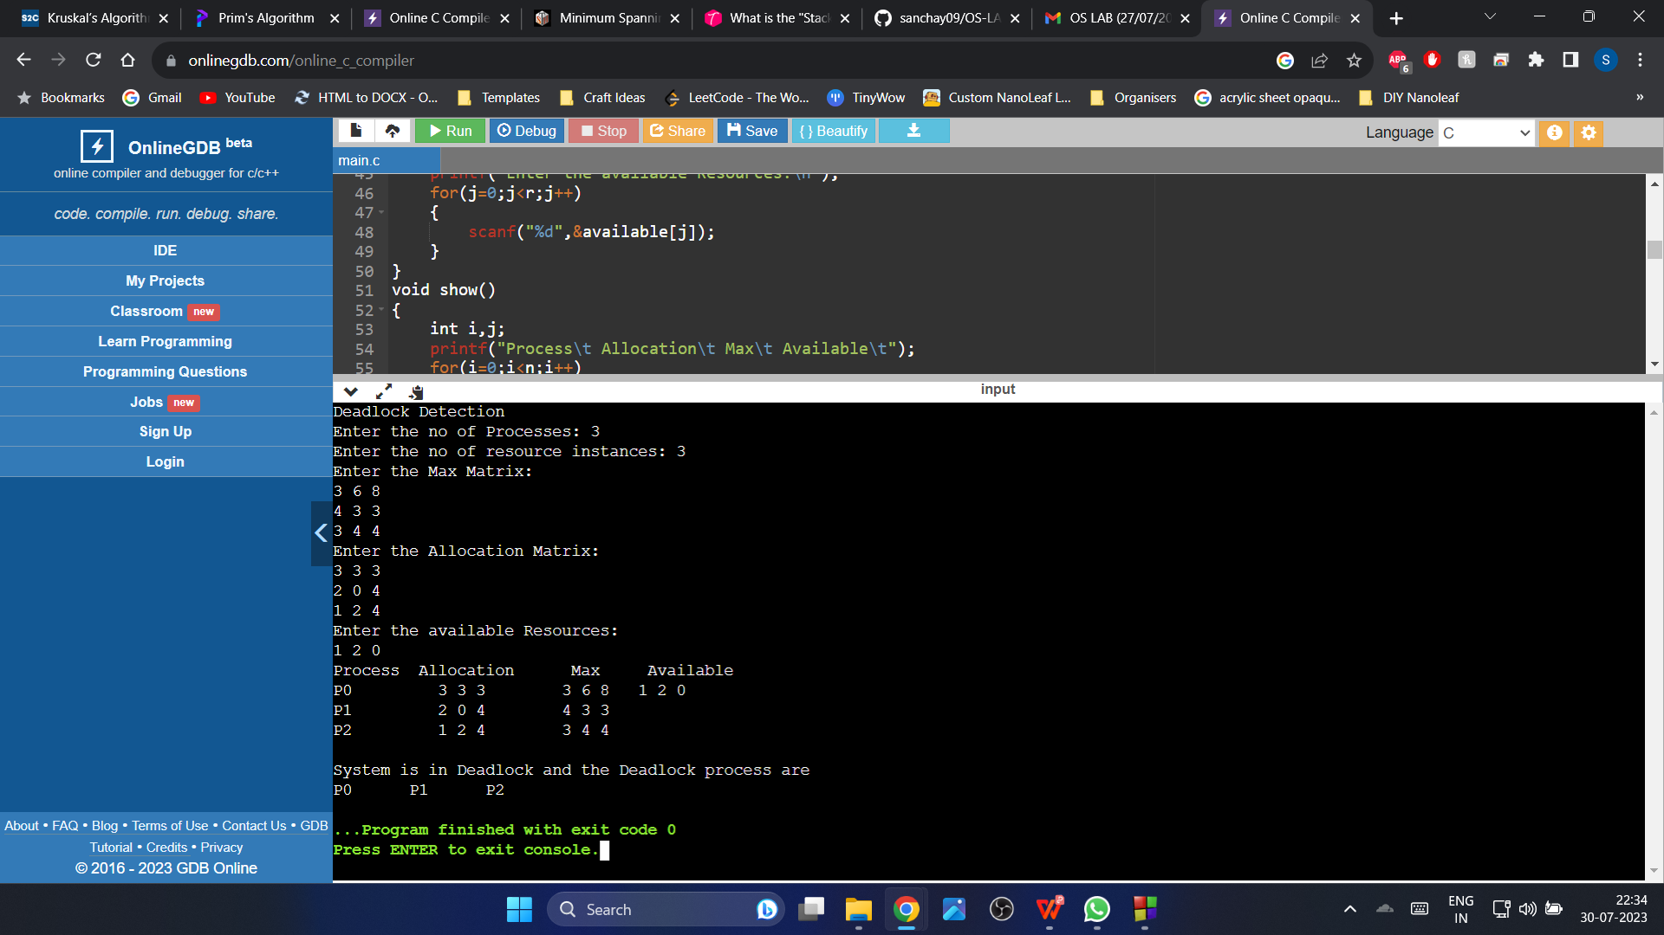

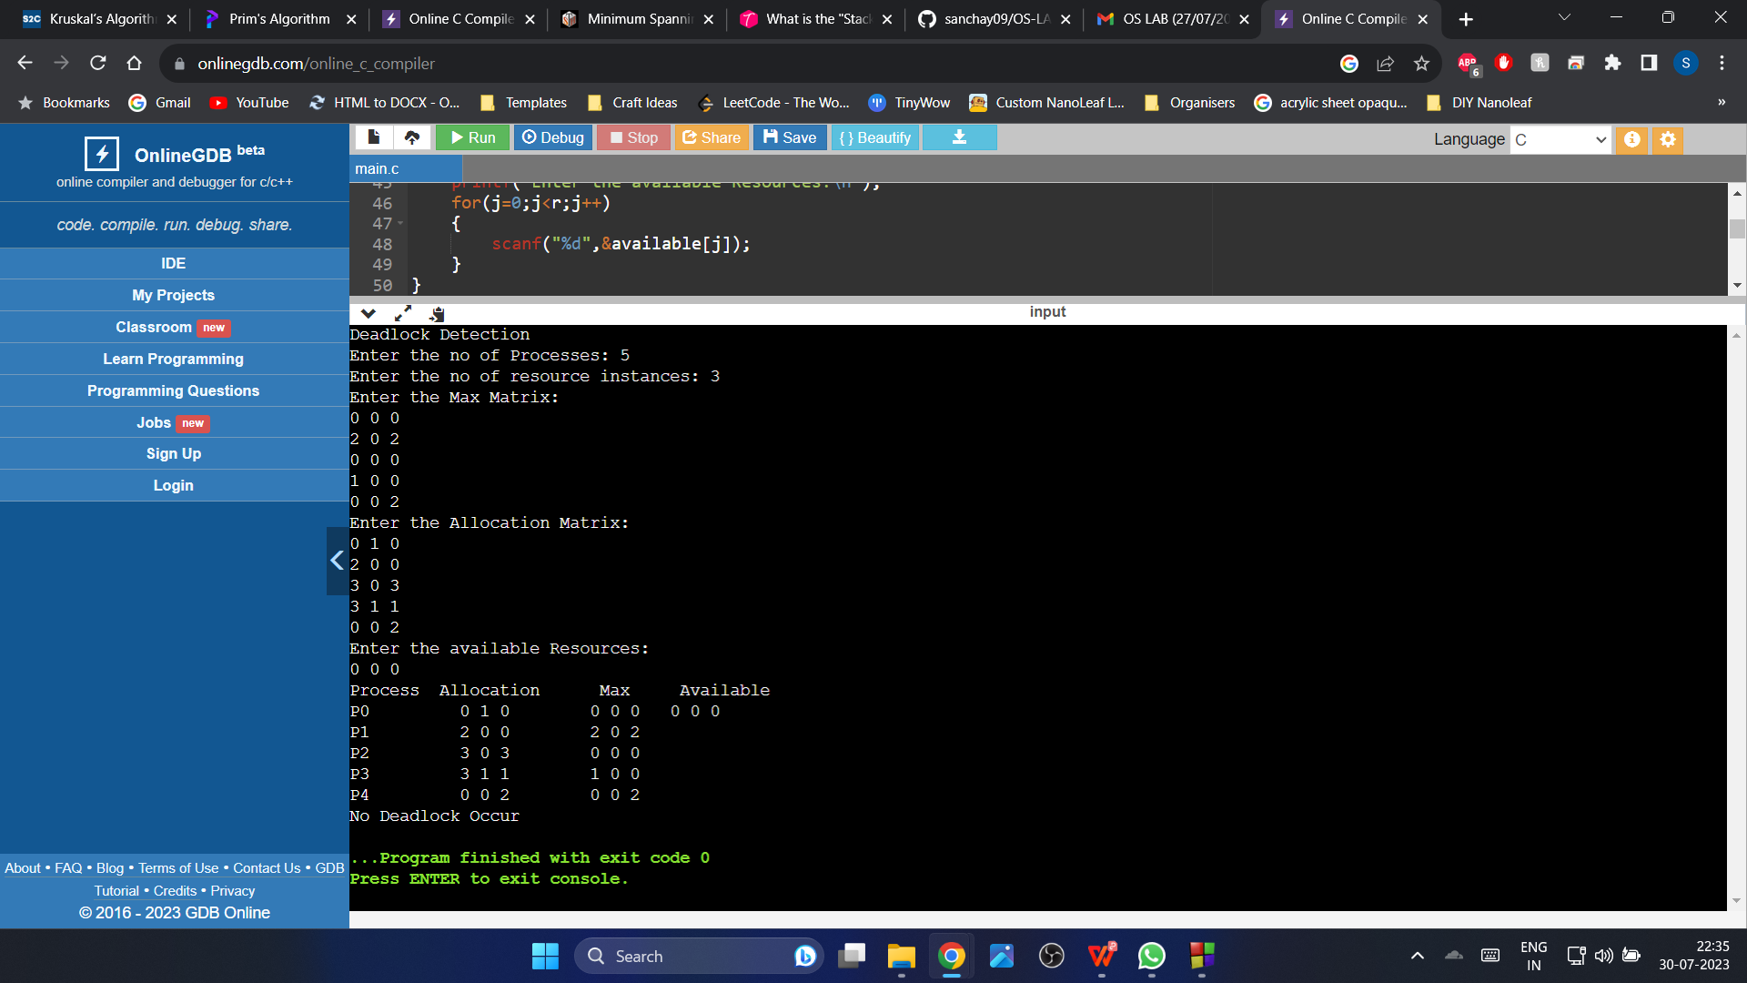

* 1. **Experiment - 9**
     1. **Question:**

Write a C program to simulate the following contiguous memory allocation techniques:

1. Worst-fit
2. Best-fit

**(c)** First-fit

* + 1. **Code**:

#include <stdio.h>

#define max 25

void firstFit(int b[], int nb, int f[], int nf);

void worstFit(int b[], int nb, int f[], int nf);

void bestFit(int b[], int nb, int f[], int nf);

int main()

{

int b[max], f[max], nb, nf;

printf("Memory Management Schemes\n");

printf("\nEnter the number of blocks:");

scanf("%d", &nb);

printf("Enter the number of files:");

scanf("%d", &nf);

printf("\nEnter the size of the blocks:\n");

for (int i = 1; i <= nb; i++)

{

printf("Block %d:", i);

scanf("%d", &b[i]);

}

printf("\nEnter the size of the files:\n");

for (int i = 1; i <= nf; i++)

{

printf("File %d:", i);

scanf("%d", &f[i]);

}

printf("\nMemory Management Scheme - First Fit");

firstFit(b, nb, f, nf);

printf("\n\nMemory Management Scheme - Worst Fit");

worstFit(b, nb, f, nf);

printf("\n\nMemory Management Scheme - Best Fit");

bestFit(b, nb, f, nf);

return 0;

}

void firstFit(int b[], int nb, int f[], int nf)

{

int bf[max] = {0};

int ff[max] = {0};

int frag[max], i, j;

for (i = 1; i <= nf; i++)

{

for (j = 1; j <= nb; j++)

{

if (bf[j] != 1 && b[j] >= f[i])

{

ff[i] = j;

bf[j] = 1;

frag[i] = b[j] - f[i];

break;

}

}

}

printf("\nFile_no:\tFile_size:\tBlock_no:\tBlock_size:\tFragment");

for (i = 1; i <= nf; i++)

{

printf("\n%d\t\t%d\t\t%d\t\t%d\t\t%d", i, f[i], ff[i], b[ff[i]], frag[i]);

}

}

void worstFit(int b[], int nb, int f[], int nf)

{

int bf[max] = {0};

int ff[max] = {0};

int frag[max], i, j, temp, highest = 0;

for (i = 1; i <= nf; i++)

{

for (j = 1; j <= nb; j++)

{

if (bf[j] != 1)

{

temp = b[j] - f[i];

if (temp >= 0 && highest < temp)

{

ff[i] = j;

highest = temp;

}

}

}

frag[i] = highest;

bf[ff[i]] = 1;

highest = 0;

}

printf("\nFile_no:\tFile_size:\tBlock_no:\tBlock_size:\tFragment");

for (i = 1; i <= nf; i++)

{

printf("\n%d\t\t%d\t\t%d\t\t%d\t\t%d", i, f[i], ff[i], b[ff[i]], frag[i]);

}

}

void bestFit(int b[], int nb, int f[], int nf)

{

int bf[max] = {0};

int ff[max] = {0};

int frag[max], i, j, temp, lowest = 10000;

for (i = 1; i <= nf; i++)

{

for (j = 1; j <= nb; j++)

{

if (bf[j] != 1)

{

temp = b[j] - f[i];

if (temp >= 0 && lowest > temp)

{

ff[i] = j;

lowest = temp;

}

}

}

frag[i] = lowest;

bf[ff[i]] = 1;

lowest = 10000;

}

printf("\nFile_no:\tFile_size:\tBlock_no:\tBlock_size:\tFragment");

for (i = 1; i <= nf && ff[i] != 0; i++)

{

printf("\n%d\t\t%d\t\t%d\t\t%d\t\t%d", i, f[i], ff[i], b[ff[i]], frag[i]);

}

}

* + 1. **Output:**

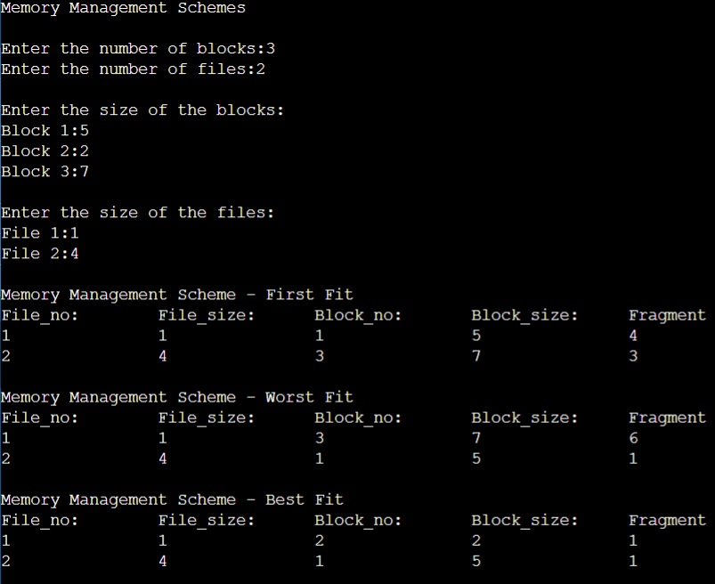

* 1. **Experiment - 10**
     1. **Question:**

Write a C program to simulate paging technique of memory management.

* + 1. **Code**:

#include<stdio.h>

#define MAX 50

int main()

{

int page[MAX],i,n,f,ps,off,pno;

int choice=0;

printf("Enter the number of pages in memory: ");

scanf("%d",&n);

printf("\nEnter Page size: ");

scanf("%d",&ps);

printf("\nEnter number of frames: ");

scanf("%d",&f);

for(i=0;i<n;i++)

page[i]=-1;

printf("\nEnter the Page Table\n");

printf("(Enter frame no as -1 if that page is not present in any frame)\n\n");

printf("\nPage No\t\tFrame No\n-------\t\t-------");

for(i=0;i<n;i++)

{

printf("\n\n%d\t\t",i);

scanf("%d",&page[i]);

}

do

{

printf("\n\nEnter the logical address(i.e,page no & offset):");

scanf("%d%d",&pno,&off);

if(page[pno]==-1)

printf("\n\nThe required page is not available in any of frames");

else

printf("\nPhysical address(i.e,frame no & offset):%d,%d",page[pno],off);

printf("\n\nDo you want to continue(1/0)?:");

scanf("%d",&choice);

}while(choice==1);

return 1;

}

* + 1. **Output:**

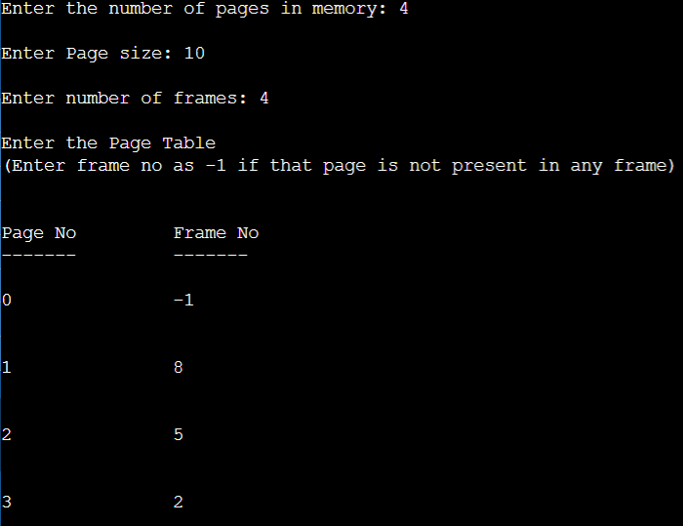

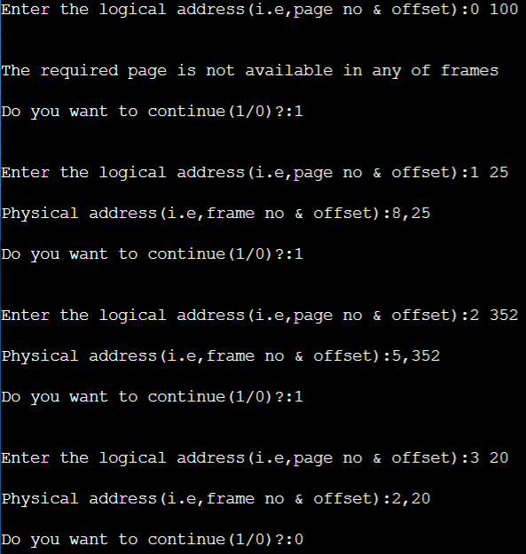

* 1. **Experiment - 11**
     1. **Question:**

Write a C program to simulate page replacement algorithms:

1. FIFO
2. LRU
3. Optimal
   * 1. **Code**:

#include<stdio.h>

int n, nf, i, j, k;

int in[100];

int p[50];

int hit=0;

int pgfaultcnt=0;

void getData()

{

printf("\nEnter length of page reference sequence:");

scanf("%d",&n);

printf("\nEnter the page reference sequence:");

for(i=0; i<n; i++)

scanf("%d",&in[i]);

printf("\nEnter no of frames:");

scanf("%d",&nf);

}

void initialize()

{

pgfaultcnt=0;

for(i=0; i<nf; i++)

p[i]=9999;

}

int isHit(int data)

{

hit=0;

for(j=0; j<nf; j++)

{

if(p[j]==data)

{

hit=1;

break;

}

}

return hit;

}

int getHitIndex(int data)

{

int hitind;

for(k=0; k<nf; k++)

{

if(p[k]==data)

{

hitind=k;

break;

}

}

return hitind;

}

void dispPages()

{

for (k=0; k<nf; k++)

{

if(p[k]!=9999)

printf(" %d",p[k]);

}

}

void dispPgFaultCnt()

{

printf("\nTotal no of page faults:%d",pgfaultcnt);

}

void fifo()

{

initialize();

for(i=0; i<n; i++)

{

printf("\nFor %d :",in[i]);

if(isHit(in[i])==0)

{

for(k=0; k<nf-1; k++)

p[k]=p[k+1];

p[k]=in[i];

pgfaultcnt++;

dispPages();

}

else

printf("No page fault");

}

dispPgFaultCnt();

}

void optimal()

{

initialize();

int near[50];

for(i=0; i<n; i++)

{

printf("\nFor %d :",in[i]);

if(isHit(in[i])==0)

{

for(j=0; j<nf; j++)

{

int pg=p[j];

int found=0;

for(k=i; k<n; k++)

{

if(pg==in[k])

{

near[j]=k;

found=1;

break;

}

else

found=0;

}

if(!found)

near[j]=9999;

}

int max=-9999;

int repindex;

for(j=0; j<nf; j++)

{

if(near[j]>max)

{

max=near[j];

repindex=j;

}

}

p[repindex]=in[i];

pgfaultcnt++;

dispPages();

}

else

printf("No page fault");

}

dispPgFaultCnt();

}

void lru()

{

initialize();

int least[50];

for(i=0; i<n; i++)

{

printf("\nFor %d :",in[i]);

if(isHit(in[i])==0)

{

for(j=0; j<nf; j++)

{

int pg=p[j];

int found=0;

for(k=i-1; k>=0; k--)

{

if(pg==in[k])

{

least[j]=k;

found=1;

break;

}

else

found=0;

}

if(!found)

least[j]=-9999;

}

int min=9999;

int repindex;

for(j=0; j<nf; j++)

{

if(least[j]<min)

{

min=least[j];

repindex=j;

}

}

p[repindex]=in[i];

pgfaultcnt++;

dispPages();

}

else

printf("No page fault!");

}

dispPgFaultCnt();

}

int main()

{

int choice;

while(1)

{

printf("\nPage Replacement Algorithms\n1.Enter data\n2.FIFO\n3.Optimal\n4.LRU\n5.Exit\nEnter your choice:");

scanf("%d",&choice);

switch(choice)

{

case 1: getData();

break;

case 2: fifo();

break;

case 3: optimal();

break;

case 4: lru();

break;

default: return 0;

break;

}

}

}

* + 1. **Output:**

1. **Enter Data:**

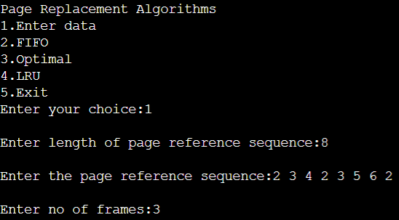

1. **FIFO:**

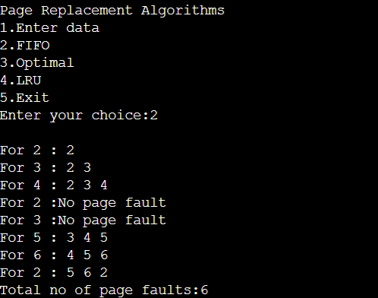

**(c) OPTIMAL:**

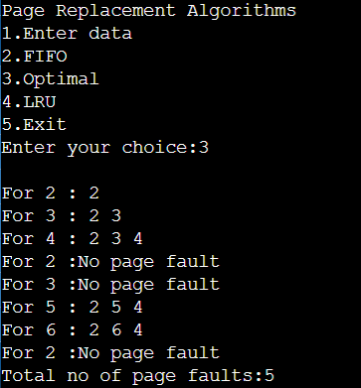

**(d) LRU:**

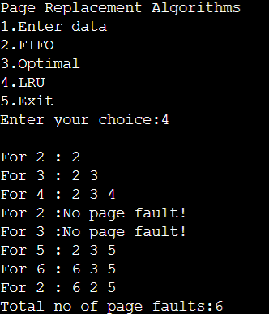

* 1. **Experiment - 12**
     1. **Question:**

Write a C program to simulate disk scheduling algorithms:

1. FCFS
2. SCAN
3. c-SCAN
   * 1. **Code**:
4. **FCFS:**

#include<stdio.h>

#include<stdlib.h>

int main()

{

int RQ[100],i,n,TotalHeadMoment=0,initial;

printf("Enter the number of Requests\n");

scanf("%d",&n);

printf("Enter the Requests sequence\n");

for(i=0;i<n;i++)

scanf("%d",&RQ[i]);

printf("Enter initial head position\n");

scanf("%d",&initial);

// logic for FCFS disk scheduling

for(i=0;i<n;i++)

{

TotalHeadMoment=TotalHeadMoment+abs(RQ[i]-initial);

initial=RQ[i];

}

printf("Total head moment is %d",TotalHeadMoment);

return 0;

}

1. **SCAN:**

#include<stdio.h>

#include<stdlib.h>

int main()

{

int RQ[100],i,j,n,TotalHeadMoment=0,initial,size,move;

printf("Enter the number of Requests\n");

scanf("%d",&n);

printf("Enter the Requests sequence\n");

for(i=0;i<n;i++)

scanf("%d",&RQ[i]);

printf("Enter initial head position\n");

scanf("%d",&initial);

printf("Enter total disk size\n");

scanf("%d",&size);

printf("Enter the head movement direction for high 1 and for low 0\n");

scanf("%d",&move);

// logic for Scan disk scheduling

/*logic for sort the request array */

for(i=0;i<n;i++)

{

for(j=0;j<n-i-1;j++)

{

if(RQ[j]>RQ[j+1])

{

int temp;

temp=RQ[j];

RQ[j]=RQ[j+1];

RQ[j+1]=temp;

}

}

}

int index;

for(i=0;i<n;i++)

{

if(initial<RQ[i])

{

index=i;

break;

}

}

// if movement is towards high value

if(move==1)

{

for(i=index;i<n;i++)

{

TotalHeadMoment=TotalHeadMoment+abs(RQ[i]-initial);

initial=RQ[i];

}

// last movement for max size

TotalHeadMoment=TotalHeadMoment+abs(size-RQ[i-1]-1);

initial = size-1;

for(i=index-1;i>=0;i--)

{

TotalHeadMoment=TotalHeadMoment+abs(RQ[i]-initial);

initial=RQ[i];

}

}

// if movement is towards low value

else

{

for(i=index-1;i>=0;i--)

{

TotalHeadMoment=TotalHeadMoment+abs(RQ[i]-initial);

initial=RQ[i];

}

// last movement for min size

TotalHeadMoment=TotalHeadMoment+abs(RQ[i+1]-0);

initial =0;

for(i=index;i<n;i++)

{

TotalHeadMoment=TotalHeadMoment+abs(RQ[i]-initial);

initial=RQ[i];

}

}

printf("Total head movement is %d",TotalHeadMoment);

return 0;

}

1. **c-SCAN:**

#include<stdio.h>

#include<stdlib.h>

int main()

{

int RQ[100],i,j,n,TotalHeadMoment=0,initial,size,move;

printf("Enter the number of Requests\n");

scanf("%d",&n);

printf("Enter the Requests sequence\n");

for(i=0;i<n;i++)

scanf("%d",&RQ[i]);

printf("Enter initial head position\n");

scanf("%d",&initial);

printf("Enter total disk size\n");

scanf("%d",&size);

printf("Enter the head movement direction for high 1 and for low 0\n");

scanf("%d",&move);

// logic for C-Scan disk scheduling

/*logic for sort the request array */

for(i=0;i<n;i++)

{

for( j=0;j<n-i-1;j++)

{

if(RQ[j]>RQ[j+1])

{

int temp;

temp=RQ[j];

RQ[j]=RQ[j+1];

RQ[j+1]=temp;

}

}

}

int index;

for(i=0;i<n;i++)

{

if(initial<RQ[i])

{

index=i;

break;

}

}

// if movement is towards high value

if(move==1)

{

for(i=index;i<n;i++)

{

TotalHeadMoment=TotalHeadMoment+abs(RQ[i]-initial);

initial=RQ[i];

}

// last movement for max size

TotalHeadMoment=TotalHeadMoment+abs(size-RQ[i-1]-1);

/*movement max to min disk */

TotalHeadMoment=TotalHeadMoment+abs(size-1-0);

initial=0;

for( i=0;i<index;i++)

{

TotalHeadMoment=TotalHeadMoment+abs(RQ[i]-initial);

initial=RQ[i];

}

}

// if movement is towards low value

else

{

for(i=index-1;i>=0;i--)

{

TotalHeadMoment=TotalHeadMoment+abs(RQ[i]-initial);

initial=RQ[i];

}

// last movement for min size

TotalHeadMoment=TotalHeadMoment+abs(RQ[i+1]-0);

/*movement min to max disk */

TotalHeadMoment=TotalHeadMoment+abs(size-1-0);

initial =size-1;

for(i=n-1;i>=index;i--)

{

TotalHeadMoment=TotalHeadMoment+abs(RQ[i]-initial);

initial=RQ[i];

}

}

printf("Total head movement is %d",TotalHeadMoment);

return 0;

}

* + 1. **Output:**

1. **FCFS:**

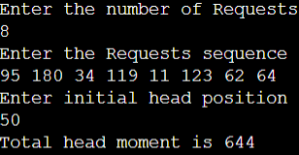

1. **SCAN:**

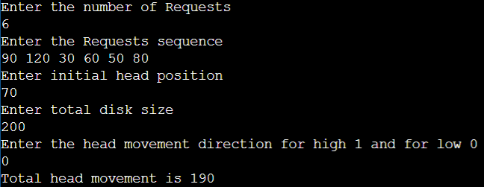

1. **C-SCAN:**

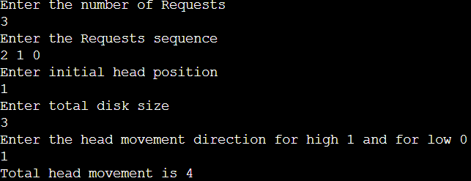

* 1. **Experiment - 13**
     1. **Question:**

Write a C program to simulate disk scheduling algorithms:

1. SSTF
2. LOOK
3. C-LOOK
   * 1. **Code**:
4. **SSTF:**

#include<stdio.h>

#include<stdlib.h>

int main()

{

int RQ[100],i,n,TotalHeadMoment=0,initial,count=0;

printf("Enter the number of Requests\n");

scanf("%d",&n);

printf("Enter the Requests sequence\n");

for(i=0;i<n;i++)

scanf("%d",&RQ[i]);

printf("Enter initial head position\n");

scanf("%d",&initial);

// logic for sstf disk scheduling

/* loop will execute until all process is completed*/

while(count!=n)

{

int min=1000,d,index;

for(i=0;i<n;i++)

{

d=abs(RQ[i]-initial);

if(min>d)

{

min=d;

index=i;

}

}

TotalHeadMoment=TotalHeadMoment+min;

initial=RQ[index];

// 1000 is for max

// you can use any number

RQ[index]=1000;

count++;

}

printf("Total head movement is %d",TotalHeadMoment);

return 0;

}

1. **LOOK:**

#include<stdio.h>

#include<stdlib.h>

int main()

{

int RQ[100],i,j,n,TotalHeadMoment=0,initial,size,move;

printf("Enter the number of Requests\n");

scanf("%d",&n);

printf("Enter the Requests sequence\n");

for(i=0;i<n;i++)

scanf("%d",&RQ[i]);

printf("Enter initial head position\n");

scanf("%d",&initial);

printf("Enter total disk size\n");

scanf("%d",&size);

printf("Enter the head movement direction for high 1 and for low 0\n");

scanf("%d",&move);

// logic for look disk scheduling

/*logic for sort the request array */

for(i=0;i<n;i++)

{

for(j=0;j<n-i-1;j++)

{

if(RQ[j]>RQ[j+1])

{

int temp;

temp=RQ[j];

RQ[j]=RQ[j+1];

RQ[j+1]=temp;

}

}

}

int index;

for(i=0;i<n;i++)

{

if(initial<RQ[i])

{

index=i;

break;

}

}

// if movement is towards high value

if(move==1)

{

for(i=index;i<n;i++)

{

TotalHeadMoment=TotalHeadMoment+abs(RQ[i]-initial);

initial=RQ[i];

}

for(i=index-1;i>=0;i--)

{

TotalHeadMoment=TotalHeadMoment+abs(RQ[i]-initial);

initial=RQ[i];

}

}

// if movement is towards low value

else

{

for(i=index-1;i>=0;i--)

{

TotalHeadMoment=TotalHeadMoment+abs(RQ[i]-initial);

initial=RQ[i];

}

for(i=index;i<n;i++)

{

TotalHeadMoment=TotalHeadMoment+abs(RQ[i]-initial);

initial=RQ[i];

}

}

printf("Total head movement is %d",TotalHeadMoment);

return 0;

}

1. **c-LOOK:**

#include<stdio.h>

#include<stdlib.h>

int main()

{

int RQ[100],i,j,n,TotalHeadMoment=0,initial,size,move;

printf("Enter the number of Requests\n");

scanf("%d",&n);

printf("Enter the Requests sequence\n");

for(i=0;i<n;i++)

scanf("%d",&RQ[i]);

printf("Enter initial head position\n");

scanf("%d",&initial);

printf("Enter total disk size\n");

scanf("%d",&size);

printf("Enter the head movement direction for high 1 and for low 0\n");

scanf("%d",&move);

// logic for C-look disk scheduling

/*logic for sort the request array */

for(i=0;i<n;i++)

{

for( j=0;j<n-i-1;j++)

{

if(RQ[j]>RQ[j+1])

{

int temp;

temp=RQ[j];

RQ[j]=RQ[j+1];

RQ[j+1]=temp;

}

}

}

int index;

for(i=0;i<n;i++)

{

if(initial<RQ[i])

{

index=i;

break;

}

}

// if movement is towards high value

if(move==1)

{

for(i=index;i<n;i++)

{

TotalHeadMoment=TotalHeadMoment+abs(RQ[i]-initial);

initial=RQ[i];

}

for( i=0;i<index;i++)

{

TotalHeadMoment=TotalHeadMoment+abs(RQ[i]-initial);

initial=RQ[i];

}

}

// if movement is towards low value

else

{

for(i=index-1;i>=0;i--)

{

TotalHeadMoment=TotalHeadMoment+abs(RQ[i]-initial);

initial=RQ[i];

}

for(i=n-1;i>=index;i--)

{

TotalHeadMoment=TotalHeadMoment+abs(RQ[i]-initial);

initial=RQ[i];

}

}

printf("Total head movement is %d",TotalHeadMoment);

return 0;

}

* + 1. **Output:**

1. **SSTF:**

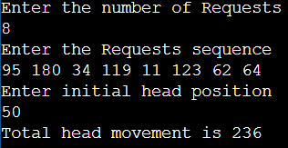

1. **LOOK:**

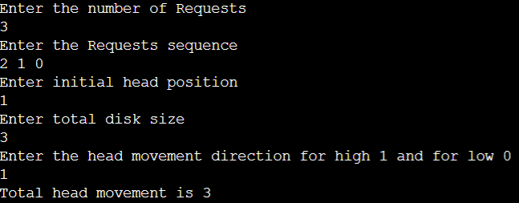

1. **c-LOOK:**

