Week -5

Employee database

create database employee;

use employee;

create table dept(no varchar(20) primary key, dname varchar(20), dloc varchar(20));

create table employee(empno int,ename varchar(20),mgr_no int,hiredate varchar(20), sal float,no varchar(20),primary key(empno,no), foreign key(no) references dept(no));

create table incentives(empno int, date VARCHAR(20), amt float,primary key(empno,date),foreign key(empno) references employee(empno));

create table project(pno int primary key, ploc VARCHAR(20),pname varchar(20));

create table Assingnedto(empno int, pno int,job_role text, primary key(empno,pno), foreign key(empno) references employee(empno), foreign key(pno) references project(pno));

insert into dept values(1,"cse","bng");

insert into dept values(2,"ise","delhi");

insert into dept values(3,"csds","bombay");

insert into dept values(4,"ece","hyderabad");

insert into dept values(5,"aiml","mysore");

insert into dept values(6,"aids","pune");

select * from dept;

insert into employee values(101,"ravi",100,"12/01/1999",200000,1);

insert into employee values(201,"tej",200,"17/01/2020",80000,2);

insert into employee values(301,"mohan",100,"01/09/2004",40000,3);

insert into employee values(401,"rahul",101,"03/08/2000",30000,4);

insert into employee values(501,"bharat",101,"29/2/2008",70000,5);

insert into employee values(601,"suresh",200,"23/03/2003",40000,6);

select * from employee;

insert into incentives values(101,"12/03/2004",50000);

insert into incentives values(201,"17/03/2024",25000);

insert into incentives values(301,"01/12/2019",15000);

insert into incentives values(401,"03/11/2019",5000);

insert into incentives values(501,"29/4/2019",45000);

select * from incentives;

insert into project values(10,"bng","chatbot");

insert into project values(40,"delhi","ml model");

insert into project values(50,"bombay","blockchain");

insert into project values(30,"hyderabad","stocks");

insert into project values(80,"mysore","android app");

insert into project values(54,"pune","web development");

select * from project;

insert into Assingnedto values(101,10,"software developer");

insert into Assingnedto values(201,40,"manager");

insert into Assingnedto values(301,50,"asst. manager");

insert into Assingnedto values(401,30,"secretary");

insert into Assingnedto values(501,80,"database manager");

select * from Assingnedto;

1. Using Scheme diagram, Create tables by properly specifying the primary keys and the foreign keys.

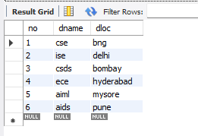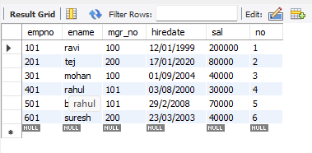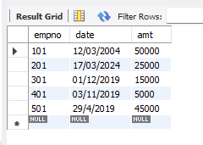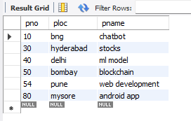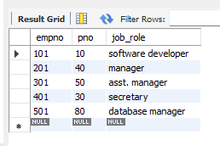

2. Retrieve the employee numbers of all employees who work on project located in Bengaluru, Hyderabad, or Mysuru

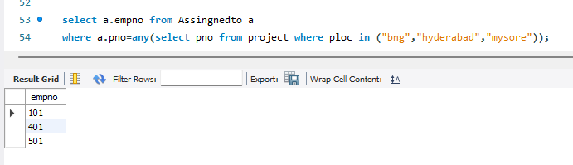

3. Get Employee ID’s of those employees who didn’t receive incentives

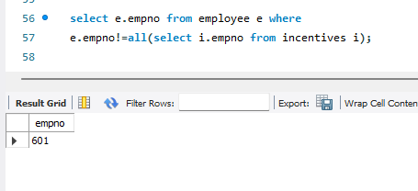

4. Write a SQL query to find the employees name, number, dept, job_role, department location and project location who are working for a project location same as his/her department location.

