Lab -6 java (Output Screenshot is there in the last page)

**CIE/Student.java**

package CIE;

import java.util.Scanner;

public class Student {

protected String usn;

protected String name;

protected int sem;

public void inputStudentDetails() {

Scanner s = new Scanner(System.in);

System.out.print("Enter USN: ");

usn = s.nextLine();

System.out.print("Enter Name: ");

name = s.nextLine();

System.out.print("Enter Semester: ");

sem = s.nextInt();

}

public void displayStudentDetails() {

System.out.println("USN: " + usn);

System.out.println("Name: " + name);

System.out.println("Semester: " + sem);

}

}

**CIE/Internals.java**

package CIE;

import java.util.Scanner;

public class Internals extends Student {

protected int[] internalMarks = new int[5];

public void inputCIEmarks() {

Scanner s = new Scanner(System.in);

System.out.println("Enter Internal Marks for 5 subjects:");

for (int i = 0; i < 5; i++) {

System.out.print("Subject " + (i + 1) + ": ");

internalMarks[i] = s.nextInt();

}

}

}

**SEE/Externals.java**

package SEE;

import CIE.Internals;

import java.util.Scanner;

public class Externals extends Internals {

private int[] seeMarks = new int[5];

private int[] finalMarks = new int[5];

public void inputSEEmarks() {

Scanner s = new Scanner(System.in);

System.out.println("Enter SEE Marks for 5 subjects:");

for (int i = 0; i < 5; i++) {

System.out.print("Subject " + (i + 1) + ": ");

seeMarks[i] = s.nextInt();

}

}

public void calculateFinalMarks() {

for (int i = 0; i < 5; i++) {

finalMarks[i] = internalMarks[i] + seeMarks[i];

}

}

public void displayFinalMarks() {

displayStudentDetails();

System.out.println("Final Marks for 5 subjects:");

for (int i = 0; i < 5; i++) {

System.out.println("Subject " + (i + 1) + ": " + finalMarks[i]);

}

}

}

**Main.java**

import SEE.Externals;

import java.util.Scanner;

class Main {

public static void main(String[] args) {

Scanner s = new Scanner(System.in);

System.out.print("Enter number of students: ");

int n = s.nextInt();

Externals[] students = new Externals[n];

for (int i = 0; i < n; i++) {

System.out.println("\nEnter details for student " + (i + 1) + ":");

students[i] = new Externals();

students[i].inputStudentDetails();

students[i].inputCIEmarks();

students[i].inputSEEmarks();

students[i].calculateFinalMarks();

}

System.out.println("\nFinal Marks of Students:");

for (int i = 0; i < n; i++) {

System.out.println("\nStudent " + (i + 1) + ":");

students[i].displayFinalMarks();

}

System.out.println("\n");

System.out.println("\nName: Afreen Anz\nUSN: 1BM23CS016");

}

}

**Output for 3 student:**

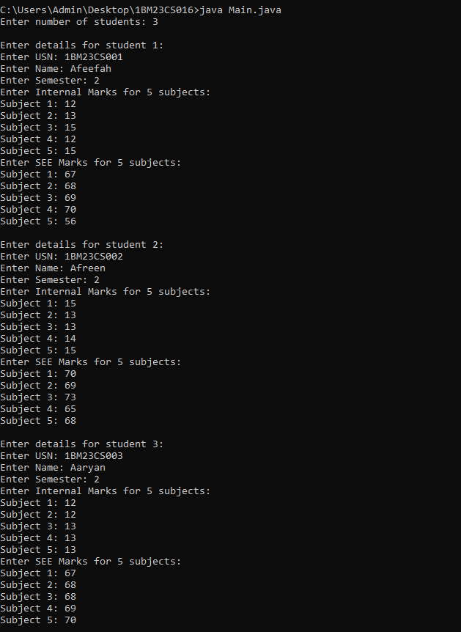

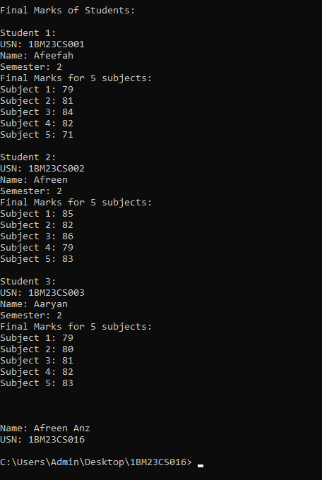

**Output for 1 student:**

