VISVESVARAYA TECHNOLOGICAL UNIVERSITY “JnanaSangama”, Belgaum -590014, Karnataka.

LAB REPORT
on
Artificial Intelligence (23CS5PCAIN)
Submitted by
Shamarao(1BM23CS308)
in partial fulfillment for the award of the degree of BACHELOR OF ENGINEERING
in
COMPUTER SCIENCE AND ENGINEERING

B.M.S. COLLEGE OF ENGINEERING
(Autonomous Institution under VTU)
BENGALURU-560019
Aug 2025 to Dec 2025
1

B.M.S. College of Engineering,
Bull Temple Road, Bangalore 560019
(Affiliated To Visvesvaraya Technological University, Belgaum) Department of Computer Science and Engineering

CERTIFICATE
This is to certify that the Lab work entitled “Artificial Intelligence (23CS5PCAIN)” carried out by Shamarao (1BM23CS308), who is bonafide student of B.M.S. College of Engineering. It is in partial fulfillment for the award of Bachelor of Engineering in Computer Science and Engineering of the Visvesvaraya Technological University, Belgaum. The Lab report has been approved as it satisfies the academic requirements in respect of an Artificial Intelligence (23CS5PCAIN) work prescribed for the said degree.
Prof. Seema patil  Assistant Professor  Department of CSE, BMSCE | Dr. Kavitha Sooda  Professor & HOD  Department of CSE, BMSCE
2

Index
Sl.  No. | Date | Experiment Title | Page No.
1 | 18-8-2025 | Implement Tic –Tac –Toe Game Implement vacuum cleaner agent | 4-9
2 | 25-8-2025 | Implement 8 puzzle problems using Depth First Search (DFS)  Implement Iterative deepening search algorithm | 10-18
3 | 8-9-2025 | Implement A* search algorithm | 19-22
4 | 15-9-2025 | Implement Hill Climbing search algorithm to solve N-Queens problem | 23-25
5 | 15-9-2025 | Simulated Annealing to Solve 8-Queens problem | 26-28
6 | 22-9-2025 | Create a knowledge base using propositional logic and show that the given query entails the knowledge base or not. | 29-31
7 | 13-10-2025 | Implement unification in first order logic | 32-38
8 | 13-10-2025 | Create a knowledge base consisting of first order logic statements and prove the given query using forward reasoning. | 39-47
9 | 27-10-2025 | Create a knowledge base consisting of first order logic statements and prove the given query using Resolution | 48-53
10 | 27-10-2025 | Implement Alpha-Beta Pruning. | 54-57
3

Github Link:
https://github.com/Shashank-u803/AI-Lab
Program 1
Implement Tic –Tac –Toe Game
Implement vacuum cleaner agent
Algorithm:

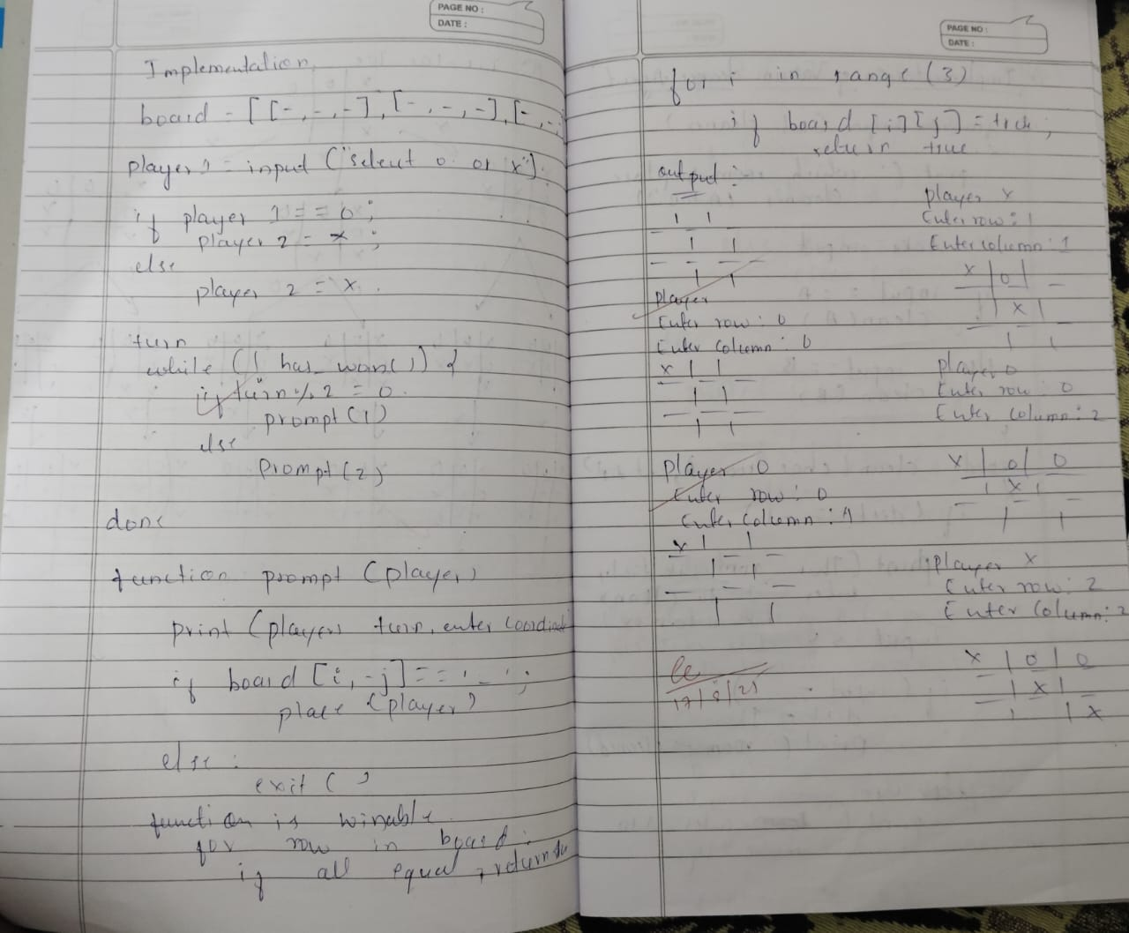
Code:
TIC TAC TOE Game

defprint_board(board):

print()
print("-------------")
for i inrange(3):

print("|", board[i][0], "|", board[i][1], "|", board[i][2], "|") print("-------------")

print()

defis_win(board,symbol):

#same row
4

for i inrange(3):
if board[i][0] == symbol and board[i][1] == symbol and board[i][2] == symbol:
returnTrue
#same Column
for j inrange(3):
if board[0][j] == symbol and board[1][j] == symbol and board[2][j] ==
symbol: | returnTrue

#same diagonal
if board[0][0] == symbol and board[1][1] == symbol and board[2][2] == symbol: returnTrue
if board[0][2] == symbol and board[1][1] == symbol and board[2][0] == symbol: returnTrue
#if all case fails
returnFalse
defis_draw(board):
for i inrange(3):
for j inrange(3):
if board[i][j] == " ": returnFalse
returnTrue
defget_input(mark,id):
whileTrue:
try:
move = input(f"Player{id}, Enter the position to place {mark}-> ") ip = move.strip().split()
iflen(ip) != 2:
print("Enter exactly 2 coordinates!")
continue
row,col = int(ip[0]),int(ip[1])
if (row>=1and row<= 3) and (col>=1and col<=3): return [row-1,col-1]
else:
print("Enter values between 1 and 3 only") except ValueError:
print("Invalid inputs, enter numbers only")
board = []
for i inrange(3):
board.append([" "," "," "])
mark1 = "X"
mark2 = "O"
p1 = 1
p2 = 2
5

curr_p = 1
curr_m = "X"
whileTrue:
print_board(board)
row,col = get_input(curr_m,curr_p)

if board[row][col] != " ":
print("Move already taken!,Try again")
continue
board[row][col] = curr_m
if is_win(board,curr_m):
print_board(board)
print(f"Congrats🎉, Player{curr_p} wins!!!") break

if is_draw(board):
print_board(board)
print("Its a draw,🫡!")
break
if curr_p == p1:
curr_p = p2
curr_m = "O"
else:

curr_p = p1
curr_m = "X"
-------------
| | | |
-------------
| | | |
-------------
| | | |
-------------
Player1, Enter the position to place X-> 1 1
-------------
| X | | |
-------------
| | | |
-------------
| | | |
-------------
Player2, Enter the position to place O-> 3 1
-------------
6

| X | | |
-------------
| | | |
-------------
| O | | |
-------------
Player1, Enter the position to place X-> 2 2
-------------
| X | | |
-------------
| | X | |
-------------
| O | | |
-------------
Player2, Enter the position to place O-> 3 2
-------------
| X | | |
-------------
| | X | |
-------------
| O | O | |
-------------
Player1, Enter the position to place X-> 3 3
-------------
| X | | |
-------------
| | X | |
-------------
| O | O | X |
-------------
Congrats, Player1 wins!!!
Vacuum Cleaner Agent
defis_clean(status):
return status[room_a] and status[room_b]

defsimulate(state, choice, status, cost, do_clean=True): if is_clean(status):
print("All rooms are clean")

return cost

if choice != 1and choice != -1: print("Invalid choice")
return cost
7

# Vacuum in room A
if state[0][0]:
if choice == -1:
if do_clean andnot state[0][1]: state[0][1] = True
status[room_a] = True
print("Cleaned room A")
cost += 1# Cost of cleaning else:
print("No cleaning in room A") elif choice == 1:
state[0][0] = False
state[1][0] = True
print("Moved vacuum from A to B") else:
print("Cannot move from A to B")
# Vacuum in room B
elif state[1][0]:
if choice == 1:
if do_clean andnot state[1][1]: state[1][1] = True
status[room_b] = True
print("Cleaned room B")
cost += 1# Cost of cleaning else:
print("No cleaning in room B") elif choice == -1:
state[1][0] = False
state[0][0] = True
print("Moved vacuum from B to A") else:
print("Cannot move from B to A") else:
print("Vacuum is not in any room!")
return cost
if __name__ == "__main__":
room_a = 'A'
room_b = 'B'
state = [[True, False], [False, False]] status = {room_a:False, room_b:False} total_cost = 0# Initialize total cost
whileTrue:
if is_clean(status):
print("All rooms are clean. Exiting.")
print(f"Total cost: {total_cost}") # Display total cost break
choice = int(input("Enter -1 to act in Room A, 1 to act in Room B: ")) action = input("Enter 'c' to clean, 'm' to move without cleaning: ").lower()
if action == 'c':
total_cost = simulate(state, choice, status, total_cost)
elif action == 'm':
total_cost = simulate(state, choice, status, total_cost, False)
8

else:

print("Invalid action choice")
Enter -1 to act in Room A, 1 to act in Room B: -1 Enter 'c' to clean, 'm' to move without cleaning: c Cleaned room A
Enter -1 to act in Room A, 1 to act in Room B: 1 Enter 'c' to clean, 'm' to move without cleaning: m Moved vacuum from A to B
Enter -1 to act in Room A, 1 to act in Room B: 1 Enter 'c' to clean, 'm' to move without cleaning: c Cleaned room B
All rooms are clean. Exiting.
Total cost: 2
9

Program 2
Implement 8 puzzle problems using Depth First Search (DFS) Implement Iterative deepening search algorithm
Algorithm:
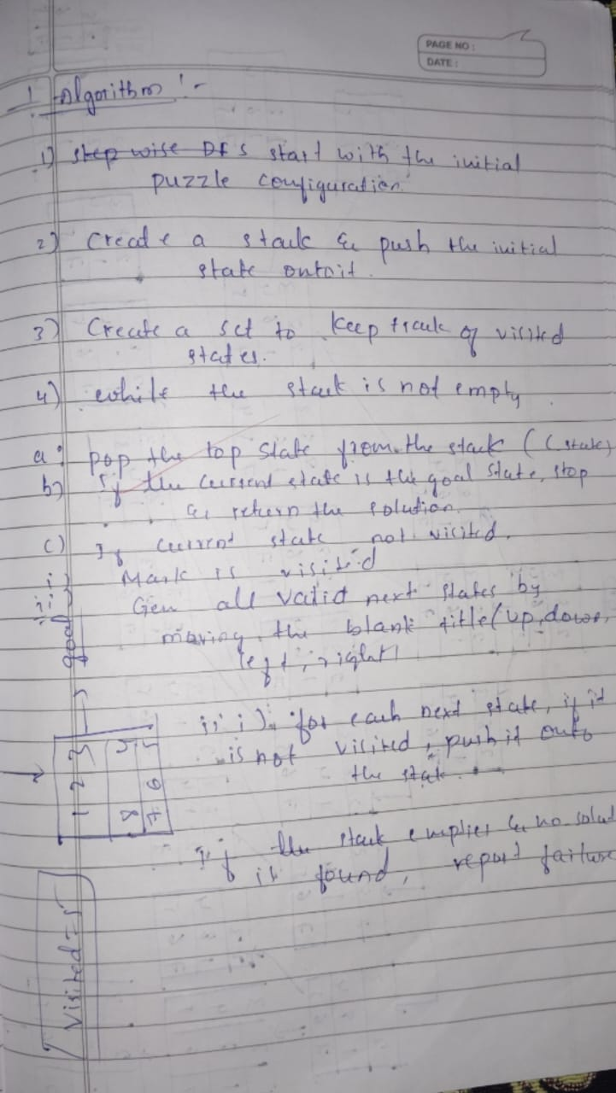
Code:
8 Puzzle using DFS
import heapq

# Initial and goal states
initial_state = ((2, 8, 3),
(1, 6, 4),
(7, 0, 5))

goal_state = ((1, 2, 3),
(8, 0, 4),
(7, 6, 5))

# Possible moves
directions = {'Up': (-1, 0), 'Down': (1, 0), 'Left': (0, -1), 'Right': (0, 1)}

# Find blank (0) position
def get_blank_pos(state):
for i in range(3):
for j in range(3):
if state[i][j] == 0:
return (i, j)

# Swap positions to generate new state
def swap_positions(state, pos1, pos2):
state_list = [list(row) for row in state]
r1, c1 = pos1
r2, c2 = pos2
state_list[r1][c1], state_list[r2][c2] = state_list[r2][c2], state_list[r1][c1]
return tuple(tuple(row) for row in state_list)

# Generate neighboring states
def get_neighbors(state):
neighbors = []
r, c = get_blank_pos(state)
for move, (dr, dc) in directions.items():
nr, nc = r + dr, c + dc
if 0 <= nr < 3 and 0 <= nc < 3:
new_state = swap_positions(state, (r, c), (nr, nc))
neighbors.append((new_state, move))
return neighbors

# Manhattan distance heuristic
def manhattan_distance(state, goal):
distance = 0
for i in range(3):
for j in range(3):
value = state[i][j]
if value != 0:
for x in range(3):
for y in range(3):
if goal[x][y] == value:
distance += abs(i - x) + abs(j - y)
return distance

# A* Search Algorithm
def a_star_8_puzzle(start, goal):
pq = [] # priority queue
heapq.heappush(pq, (0, start, [])) # (f, state, path)
visited = set()
visited.add(start)

while pq:
f, state, path = heapq.heappop(pq)

if state == goal:
return path, len(visited)

for neighbor, move in get_neighbors(state):
if neighbor not in visited:
visited.add(neighbor)
g = len(path) + 1 # cost so far
h = manhattan_distance(neighbor, goal)
f = g + h
heapq.heappush(pq, (f, neighbor, path + [move]))

return None, len(visited)

# Run A* Search
solution_path, total_visited = a_star_8_puzzle(initial_state, goal_state)

# Print results
if solution_path:
print(f"✅ Solution found in {len(solution_path)} moves")
print("Moves:", solution_path)
print(f"Total states visited: {total_visited}\n")
else:
print("❌ No solution found")

Solution length: 5 moves
Solution moves: ['Up', 'Up', 'Left', 'Down', 'Right']
Total states visited: 62

States level-wise:

Level 0:
(2, 8, 3)
(1, 6, 4)
(7, 0, 5)
---

Level 1:
(2, 8, 3)
(1, 0, 4)
(7, 6, 5)
---
(2, 8, 3)
(1, 6, 4)
(0, 7, 5)
---
(2, 8, 3)
(1, 6, 4)
(7, 5, 0)
---

Level 2:
(2, 0, 3)
(1, 8, 4)
(7, 6, 5)
---
(2, 8, 3)
(0, 1, 4)
(7, 6, 5)
---
(2, 8, 3)
(1, 4, 0)
(7, 6, 5)
---
(2, 8, 3)
(0, 6, 4)
(1, 7, 5)
---
(2, 8, 3)
(1, 6, 0)
(7, 5, 4)
---

Level 3:
(0, 2, 3)
(1, 8, 4)
(7, 6, 5)
---
(2, 3, 0)
(1, 8, 4)
(7, 6, 5)
---
(0, 8, 3)
(2, 1, 4)
(7, 6, 5)
---
(2, 8, 3)
(7, 1, 4)
(0, 6, 5)
---
(2, 8, 0)
(1, 4, 3)
(7, 6, 5)
---
(2, 8, 3)
(1, 4, 5)
(7, 6, 0)
---
(0, 8, 3)
(2, 6, 4)
(1, 7, 5)
---
(2, 8, 3)
(6, 0, 4)
(1, 7, 5)
---
(2, 8, 0)
(1, 6, 3)
(7, 5, 4)
---
(2, 8, 3)
(1, 0, 6)
(7, 5, 4)
---

Level 4:
(1, 2, 3)
(0, 8, 4)
(7, 6, 5)
---
(2, 3, 4)
(1, 8, 0)
(7, 6, 5)
---
(8, 0, 3)
(2, 1, 4)
(7, 6, 5)
---
(2, 8, 3)
(7, 1, 4)
(6, 0, 5)
---
(2, 0, 8)
(1, 4, 3)
(7, 6, 5)
---
(2, 8, 3)
(1, 4, 5)
(7, 0, 6)
---
(8, 0, 3)
(2, 6, 4)
(1, 7, 5)
---
(2, 0, 3)
(6, 8, 4)
(1, 7, 5)
---
(2, 8, 3)
(6, 7, 4)
(1, 0, 5)
---
(2, 8, 3)
(6, 4, 0)
(1, 7, 5)
---
(2, 0, 8)
(1, 6, 3)
(7, 5, 4)
---
(2, 0, 3)
(1, 8, 6)
(7, 5, 4)
---
(2, 8, 3)
(1, 5, 6)
(7, 0, 4)
---
(2, 8, 3)
(0, 1, 6)
(7, 5, 4)
---

Level 5:
(1, 2, 3)
(7, 8, 4)
(0, 6, 5)
---
(1, 2, 3)
(8, 0, 4)
(7, 6, 5)
---

8 Puzzle using Iterative Deepening DFS
from collections import deque
# Helper to print board in 3x3 format
defprint_board(state):
for i inrange(0, 9, 3):

print(state[i:i+3])
print()

# Generate possible moves
defget_neighbors(state):

neighbors = []
idx = state.index(0) # blank space
row, col = divmod(idx, 3)
moves = []
if row > 0: moves.append((-1, 0, 'Up'))
if row < 2: moves.append((1, 0, 'Down'))
if col > 0: moves.append((0, -1, 'Left'))
if col < 2: moves.append((0, 1, 'Right'))
for dr, dc, action in moves:
new_row, new_col = row + dr, col + dc
new_idx = new_row * 3 + new_col
new_state = list(state)
new_state[idx], new_state[new_idx] = new_state[new_idx], new_state[idx] neighbors.append((tuple(new_state), action))
return neighbors
# Depth-Limited Search (helper for IDDFS) defdls(state, goal, depth, path, explored):

if state == goal:
return path
if depth == 0:
returnNone
explored.add(state)
for neighbor, action in get_neighbors(state):
if neighbor notin explored:
result = dls(neighbor, goal, depth-1, path + [(action, neighbor)], explored)
if result isnotNone:
return result
returnNone
# Iterative Deepening DFS
defiddfs(start, goal, max_depth=50):
for depth inrange(max_depth):
explored = set()
result = dls(start, goal, depth, [], explored) if result isnotNone:
return result
returnNone
if __name__ == "__main__":
print("Enter the initial state (0 for blank, space-separated, 9 numbers):") start = tuple(map(int, input().split()))
print("Enter the goal state (0 for blank, space-separated, 9 numbers):") goal = tuple(map(int, input().split()))
print("\nSolving puzzle with Iterative Deepening DFS...\n") solution = iddfs(start, goal)
if solution:
print("Optimal solution found using IDDFS!\n") print("Total steps:", len(solution))
current = start
print("Initial State:")
print_board(current)
for step, state in solution:
print("Move:", step)
print_board(state)
else:
print("No solution found within depth limit.")
Enter the initial state (0 for blank, space-separated, 9 numbers): 2 8 3 1 6 4 7 0 5
Enter the goal state (0 for blank, space-separated, 9 numbers): 1 2 3 8 0 4 7 6 5
Solving puzzle with Iterative Deepening DFS...
Optimal solution found using IDDFS!
Total steps: 5
Initial State:
(2, 8, 3)
(1, 6, 4)
17

(7, 0, 5)
Move: Up
(2, 8, 3)
(1, 0, 4)
(7, 6, 5)
Move: Up
(2, 0, 3)
(1, 8, 4)
(7, 6, 5)
Move: Left
(0, 2, 3)
(1, 8, 4)
(7, 6, 5)
Move: Down
(1, 2, 3)
(0, 8, 4)
(7, 6, 5)
Move: Right
(1, 2, 3)
(8, 0, 4)
(7, 6, 5)
18

Program 3
Implement A* search algorithm
Algorithm:
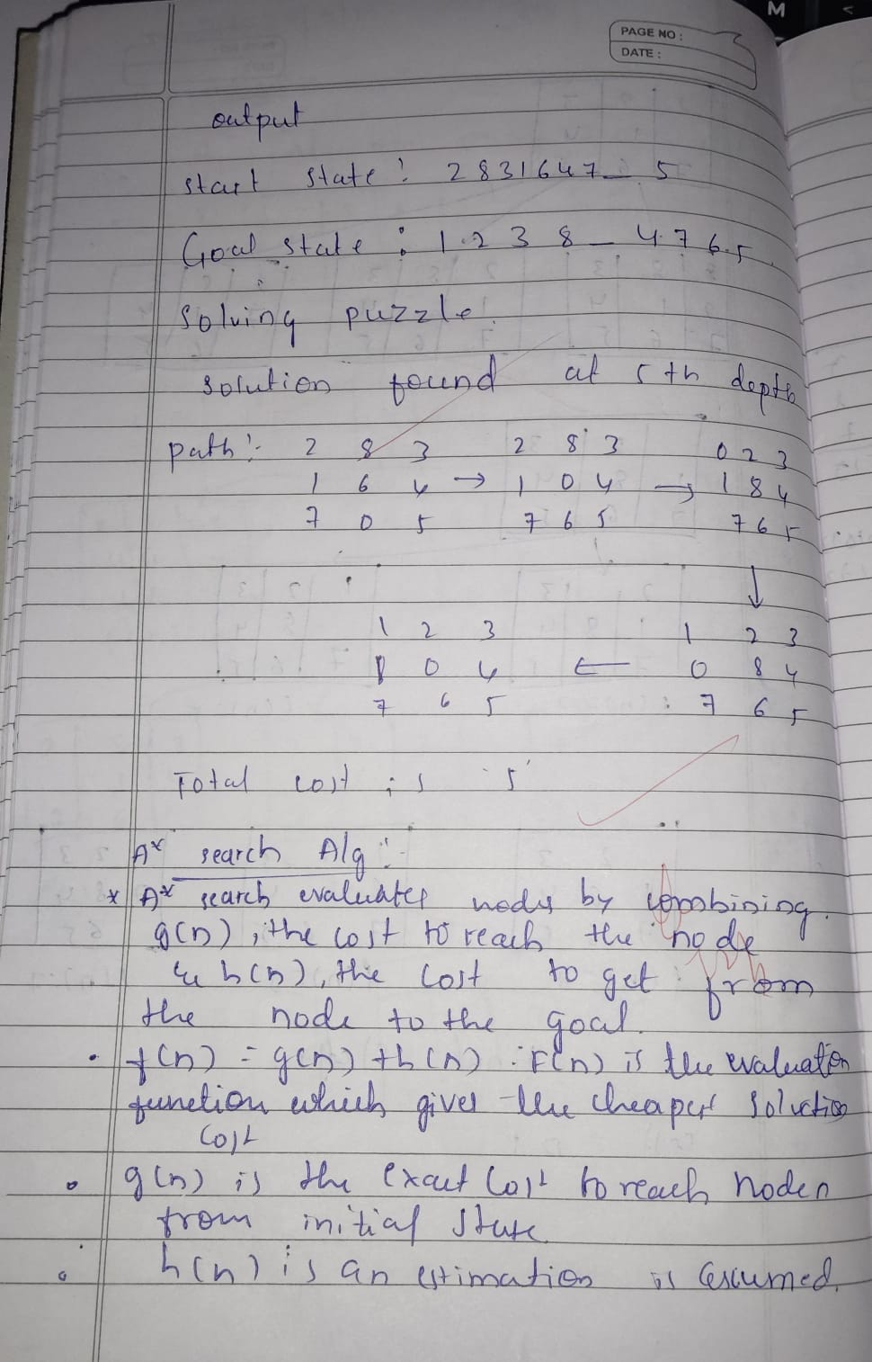
Code:
A* using misplaced tiles for 8 puzzle
from heapq import heappush, heappop
MOVES = {
} | 'up': -3,  'down': 3,  'left': -1,  'right': 1

defis_valid_move(zero_pos, move):
if move == 'left'and zero_pos % 3 == 0:
returnFalse
if move == 'right'and zero_pos % 3 == 2:
returnFalse
if move == 'up'and zero_pos < 3: returnFalse
if move == 'down'and zero_pos > 5:
returnFalse
returnTrue
defmisplaced_tiles(state, goal):
returnsum([1if state[i] != 0and state[i] != goal[i] else0for i in range(9)])

defprint_state_formatted(state): for i inrange(0, 9, 3):
19

row = state[i:i+3]
print(" ".join(str(x) if x != 0else" "for x in row)) print()
defa_star_misplaced(start, goal):
open_set = []
closed_set = set()
g = 0
h = misplaced_tiles(start, goal)
f = g + h
heappush(open_set, (f, g, start, [], None)) # last element: move that got here
while open_set:
f, g, current, path, move_made = heappop(open_set)
# Print detailed info with matrix format and move made
if move_made isNone:
print(f"Expanding node with f={f}, g={g} - Start state") else:
print(f"Expanding node with f={f}, g={g} - Move: {move_made}") print_state_formatted(current)
if current == goal:
print("Goal reached!")
print("Solution path (moves):", path)
print(f"Final depth (number of moves): {g}") return path, g
closed_set.add(current)
zero_pos = current.index(0)
for move, shift in MOVES.items():
if is_valid_move(zero_pos, move):
new_zero_pos = zero_pos + shift
new_state = list(current)
new_state[zero_pos], new_state[new_zero_pos] = new_state[new_zero_pos], new_state[zero_pos]
new_state = tuple(new_state)
if new_state in closed_set:
continue
new_g = g + 1
new_h = misplaced_tiles(new_state, goal)
new_f = new_g + new_h
heappush(open_set, (new_f, new_g, new_state, path + [move], move))
print("No solution found.")
returnNone, None
defget_state_matrix(prompt):
print(prompt)
matrix = []
for i inrange(3):
whileTrue:
try:
row = list(map(int, input().strip().split())) iflen(row) != 3:
20

raise ValueError("Each row must have exactly 3 numbers.") matrix.extend(row)
break
except Exception as e:
print("Invalid input:", e)
ifset(matrix) != set(range(9)):
print("Error: The numbers must be from 0 to 8 without repetition.") return get_state_matrix(prompt)
returntuple(matrix)
if __name__ == "__main__":
start_state = get_state_matrix("Enter the initial state (3 rows, each with 3 numbers separated by spaces):")

goal_state = get_state_matrix("Enter the goal state (3 rows, each with 3 numbers separated by spaces):")

print("\nInitial State:")
print_state_formatted(start_state)

print("Goal State:")
print_state_formatted(goal_state)

a_star_misplaced(start_state, goal_state)
Enter the initial state (3 rows, each with 3 numbers separated by spaces): 2 8 3
1 6 4
7 0 5
Enter the goal state (3 rows, each with 3 numbers separated by spaces): 1 2 3
8 0 4
7 6 5
Initial State:
2 8 3
1 6 4
7 5
Goal State:
1 2 3
8 4
7 6 5
Expanding node with f=4, g=0 - Start state 2 8 3
1 6 4
7 5
Expanding node with f=4, g=1 - Move: up
2 8 3
1 4
7 6 5
Expanding node with f=5, g=2 - Move: up
2 3
1 8 4
21

7 6 5
Expanding node with f=5, g=2 - Move: left
2 8 3
1 4
7 6 5
Expanding node with f=5, g=3 - Move: left
2 3
1 8 4
7 6 5
Expanding node with f=5, g=4 - Move: down
1 2 3
8 4
7 6 5
Expanding node with f=5, g=5 - Move: right 1 2 3
8 4
7 6 5
Goal reached!
Solution path (moves): ['up', 'up', 'left', 'down', 'right'] Final depth (number of moves): 5
22

Program 4
Implement Hill Climbing search algorithm to solve N-Queens problem
Algorithm:
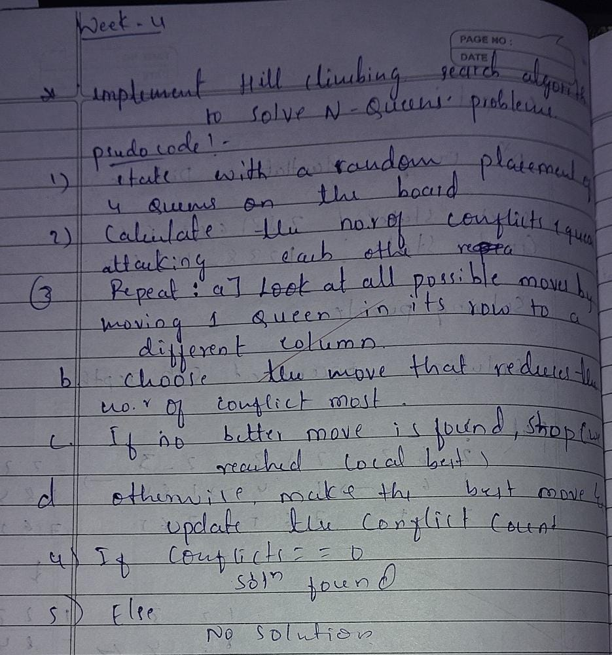
Code:
defget_user_input(n):
board = []
print(f"Enter the row positions (0 to {n-1}) of the queens for each column:") for col inrange(n):
whileTrue:
try:
row = int(input(f"Column {col}: "))
if0 <= row < n:
board.append(row)
1}.") | break  else:  print(f"Invalid input. Please enter a number between 0 and {n-  except ValueError:

print("Invalid input. Please enter an integer.") return board

defprint_board(board):
n = len(board)

for row inrange(n):
line = ""
for col inrange(n):
if board[col] == row:
line += " Q "
23

else:
line += " . "
print(line)
print()
defheuristic(board):
n = len(board)
attacks = 0
for i inrange(n):
for j inrange(i+1, n):
# Check same row
if board[i] == board[j]:
attacks += 1
# Check same diagonal
ifabs(board[i] - board[j]) == abs(i - j): attacks += 1
return attacks
defget_best_neighbor(board):
n = len(board)
current_heuristic = heuristic(board)
best_board = list(board)
best_heuristic = current_heuristic
for col inrange(n):
for row inrange(n):
if board[col] != row:
new_board = list(board)
new_board[col] = row
new_heuristic = heuristic(new_board) if new_heuristic < best_heuristic: best_heuristic = new_heuristic best_board = new_board
return best_board, best_heuristic
defhill_climbing_with_user_input(n):
board = get_user_input(n)
current_heuristic = heuristic(board)
steps = 0
whileTrue:
print(f"Step {steps}: Heuristic = {current_heuristic}") print_board(board)
if current_heuristic == 0:
print("Solution found!")
return board
neighbor, neighbor_heuristic = get_best_neighbor(board)
# If no improvement, stuck at local minimum
if neighbor_heuristic >= current_heuristic:
print("Reached local minimum (no better neighbors).") return board
board = neighbor
current_heuristic = neighbor_heuristic
steps += 1
24

# Run the algorithm
if __name__ == "__main__":
n = 4

solution = hill_climbing_with_user_input(n) print("Final solution:")

print_board(solution)
Enter the row positions (0 to 3) of the queens for each column: Column 0: 3
Column 1: 1
Column 2: 2
Column 3: 0
Step 0: Heuristic = 2
. . . Q
. Q . .
. . Q .
Q . . .
Reached local minimum (no better neighbors). Final solution:
. . . Q
. Q . .
. . Q .
Q . . .
25

Program 5
Simulated Annealing to Solve 8-Queens problem
Algorithm:
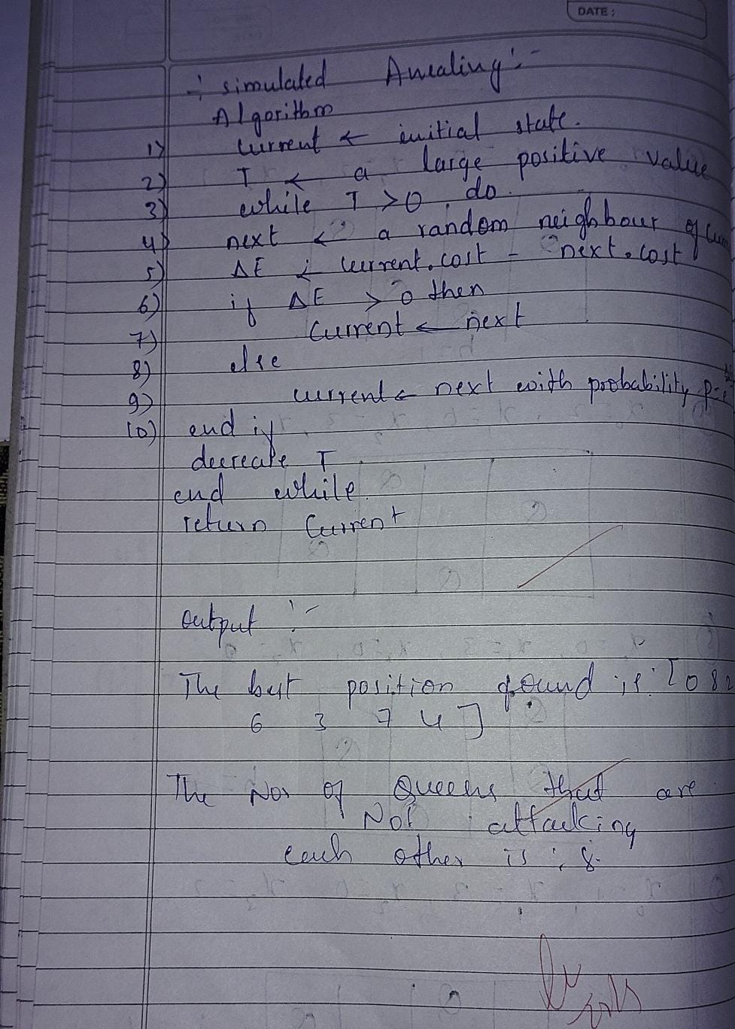
Code:
import random
import math
defget_user_input(n):
board = []
print(f"Enter the row positions (0 to {n-1}) of the queens for each column:")
for col inrange(n):
whileTrue:
try:
row = int(input(f"Column {col}: "))
if0 <= row < n:
1}.") | board.append(row)  break  else:  print(f"Invalid input. Please enter a number between 0 and {n-
except ValueError:
print("Invalid input. Please enter an integer.") return board
defprint_board(board):
n = len(board)
for row inrange(n):
line = ""
for col inrange(n):
line += " Q "if board[col] == row else" . "
print(line)
26

print()
defheuristic(board):
n = len(board)
attacks = 0
for i inrange(n):
for j inrange(i+1, n):
if board[i] == board[j] orabs(board[i] - board[j]) == abs(i - j): attacks += 1
return attacks
defrandom_neighbor(board):
n = len(board)
neighbor = list(board)
col = random.randint(0, n-1)
row = random.randint(0, n-1)
while row == neighbor[col]:
row = random.randint(0, n-1)
neighbor[col] = row
return neighbor
defsimulated_annealing(n=8, max_iter=100000, initial_temp=100, cooling_rate=0.995): current_board = get_user_input(n)
current_heuristic = heuristic(current_board)
temperature = initial_temp
iteration = 0
print(f"Initial heuristic: {current_heuristic}") print_board(current_board)
while temperature > 0.1and current_heuristic > 0and iteration < max_iter: neighbor = random_neighbor(current_board)
neighbor_heuristic = heuristic(neighbor)
delta_e = current_heuristic - neighbor_heuristic
if delta_e > 0:
current_board = neighbor
current_heuristic = neighbor_heuristic
else:
probability = math.exp(delta_e / temperature) if random.random() < probability:
current_board = neighbor
current_heuristic = neighbor_heuristic
temperature *= cooling_rate
iteration += 1
if iteration % 1000 == 0:
print(f"Iteration {iteration}, Temperature: {temperature:.2f}, Heuristic: {current_heuristic}")
print_board(current_board)
if current_heuristic == 0:
print("Solution found!")
else:
print("Stopped without full solution. Best board found:") print(f"Final heuristic: {current_heuristic}")
print_board(current_board)
27

if __name__ == "__main__":

simulated_annealing()
Enter the row positions (0 to 7) of the queens for each column: Column 0: 4
Column 1: 6
Column 2: 1
Column 3: 5
Column 4: 2
Column 5: 0
Column 6: 3
Column 7: 7
Initial heuristic: 0
. . . . . Q . .
. . Q . . . . .
. . . . Q . . .
. . . . . . Q .
Q . . . . . . .
. . . Q . . . .
. Q . . . . . .
. . . . . . . Q
Solution found!
Final heuristic: 0
. . . . . Q . .
. . Q . . . . .
. . . . Q . . .
. . . . . . Q .
Q . . . . . . .
. . . Q . . . .
. Q . . . . . .
. . . . . . . Q
28

Program 6
Create a knowledge base using propositional logic and show that the given query entails the knowledge base or not.
Algorithm:
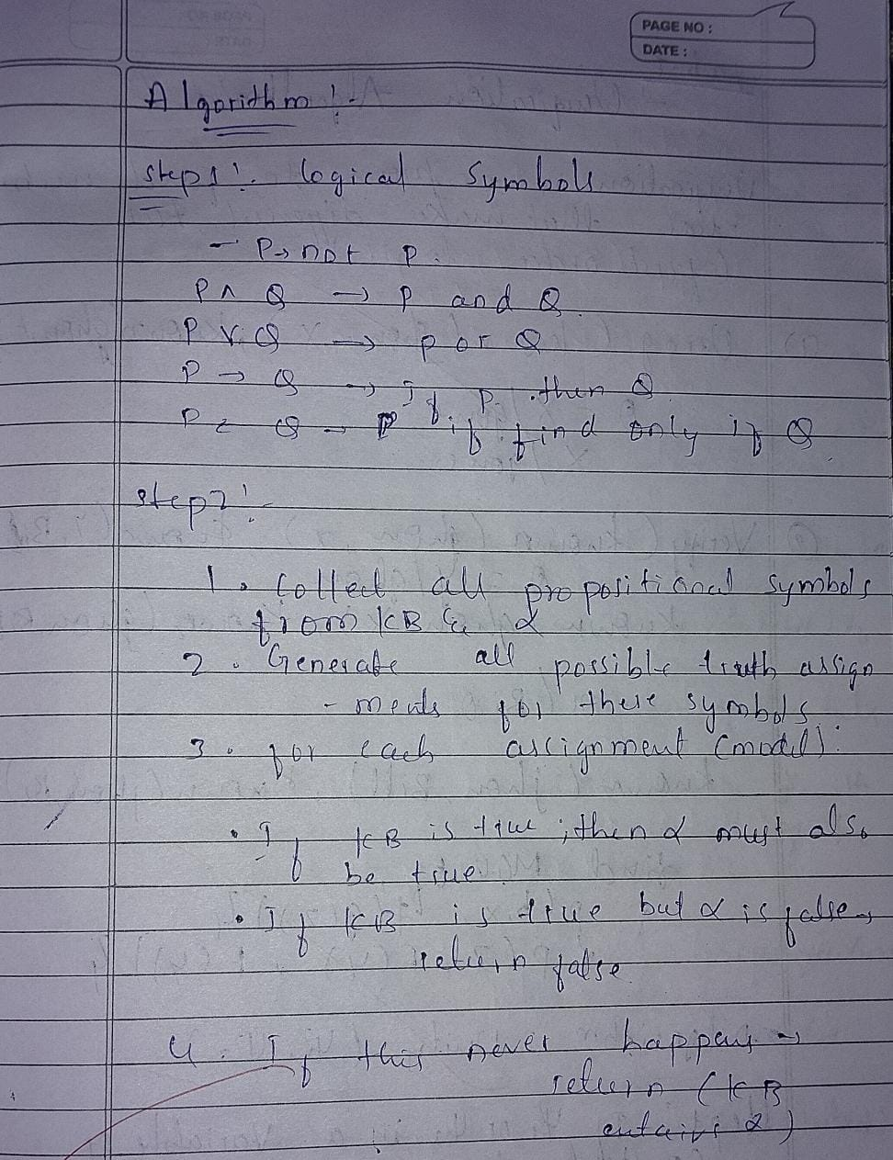
Code:
import itertools
import pandas as pd
import re

defreplace_implications(expr): """

Replace every X => Y with (not X or Y).
This uses regex with a callback to avoid partial string overwrites.
"""

# Pattern: capture left side and right side around => # Made more flexible to handle various expressions pattern = r'([^=><]+?)\s*=>\s*([^=><]+?)(?=\s|$|[&|)])' while re.search(pattern, expr):
expr = re.sub(pattern,

lambda m: f"(not {m.group(1).strip()} or {m.group(2).strip()})",
return expr | expr,  count=1)

defpl_true(sentence, model):
expr = sentence.strip()
expr = expr.replace("<=>", "==") expr = replace_implications(expr)

# Replace propositional symbols with their truth values safely for sym, val in model.items():
expr = re.sub(rf'\b{sym}\b', str(val), expr)

# Clean up spacing and add proper spacing for boolean operators
expr = re.sub(r'\s+', ' ', expr) # Remove extra spaces
expr = expr.replace(" and ", " and ").replace(" or ", " or ").replace(" not ", " not ")
returneval(expr)
defget_symbols(KB, alpha):
symbols = set()
for sentence in KB + [alpha]:
# Find all alphabetic tokens (propositional variables)
for token in re.findall(r'\b[A-Za-z]+\b', sentence):
if token notin ['and', 'or', 'not']: # Exclude boolean operators symbols.add(token)
returnsorted(list(symbols))
deftt_entails(KB, alpha):
symbols = get_symbols(KB, alpha)
rows = []
entails = True
for values in itertools.product([True, False], repeat=len(symbols)): model = dict(zip(symbols, values))
try:
kb_val = all(pl_true(sentence, model) for sentence in KB) alpha_val = pl_true(alpha, model)
rows.append({**model, "KB": kb_val, "alpha": alpha_val})
if kb_val andnot alpha_val:
entails = False
except Exception as e:
print(f"Error evaluating with model {model}: {e}") returnFalse
df = pd.DataFrame(rows)
# Create a beautiful formatted table
print("\n" + "="*50)
print(" TRUTH TABLE")
print("="*50)
# Get column widths for proper alignment
col_widths = {}
for col in df.columns:
col_widths[col] = max(len(str(col)), df[col].astype(str).str.len().max())
# Calculate total table width
table_width = sum(col_widths.values()) + len(df.columns) * 3 - 1
# Print top border
print("┌" + "─" * table_width + "┐")
# Print header
header = "│"
for col in df.columns:
header += f" {col:^{col_widths[col]}} │" print(header)
30

# Print separator
separator = "├"
for col in df.columns:
separator += "─" * (col_widths[col] + 2) + "┼" separator = separator[:-1] + "┤"
print(separator)
# Print rows
for _, row in df.iterrows():
row_str = "│"
for col in df.columns:
value = str(row[col])
row_str += f" {value:^{col_widths[col]}} │" print(row_str)
# Print bottom border
print("└" + "─" * table_width + "┘")

# Print result with styling
print("\n" + "="*50)
result_text = f"KB ENTAILS ALPHA: {'✓ YES' if entails else '✗ NO'}" print(f"{result_text:^50}")
print("="*50)
return entails
# --- Interactive input ---
print("Enter Knowledge Base (KB) sentences, separated by commas.") print("Use symbols like A, B, C and operators: and, or, not, =>, <=>")
kb_input = input("KB: ").strip()
KB = [x.strip() for x in kb_input.split(",")] alpha = input("Enter query (alpha): ").strip() result = tt_entails(KB, alpha)
print(f"Result: {result}")
#
Enter Knowledge Base (KB) sentences, separated by commas. Use symbols like A, B, C and operators: and, or, not, =>, <=> KB: not (S or T)
Enter query (alpha): T or (not T)
================================================== TRUTH TABLE
================================================== ┌───────────────────────────────┐
│ S │ T │ KB │ alpha │
├───────┼───────┼───────┼───────┤
│ True │ True │ False │ True │
│ True │ False │ False │ True │
│ False │ True │ False │ True │
│ False │ False │ True │ True │
└───────────────────────────────┘
================================================== KB ENTAILS ALPHA: ✓ YES ================================================== Result: True
31

Program 7
Implement unification in first order logic
Algorithm:
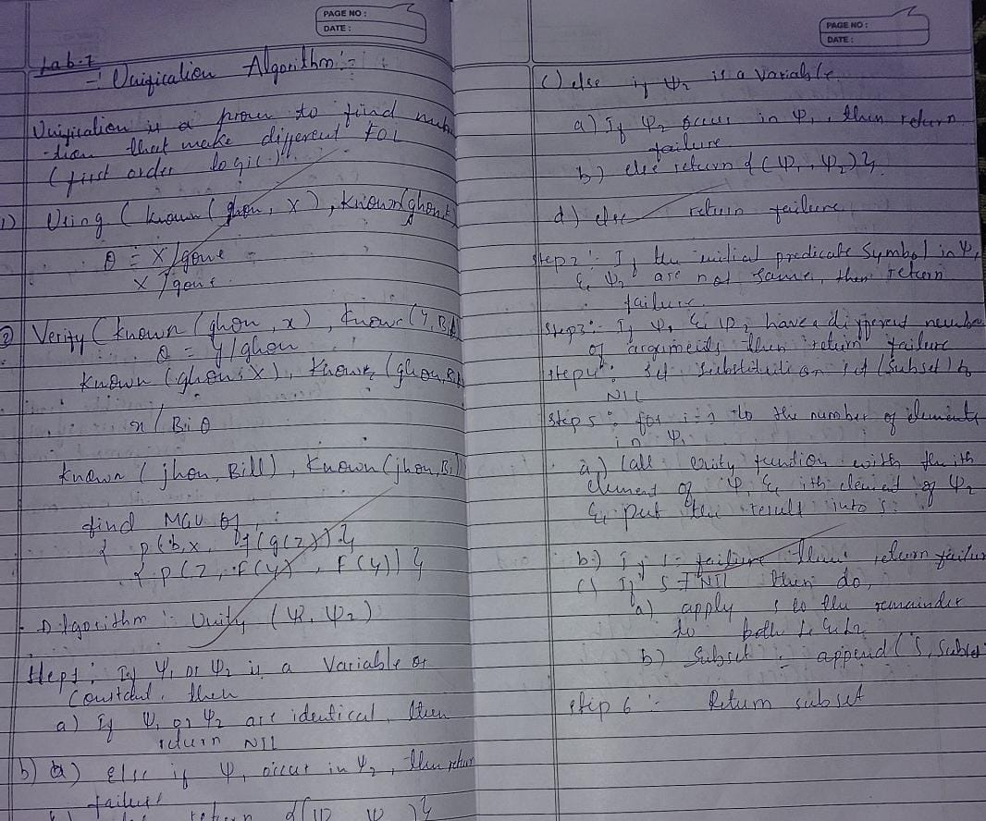
Code:
classTerm:
"""Base class for terms in first-order logic""" pass

classConstant(Term):
"""Represents a constant"""

def__init__(self, name):
self.name = name

def__eq__(self, other):
returnisinstance(other, Constant) and self.name == other.name

def__repr__(self):
return self.name
def__hash__(self):
returnhash(('Constant', self.name))
classVariable(Term):
"""Represents a variable""" def__init__(self, name):
self.name = name

def__eq__(self, other):
returnisinstance(other, Variable) and self.name == other.name
def__repr__(self):
return self.name
def__hash__(self):
returnhash(('Variable', self.name))
classPredicate(Term):
"""Represents a predicate with arguments"""
def__init__(self, name, args):
self.name = name
self.args = args ifisinstance(args, list) else [args]
def__eq__(self, other):
return (isinstance(other, Predicate) and
self.name == other.name and
len(self.args) == len(other.args) and
all(a == b for a, b inzip(self.args, other.args)))
def__repr__(self):
returnf"{self.name}({', '.join(str(arg) for arg in self.args)})"
defoccurs_check(var, term, subst):
"""Check if variable occurs in term (prevents infinite structures)""" if var == term:
returnTrue
elifisinstance(term, Variable) and term in subst:
return occurs_check(var, subst[term], subst)
elifisinstance(term, Predicate):
returnany(occurs_check(var, arg, subst) for arg in term.args) returnFalse
defapply_substitution(term, subst):
"""Apply substitution to a term"""
ifisinstance(term, Variable):
if term in subst:
return apply_substitution(subst[term], subst)
return term
elifisinstance(term, Predicate):
new_args = [apply_substitution(arg, subst) for arg in term.args] return Predicate(term.name, new_args)
else:
return term
defunify(term1, term2, subst=None):
"""
Unification Algorithm
Returns substitution set if unification succeeds, None if it fails """
if subst isNone:
subst = {}
# Apply existing substitutions
term1 = apply_substitution(term1, subst)
term2 = apply_substitution(term2, subst)
# Step 1: If term1 or term2 is a variable or constant
33

# Step 1a: If both are identical
if term1 == term2:
return subst
# Step 1b: If term1 is a variable
elifisinstance(term1, Variable):
if occurs_check(term1, term2, subst):
returnNone# FAILURE
else:
new_subst = subst.copy()
new_subst[term1] = term2
return new_subst
# Step 1c: If term2 is a variable
elifisinstance(term2, Variable):
if occurs_check(term2, term1, subst):
returnNone# FAILURE
else:
new_subst = subst.copy()
new_subst[term2] = term1
return new_subst
# Step 1d: Both are constants but not equal
elifisinstance(term1, Constant) orisinstance(term2, Constant): returnNone# FAILURE
# Step 2: Check if both are predicates with same name
elifisinstance(term1, Predicate) andisinstance(term2, Predicate): if term1.name != term2.name:
returnNone# FAILURE
# Step 3: Check if they have same number of arguments iflen(term1.args) != len(term2.args):
returnNone# FAILURE
# Step 4 & 5: Unify arguments recursively
current_subst = subst.copy()
for arg1, arg2 inzip(term1.args, term2.args):
current_subst = unify(arg1, arg2, current_subst) if current_subst isNone: # If unification fails returnNone
return current_subst
else:
returnNone# FAILURE
defprint_substitution(subst):
"""Pretty print substitution set"""
if subst isNone:
print("FAILURE: Unification failed") elifnot subst:
print("NIL: Terms are already unified") else:
print("Substitution:")
for var, term in subst.items():
print(f" {var} -> {term}")
defparse_term(term_str):
34

"""Parse a string representation of a term into Term objects""" term_str = term_str.strip()
# Check if it's a predicate (contains parentheses) if'('in term_str:
paren_idx = term_str.index('(')
pred_name = term_str[:paren_idx].strip()
# Extract arguments between parentheses
args_str = term_str[paren_idx+1:term_str.rindex(')')].strip()
# Split arguments by comma (handle nested predicates) args = []
depth = 0
current_arg = ""
for char in args_str:
if char == ','and depth == 0:
args.append(parse_term(current_arg))
current_arg = ""
else:
if char == '(':
depth += 1
elif char == ')':
depth -= 1
current_arg += char
if current_arg.strip():
args.append(parse_term(current_arg))
return Predicate(pred_name, args)
# Check if it's a variable (lowercase first letter or starts with ?) elif term_str[0].islower() or term_str[0] == '?':
return Variable(term_str)
# Otherwise it's a constant (uppercase first letter) else:
return Constant(term_str)
defrun_interactive():
"""Interactive mode for user input"""
print("=== Unification Algorithm (Interactive Mode) ===") print("Enter terms to unify. Use:")
print(" - Variables: lowercase letters (x, y, z) or ?x, ?y") print(" - Constants: uppercase letters (John, Mary, A)") print(" - Predicates: Name(arg1, arg2, ...) e.g., P(x, y)") print(" - Type 'quit' to exit\n")
whileTrue:
print("-" * 50)
term1_str = input("Enter first term: ").strip()
if term1_str.lower() == 'quit':
print("Exiting...")
break
term2_str = input("Enter second term: ").strip()
if term2_str.lower() == 'quit':
35

print("Exiting...")
break
try:
term1 = parse_term(term1_str)
term2 = parse_term(term2_str)
print(f"\nUnifying: {term1} and {term2}") result = unify(term1, term2)
print_substitution(result)
print()
except Exception as e:
print(f"Error parsing terms: {e}")
print("Please check your input format.\n")
defrun_examples():
"""Run predefined examples"""
print("=== Unification Algorithm Examples ===\n")
# Example 1: Unifying variables
print("Example 1: Unify(x, y)")
x = Variable('x')
y = Variable('y')
result = unify(x, y)
print_substitution(result)
print()
# Example 2: Unifying variable with constant print("Example 2: Unify(x, John)")
x = Variable('x')
john = Constant('John')
result = unify(x, john)
print_substitution(result)
print()
# Example 3: Unifying predicates
print("Example 3: Unify(P(x, y), P(John, z))")
p1 = Predicate('P', [Variable('x'), Variable('y')]) p2 = Predicate('P', [Constant('John'), Variable('z')]) result = unify(p1, p2)
print_substitution(result)
print()
# Example 4: Unifying complex predicates
print("Example 4: Unify(P(x, f(y)), P(a, f(b)))")
p1 = Predicate('P', [Variable('x'), Predicate('f', [Variable('y')])]) p2 = Predicate('P', [Constant('a'), Predicate('f', [Constant('b')])]) result = unify(p1, p2)
print_substitution(result)
print()
# Example 5: Failure case - occurs check
print("Example 5: Unify(x, f(x)) - Occurs Check") x = Variable('x')
fx = Predicate('f', [x])
result = unify(x, fx)
print_substitution(result)
print()
36

# Example 6: Failure case - different predicates
print("Example 6: Unify(P(x), Q(x)) - Different Predicates") p1 = Predicate('P', [Variable('x')])
p2 = Predicate('Q', [Variable('x')])
result = unify(p1, p2)
print_substitution(result)
print()

# Example 7: Failure case - different constants
print("Example 7: Unify(John, Mary) - Different Constants") john = Constant('John')
mary = Constant('Mary')
result = unify(john, mary)
print_substitution(result)
# Main program
if __name__ == "__main__":
print("Choose mode:")
print("1. Run predefined examples")
print("2. Interactive mode (enter your own terms)")
choice = input("\nEnter choice (1 or 2): ").strip() print()
if choice == '1':
run_examples()
elif choice == '2':
run_interactive()
else:
print("Invalid choice. Running examples by default...\n") run_examples()
Choose mode:
1. Run predefined examples
2. Interactive mode (enter your own terms)
Enter choice (1 or 2): 1
=== Unification Algorithm Examples ===
Example 1: Unify(x, y)
Substitution:
x -> y
Example 2: Unify(x, John)
Substitution:
x -> John
Example 3: Unify(P(x, y), P(John, z))
Substitution:
x -> John
y -> z
37

Example 4: Unify(P(x, f(y)), P(a, f(b)))
Substitution:
x -> a
y -> b
Example 5: Unify(x, f(x)) - Occurs Check
FAILURE: Unification failed
Example 6: Unify(P(x), Q(x)) - Different Predicates FAILURE: Unification failed
Example 7: Unify(John, Mary) - Different Constants FAILURE: Unification failed
38

Program 8
Create a knowledge base consisting of first order logic statements and prove the given query using forward reasoning.
Algorithm:
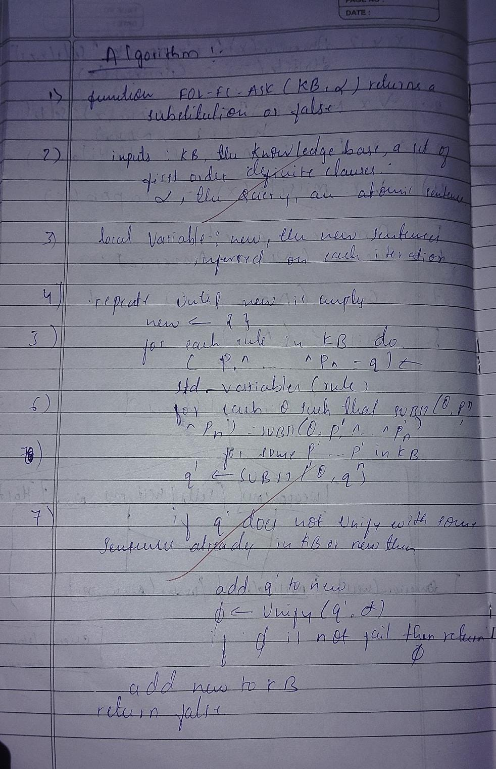
Code:
classTerm:
"""Base class for terms in first-order logic""" pass

classConstant(Term):
"""Represents a constant"""

def__init__(self, name):
self.name = name

def__eq__(self, other):
returnisinstance(other, Constant) and self.name == other.name
def__repr__(self):
return self.name
def__hash__(self):
returnhash(('Constant', self.name))
classVariable(Term):
"""Represents a variable""" def__init__(self, name):
self.name = name

def__eq__(self, other):
returnisinstance(other, Variable) and self.name == other.name
def__repr__(self):
return self.name
def__hash__(self):
returnhash(('Variable', self.name))
classPredicate(Term):
"""Represents a predicate with arguments"""
def__init__(self, name, args):
self.name = name
self.args = args ifisinstance(args, list) else [args]
def__eq__(self, other):
return (isinstance(other, Predicate) and
self.name == other.name and
len(self.args) == len(other.args) and
all(a == b for a, b inzip(self.args, other.args)))
def__repr__(self):
returnf"{self.name}({', '.join(str(arg) for arg in self.args)})"
def__hash__(self):
returnhash((self.name, tuple(self.args)))
classRule:
"""Represents an implication rule: premises => conclusion"""
def__init__(self, premises, conclusion):
self.premises = premises ifisinstance(premises, list) else [premises] self.conclusion = conclusion
def__repr__(self):
premises_str = ' ∧ '.join(str(p) for p in self.premises) returnf"{premises_str} => {self.conclusion}"
# Variable counter for standardization
_var_counter = 0
defget_new_variable():
"""Generate a new unique variable"""
global _var_counter
_var_counter += 1
return Variable(f"v{_var_counter}")
defstandardize_variables(rule):
"""Replace all variables in rule with new unique variables""" var_mapping = {}
defreplace_vars(term):
ifisinstance(term, Variable):
if term notin var_mapping:
var_mapping[term] = get_new_variable()
return var_mapping[term]
elifisinstance(term, Predicate):
new_args = [replace_vars(arg) for arg in term.args] return Predicate(term.name, new_args)
else:
40

return term
new_premises = [replace_vars(p) for p in rule.premises] new_conclusion = replace_vars(rule.conclusion)
return Rule(new_premises, new_conclusion)
defoccurs_check(var, term, subst):
"""Check if variable occurs in term"""
if var == term:
returnTrue
elifisinstance(term, Variable) and term in subst:
return occurs_check(var, subst[term], subst)
elifisinstance(term, Predicate):
returnany(occurs_check(var, arg, subst) for arg in term.args) returnFalse
defapply_substitution(term, subst):
"""Apply substitution to a term"""
ifisinstance(term, Variable):
if term in subst:
return apply_substitution(subst[term], subst)
return term
elifisinstance(term, Predicate):
new_args = [apply_substitution(arg, subst) for arg in term.args] return Predicate(term.name, new_args)
else:
return term
defunify(term1, term2, subst=None):
"""Unification algorithm"""
if subst isNone:
subst = {}
term1 = apply_substitution(term1, subst)
term2 = apply_substitution(term2, subst)
if term1 == term2:
return subst
elifisinstance(term1, Variable):
if occurs_check(term1, term2, subst):
returnNone
else:
new_subst = subst.copy()
new_subst[term1] = term2
return new_subst
elifisinstance(term2, Variable):
if occurs_check(term2, term1, subst):
returnNone
else:
new_subst = subst.copy()
new_subst[term2] = term1
return new_subst
elifisinstance(term1, Constant) orisinstance(term2, Constant): returnNone
elifisinstance(term1, Predicate) andisinstance(term2, Predicate): if term1.name != term2.name orlen(term1.args) != len(term2.args): returnNone
current_subst = subst.copy()
41

for arg1, arg2 inzip(term1.args, term2.args):
current_subst = unify(arg1, arg2, current_subst) if current_subst isNone:
returnNone
return current_subst
else:
returnNone
defunify_all(premises, kb_facts, subst=None): """Try to unify all premises with facts in KB""" if subst isNone:
subst = {}
ifnot premises:
return [subst]
first_premise = premises[0]
remaining_premises = premises[1:]
all_substitutions = []
for fact in kb_facts:
theta = unify(first_premise, fact, subst.copy())
if theta isnotNone:
# Apply substitution to remaining premises
substituted_remaining = [apply_substitution(p, theta) for p in remaining_premises]
# Recursively unify remaining premises
result_substs = unify_all(substituted_remaining, kb_facts, theta) all_substitutions.extend(result_substs)
return all_substitutions
deffol_fc_ask(kb_facts, kb_rules, query, max_iterations=100): """
Forward Chaining Algorithm for First-Order Logic
Args:
kb_facts: List of atomic sentences (facts) in KB
kb_rules: List of implication rules in KB
query: The query to prove (atomic sentence)
max_iterations: Maximum number of iterations to prevent infinite loops
Returns:
Substitution if query can be proved, None otherwise """
print("=== Forward Chaining Algorithm ===\n")
print(f"Query: {query}\n")
print("Initial KB Facts:")
for fact in kb_facts:
print(f" {fact}")
print("\nKB Rules:")
for rule in kb_rules:
print(f" {rule}")
print("\n" + "="*50 + "\n")
iteration = 0
while iteration < max_iterations:
42

iteration += 1
new = []
print(f"Iteration {iteration}:")
# For each rule in KB
for rule in kb_rules:
# Standardize variables in the rule std_rule = standardize_variables(rule)
# Try to find substitutions that satisfy all premises substitutions = unify_all(std_rule.premises, kb_facts)
# For each valid substitution
for theta in substitutions:
# Apply substitution to conclusion
inferred = apply_substitution(std_rule.conclusion, theta)
# Check if this fact is new
if inferred notin kb_facts and inferred notin new: new.append(inferred)
print(f" Inferred: {inferred}")
print(f" From rule: {std_rule}")
print(f" With substitution: {theta}")
# Check if inferred fact unifies with query result = unify(inferred, query)
if result isnotNone:
print(f"\n*** Query proved! ***")
print(f"Substitution: {result}")
return result
# If no new facts inferred, we're done
ifnot new:
print(" No new facts inferred.")
print("\nForward chaining completed. Query cannot be proved.") returnNone
# Add new facts to KB
kb_facts.extend(new)
print()
print(f"Maximum iterations ({max_iterations}) reached.") returnNone
defparse_term(term_str):
"""Parse a string into a Term object""" term_str = term_str.strip()
if'('in term_str:
paren_idx = term_str.index('(')
pred_name = term_str[:paren_idx].strip()
args_str = term_str[paren_idx+1:term_str.rindex(')')].strip()
args = []
depth = 0
current_arg = ""
for char in args_str:
if char == ','and depth == 0:
43

args.append(parse_term(current_arg))
current_arg = ""
else:
if char == '(':
depth += 1
elif char == ')':
depth -= 1
current_arg += char
if current_arg.strip():
args.append(parse_term(current_arg))
return Predicate(pred_name, args)
elif term_str[0].islower():
return Variable(term_str)
else:
return Constant(term_str)
defparse_rule(rule_str):
"""Parse a rule string like 'P(x) ∧ Q(x) => R(x)'""" if'=>'in rule_str:
parts = rule_str.split('=>')
conclusion_str = parts[1].strip()
premises_str = parts[0].strip()
# Split premises by ∧ or AND
premise_parts = [p.strip() for p in premises_str.replace('AND', '∧').split('∧')]
premises = [parse_term(p) for p in premise_parts] conclusion = parse_term(conclusion_str)
return Rule(premises, conclusion)
else:
# It's just a fact
return parse_term(rule_str)
# Example usage
if __name__ == "__main__":
print("Choose mode:")
print("1. Run example (Animal reasoning)") print("2. Interactive mode")
choice = input("\nEnter choice (1 or 2): ").strip() print()
if choice == '1':
# Example: Animal reasoning
# Facts
kb_facts = [
Predicate('Animal', [Constant('Dog')]),
] | Predicate('Animal', [Constant('Cat')]),  Predicate('Loves', [Constant('John'), Constant('Dog')]), Predicate('Owns', [Constant('John'), Constant('Dog')])
# Rules
kb_rules = [
# Animal(x) ∧ Loves(y, x) => Loves(x, y)
44

Rule([Predicate('Animal', [Variable('x')]),
Predicate('Loves', [Variable('y'), Variable('x')])], Predicate('Loves', [Variable('x'), Variable('y')])),
] | # Owns(x, y) ∧ Animal(y) => KeepsAsPet(x, y)  Rule([Predicate('Owns', [Variable('x'), Variable('y')]), Predicate('Animal', [Variable('y')])],  Predicate('KeepsAsPet', [Variable('x'), Variable('y')]))
# Query: Does Dog love John?
query = Predicate('Loves', [Constant('Dog'), Constant('John')])
result = fol_fc_ask(kb_facts, kb_rules, query)
elif choice == '2':
print("=== Interactive Forward Chaining ===")
print("Enter facts and rules for the knowledge base.\n")
kb_facts = []
kb_rules = []
# Input facts
print("Enter facts (one per line, empty line to finish):") print("Example: Animal(Dog), Loves(John, Dog)")
whileTrue:
fact_str = input("Fact: ").strip()
ifnot fact_str:
break
try:
fact = parse_term(fact_str)
kb_facts.append(fact)
except Exception as e:
print(f"Error parsing fact: {e}")
# Input rules
print("\nEnter rules (one per line, empty line to finish):") print("Example: Animal(x) ∧ Loves(y,x) => Loves(x,y)") print("You can also use 'AND' instead of ∧")
whileTrue:
rule_str = input("Rule: ").strip()
ifnot rule_str:
break
try:
rule = parse_rule(rule_str)
kb_rules.append(rule)
except Exception as e:
print(f"Error parsing rule: {e}")
# Input query
print("\nEnter query:")
query_str = input("Query: ").strip()
try:
query = parse_term(query_str)
result = fol_fc_ask(kb_facts, kb_rules, query) except Exception as e:
print(f"Error parsing query: {e}")
else:
45

print("Invalid choice.")
Choose mode:
1. Run example (Animal reasoning)
2. Interactive mode
Enter choice (1 or 2): 2
=== Interactive Forward Chaining ===
Enter facts and rules for the knowledge base.
Enter facts (one per line, empty line to finish): Example: Animal(Dog), Loves(John, Dog)
Fact: Owns(A, T1)
Fact: Missile(T1)
Fact: American(Robert)
Fact: Enemy(A, America)
Fact:
Enter rules (one per line, empty line to finish):
Example: Animal(x) ∧ Loves(y,x) => Loves(x,y)
You can also use 'AND' instead of ∧
Rule: American(p) ∧ Weapon(q) ∧ Sells(p,q,r) ∧ Hostile(r) => Criminal(p) Rule: Missile(x) ∧ Owns(A,x) => Sells(Robert,x,A)
Rule: Missile(x) => Weapon(x)
Rule: Enemy(x,America) => Hostile(x)
Rule:
Enter query:
Query: Criminal(Robert)
=== Forward Chaining Algorithm ===
Query: Criminal(Robert)
Initial KB Facts:
Owns(A, T1)
Missile(T1)
American(Robert)
Enemy(A, America)
KB Rules:
American(p) ∧ Weapon(q) ∧ Sells(p, q, r) ∧ Hostile(r) => Criminal(p) Missile(x) ∧ Owns(A, x) => Sells(Robert, x, A)
Missile(x) => Weapon(x)
Enemy(x, America) => Hostile(x)
==================================================
46

Iteration 1:
Inferred: Sells(Robert, T1, A)
From rule: Missile(v4) ∧ Owns(A, v4) => Sells(Robert, v4, A) With substitution: {v4: T1}
Inferred: Weapon(T1)
From rule: Missile(v5) => Weapon(v5)
With substitution: {v5: T1}
Inferred: Hostile(A)
From rule: Enemy(v6, America) => Hostile(v6)
With substitution: {v6: A}
Iteration 2:
Inferred: Criminal(Robert)
From rule: American(v7) ∧ Weapon(v8) ∧ Sells(v7, v8, v9) ∧ Hostile(v9) => Crimin al(v7)
With substitution: {v7: Robert, v8: T1, v9: A}
*** Query proved! ***
Substitution: {}
47

Program 9
Create a knowledge base consisting of first order logic statements and prove the given query using Resolution
Algorithm:
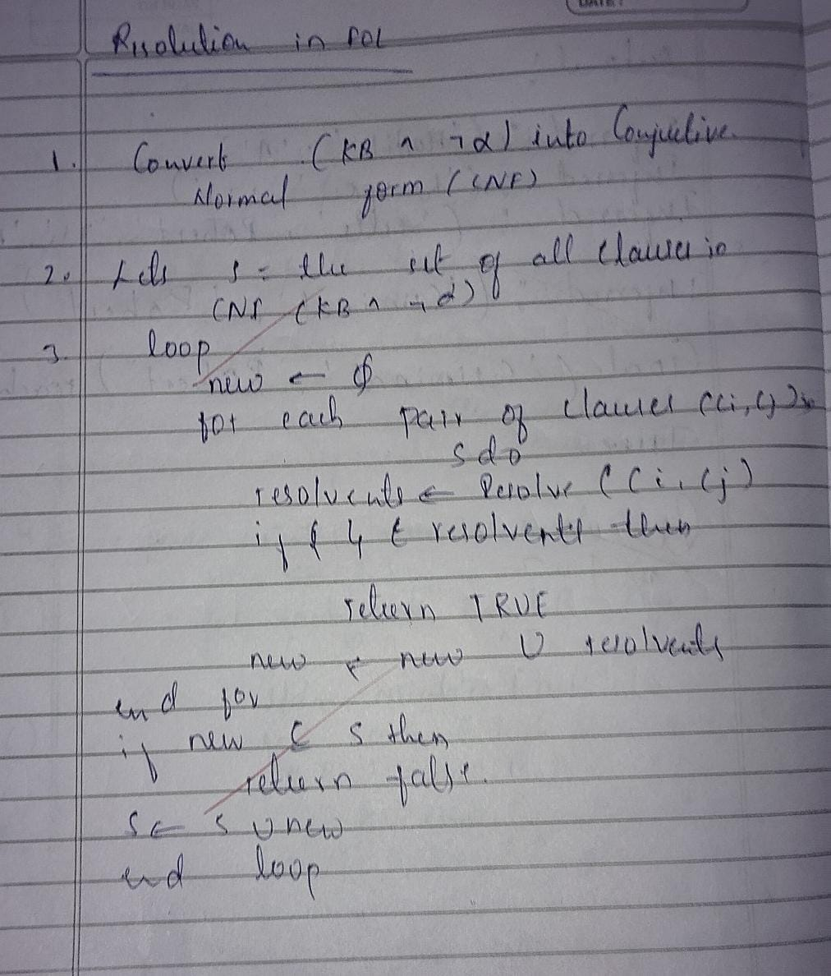
Code:
import re
import itertools

VAR_RE = re.compile(r'^[a-z](_\d+)?$') # single-letter variable optionally standardized (x_0, y_3)

defis_variable(token: str) -> bool: returnbool(VAR_RE.fullmatch(token))
defparse_literal(text):
text = text.strip()
neg = False
if text.startswith('¬') or text.startswith('~'):
neg = True
text = text[1:].strip()
if'('in text:
pred = text[:text.index('(')].strip()
args = [a.strip() for a in text[text.index('(')+1:-1].split(',')]
else:
pred = text
args = []
return {'neg': neg, 'pred': pred, 'args': args}

defclause_to_str(clause):
if clause == []:
return'⊥'
parts = []
for lit in clause:
48

s = ('¬'if lit['neg'] else'') + (lit['pred'] + '(' + ', '.join(lit['args']) + ')'if lit['args'] else lit['pred'])
parts.append(s)
return' ∨ '.join(parts)
defstandardize_apart_clause(clause, idx):
# only rename variables (single-letter) to var_index form
mapping = {}
new_clause = []
for lit in clause:
new_args = []
for a in lit['args']:
if is_variable(a):
if a notin mapping:
mapping[a] = f"{a}_{idx}"
new_args.append(mapping[a])
else:
new_args.append(a)
new_clause.append({'neg': lit['neg'], 'pred': lit['pred'], 'args': new_args})
return new_clause
# ----- Unification for flat args (no nested function terms) -----defoccurs_check(var, val, subs):
# var and val are token strings
if var == val:
returnTrue
if is_variable(val) and val in subs:
return occurs_check(var, subs[val], subs)
returnFalse
defapply_subs_token(tok, subs):
if is_variable(tok):
while tok in subs:
tok = subs[tok]
return tok
return tok
defapply_subs_literal(lit, subs):
new_args = [apply_subs_token(a, subs) for a in lit['args']] return {'neg': lit['neg'], 'pred': lit['pred'], 'args': new_args}
defunify_tokens(x, y, subs):
# x,y are token strings (variables or constants) if x == y:
return subs
if is_variable(x):
if x in subs:
return unify_tokens(subs[x], y, subs) if occurs_check(x, y, subs):
returnNone
new = subs.copy()
new[x] = y
return new
if is_variable(y):
return unify_tokens(y, x, subs)
# both constants and different => fail
returnNone
49

defunify_arg_lists(a_list, b_list):
iflen(a_list) != len(b_list):
returnNone
subs = {}
for a, b inzip(a_list, b_list):
a_ap = a ifnot is_variable(a) else a
b_ap = b ifnot is_variable(b) else b
subs = unify_tokens(apply_subs_token(a_ap, subs), apply_subs_token(b_ap, subs), subs)
if subs isNone:
returnNone
return subs
# ----- Resolution -----
defis_tautology_clause(clause):
# clause is a list of literals (after substitution). If it contains A and ¬A same args -> tautology
seen = {}
for lit in clause:
key = (lit['pred'], tuple(lit['args']))
if key in seen:
if seen[key] != lit['neg']:
returnTrue
else:
seen[key] = lit['neg']
returnFalse
defresolve_pair(c1, c2):
# c1, c2 are lists of literals (each literal dict)
for i, l1 inenumerate(c1):
for j, l2 inenumerate(c2):
if l1['pred'] == l2['pred'] and l1['neg'] != l2['neg']:
# try to unify their args
subs = unify_arg_lists(l1['args'], l2['args'])
if subs isNone:
continue
# apply substitution to the remainder of both clauses
new_clause = []
for k, lit inenumerate(c1):
if k == i: continue
new_clause.append(apply_subs_literal(lit, subs))
for k, lit inenumerate(c2):
if k == j: continue
new_clause.append(apply_subs_literal(lit, subs))
# remove duplicates (syntactic)
uniq = []
for lit in new_clause:
ifnotany(lit['pred']==u['pred'] and lit['neg']==u['neg'] and lit['args']==u['args'] for u in uniq):
uniq.append(lit)
if is_tautology_clause(uniq):
continue
return uniq, subs, (i, j)
returnNone, None, None
# ----- Build derivation tree nodes -----
classNode:
def__init__(self, clause, parents=None, label=None): self.clause = clause
50

self.parents = parents if parents else [] self.label = label
defresolution_with_tree(initial_clauses, goal_clause):
# standardize apart initial clauses
clauses_nodes = []
for idx, c inenumerate(initial_clauses):
std = standardize_apart_clause(c, idx)
clauses_nodes.append(Node(std, parents=[] , label=f"C{idx}"))
# add negated goal as a fresh clause (standardize apart too)
neg_goal = []
# goal_clause is a clause list (we take its first literal if single-literal goal)
for lit in goal_clause:
# negate each literal in goal clause (if goal is a single positive literal user passed)
neg_goal.append({'neg': not lit['neg'], 'pred': lit['pred'], 'args': lit['args'][:]})
neg_goal_std = standardize_apart_clause(neg_goal, len(clauses_nodes))
goal_node = Node(neg_goal_std, parents=[], label="¬Goal")
clauses_nodes.append(goal_node)
# mapping from index -> Node
idx = len(clauses_nodes)
seen_clauses = {clause_to_str(n.clause): i for i, n inenumerate(clauses_nodes)}
# perform breadth-first-ish resolution (pairwise), record parents as indices for a_index inrange(len(clauses_nodes)):
pass# placeholder, we'll use dynamic loop below
frontier_changed = True
whileTrue:
new_added = False
# iterate pairs over current clauses
n = len(clauses_nodes)
pairs = [(i,j) for i inrange(n) for j inrange(i+1, n)]
for i,j in pairs:
c1 = clauses_nodes[i].clause
c2 = clauses_nodes[j].clause
resolvent, subs, which = resolve_pair(c1, c2)
if resolvent isNone:
continue
s = clause_to_str(resolvent)
if s in seen_clauses:
continue
# add node
new_node = Node(resolvent, parents=[i, j], label=f"R{idx}") clauses_nodes.append(new_node)
seen_clauses[s] = idx
new_added = True
idx += 1
if resolvent == []:
# build bottom-up tree node for ⊥
root = new_node
return clauses_nodes, seen_clauses, idx-1# return nodes, map, index of empty clause node
ifnot new_added:
return clauses_nodes, seen_clauses, None
51

# ----- ASCII print bottom-up (root bottom) -----
defprint_bottom_up_tree(nodes, root_index):
# recursively print node; ensure parents printed above defrecurse(node_index, prefix="", is_last=True):
node = nodes[node_index]
connector = "└── "if is_last else"├── "
print(prefix + connector + clause_to_str(node.clause))
# if this node has parents, print them above (parents as children in recursion so they appear above)
parents = node.parents
for k, pidx inenumerate(parents):
recurse(pidx, prefix + (" "if is_last else"│ "), k ==
len(parents)-1)
recurse(root_index, "", True)
# ----- Runner -----
if __name__ == "__main__":
print("="*70)
print("FIRST-ORDER LOGIC RESOLUTION SYSTEM (FIXED)")
print("="*70)
print("Enter CNF clauses (one per line). End with a blank line.")
raw = []
whileTrue:
try:
line = input().strip()
except EOFError:
break
if line == "":
break
raw.append(line)
clauses = [ [parse_literal(tok.strip()) for tok in re.split(r"∨", line) ] for line in raw ]
# read goal
goal_line = input("\nEnter GOAL clause (single literal form): ").strip() goal_clause = [parse_literal(goal_line)]
nodes, seen_map, root_idx = resolution_with_tree(clauses, goal_clause) if root_idx isNone:
print("\nNo empty clause could be derived — goal not entailed by KB.") else:
print("\nDERIVATION TREE (bottom-up):") print_bottom_up_tree(nodes, root_idx)
print("\nResolution complete — ⊥ derived.")
52

====================================================================== FIRST-ORDER LOGIC RESOLUTION SYSTEM
====================================================================== Enter CNF clauses (one per line). End with a blank line.
¬human(x) ∨ mortal(x)
human(Socrates)
Enter GOAL clause (single literal form): mortal(Socrates)
DERIVATION TREE (bottom-up):
└── ⊥
├── human(Socrates)
└── ¬human(Socrates)
├── ¬human(x_0) ∨ mortal(x_0)
└── ¬mortal(Socrates)
Resolution complete — ⊥ derived.
53

Program 10
Implement Alpha-Beta Pruning.
Algorithm:
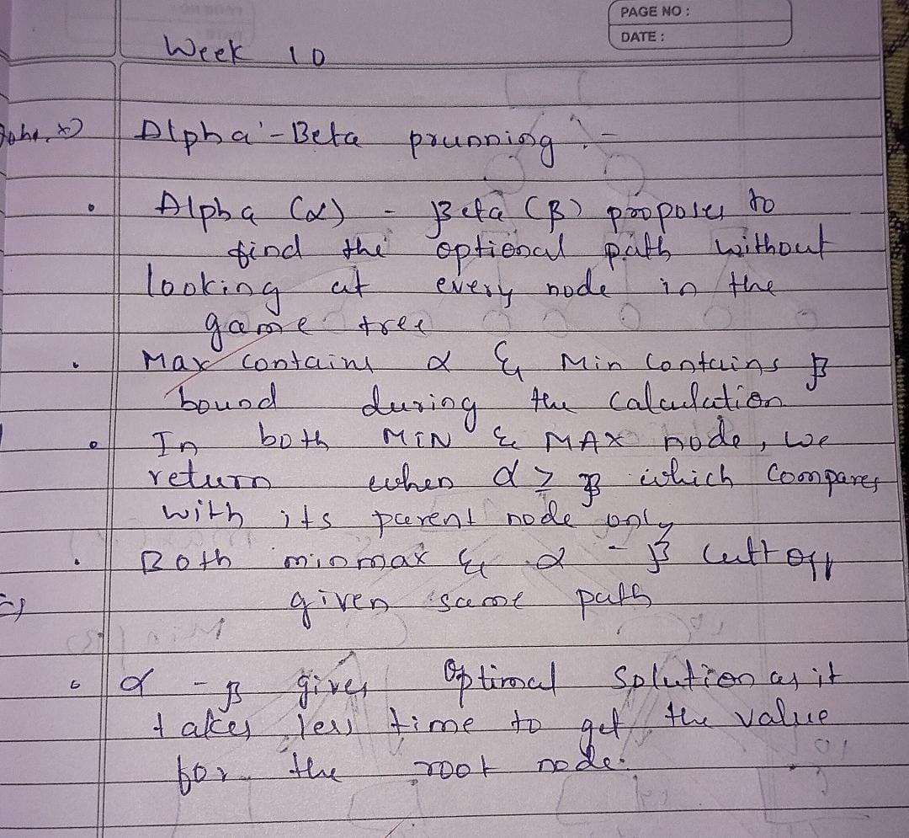
Code:
import networkx as nx
import matplotlib.pyplot as plt
import math
# --- Alpha-Beta Pruning ---
defalpha_beta(node, depth, alpha, beta, maximizing, tree, values, pruned_nodes, path):

# Leaf node
if depth == 0or node notin tree: return values.get(node, None)
if maximizing:
value = -math.inf
for child in tree[node]:
val = alpha_beta(child, depth - 1, alpha, beta, False, tree, values,
pruned_nodes, path)
if val isNone:
continue
value = max(value, val)
alpha = max(alpha, value)
if beta <= alpha:
# Prune remaining children
prune_index = tree[node].index(child) + 1 for c in tree[node][prune_index:]:
54

pruned_nodes.append(c)
break
values[node] = value
return value
else:
value = math.inf
for child in tree[node]:
val = alpha_beta(child, depth - 1, alpha, beta, True, tree, values, pruned_nodes, path)
if val isNone:
continue
value = min(value, val)
beta = min(beta, value)
if beta <= alpha:
prune_index = tree[node].index(child) + 1
for c in tree[node][prune_index:]:
pruned_nodes.append(c)
break
values[node] = value
return value
# --- Draw Game Tree ---
defdraw_game_tree(G, path, pruned):
pos = nx.nx_agraph.graphviz_layout(G, prog="dot") plt.figure(figsize=(9, 6))
edge_colors = []
for (u, v) in G.edges():
if u in path and v in path:
edge_colors.append('green')
elif v in pruned:
edge_colors.append('red')
else:
edge_colors.append('black')
node_colors = []
for node in G.nodes():
if node in path:
node_colors.append('green')
elif node in pruned:
node_colors.append('red')
else:
node_colors.append('skyblue')
nx.draw(
G, pos, with_labels=True,
node_color=node_colors,
) | edge_color=edge_colors,  node_size=1200,  font_size=10
plt.title("Alpha-Beta Pruning Game Tree\nGreen = Optimal Path | Red = Pruned Nodes")
plt.show()
55

# --- Main Program ---
defmain():
tree = {}
G = nx.DiGraph()
n = int(input("Enter number of non-leaf nodes: ")) for _ inrange(n):
parent = input("\nEnter parent node: ").strip()
children = input("Enter children of " + parent + " (space separated): ").split()
tree[parent] = children
for c in children:
G.add_edge(parent, c)
leaf_count = int(input("\nEnter number of leaf nodes: "))
values = {}
for _ inrange(leaf_count):
leaf, val = input("Enter leaf node and its value (e.g. E 3): ").split() values[leaf] = int(val)
root = input("\nEnter root node: ").strip()
depth = int(input("Enter total depth of tree: "))

pruned_nodes = []
path = []
print("\n--------------------------------")
result = alpha_beta(root, depth, -math.inf, math.inf, True, tree, values, pruned_nodes, path)
print(f"Final Optimal Value: {result}")
print(f"Pruned Nodes: {pruned_nodes}")
print("--------------------------------")
draw_game_tree(G, path=[root, 'C', 'G'], pruned=pruned_nodes)

if __name__ == "__main__":
main()
Enter number of non-leaf nodes: 4
Enter parent node: A
Enter children of A (space separated): B C D
Enter parent node: B
Enter children of B (space separated): E F
Enter parent node: C
Enter children of C (space separated): G H
Enter parent node: D
Enter children of D (space separated): I J
Enter number of leaf nodes: 6
Enter leaf node and its value (e.g. E 3): E 3 Enter leaf node and its value (e.g. E 3): F 5 Enter leaf node and its value (e.g. E 3): G 6
56

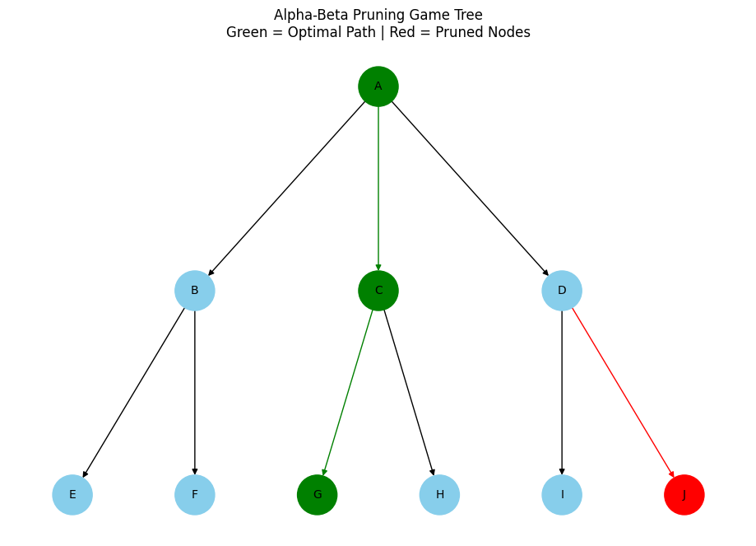
Enter leaf node and its value (e.g. E 3): H 9 Enter leaf node and its value (e.g. E 3): I 1 Enter leaf node and its value (e.g. E 3): J 2
Enter root node: A
Enter total depth of tree: 3
--------------------------------
Final Optimal Value: 6
Pruned Nodes: ['J']
--------------------------------
57

