1SANG BANYUHAY FINANCIAL GROUP
1B Coaching Hub
Manager's Guide
A practical, step-by-step guide to logging coaching sessions,
reading your dashboard, and understanding how acknowledgment works.
September 2026

Contents
1. Getting Started 3
2. Your Dashboard 3
2.1 Overview tab 3
2.2 Planner Summary tab 5
3. My Planners 6
4. Logging a Coaching Session 6
5. Competency Levels and the 24-Hour Rule 8
5.1 Rating Proficient closes the loop 8
5.2 The 24-hour acknowledge window 8
6. Viewing a Session's Full Details 9
7. Quick Reference: Status Badges 9

1. Getting Started
The 1B Coaching Hub is where you log, track, and follow up on coaching sessions with the planners on your team. It is not a learning-management system — it does not deliver training content. It is a record of who you coached, what you covered, how they're progressing, and whether they've acknowledged the session.
As a Manager, you'll use it to:
- Log a coaching session right after you have one with a planner.
- Track each planner's competency and coaching history over time.
- See, at a glance, who on your team still needs coaching this period.
- Make sure sessions are acknowledged within the 24-hour window so they count.

Signing in and finding your way around
Once signed in, your left-hand menu gives you six sections:
- Dashboard — your coaching overview and planner summary (covered in Section 2).
- My Planners — the full roster of planners who report to you (Section 3).
- Sales Cycle, Income Simulation, Terminologies, Useful Links — reference and selling tools outside the coaching workflow, not covered in this guide.
Your name and role show in the top-right corner of every page, so you always know which account you're on.

2. Your Dashboard
Your dashboard has two tabs: Overview, and Planner Summary.

2.1 Overview tab
This is what you land on. It shows your team's coaching activity for whichever period you have selected, plus the full list of sessions behind those numbers.
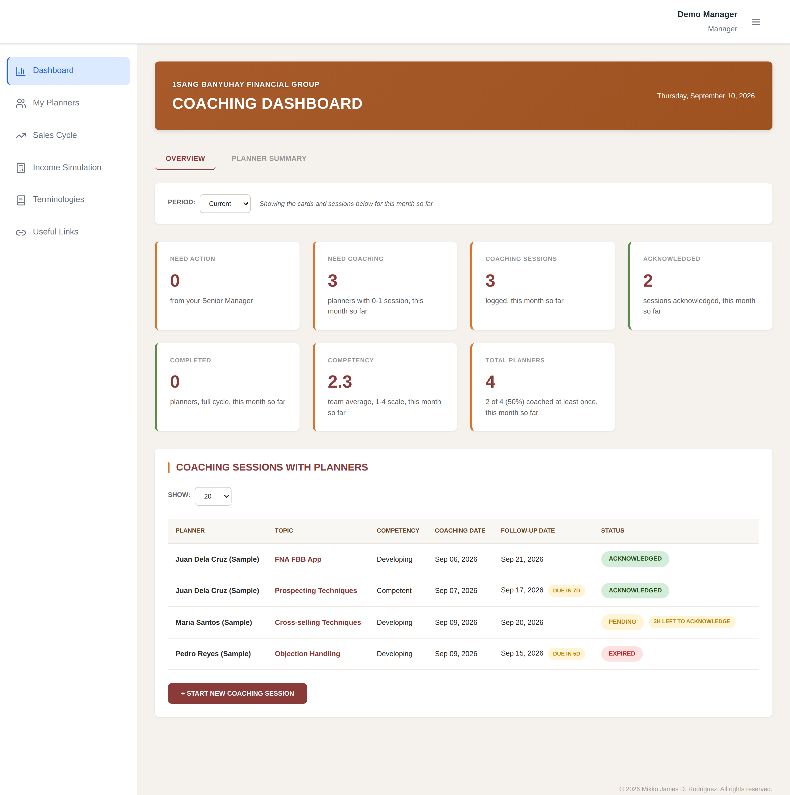
The Overview tab — period selector, metric cards, and the sessions table. Sample data shown.
The Period selector controls everything on this tab:
- Current — this month so far (the default view).
- Previous — last month, in full.
- QTD — quarter-to-date.
- YTD — year-to-date.
The seven cards summarize the selected period:
- Need Action — coaching sessions your own Senior Manager logged for you that you still need to acknowledge.
- Need Coaching — how many of your planners have had 0–1 session in the period. Use this to spot who's falling behind.
- Coaching Sessions — total sessions logged with your team in the period.
- Acknowledged — of those, how many the planner has confirmed.
- Completed — planners who finished a full coaching cycle (reached Proficient and closed it out) in the period.
- Competency — your team's average competency score, on the 1–4 scale, for sessions logged in the period.
- Total Planners — your full headcount, with how many you've coached at least once this period.
Below the cards, the Coaching Sessions With Planners table lists every session in the period, with its topic, competency rating, coaching date, follow-up date, and status. A short explanation of each status badge is in Section 6 (Quick Reference).

2.2 Planner Summary tab
Planner Summary is a single, always-current table: all-time totals for every planner on your team, no matter what period is selected on Overview. Use this when you want the full picture for one planner rather than a monthly snapshot.
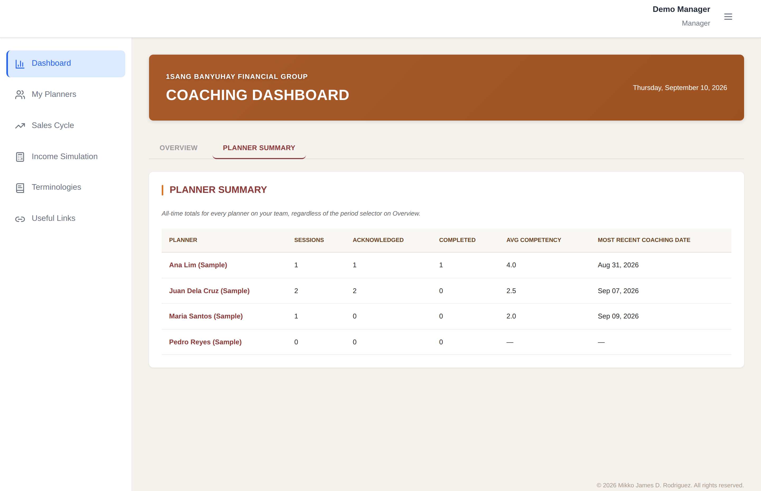
The Planner Summary tab — all-time sessions, acknowledgment rate, and average competency per planner.
Click any planner's name, here or on My Planners, to open their full coaching history.

3. My Planners
This page lists every planner who reports to you, with their branch, total sessions logged, and current status — Needs Coaching or Acknowledged — at a glance.
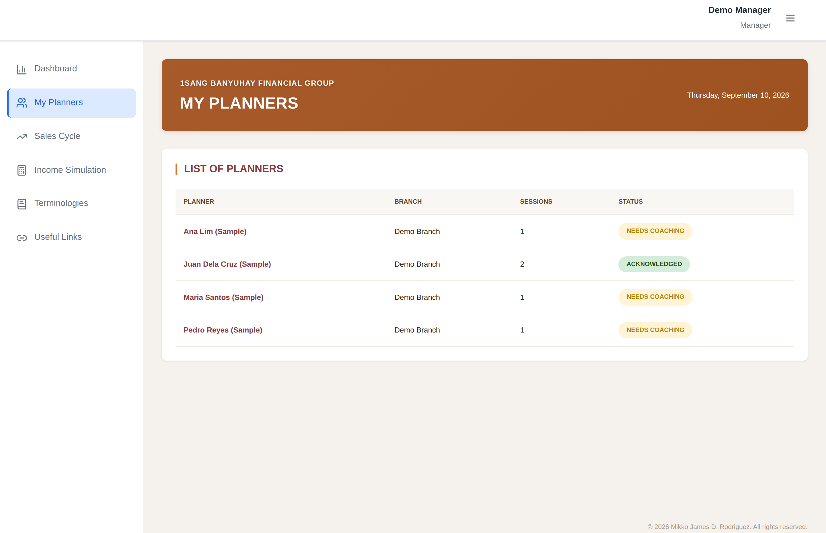
My Planners — your full roster with a one-glance status per planner.
Use this list to decide who to prioritize for a coaching session: anyone marked Needs Coaching hasn't had a recent acknowledged session.

4. Logging a Coaching Session
Start a new session from the + Start New Coaching Session button on the Overview tab. The form has five sections, and you must complete all of them before you can save.
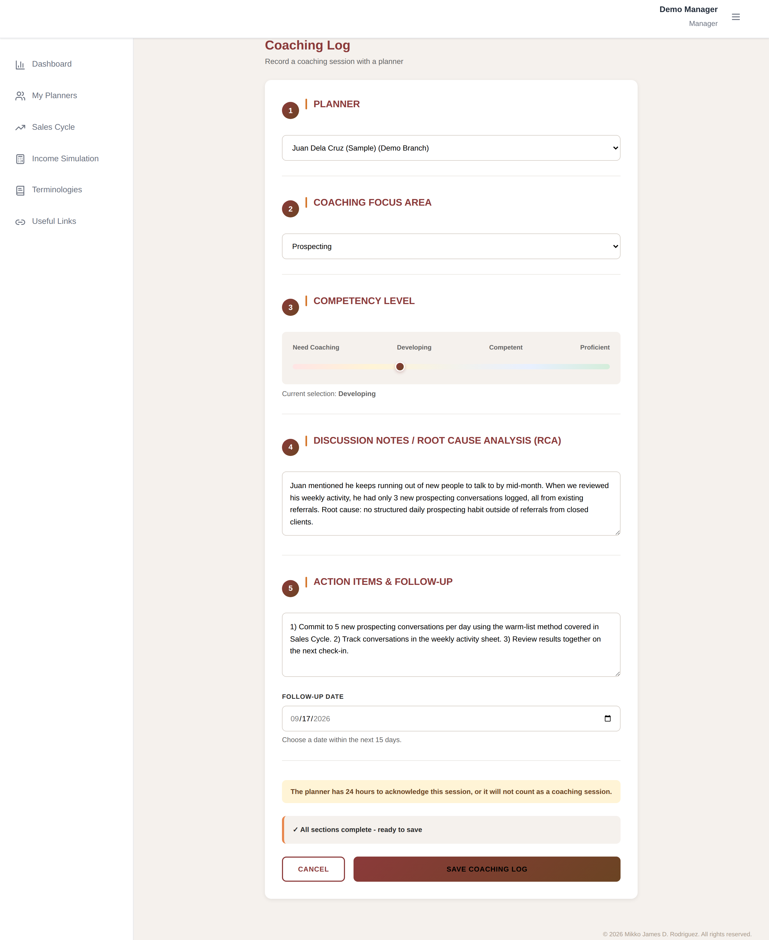
The Coaching Log form, filled out as an example. The status bar at the bottom confirms when every section is complete.
Walking through it:
- Planner — choose who the session is with, from your roster.
- Coaching Focus Area — pick the topic you covered, from a fixed list (Prospecting, Objection-Handling, Closing, FNA FBB App, and so on).
- Competency Level — rate the planner on this topic using the slider: Need Coaching, Developing, Competent, or Proficient. Your current selection is shown in bold beneath the slider. Rating a planner Proficient opens an extra choice — see Section 5.
- Discussion Notes / Root Cause Analysis (RCA) — what you observed, and what's actually behind it. This is the coaching record itself, so be specific: what did the planner do, and why.
- Action Items & Follow-Up — what the planner commits to before next time, plus a Follow-Up Date. The date must fall within the next 15 days.
Two important notes about coaching dates:
- There is no backdating. Every session is logged as happening today — there's no field to set an earlier date. Log the session on the day it actually happens.
- Once you save, the planner has 24 hours to acknowledge it — covered in full in Section 5.

5. Competency Levels and the 24-Hour Rule

5.1 Rating Proficient closes the loop
If you rate a planner Proficient on a topic, the form assumes that topic's coaching cycle is done and gives you a choice:
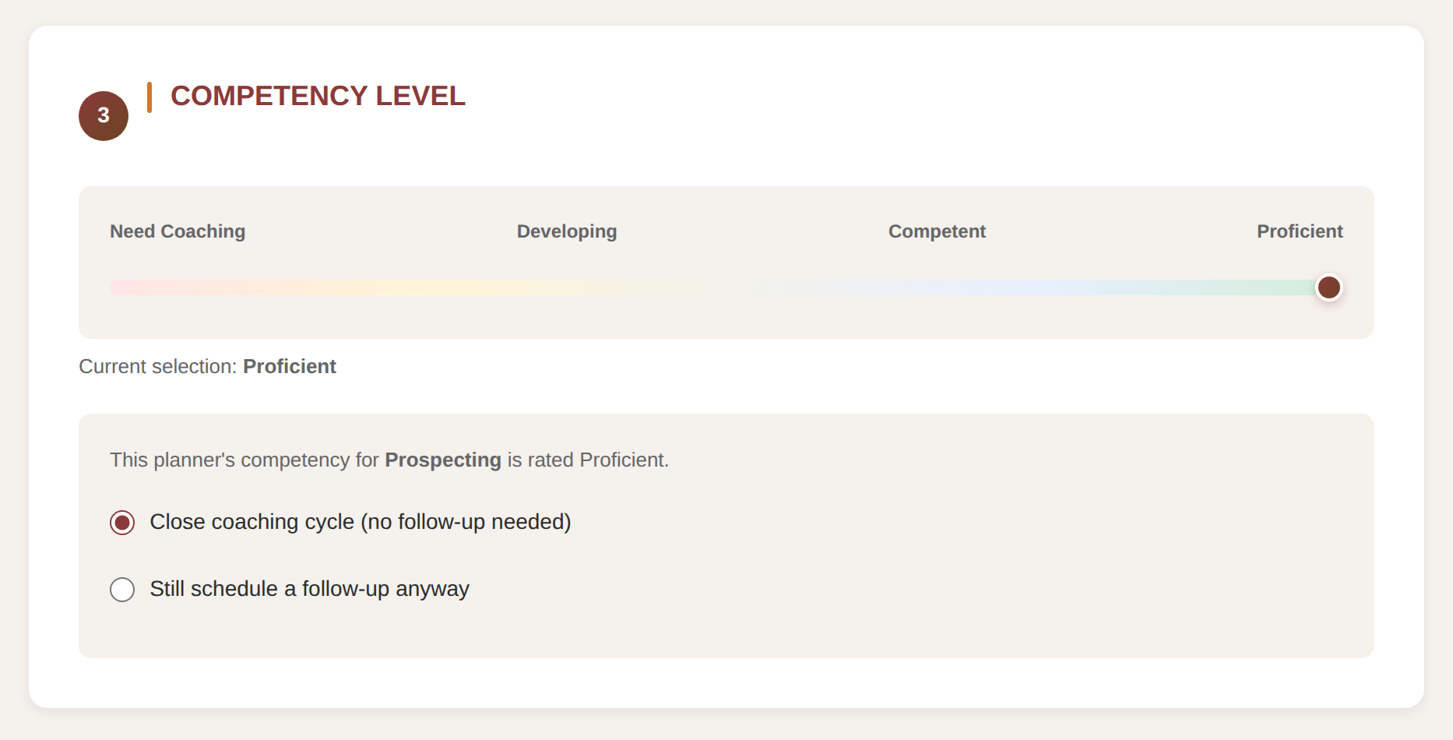
Only appears when the slider is set to Proficient.
- Close coaching cycle (no follow-up needed) — selected by default. No follow-up date is required for this topic.
- Still schedule a follow-up anyway — pick this if you want to check in again even though the planner has mastered the topic.

5.2 The 24-hour acknowledge window
A session only counts as coaching once the planner acknowledges it — and they have exactly 24 hours from the moment you save it to do so.

This is a hard rule, with no exceptions and no manual override:
- If the planner acknowledges within 24 hours, the session is confirmed and counts toward every dashboard stat — sessions logged, acknowledged count, competency average, and the planner's summary.
- If 24 hours pass with no acknowledgment, the session automatically expires. This is permanent — there is no way to reopen or override an expired session, for anyone.
- An expired session is never deleted. It stays visible in the sessions table and in the planner's history, clearly marked Expired, so the trend is never hidden — it's simply excluded from the numbers, because it isn't considered a completed coaching interaction without the planner's acknowledgment.
What this means for you day-to-day: log sessions promptly, and let your planner know right after the session that they need to acknowledge it in the app within 24 hours. The Overview table will show “Xh left to acknowledge” once a pending session is down to its last few hours — that's your cue to follow up with the planner directly if it's still unacknowledged.

6. Viewing a Session's Full Details
Click any topic in a sessions table — on Overview, Planner Summary, or My Planners — to open the full record: who coached whom, the competency rating, both dates, current status, and the complete Discussion Notes and Action Items you wrote.
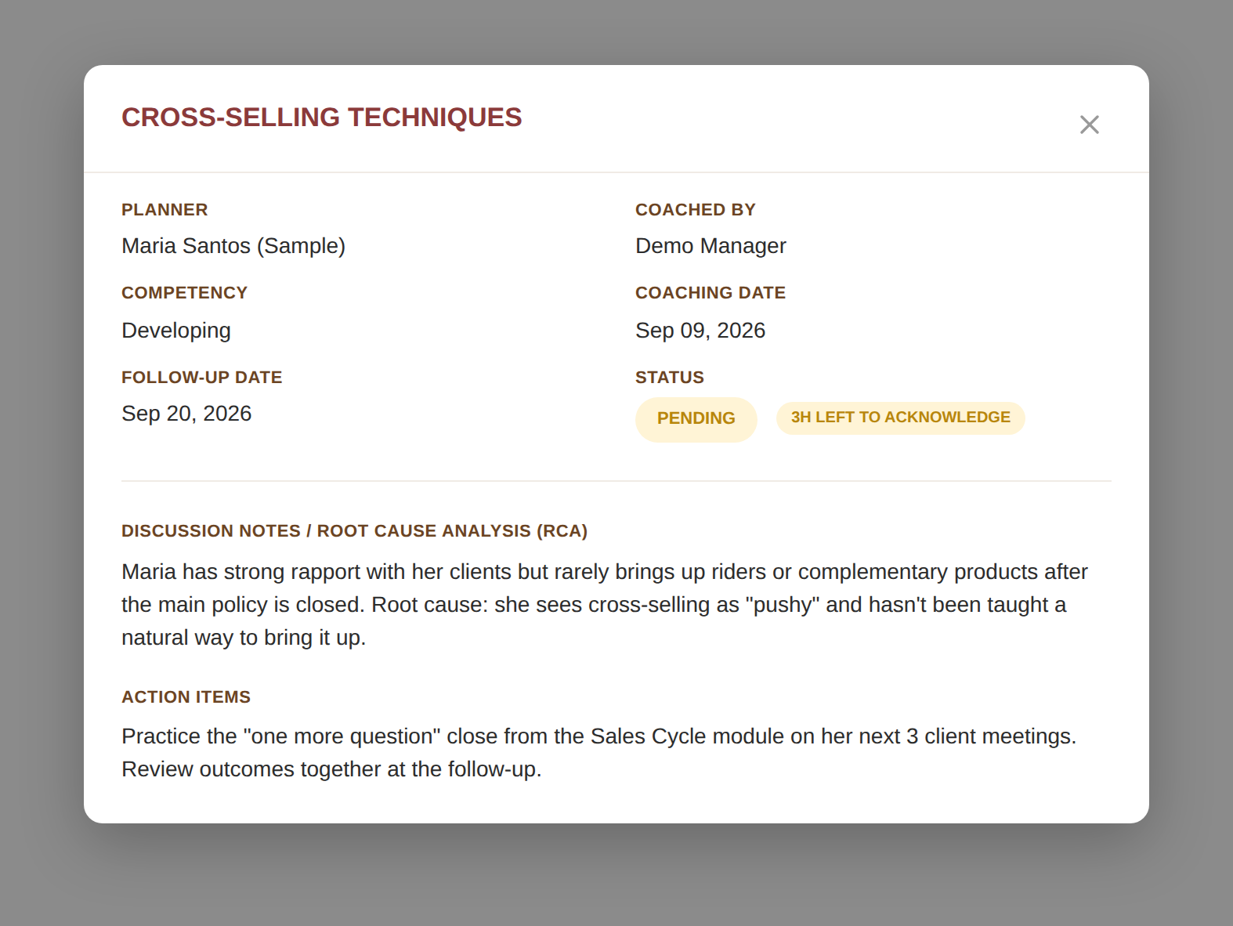
Session detail view. This example is Pending, with a few hours left in its acknowledge window.

7. Quick Reference: Status Badges
A short legend for every badge you'll see in the sessions tables:
Badge | What it means
Acknowledged | The planner confirmed the session within the 24-hour window. Counts toward all dashboard stats.
Pending | Logged, waiting on the planner to acknowledge. Still within the 24-hour window.
— Xh left to acknowledge | Appears next to Pending when less than 4 hours remain — a nudge to follow up with the planner.
Expired | The 24-hour window passed with no acknowledgment. Permanently locked — stays visible in history, but excluded from every stat and average.
Due in Xd / Due today | Shown next to the Follow-Up Date as that date approaches.

Questions about the Coaching Hub? Reach out to your Senior Manager or the team that maintains this tool.

