**试题116**

**76题**

SELECT student.sno,student.sname,grade.cno,grade.score

FROM student,grade

WHERE (student.sno=grade.sno)AND (grade.score between 80 and 89) ;

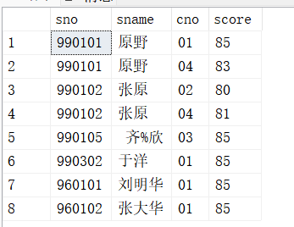

**77题**

SELECT cno,cname,credit

FROM course;

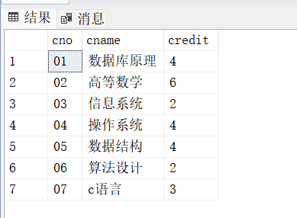

**78题**

SELECT DISTINCT SNO

FROM GRADE X

WHERE NOT EXISTS

(SELECT *

FROM GRADE Y

WHERE Y.SNO='990102' AND

NOT EXISTS

(SELECT *

FROM GRADE Z

WHERE Z.SNO = X.SNO AND Z.CNO = Y.CNO

)

);

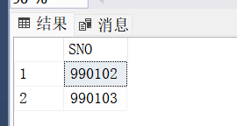

**79题**

SELECT TEACHER

FROM COURSE

WHERE CNO IN

(SELECT CNO

FROM GRADE,DEPARTMENT,STUDENT

WHERE STUDENT.SNO=GRADE.SNO AND STUDENT.DNO = DEPARTMENT.DNO AND DEPARTMENT.HEAD='秦峰');

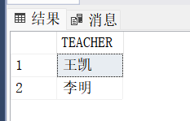

**80题**

SELECT STUDENT.SNO,STUDENT.SNAME,CNAME,SCORE

FROM STUDENT,GRADE,COURSE

WHERE STUDENT.SNO=GRADE.SNO AND GRADE.CNO = COURSE.CNO

