工程数学第8次实验报告

实验名称：矩阵的高阶运算3
姓 名： 薄劲阳
专 业： 计算机科学与技术
学 号： 2020115025

一、实验目的
掌握矩阵的常见仿真运算
- 实验内容及设备
1.实验内容:
编程生成两个随机方阵A，B
（1）实现并输出A+B
（2）验证det(A+B)=det(A)+det(B)是否成立
（3）验证det(A+B)=det(A)det(B)是否成立
（4）验证det(A⁻¹)=(det(A))⁻¹是否成立
2.实验设备:
台式计算机(笔记本)， Visual studio平台
- 程序代码
- #include <iostream>
- #include <time.h>
- #include <cstdlib>
- using namespace std;

- //计算行列式(3阶)
- int det(int a[][3]) {
- int result = 0;
- result = a[0][0] * a[1][1] * a[2][2] + a[0][1] * a[1][2] * a[2][0] + a[0][2] * a[1][0] * a[2][1] - a[0][0] * a[1][2] * a[2][1] - a[0][1] * a[1][0] * a[2][2] - a[0][2] * a[1][1] * a[2][0];

- return result;

- }
- int main() {
- srand(time(NULL));
- int A[3][3] = {0}, B[3][3] = {0};
- for (int i = 0; i < 3; ++i) {
- for (int j = 0; j < 3; ++j) {
- A[i][j] = rand() % 100;
- }
- }
- for (int i = 0; i < 3; ++i) {
- for (int j = 0; j < 3; ++j) {
- B[i][j] = rand() % 100;
- }

- }
- cout << "A is:" << endl;
- for (int i = 0; i < 3; ++i) {
- for (int j = 0; j < 3; ++j) {
- cout << A[i][j] << " ";
- }
- cout << endl;
- }

- cout << "B is:" << endl;
- for (int i = 0; i < 3; ++i) {
- for (int j = 0; j < 3; ++j) {
- cout << B[i][j] << " ";
- }
- cout << endl;
- }

- int sum[3][3] = {0};

- for (int i = 0; i < 3; ++i) {
- for (int j = 0; j < 3; ++j) {
- sum[i][j] = A[i][j] + B[i][j];
- }

- }
- cout << "sum is " << endl;

- for (int i = 0; i < 3; ++i) {
- for (int j = 0; j < 3; ++j) {
- cout << sum[i][j] << " ";
- }
- cout << endl;
- }

- int detA_B = 0;
- detA_B = det(sum);

- int deta = 0, detb = 0;
- deta = det(A);
- detb = det(B);
- if (detA_B == deta + detb) {
- cout << "det(A+B)=det(A)+det(B)" << endl;
- }
- else
- cout << "det(A+B)!=det(A)+det(B)" << endl;
- if (detA_B == deta * detb) {
- cout << "det(A+B)=det(A)det(B)" << endl;
- }

- else
- cout << "det(A+B)!=det(A)det(B)" << endl;

- int A_[3][3] = {0};
- //伴随矩阵计算
- A_[0][0] = A[1][1] * A[2][2] - A[1][2] * A[2][1];
- A_[0][1] = -(A[0][1] * A[2][2] - A[0][2] * A[2][1]);
- A_[0][2] = A[0][1] * A[1][2] - A[0][2] * A[1][1];
- A_[1][0] = -(A[1][0] * A[2][2] - A[1][2] * A[2][0]);
- A_[1][1] = A[0][0] * A[2][2] - A[0][2] * A[2][0];
- A_[1][2] = -(A[0][0] * A[1][2] - A[0][2] * A[1][0]);
- A_[2][0] = A[1][0] * A[2][1] - A[1][1] * A[2][0];
- A_[2][1] = -(A[0][0] * A[2][1] - A[0][1] * A[2][0]);
- A_[2][2] = A[0][0] * A[1][1] - A[0][1] * A[1][0];
- //求逆矩阵
- for (int i = 0; i < 3; ++i) {
- for (int j = 0; j < 3; ++j) {
- A_[i][j] = A_[i][j] / det(A);
- }

- }
- int x = 1 / det(A);
- if (det(A_) == x) {
- cout << "det(A)-1=(det(A))-1" << endl;
- }
- else
- cout << "det(A)-1!=(det(A))-1" << endl;
- }

- 代码分析
- 逆矩阵的计算通过采用伴随矩阵法来计算
- 三阶行列式的计算可直接采用玫瑰线法则计算

五、数据输入与运行结果
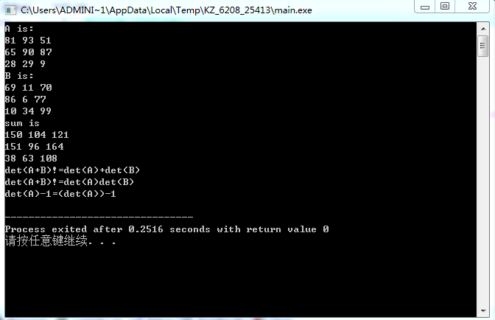

六、总结
- 注意行列式与矩阵的区别

