Challenge: Compressor

# Challenge Description :

**Ramona's obsession with modifications and the addition of artifacts to her body has slowed her down and made her fail and almost get killed in many missions. For this reason, she decided to hack a tiny robot under Golden Fang's ownership called "Compressor", which can reduce and increase the volume of any object to minimize/maximize it according to the needs of the mission. With this item, she will be able to carry any spare part she needs without adding extra weight to her back, making her fast. Can you help her take it and hack it?**

# Context :

## This is a weird one, you will need to NCat into the IP:PORT and then find a way to print the flag or get a shell.

# Notes :

* Tools:
  + - Cli Terminal - A Terminal to Netcat into the server and do this.

# Flag :

* Start the instance, and then Netcat into the server with the IP:PORT. Looking at the Interface i got when I first connected seems to be some sort of file Directory service.
* First thing I notice is that they are using Popular command to run functions on this, the main one being Zip.
* To explore potential uses of this information, we can visit the book.hacktricks.xyz website. For more reliable results, we should check GTFObins to learn about the Zip command and how to exploit it.

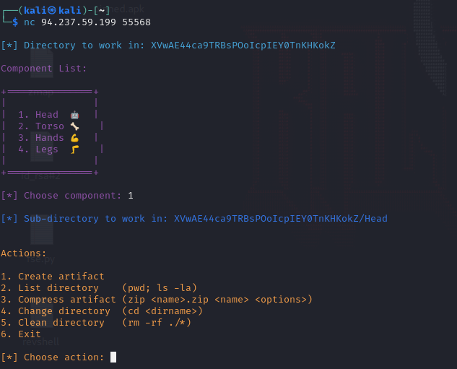

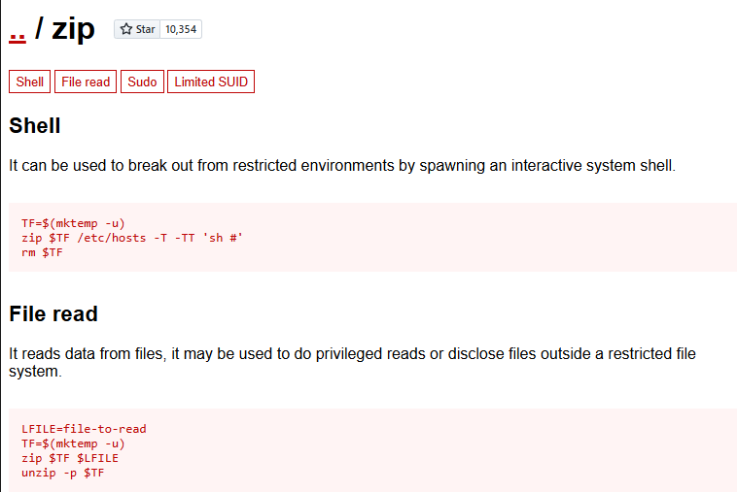

* After checking the GTFObins we know that we can get a working shell on this Directory service
* To do this the POC is to be able to enter:

” -T -TT 'sh #' ”

* Before exploiting it we will need to create a file [“Artifact”] in the Directory service to be able to use Zip or it will result in a failure because of there being a non-existing file being called, Using it in action would result in this :

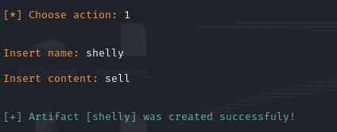

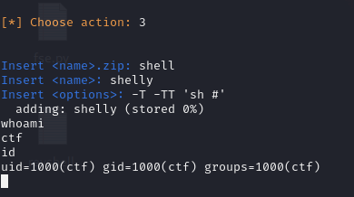

* Easy shell, you can set up TTY property is needed but this should be sufficient. Username is CTF and flag should be in the users system Directory

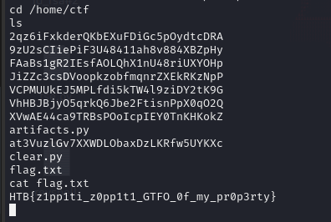

* Then we get the flag : HTB{z1pp1ti_z0pp1t1_GTFO_0f_my_pr0p3rty}