Challenge: Gawk

# Challenge Description:

**I lost access to my computer and needed a document urgently which got stuck in a printer. Can you get me the document ?**

# Context:

## Just Exploit a Printer to Find a Saved PDF Print-job with the Flag

# Notes:

* Tools:
  + - PRET - Printer Exploitation Toolkit

https://github.com/RUB-NDS/PRET

# Challenge:

* Exploit the Printer using PRET to then discover a PDF file with the Flag

# Flag:

* First Download PRET from github, then run it against the IP:PORT from the HTB Instance.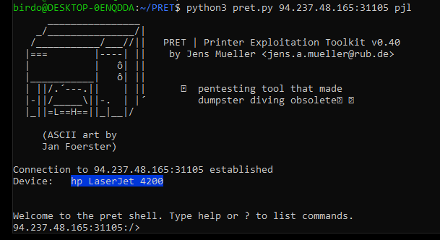
* Then you will get a shell for the printer, with this we could list the printing jobs, or better go through the directories of the printer to find the PDF.
* When we Enter the directory **‘/saveDevice/SavedJobs/InProgress’** We see a PDF file. We then downloaded the PDF file, I first checked the file to see if there's any hidden strings or the Flag but there's nothing.
* But the File is base64 encoded, so to decode it i just ran:

**‘base64 -d Filename.pdf > HR-normal’**

* After that i opened the HR-normal file and got a PDF file with a Flag

See Images Below

We get the flag : HTB{tr4v3rs3_m4n4g3ment_d3240!}

