Challenge:

Illumination

# Challenge Description :

A Junior Developer just switched to a new source control platform. Can you find the secret token?

# Context :

## A Zip File for analysts. Check the contents of the Zip file.

# Notes :

* I'm just using basic linux commands
  + - Notice the .git folder
    - Must have Git installed.

# Challenge :

* Just look into the .git folder and show a different committed version, then decode a weird string from a weird file maybe..?.

# Flag :

* First Download the Zip folder and extract it, after opening do **‘git log’**

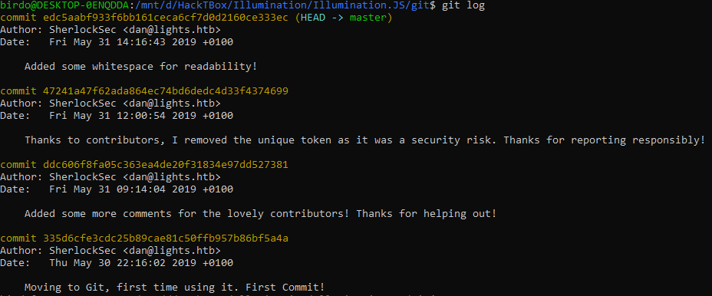

* After we show the commit **‘47241a47f62ada864ec74bd6dedc4d33f4374699’**

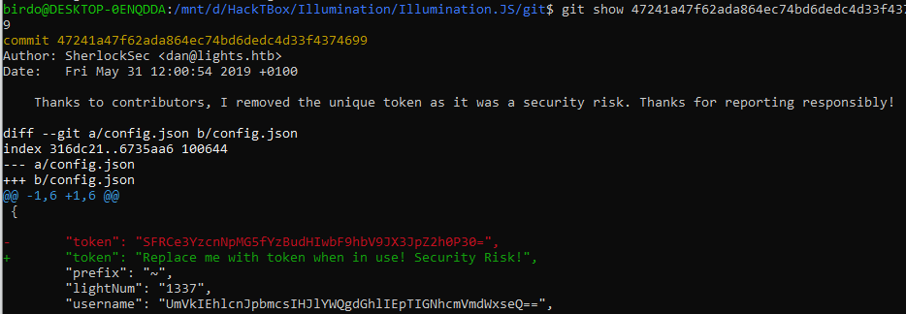

* By doing ‘git show 47241a47f62ada864ec74bd6dedc4d33f4374699’ we see the difference between the commits, this one takes about a security risk as well.
* By looking at it we base64 decode each value, the Token is the only one giving something. The Flag.

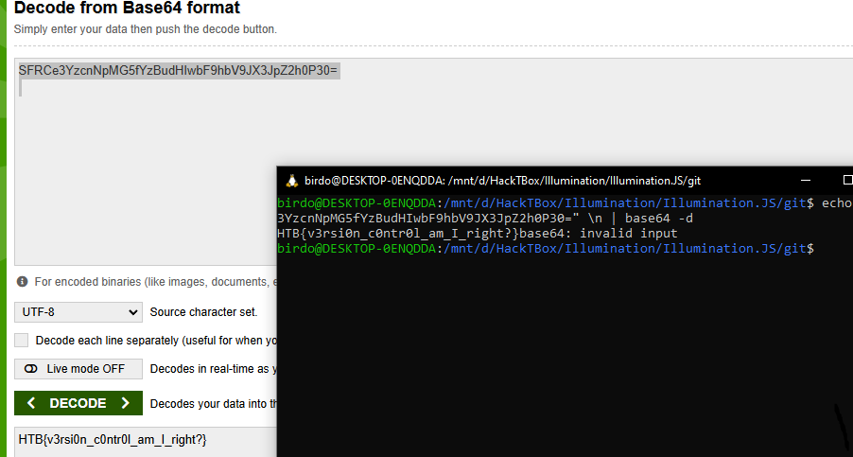

We get the flag : HTB{v3rsi0n_c0ntr0l_am_I_right?}

From Birdo