Challenge:Questionnaire

# Challenge Description :

**It's time to learn some things about binaries and basic c. Connect to a remote server and answer some questions to get the flag.**

# Context :

## This is a questionnaire about the C programming language, you get given a compiled program and you need to answer the question according to the questionnaire via a server that you connect to via netcat.

* **The questions will also give little hints and what tools you can use to find the answer but isnt always direct with it.**
* **A similar challenge like this is called Lesson.**

# Notes :

* Tools:
  + - Cli Terminal - A Terminal to Netcat into the server to answer the questions you just need to type.

# Flag :

* Start the instance, and then Netcat into the server with the IP:PORT. First look at the terminal I got when I first connected seems to be a questionnaire.
* I don't think this challenge is really important as there are better challenges to learn from.
* The answers to the Questions goes as:

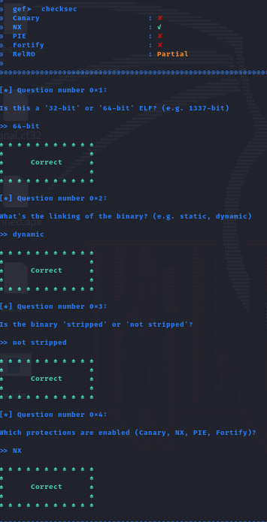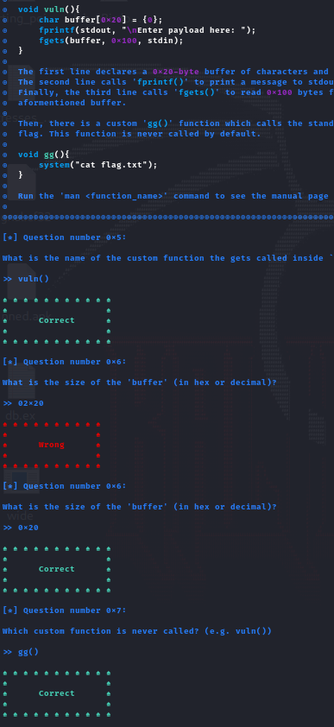

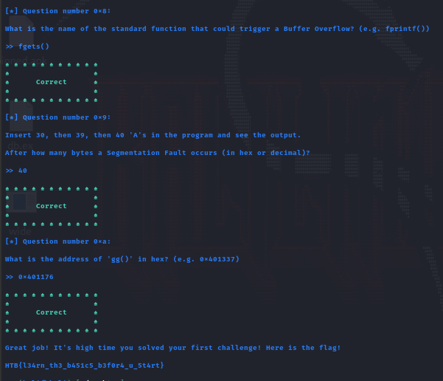

* At the end we get the flag : **HTB{l34rn_th3_b451c5_b3f0r4_u_5t4rt}**