Challenge: Regularity

# Challenge Description :

**Nothing much changes from day to day. Famine, conflict, hatred - it's all part and parcel of the lives we live now. We've grown used to the animosity that we experience every day, and that's why it's so nice to have a useful program that asks how I'm doing. It's not the most talkative, though, but it's the highest level of tech most of us will ever see....**

# Context :

## You are given a compiled file, analyze it and get the flag.

# Flag :

* **First Install the files and start the instance. Connecting to the server as soon as possible.**
* **The interface given to you isn't much, when you run the compiled file with Ltrace or Strace not much is given.**

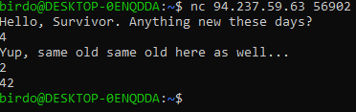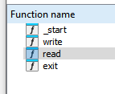

* **On Hex-Ida there only seems to be a limited amount of functions and not a lot of strings either, within the file.**
* **Analyzing the Binary code we find a Buffer-Overflow exploit present, meaning we can potentially gain a RCE abusing this.**

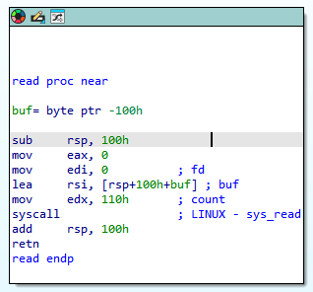

* **The Buffer-Overflow exploit is within the read function where we create a buffer on a stack of 100 bytes that we can read, but it's changed to read 110 bytes of data.**
* **That gives us enough space to write some shell code on the stack more possible due to no protection on the file.**
* **Meaning we can also overwrite the address that reaches the stack, we need to find where the stack is, so we can jump there.**
* **In the start function the read function gets the address from the [ rsi ] binary, making it the stack address that is storing it. It also contains a [ jmp rsi ] binary we can use on the address 0x401041**

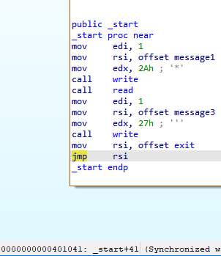

* **To exploit the server with this Buffer-Overflow I'm going to create a script in python using PWN to send over a Buffer-Overflow payload and hopefully give me a easy shell using that address.**

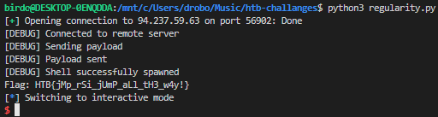

* **Making the script with the exploit as a poc finally worked and got a shell.**
* **The script will be on my github if you interested here is the {**[**link**](https://github.com/Birdo1221/HTB-writeup/blob/main/Regularity.py)**}**
* **The Flag given to us is : HTB{jMp_rSi_jUmP_aLl_tH3_w4y!}**