Challenge: SpookTastic

# Challenge Description :

**On a moonless night, you delve into the dark web to uncover the hacker group "The Cryptic Shadows." You find an encrypted message guiding you to a web challenge. They claim a cursed amulet, the 'Amulet of Samhain,' can unveil their treasures location**

# Context :

## The description tells us about a hidden message, we need to find a place for data input.

# Flag :

* Start the instance, loading the website there seems to be only one place to insert data .

## 

* Thinking of what we can do, the first thing I tried was to test for XSS [Cross-site scripting]. Popping an Alert via XSS will give you the flag. Simple.

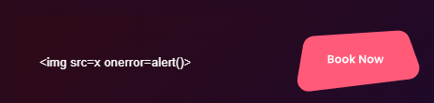

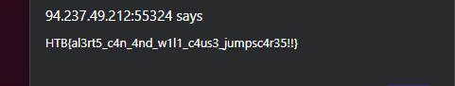

We finally got the Flag: **HTB{al3rt5_c4n_4nd_w1l1_c4us3_jumpsc4r35!!}**